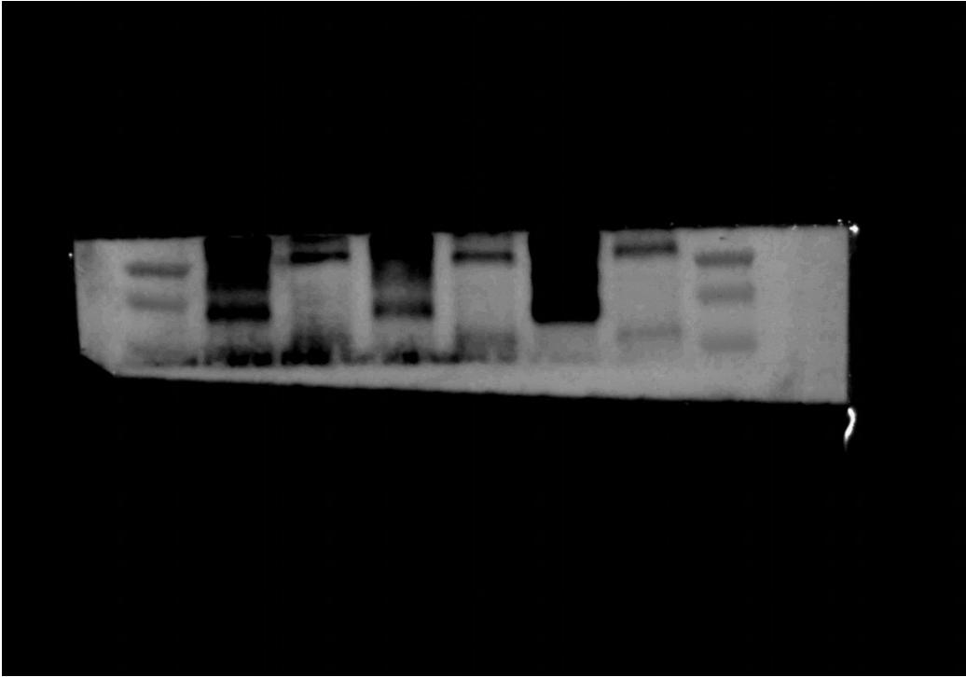

Fig.5A-siglec-15-lower

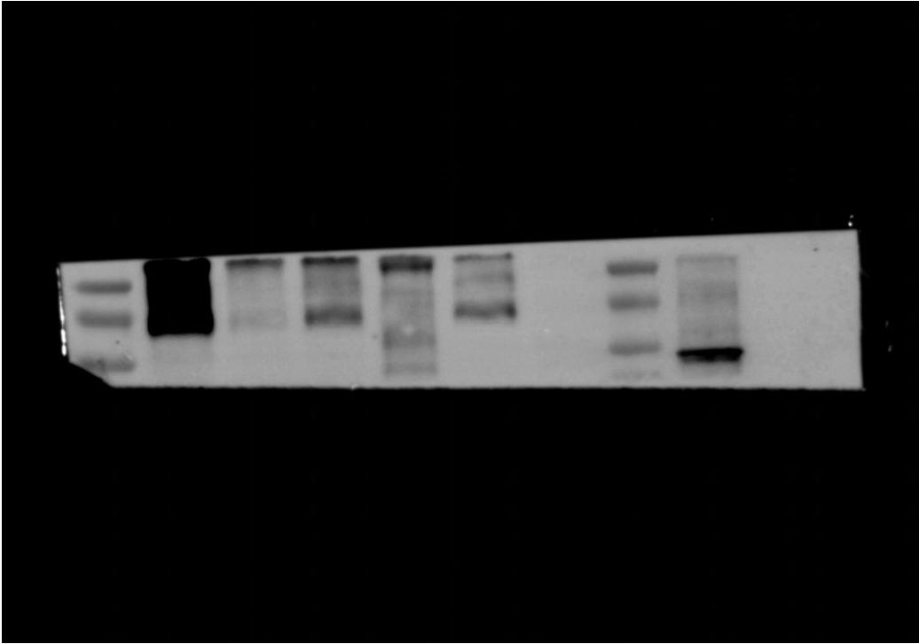

Fig.5A-siglec-15-upper.tiff

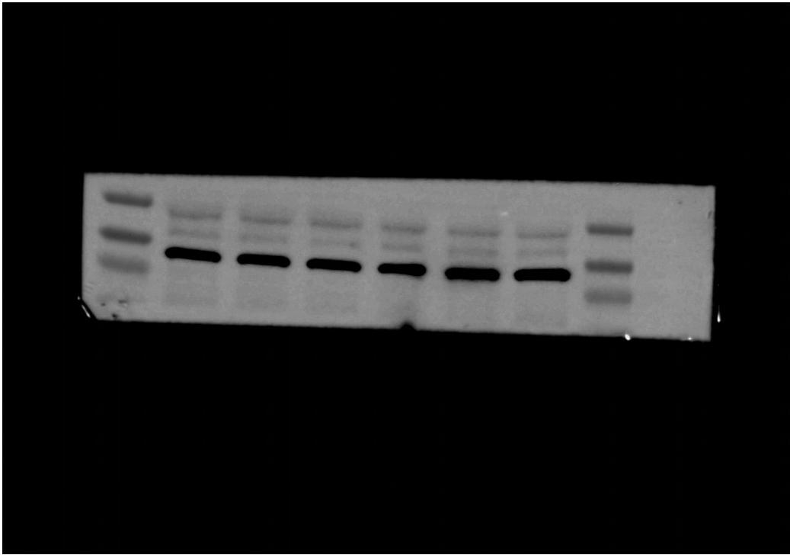

Fig.5A-β-actin-lower

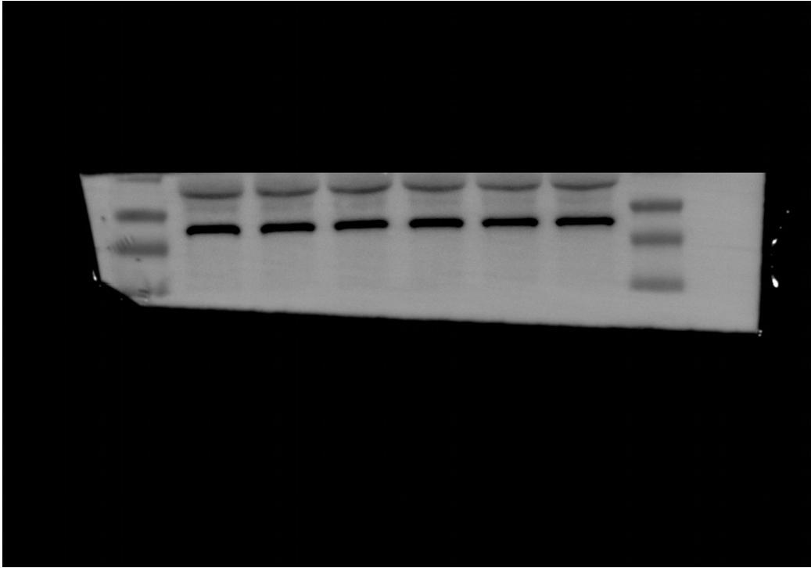

Fig.5A-β-actin-upper

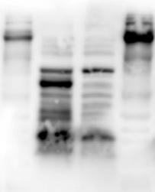

Fig.5B-siglec-15-BT549

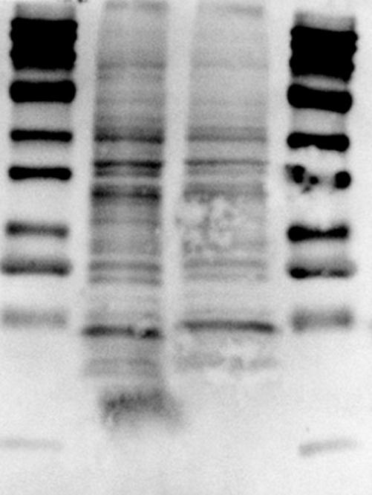

Fig.5B-Siglec-15-MDA-MB-231

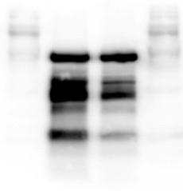

Fig.5B-β-Tublin-BT549

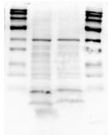

Fig.5B-β-Tublin-MDA-MB-231

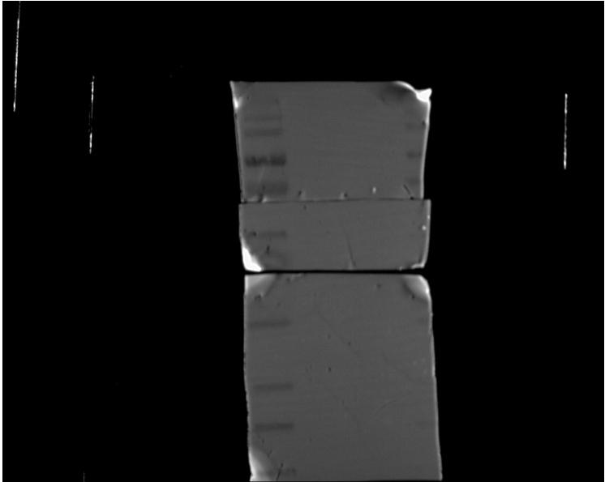

Fig.6D-MDA-MB-231

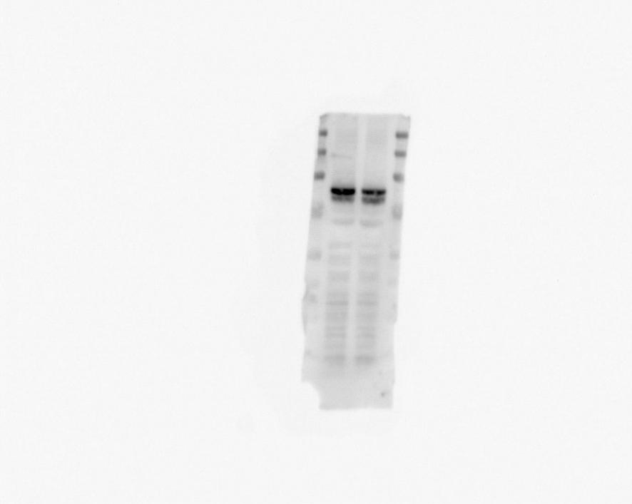

Fig.6D-p-STAT-3-BT549

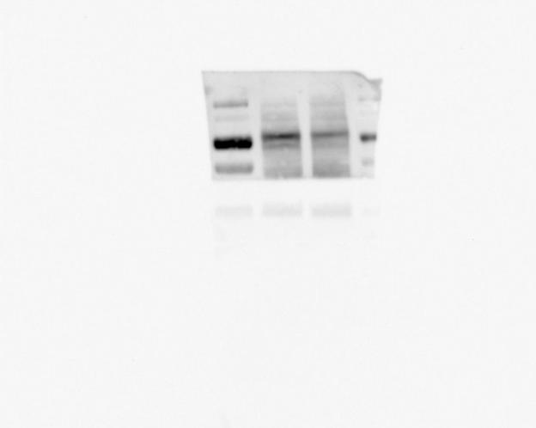

Fig.6D-p-STAT-3-MDA-MB-231

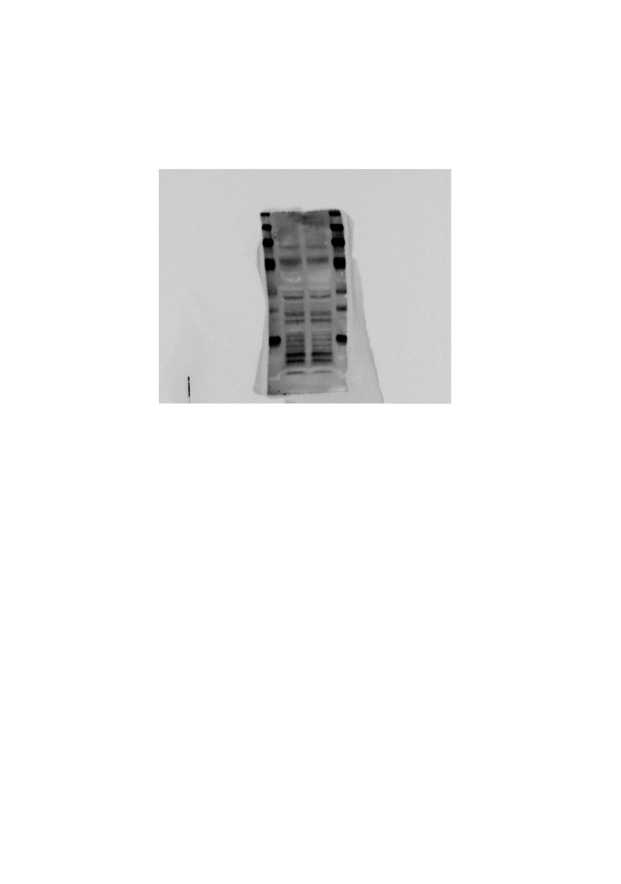
Fig.6D-Siglec-15-BT549.tif

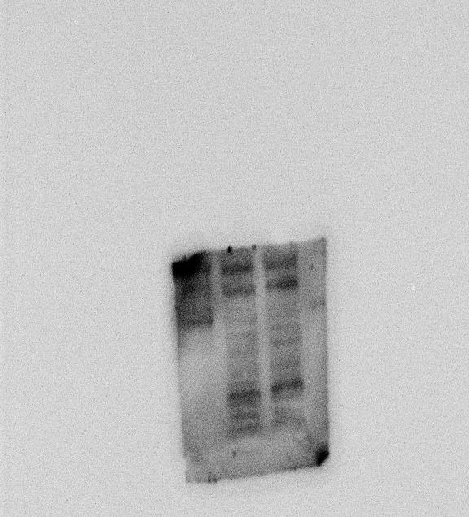

Fig.6D-Siglec-15-MDA-MB-231

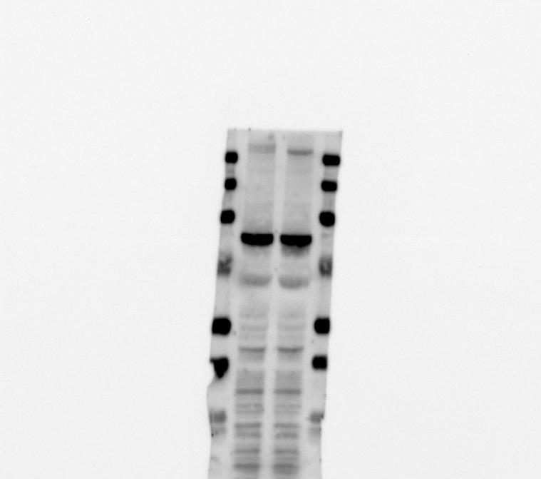

Fig.6D-STAT-3-BT549

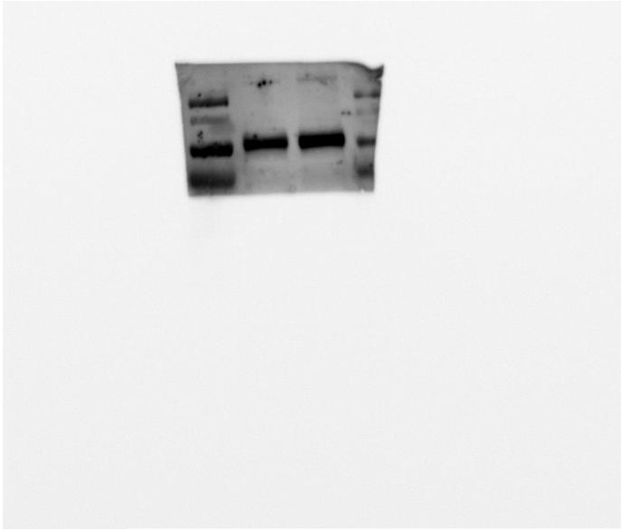

Fig.6D-STAT-3-MDA-MB-231

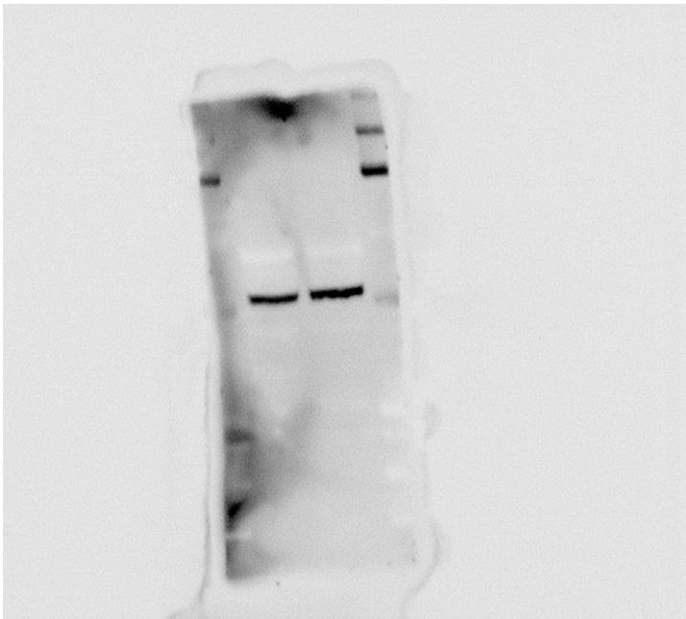

Fig.6D-β-tublin-BT549

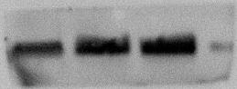

Fig.6D-β-tublin-MDA-MB-231

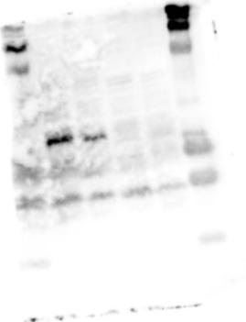

Fig.6N-DcR3-BT549

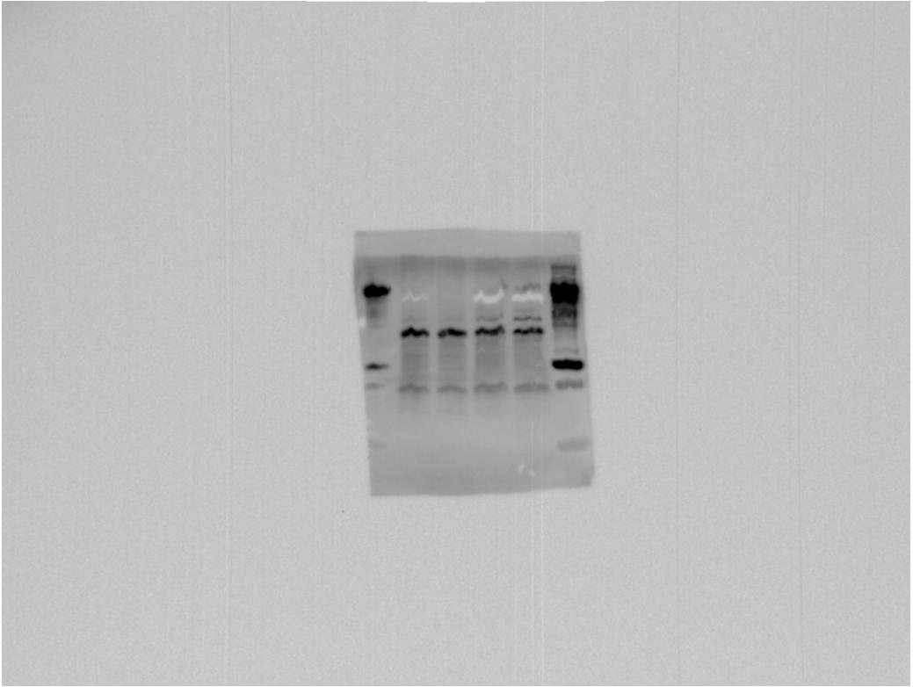

Fig.6N-Ikb-α-BT549

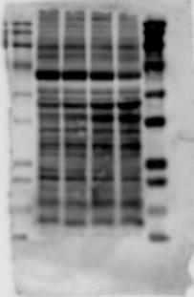

Fig.9N-p65-BT549

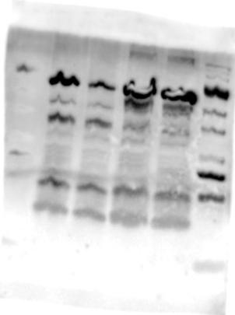

Fig.6N-p-Ikb-α-BT549

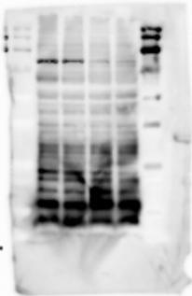

Fig.6N-p-p65-BT549

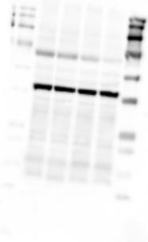

Fig.6N-β-Actin-BT549

