Supplementary Material
Development and internal validation of a contrast-enhanced CT-based clinical-radiomics model for preoperative prediction of lymph node metastasis in rectal cancer
Additional file 1: Supplementary figures.

Supplementary Figure S1
LASSO-based radiomics feature selection and coefficient profiles for construction of the radiomics model.
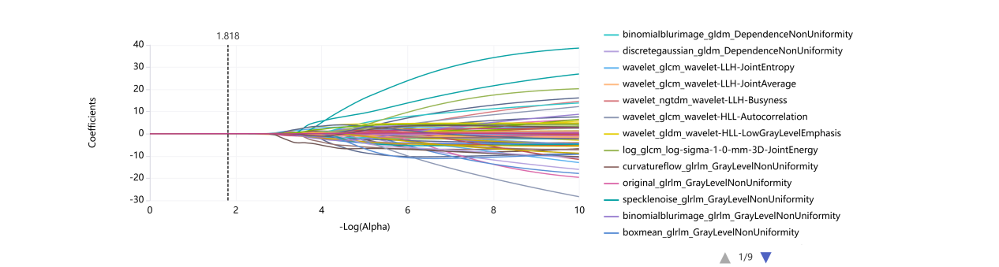
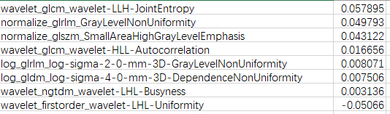
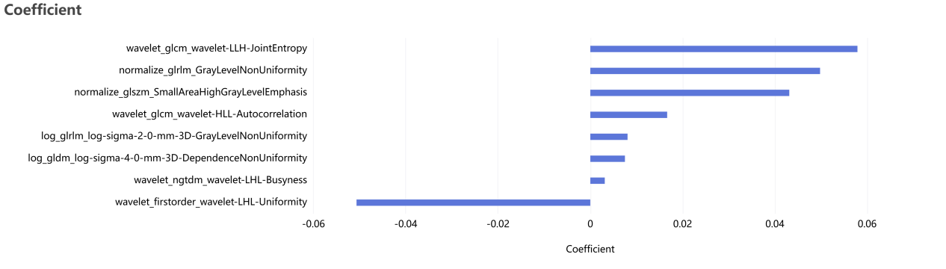
(A) LASSO coefficient profiles of radiomics features plotted against -log(lambda); (B) radiomics features retained after LASSO shrinkage with non-zero coefficients; and (C) the corresponding coefficients of the selected radiomics features. A total of eight radiomics features were ultimately retained for radiomics model construction.

Supplementary Figure S2
Confusion matrices of the clinical, radiomics, and combined models in the training and validation cohorts.
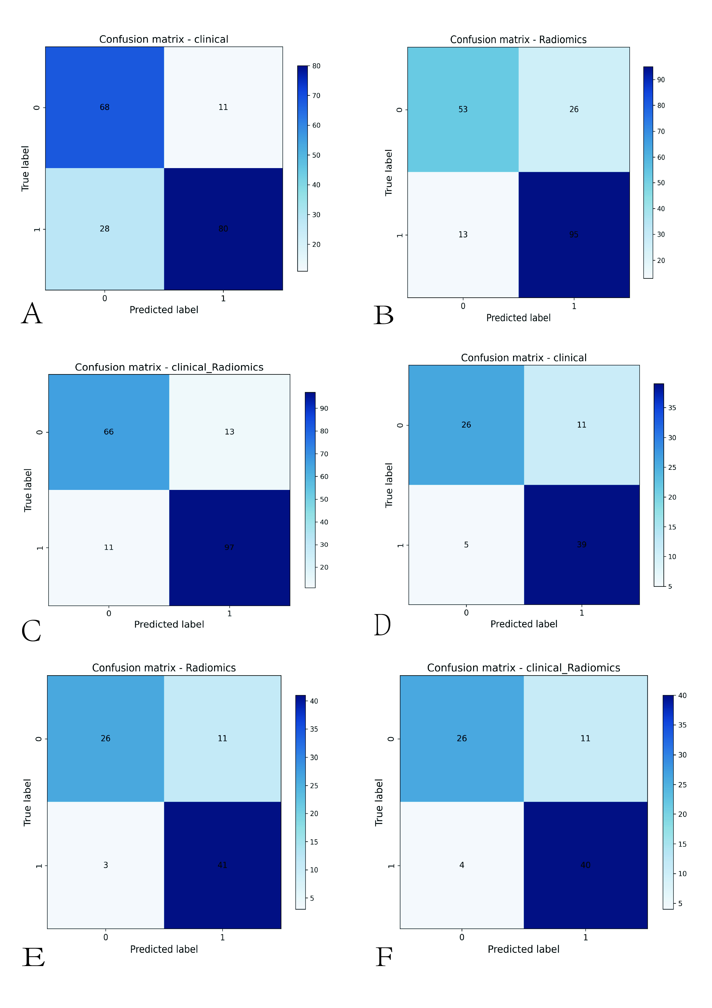
(A) Clinical model in the training cohort; (B) radiomics model in the training cohort; (C) combined model in the training cohort; (D) clinical model in the validation cohort; (E) radiomics model in the validation cohort; and (F) combined model in the validation cohort. The confusion matrices provide an intuitive presentation of the classification performance of each model for preoperative prediction of lymph node metastasis in rectal cancer.

