Table S1. Statistics of sequencing data.
Sample | Raw reads | Clean reads | Clean base | Error rate/% | Q₂₀/% | Q₃₀/% | GC content/%
Control_1 | 4537036 | 42180664  （99.16%） | 6305177806 | 0.0121 | 98.61 | 95.89 | 38.82
Control_2 | 4993228 | 44588790  （99.10%） | 6671881588 | 0.0123 | 98.51 | 95.58 | 45.62
Control_3 | 4609896 | 45156032  （99.00%） | 6760989186 | 0.0123 | 98.50 | 95.59 | 42.89
Control_4 | 47117266 | 46675196  （99.06%） | 6986539632 | 0.0123 | 98.54 | 95.62 | 42.11
Control_5 | 45331160 | 44906130  （99.06%） | 6736619894 | 0.0123 | 98.54 | 95.57 | 48.74
Control_6 | 40792980 | 40455546  （99.17%） | 6056125285 | 0.0122 | 98.57 | 95.73 | 41.63
EHP_1 | 45848208 | 45487600  （99.21%） | 6828810486 | 0.0123 | 98.49 | 95.42 | 51.90
EHP_2 | 42994410 | 42682268  （99.27%） | 6411571931 | 0.0121 | 98.61 | 95.80 | 50.63
EHP_3 | 42876030 | 42528294  （99.19%） | 6388270221 | 0.0124 | 98.45 | 95.36 | 51.15
EHP_4 | 43522444 | 43130614  （99.10%） | 6467064328 | 0.0124 | 98.44 | 95.33 | 51.08
EHP_5 | 47751638 | 47232596  （98.91%） | 7074057831 | 0.0124 | 98.46 | 95.35 | 51.69
EHP_6 | 47751638 | 46185890  （96.72%） | 6930818571 | 0.0123 | 98.49 | 95.47 | 53.32

Fig. S1 Results of PCA analysis of samples

Fig. S2 Heatmap of DEGs in each group after EHP infection in L. vannamei.
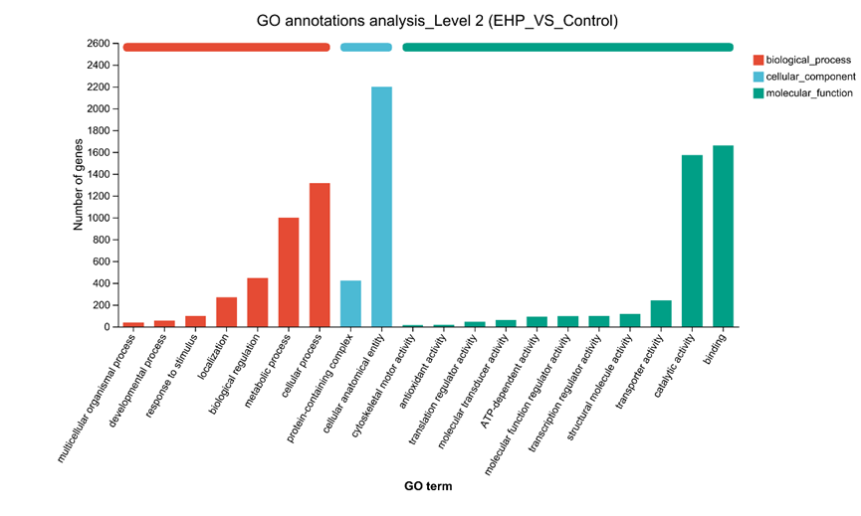
Fig. S3 Top 20 GO annotation terms for DEGs in the EHP VS Control group.

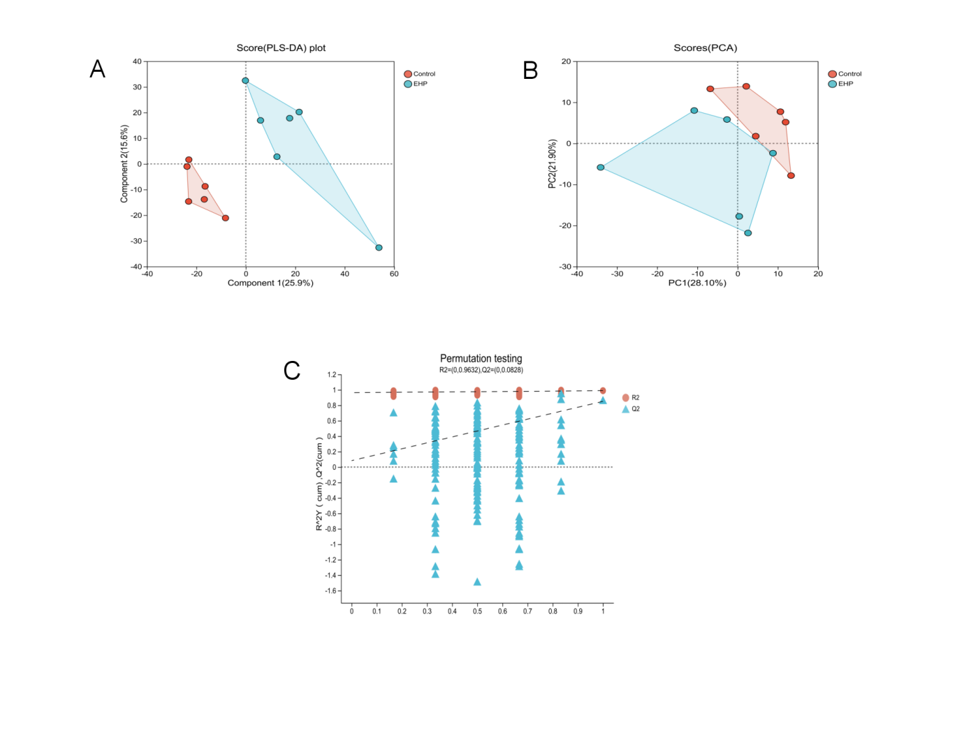
Fig. S4 Scatterplot of PCA and PLS-DA among samples. A: the PCA scatterplot; B: the PLS-DA scatterplot; C: PLS-DA permutation test plot.
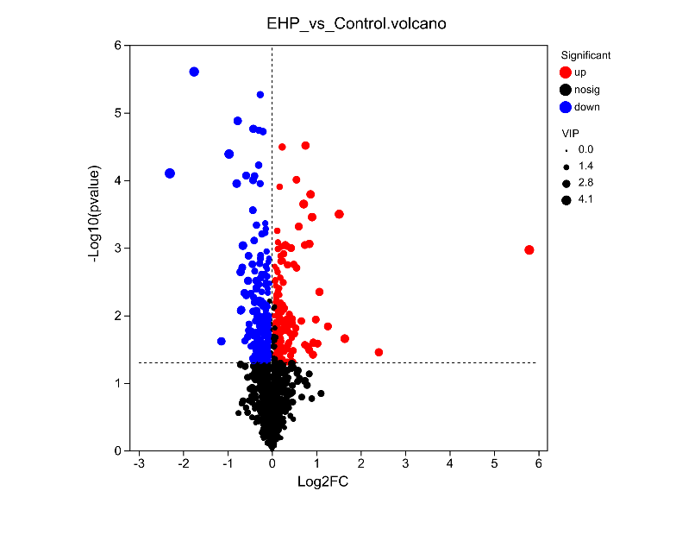
Fig. S5 DMs difference volcano map.
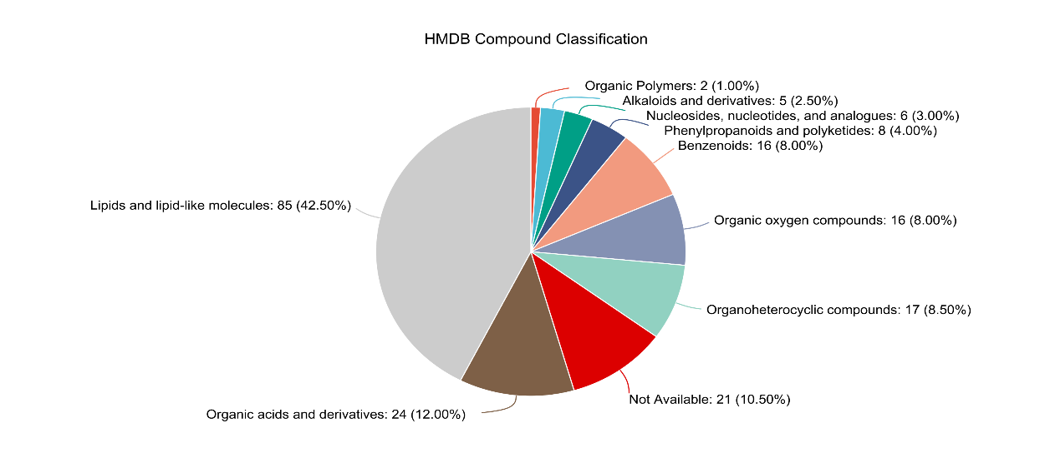
Fig. S6 Classification map of DMs in the EHP VS Control group based on the HMDB database.
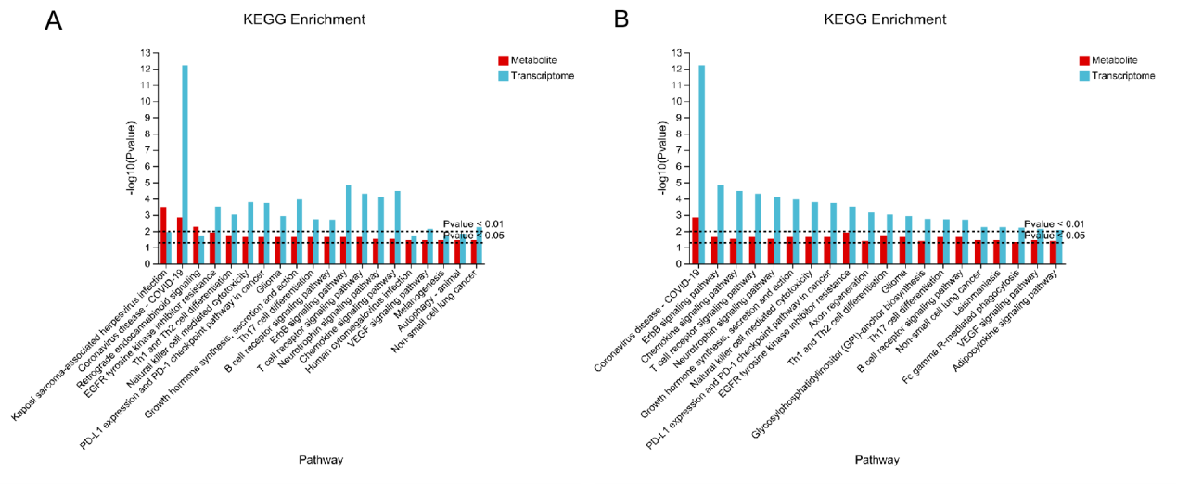
Fig. S7 DEGs and DMs enriched in KEGG pathway in EHP VS Control group.

