Supplementary informations
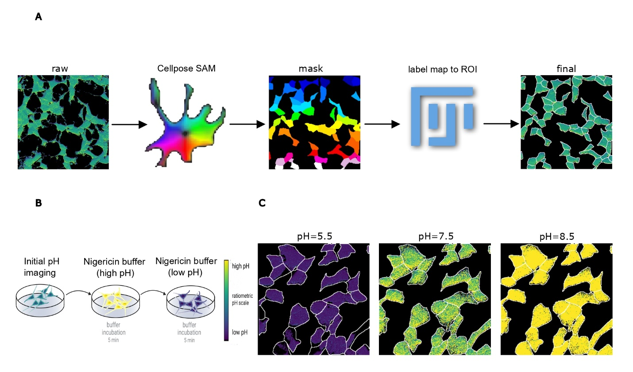
Supplementary figure 1. (A) Workflow for image segmentation: starting from the two channels (488/440 nm) alignment (using StackReg) and Gaussian filtering have been performed and after the ratiometric images has been obtained through RIA-J plug-in. The images are then runned on Cellpose CNN alghorythm (SAM) to obtain alabel map). The cells labels are then exported to Fiji and here ROIs are extracted by using the command "Label Map to ROIs". Area outside the ROIs has been cleared to obtain final measurements. (B) Schematic of single cell pH measurement using BCECF sensor and the protonophore nigericin to standardize the biosensor (see methods for details). (C) Representative images of pH calibration at defined pH values (5.5, 7.5 and 8.5).

