Supplementary Table 1. Search strategy of this meta-analysis.

Searches |  | Results
Pubmed search strategy
#1 | Search: ((((Methotrexate) OR (Canakinumab)) OR (Varespladib)) OR (Darapladib)) OR (Colchicine) | 3838
#2 | Search: ((Inflammation) OR (interleukin)) OR (phospholipase A₂) | 17760
#3 | Search: ((((Atherosclerosis) OR (coronary artery disease)) OR (Acute coronary syndrome)) OR (Myocardial infarction)) OR (cardiovascular) | 56962
#4 | Search: ((((((Methotrexate) OR (Canakinumab)) OR (Varespladib)) OR (Darapladib)) OR (Colchicine) AND (randomizedcontrolledtrial[Filter])) AND (((Inflammation) OR (interleukin-1)) OR (PLA2) AND (randomizedcontrolledtrial[Filter]))) AND (((((Atherosclerosis) OR (coronary artery disease)) OR (Acute coronary syndrome)) OR (Myocardial infarction)) OR (cardiovascular) AND (randomized controlled trial[Filter])) | 63
EMBASE search strategy.
#1 | 'methotrexate':ti,ab,kw OR 'canakinumab':ti,ab,kw OR 'varespladib':ti,ab,kw OR 'darapladib':ti,ab,kw OR 'colchicine':ti,ab,kw | 226620
#2 | 'inflammation':ti,ab,kw OR 'interleukin':ti,ab,kw OR 'phospholipase A₂':ti,ab,kw | 1023506
#3 | 'atheroscierosis':ti,ab,kw OR 'cornory artery disease':ti,ab,kw OR 'acute cornory syndrome':ti,ab,kw OR 'myocardial infarction':ti,ab,kw OR 'cardiovascular' | 2107240
#4 | #1 AND #2 AND #3 | 2817
#5 | 'RCT':ti,ab,kw OR 'randomized controlled trial':ti,ab,kw | 919945
#6 | #4 AND #5 | 381
Cochrane Library search strategy.

#1 | (Randomized Controlled Trial):ti,ab,kw OR (RCT):ti,ab,kw | 1193619
#2 | (Methotrexate):ti,ab,kw OR (Canakinumab):ti,ab,kw OR (Varespladib):ti,ab,kw OR (Darapladib):ti,ab,kw OR (Colchicine):ti,ab,kw | 128861
#3 | (Atheroscierosis):ti,ab,kw OR (Cornory Artery Disease):ti,ab,kw OR (Acute Cornory Syndrome):ti,ab,kw OR (Myocardial Infarction):ti,ab,kw OR (Cardiovascular) | 129011
#4 | (Inflammation):ti,ab,kw OR (interleukin):ti,ab,kw OR (phospholipase A₂):ti,ab,kw | 44439
#5 | #1 and #2 and #3 and #4 | 234
Web of science search strategy
#1 | TS= (Methotrexate OR Canakinumab OR Varespladib OR Darapladib OR Colchicine) | 12863
#2 | TS= (Atheroscierosis OR Cornory artery disease OR Acute cornory syndrome OR Myocardial infarction OR cardiovascular) | 199494
#3 | TS= (Inflammation OR interleukin OR phospholipase A₂) | 197047
#4 | #1 AND #2 AND #3 | 337
Article searched by the ACC 2014 and ESC 2020
 | Study title: The STABILITY Investigators. Darapladib for Preventing Ischemic Events in Stable Coronary Heart Disease  Study title: Effect of Darapladib on Major Coronary Events After an Acute Coronary Syndrome The SOLID-TIMI 52 Randomized Clinical Trial.  Study title: S.M. Nidorf, A.T.L. Fiolet, A. Mosterd, et al. Colchicine in Patients with Chronic Coronary Disease. | 3

Supplementary Table 2. Summary of GRADE evidence quality for each outcome.
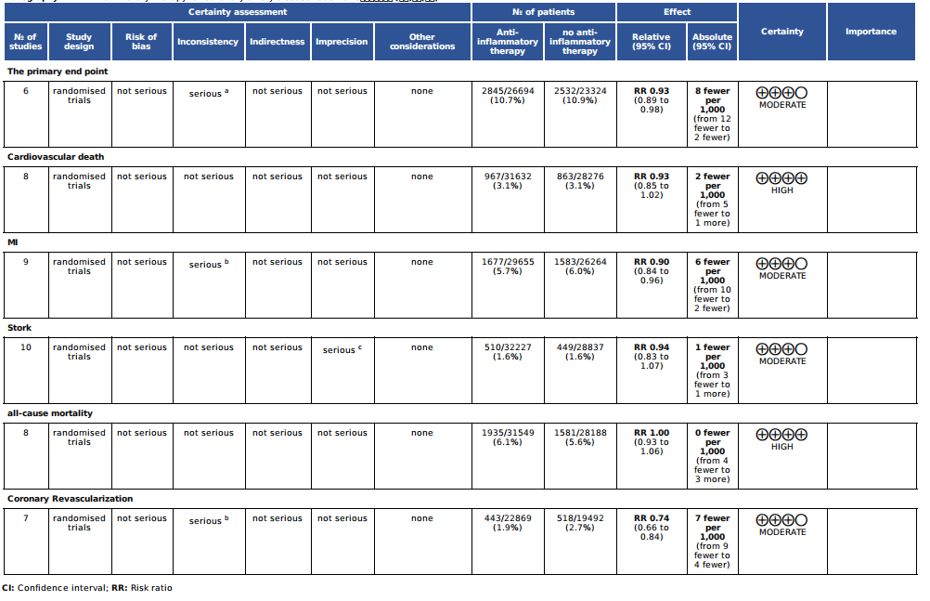

Supplementary Figure 1. Size of information required for each outcome. (A) The primary outcome, (B) MI, (C) Coronary revascularization, (D) Cardiovascular death, (E) Stroke.

Supplementary Figure 2. Assessment for the risk of bias in each randomized controlled trial included.

Supplementary Figure 3. Funnel plot of each outcome. (A) The primary outcome, (B) MI, (C) Coronary revascularization, (D) Cardiovascular death, (E) All-cause death, (F) Stroke.

Supplementary Figure 4. Funnel plot of each outcome. (A) The primary outcome, (B) MI, (C) Coronary revascularization, (D) Cardiovascular death, (E) All-cause death, (F) Stroke.

