Supplementary Materials

Supplementary Table 1: Background characteristics of interview participants. Baseline scores and score changes are shown for each participant, alongside demographic details, relationship to patient, and the patient’s main diagnosis. Net Promoter Score (NPS) ratings are also reported.

Participant Number | Baseline SDM-17 Score | Difference in SDM-17 Score | NPS | Gender | Age Group | Relationship with Patient | Main Diagnosis of Patient
P8 | 50-75th percentile | Positive | 8 | Female | 26-35 years | Grandmother | Diabetes
P13 | 0-25th percentile | Positive | 7 | Female | 36-45 years | Mother | Blocked arteries, pseudo gout, diabetes
P15 | 0-25th percentile | Negative | 8 | Male | 36-45 years | Father | Colon cancer
P20 | 0-25th percentile | Positive | 10 | Female | 21-25 years | Father | Pancreatic cancer
P29 | 75-100th percentile | Negative | 8 | Male | 26-35 years | Grandfather | Stroke and lung cancer
P44 | 0-25th percentile | Positive | 5 | Female | 46-55 years | Mother | Chronic conditions and multiple comorbidities

Supplementary Figure 1: Example of a Careverse Dashboard. (a) Dashboard overview showing the four caregiver guides with links to key pages. (b) Example of a guide-specific view displaying user progress and the option to download completed tool outputs as PDF files. (Stock images licensed from iStock)
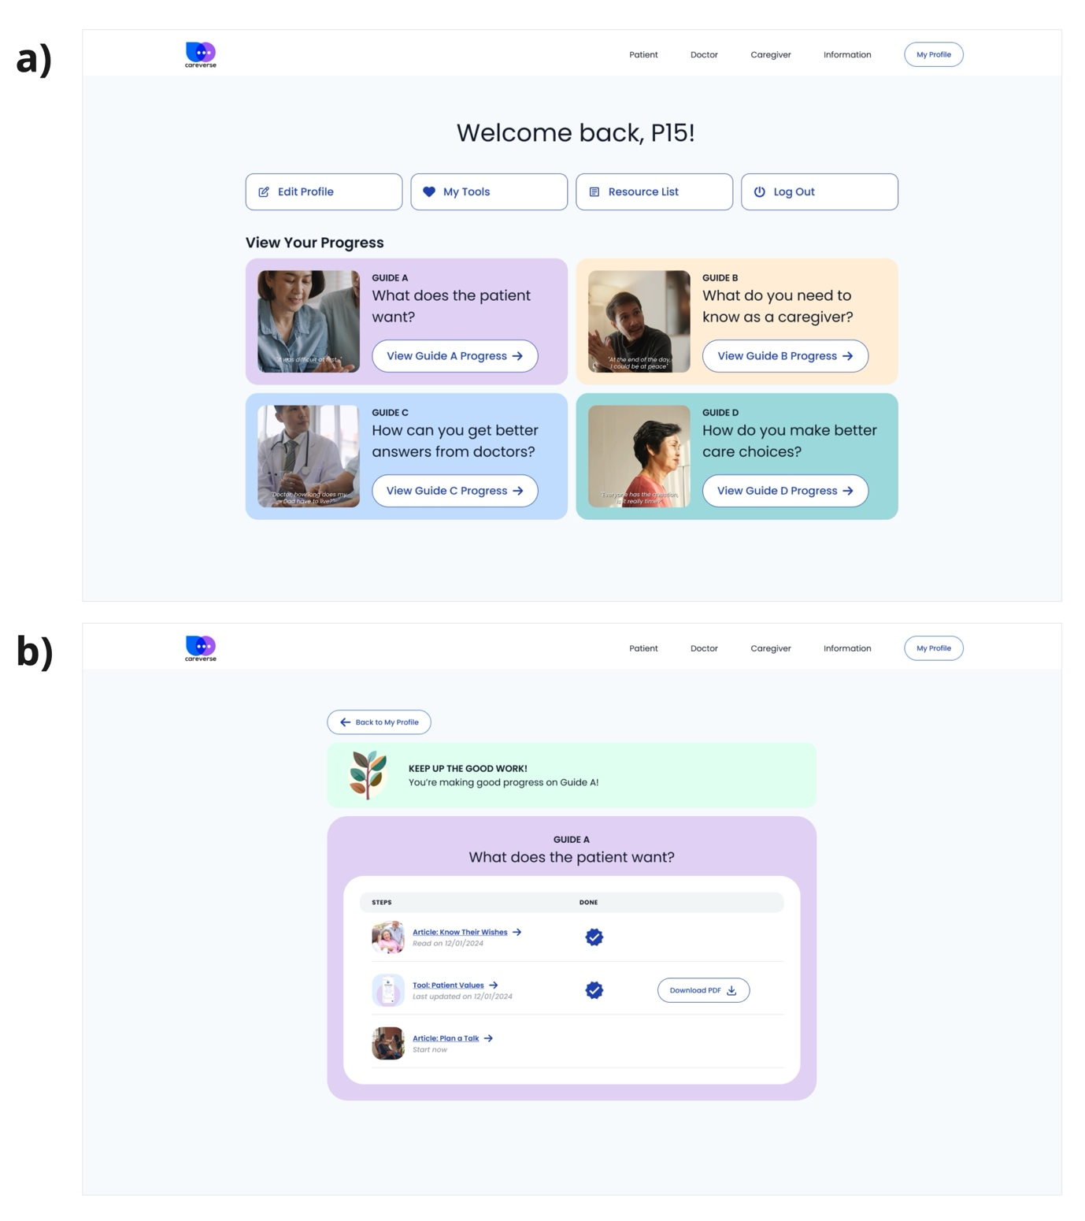

Supplementary Figure 2: Careverse homepage. A screenshot of the landing page, featuring a banner that frames the site as a safe space acknowledging caregiver concerns and uncertainties around surrogate decision-making. (Stock images licensed from iStock)
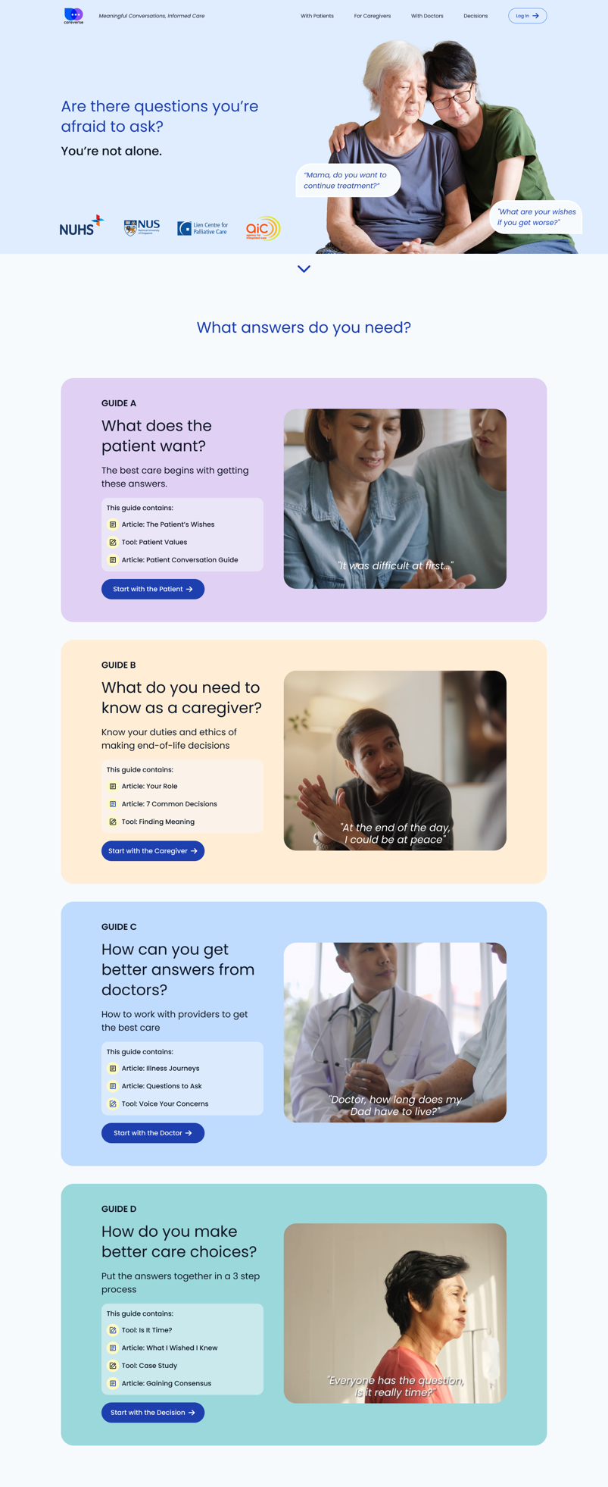
Supplementary Figure 3: Example of a shareable tool output. This PDF is generated by the Case Study Tool, which caregivers can use to communicate with care providers, share with family members, or keep for their own records



