Supplementary Table 1 Univariate Logistic Regression Analysis of Disease Progression of COVID-19 in the Development cohort
 | Univariate Logistic analysis
Variables | HR (95% CIs) | P value
Gender, male | 1.73 (1.24-2.40) | 0.001
Age, per year increment | 1.06 (1.04-1.07) | <0.001
Respiratory rate (times), ≥30 | 25.06 (12.48-50.34) | <0.001
Ever smoking | 0.77 (0.42-1.42) | 0.774
Ever drinking | 1.18 (0.59-2.37) | 0.633
Symptoms
Fever | 1.10 (0.77-1.59) | 0.597
Cough | 1.22 (0.84-1.76) | 0.299
Fatigue | 1.20 (0.86-1.66) | 0.280
Anorexia | 1.12 (0.81-1.55) | 0.479
Short breath | 2.42 (1.72-3.40) | <0.001
Myalgia | 1.10 (0.79-1.53) | 0.586
Chest tight | 1.59 (1.15-2.20) | 0.005
Expectoration | 1.08 (0.72-1.63) | 0.710
Diarrhea | 0.78 (0.38-1.62) | 0.509
Dyspnea | 9.12 (6.29-13.21) | <0.001
Sore throat | 0.56 (0.20-1.53) | 0.258
Nausea | 1.55 (0.70-3.41) | 0.277
Headache | 0.51 (0.13-2.11) | 0.356
Vomiting | 1.04 (0.37-2.89) | 0.941
Dizziness | 0.98 (0.98-2.72) | 0.970
Chill | 0.30 (0.04-2.18) | 0.234
Hemoptysis | 1.87 (0.43-8.09) | 0.403
Coexisting disorders
Hypertension | 2.35 (1.71-3.23) | <0.001
Diabetes | 1.73 (1.17-2.55) | 0.006
Coronary heart disease | 2.64 (1.68-4.15) | <0.001
Cardiovascular disease | 4.43 (3.07-6.39) | <0.001
Cerebrovascular disease | 4.34 (2.62-7.16) | <0.001
Tumor | 3.44 (1.82-6.51) | <0.001
Bronchitis | 3.85 (1.85-8.05) | <0.001
COPD | 4.55 (1.83-11.28) | 0.001
Respiratory disease | 3.84 (2.15-6.86) | <0.001
Chronic kidney disease | 3.86 (2.20-6.77) | <0.001
Chronic liver disease | 2.47 (1.54-3.98) | <0.001
Laboratory findings
White-cell count (×10⁹/L)
4-10 | Referent
≤4 or ≥10 | 2.40 (1.70-3.38) | <0.001
Neutrophil count (×10⁹/L)
2.8-3.6 | Referent
≤1.8 or ≥3.6 | 5.86 (3.74-9.18) | <0.001
Lymphocyte count, <1.5×10⁹/L | 6.52 (4.13-10.29) | <0.001
Monocyte count, ≥0.6 ×10⁹/L | 1.20 (0.99-1.45) | 0.060
Platelet count, <150 ×10⁹/L | 4.46 (3.14-6.34) | <0.001
C-reactive protein, >10mg/l | 12.26 (8.26-18.2) | <0.001
D-dimer, ≥0.5 mg/L | 12.2 (7.09-20.97) | <0.001
Alanine aminotransferase, >40 U/L | 1.68 (1.19-2.37) | 0.003
Aspartate aminotransferase, >40 U/L | 3.70 (2.54-5.39) | <0.001
Albumin, <40 g/L | 7.93 (3.88-16.23) | <0.001
Total bilirubin, >17.1 μmol/L | 2.38 (1.55-3.67) | <0.001
Blood glucose, >6.1 mmol/L | 4.44 (3.20-6.16) | <0.001
Urea, >7.5 mmol/L | 11.76 (8.24-16.8) | <0.001
Creatinine, ≥133 μmol/L | 6.34 (3.38-11.87) | <0.001
Lactate dehydrogenase, ≥250 U/L | 14.76 (10.47-20.82) | <0.001

Supplementary Table 2 Univariate Logistic Regression Analysis of Severity of COVID-19 in the Development cohort
 | Univariate Logistic analysis
Variables | HR (95% CIs) | P value
Gender, male | 1.17 (0.99-1.38) | 0.052
Age, per year increment | 1.04 (1.04-1.05) | <0.001
Respiratory rate (times), ≥30 | 15.8 (6.11-41.0) | <0.001
Ever smoking | 0.96 (0.74-1.25) | 0.777
Ever drinking | 0.81 (0.56-1.19) | 0.285
Symptoms
Fever | 1.31 (1.08-1.57) | 0.005
Cough | 1.31 (1.09-1.58) | 0.004
Fatigue | 1.14 (0.97-1.34) | 0.126
Anorexia | 1.01 (0.86-1.19) | 0.890
Short breath | 1.63 (1.39-1.92) | <0.001
Myalgia | 1.00 (0.84-1.18) | 0.994
Chest tight | 1.53 (1.29-1.82) | <0.001
Expectoration | 1.33 (1.08-1.63) | 0.006
Diarrhea | 0.81 (0.57-1.15) | 0.238
Dyspnea | 4.81 (3.55-6.51) | <0.001
Sore throat | 0.80 (0.53-1.22) | 0.305
Nausea | 0.72 (0.43-1.21) | 0.217
Headache | 0.60 (0.33-1.10) | 0.097
Vomiting | 0.82 (0.47-1.41) | 0.466
Dizziness | 0.88 (0.52-1.49) | 0.635
Chill | 1.71 (1.01-2.91) | 0.046
Hemoptysis | 1.33 (0.53-3.30) | 0.542
Coexisting disorders
Hypertension | 1.91 (1.62-2.26) | <0.001
Diabetes | 1.78 (0.44-2.21) | <0.001
Coronary heart disease | 2.20 (1.65-2.93) | <0.001
Cardiovascular disease | 2.60 (2.03-3.34) | <0.001
Cerebrovascular disease | 2.31 (1.59-3.36) | <0.001
Tumor | 1.82 (1.14-2.89) | 0.011
Bronchitis | 1.97 (1.13-3.43) | 0.017
COPD | 2.68 (1.30-5.51) | 0.007
Respiratory disease | 2.22 (1.45-3.40) | <0.001
Chronic kidney disease | 1.97 (1.30-2.99) | 0.001
Chronic liver disease | 1.03 (0.75-1.43) | 0.852
Laboratory findings
White-cell count (×10⁹/L)
4-10 | Referent
≤4 or ≥10 | 1.55 (1.28-1.90) | <0.001
Neutrophil count (×10⁹/L)
2.8-3.6 | Referent
≤1.8 or ≥3.6 | 1.85 (1.56-2.19) | <0.001
Lymphocyte count, <1.5×10⁹/L | 2.07 (1.75-2.44) | <0.001
Monocyte count, ≥0.6 ×10⁹/L | 1.48 (1.21-1.81) | <0.001
Platelet count, <150 ×10⁹/L | 1.89 (1.50-2.39) | <0.001
C-reactive protein, >10mg/l | 2.87 (2.38-3.45) | <0.001
D-dimer, ≥0.5 mg/L | 3.27 (2.72-3.92) | <0.001
Alanine aminotransferase, >40 U/L | 1.07 (0.88-1.30) | 0.504
Aspartate aminotransferase, >40 U/L | 1.53 (1.18-1.97) | 0.001
Albumin, <40 g/L | 2.19 (1.79-2.68) | <0.001
Total bilirubin, >17.1 μmol/L | 1.70 (1.30-2.22) | <0.001
Blood glucose, >6.1 mmol/L | 2.39 (1.96-2.90) | <0.001
Urea, >7.5 mmol/L | 3.68 (2.78-4.88) | <0.001
Creatinine, ≥133 μmol/L | 2.50 (1.47-4.25) | 0.001
Lactate dehydrogenase, ≥250 U/L | 4.48 (3.63-5.54) | <0.001

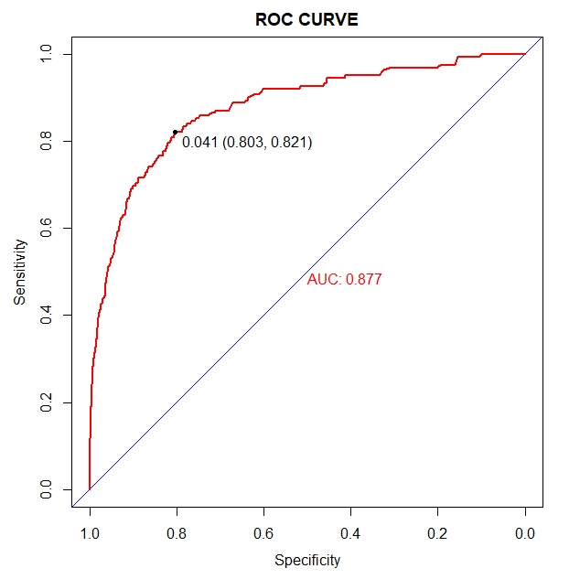
Supplementary Figure 1 ROC curve for disease progression of COVID-19 in the Development cohort

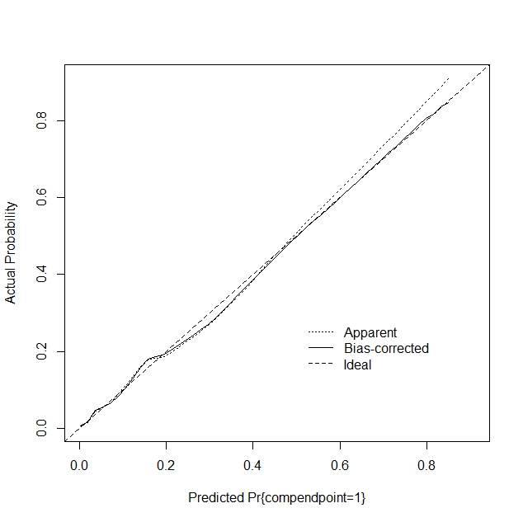
Supplementary Figure 2 calibration plot for disease progression of COVID-19 in the Development cohort. Nomogram-predicted probability of disease progression is plotted on the x-axis; actual disease progression is plotted on the y-axis.

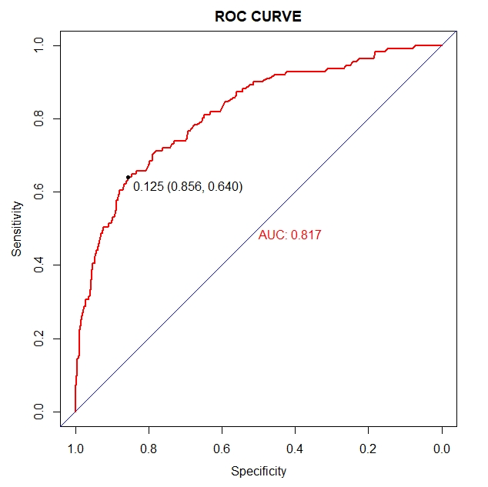
Supplementary Figure 3 ROC curve for disease progression of COVID-19 in the validation cohort

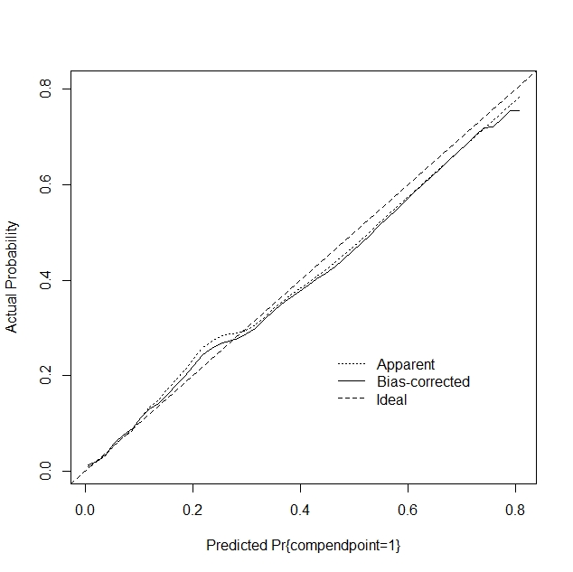
Supplementary Figure 4 calibration plot for disease progression of COVID-19 in the validation cohort. Nomogram-predicted probability of disease progression is plotted on the x-axis; actual disease progression is plotted on the y-axis.

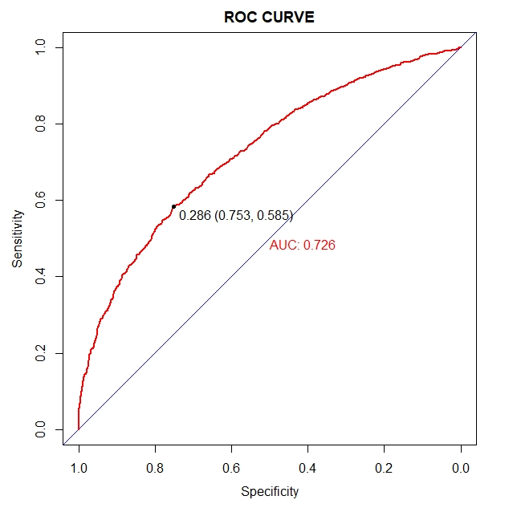
Supplementary Figure 5 ROC curve for severity of COVID-19 at admission in the Development cohort

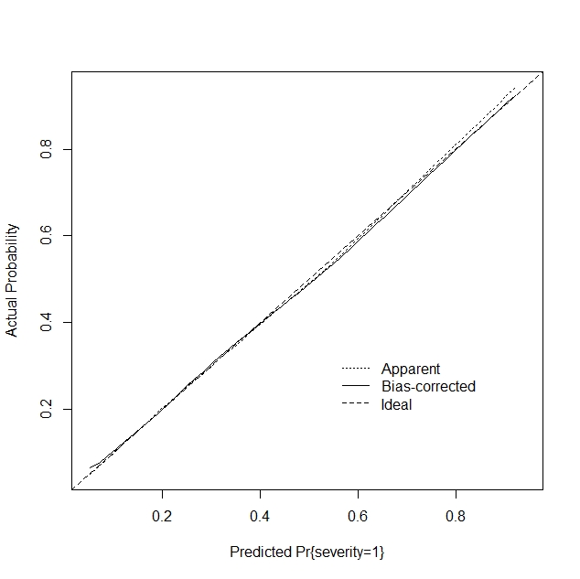
Supplementary Figure 6 The calibration plot for severity of COVID-19 at admission in the Development cohort. Nomogram-predicted probability of severity is plotted on the x-axis; actual severity is plotted on the y-axis.

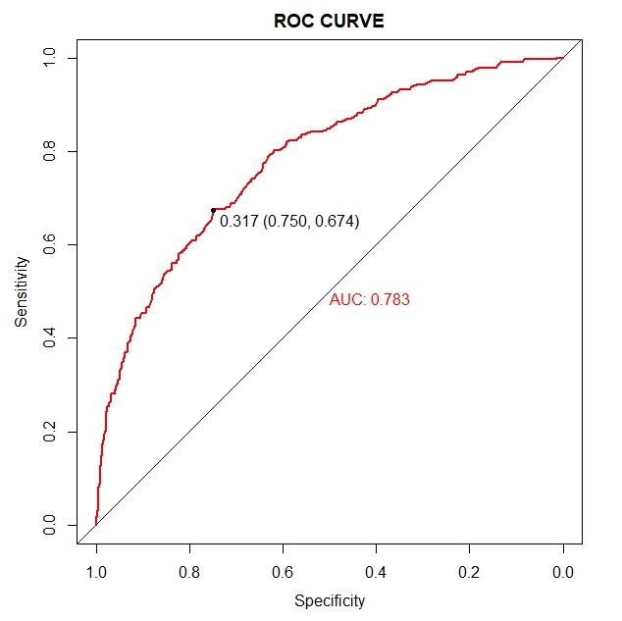
Supplementary Figure 7 ROC curve for severity of COVID-19 at admission in the validation cohort

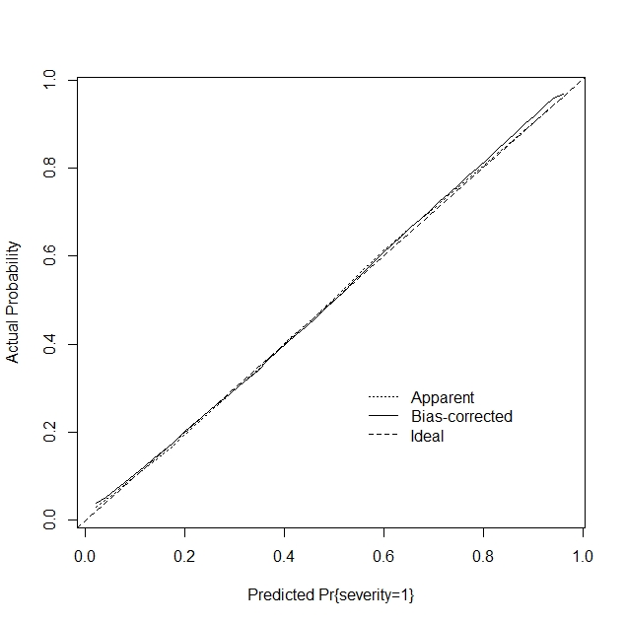
Supplementary Figure 8 calibration plot for severity of COVID-19 at admission in the validation cohort. Nomogram-predicted probability of severity is plotted on the x-axis; actual severity is plotted on the y-axis.

