Supplementary Material

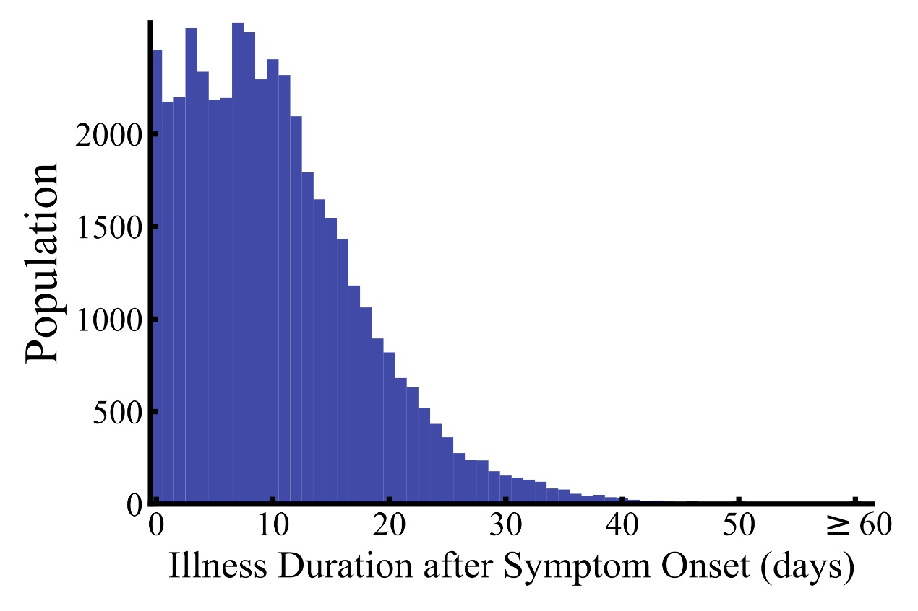
Figure E1. Illness Duration in the Study Population.
This picture shows the distribution of the duration of the disease after the onset of symptoms in the studied patients.

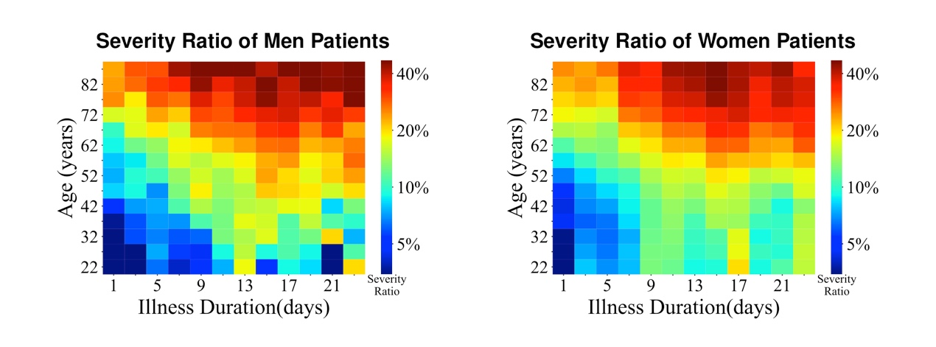
Figure E2. Severity Ratio at Different Ages and Illness Durations, in Men and Women.
Severity Ratio refers to the proportion of patients with severe disease.

