Supplementary materials
Supplementary Table 1 HR (95% CI) for all-cause and cause-specific mortality based on premature aging markers among diabetics.
 | All-cause mortality | CVD mortality | Cancer mortality
Phenotypic Age Acceleration
Model 1 | 1.04 (1.04, 1.05) | 1.05 (1.03, 1.06) | 1.04 (1.03, 1.06)
Model 2 | 1.04 (1.03, 1.05) | 1.04 (1.02, 1.05) | 1.04 (1.03, 1.06)
ΔPhenotypic Age
Model 1 | 1.04 (1.03, 1.05) | 1.04 (1.03, 1.06) | 1.03 (1.02, 1.05)
Model 2 | 1.04 (1.03, 1.04) | 1.04 (1.02, 1.05) | 1.03 (1.02, 1.05)
Biological Age Acceleration
Model 1 | 1.05 (1.03, 1.07) | 1.06 (1.02, 1.10) | 1.00 (0.95, 1.06)
Model 2 | 1.04 (1.02, 1.06) | 1.05 (1.01, 1.08) | 0.99 (0.94, 1.04)
ΔBiological Age
Model 1 | 1.05 (1.03, 1.06) | 1.06 (1.02, 1.11) | 1.00 (0.95, 1.05)
Model 2 | 1.04 (1.02, 1.05) | 1.05 (1.01, 1.09) | 0.98 (0.93, 1.04)
Model 1: adjusted for age (<65 or ≥65), sex (male or female), race/ethnicity (Mexican American, other Hispanic, non-Hispanic White, non-Hispanic Black, or other), marital status (married/cohabiting, widowed/divorced/separated, or never married), BMI (<25.0, 25.0-29.9, or ≥30.0 kg/m²), physical activity (moderate or vigorous), drinking alcohol status (ever or never), and Ln-cotinine concentration (continuous). Model 2: further adjusted (from Model 1) for triglyceride (continuous), medication use (insulin/pills or no), CVD (yes or no), cancer (yes or no), and hypertension (yes or no).
Phenotypic/Biological Age Acceleration defined as the residual resulting from a linear model when regressing Phenotypic/Biological Age on chronological age. ΔPhenotypic/Biological Age defined as the value of Phenotypic/Biological Age minus chronological age.
A
B

B

Supplementary Fig. 1 The dose-response relationship of aging markers with CVD mortality (a) and cancer mortality (b) assessed by restricted cubic spline regression. Models were adjusted for age (<65 or ≥65), sex (male or female), race/ethnicity (Mexican American, other Hispanic, non-Hispanic White, non-Hispanic Black, or other), marital status (married/cohabiting, widowed/divorced/separated, or never married), BMI (<25.0, 25.0-29.9, or ≥30.0 kg/m²), physical activity (moderate or vigorous), drinking alcohol status (ever or never), Ln-cotinine concentration (continuous), triglyceride (continuous), medication use (insulin/pills or no), CVD (yes or no), cancer (yes or no), and hypertension (yes or no).
Supplementary Table 2 HR (95% CI) for all-cause and cause-specific mortality based on aging markers after excluding diabetics with a diagnosis of diabetes before the age of 20 years
 | All-cause mortality | CVD mortality | Cancer mortality
Phenotypic Age (years)
Deaths/total | 1211/3580 | 309/2949 | 202/2842
Continuous | 1.05 (1.05, 1.07) | 1.05 (1.04, 1.07) | 1.05 (1.03, 1.07)
T1 | 1.00 (reference) | 1.00 (reference) | 1.00 (reference)
T2 | 2.02 (1.40, 2.92) | 1.5 (0.74, 3.05) | 1.10 (0.47, 2.58)
T3 | 5.07 (3.49, 7.38) | 3.45 (1.66, 7.18) | 2.87 (1.22, 6.76)
P_{trend} | <0.001 | <0.001 | 0.004
Biological Age (years)
Deaths/total | 1169/3721 | 302/2854 | 1912743
Continuous | 1.06 (1.05, 1.07) | 1.08 (1.05, 1.10) | 1.05 (1.03, 1.08)
T1 | 1.00 (reference) | 1.00 (reference) | 1.00 (reference)
T2 | 1.83 (1.32, 2.53) | 1.55 (0.80, 2.98) | 1.86 (0.78, 4.42)
T3 | 3.50 (2.40, 5.09) | 4.59 (1.75, 12.09) | 1.88 (0.61, 5.82)
P_{trend} | <0.001 | 0.004 | 0.183
Mean T/S ratio
Deaths/total | 423/877 | 115/569 | 55/509
Continuous | 0.51 (0.27, 0.96) | 0.36 (0.11, 1.18) | 0.29 (0.03, 2.60)
T1 | 1.00 (reference) | 1.00 (reference) | 1.00 (reference)
T2 | 0.69 (0.49, 0.95) | 0.56 (0.27, 1.15) | 0.78 (0.32, 1.91)
T3 | 0.65 (0.44, 0.98) | 0.76 (0.43, 1.36) | 0.49 (0.12, 1.98)
P_{trend} | 0.034 | 0.266 | 0.293
Klotho (ng/mL)
Deaths/total | 279/2501 | 58/2280 | 66/2288
Continuous | 0.76 (0.51, 1.12) | 0.59 (0.17, 2.03) | 0.87 (0.31, 2.42)
T1 | 1.00 (reference) | 1.00 (reference) | 1.00 (reference)
T2 | 0.65 (0.46, 0.92) | 0.51 (0.28, 0.93) | 0.51 (0.30, 0.84)
T3 | 0.87 (0.60, 1.25) | 0.84 (0.37, 1.91) | 0.83 (0.39, 1.77)
P_{trend} | 0.397 | 0.615 | 0.632
Models were adjusted for age (<65 or ≥65), sex (male or female), race/ethnicity (Mexican American, other Hispanic, non-Hispanic White, non-Hispanic Black, or other), marital status (married/cohabiting, widowed/divorced/separated, or never married), BMI (<25.0, 25.0-29.9, or ≥30.0 kg/m²), physical activity (moderate or vigorous), drinking alcohol status (ever or never), Ln-cotinine concentration (continuous), triglyceride (continuous), medication use (insulin/pills or no), CVD (yes or no), cancer (yes or no), and hypertension (yes or no). Deaths/total, the ratio of the number of deaths to the total participants; T, tertile.
Supplementary Table 3 HR (95% CI) for all-cause and cause-specific mortality based on aging markers after excluding the deaths within 1 years of follow-up
 | All-cause mortality | CVD mortality | Cancer mortality
Phenotypic Age (years)
Deaths/total | 1168/3920 | 297/3049 | 192/2944
Continuous | 1.05 (1.04, 1.06) | 1.05 (1.04, 1.06) | 1.04 (1.03, 1.06)
T1 | 1.00 (reference) | 1.00 (reference) | 1.00 (reference)
T2 | 2.04 (1.36, 3.04) | 1.50 (0.66, 3.44) | 1.07 (0.45, 2.54)
T3 | 4.83 (3.23, 7.22) | 3.18 (1.29, 7.83) | 2.66 (1.11, 6.38)
P_{trend} | <0.001 | <0.001 | 0.009
Biological Age (years)
Deaths/total | 1126/3783 | 289/2946 | 184/2841
Continuous | 1.06 (1.05, 1.07) | 1.08 (1.05, 1.10) | 1.05 (1.03, 1.08)
T1 | 1.00 (reference) | 1.00 (reference) | 1.00 (reference)
T2 | 1.97 (1.42, 2.72) | 1.86 (0.96, 3.61) | 1.91 (0.79, 4.64)
T3 | 3.77 (2.59, 5.49) | 5.24 (2.00, 13.71) | 1.86 (0.59, 5.86)
P_{trend} | <0.001 | 0.002 | 0.187
Mean T/S ratio
Deaths/total | 413/886 | 109/582 | 53/526
Continuous | 0.55 (0.30, 0.99) | 0.37 (0.11, 1.25) | 0.37 (0.05, 2.84)
T1 | 1.00 (reference) | 1.00 (reference) | 1.00 (reference)
T2 | 0.67 (0.48, 0.94) | 0.50 (0.25, 1.03) | 0.79 (0.32, 1.97)
T3 | 0.69 (0.47, 1.02) | 0.76 (0.42, 1.38) | 0.56 (0.16, 2.01)
P_{trend} | 0.050 | 0.284 | 0.364
Klotho (ng/mL)
Deaths/total | 254/2516 | 51/2313 | 61/2323
Continuous | 0.71 (0.47, 1.09) | 0.52 (0.14, 1.93) | 0.89 (0.33, 2.39)
T1 | 1.00 (reference) | 1.00 (reference) | 1.00 (reference)
T2 | 0.58 (0.39, 0.85) | 0.42 (0.22, 0.80) | 0.89 (0.33, 2.39)
T3 | 0.80 (0.54, 1.18) | 0.82 (0.35, 1.90) | 0.76 (0.38, 1.52)
P_{trend} | 0.216 | 0.549 | 0.447
Models were adjusted for age (<65 or ≥65), sex (male or female), race/ethnicity (Mexican American, other Hispanic, non-Hispanic White, non-Hispanic Black, or other), marital status (married/cohabiting, widowed/divorced/separated, or never married), BMI (<25.0, 25.0-29.9, or ≥30.0 kg/m²), physical activity (moderate or vigorous), drinking alcohol status (ever or never), Ln-cotinine concentration (continuous), triglyceride (continuous), medication use (insulin/pills or no), CVD (yes or no), cancer (yes or no), and hypertension (yes or no). Deaths/total, the ratio of the number of deaths to the total participants; T, tertile.
Supplementary Table 4 HR (95% CI) for all-cause and cause-specific mortality based on aging markers after imputing the missing data of covariates with multiple imputation
 | All-cause mortality | CVD mortality | Cancer mortality
Phenotypic Age (years)
Continuous | 1.05 (1.04, 1.06) | 1.05 (1.04, 1.06) | 1.05 (1.04, 1.07)
T1 | 1.00 (reference) | 1.00 (reference) | 1.00 (reference)
T2 | 2.09 (1.41, 3.10) | 1.29 (0.55, 3.04) | 1.28 (0.48, 3.39)
T3 | 5.16 (3.43, 7.74) | 2.71 (1.02, 7.18) | 3.39 (1.39, 8.25)
P_{trend} | <0.001 | 0.005 | 0.001
Biological Age (years)
Continuous | 1.06 (1.05, 1.07) | 1.08 (1.05, 1.10) | 1.05 (1.03, 1.08)
T1 | 1.00 (reference) | 1.00 (reference) | 1.00 (reference)
T2 | 2.02 (1.47, 2.76) | 1.78 (1.05, 2.99) | 1.9 (0.72, 5.02)
T3 | 3.86 (2.65, 5.61) | 5.22 (2.08, 13.14) | 2.17 (0.64, 7.42)
P_{trend} | <0.001 | 0.001 | 0.162
Mean T/S ratio
Continuous | 0.55 (0.32, 0.97) | 0.39 (0.13, 1.15) | 0.33 (0.04, 2.49)
T1 | 1.00 (reference) | 1.00 (reference) | 1.00 (reference)
T2 | 0.72 (0.53, 0.96) | 0.5 (0.25, 1.03) | 0.81 (0.33, 1.97)
T3 | 0.69 (0.47, 0.99) | 0.72 (0.42, 1.25) | 0.56 (0.16, 1.98)
P_{trend} | 0.039 | 0.199 | 0.372
Klotho (ng/mL)
Continuous | 0.7 (0.46, 1.06) | 0.51 (0.15, 1.79) | 0.89 (0.31, 2.53)
T1 | 1.00 (reference) | 1.00 (reference) | 1.00 (reference)
T2 | 0.61 (0.43, 0.88) | 0.44 (0.24, 0.81) | 0.46 (0.25, 0.86)
T3 | 0.83 (0.58, 1.19) | 0.81 (0.36, 1.85) | 0.88 (0.41, 1.86)
P_{trend} | 0.262 | 0.518 | 0.688
Models were adjusted for age (<65, or ≥65), sex (male or female), race/ethnicity (Mexican American, other Hispanic, non-Hispanic White, non-Hispanic Black, or other), marital status (married/cohabiting, widowed/divorced/separated, or never married), BMI (<25.0, 25.0-29.9, or ≥30.0 kg/m²), physical activity (moderate or vigorous), drinking alcohol status (ever or never), Ln-cotinine concentration (continuous), triglyceride (continuous), medication use (insulin/pills or no), CVD (yes or no), cancer (yes or no), and hypertension (yes or no). T, tertile.

Supplementary Table 5 HR (95% CI) for all-cause and cause-specific mortality based on aging markers with further adjustment for HbA_{1c} level and duration of diabetes
 | All-cause mortality | CVD mortality | Cancer mortality
Phenotypic Age (years)
Continuous | 1.05 (1.04, 1.06) | 1.05 (1.04, 1.07) | 1.05 (1.04, 1.07)
T1 | 1.00 (reference) | 1.00 (reference) | 1.00 (reference)
T2 | 2.04 (1.37, 3.02) | 1.34 (0.60, 3.04) | 1.15 (0.49, 2.73)
T3 | 4.98 (3.31, 7.48) | 2.97 (1.21, 7.29) | 3.25 (1.36, 7.75)
P_{trend} | <0.001 | 0.001 | 0.002
Biological Age (years)
Continuous | 1.06 (1.05, 1.08) | 1.08 (1.05, 1.11) | 1.05 (1.03, 1.08)
T1 | 1.00 (reference) | 1.00 (reference) | 1.00 (reference)
T2 | 1.89 (1.38, 2.60) | 1.80 (0.95, 3.42) | 1.94 (0.81, 4.63)
T3 | 3.72 (2.57, 5.38) | 5.20 (1.99, 13.60) | 1.92 (0.62, 5.93)
P_{trend} | <0.001 | 0.002 | 0.159
Mean T/S ratio
Continuous | 0.52 (0.29, 0.96) | 0.35 (0.10, 1.21) | 0.30 (0.03, 2.64)
T1 | 1.00 (reference) | 1.00 (reference) | 1.00 (reference)
T2 | 0.71 (0.51, 0.98) | 0.57 (0.27, 1.20) | 0.81 (0.32, 2.03)
T3 | 0.67 (0.46, 0.98) | 0.74 (0.40, 1.39) | 0.52 (0.14, 1.99)
P_{trend} | 0.036 | 0.278 | 0.332
Klotho (ng/mL)
Continuous | 0.73 (0.48, 1.11) | 0.59 (0.16, 2.20) | 0.93 (0.33, 2.63)
T1 | 1.00 (reference) | 1.00 (reference) | 1.00 (reference)
T2 | 0.63 (0.44, 0.91) | 0.49 (0.27, 0.91) | 0.45 (0.23, 0.89)
T3 | 0.85 (0.59, 1.24) | 0.87 (0.37, 2.05) | 0.97 (0.44, 2.13)
P_{trend} | 0.339 | 0.645 | 0.846
Models were adjusted for age (<65, or ≥65), sex (male or female), race/ethnicity (Mexican American, other Hispanic, non-Hispanic White, non-Hispanic Black, or other), marital status (married/cohabiting, widowed/divorced/separated, or never married), BMI (<25.0, 25.0-29.9, or ≥30.0 kg/m²), physical activity (moderate or vigorous), drinking alcohol status (ever or never), Ln-cotinine concentration (continuous), triglyceride (continuous), medication use (insulin/pills or no), CVD (yes or no), cancer (yes or no), hypertension (yes or no), HbA1c level (<6.5% or ≥6.5%), and duration of diabetes (<3, 3-10, or >10 years). T, tertile.

Supplementary Table 6 HR (95% CI) for all-cause and cause-specific mortality based on aging markers with further adjustment of education levels and family income-poverty ratio
 | All-cause mortality | CVD mortality | Cancer mortality
Phenotypic Age (years)
Continuous | 1.05 (1.04, 1.06) | 1.05 (1.04, 1.06) | 1.05 (1.03, 1.06)
T1 | 1.00 (reference) | 1.00 (reference) | 1.00 (reference)
T2 | 1.99 (1.37, 2.90) | 1.34 (0.61, 2.96) | 1.10 (0.47, 2.57)
T3 | 4.72 (3.22, 6.92) | 2.80 (1.19, 6.59) | 2.72 (1.19, 6.21)
P_{trend} | <0.001 | 0.001 | 0.004
Biological Age (years)
Continuous | 1.06 (1.05, 1.07) | 1.08 (1.05, 1.10) | 1.05 (1.03, 1.07)
T1 | 1.00 (reference) | 1.00 (reference) | 1.00 (reference)
T2 | 1.92 (1.41, 2.61) | 1.88 (0.99, 3.56) | 1.96 (0.83, 4.62)
T3 | 3.80 (2.64, 5.49) | 5.42 (2.14, 13.76) | 1.86 (0.63, 5.46)
P_{trend} | <0.001 | <0.001 | 0.162
Mean T/S ratio
Continuous | 0.54 (0.30, 0.97) | 0.35 (0.10, 1.21) | 0.32 (0.04, 2.47)
T1 | 1.00 (reference) | 1.00 (reference) | 1.00 (reference)
T2 | 0.72 (0.52, 1.00) | 0.61 (0.29, 1.29) | 0.86 (0.36, 2.05)
T3 | 0.68 (0.46, 1.00) | 0.82 (0.46, 1.47) | 0.50 (0.12, 2.20)
P_{trend} | 0.046 | 0.363 | 0.344
Klotho (ng/mL)
Continuous | 0.72 (0.49, 1.07) | 0.58 (0.17, 1.93) | 0.87 (0.29, 2.58)
T1 | 1.00 (reference) | 1.00 (reference) | 1.00 (reference)
T2 | 0.63 (0.44, 0.90) | 0.49 (0.27, 0.87) | 0.45 (0.24, 0.87)
T3 | 0.83 (0.57, 1.21) | 0.84 (0.38, 1.85) | 0.83 (0.38, 1.83)
P_{trend} | 0.283 | 0.562 | 0.630
Models were adjusted for age (<65, or ≥65), sex (male or female), race/ethnicity (Mexican American, other Hispanic, non-Hispanic White, non-Hispanic Black, or other), marital status (married/cohabiting, widowed/divorced/separated, or never married), BMI (<25.0, 25.0-29.9, or ≥30.0 kg/m²), physical activity (moderate or vigorous), drinking alcohol status (ever or never), Ln-cotinine concentration (continuous), triglyceride (continuous), medication use (insulin/pills or no), CVD (yes or no), cancer (yes or no), hypertension (yes or no), education levels (under high school, high school or equivalent, or above high school), and family income-poverty ratio (0-1.0, 1.0-3.0, or >3.0). T, tertile.

Supplementary Table 7 HR (95% CI) for all-cause and cause-specific mortality based on aging markers with further adjustment of HDL-cholesterol, total cholesterol and HOMA of insulin resistance
 | All-cause mortality | CVD mortality | Cancer mortality
Phenotypic Age (years)
Continuous | 1.05 (1.04, 1.06) | 1.05 (1.04, 1.07) | 1.05 (1.03, 1.07)
T1 | 1.00 (reference) | 1.00 (reference) | 1.00 (reference)
T2 | 2.01 (1.37, 2.95) | 1.30 (0.58, 2.90) | 1.09 (0.46, 2.58)
T3 | 4.83 (3.27, 7.15) | 2.86 (1.21, 6.76) | 2.78 (1.18, 6.57)
P_{trend} | <0.001 | 0.001 | 0.005
Biological Age (years)
Continuous | 1.07 (1.06, 1.08) | 1.09 (1.06, 1.11) | 1.06 (1.03, 1.09)
T1 | 1.00 (reference) | 1.00 (reference) | 1.00 (reference)
T2 | 1.94 (1.42, 2.65) | 1.79 (0.96, 3.32) | 2.06 (0.87, 4.87)
T3 | 4.02 (2.78, 5.79) | 5.74 (2.26, 14.55) | 2.41 (0.80, 7.22)
P_{trend} | <0.001 | 0.001 | 0.072
Mean T/S ratio
Continuous | 0.53 (0.29, 0.97) | 0.35 (0.10, 1.21) | 0.28 (0.04, 2.15)
T1 | 1.00 (reference) | 1.00 (reference) | 1.00 (reference)
T2 | 0.72 (0.51, 1.01) | 0.61 (0.30, 1.23) | 0.87 (0.37, 2.07)
T3 | 0.70 (0.48, 1.03) | 0.79 (0.44, 1.42) | 0.56 (0.17, 1.90)
P_{trend} | 0.057 | 0.337 | 0.351
Klotho (ng/mL)
Continuous | 0.69 (0.46, 1.03) | 0.52 (0.16, 1.67) | 0.89 (0.33, 2.44)
T1 | 1.00 (reference) | 1.00 (reference) | 1.00 (reference)
T2 | 0.62 (0.43, 0.88) | 0.47 (0.26, 0.86) | 0.48 (0.26, 0.88)
T3 | 0.82 (0.57, 1.16) | 0.77 (0.35, 1.70) | 0.87 (0.41, 1.83)
P_{trend} | 0.214 | 0.441 | 0.682
Models were adjusted for age (<65, or ≥65), sex (male or female), race/ethnicity (Mexican American, other Hispanic, non-Hispanic White, non-Hispanic Black, or other), marital status (married/cohabiting, widowed/divorced/separated, or never married), BMI (<25.0, 25.0-29.9, or ≥30.0 kg/m²), physical activity (moderate or vigorous), drinking alcohol status (ever or never), Ln-cotinine concentration (continuous), triglyceride (continuous), medication use (insulin/pills or no), CVD (yes or no), cancer (yes or no), hypertension (yes or no), HDL-cholesterol (continuous), total cholesterol (continuous), and HOMA of insulin resistance (continuous). T, tertile.
Supplementary Table 8 HR (95% CIs) for all-cause and cause-specific mortality based on the year of metformin use stratified by HbA_{1c} level among diabetics in NHANES 1999-2014.
 | Total population | HbA_{1c}<6.5% | HbA_{1c}≥6.5%
All-cause mortality
Year=0 | 1.00 (reference) | 1.00 (reference) | 1.00 (reference)
Year<1 | 0.67 (0.47, 0.96) | 0.45 (0.22, 0.89) | 0.73 (0.47, 1.12)
Year≥1 | 0.62 (0.53, 0.73) | 0.57 (0.41, 0.78) | 0.63 (0.52, 0.78)
P_{trend} | <0.001 | <0.001 | <0.001
CVD mortality
Year=0 | 1.00 (reference) | 1.00 (reference) | 1.00 (reference)
Year<1 | 0.50 (0.26, 0.95) | 0.44 (0.10, 1.91) | 0.49 (0.24, 1.00)
Year≥1 | 0.49 (0.36, 0.65) | 0.38 (0.21, 0.67) | 0.53 (0.36, 0.80)
P_{trend} | <0.001 | <0.001 | 0.002
Cancer mortality
Year=0 | 1.00 (reference) | 1.00 (reference) | 1.00 (reference)
Year<1 | 0.98 (0.54, 1.77) | 0.57 (0.14, 2.27) | 1.29 (0.69, 2.44)
Year≥1 | 0.58 (0.37, 0.91) | 0.43 (0.17, 1.08) | 0.70 (0.40, 1.21)
P_{trend} | 0.017 | 0.056 | 0.216
Models adjusted for age (<65, or ≥65 years), sex (male or female), race/ethnicity (Mexican American, other Hispanic, non-Hispanic White, non-Hispanic Black, or other), marital status (married/cohabiting, widowed/divorced/separated, or never married), BMI (<25.0, 25.0-29.9, or ≥30.0 kg/m²), physical activity (moderate or vigorous), drinking alcohol status (ever or never), Ln-cotinine concentration (continuous), and triglyceride (continuous), medication use (insulin/pills or no), CVD (yes or no), cancer (yes or no), and hypertension (yes or no). Year, the year of metformin use
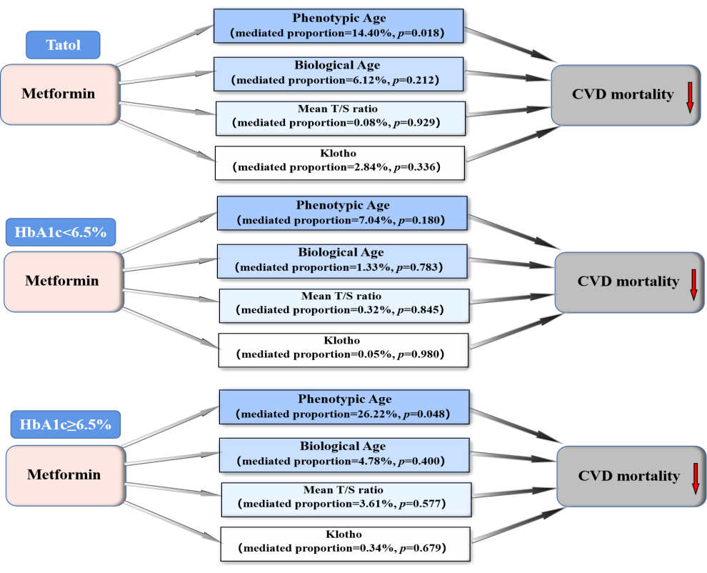
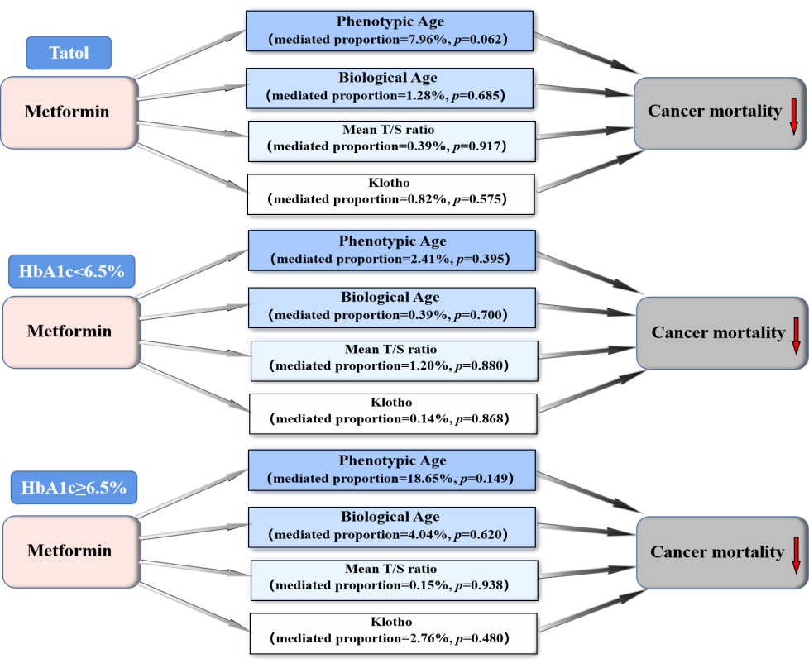
A
B

Supplementary Fig. 1 The mediation effects of aging markers on associations of metformin use with CVD mortality (a) and cancer mortality (b). Models were adjusted for age (<65, or ≥65 years), sex (male or female), race/ethnicity (Mexican American, other Hispanic, non-Hispanic White, non-Hispanic Black, or other), marital status (married/cohabiting, widowed/divorced/separated, or never married), BMI (<25.0, 25.0-29.9, or ≥30.0 kg/m²), physical activity (moderate or vigorous), drinking alcohol status (ever or never), Ln-cotinine concentration (continuous), triglyceride (continuous), medication use (insulin/pills or no), CVD (yes or no), cancer (yes or no), and hypertension (yes or no).

