Supplementary Information

Biomimetic tendon-inspired organogels with high strength and toughness via in-situ alignment-locked densification strategy

Zhentao Zhang¹, Min Sang^{1*}, Shuai Liu¹, Yucheng Pan¹, Zimu Li¹, Shilong Duan¹, Xinglong Gong^{1, 2*}

¹Department of Modern Mechanics, University of Science and Technology of China (USTC), Hefei, Anhui 230027, PR China
²State Key Laboratory of Fire Science, University of Science and Technology of China (USTC), Hefei, Anhui 230026, PR China.

Corresponding author: Tel: 86-551-63600419; Fax: 86-551-63600419.
E-mail: gongxl@ustc.edu.cn (X. L. Gong)
sm019050@mail.ustc.edu.cn (M. Sang)

The file includes
Supplementary Figs. 1 to 12
Supplementary Table 1

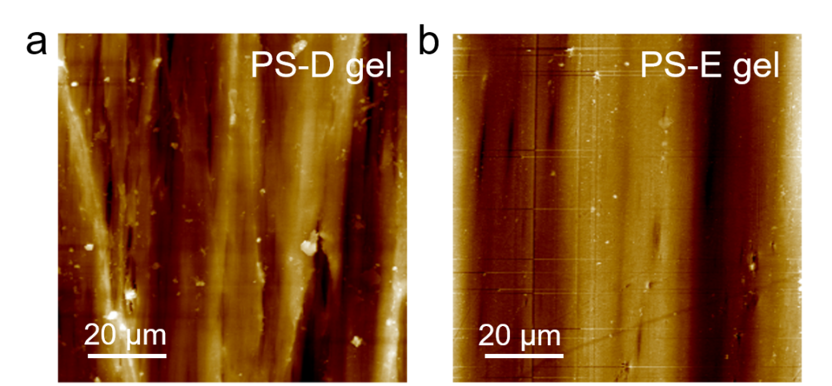
Supplementary Fig. 1 | AFM images of the PS-D gel (a) and PS-E gel (b).

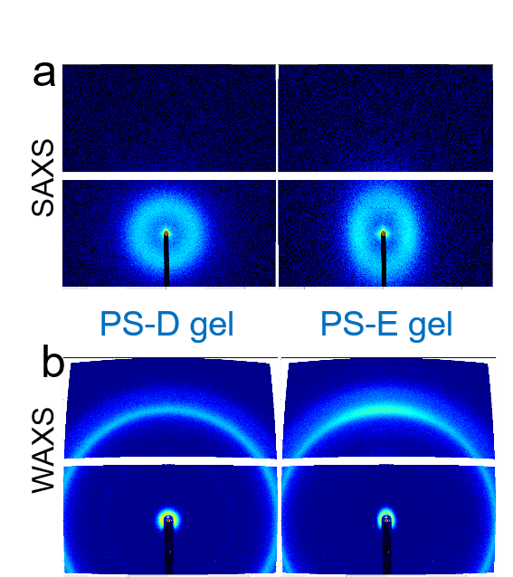
Supplementary Fig. 2 | 2D SAXS patterns of the PS-D gel (a) and PS-E gel (b).

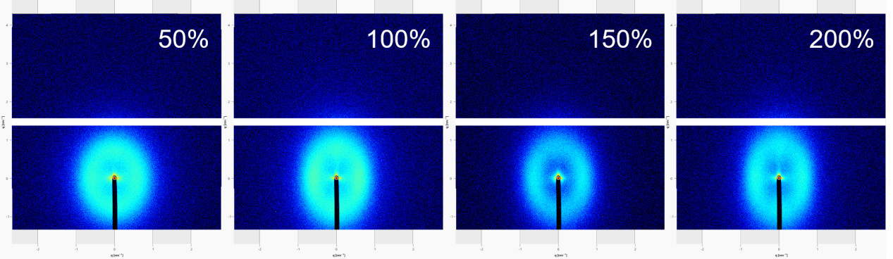
Supplementary Fig. 3 | 2D SAXS patterns of PS-DE gels at different pre-stretching levels. 2D SAXS patterns of PS-DE gels with pre-stretching levels of 50%, 100%, 150%, and 200%,

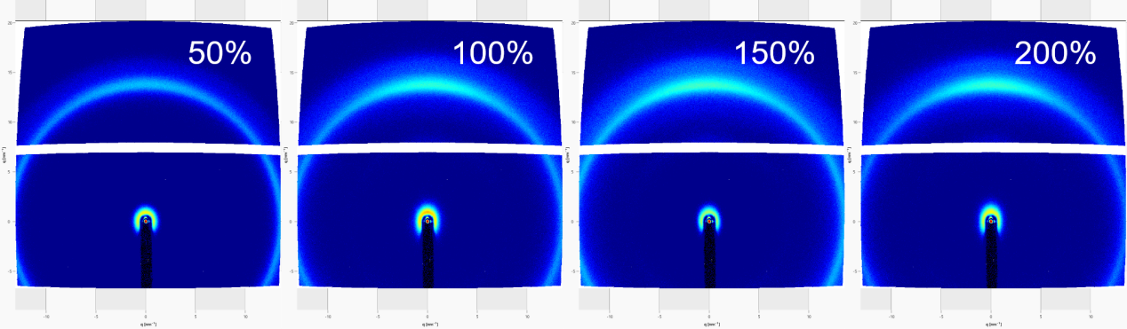
Supplementary Fig. 4 | 2D WAXS patterns of PS-DE gels at different pre-stretching levels. 2D WAXS patterns of PS-DE gels with pre-stretching levels of 50%, 100%, 150%, and 200%, revealing the evolution of crystalline orientation with increasing pre-stretching.

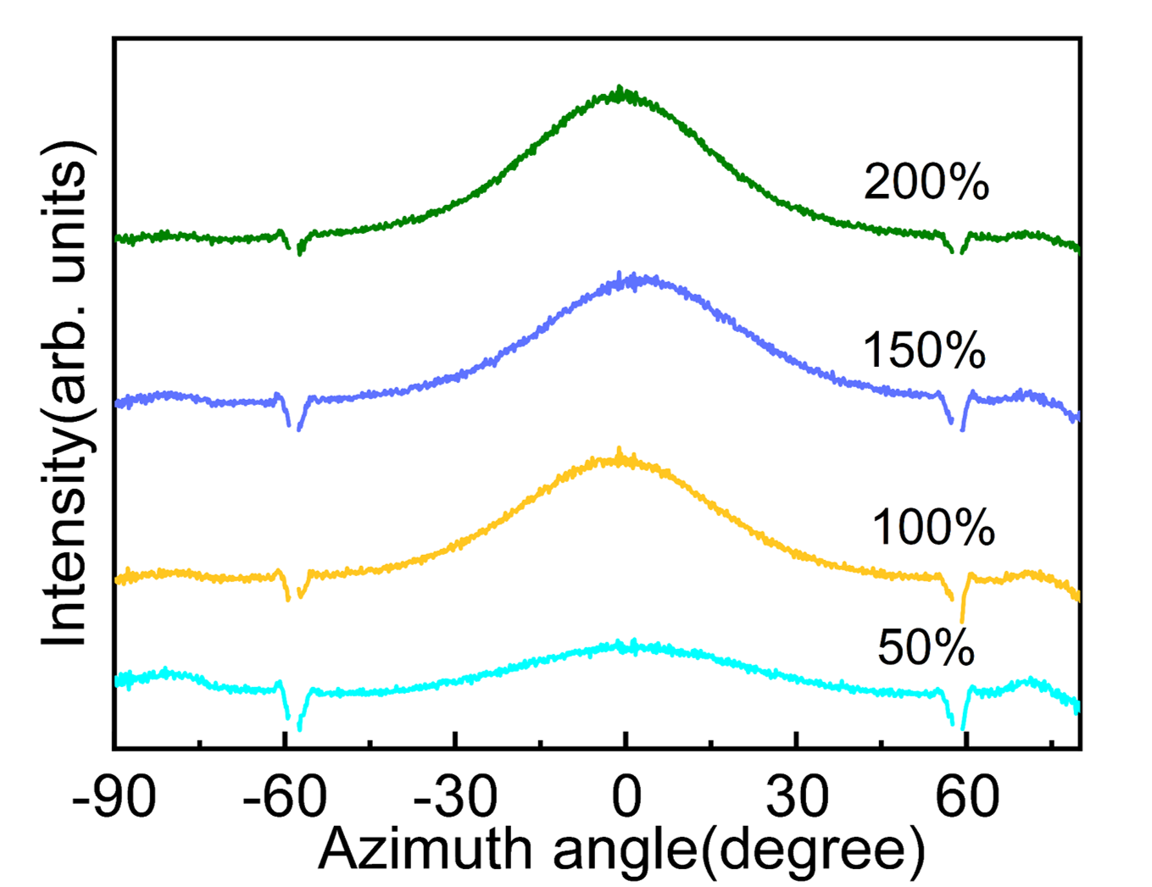
Supplementary Fig. 5 | Azimuthal intensity distributions of PS-DE gels at different pre-stretching levels. Azimuthal intensity distributions of PS-DE gels with pre-stretching levels of 50%, 100%, 150%, and 200%.

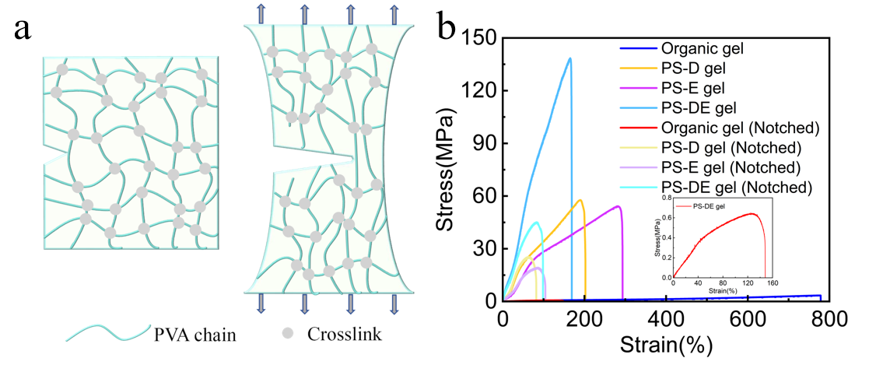
Supplementary Fig. 6 | Fracture toughness of the organic gel. a, Schematic illustration of the energy dissipation mechanism at the crack tip. b, Tensile stress-strain curves of notched and unnotched samples.
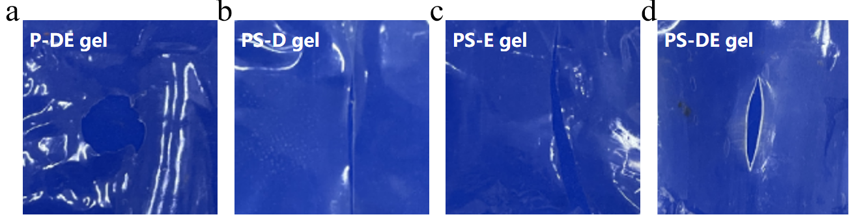
Supplementary Fig. 7. | Post-impact morphologies of the gels. Physical morphologies of P-DE (a), PS-D (b), PS-E (c), and PS-DE (d) gels after ballistic penetration.

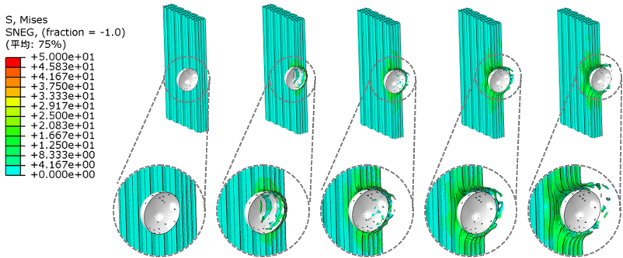
Supplementary Fig. 8 | FEA simulation of ballistic impact. The internal stress distribution of the PS-D gel during projectile penetration.

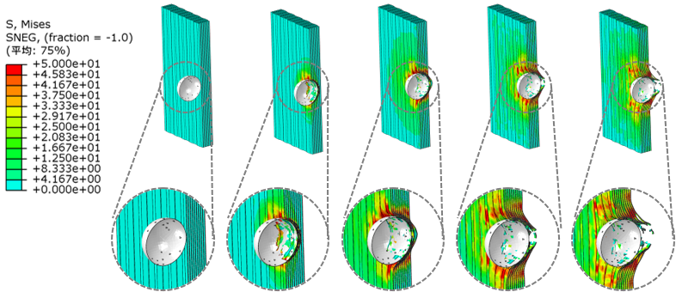

Supplementary Fig. 9 | FEA simulation of ballistic impact. The internal stress distribution of the PS-E gel during projectile penetration.

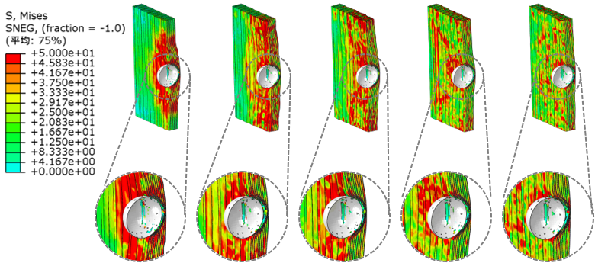

Supplementary Fig. 10 | FEA simulation of ballistic impact. Internal stress distribution of the PS-DE gel during the projectile rebound phase.

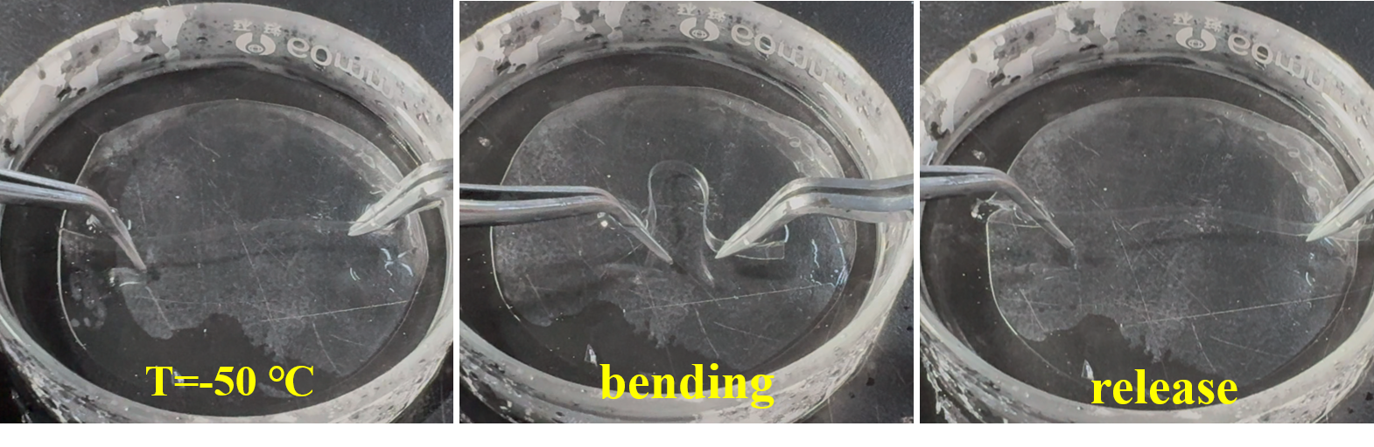
Supplementary Fig. 11 | Low-temperature flexibility of the PS-DE gel. Photographs demonstrating the bending and release process at -50 °C.

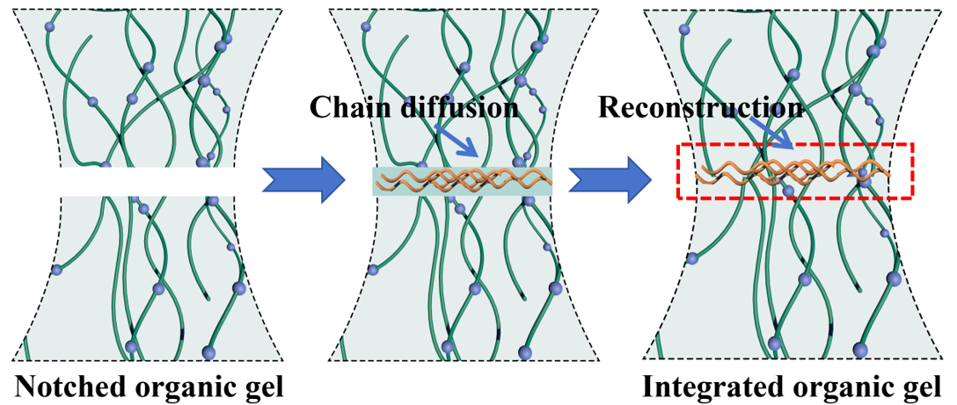
Supplementary Fig. 12. | Schematic of the repairability mechanism.

Supplementary Table 1. Comparison of the toughness, tensile strength, and modulus of PS-DE gel with other reported gels.
Material | Toughness (MJ/m³) | Strength (MPa) | Ref | Journal name
P-gel | 125.6 | 129.3 | This work | \
FC-EtFe | 58.9 | 8.5 | [1] | Science Advances
highly entangled hydrogel | 19.8 | 10.2 | [2] | Science
SR-0.38 | 0.6 | 0.4 | [3] | Science
CR-4 | 22.0 | 5.5 | [4] | Nature Materials
p-Pep/Cu²⁺ | 87.7 | 1.1 | [5] | Nature Communications
AFH | 37 | 7 | [6] | Nature Communications
CSNF-TA-PVA | 122.4 | 60.2 | [7] | Nature Communications
AV20SH-120 | 106 | 61 | [8] | Nature Communications
PVA-NC | 135 | 61 | [9] | Nature Communications
RHOCF | 76.85 | 7.93 | [10] | Nature Communications
SM-PVA | 120.98 | 25.79 | [11] | Nature Communications
sBIN | 8.9 | 15.3 | [12] | Nature Materials

Supplementary Reference:
1. Guo, X., Dong, X., Zou, G., Gao, H. & Zhai, W. Strong and tough fibrous hydrogels reinforced by multiscale hierarchical structures with multimechanisms. Sci. Adv. 9, 7075 (2023).
2. Kim, J., Zhang, G., Shi, M. & Suo, Z. Fracture, fatigue, and friction of polymers in which entanglements greatly outnumber cross-links. Science 374, 212-216 (2021).
3. Liu, C. et al. Tough hydrogels with rapid self-reinforcement. Science 372, 1078-1081 (2021).
4. Li, W. et al. Nanoconfined polymerization limits crack propagation in hysteresis-free gels. Nat. Mater. 23, 131-138 (2024).
5. Xue, B. et al. Strong, tough, rapd-recovery, and fatigue-resistant hydrogels made of picot peptide fibres. Nat. Commun. 14, 2583 (2023).
6. Wu, S. et al. Spider-silk-inspired strong and tough hydrogel fibers with anti-freezing and water retention properties. Nat. Commun. 15, 4441 (2024).
7. Zhuo, H. et al. Bamboo-inspired ultra-strong nanofiber-reinforced composite hydrogels. Nat. Commun. 16, 980 (2025).
8. Li, H. et al. Hierarchical crack-resistant, tissue-mimetic hydrogels enabled by progressive nanocrystallization of anisotropic polymer networks. Nat. Commun. 16, 10890 (2025).
9. Shi, D., Ji, D. & Bae, J. Hierarchically structuralized hydrogels with ligament-like mechanical performance. Nat. Commun. 16, 11492 (2025).
10. Guo, X. et al. Robust zwitterionic hydrogels enabled by consolidated supramolecular networks and spatially hierarchical structures. Nat. Commun. 16, 9454 (2025).
11. Yang, D. et al. Tough and tear resistant hydrogel with a sandwich mineralized structure induced by bidirectional ion migration. Nat. Commun. 16, 11328 (2025).
12. Bao, B. et al. Rapid fabrication of physically robust hydrogels. Nat. Mater. 22, 1253–1260 (2023).

