Supplementary Table1 Clinicopathological information of the patients with CRC in TCGA.
Covariates | Type | Total  (n=433) | Test set  (n=216) | Training set (n=217) | P-value
Age (%) | ≤65 | 178(41.11%) | 88(40.74%) | 90(41.47%) | 0.9541
 | ＞65 | 255(58.89%) | 128(59.26%) | 127(58.53%)
Sex (%) | Female | 204(47.11%) | 101(46.76%) | 103(47.47%) | 0.9594
 | Male | 229(52.89%) | 115(53.24%) | 114(52.53%)
Tumor Stage (%) | Stage I-II | 244(56.35%) | 123(56.94%) | 121(55.76%) | 0.8317
 | Stage III-IV | 178(41.11%) | 87(40.28%) | 91(41.94%)
 | unknow | 11(2.54%) | 6(2.78%) | 5(2.3%)
T Stage (%) | T1-2 | 86(19.86%) | 44(20.37%) | 42(19.35%) | 0.8662
 | T3-4 | 346(79.91%) | 171(79.17%) | 175(80.65%)
 | unknow | 1(0.23%) | 1(0.46%) | 0(0%)
M Stage (%) | M0 | 318(73.44%) | 163(75.46%) | 155(71.43%) | 0.6089
 | M1 | 60(13.86%) | 28(12.96%) | 32(14.75%)
 | unknow | 55(12.7%) | 25(11.57%) | 30(13.82%)
N Stage (%) | N0 | 259(59.82%) | 129(59.72%) | 130(59.91%) | 1
 | N1-2 | 174(40.18%) | 87(40.28%) | 87(40.09%)

Supplementary Figures

Supplementary Figure 1
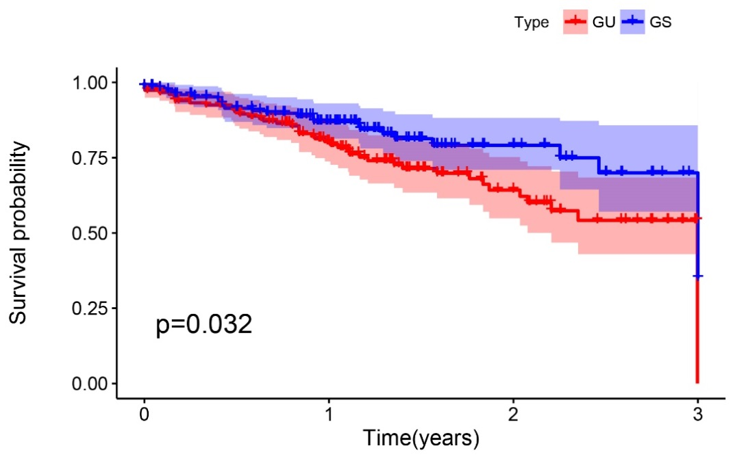

Supplementary Figure 1. Kaplan-Meier curves of patients with high- and low-level somatic mutation.

Supplementary Figure 2
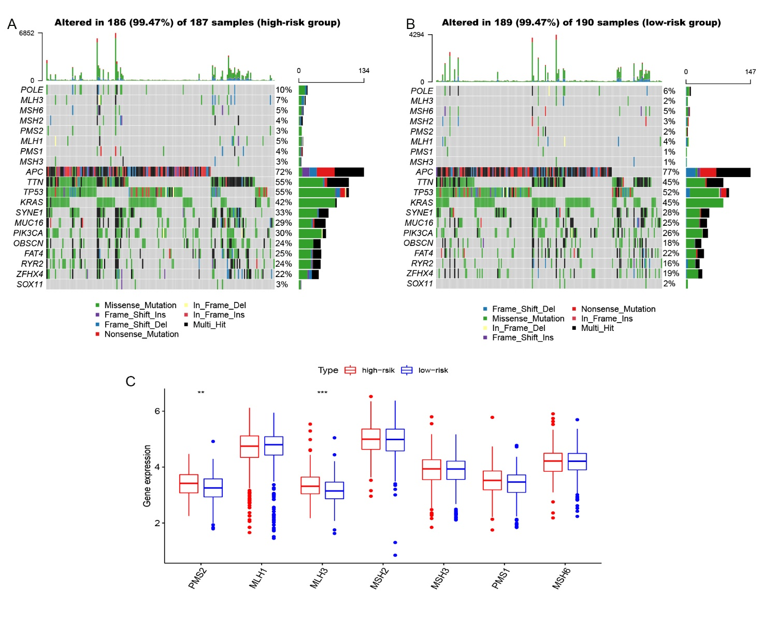
Supplementary Figure 2. The waterfall plot of MMR and POLE mutation in the high-risk group (A) and the low-risk group (B). The bar chart under the legend represents the amount of mutation. Different colors with specific annotations at the bottom meant the various mutation types. (C) The box plot of MMR gene expression in high- and low-risk groups. **P<0.01, *** P<0.001.

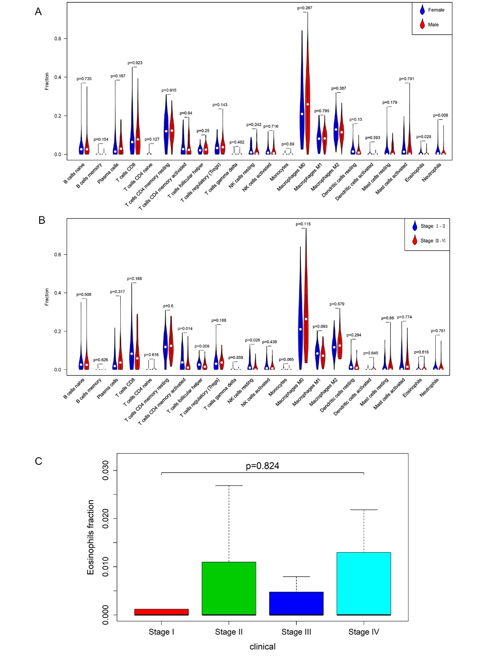
Supplementary Figure 3

Supplementary Figure 3. Association analysis between eosinophils and the clinic-pathological data of CRC patients. (A-B) Vioplot visualizing the comparison of each immune cell type in different gender (A) and different stage(B). (C) The Eosinophils fraction of different clinical stages.
Supplementary Figure 4

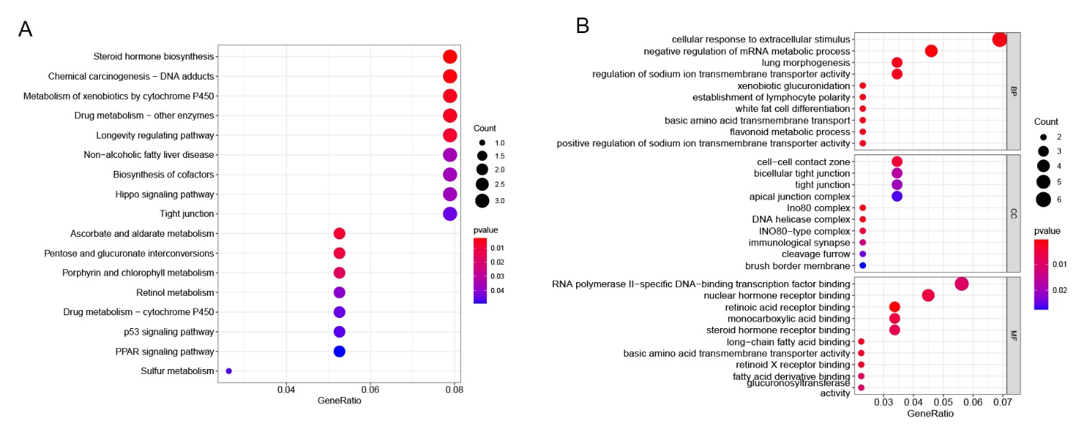
Supplementary Figure 4. (A) The Bubble plots of KEGG pathways (B) The Bubble plots of GO enrichment analysis.

