Supplemental Tables
Table S1. Metagenomic shotgun sequencing details.
Treatment | Date sampled | Sample Type | File Size (Gb)* | Total Reads* | MG-RAST ID | SRA Accession
Raw Sewage (RS) | October 22, 2019 | Bacteria | 0.71 | 1495081 | mgm4916805.3 | SRR16214424
Raw Sewage (RS) | November 28, 2019 | Bacteria | 0.68 | 1430320 | mgm4916782.3 | SRR16214422
Raw Sewage (RS) | December 18, 2019 | Bacteria | 0.91 | 1904436 | mgm4916801.3 | SRR16214421
Raw Sewage (RS) | February 6, 2020 | Bacteria | 0.86 | 1808603 | mgm4916787.3 | SRR16214420
Raw Sewage (RS) | October 22, 2019 | Phage | 1.30 | 2602558 | mgm4916781.3 | SRR16214419
Raw Sewage (RS) | November 28, 2019 | Phage | 1.60 | 3332632 | mgm4916783.3 | SRR16214418
Raw Sewage (RS) | December 18, 2019 | Phage | 1.50 | 3141003 | mgm4916798.3 | SRR16214417
Raw Sewage (RS) | February 6, 2020 | Phage | 0.80 | 1657329 | mgm4916814.3 | SRR16214416
Returned Activated Sludge (RAS) | October 22, 2019 | Bacteria | 1.20 | 2496292 | mgm4916793.3 | SRR16214432
Returned Activated Sludge (RAS) | November 28, 2019 | Bacteria | 1.40 | 2984571 | mgm4916804.3 | SRR16214431
Returned Activated Sludge (RAS) | December 18, 2019 | Bacteria | 0.89 | 1861066 | mgm4916786.3 | SRR16214430
Returned Activated Sludge (RAS) | February 6, 2020 | Bacteria | 1.20 | 2548769 | mgm4916809.3 | SRR16214429
Returned Activated Sludge (RAS) | October 22, 2019 | Phage | 1.40 | 2785175 | mgm4916803.3 | SRR16214428
Returned Activated Sludge (RAS) | November 28, 2019 | Phage | 0.63 | 1329879 | mgm4916808.3 | SRR16214427
Returned Activated Sludge (RAS) | December 18, 2019 | Phage | 0.49 | 1022720 | mgm4916795.3 | SRR16214426
Returned Activated Sludge (RAS) | February 6, 2020 | Phage | 1.50 | 3081713 | mgm4916802.3 | SRR16214425
Effluent (EFF) | October 22, 2019 | Bacteria | 0.99 | 2110661 | mgm4916794.3 | SRR16214435
Effluent (EFF) | November 28, 2019 | Bacteria | 0.61 | 1277227 | mgm4916806.3 | SRR16214434
Effluent (EFF) | December 18, 2019 | Bacteria | 0.87 | 1894603 | mgm4916807.3 | SRR16214423
Effluent (EFF) | February 6, 2020 | Bacteria | 0.85 | 1806721 | mgm4916791.3 | SRR16214412
Effluent (EFF) | October 22, 2019 | Phage | 0.80 | 1660030 | mgm4916796.3 | SRR16214404
Effluent (EFF) | November 28, 2019 | Phage | 1.20 | 2509560 | mgm4916815.3 | SRR16214403
Effluent (EFF) | December 18, 2019 | Phage | 1.80 | 3546951 | mgm4916788.3 | SRR16214402
Effluent (EFF) | February 6, 2020 | Phage | 0.66 | 1308426 | mgm4916797.3 | SRR16214401
Dewatered Sludge (SC) | December 18, 2019 | Bacteria | 0.79 | 1663544 | mgm4916792.3 | SRR16214415
Dewatered Sludge (SC) | February 6, 2020 | Bacteria | 0.96 | 2000191 | mgm4916800.3 | SRR16214414
Dewatered Sludge (SC) | December 18, 2019 | Phage | 1.40 | 2993037 | mgm4916799.3 | SRR16214413
Dewatered Sludge (SC) | February 6, 2020 | Phage | 0.05 | 88061 | mgm4916785.3 | SRR16214411
Negative Control (NEG) | October 22, 2019 | Bacteria | 6.30 Mb | 12729 | mgm4916813.3 | SRR16214409
Negative Control (NEG) | November 28, 2019 | Bacteria | 5.30 Mb | 10343 | mgm4916784.3 | SRR16214408
Negative Control (NEG) | December 18, 2019 | Bacteria | 1.17 Kb | ‡ | ‡ | SRR16214407
Negative Control (NEG) | February 6, 2020 | Bacteria | 1.58 Kb | ‡ | ‡ | SRR16214406
Negative Control (NEG) | † | Phage | 9.20 Mb | 18278 | mgm4916790.3 | SRR16214405
Mock Community | - | Bacteria | 2.00 | 4290164 | mgm4916810.3 | SRR16214400
Mock Community | - | Bacteria | 0.87 | 1848661 | mgm4916812.3 | SRR16214399
Mock Community | - | Phage | 0.39 | 816011 | mgm4916789.3 | SRR16214433
* After paired-end merge and filtering.
† Negative controls combined across the four sampling periods.
‡ File too small to upload to MG-RAST.
Table S2. R packages used for network analysis and visualization.
Package name | Version | Reference
devtools | 2.4.2 | [1]
readxl | 1.3.1 | [2]
report | 0.3.5 | [3]
rstudioapi | 0.13 | [4]
Hmisc | 4.5-0 | [5]
reshape2 | 1.4.4 | [6]
tidyverse | 1.3.1 | [7]

Supplemental Figures
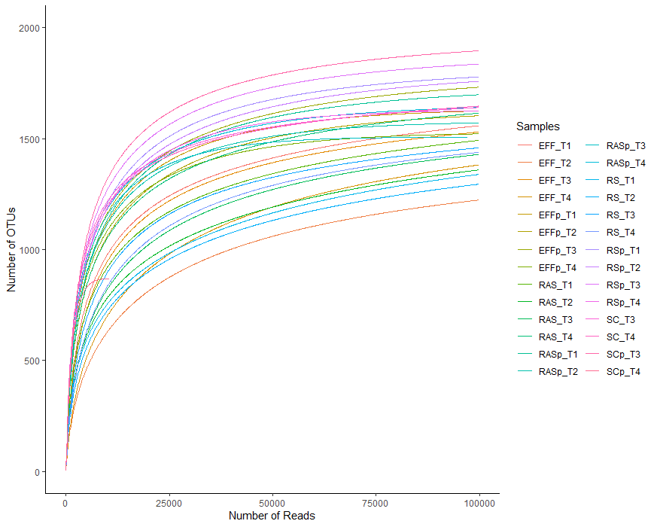
Figure S1. Rarefaction curve of each metagenomic shotgun sequencing sample. Species-level count data was obtained from MG-RAST with singletons and doubletons removed. Effluent (EFF), returned activated sludge (RAS), raw sewage/influent (RS), dewatered sludge (SC), negative control (NEG), October (T1), November (T2), December (T3), February (T4), notation of “p” indicates phage sample.

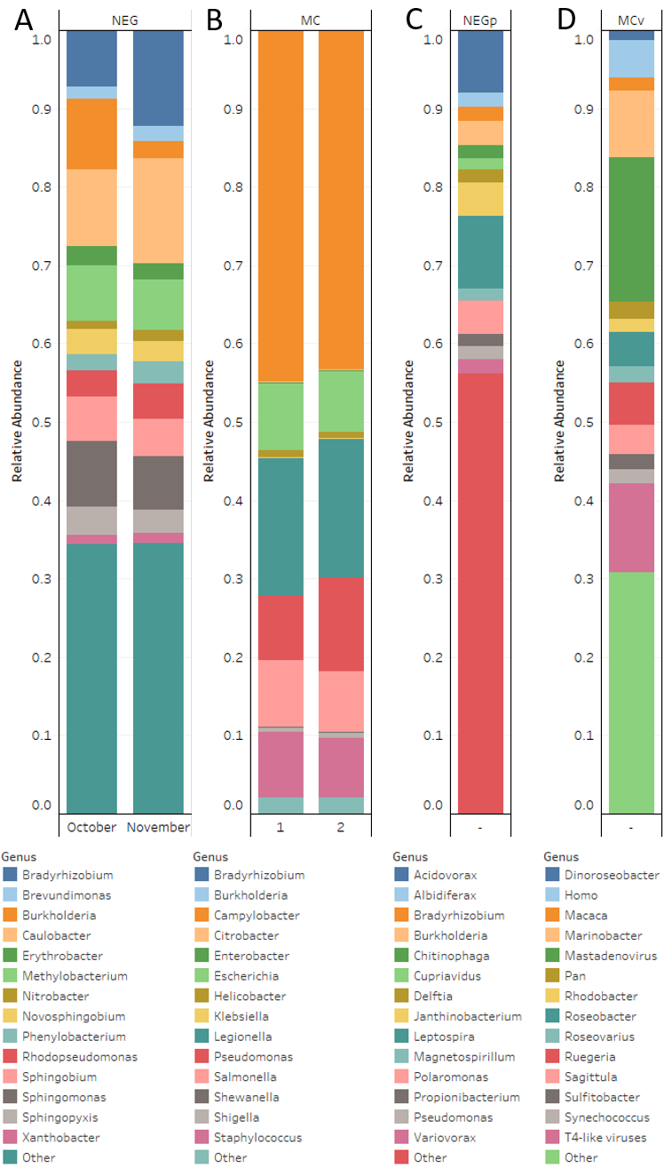
Figure S2. Composition of bacteria and phage at the genus level in the control samples. (A) Bacterial fraction negative control relative abundance. (B) Bacterial mock community relative abundance. (C) Viral fraction negative control relative abundance. (D) Viral mock community relative abundance. Mock community (MC), negative control (NEG), viral mock community (MCv), viral negative control (NEGp).

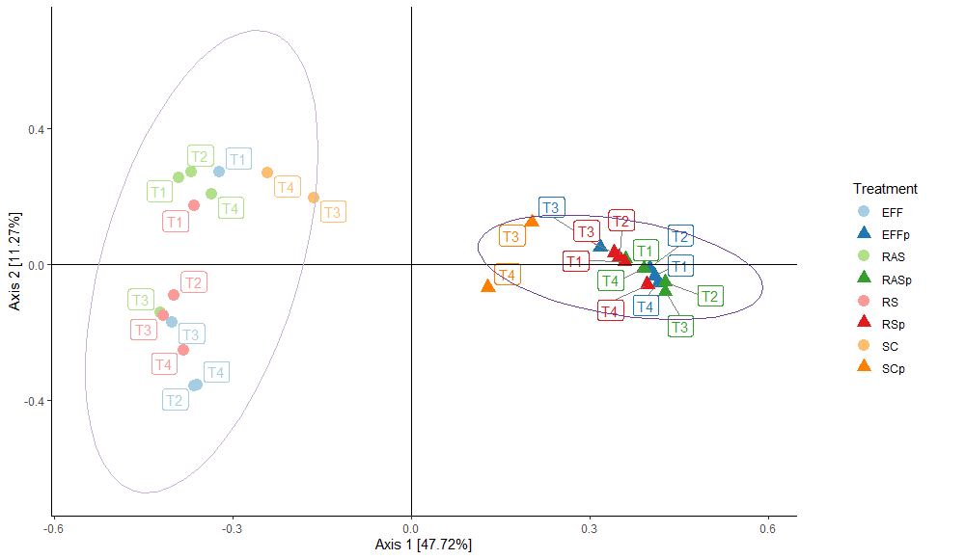
Figure S3. Comparison of unstratified bacteria and phage samples by principal coordinate analysis across treatments. Bray-Curtis distance matrix was used with the species taxonomic data from MG-RAST. Principal components 1 and 2 explain 58.99% of the variation. Effluent (EFF), returned activated sludge (RAS), raw sewage/influent (RS), dewatered sludge (SC), negative control (NEG), October (T1), November (T2), December (T3), February (T4), notation of “p” indicates phage sample.

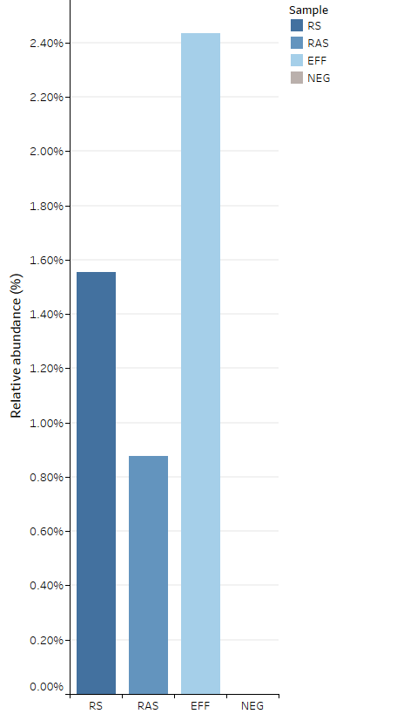
Figure S4. Ratio of uidA to 16S rRNA gene over each treatment process expressed as percentage. The average of each month was expressed for the four treatments. Effluent (EFF), returned activated sludge (RAS), raw sewage/influent (RS), negative control (NEG).
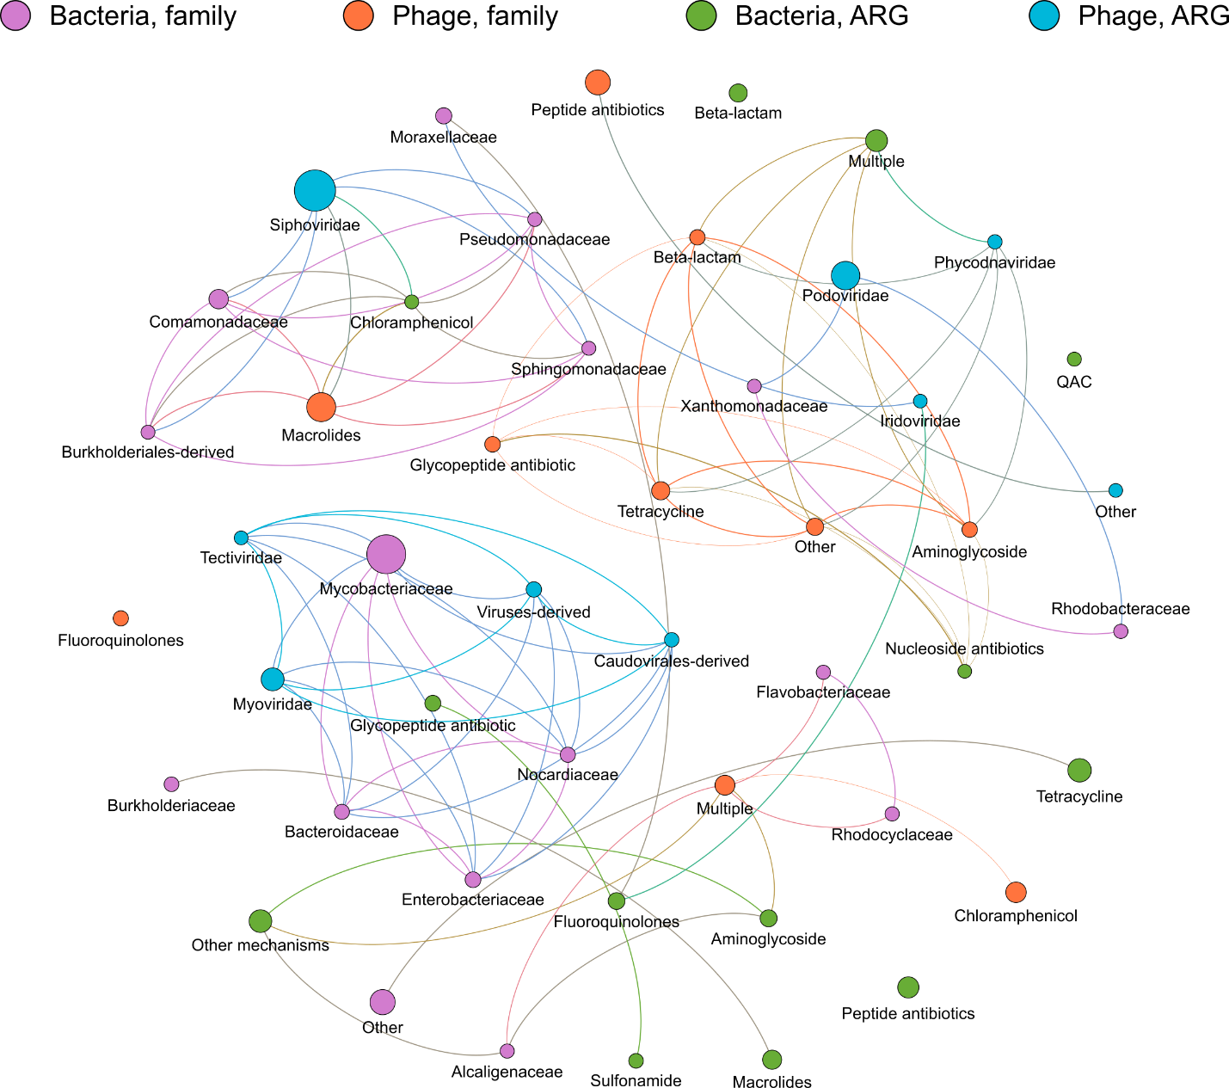
Figure S5. Network analysis of co-occurrence patterns among ARGs and microbial taxa in RS samples. Node sizes correspond to relative abundances. Antibiotic resistance gene (ARG), raw sewage (RS).
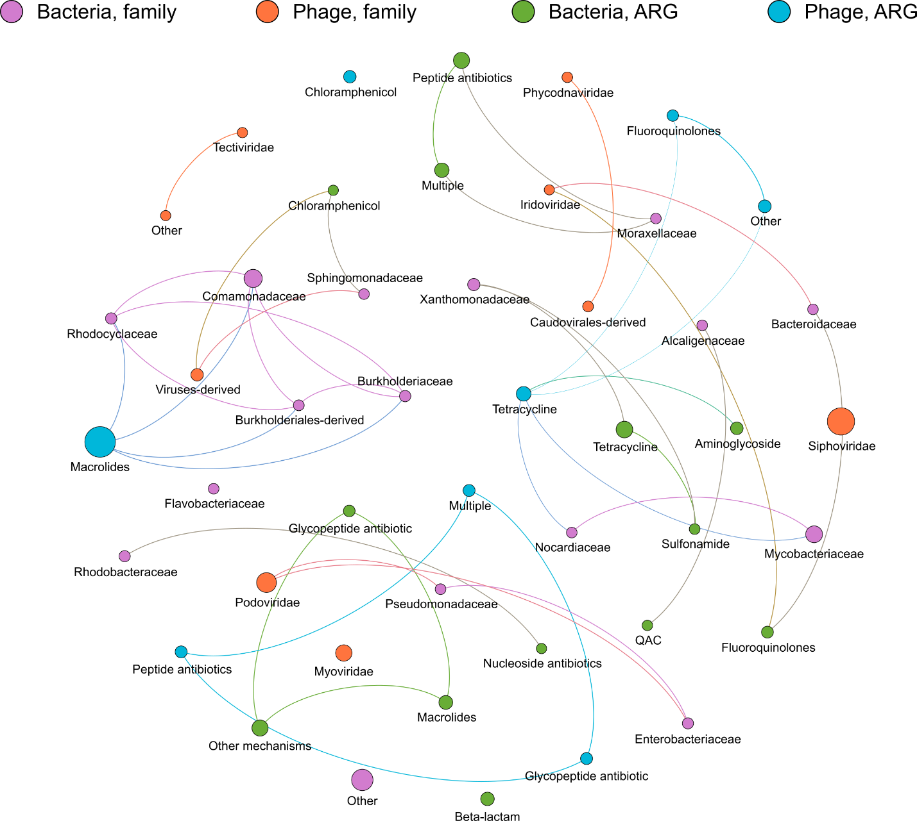
Figure S6. Network analysis of co-occurrence patterns among ARGs and microbial taxa in RAS samples. Node sizes correspond to relative abundances. Antibiotic resistance gene (ARG), returned activated sludge (RAS).
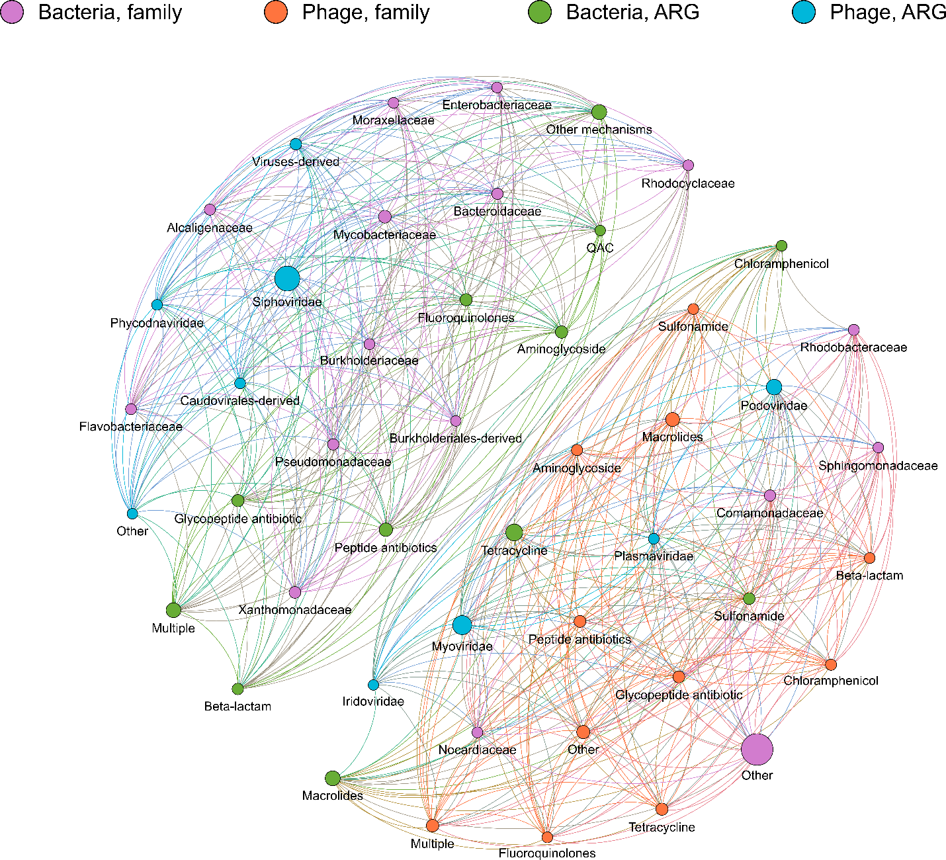
Figure S7. Network analysis of co-occurrence patterns among ARGs and microbial taxa in SC samples. Node sizes correspond to relative abundances. Antibiotic resistance gene (ARG), dewatered sludge (SC).

Supplemental References:
1. Wickham H, Hester J, Chang W. devtools: Tools to Make Developing R Packages Easier. 2021. https://cran.r-project.org/package=devtools.
2. Wickham H, Bryan J. readxl: Read Excel Files. 2019. https://cran.r-project.org/package=readxl.
3. Makowski D, Ben-Shachar M., Patil I, Lüdecke D. Automated Reporting of Results and Statistical Models. 2020. https://github.com/easystats/report.
4. Ushey K, Allaire J, Wickham H, Ritchie G. rstudioapi: Safely Access the RStudio API Access. 2020. https://cran.r-project.org/package=rstudioapi.
5. Harrel Jr FE. Hmisc: Harrell Miscellaneous. 2021. https://cran.r-project.org/package=Hmisc.
6. Wickham H. reshape2: Flexibly Reshape Data: A Reboot of the Reshape Package. 2020. https://cran.r-project.org/package=reshape2.
7. Wickham H, Averick M, Bryan J, Chang W, McGowan L, François R, et al. Welcome to the Tidyverse. J Open Source Softw. 2019;4:1686.

