Supplementary Figures and Tables for
Layer-dependent magnetic phase diagram in Fe_{n}GeTe₂ (3≤n≤7) ultrathin films: coexistence of localized and itinerant electronic states of Fe with variable valence
Qinxi Liu ¹, Jianpei Xing ¹, Zhou Jiang ¹, Yu Guo ¹, Xue Jiang ¹*, Yan Qi ^{2,1}*, and Jijun Zhao ¹
¹Key laboratory of Material Modification by Laser, Ion and Electron Beams (Dalian University of Technology), Ministry of Education, Dalian, 116024, China
²School of Physics and Materials Engineering, Dalian Minzu University, Dalian 116600, China

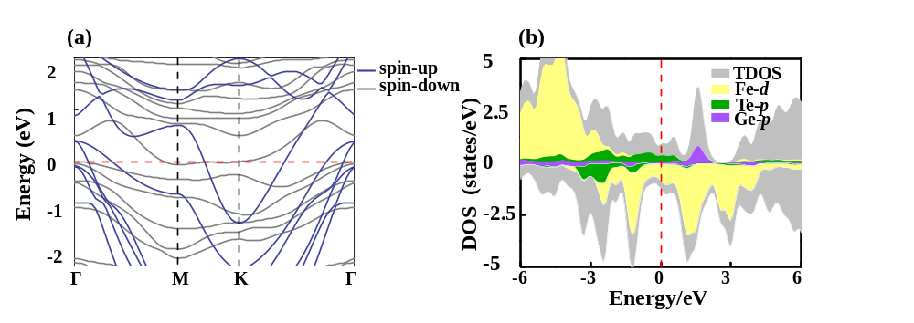
Supplementary Figure 1. The electronic structures of 2D Fe₃GeTe₂. a The calculated band strcture. Blue and gray lines respresent the spin-up and down band structure. b The total and orbital-projected density of states. The Fermi level (red dash line) is set to zero.

Supplementary Figure 2. The side and top view of the schematic diagrams for 2D Fe₃GeTe₂ in FM and various AFM magnetic configurations. The gold and pink atoms are Fe³⁺ and Fe²⁺ ions, respectively. The red and bule arrows represent the magnetic ions in spin-up and spin-down states, respectively.

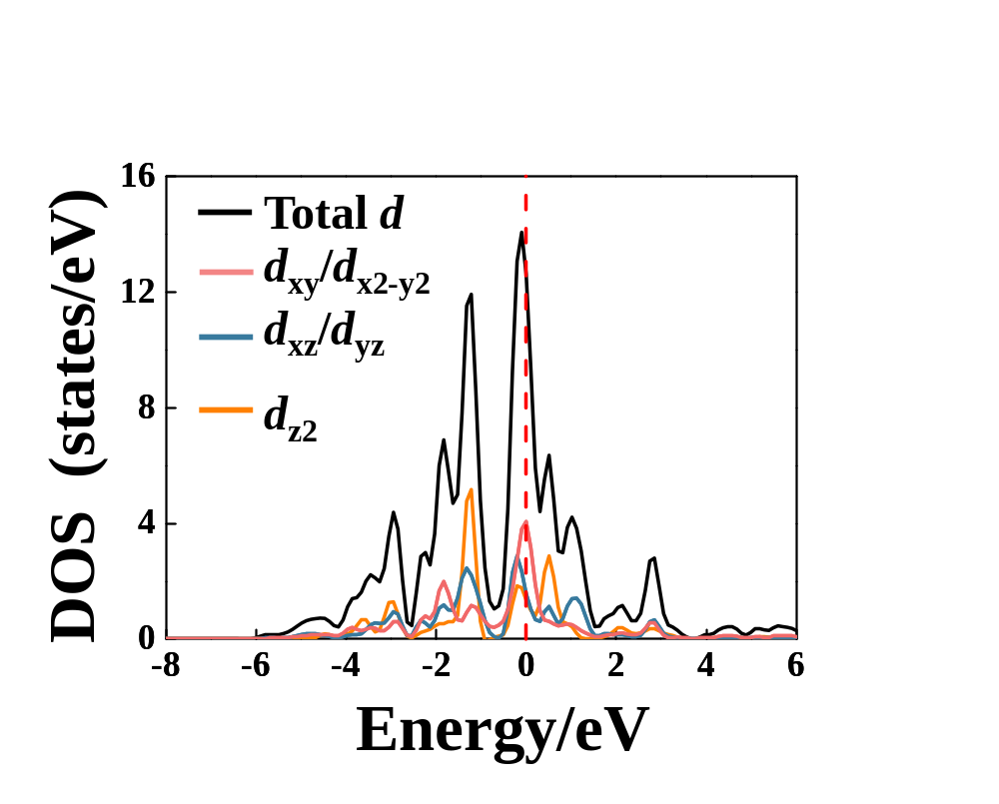
Supplementary Figure 3. The density of states for total and projected density of Fe 3d states in the non-spin-polarized phase of 2D Fe₃GeTe₂. The Fermi level (red dash line) is set to zero.

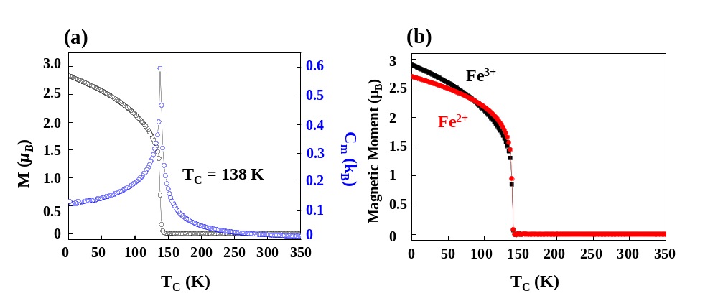
Supplementary Figure 4. Magnetic properties for 2D Fe₃GeTe₂. a Calculated on-site magnetic moments (black) and specific heat C_{m} (blue) for 2D Fe₃GeTe₂. b Calculated on-site magnetic moments for each Fe sublattice in 2D Fe₃GeTe₂.

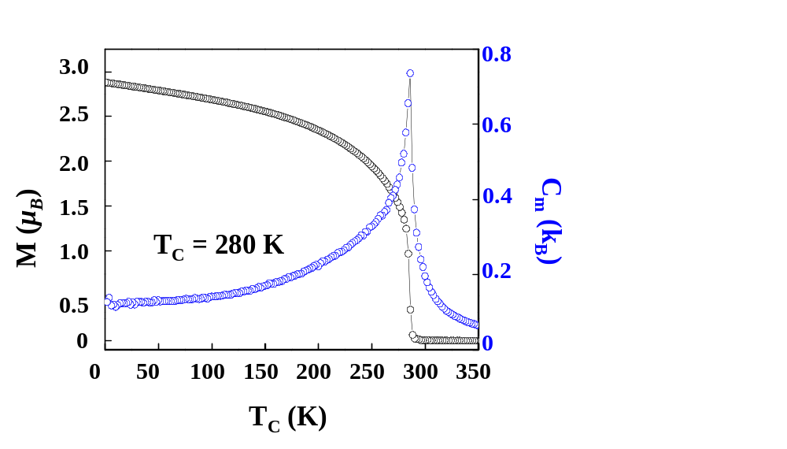
Supplementary Figure 5. Calculated on-site magnetic moments (black) and specific heat C_{m} (blue) for bulk Fe₃GeTe₂.

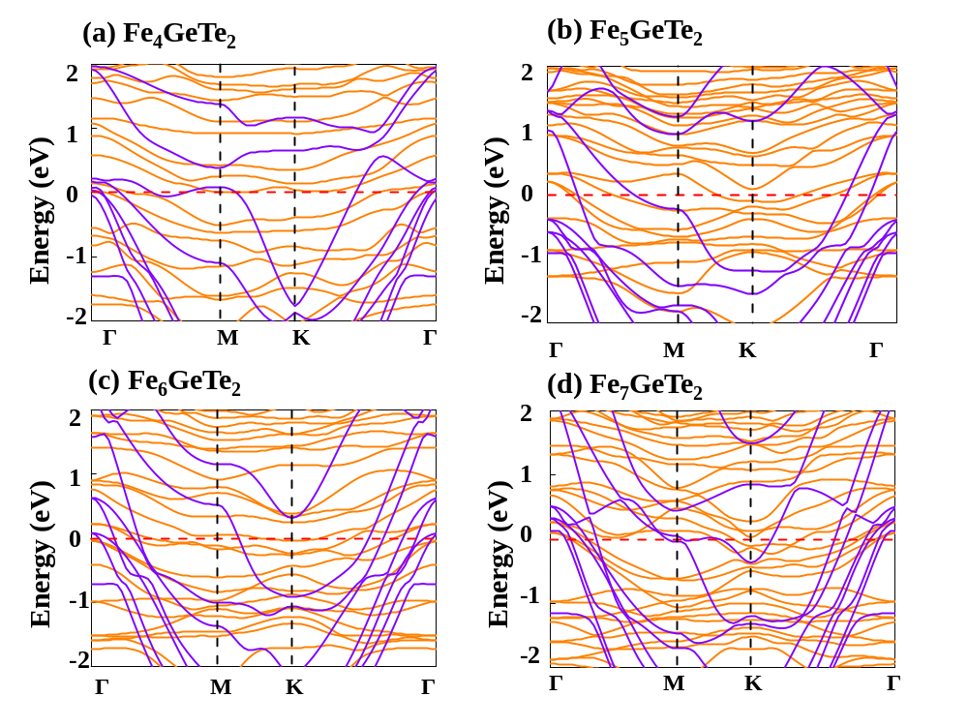
Supplementary Figure 6. DFT+U calculated band structure. a-d The band structures of Fe_{n}GeTe₂ multilayer films. The purple and orange lines are spin-up and down bands. The Fermi level (red dash line) is set to zero.

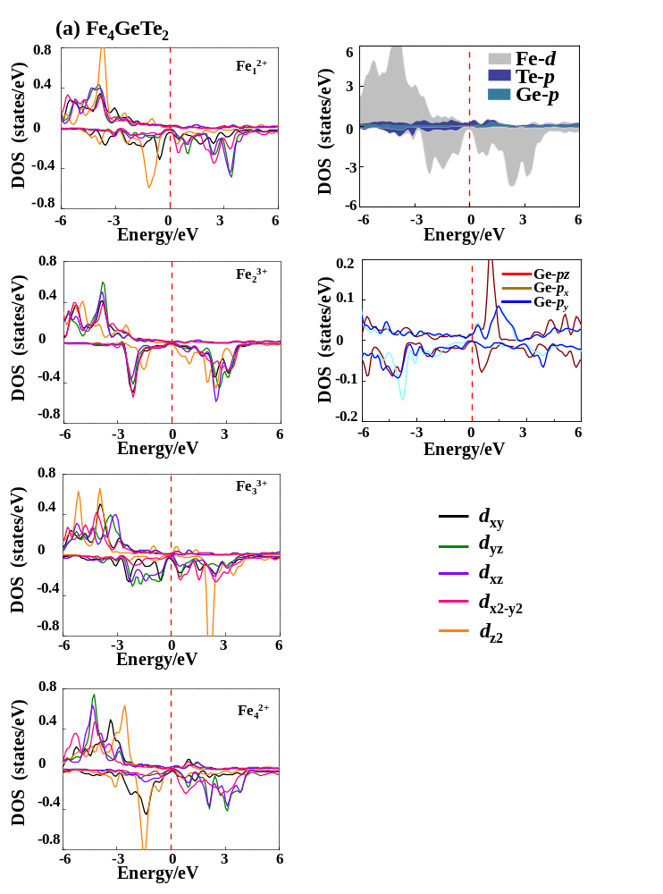

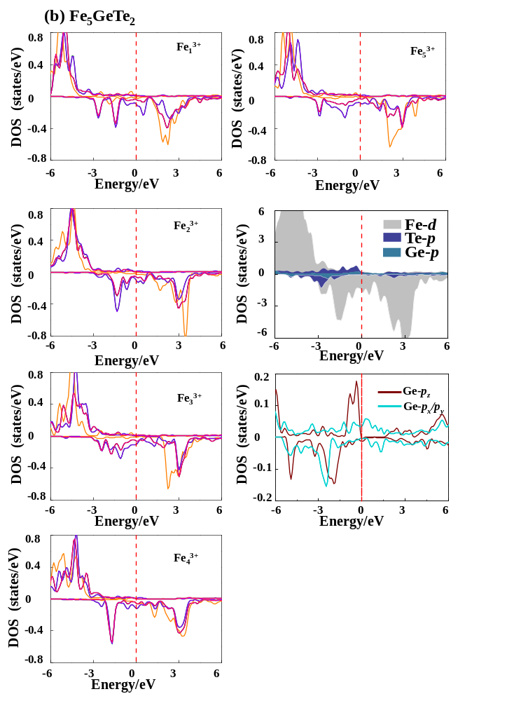

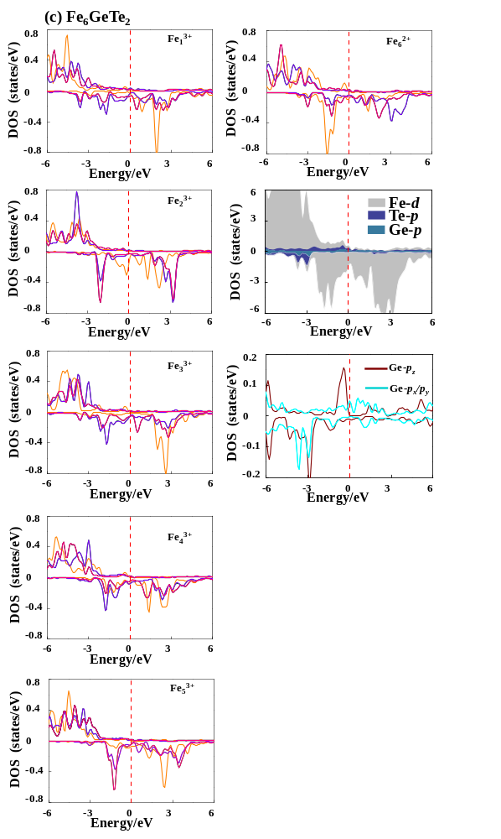
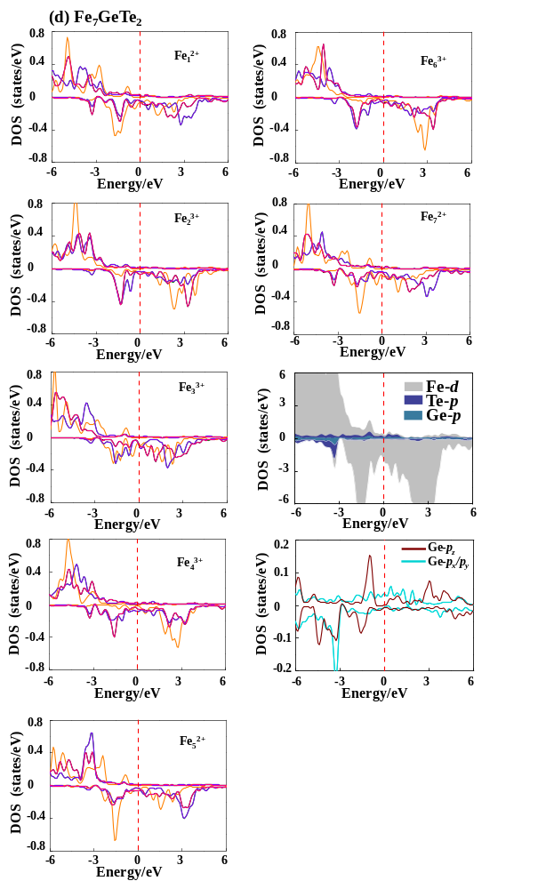
Supplementary Figure 7. DFT+U calculated Density of states. a-d The orbital project density of states for Fe_{n}GeTe₂ multilayer films. The Fermi level (red dash line) is set to zero.

Supplementary Figure 8. Schematic diagrams for Fe_{n}GeTe₂ (4≤n≤7) multilayer films in FM and various AFM magnetic configurations. The gold and pink atoms are Fe³⁺ and Fe²⁺ ions, respectively. The red and bule arrows represent the magnetic ions in spin-up and spin-down states, respectively.
Supplementary Figure 9. The side and top views show exchange parameters J for Fe−Fe coupling in Fe_{n}GeTe₂ (4≤n≤7) multilayer films. Only Fe ions are shown in the structures for clarity.

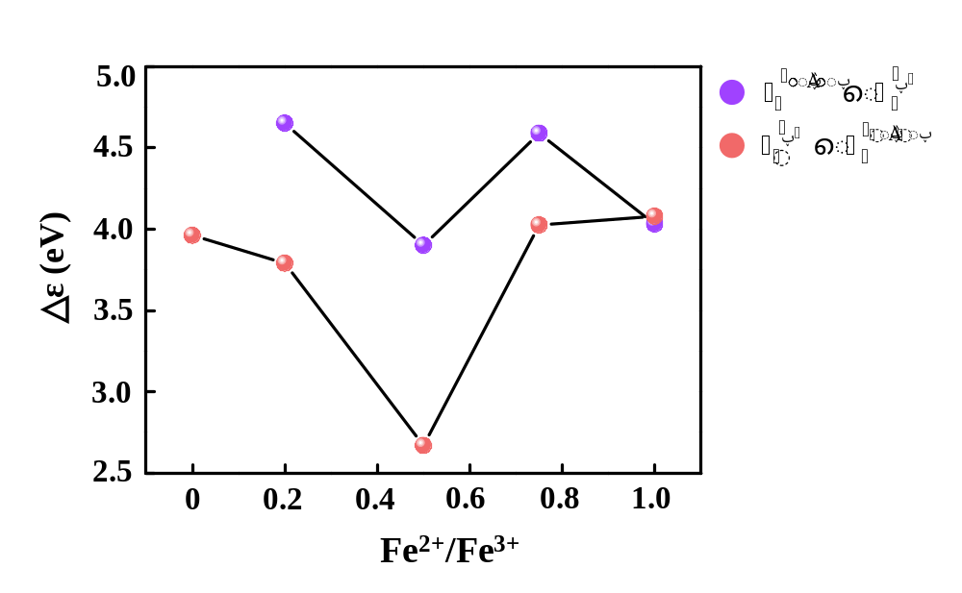
Supplementary Figure 10. The ratio of Fe²⁺/Fe³⁺ in multilayer Fe_{n}GeTe₂ (3≤n≤7) as a function of the average orbital energy level difference.

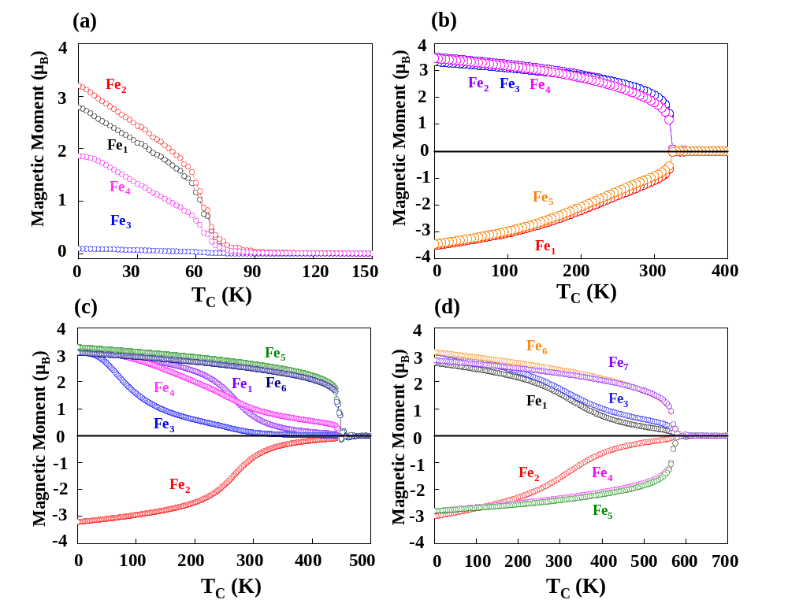
Supplementary Figure 11. The calculated T_{C} of each layers for (a) Fe₄GeTe₂, (b) Fe₅GeTe₂, (c) Fe₆GeTe₂, and (d) Fe₇GeTe₂.

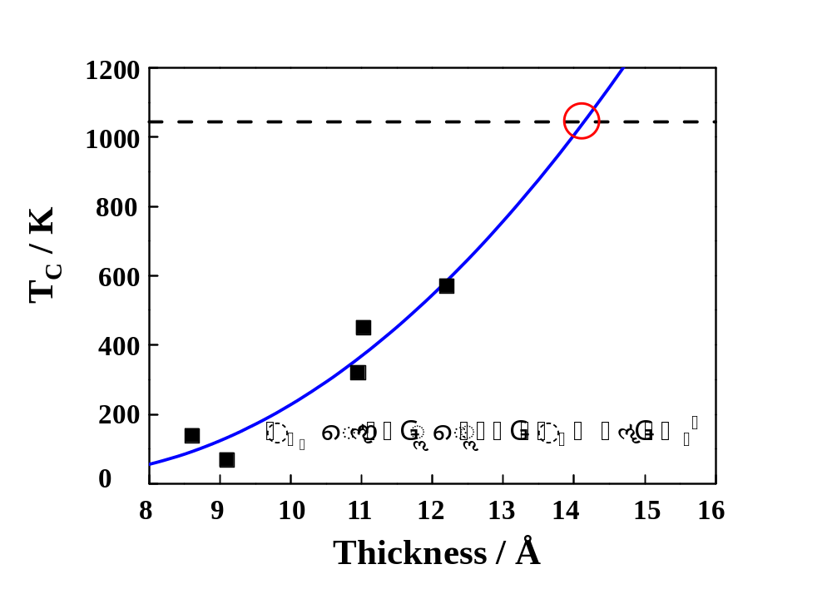
Supplementary Figure 12. The calculated T_{C} of difference effective thickness of multilayer Fe_{n}GeTe₂. Blue solid line is the fitting curves. The black line represents the T_{C} of pure Fe solid of bcc phase (1043 K).

Supplementary Table 1. The calculated Bader charge for Fe_{n}GeTe₂ multilayer films. The negative and positive values represent loss and gain of electrons, respectively.

 | Fe³⁺ | Fe²⁺ | Ge | Te
Fe₃GeTe₂ | -0.4 | 0.0 | 0.1 | 0.3
Fe₄GeTe₂ | -0.2 | -0.1 | 0.1 | 0.3
Fe₅GeTe₂ | -0.3 | / | 0.7 | 0.5
Fe₆GeTe₂ | -0.2 | -0.1 | 0.4 | 0.3
Fe₇GeTe₂ | -0.3 | 0.0 | 0.5 | 0.3

Supplementary Table 2. The exchange parameters J₁, J₂, J₃, J₄ and J₅ (meV) of Fe_{n}GeTe₂ (5<n<7) multilayer films.
 | J₁ | J₂ | J₃ | J₄ | J₅
Fe₅GeTe₂ | -0.2 | 4.7 | -2.6 | 5.9 | 0.1
Fe₆GeTe₂ | 6.6 | -8.6 | 21.2 | -1.0 | -5.3
Fe₇GeTe₂ | -29.4 | 23.0 | 27.5 | -11.2 | 19.3

