Supplementary Materials and Methods

T-cell immunophenotyping
T-cell maturation state was performed using CD45RA, CD45RO, CD62L and CD95 expression (48). Five different states of maturation were distinguished T_{pN}, T_{SCM}, T_{CM}, T_{EM}, T_{EMRA}. T_{pN} were defined pseudo naïve (pN) since they were stimulated by CD3/CD28 polymer nanomatrix (TransAct®) according to the T-cell expansion protocol prior to lentiviral T-cell transduction. T naïve (T_{pN}) were defined as (CD45RA⁺/CD45RO⁻/ CD62L⁺/CD95⁻), stem cell-like memory T cells (T_{SCM}) as (CD45RA⁺/CD45RO⁻/CD62L⁺/CD95⁺), central memory T cells (T_{CM}) as (CD45RA⁻/CD45RO⁺/CD62L⁺/CD95⁺), effector memory T cells (T_{EM}) as (CD45RA⁻/CD45RO⁺/CD62L⁻/CD95⁺) and effector T cells (T_{EMRA}) as (CD45RA⁺/CD45RO⁻/CD62L⁻/CD95⁺).

Repetitive stimulation and serial killing of CAR-T cells
220.000 CAR-T cells were mixed with 440.000 mCherry expressing NALM6 cells (E:T 1:2) on day -1 in a final volume of 1,1 ml in RPMI media supplemented with 10%FCS, P/S and L-Glut. Conditions 1, 3, and 6 comprised only CAR-T cells without tumor cells and served as controls. In the respective conditions (5 and 8), LLE-CD19 4G7SDIE mAb was added to reach a final concentration of 10 ng/mL. On day 0, 100 μl were directly withdrawn from the different conditions, to measure the mCherry fluorescence of the NALM6 cells at the beginning leaving 200.000 CAR-T cells versus 400.000 NALM6 in the experiment. Measurements were performed using the MACSQuant analyzer applying an uptake volume of 50 μl of the cell suspension. A reaction volume of 1 mL containing CAR-T cells with/without tumor cells and with/without antibody was incubated at 37°C and 5% CO2 for 8 days in total.
On days +2, +4, +7 100 μl of the reaction mixture was withdrawn for analysis after mixing the cells by pipetting them up and down. Analysis of the NALM6-mCherry signal was again performed with the MACSQuant analyzer, taking up 50 μl of the cell suspension. The remaining cell solution (900 μl) was centrifuged (210xg, 5min), 400 μl supernatant was carefully removed. On day +2 and +4, 500 μl media was added, containing 200.000 NALM6 cells for conditions 2, 4, 5, 7 and 8. Conditions 1, 3, and 6 were only supplemented with 500 μl RPMI media. Moreover, LLE-CD19 4G7SDIE antibody was added in conditions 5 and 8, to reach a final antibody concentration of 10ng/mL. Gating strategy: Gates were determined for each experiment day (1, 3, 5, and 8). Doublet discrimination for FSC Doublet discrimination for SSC gating for single, living lymphocytes (including NALM6 and CAR-T cells) in FSC/SSC subset gating for mCherry⁺ cells in the B3 channel (655–730 nm) (T cells = mCherry⁻, Nalm6 = mCherry⁺). Experiments were performed with CAR-T cells from three different donors and were done in triplicates.

Proliferation Assay
CAR T cells were stained with CellTraceTM Violet (Thermo Fisher) according to the manufacturer’s instruction. Stained CAR T cells were diluted in RPMI 1640-based complete media and transferred to round bottom polystyrene tubes at 300.000 CAR T cells per tube. NALM6 tumor cells were added at a concentration of 300.000 cells per tube to obtain an effector to target ratio of 1:1. Target antibodies were added at a final concentration of 10 ng/mL in a total volume of 3 ml per tube. Plates were incubated in a HERAcell incubator (Heraeus) at 37°C, 95% humidity and 5% CO2 for the indicated time. Cells were washed with PBS and analyzed with a FACSCantoTM Cell Analyzer.

In vivo experiment AdCAR-T versus NALM
General introduction of animal models is described in the Materials and Methods section of the manuscript. On day -6 of the experiment, 0.5 x 10⁶ NALM6 cells, stably expressing a firefly luciferase gene, were injected into the tail vein. Engraftment of the tumor cells was monitored by in vivo bioluminescence imaging (BLI) on day 0 and animals were randomized into groups according to tumor burden. All mice received 10 mg human IgG (Gammaguard) by intraperitoneal injection twice weekly starting on day -1. LLE-CD19 4G7SDIE mAb (50µg) was applied by intraperitoneal injection twice per week starting on day -1. CAR-T were injected intravenously on day 0. Tumor growth was monitored by BLI. Mice were sacrificed when reaching end point criteria or latest after 50 days according to the approval by the local authorities.

In vivo experiment AdCAR-T versus JeKo-1 utilizing LLE-CD19 mAb and LLE-CD20 mAb at two distinct dose levels
General introduction of animal models is described in the Materials and Methods section of the manuscript. On day -5 of the experiment, 1 x 10⁶ JeKo-1^{WT} cells, stably expressing a firefly luciferase gene, were injected into the tail vein. Engraftment of the tumor cells was monitored by in vivo bioluminescence imaging (BLI) on day 0 and animals were randomized into groups according to tumor burden. All mice received 10 mg human IgG (Gammaguard) by intraperitoneal injection twice weekly starting on day -1. CD19 4G7SDIE mAb and CD20 rituximab without LLE conjugation served as controls. LLE-CD19 4G7SDIE mAb or LLE-CD20 rituximab was applied by intraperitoneal injection twice per week starting on day -1 at two distinct dose levels, DL1 50 µg and DL2 5 µg. CAR-T were injected intravenously on day 0. Tumor growth was monitored by BLI. Mice were sacrificed when reaching end point criteria or latest after 50 days according to the approval by the local authorities.

Inhibitory effect of supraphysiologic concentrations of free biotin on AdCAR-T function
NALM6 cells were plated in RPMI 1640-based complete media at 30.000 cells per well in white 96-well flat bottom plates (Greiner bio one). Effector cells were added at an effector to target ratio of 1:1. Biotinylated antibody (LLE-CD19 4G7SDIE mAb) as well as free biotin (Sigma Aldrich) were used at indicated concentrations. Synthetic D-luciferin (Sigma Aldrich) was added at 4 µg/ml in a total volume of 200 µl per well. Plates were incubated in a HERAcell incubator (Heraeus) at 37°C, 95% humidity and 5% CO2. Plates were measured using a Tecan Microplate reader (BioTek Instruments) at 37°C. Lysis was determined by calculation of the relative luminescence of testing condition to a standard curve.

Standard curve for the quantification of LLE-CD19 mAb in human/mouse plasma
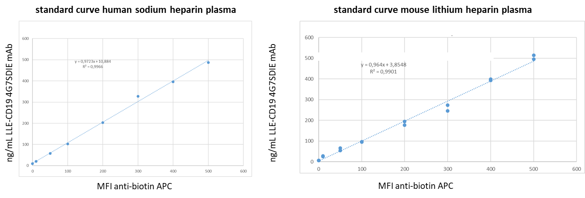
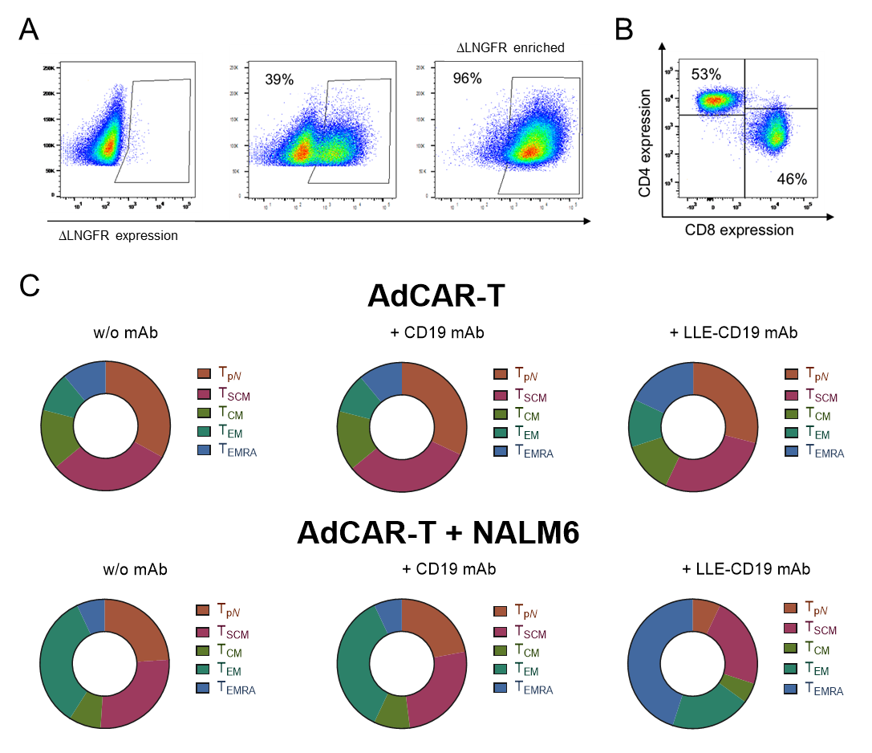
Fig. S1. AdCAR-T expression and immunophenotyping
A) AdCAR expression was determined by flow cytometry for ΔLNGFR, co-expressed with the AdCAR. Representative plots for non-transduced T cell (left), AdCAR transduced T cells (middle) and AdCAR-T after ΔLNGFR⁺ MACS enrichment are shown. B) Distribution of CD4⁺ and CD8⁺ AdCAR-T on day +14 of expansion are displayed, representative plot shown. C) AdCAR-T were incubated for 24 hours with or without CD19⁺ BCP-ALL cell line NALM6, with or without 10 ng/mL unbiotinylated CD19 mAb or LLE-CD19 mAb. AdCAR-T phenotype after incubation was determined by flow cytometry by staining the cell surface markers CD45RA, CD45RO, CD62L and CD95. The subsets T_{pN} (pseudo naïve after CD3/CD28 stimulation with TransAct®), T_{SCM}, T_{CM}, T_{EM} and T_{EMRA}.
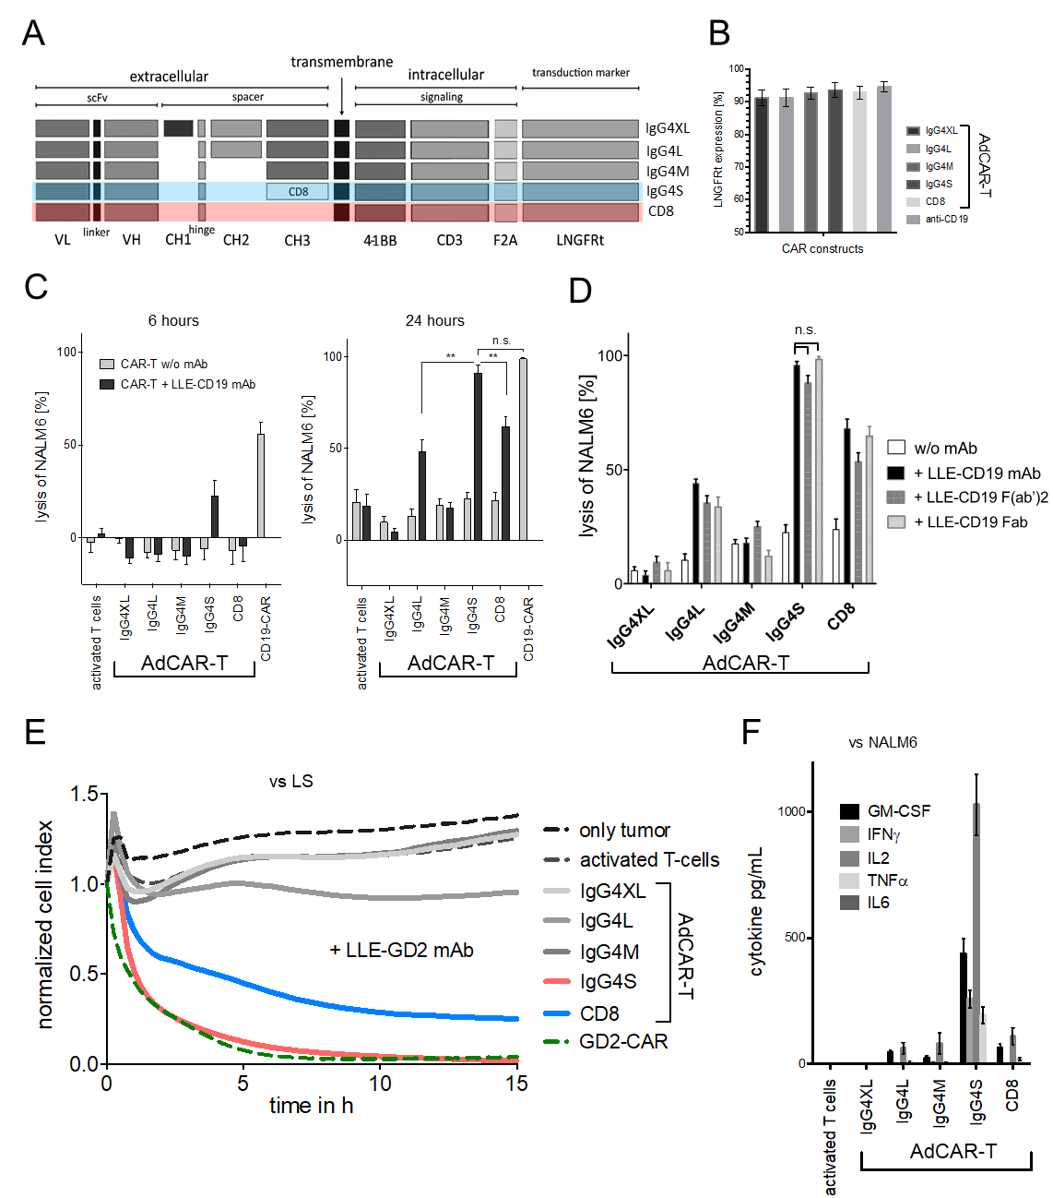
Fig. S2. Evaluation of different spacers on effector function of AdCAR-T
A) Schematic illustration of different evaluated AdCAR-T formats. B) Expression of different AdCAR constructs after ΔLNGFR⁺ MACS enrichment was determined by flow cytometry for ΔLNGFR expression. C, F) AdCAR-T, expressing different AdCAR constructs as indicated, non-transduced activated T cells or conventional CD19-CAR-T were incubated with CD19⁺ BCP-ALL cell line NALM6 at an E:T ratio of 1:1 with or without 10 ng/mL LLE-CD19 mAb. In C) target-cell lysis after 6 and 24h was determined by LCA. In F) indicated cytokine levels in the supernatant were determined after 12h. E) AdCAR-T, expressing different AdCAR constructs as indicated, non-transduced activated T cells or conventional GD2-CAR-T were incubated with the GD2⁺ neuroblastoma cell line LS at an E:T ratio of 2:1 with or without 10 ng/mL LLE-GD2 mAb. Target-cell lysis was determined by ICA. D) AdCAR-T, expressing different AdCAR constructs as indicated were incubated with CD19⁺ BCP-ALL cell line NALM6 at an E:T ratio of 1:1 with or without 10 ng/mL LLE-CD19 mAb, LLE-CD19 F(ab’)2 or LLE-CD19 Fab. Target-cell lysis after 24h was determined by LCA. Data shown in B-C, E) represent mean ± SEM of (n=3) independent experiments in triplicates from 3 different donors. Data shown in D, F) represent mean ± SEM of (n=2) independent experiments in triplicates from 2 different donors. Significance was determined by one-way ANOVA and Tukey post hoc test. (n.s.) not significant.

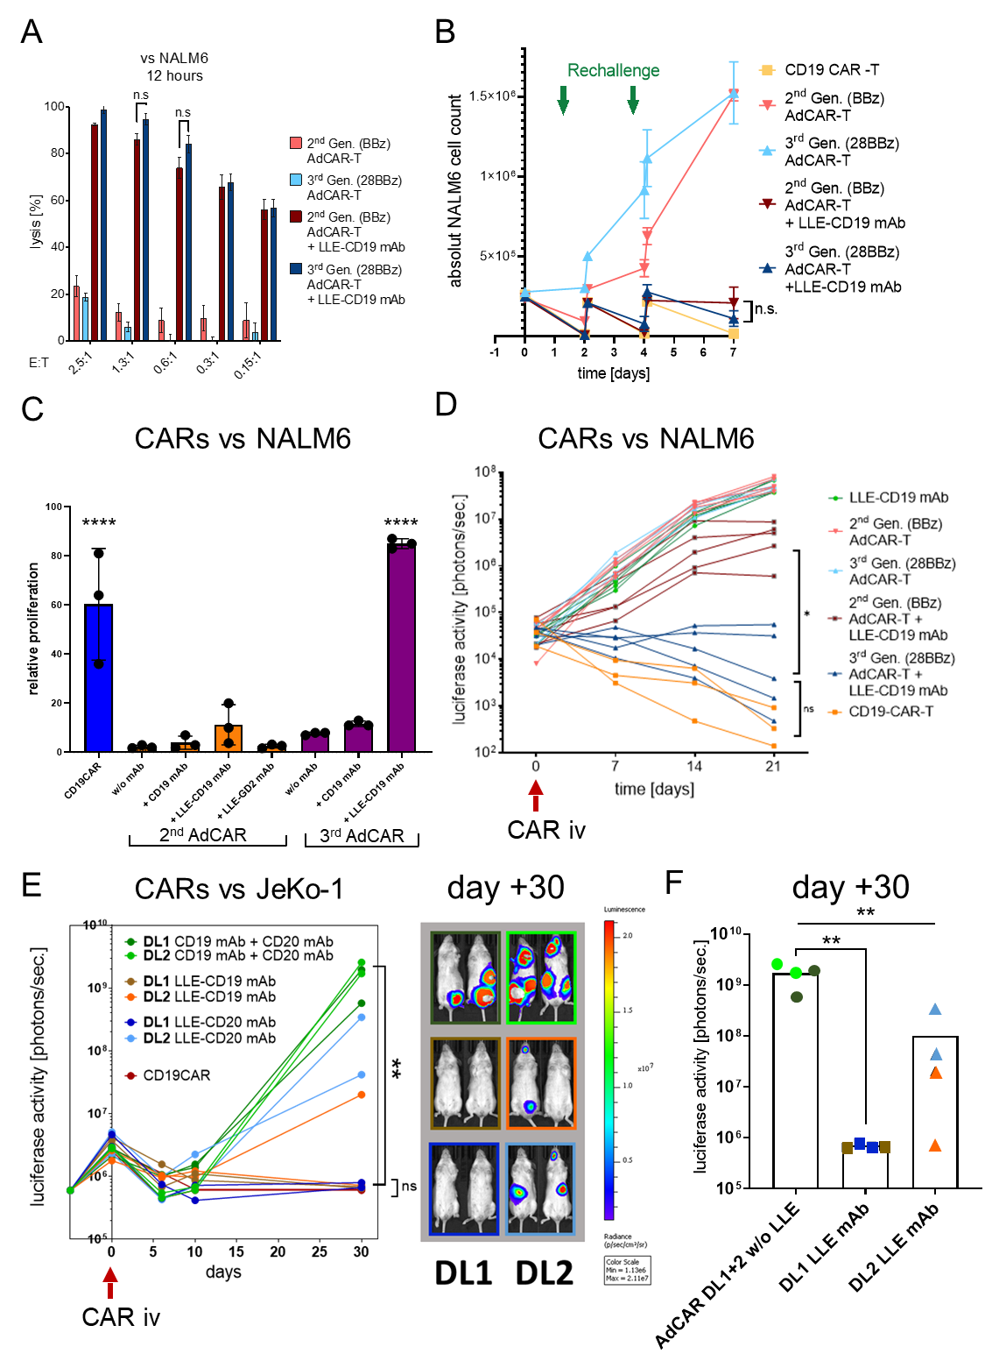
Fig. S3. 2nd versus 3rd generation of AdCAR-T and in vivo performance of AdCAR-T
A) 2nd generation CD19CAR-T (BBzeta) or 2nd generation (BBzeta) or 3rd generation (CD28BBzeta) AdCAR-T were incubated for 12h with NALM6 at indicated E:T ratios in the presence of 10 ng/mL LLE-CD19 mAb. Target-cell lysis was determined by LCA. Comparison of 2nd versus 3rd generation AdCAR-T was not significant. B) AdCAR-T, 2nd generation (BBzeta) or 3rd generation (CD28BBzeta), were incubated with NALM6 at an E:T ratio 1:2 (200.000 AdCAR-T : 400.000 NALM6) in the presence or absence of 10 ng/mL LLE-CD19 mAb, as indicated. On day+2 and day+4 CAR-T cells were rechallenged with an additional dose of 200.000 NALM6 per condition, indicated by arrow heads. Target-cell number was determined by flow cytometry at indicated time points. Comparison of final NALM6 leukemic cell number between AdCAR constructs with LLE-CD19 mAb and CD19CAR on day 7, was not significant. C) CAR-T cell proliferation was determined by flow cytometry (CellTraceTM) at an E:T ratio 1:1 according to the manufacturer’s instruction under proliferative stimulation with NALM6 for 96 hours. Conditions comprised AdCAR-T ^{i)} w/o mAb, ^{ii)} mAb without LLE conjugation (CD19 mAb) and ^{iii)} antibody of irrelevant specificity (LLE-GD2 mAb) and 2nd generation CD19CAR-T cells (BBzeta) as controls. Antibodies was consistently used at 10 ng/mL. The most important comparison was 2nd generation (BBzeta) or 3rd generation (CD28BBzeta) AdCAR-T constructs. Proliferation was calculated by histogram subtraction and relative proliferation as indicated was calculated for the fraction of cells that did not undergo spontaneous proliferation. Since CD19CAR-T showed a high tendency for proliferation without specific stimulation, the relative proliferation was lower compared to the 3rd AdCAR-T + LLE-CD19 mAb. Thus no direct statistic comparison of CD19CAR vs 3rd generation AdCAR was calculated, yet, both showed a significantly higher proliferation capacity than the 2nd generation AdCAR and all the depicted controls.
D) NSG mice were inoculated with 0.5 x 10⁶ NALM6 (NALM-fluc) at day -6. We injected 50 µg of LLE-CD19 4G7SDIE mAb along with 10 mg human IgG intraperitoneally twice weekly as indicated, starting on day -1. 1 x 10⁶ CAR-positive AdCAR-T, 2nd generation (BBzeta) or 3rd generation (CD28BBzeta), or CD19-CAR-T (BBzeta) were injected intravenously as indicated on day 0. Luciferase activity [photons/sec] was determined by in vivo BLI, quantified and plotted over time. Comparison of BLI activity at day 21 revealed a significant difference between 2nd generation (BBzeta) versus 3rd generation (CD28BBzeta) AdCAR-T + LLE-CD19 4G7SDIE mAb, (n=5 mice, p=0.011). No significant difference was found for the comparison of 3rd AdCAR-T + LLE-CD19 mAb versus CD19CAR-T, even though direct CD19CAR-T showed faster and more profound tumor clearance (n_{CD19CAR}=3, n_{3rdAdCAR}=5, p=0.011). Statistical analysis was performed by Mann-Whitney. (BLI) bioluminescence. (n.s.) not significant. E) NSG mice were inoculated with 1 x 10⁶ JeKo-1^{WT/CD19+CD20+} (JeKo-1-fluc) at day -5. At two dose levels either LLE-CD19 4G7SDIE mAb or LLE-CD20 rituximab (DL1 50 µg, DL2 5 µg) along with 10 mg human IgG intraperitoneally twice weekly, starting on day -1. 1 x 10⁷ 3rd generation AdCAR (CD28BBzeta) or 2nd generation CD19CAR (BBzeta) were injected intravenously as indicated on day 0. AdCAR-T plus CD19 mAb and CD20 mAb without LLE conjugation served as negative controls. At DL1 either with LLE-CD19 mAb or LLE-CD20 mAb, AdCAR-T controlled tumor growth, whereas at DL2 tumor growth kinetics were delayed in 3 mice and one mouse only achieved tumor clearance. Luciferase activity [photons/sec] was determined by in vivo BLI, quantified and plotted over time. F) Comparison of BLI activity at day +30 revealed a significant difference between the control group receiving CD19 mAb and CD20 mAb without LLE conjugation and the treatment groups receiving LLE-CD19 or LLE-CD20 mAb. Significance was determined by one-way ANOVA and Tukey post hoc test. Data shown in A) represent ± SEM of one experiment in triplicates of (n=4) different donors, B) represent ± SEM of one experiment in triplicates of (n=3) different donors, C) represent one experiment of (n=3) different donors. E-F) Data shown from one experiment with n=4 mice in each group (DL1=2 and DL2=2). B-F) Significance was determined by one-way ANOVA and Tukey post hoc test. (n.s.) not significant.

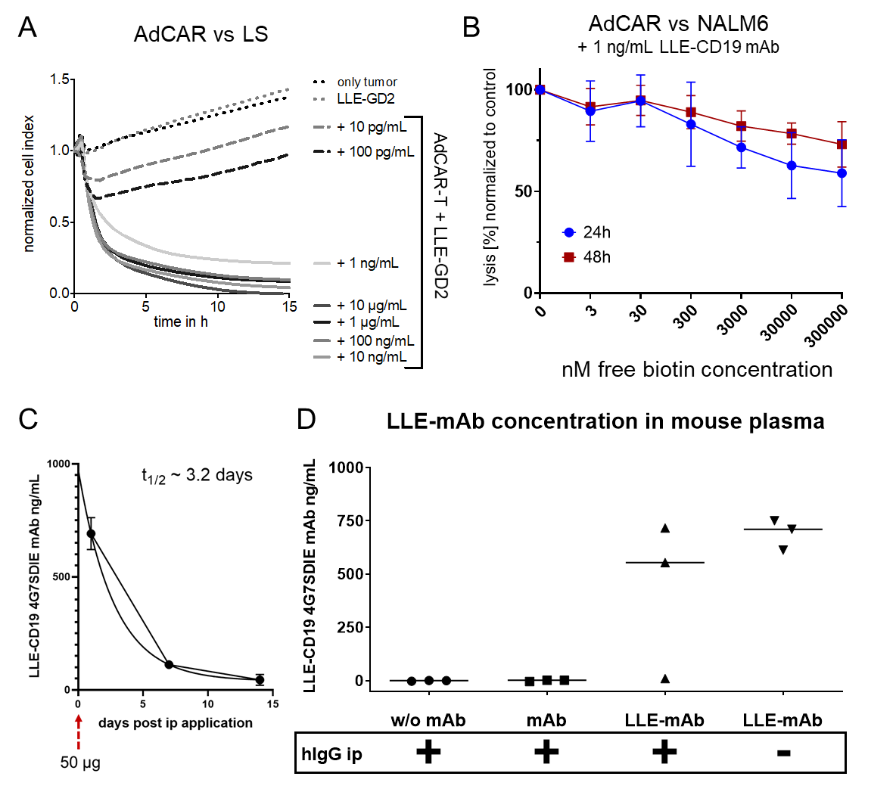
Fig. S4. A) Titration of LLE-GD2 mAb on AdCAR-T function, B) inhibitory effect of free biotin on AdCAR-T mediated lysis, C) plasma half-life of LLE-CD19 mAb in vivo, D) effect of human IgG on plasma concentration of LLE-CD19 mAb
A) AdCAR-T were incubated with GD2⁺ neuroblastoma cell line LS at an E:T ratio of 2:1 in the presence of indicated concentrations of LLE-GD2 mAb. Target-cell lysis was determined by ICA. Data shown represent mean ± SEM of (n=3) independent experiments in triplicates of three different donors. B) Cytotoxicity of AdCAR-T versus NALM6 at an E:T ratio of 1:1 and 1 ng/mL LLE-CD19 mAb was tested under increasing concentrations of free biotin at indicated concentrations and measured at 24 and 48 hours. At supraphysiologic concentrations free biotin moderately inhibited the AdCAR mediated cytolysis. Data shown represent mean ± SEM of one experiment in triplicates of (n=2) different donors. C) Three mice received 50 µg of LLE-CD19 mAb intraperitoneally. At the time points 24 hours, 7 days and 14 days plasma levels of LLE-CD19 mAb were measured by flow cytometry. Plasma half-life of LLE-CD19 mAb was calculated for the application of 50 µg LLE-CD19 mAb. The calculated half-life was t_{1/2} = 3.19 days. D) Three mice per group were applied intraperitoneally PBS (w/mAb), CD19 mAb or LLE-CD19 mAb. Additionally, 10 mg of human IgG was applied as indicated by (+ yes) / (- no) in order to evaluate the FcR mediated binding and thus reduction of free available LLE-mAb in the mouse plasma. No impact of human IgG application was found on the plasma LLE-CD19 mAb levels after 24 hours. The outlier in the group with human IgG underscores the risk of mAb-application failure using ip-application.
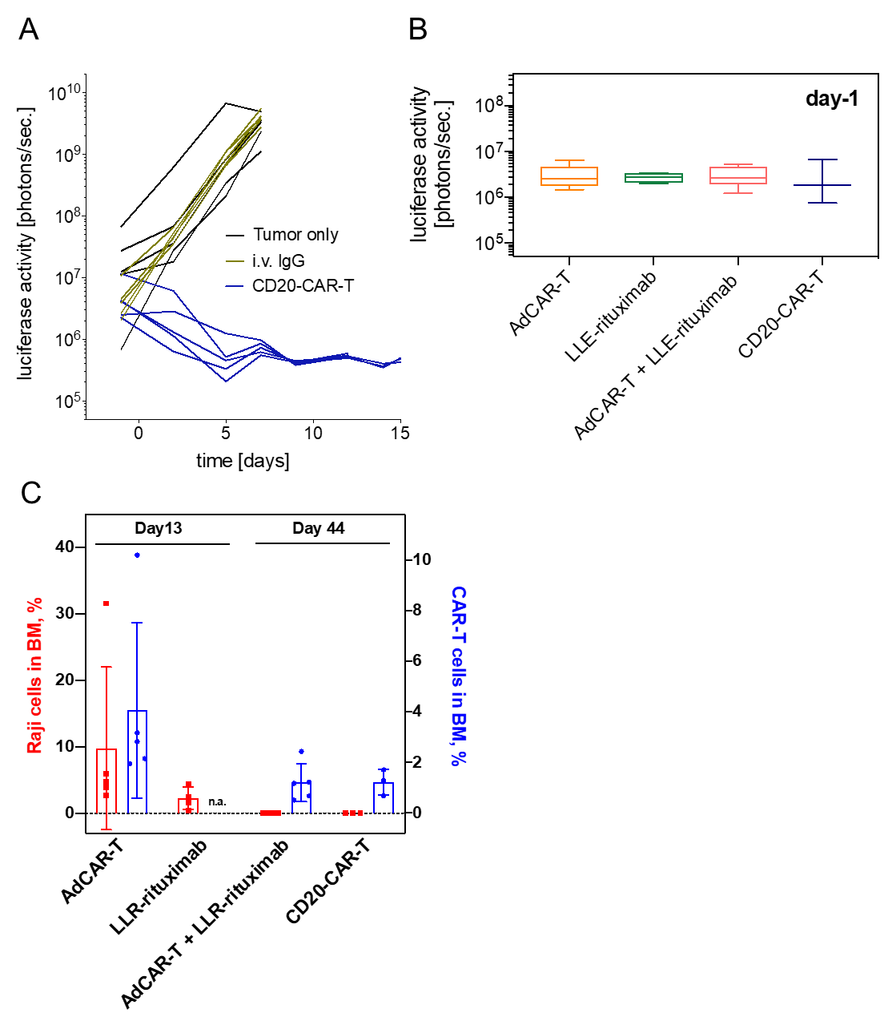
Fig. S5. AdCAR-T versus Raji in vivo experiment: bioluminescence and flow cytometric analyses of leukemic blasts and CAR-T cells in murine bone marrow
NSG mice were inoculated with the NHL cell line Raji (Raji-fluc) at day -6. At day -1, mice were randomized after in vivo imaging. Luciferase activity [photons/sec] was determined by in vivo BLI, quantified and plotted over time. A) Data from a pre-study is demonstrated, evaluating tumor progression without treatment, with human IgG (Gammaguard) (10 mg) injected intraperitoneally twice weekly starting day -1 and treatment with CD20-CAR-T at day 0, serving as a positive control. In B) and C) mice were injected as indicated with rituximab-LLE (50 µg) intraperitoneally twice weekly as indicated, starting on day -1 and AdCAR-T or CD20-CAR-T intravenously on day 0. Application of rituximab-LLE was suspended on day +23. b) Mean luciferase activity [photons/sec] of different groups after randomization on at day -1 is demonstrated. C) For end point analysis flow cytometry of bone marrow was performed. Of note, mice in the control groups AdCAR-T and LLE-rituximab were sacrificed on day +13, mice in the control group CD20-CAR-T and study group AdCAR-T + LLE-rituximab were sacrificed on day +44. Bone marrow infiltrates of Raji-fluc and CAR-T (AdCAR-T or CD20-CAR-T) is shown. Data shown in B) and C) represent mean ± SEM of 5 mice in the groups AdCAR-T and AdCAR-T + LLE-rituximab, 4 mice in the group LLE-rituximab and 3 mice in the CD20-CAR-T group.

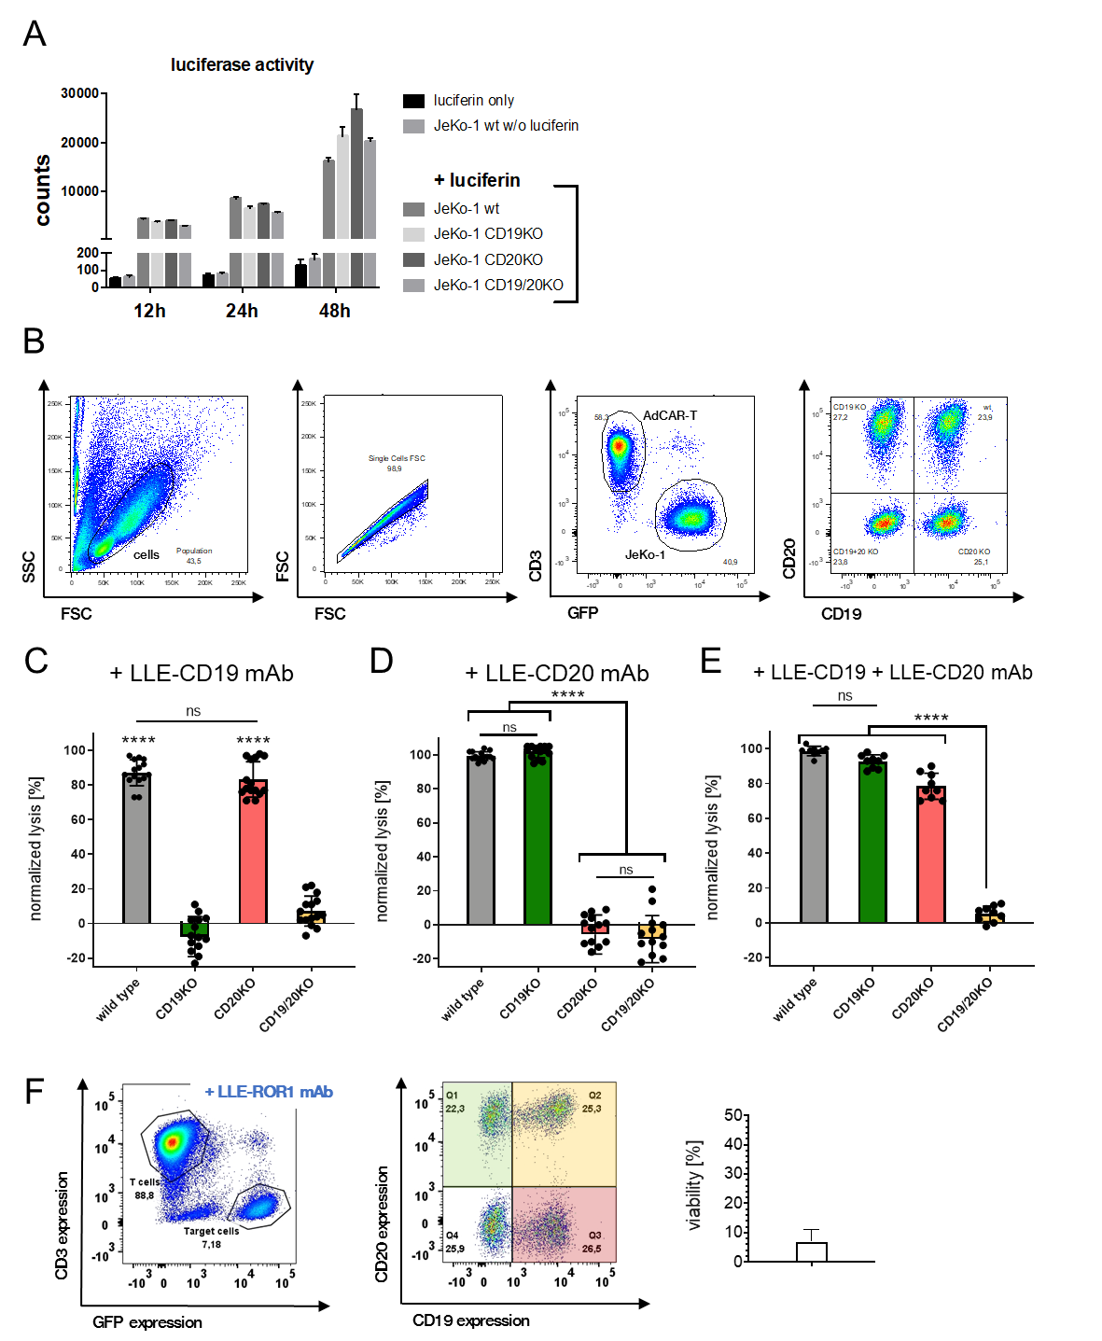
Fig. S6. Versatile targeting of AdCAR-T versus JeKo-1
A) Luciferase activity of different target-cell populations, JeKo-1^{WT}, JeKo-1^{CD19KO}, JeKo1^{CD20KO}and Jeko-1^{CD19/CD20KO} was determined at indicated timepoints of incubation, demonstrating comparable proliferation rates. Data shown in represent mean ± SEM of 3 independent experiments. B) Gating strategy for Flow cytometry-based cytotoxicity assays (antigen evasion): 1. Viable effector and target cell were selected by FSC/SSC plot. 2. Cell aggregates were excluded. 3. Effector cells (AdCAR-T) CD3⁺ and target cells GFP⁺ were discriminated. 4. Target-cell populations were itemized by CD19 and CD20 expression:
JeKo-1^{WT} (upper right), JeKo-1^{CD19KO} (upper left), JeKo-1^{CD20KO} (lower right) and Jeko-1^{CD19/CD20KO} (lower left) (middle panel). Representative plots are shown.
C-E) AdCAR-T were incubated with either JeKo-1^{WT}, JeKo-1^{CD19KO}, JeKo1^{CD20KO} or Jeko-1^{CD19/CD20KO} as indicated at an E:T ratio of 1:1 for 48 hours in the presence of 10 ng/mL LLE-CD19 mAb C), LLE-CD20 mAb D) or 10 ng/mL LLE-CD19 mAb and 10 ng/mL LLE-CD20 mAb E). Target-cell lysis was determined by LCA. F) AdCAR-T were incubated for 48h with an equicellular mix of antigen knockout variants of Jeko-1 (JeKo-1^{WT}, JeKo-1^{CD19KO}, JeKo1^{CD20KO} and Jeko-1^{CD19/CD20KO}) at an E:T (AdCAR-T to JeKo-1) of 2:1 in the presence or absence of the 10 ng/mL LLE-ROR1 mAb analyzed by flow cytometry. Absolute populations (left panel), quantification of the viability of the Jeko-1 (middle panel) and distribution of the Jeko-1 variants (right panel) are demonstrated. Data shown in C-E) represent mean ± SEM of (n=3) independent experiments in triplicates of three different donors. Data shown in F) are representative plots and mean ± SEM of (n=2) independent experiments in triplicates of two different donors. Significance was determined by one-way ANOVA and Tukey post hoc test. (n.s.) not significant.

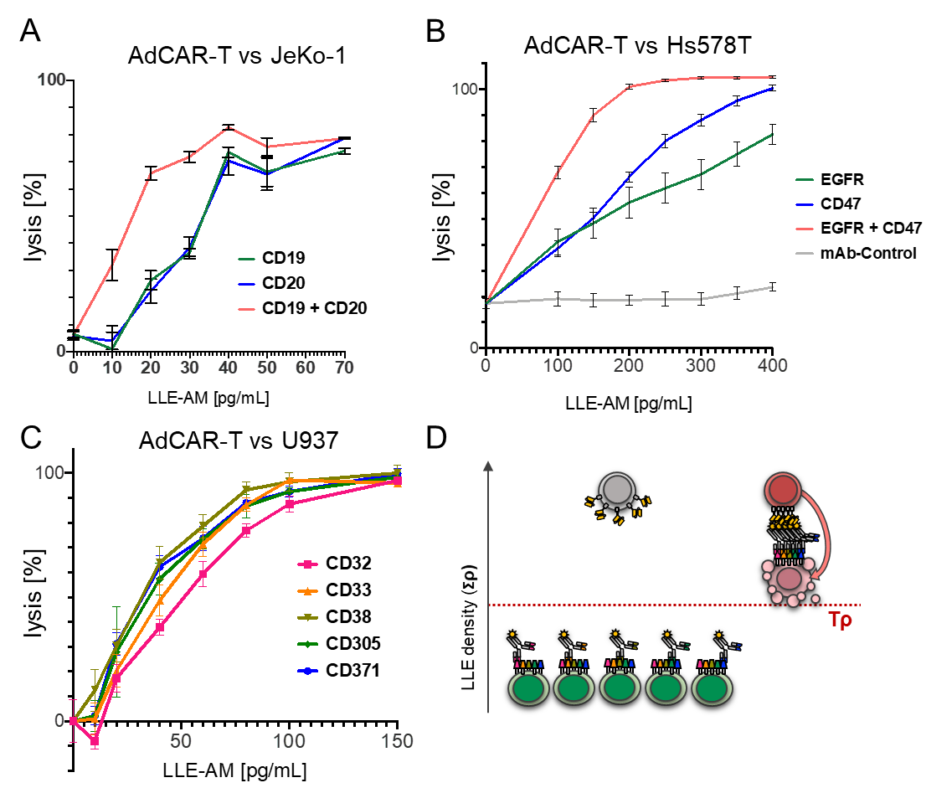
Fig. S7. Surface Activation Matrix of AdCAR-T – a proof of concept
A) AdCAR-T were incubated with Jeko-1 at an E:T ratio of 2:1 for 48h in presence of the indicated AMs at indicated concentrations or an additive combination of both. Target-cell lysis was determined by LCA. Titration curves without further calculation are shown. B) AdCAR-T were incubated with Hs578T at an E:T ratio of 2:1 for 48h in presence of the indicated AMs or additive combinations thereof at indicated concentrations. Target-cell lysis was determined by LCA. C) AdCAR-T were incubated with U937 at an E:T ratio of 1:2 for 48h in the presence of the indicated AMs at indicated concentrations or an additive combination of all five. Target-cell lysis was determined by LCA. Titration curves without further calculation are shown. D) Schematic illustration of exclusive target cell identification and lysis by integration of a 5-antigen expression profile (SAM-effect). Data shown in A) represent mean ± SEM of (n=3) independent experiments from different donors in triplicates. Data shown in B) represent mean ± SEM of (n=5) independent experiments from 5 different donors in triplicates. Data shown in C) represent mean ± SEM of (n=2) independent experiments from different donors in triplicates.

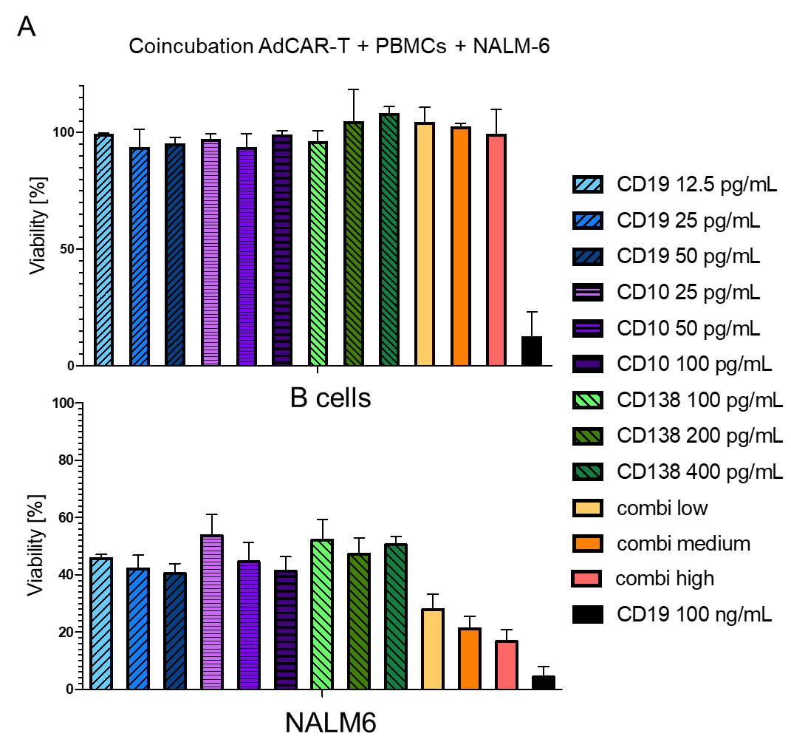
Fig. S8. Susceptibility of B cells and NALM6 to AdCAR mediated lysis
A) AdCAR-T were incubated for 24h with NALM6 and freshly isolated PBMCs at a ratio of 2:1:3 (AdCAR-T : NALM6 : PBMCs) in the presence or absence of indicated concentrations of LLE-CD19 mAb, LLE-CD10 mAb or LLE-CD138 mAb or the combination thereof. The data was acquired and analyzed by flow cytometry. Data shown in A) represent mean ± SEM of (n=3) independent experiments from different donors.

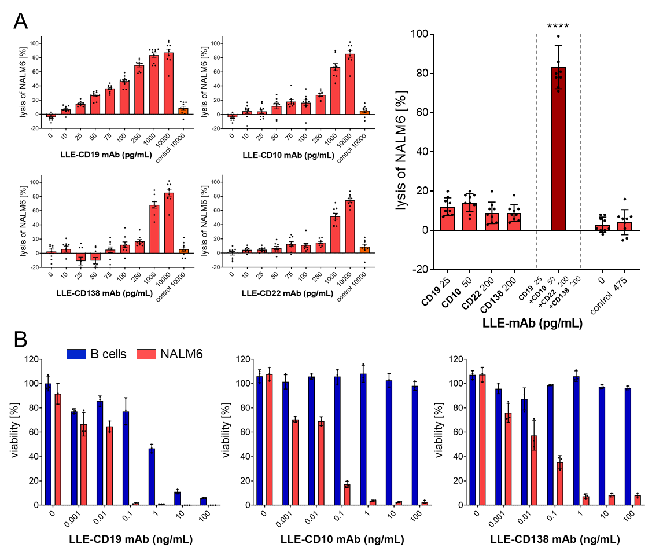
Fig. S9. Effector function of AdCAR-T at increasing LLE-mAb concentrations and LLE-mAb combination plus the intrinsic susceptibility of NALM6 in comparison to healthy B cells to cellular cytotoxicity
A) AdCAR-T were incubated with NALM6 at an E:T ratio of 2:1 for 24h in presence of the indicated AMs at indicated concentrations or an additive combination of these. Target-cell lysis was determined by LCA. ± SEM of (n=3) independent experiments from different donors in triplicates. Significance was determined by one-way ANOVA and Tukey post hoc test. B) In the flow-based cytotoxicity assay, AdCAR-T were incubated for 48h with NALM6 and freshly isolated peripheral B-cells at an E:T ratio of 2:1:1 (AdCAR-T : NALM6 : B cells) in the presence or absence of indicated LLE-CD19 mAb, LLE-CD10 mAb or LLE-CD138 mAb. Viability of cell subsets was assessed by flow cytometry and calculated to the fraction of the untreated control condition. Data is shown from one experiment (n=1) from one donor in triplicates.

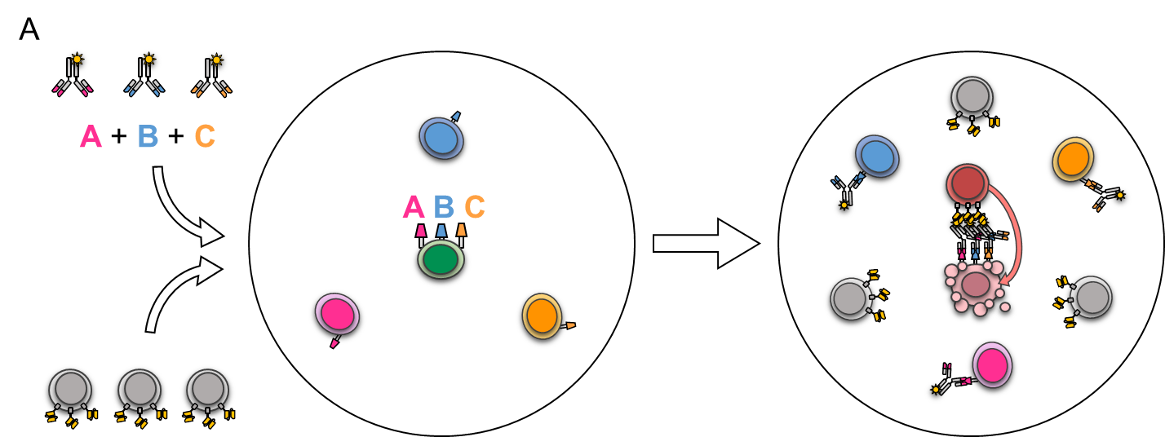
Fig. S10. Principle of Surface Activation Matrix: Identification and target cell lysis by integration of expression profiles
Schematic illustration of differential target cell identification and lysis of target cell expressing promiscuous target antigens by integration of multiplex expression profiles. Healthy cells are illustrated in blue, pink and yellow. They do express only one single target antigen encoded in the same colors in the binding region of the LLE-mAbs. In contrast to healthy cells, the cancerous cell indicated in green does express all three target antigens A + B + C due to an aberrant expression profile. Once applied to the patient (the circle) the AdCAR-T cells and LLE-mAbs are distributed in the system. At below threshold LLE-mAb concentrations, the LLE-mAb are relatively enriched on the cancerous cell (cell surface painting / Surface Activation Matrix) thus able to generate a therapeutic window by selective enrichment of LLE-mAbs on cancerous cells focusing AdCAR mediated effector function to cells with aberrant expression profiles and sparing healthy tissues.
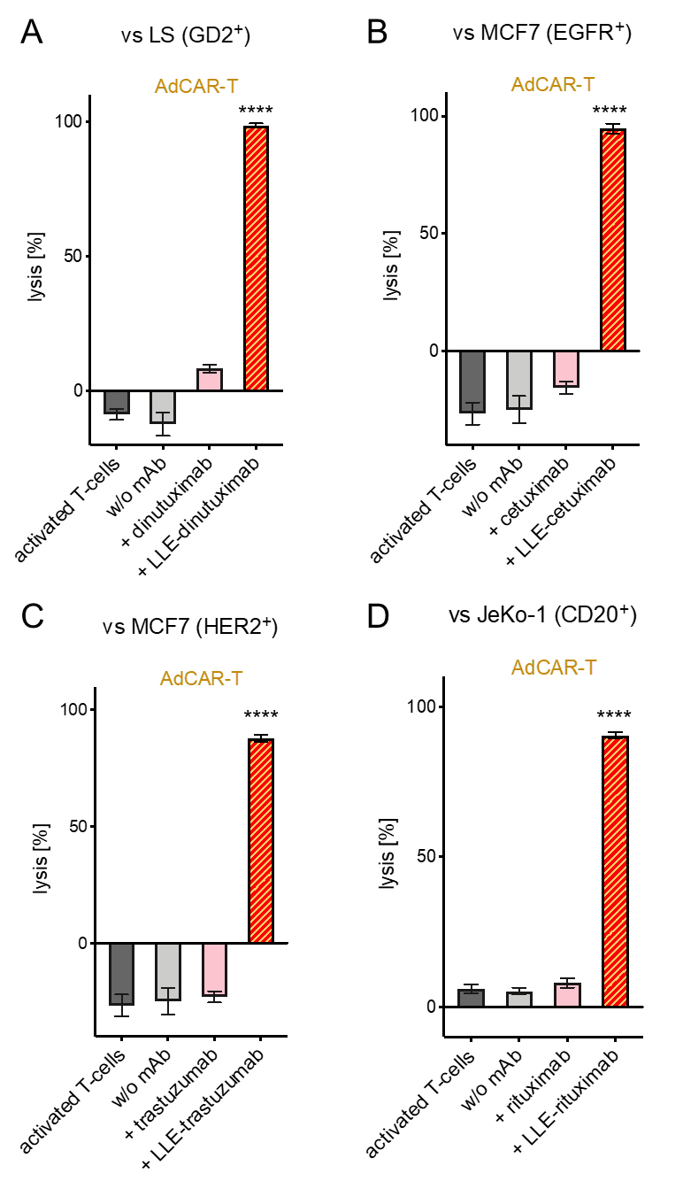
Fig. S11. Use of LLE-FDA/EMA approved monoclonal antibodies to redirect AdCAR-T cells towards tumor-associated antigens
AdCAR-T were incubated with the tumor cell lines A) neuroblastoma LS, B-C) breast cancer MCF7 and D) NHL JeKo-1 at an E:T ratio of 2:1 for 48h in the presence of the indicated therapeutic commercially available mAb. Antibodies were biotinylated to generate LLE-mAb.AMs were used at 10 ng/mL. Target-cell lysis was determined by LCA. Data shown in A-D) represent mean ± SEM of (n=3, p<0.0001) independent experiments in triplicates from different donors. Significance was determined by one-way ANOVA and Tukey post hoc test.
Table S1
Adapter molecules (mAb):
Antigen | Clone | Conjugate | Species / Isotype | Manufacturer
CD10 | REA877 | LLE biotin | Human(recomb.) IgG1 | Miltenyi
CD19 | 4G7SDIE | LLE biotin | Mouse IgG1 | in house
CD19 | REA675 | LLE biotin | Human(recomb.) IgG1 | Miltenyi
CD20 | REA780 | LLE biotin | Human(recomb.) IgG1 | Miltenyi
CD20 | Rituximab | LLE biotin | chim mouse/human IgG1 | Roche
ROR1 | REA1051 | LLE biotin | Human(recomb.) IgG1 | Miltenyi
EGFR | REA688 | LLE biotin | Human(recomb.) IgG1 | Miltenyi
CD15 | VIMC6 | LLE biotin | Mouse IgM | Miltenyi
CD32 | REA997 | LLE biotin | Human(recomb.) IgG1 | Miltenyi
CD33 | REA775 | LLE biotin | Human(recomb.) IgG1 | Miltenyi
CD38 | REA683 | LLE biotin | Human(recomb.) IgG1 | Miltenyi
CD47 | REA220 | LLE biotin | Human(recomb.) IgG1 | Miltenyi
CD117 | REA787 | LLE biotin | Human(recomb.) IgG1 | Miltenyi
CD123 | AC145 | LLE biotin | Mouse IgG2 | Miltenyi
CD133 | REA753 | LLE biotin | Human(recomb.) IgG1 | Miltenyi
CD135 | REA786 | LLE biotin | Human(recomb.) IgG1 | Miltenyi
CD138 | REA104 | LLE biotin | Human(recomb.) IgG1 | Miltenyi
CD276 | FM276 | LLE biotin | Mouse IgG2 | Miltenyi
CD305 | REA447 | LLE biotin | Human(recomb.) IgG1 | Miltenyi
CD371 | REA431 | LLE biotin | Human(recomb.) IgG1 | Miltenyi
GD2 | Ch14.18 | LLE biotin | chim mouse/human IgG1 | EUSA Pharma
HER2 | Hu5 | LLE biotin | Humanized IgG1 | Roche
EGFR | Hu1 | LLE biotin | Human(recomb.) IgG1 | Bristol-Myers Squibb

Abbreviations: CD, cluster of differentiation; LLE, linker-label-epitope; recomb., recombinant; FITC, fluorescein isothiocyanate; APC, allophycocyanin; PE, phycoerythrin; IgG, immunoglobulin G; BD, Becton Dickinson Bioscience.

Table S2:
Antibodies for flow cytometry:
Antigen | Clone | Conjugate | Species / Isotype | Manufacturer
CD3 | BW264/56 | Violet-Blue | Mouse IgG2a | Miltenyi
CD4 | SK3 | BUV395 | Mouse IgG1 | BD
CD8 | BW135/80 | APC-Vio770 | Mouse IgG2a | Miltenyi
CD10 | REA877 | APC | Human(recomb.) IgG1 | Miltenyi
CD10 | HI10A | PE-CF594 | Mouse IgG1 | BD
CD19 | REA675 | APC | Human(recomb.) IgG1 | Miltenyi
CD20 | REA780 | PE | Human(recomb.) IgG1 | Miltenyi
CD45 | HIB19 | PE-Cy7 | Mouse IgG1 | BioLegend
CD45 | REA747 | APC | Human(recomb.) IgG1 | Miltenyi
CD45RA | HI100 | BV785 | Mouse IgG2b | BioLegend
CD45RO | UCHL1 | PE | Mouse IgG2a | Miltenyi
CD62L | 145/15 | CD62L | Mouse IgG1 | Miltenyi
CD95 | DX2 | PE-Vio77 | Mouse IgG1 | Miltenyi
CD138 | REA104 | APC | Human(recomb.) IgG1 | Miltenyi
CD271 | REA844 | PE, APC | Human(recomb.) IgG1 | Miltenyi
LLE-Biotin | Bio3 | FITC, APC | Mouse IgG1 | Miltenyi
Mouse CD45 | 30-F11 | FITC, APC-eFluor780 | Rat IgG2b | Miltenyi

Abbreviations: CD, cluster of differentiation; LLE, linker-label-epitope; recomb., recombinant; FITC, fluorescein isothiocyanate; APC, allophycocyanin; PE, phycoerythrin; IgG, immunoglobulin G; BD, Becton Dickinson Bioscience.

Table S3:
Cell lines used in the experiments:
Cell line | Species | DSMZ no.:
NALM6 | Human | ACC 128
LS | Human | ACC 675
RAJI | Human | ACC 319
JEKO-1 | Human | ACC 553
KASUMI-1 | Human | ACC 220
U937 | Human | ACC 5
MCF7 | Human | ACC 115
HL-60 | Human | ACC 3
MOLM-13 | Human | ACC 554

Use DSMZ number at www.dsmz.de to find the cell line specifications and to order the cell line for research use.

