SUPPORTING INFORMATION

Computational Methods
The Fe₃O₄@Ag hybrid nanostructure was modeled starting with a representative unit cell of magnetite (Fe₃O₄), based on its cubic inverse spinel structure (space group: Fd3m). A surface fragment corresponding to the Fe₃O₄ (111) plane was extracted from bulk crystal data obtained from crystallographic databases (ICSD or COD) to represent the nanoparticle core. To approximate the experimentally observed quasi-spherical morphology, this surface cluster was truncated and passivated to eliminate artificial dangling bonds.
Natural Bond Orbital (NBO) analysis was performed to evaluate donor-acceptor interactions using the second-order perturbation theory of the Fock matrix in the NBO basis. The stabilization energy for electron delocalization from donor NBO i to acceptor NBO j is given by:
${E\left(2\right)=E}_{i→j}=q_{i}\frac{F{(i,j)}^{2}}{ε_{j}-ε_{i}}$ (1)
Where qi as the donor orbital occupancy, εi and εj are the diagonal elements (orbital energies) and F(i,j) is the off diagonal NBO Fock matrix element.
In this context, I and A represent the ionization energy and electron affinity, respectively. Employing the Density Functional Theory (DFT) framework, grounded in Koopmans' theorem and the Kohn-Sham formalism, the equation can be formulated as follows

Gap Energy = ELUMO - EHOMO (2)
Where EHOMO is the energy of the highest occupied molecular orbital and ELUMO is the energy of the lowest unoccupied molecular orbital.
In addition, hardness (η) can be calculated using the Koopmans’ theorem
η = E Lumo – E Homo/ 2 (3)
Chemical potential (µ) is defined based the subsequent equation
2 (4)/E Lumo + E Homo) µ = - (

Figure S₁. Hybrid unit cell model of the Fe₃O₄@Ag core–shell system prior to optimization

Figure S₂. DFT-optimized cluster model derived from the hybrid unit cell, used in DFT and TDDFT simulations.

Figure S3. Electrostatic surface potential (ESP) map of glucose nanostructure, showing charge distribution and polarity.

HOMO | HOMO-1
LUMO | LUMO+1

LUMO+2
HOMO-2

 |  | HOMO-2
HOMO | HOMO-1
 |  | LUMO+2
LUMO | LUMO+1

HOMO | HOMO-1 | HOMO-2
LUMO | LUMO+1 | LUMO+2

Figure S4–S6. Frontier orbital plots (HOMO → HOMO−2, LUMO → LUMO−2) for (i) glucose, (ii) pristine Fe₃O₄@Ag, and (iii) Fe₃O₄@Ag–glucose. Orbital redistribution upon adsorption is highlighted.

Table S₁. Selected bond distances/Å for Fe3O4@Ag-glucose.
 |  | Bond lengths Å
O(32) | Ag(19) | 2.4 | O(30)–H(48) | 0.969
O(31) | Ag(18) | 2.415 | O(31)–H(49) | 0.969
O(27) | Ag(22) | 2.684 | O(32)–H(50) | 0.97
O(32) | Fe(5) | 4.842 | O(28)–H(46) | 0.971
O(31) | Fe(3) | 5.042 | O(29)–H(47) | 0.971
O(27) | Fe (3) | 5.218 | C(37)–O(31) | 1.376
O(31) | H(49) | 0.969 | C(34)–O(29) | 1.401
O(32) | H(50) | 0.97 | C(36)–O(30) | 1.403
H(49) | Ag(18) | 1.941 | C(38)–O(32) | 1.405
H(50) | Ag(19) | 2.163 | C(33)–O(28) | 1.417
 |  |  | C(35)–O(27) | 1.418
 |  |  | C(37)–O(27) | 1.422

Table S2. Projected density of states (PDOS) decomposition (%) of selected frontier orbitals for pristine Fe₃O₄@Ag and Fe₃O₄@Ag–glucose.
System | Orbital | Fe 3d (%) | O 2p (%) | Ag 5s/5p (%) | C/O (glucose) (%)
Pristine Fe₃O₄@Ag | HOMO | 65–70 | 25–30 | 5–10 | –
 | LUMO | 10–15 | <5 | 70–75 | –
 | LUMO+5 | 10–15 | <5 | 70–75 | –
Fe₃O₄@Ag–glucose | HOMO | 10–15 | ~5 | 55–65 | 10–20
 | LUMO+7 | 60–70 | 10–15 | 15–20 | <5

Table S3. Zero-point energy (ZPE), thermal corrected energy, and Gibbs free energy values (in atomic units, a.u.) calculated at the CAM-B3LYP/LANL2DZ (Fe, Ag) and 6-311G(d) (nonmetals) level of theory in water (PCM).
Species | ZPE Energy (a.u.) | Thermal Energy (a.u.) | Free Energy (a.u.)
Glucose | −686.863203 | −686.850967 | −686.900791
Fe₃O₄@Ag core–shell | −3090.255454 | −3090.212649 | −3090.346232
Complex | −3777.179075 | −3777.124752 | −3777.281000

Table S4. Key donor–acceptor interactions in the Fe₃O₄@Ag core–shell system from NBO analysis. Stabilization energies E(2), energy gaps ΔE, and Fock matrix elements F(i,j) indicate weak to moderate O–H and O lone pair to Ag interactions, along with strong Fe-to-Ag metal-to-metal ligand charge transfer (MMLCT) crucial for electronic communication across the interface.
Donor Orbital | Acceptor Orbital | E(2) (kcal·mol⁻¹) | ΔE (a.u.) | F(i,j) (a.u.) | Type of Interaction
BD (1) O31–H49 | LP*(7) Ag18 | 1.78 | 0.92 | 0.036 | O–H → Ag (weak hydrogen-bond-like donation)
LP (1) O31 | LP (6) Ag18 | 1.56 | 0.78 | 0.039 | O lone pair → Ag lone pair (polarization)
LP (1) O31 | LP*(7) Ag18 | 1.96 | 0.76 | 0.034 | O lone pair → Ag antibonding orbital (weak coordination)
BD (1) O32–H50 | LP (6) Ag19 | 1.52 | 0.91 | 0.040 | O–H → Ag (weak hydrogen-bond-like donation)
LP (1) O32 | LP*(7) Ag19 | 2.78 | 0.75 | 0.041 | O lone pair → Ag antibonding orbital (moderate coordination)
LP (2) O27 | LP*(9) Ag22 | 11.25 | 0.65 | 0.078 | O lone pair → Ag antibonding orbital (strong coordination)
BD (Fe1–O10) | LP*(Ag21) | 3.71 | 0.49 | 0.165 | Fe–O bond → Ag antibonding orbital (moderate MMLCT)
LP*(Fe3) | LP*(9) Ag22 | 85.50 | 0.08 | 0.102 | Fe antibonding → Ag antibonding (strong MMLCT)

Extraction from the plant
For this purpose, we used specific concentration (0.03 g. mL-1) of dry plant in distilled water at different temperatures (25 °C / RT, 40 °C and 55 °C) for about 45 minutes. During this process, the polysaccharide present in the plant is hydrolyzed and converted into glucose (Equation 1). In Figure S7., we can see the molecular structure of Polysaccharide [1,2].
${\left(C_{6}H_{10}O_{5}\right)}_{n}\underset{→}{H_{2}O}{n C}_{6}H_{12}O_{6}$ (2)
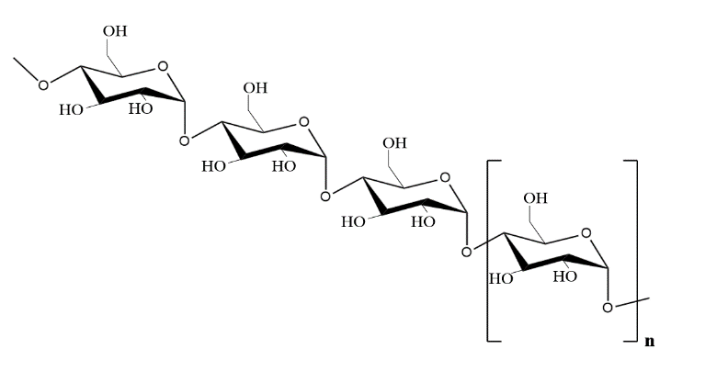
Figure S₇. General molecular structure of a polysaccharide, showing repeating monosaccharide units linked by glucosides bonds.
Glucose molecules formed by polysaccharide hydrolysis in the reaction because of proximity with metal salt performs an oxidation-reduction reaction, which causes the formation of metal particles.
Synthesis of Fe3O4 as a NP core
In this stage, like the approach adopted in our previous study, a 0.1 M solution of FeCl₂·4H₂O and FeCl₃·6H₂O was prepared for the green synthesis of iron nanoparticles. The iron salts were mixed in a ratio of 1-part FeCl₃·6H₂O to 2 parts FeCl₂·4H₂O, after which 25 ml of the plant extract (0.03 g/ml) was added to the mixture until a color change to brown indicated the nucleation phase. Following this, an 8 M sodium hydroxide solution was gradually introduced to the mixture until the pH level reached 11. The reaction was allowed to proceed by stirring the solution for 90 minutes. Subsequently, the magnetic nanoparticles formed were separated using a magnet, rinsed six times with 20 ml of distilled water to adjust the pH to a neutral range (7-8), and dried at 70 °C in an oven for 6 hours [3].
Synthesis of Fe3O4@Ag NP (Core- shell)
Using Design-Expert 13 software and the Central Composite Design (CCD) method, various conditions, including extract concentration and the mass of silver metal salt, were analyzed for the synthesis of magnetite-silver composite nanoparticles, as detailed in Table S5. The composite nanoparticles were synthesized at 70 °C oven for a duration of approximately 5 hours [2], and all samples were prepared under these fixed conditions. In each case, 0.1 g of previously synthesized Fe₃O₄ nanoparticles was placed into a round-bottom flask along with a designated amount of silver salt, followed by the addition of a specific volume of plant extract. This mixture underwent thermal treatment for around 5 hours at a steady temperature of 70 °C. Afterward, the solid material was separated from the solution using a magnet, washed six times with 20 ml portions of distilled water, and then dried in an oven at 70 °C. This process led to the formation of Fe₃O₄@Ag core-shell magnetic nanoparticles [4].
Table S5. Different experimental conditions applied for the green synthesis of iron-silver composite nanoparticles (NPs). The table outlines the varying parameters, including the volume of plant extract and the initial mass of the silver salt, used to synthesize the iron-silver NPs. These conditions were systematically varied to optimize the synthesis process.
Response 2  C: Yield  (%) | Response 1  B: mass of shell/ Ag  (g) | Factor 2  B: Extract volume  (ml) | Factor 1  A: AgNO3  (g) | Run
79.54 | 0.12 | 15 | 0.165 | 1
67.50 | 0.02 | 15 | 0.03 | 2
84.54 | 0.12 | 20 | 0.165 | 3
63.12 | 0.22 | 15 | 0.3 | 4
88.65 | 0.02 | 25 | 0.03 | 5
67.50 | 0.22 | 20 | 0.3 | 6
70.90 | 0.12 | 25 | 0.165 | 7
61.87 | 0.22 | 25 | 0.3 | 8
67.50 | 0.02 | 20 | 0.03 | 9

Experimental analysis
Examining the concentration of extracts in water
The concentration of glucose in the solvent (distilled water) at varying temperatures was analyzed using ultraviolet-visible (UV-Vis) spectroscopy. As shown in Fig.S8, as anticipated, the highest glucose concentration was observed at the elevated temperature of 55°C. A temperature of 60 degrees Celsius was also used, but because the heating process lasted for 45 minutes, a lot of the solvent evaporates, and it was not a suitable result for the research.

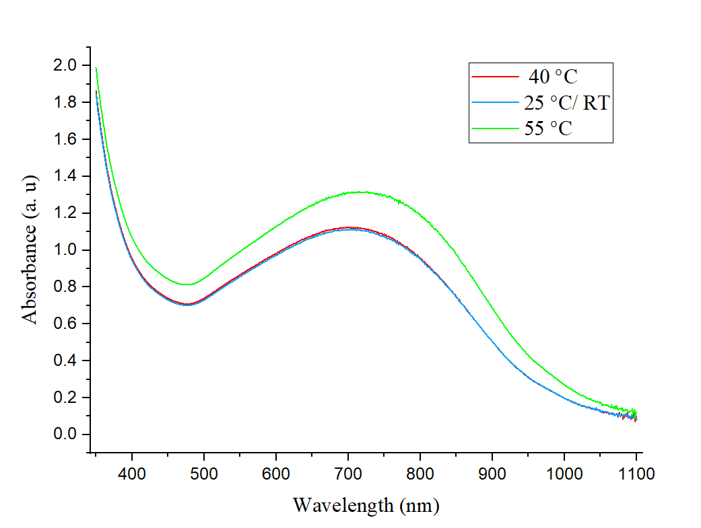
Figure S₈. UV-vis absorption spectrum of extract in different temperature

Reference
[1] Singh, R., Kumar, P., & Sharma, A. (2023). Green synthesis of silver nanoparticles using Alcea rosea extract: Optimization and antibacterial activity. Journal of Environmental Nanotechnology, 12(3), 215-228.
[2] Lee, S., & Park, H. (2023). Role of polysaccharides in the green synthesis of gold nanoparticles using medicinal plants. International Journal of Nanomedicine, 18, 1123-1135.
[3] Patel, R., & Shah, N. (2022). Green synthesis of iron nanoparticles using plant extracts and their potential for antibacterial applications. Journal of Environmental Chemical Engineering, 10(2), 107591.
[4] Gupta, R., & Sharma, A. (2023). Application of Central Composite Design for optimizing the green synthesis of Fe₃O₄/Ag nanocomposites. Journal of Materials Science: Materials in Electronics, 34(1), 298-312.

