Supplementary Appendix to:

Federated target trial emulation for time-to-event outcomes via POLARIS: Pooled-equivalent One-shot Likelihood Aggregation for Real-world Inference in Survival

Table of Contents
Section S1 Data description 2
A. Description of University of Pennsylvania Health System (UPHS) 2
B. Description of Yale New Haven Health System (YNHHS) 2
C. Description of Mayo Clinic (Mayo) 2
D. Description of OneFlorida+ Clinical Research Network (OneFlorida+) 2
E. Description of UT Southwestern Medical Center (UTSW) 3
Section S2 Supplemental Methods 3
A. Study Cohort Definition for Target Trial Emulation 3
B. Study Variables 5
C. Attrition table for each site 9
D. Follow-up Time 11
E. Imputation for Lab Results 12
F. Binary Modifier Variables 33
Section S3 Supplemental Method: POLARIS 34
A. More details regarding Grid-Based Function in POLARIS 34
Section S4 Supplemental Results 36
A. Subgroup-specific Treatment Effects (Hazard Ratios and 95% Confidence Intervals) 36
B. Site-specific Comparison of (i) GLP-1RA vs SGLT2i; (ii) GLP-1RA vs DPP4i 36
C. Covariate Balance 36

Section S1 Data description

Description of University of Pennsylvania Health System (UPHS)
The University of Pennsylvania Health System (UPHS) is a large, diverse academic health system situated in the Greater Philadelphia area, operating under the direction of Penn Medicine. UPHS encompasses multiple hospitals and outpatient facilities affiliated with the University of Pennsylvania’s Perelman School of Medicine, providing a full spectrum of clinical services across primary, specialty, and tertiary care. The Penn Data Store, UPHS’s clinical data warehouse, aggregates electronic health record (EHR) data from across the health system’s hospital network, capturing longitudinal patient information including demographics, diagnoses, procedures, medications, laboratory results, vital signs, and other clinical variables. In total, the Penn Data Store contains EHR records pertaining to more than 6.5 million unique patients.

Description of Yale New Haven Health System (YNHHS)
Yale New Haven Health System (YNHHS) is a nonprofit healthcare system headquartered in New Haven, Connecticut, and is the largest healthcare provider in the state. The system includes five acute-care hospitals: Yale New Haven Hospital, Bridgeport Hospital, Greenwich Hospital, Lawrence + Memorial Hospital, and Westerly Hospital, along with a multispecialty physician foundation (Northeast Medical Group) and numerous outpatient sites spanning Connecticut, southeastern New York, and Rhode Island. YNHHS is affiliated with Yale University and serves as the primary teaching hospital for Yale School of Medicine, supporting advanced patient care, clinical research, and graduate medical education. The YNHHS EHR data repository contains records for approximately 4 million patients, encompassing structured clinical data including demographics, encounter records, diagnoses, procedures, medications, laboratory values, and vital signs.

Description of Mayo Clinic (Mayo)
Mayo Clinic is a nonprofit academic medical center with major campuses in Rochester, Minnesota; Jacksonville, Florida; and Phoenix/Scottsdale, Arizona. As one of the largest and most comprehensive medical centers in the United States, Mayo Clinic provides integrated clinical care, education, and research across virtually every medical specialty, treating more than 1.3 million patients annually from all 50 states and over 130 countries. The Mayo Clinic Health System additionally operates more than 70 affiliated hospitals and clinics across Minnesota, Wisconsin, and Iowa. Mayo Clinic maintains an extensive clinical data infrastructure, including the Enterprise Data Trust, which integrates EHR data from across its practice sites. The Mayo Clinic EHR repository contains longitudinal records for approximately 10 million patients, spanning decades of clinical encounters and encompassing demographics, diagnoses, procedures, medications, laboratory results, imaging data, and clinical notes.

Description of OneFlorida+ Clinical Research Network (OneFlorida+)
OneFlorida+ is a clinical research network within the national Patient-Centered Clinical Research Network (PCORnet), funded by the Patient-Centered Outcomes Research Institute (PCORI). Led by the University of Florida, the network brings together academic institutions, public and private health systems, and state agencies to create an enduring infrastructure for pragmatic clinical trials, comparative effectiveness research, and observational studies. The OneFlorida+ Data Trust serves as a centralized research data repository, containing EHR and administrative claims data that are cleaned, transformed, and curated according to the PCORnet Common Data Model (CDM). The Data Trust contains records for over 18 million patients from Florida, covering nearly 85% of the state’s population, as well as over 6 million patients from other states, including Alabama, Georgia, Arkansas, California, and Minnesota. Available data elements include patient demographics, vital signs, diagnoses, procedures, prescribing and dispensing records, laboratory results, and other clinical variables.

Description of UT Southwestern Medical Center (UTSW)
UT Southwestern Medical Center (UTSW) is a premier academic medical center located in Dallas, Texas, integrating biomedical research, clinical care, and education. The institution comprises the William P. Clements Jr. University Hospital and its Zale Lipshy Pavilion, and its faculty also provide patient care at Parkland Memorial Hospital, Children’s Medical Center Dallas, and other affiliated hospitals and clinics throughout the Dallas-Fort Worth metroplex. Together, UTSW physicians provide care in more than 80 specialties to over 120,000 hospitalized patients, more than 360,000 emergency department cases, and nearly 5 million outpatient visits annually. UTSW maintains a Clinical Research Data Warehouse (CRDW) built on the i2b2 platform, as well as Epic-based EHR infrastructure, that aggregates clinical data including demographics, diagnoses, procedures, medications, laboratory values, and vital signs across its affiliated hospitals and practice sites.

Section S2 Supplemental Methods

Study Cohort Definition for Target Trial Emulation
We conducted a federated comparative effectiveness study emulating a pragmatic trial: (i)GLP-1 receptor agonists (GLP-1RAs) versus SGLT-2 inhibitors (SGLT2is); (ii) GLP-1 receptor agonists (GLP-1RAs) versus dipeptidyl peptidase 4 inhibitors (DPP4is) among adults with type 2 diabetes across five U.S. health systems from January 1, 2019, to September 30, 2024. The full target trial protocol and its operationalization in EHR data are specified in Table S1. Briefly, eligible patients were adults (≥18 years) initiating a study medication without prior use of any study drug class, with ≥1 healthcare encounter and a confirmed Type 2 Diabetes (T2D) diagnosis during the 1-year baseline period, and no prior record of any primary gastrointestinal outcome (unified washout applied across all five outcomes). Follow-up was administratively censored on December 31, 2024.

Protocol element | Target trial specification | Emulation in our EHR data
Eligibility criteria | Adults (≥18 years) with Type 2 Diabetes (T2D); no prior use of study medications; no Type 1 Diabetes (T1D) or end-stage renal disease (ESRD); ≥1 healthcare encounter in the 1-year baseline period | Adults (≥18 years) in the EHR with ≥1 T2D diagnosis; no prior prescription of GLP-1 receptor agonists (GLP-1RAs) or sodium-glucose cotransporter 2 inhibitors (SGLT2is); no T1D or ESRD diagnosis; ≥1 encounter in the 1-year baseline window; excluded if any primary gastrointestinal outcome recorded during baseline (unified washout)
Treatment strategies | Random assignment to initiation of GLP-1RAs or SGLT2is | Observed first prescription of GLP-1RA or SGLT2i between January 1, 2019, and September 30, 2024; treatment class defined by RxNorm codes (see Table S2)
Assignment procedures | Randomization | Emulation of randomization via propensity score weighting (ℓ1-weighted penalized logistic regression); standardized mean differences assessed for all baseline covariates
Start of follow-up (time zero) | Date of treatment initiation | Index date: date of first qualifying prescription of GLP-1RAs or SGLT2is, with no prior use of either class
Baseline period (covariate capture & washout) | 1 year before treatment initiation | 1-year lookback prior to the index date for covariate extraction, eligibility verification, and gastrointestinal outcome washout; laboratory values imputed using MICE if missing (see Imputation for Lab Results)
Follow-up period | From randomization until incident gastrointestinal event, death, loss to follow-up, or trial end | From the index date until the first of: incident outcome event, death, last healthcare encounter, or December 31, 2024 (administrative censoring)
Outcomes of interest | Incident gastrointestinal events: abdominal pain, constipation, GERD, nausea, and vomiting. | Ascertainment via ICD-10 codes applied to EHR condition occurrence and visit occurrence domains; non-fatal events distinguished from fatal events using a 30-day death window (see Table S2 for complete code sets)
Potential Effect modification | Heterogeneous treatment effects (HTE) across patient subgroups defined by demographic, clinical, and laboratory characteristics | HTE estimated via 13 pre-specified binary effect modifiers spanning demographics (age, sex, ethnicity), baseline comorbidities, concomitant medications, and laboratory thresholds; binary operationalization described in Table S4.
Causal contrast of interest | Intention-to-treat effect of initiating (i) GLP-1RA versus SGLT2i;  (ii) GLP-1RA versus DPP4i. | Subgroup-specific hazard ratios (HRs) from weighted Cox proportional hazards model: $λ\left(t | A,M\right)=λ_{0}(t)\exp\left\{β_{1}A+β_{2}M+β_{3}A*M\right\}$, where $β_{1}$ = treatment effect in reference subgroup (M = 0), $β_{1}+β_{3}$= treatment effect in comparison subgroup (M = 1)
Analysis plan | Weighted Cox proportional hazards model; federated estimation across participating sites | POLARIS framework: (1) each site estimates propensity scores and evaluates the weighted Cox risk function on a Chebyshev grid, compressed via tensor-train (TT) decomposition; (2) coordinating center aggregates TT summaries in one communication round and reconstructs the pooled risk function to obtain estimates identical to centralized pooled analysis
Table S1. Specification of the target trial and its emulation in our EHR study. Each row describes one protocol element of the target trial and its corresponding operationalization in the federated EHR analysis.

Study Variables
Table S2 provides complete definitions for all treatments, outcomes and confounding variables used in the analysis, including ICD-10 code sets for comorbidities and RxNorm codes for medication history. Variables used as potential effect modifiers and their binary operationalization for HTE estimation are described in Section S2F and Table S4.

Variable |  | Functional form | Values | Detail |  | Codes/references
Treatment (i.e., Exposure)
GLP-1 receptor agonists (GLP-1RAs) |  | Indicator | Yes/No | Defined based on the medication domain. Patients with a recorded prescription or administration of any GLP-1RA agent were considered exposed. |  | Albiglutide, Dulaglutide, Exenatide, Liraglutide, Lixisenatide, Semaglutide, Tirzepatide
SGLT2 inhibitors (SGLT2is) |  | Indicator | Yes/No | Defined based on the medication domain. Patients with a recorded prescription or administration of any SGLT2 agent were considered exposed. |  | Canagliflozin, Dapagliflozin, Empagliflozin, Ertugliflozin, Sotagliflozin, Bexagliflozin
Outcomes
Abdominal pain |  | Indicator | Yes/No | Based on the condition occurrence domain. Defined as the first occurrence of an abdominal pain diagnosis code during the follow-up period. |  | ICD-10: R10.10 (upper abdominal pain), R10.30 (lower abdominal pain), R10.8 (other abdominal pain), R10.84 (generalized abdominal pain), R10.9 (abdominal pain, unspecified)
Constipation |  | Indicator | Yes/No | Based on the condition occurrence domain. Defined as the first occurrence of a constipation diagnosis code during the follow-up period. |  | ICD-10: K59.0 (constipation), K59.00 (constipation, unspecified), K59.01 (slow transit constipation), K59.02 (outlet dysfunction constipation), K59.03 (drug-induced constipation), K59.04 (chronic idiopathic constipation), K59.09 (other constipation)
GERD |  | Indicator | Yes/No | Based on the condition occurrence domain. Defined as the first occurrence of a GERD diagnosis code during the follow-up period. |  | ICD-10: K21 (gastro-esophageal reflux disease), K21.0 (GERD with esophagitis), K21.00 (GERD with esophagitis without bleeding), K21.01 (GERD with esophagitis with bleeding), K21.9 (GERD without esophagitis)
Nausea |  | Indicator | Yes/No | Based on the condition occurrence domain. Defined as the first occurrence of a nausea diagnosis code during the follow-up period. |  | ICD-10: R11.0 (nausea)
Vomiting |  | Indicator | Yes/No |  |  | ICD-10: G43.A (cyclical vomiting syndrome), G43.A0 (cyclical vomiting syndrome, not intractable), G43.A1 (cyclical vomiting syndrome, intractable), P92.0 (vomiting of newborn), P92.01 (bilious vomiting of newborn), P92.09 (other vomiting of newborn), R11.1 (vomiting), R11.10 (vomiting, unspecified), R11.11 (vomiting without nausea), R11.12 (projectile vomiting), R11.13 (vomiting with nausea), R11.14 (bilious vomiting), R11.15 (cyclical vomiting), J69.0 (pneumonitis due to inhalation of food and vomit)
Confounding variables
Age (years) | Linear |  | NA |  | Based on records in the person domain. | Age is defined as the integer of (date – birth date)/365.25
Sex | Indicator |  | Male/Female |  | Based on records in the person domain. | NA
Race | 4 categories |  | White  Non-Hispanic Black  Asian  Other/unknown |  | Based on records in the person domain. | NA
Ethnicity | 2 Categories |  | Non-Hispanic  Hispanic or Latino |  | Based on records in the site domain.
Entry Date (index calendar month) | Categorical (year-month fixed effects) |  | each YYYY-MM from cohort start to end (e.g., 2019-01, 2019-02, …, 2024-09) |  | Derived by truncating the index date to year-month.
Diagnosis of each medical condition cluster in 1 year prior to the entry | Indicator |  | Yes/No |  | Medical condition clusters were defined based on the condition occurrence and visit occurrence domains. | The codeset for medical conditions is available at https://github.com/Penncil/POLARIS/blob/df42d7d1bd826a3be37334c3221df88c0794f777/cluster_master.csv.
Number of visits to emergency department in 1 year prior to the entry | 4 categories |  | 0  1  2  >=3 |  | Based on the condition occurrence and visit occurrence domains. | NA
Number of inpatient visits in 1 year prior to the entry | 4 categories |  | 0  1  2  >=3 |  | Based on the condition occurrence and visit occurrence domains, including Inpatient Hospital Stay, Emergency Department Admit to Inpatient Hospital Stay, and Observation Stay | NA
Number of outpatient visits in 1 year prior to the entry | 4 categories |  | 0  1  2  >=3 |  | Based on the condition occurrence and visit occurrence domains including Ambulatory/Outpatient Visit (With a Physician) and Interactive Telemedicine Service | NA
Prescription of each medication cluster in 1 year prior to the entry | Indicator |  | Yes/No |  | A total of 27 medication clusters were defined based on the medication domain. Patients with a recorded prescription or administration of any agent within each cluster during the 1-year baseline period were flagged. Clusters with prevalence <1% were excluded from the propensity score model. | The codeset for medical conditions is available at https://github.com/Penncil/POLARIS/blob/df42d7d1bd826a3be37334c3221df88c0794f777/code_med.csv.
Lab Variables
HbA1c (%) | Linear | NA | Based on laboratory test records. | LOINC: 4548-4
Triglycerides (mg/dL) | Linear | NA | Based on laboratory test records. | LOINC: 2571-8
HDL cholesterol (mg/dL) | Linear | NA | Based on laboratory test records. | LOINC: 2085-9
LDL cholesterol (mg/dL) | Linear | NA | Based on laboratory test records. | LOINC: 13457-7
Total cholesterol (mg/dL) | Linear | NA | Based on laboratory test records. | LOINC: 2093-3
Vital
Body mass index (BMI, kg/m²) | Linear | NA | Based on vital signs records.
Systolic blood pressure (SBP, mmHg) | Linear | NA | Based on vital signs records.
Diastolic blood pressure (DBP, mmHg) | Linear | NA | Based on vital signs records.
Table S2. Definitions of treatments, outcomes and confounding variables. This table provides operational definitions for all variables used in the target trial emulation, including the treatment strategies ((i) GLP-1 receptor agonists and SGLT-2 inhibitors; (ii) GLP-1 receptor agonists and DPP4 inhibitors, five gastrointestinal outcomes, and baseline confounders (demographics, healthcare utilization, comorbidities, concomitant medications, and laboratory values). For each variable, the table reports the functional form, categorical values where applicable, definition based on EHR domains, and corresponding ICD-10 or RxNorm code sets.

Attrition table for each site
Figures S1a-S1e summarize patient attrition at each participating site for the GLP-1RA versus SGLT2i comparison. Each table reports the number of patients remaining after sequential application of eligibility criteria.

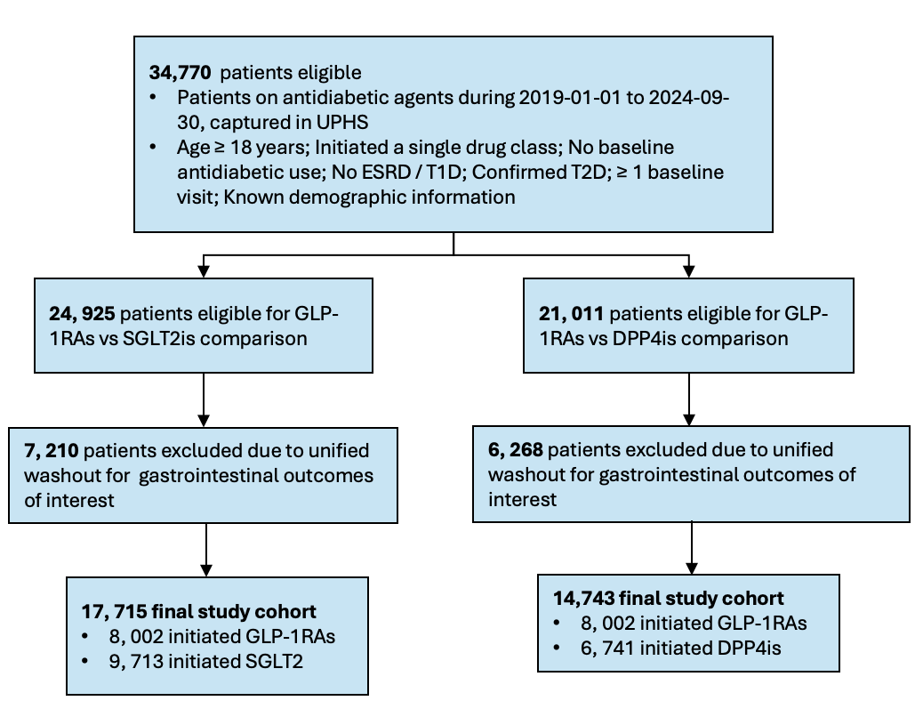
Figure S1-a. Attrition for University of Pennsylvania Health System (UPHS). Sequential exclusion counts and cumulative sample sizes for (i) GLP-1RA and SGLT2i cohorts; (ii) GLP-1RA and DPP4i cohorts at UPHS, following application of each eligibility criterion.

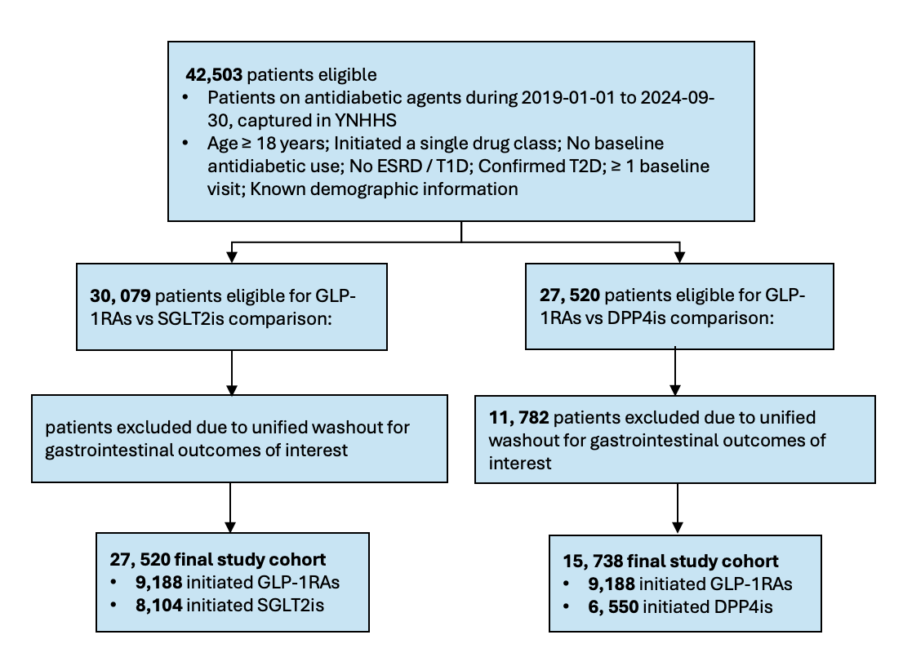
Figure S1-b. Attrition for Yale New Haven Health System (YNHHS). Sequential exclusion counts and cumulative sample sizes for (i) GLP-1RA and SGLT2i cohorts; (ii) GLP-1RA and DPP4i cohorts at YNHHS, following application of each eligibility criterion.

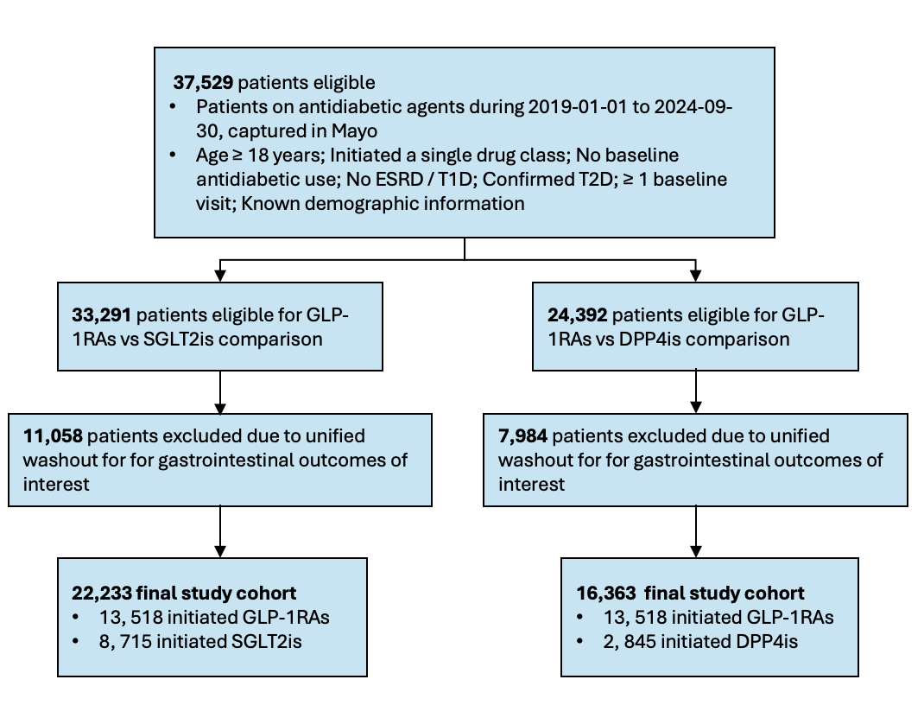
Figure S1-c. Attrition for Mayo Clinic. Sequential exclusion counts and cumulative sample sizes for (i) GLP-1RA and SGLT2i cohorts; (ii) GLP-1RA and DPP4i cohorts at Mayo Clinic, following application of each eligibility criterion.

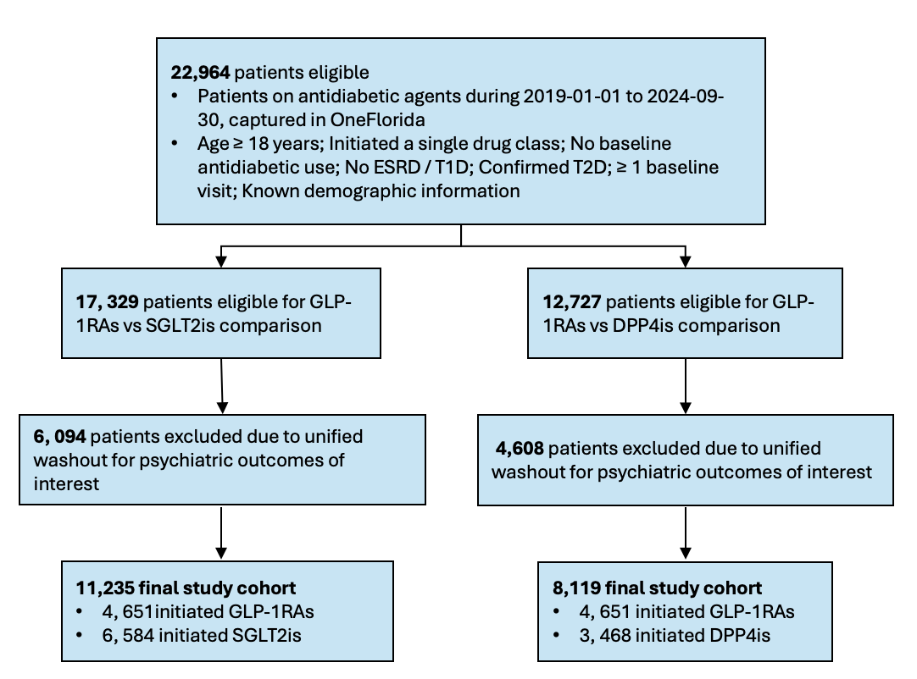
Figure S1-d. Attrition for OneFlorida+ Clinical Research Network. Sequential exclusion counts and cumulative sample sizes for (i) GLP-1RA and SGLT2i cohorts; (ii) GLP-1RA and DPP4i cohorts at OneFlorida+, following application of each eligibility criterion.

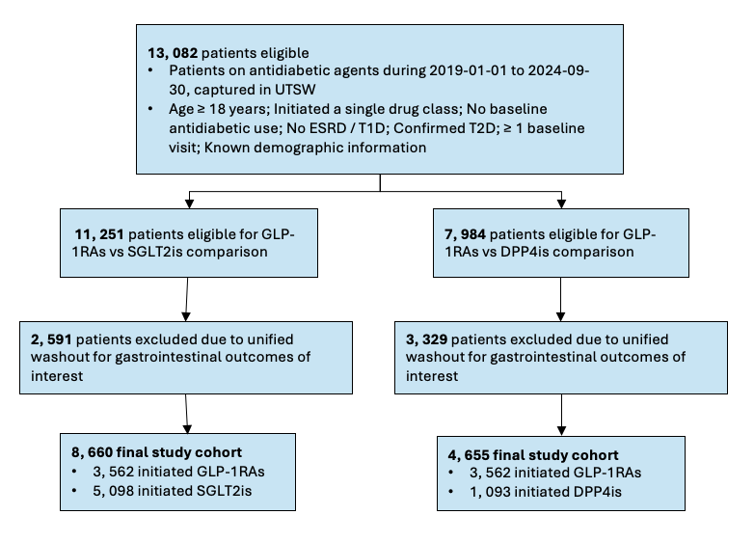
Figure S1-e. Attrition for UT Southwestern Medical Center (UTSW). Sequential exclusion counts and cumulative sample sizes for (i) GLP-1RA and SGLT2i cohorts; (ii) GLP-1RA and DPP4i cohorts at UTSW, following application of each eligibility criterion.

Follow-up Time
Follow-up time for each patient was calculated from cohort entry to the earliest of: (1) recorded death date, (2) last healthcare encounter date, or (3) the administrative study end on December 31, 2024. The last healthcare encounter date was defined as the maximum recorded date across all available EHR data tables for each patient. When a patient's recorded death date fell after their last encounter date, the last encounter date was used for censoring, as outcomes could not be reliably ascertained beyond the last data collection point. Patients with follow-up time ≤ 0 days (n=1,898, 1.6% prior to washout) were assigned 0.5 days to permit inclusion in Cox regression models. Outcome events recorded after a patient's censoring date were treated as non-events.

Imputation for Lab Results
Missing baseline laboratory values were imputed using Multivariate Imputation by Chained Equations (MICE), implemented via scikit-learn’s IterativeImputer with Bayesian Ridge Regression as the conditional model. Eight variables were imputed: body mass index (BMI), systolic blood pressure (SBP), diastolic blood pressure (DBP), hemoglobin A1c (HbA1c), high-density lipoprotein cholesterol (HDL), low-density lipoprotein cholesterol (LDL), total cholesterol, and triglycerides. Prior to imputation, known placeholder values were set to missing, and values outside the 1st–99th percentile range were trimmed. The imputation model incorporated up to 35 predictor variables, including treatment assignment, demographics, comorbidities, concomitant medications, healthcare utilization, and the laboratory variables themselves as mutual predictors. A non-negativity constraint (min_value = 0) was applied. The identical pipeline was executed independently at each site; all eight variables achieved complete imputation (0% missing) at every site.
Table S3 presents the pre-imputation missingness rates across sites. Missingness was generally lowest for vital signs (SBP, DBP) and highest for lipid panels and LDL, though rates varied substantially by site depending on local data capture practices.
Imputation fidelity was assessed using two sets of diagnostic figures. Figures S2a-S2e show three-stage comparisons (raw, cleaned, and post-imputation distributions) for each laboratory variable at each site, including side-by-side box plots, overlaid density histograms, and quantile-quantile plots with Pearson correlation against the identity line. Figures S3a-S3e show direct comparisons between the observed (pre-imputation) and complete (post-imputation) distributions. Across all sites and lab variables, the post-imputation distributions closely matched the observed distributions: box plot medians and interquartile ranges were stable across stages, density curves of imputed-only values aligned with the observed data, and Q-Q plots showed strong agreement with the identity line. These diagnostics confirm that the MICE procedure did not materially shift the central tendency or shape of any laboratory variable at any site, supporting the validity of the imputed values for downstream propensity score estimation and Cox regression.

Lab Variable | UPHS | Mayo Clinic | YNHHS | UTSW | OneFlorida+
BMI | 9.9 | 14.0 | 7.0 | 72.2 | 36.2
SBP | 5.8 | 5.8 | 3.8 | 72.5 | 34.0
DBP | 5.9 | 5.8 | 3.6 | 72.5 | 33.9
HbA1c | 33.2 | 16.8 | 17.2 | 44.7 | 45.8
HDL | 40.9 | 34.1 | 39.3 | 57.7 | 41.6
LDL | 45.8 | 37.8 | 62.7 | 64.1 | 70.9
Total cholesterol | 44.0 | 33.9 | 39.3 | 92.3 | 44.0
Triglycerides | 40.5 | 66.4 | 38.7 | 57.3 | 41.2
Table S3. Pre-imputation missingness rates (%) for laboratory variables by site. Values represent the percentage of patients with missing data for each variable after removal of implausible placeholder values and trimming to the 1st -99th percentile range. All eight variables achieved 0% missingness after MICE imputation at every participating site. †Abbreviations: BMI, body mass index; SBP, systolic blood pressure; DBP, diastolic blood pressure; HbA1c, hemoglobin A1c; HDL, high-density lipoprotein cholesterol; LDL, low-density lipoprotein cholesterol.

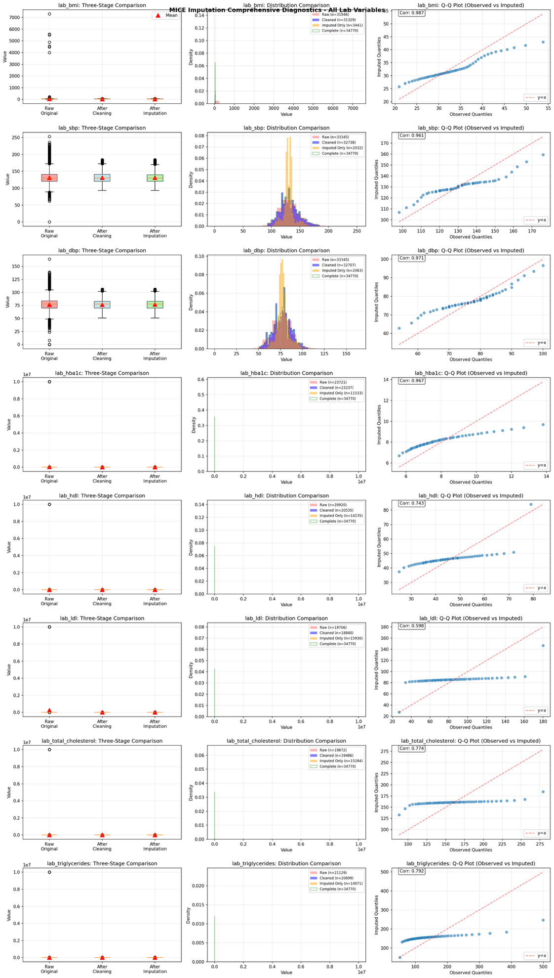
Figure S2-a. MICE imputation diagnostics: three-stage comparison University of Pennsylvania Health System (UPHS). For each laboratory variable at each site, the left panel shows box plots comparing raw, cleaned (after outlier removal), and imputed distributions, with red triangles indicating means; the middle panel shows overlaid density histograms of raw (red), cleaned (blue), imputed-only (orange), and complete post-imputation (green outline) distributions; and the right panel shows a quantile–quantile plot of observed versus imputed values with the Pearson correlation annotated. The dashed red line denotes the identity line. Stable medians and overlapping densities across stages indicate that imputation preserved the original distributional characteristics of each variable.

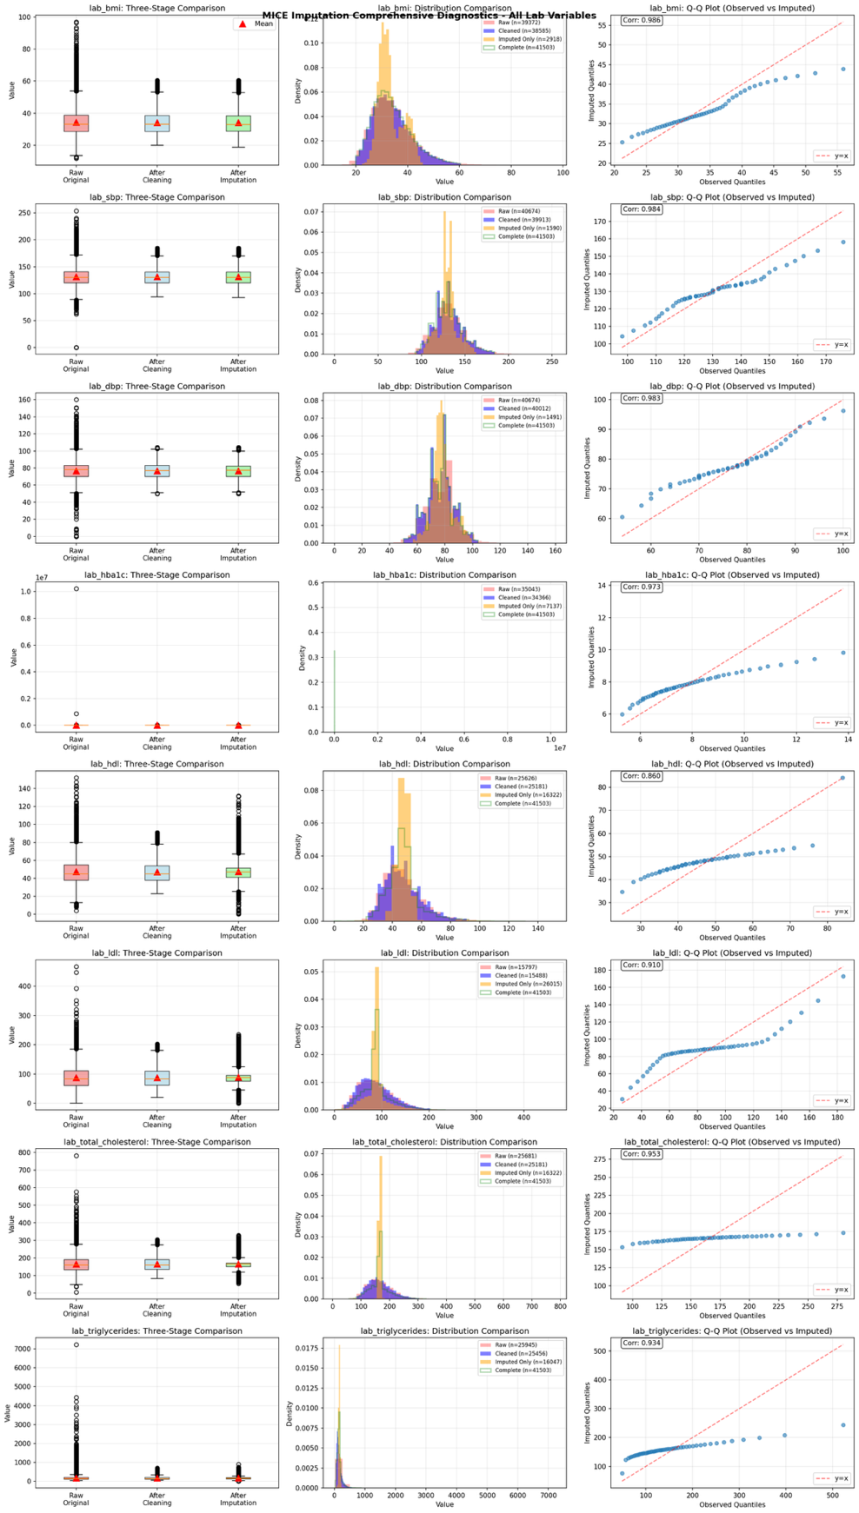

Figure S2-b. MICE imputation diagnostics: three-stage comparison for Yale New Haven Health System (YNHHS). For each laboratory variable at each site, the left panel shows box plots comparing raw, cleaned (after outlier removal), and imputed distributions, with red triangles indicating means; the middle panel shows overlaid density histograms of raw (red), cleaned (blue), imputed-only (orange), and complete post-imputation (green outline) distributions; and the right panel shows a quantile–quantile plot of observed versus imputed values with the Pearson correlation annotated. The dashed red line denotes the identity line. Stable medians and overlapping densities across stages indicate that imputation preserved the original distributional characteristics of each variable.

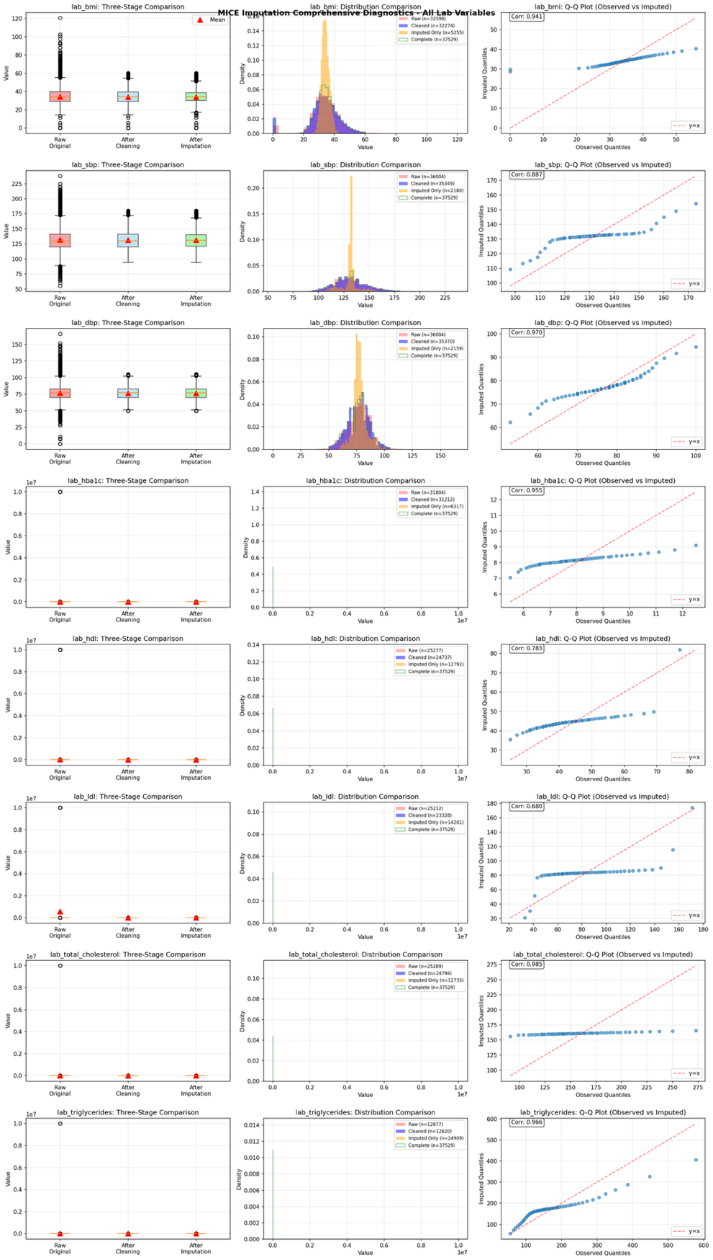

Figure S2-c. MICE imputation diagnostics: three-stage comparison for Mayo Clinic. For each laboratory variable at each site, the left panel shows box plots comparing raw, cleaned (after outlier removal), and imputed distributions, with red triangles indicating means; the middle panel shows overlaid density histograms of raw (red), cleaned (blue), imputed-only (orange), and complete post-imputation (green outline) distributions; and the right panel shows a quantile–quantile plot of observed versus imputed values with the Pearson correlation annotated. The dashed red line denotes the identity line. Stable medians and overlapping densities across stages indicate that imputation preserved the original distributional characteristics of each variable.

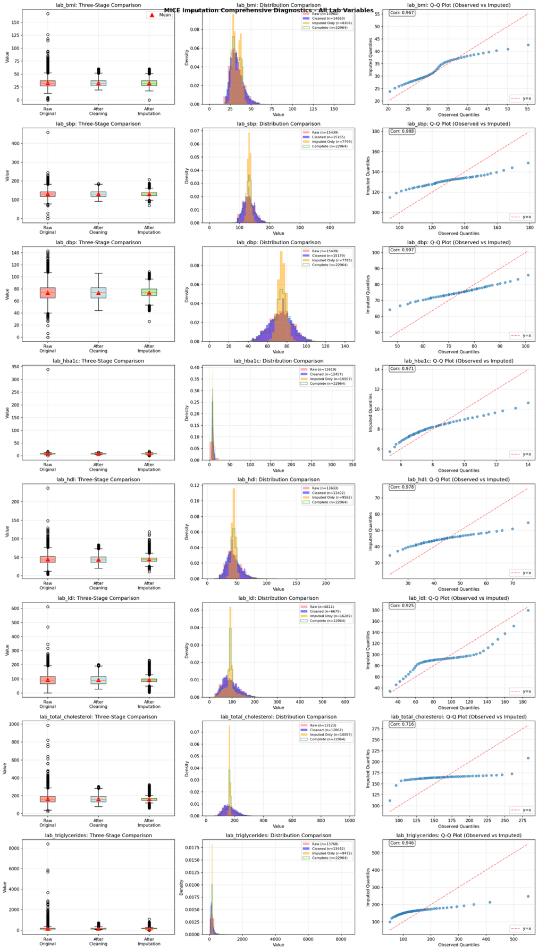

Figure S2-d. MICE imputation diagnostics: three-stage comparison for OneFlorida+ Clinical Research Network. For each laboratory variable at each site, the left panel shows box plots comparing raw, cleaned (after outlier removal), and imputed distributions, with red triangles indicating means; the middle panel shows overlaid density histograms of raw (red), cleaned (blue), imputed-only (orange), and complete post-imputation (green outline) distributions; and the right panel shows a quantile–quantile plot of observed versus imputed values with the Pearson correlation annotated. The dashed red line denotes the identity line. Stable medians and overlapping densities across stages indicate that imputation preserved the original distributional characteristics of each variable.

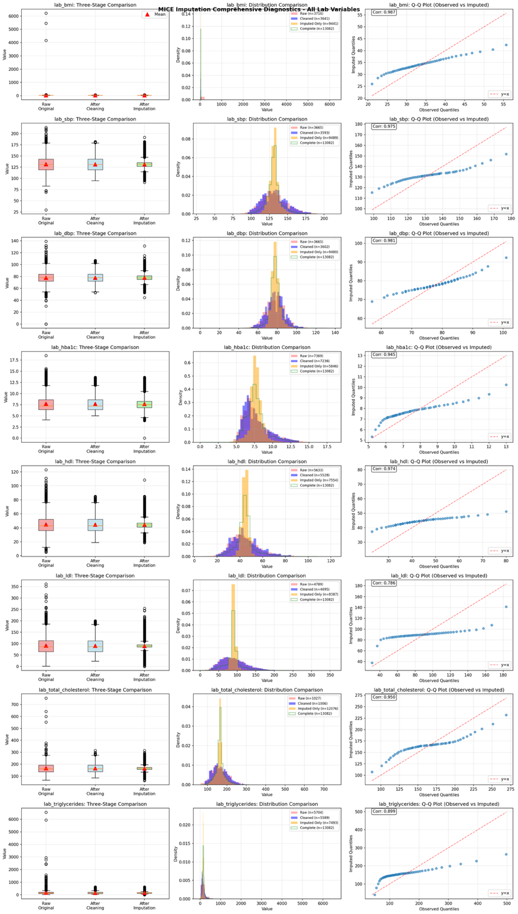

Figure S2-e. MICE imputation diagnostics: three-stage comparison for UT Southwestern Medical Center (UTSW). For each laboratory variable at each site, the left panel shows box plots comparing raw, cleaned (after outlier removal), and imputed distributions, with red triangles indicating means; the middle panel shows overlaid density histograms of raw (red), cleaned (blue), imputed-only (orange), and complete post-imputation (green outline) distributions; and the right panel shows a quantile–quantile plot of observed versus imputed values with the Pearson correlation annotated. The dashed red line denotes the identity line. Stable medians and overlapping densities across stages indicate that imputation preserved the original distributional characteristics of each variable.

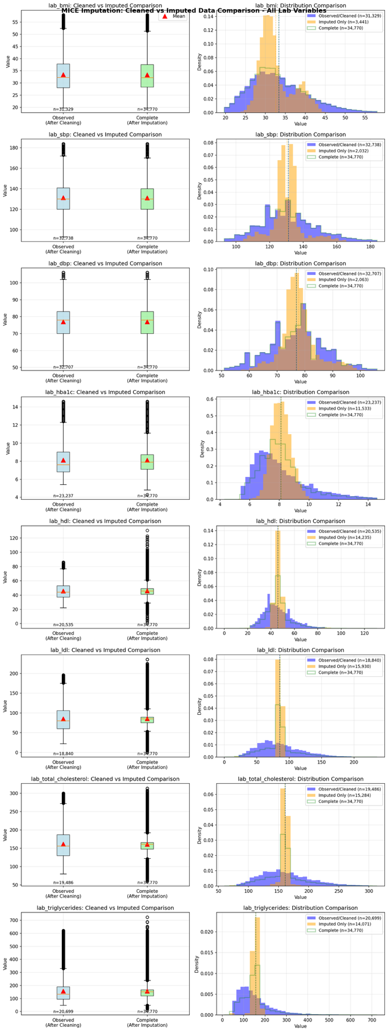
Figure S3-a. MICE imputation diagnostics: observed versus imputed value comparison for University of Pennsylvania Health System (UPHS). For each laboratory variable at each site, the left panel shows side-by-side box plots of observed (pre-imputation) and complete (post-imputation) distributions; the right panel shows overlaid density histograms of observed values (blue), imputed-only values (orange), and the complete post-imputation distribution (green outline), with dashed vertical lines indicating distribution means. Close alignment of the observed and complete densities indicates that the complete dataset faithfully reflects the observed data.

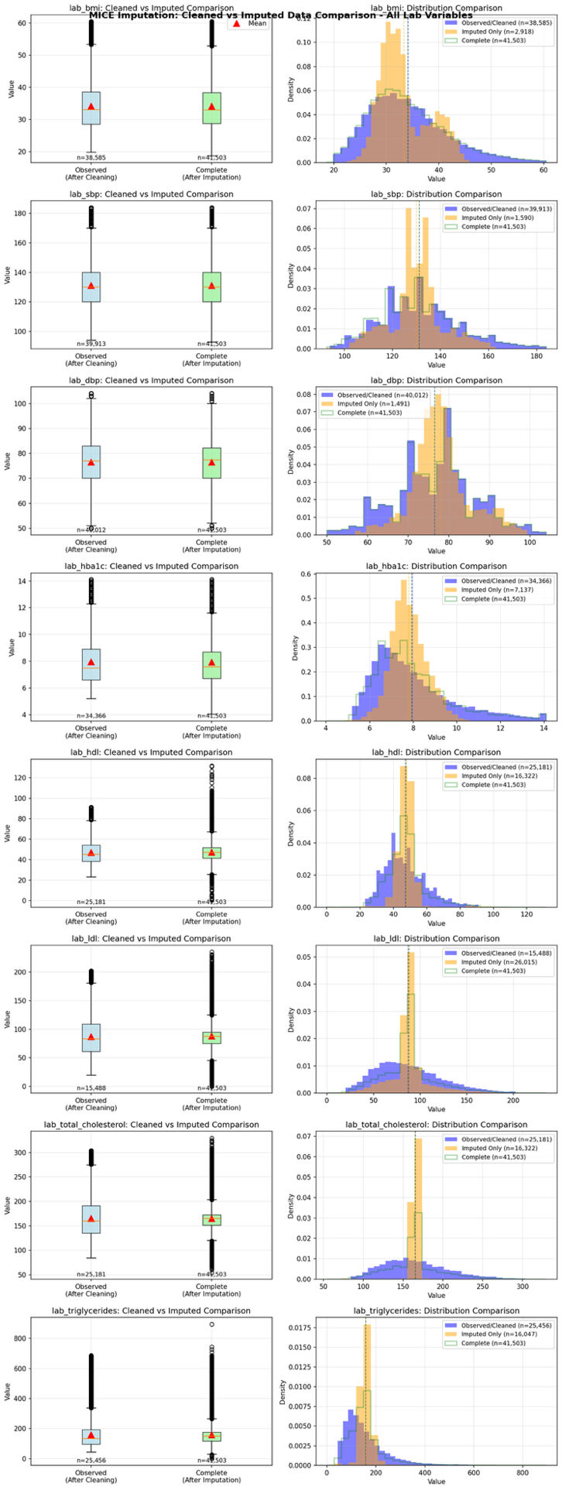
Figure S3-b. MICE imputation diagnostics: observed versus imputed value comparison for Yale New Haven Health System (YNHHS). For each laboratory variable at each site, the left panel shows side-by-side box plots of observed (pre-imputation) and complete (post-imputation) distributions; the right panel shows overlaid density histograms of observed values (blue), imputed-only values (orange), and the complete post-imputation distribution (green outline), with dashed vertical lines indicating distribution means. Close alignment of the observed and complete densities indicates that the complete dataset faithfully reflects the observed data.

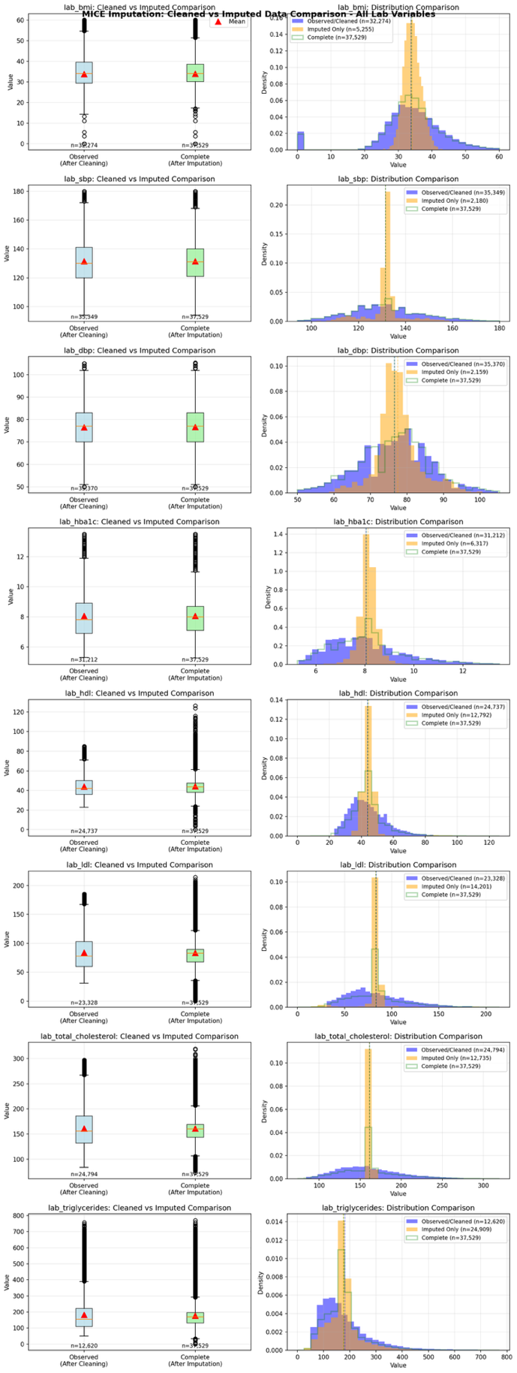

Figure S3-c. MICE imputation diagnostics: observed versus imputed value comparison for Mayo Clinic. For each laboratory variable at each site, the left panel shows side-by-side box plots of observed (pre-imputation) and complete (post-imputation) distributions; the right panel shows overlaid density histograms of observed values (blue), imputed-only values (orange), and the complete post-imputation distribution (green outline), with dashed vertical lines indicating distribution means. Close alignment of the observed and complete densities indicates that the complete dataset faithfully reflects the observed data.
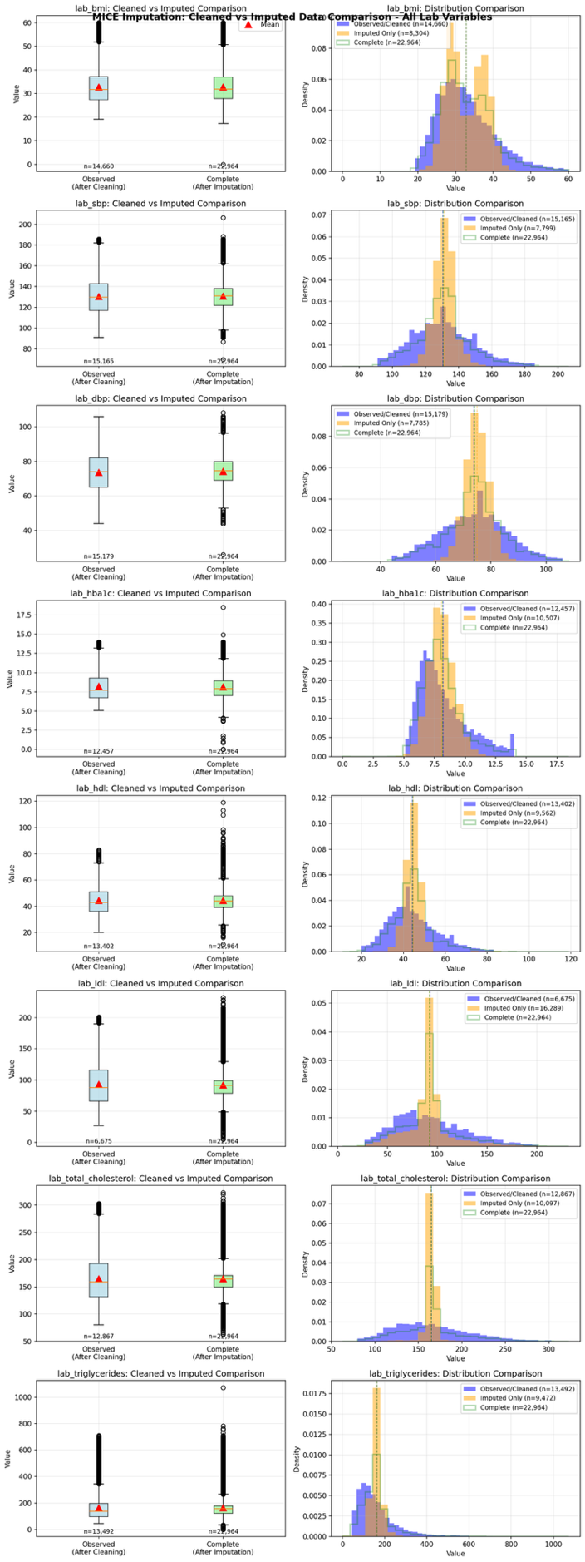

Figure S3-d. MICE imputation diagnostics: observed versus imputed value comparison for OneFlorida+ Clinical Research Network. For each laboratory variable at each site, the left panel shows side-by-side box plots of observed (pre-imputation) and complete (post-imputation) distributions; the right panel shows overlaid density histograms of observed values (blue), imputed-only values (orange), and the complete post-imputation distribution (green outline), with dashed vertical lines indicating distribution means. Close alignment of the observed and complete densities indicates that the complete dataset faithfully reflects the observed data.

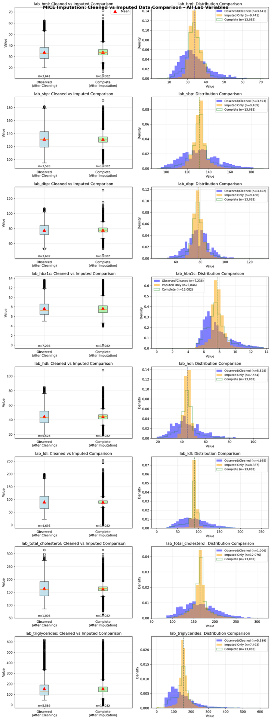

Figure S3-e. MICE imputation diagnostics: observed versus imputed value comparison for UT Southwestern Medical Center (UTSW). For each laboratory variable at each site, the left panel shows side-by-side box plots of observed (pre-imputation) and complete (post-imputation) distributions; the right panel shows overlaid density histograms of observed values (blue), imputed-only values (orange), and the complete post-imputation distribution (green outline), with dashed vertical lines indicating distribution means. Close alignment of the observed and complete densities indicates that the complete dataset faithfully reflects the observed data.

Binary Modifier Variables
We pre-specified 13 baseline variables as candidate effect modifiers to examine HTEs. Table S4 describes how each potential binary modifier variable was defined for our study.

Demographic factors | Element | Details
Age at entry | <65 vs ≥65 years | Derived from age_at_entry. Coded as 1 if age ≥65 years, 0 otherwise.
Gender | Female vs Male | Derived from gender field. Coded as 1 for Male, 0 for Female.
Ethnicity | Hispanic vs Non-Hispanic | Derived from ethnicity field. Coded as 1 for Hispanic or Latino, 0 for Non-Hispanic or Latino.
Baseline comorbidities
Chronic kidney disease (CKD) | Yes/No | Based on diagnosis of chronic kidney disease during the 1-year baseline period, identified from medical condition clusters.
Hypertension | Yes/No | Based on diagnosis of hypertension during the 1-year baseline period, identified from medical condition clusters.
Obesity | Yes/No | Based on diagnosis of obesity during the 1-year baseline period, identified from medical condition clusters.
Sleep disorders | Yes/No | Based on diagnosis of sleep disorders during the 1-year baseline period, identified from outcome/covariate ICD codes (F51, G47).
Baseline medications
opioids | Yes/No | Based on recorded prescription or administration of any opioids during the 1-year baseline period.
Metformin | Yes/No | Based on recorded prescription or administration of metformin during the 1-year baseline period.
Lipid therapy: Lipid-lowering medications | Yes/No | Based on recorded prescription or administration of any lipid-lowering agent (statins, fibrates, PCSK9 inhibitors, ezetimibe, etc.) during the 1-year baseline period.
NSAIDs | Yes/No | Based on recorded prescription or administration of any NSAID during the 1-year baseline period.
Laboratory thresholds
HbA1c | ≥8.5% vs <8.5% | Derived from baseline HbA1c value (LOINC: 4548-4). Coded as 1 if HbA1c ≥8.5%, 0 otherwise.
Body mass index (BMI) | ≥30 vs <30 kg/m² | Derived from baseline BMI value (vital signs). Coded as 1 if BMI ≥30 kg/m², 0 otherwise.
Table S4. Definition of pre-specified potential binary modifier variables. Each of the 13 binary effect modifiers is described by domain (demographic, baseline comorbidity, baseline medication, laboratory threshold), variable name, binary coding scheme, and operational definition based on EHR data. †Abbreviations: CKD, chronic kidney disease; NSAID, nonsteroidal anti-inflammatory drug; HbA1c, hemoglobin A1c; BMI, body mass index.

Section S3 Supplemental Method: POLARIS

More details regarding Grid-Based Function in POLARIS

This section illustrates the technical details of the algorithm POLARIS.

Grid-Based Function Evaluation Approach for approximate Risk Function: The core challenge in federated survival analysis is reconstructing the global likelihood function without accessing patient-level data. Our approach addresses this by having each site evaluate their local risk function $R_{k}(β)$ at predetermined grid points across the parameter space and share the resulting evaluated function values to the coordinating center. Each site only needs to share such data with the coordinating center once. Then, based on the grid points and the respective function values, the coordinating center can recover the local risk functions $R_{k}\left(β\right)$ and the pooled risk function $R(β)$ by fitting a certain model. In particular, as long as the number of grid points is large enough, the reconstructed risk function can be arbitrarily close to the original risk function.
- Standardized Grid Specifications and Parameter Domain: To facilitate information synthesis across sites, all participating sites must use identical Chebyshev node locations spanning the estimated parameter space. In this study, we use Chebyshev nodes as the grid points and recover the local risk functions in the coordinating center using Chebyshev polynomials because it achieves near-optimal approximation error rate among all interpolation approaches.

- Tensor Train Compression for Memory and Communication Efficiency: Although grid-based evaluation preserves the lossless one-shot property, directly transmitting function evaluations at every grid point would impose a considerable communication burden. For instance, using 20 grid points per parameter in a three-parameter setting (such as treatment effect, effect modifier, and their interaction in our framework) requires each site to send a full 20³ = 8,000-point evaluation matrix. Tensor train (TT) decomposition alleviates this issue by replacing the transmission of the full tensor with compact core representations. Instead of sharing all 8,000 entries, TT factorization approximates the original tensor using a low-rank structure that can be encoded as a sequence of lightweight TT cores. Concretely, rather than communicating the entire tensor, each site only needs to transmit three TT cores, each with dimensions $r×20×r$, where $r$ is the rank that can be adjusted to control error. Our numerical experiments indicate that setting $r=5$ already provides a highly accurate approximation. Under this configuration, each site transmits roughly 1,500 values with the coordinating center, leading to a substantial reduction in communication cost.

Section S4 Supplemental Results

Subgroup-specific Treatment Effects (Hazard Ratios and 95% Confidence Intervals)
Subgroup-specific treatment effect estimates for all five gastrointestinal outcomes are provided in Supplementary Data File 1. For each participating site, outcome, and pre-specified effect modifier subgroup, the file reports hazard ratios (HRs) with corresponding 95% confidence intervals (CIs) derived from the weighted Cox proportional hazards models. Results are presented separately for the two active-comparator analyses: (i) GLP-1RA versus SGLT2i and (ii) GLP-1RA versus DPP4i. For each outcome and modifier, the table includes subgroup-specific HR estimates for both levels of the binary modifier, along with interaction terms quantifying heterogeneity of treatment effects where applicable. All estimates are obtained using the POLARIS federated framework, which ensures equivalence to pooled IPW Cox regression while preserving data locality. These results enable detailed assessment of treatment effect heterogeneity across demographic, clinical, medication, and laboratory-defined subgroups, and facilitate comparison of effect magnitude and direction across sites and outcomes.

Site-specific Comparison of (i) GLP-1RA vs SGLT2i; (ii) GLP-1RA vs DPP4i
Site-specific subgroup-specific event counts and event rates for (i) GLP-1RA versus SGLT2i comparison across all 13 effect modifiers and five gastrointestinal outcomes are provided in Supplementary Data File 2. For each participating site, outcome, and effect modifier subgroup, the table reports the number of patients (N) and observed events with event rate [n (%)] separately for the (i) GLP-1RA and SGLT2i cohorts; (ii) GLP-1RA and DPP4i cohorts across all 13 pre-specified binary modifiers and five gastrointestinal outcomes per sheet. These site-level summaries support assessment of subgroup-specific event sparsity and cross-site heterogeneity in baseline event rates.

Covariate Balance
Covariate balance was assessed using standardized mean differences (SMDs) before and after propensity score weighting⁴⁻⁶. Figures S4a-S4e display the top 20 covariates with the largest absolute SMD before weighting for the GLP-1RA versus SGLT2i comparison at each participating site.
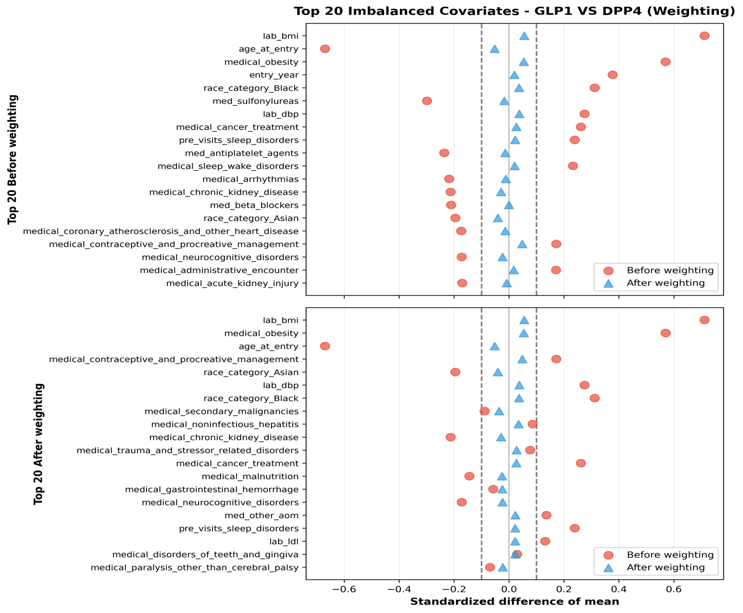
Figure S4-a-1. Covariate balance before and after propensity score weighting for University of Pennsylvania Health System (UPHS). Standardized mean differences (SMDs) for the 20 covariates with the largest absolute imbalance before propensity score weighting for the GLP-1RA versus DPP4i comparison. Open symbols show pre-weighting SMDs; filled symbols show post-weighting SMDs. The vertical dashed lines at SMD = ±0.1 indicate the threshold for acceptable balance.

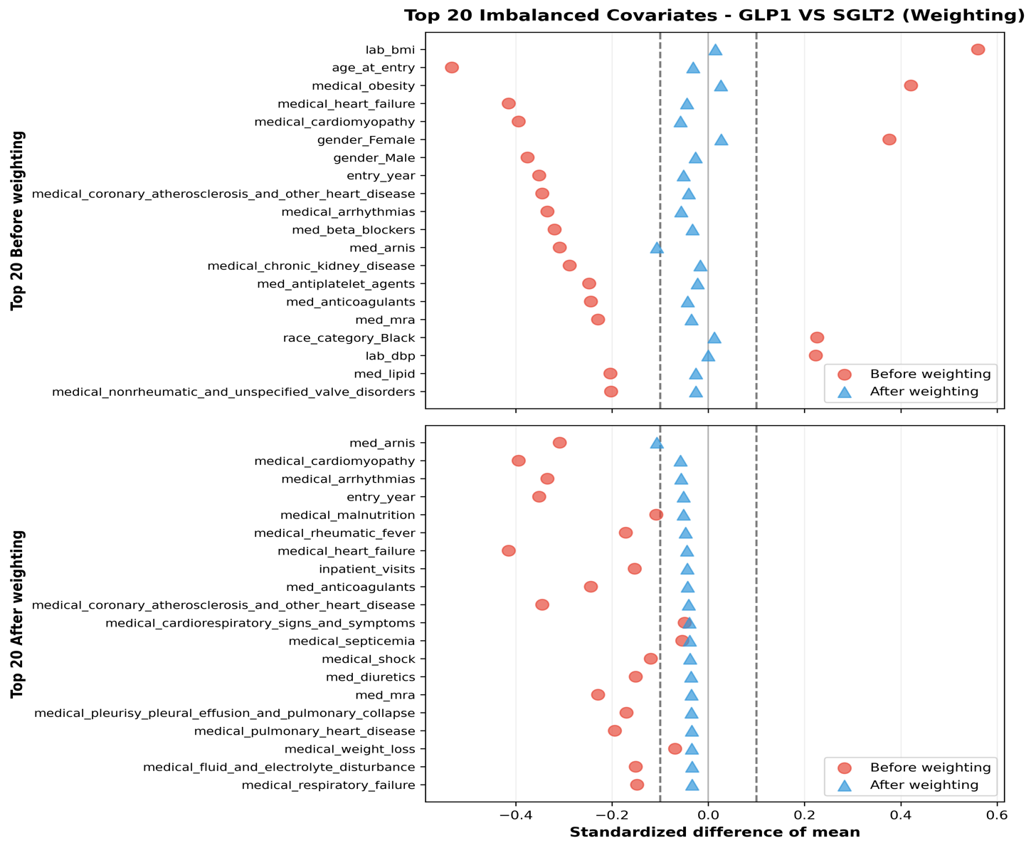

Figure S4-a-2. Covariate balance before and after propensity score weighting for University of Pennsylvania Health System (UPHS). Standardized mean differences (SMDs) for the 20 covariates with the largest absolute imbalance before propensity score weighting for the GLP-1RA versus SGLT2i comparison. Open symbols show pre-weighting SMDs; filled symbols show post-weighting SMDs. The vertical dashed lines at SMD = ±0.1 indicate the threshold for acceptable balance.

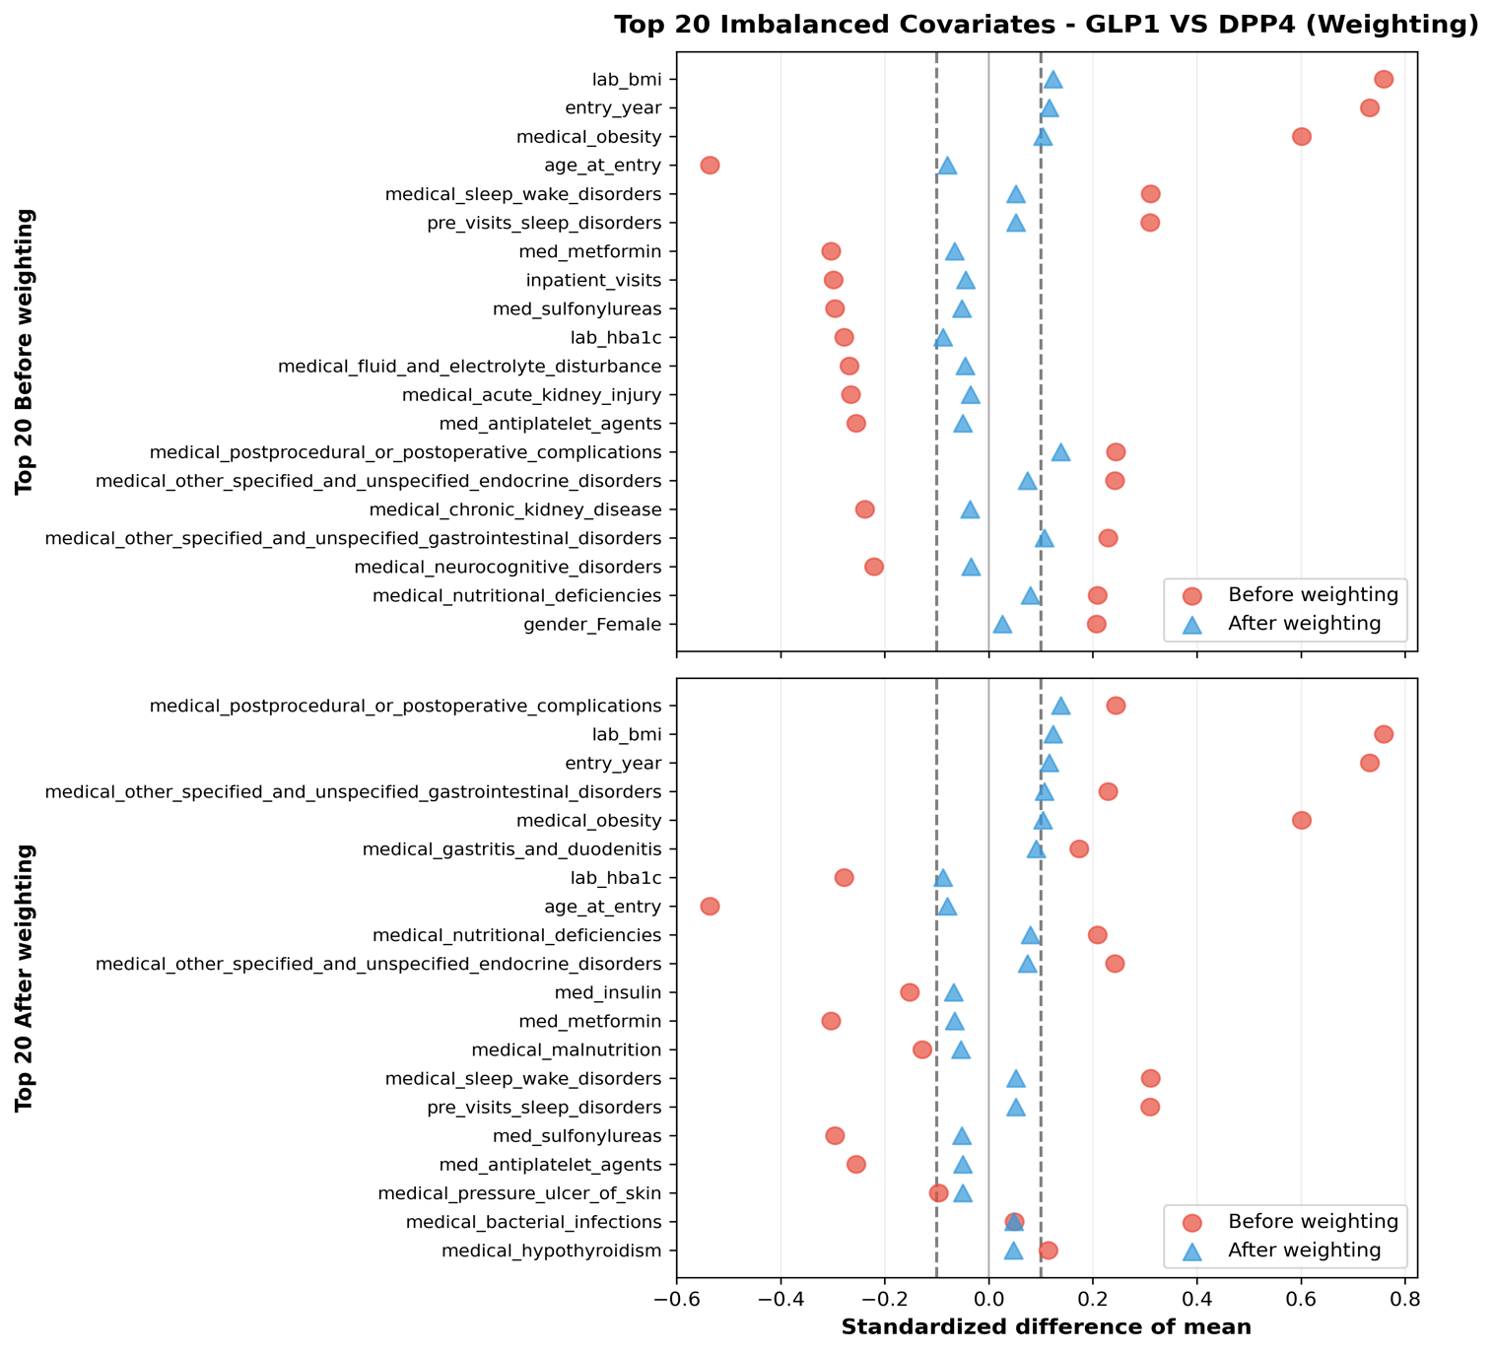
Figure S4-b-1. Covariate balance before and after propensity score weighting for Yale New Haven Health System (YNHHS). Standardized mean differences (SMDs) for the 20 covariates with the largest absolute imbalance before propensity score weighting for the GLP-1RA versus DPP4i comparison. Open symbols show pre-weighting SMDs; filled symbols show post-weighting SMDs. The vertical dashed lines at SMD = ±0.1 indicate the threshold for acceptable balance.

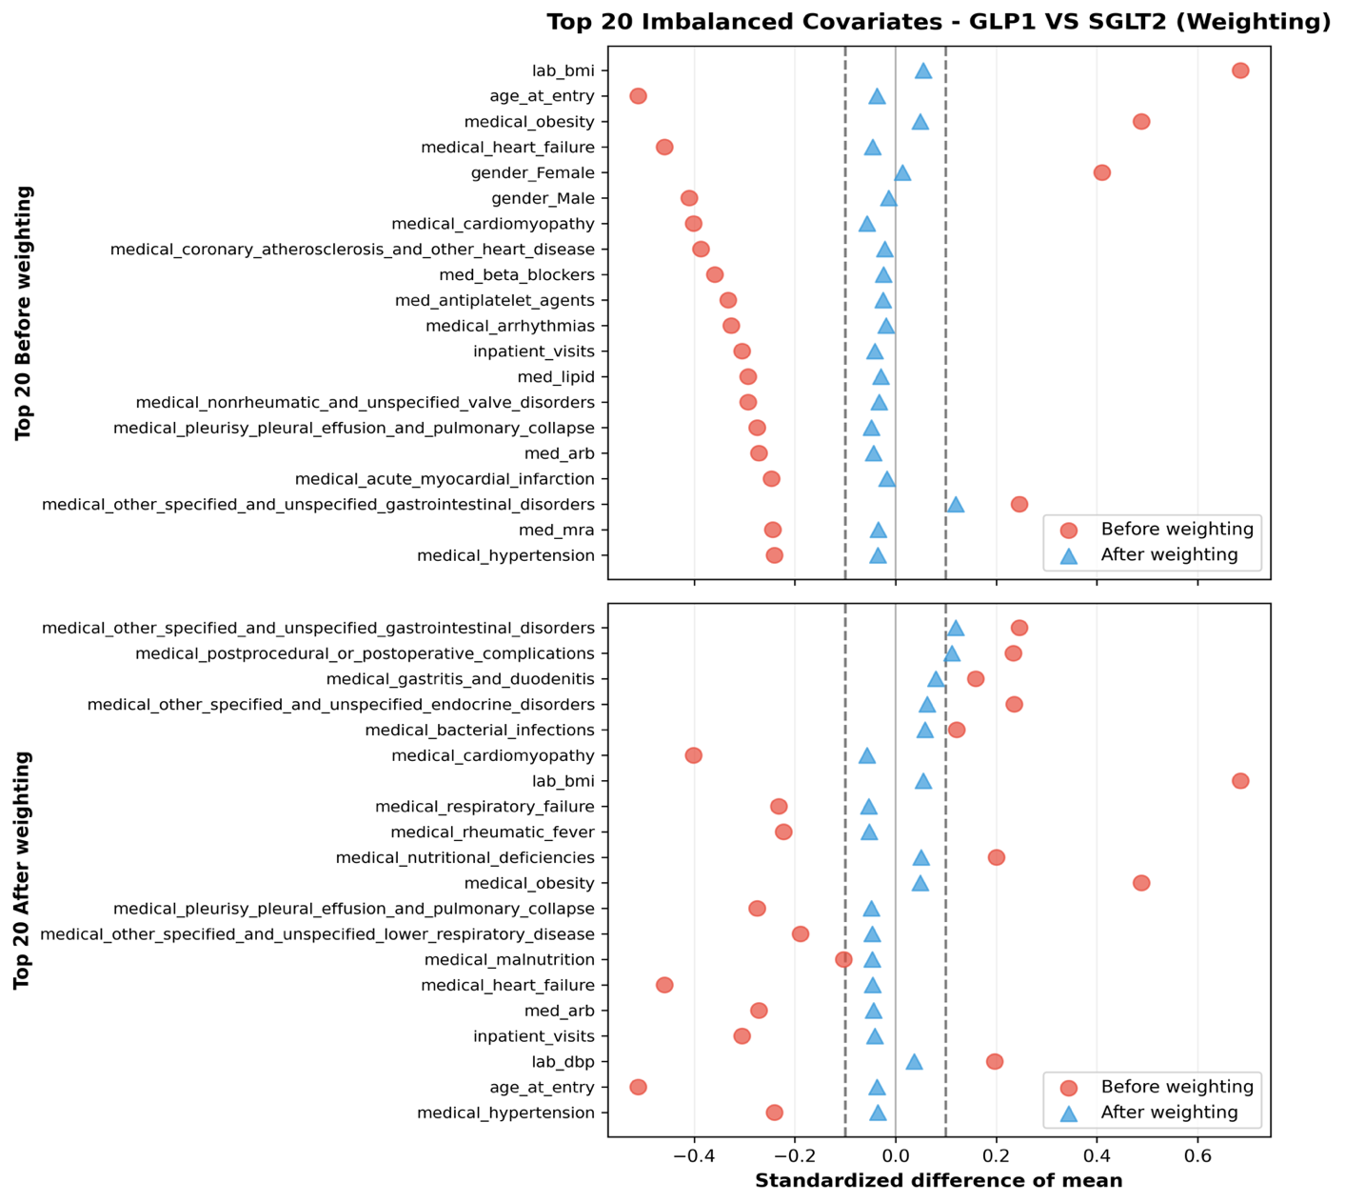
Figure S4-b-2. Covariate balance before and after propensity score weighting for Yale New Haven Health System (YNHHS). Standardized mean differences (SMDs) for the 20 covariates with the largest absolute imbalance before propensity score weighting for the GLP-1RA versus SGLT2i comparison. Open symbols show pre-weighting SMDs; filled symbols show post-weighting SMDs. The vertical dashed lines at SMD = ±0.1 indicate the threshold for acceptable balance.

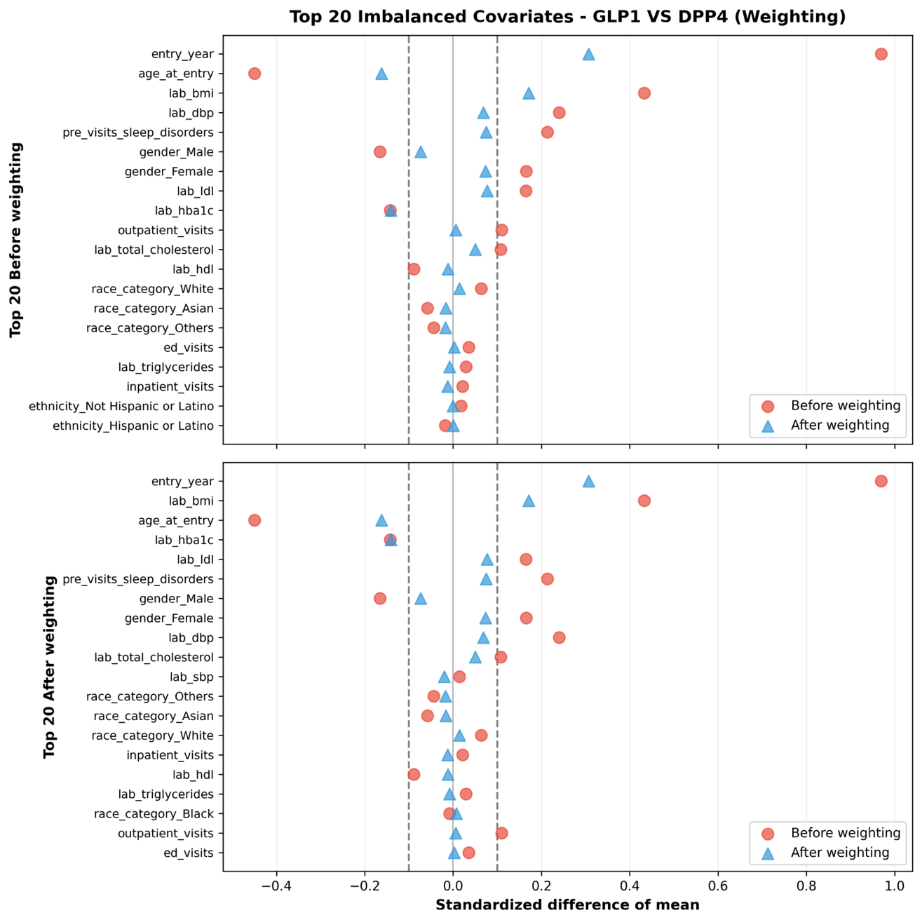
Figure S4c-1. Covariate balance before and after propensity score weighting for Mayo Clinic. Standardized mean differences (SMDs) for the 20 covariates with the largest absolute imbalance before propensity score weighting for the GLP-1RA versus DPP4i comparison. Open symbols show pre-weighting SMDs; filled symbols show post-weighting SMDs. The vertical dashed lines at SMD = ±0.1 indicate the threshold for acceptable balance.

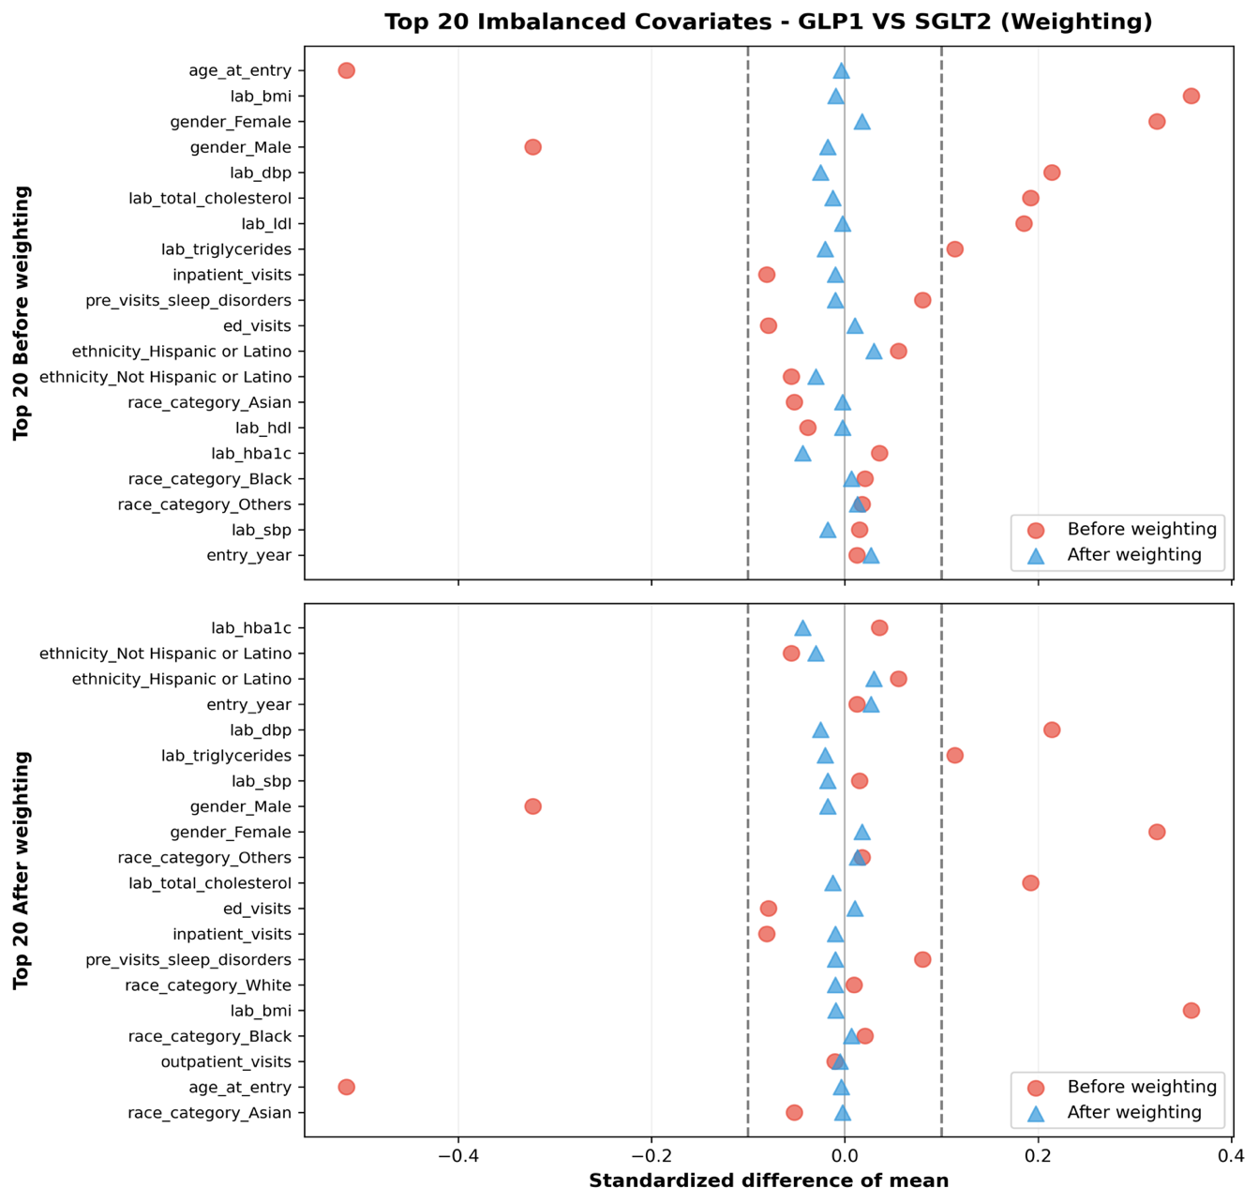
Figure S4-c-2. Covariate balance before and after propensity score weighting for Mayo Clinic. Standardized mean differences (SMDs) for the 20 covariates with the largest absolute imbalance before propensity score weighting for the GLP-1RA versus SGLT2i comparison. Open symbols show pre-weighting SMDs; filled symbols show post-weighting SMDs. The vertical dashed lines at SMD = ±0.1 indicate the threshold for acceptable balance.

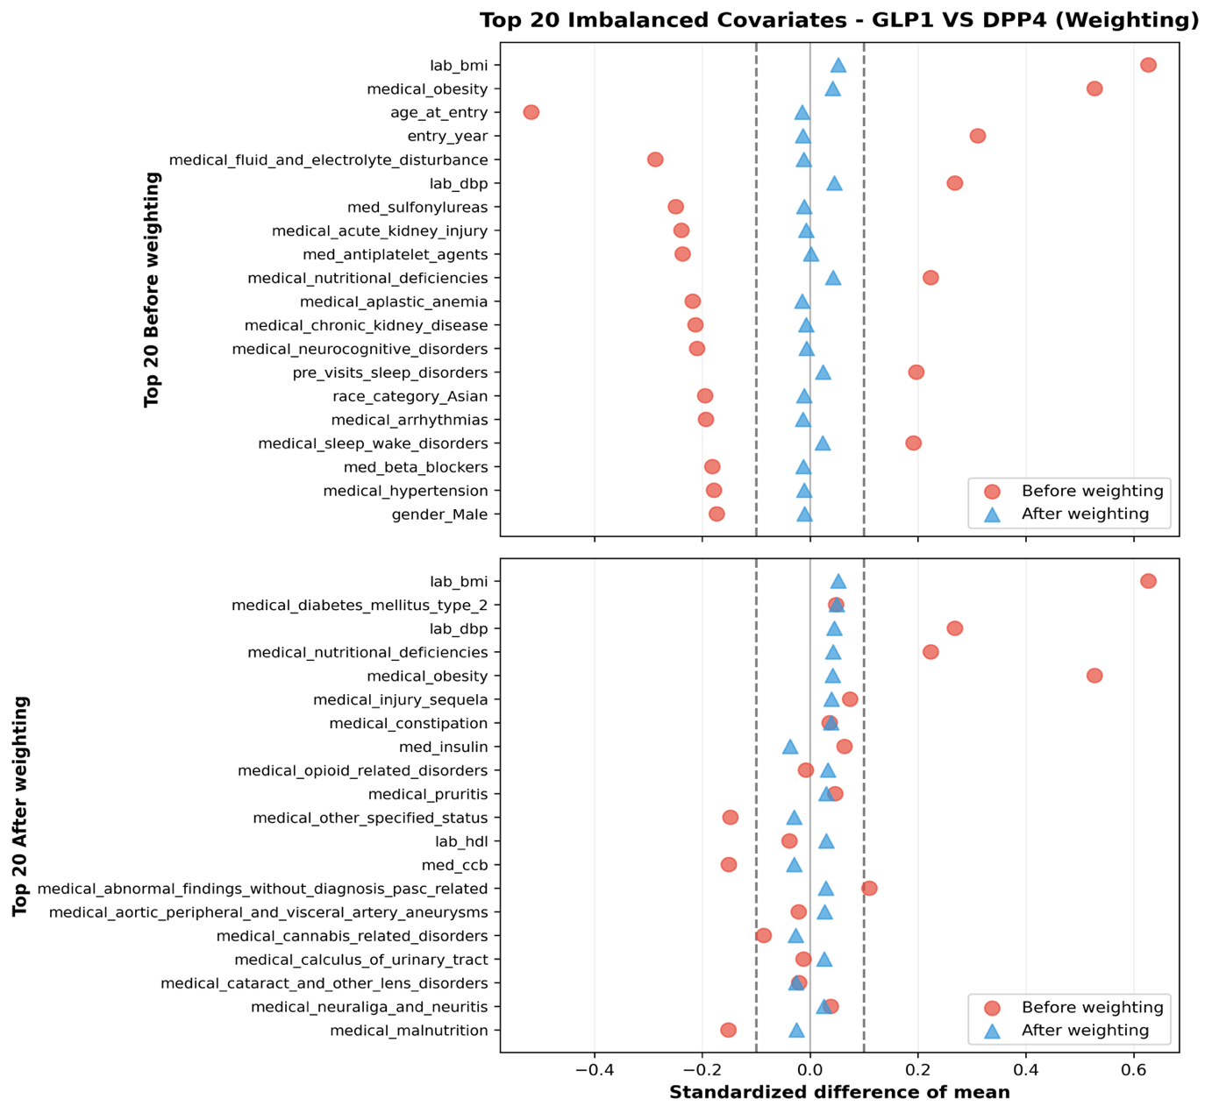

Figure S4-d-1. Covariate balance before and after propensity score weighting for OneFlorida+ Clinical Research Network (OneFlorida+). Standardized mean differences (SMDs) for the 20 covariates with the largest absolute imbalance before propensity score weighting for the GLP-1RA versus DPP4i comparison. Open symbols show pre-weighting SMDs; filled symbols show post-weighting SMDs. The vertical dashed lines at SMD = ±0.1 indicate the threshold for acceptable balance.

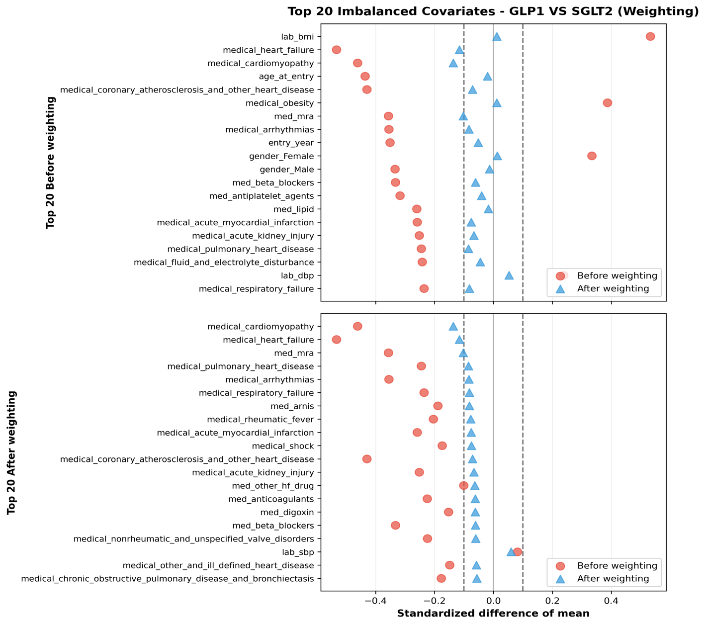
Figure S4-d-2. Covariate balance before and after propensity score weighting for OneFlorida+ Clinical Research Network (OneFlorida+). Standardized mean differences (SMDs) for the 20 covariates with the largest absolute imbalance before propensity score weighting for the GLP-1RA versus SGLT2i comparison. Open symbols show pre-weighting SMDs; filled symbols show post-weighting SMDs. The vertical dashed lines at SMD = ±0.1 indicate the threshold for acceptable balance.

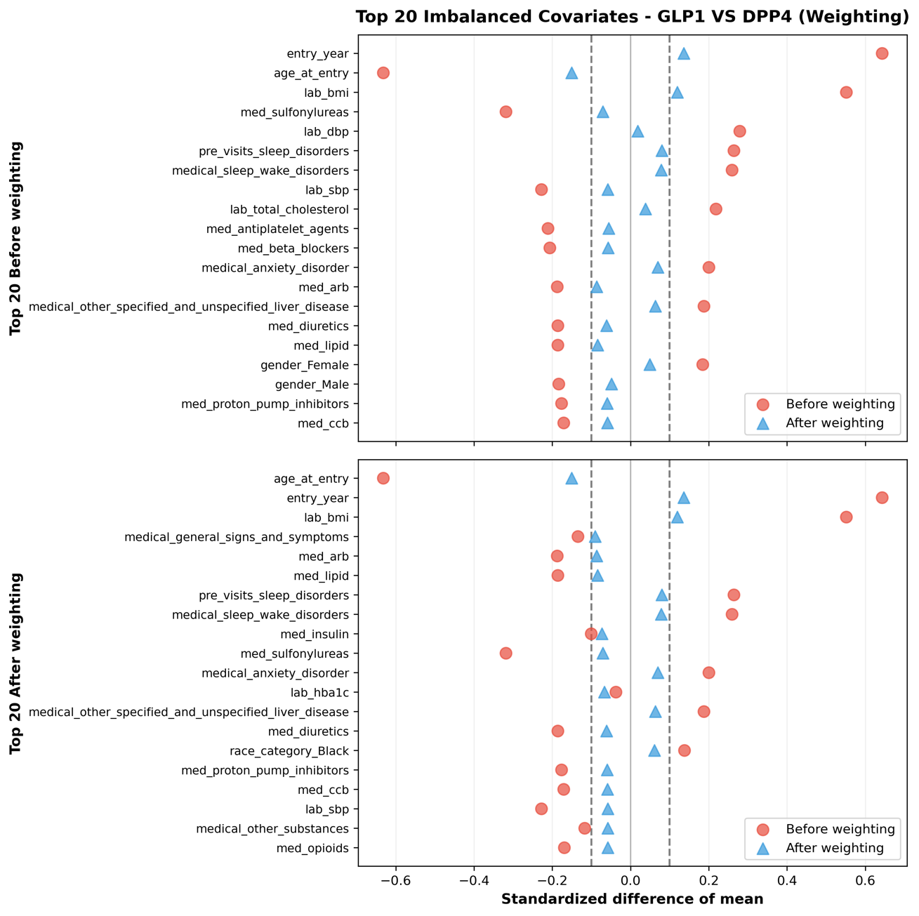
Figure S4-e-1. Covariate balance before and after propensity score weighting for UT Southwestern Medical Center (UTSW). Standardized mean differences (SMDs) for the 20 covariates with the largest absolute imbalance before propensity score weighting for the GLP-1RA versus DPP4i comparison. Open symbols show pre-weighting SMDs; filled symbols show post-weighting SMDs. The vertical dashed lines at SMD = ±0.1 indicate the threshold for acceptable balance.

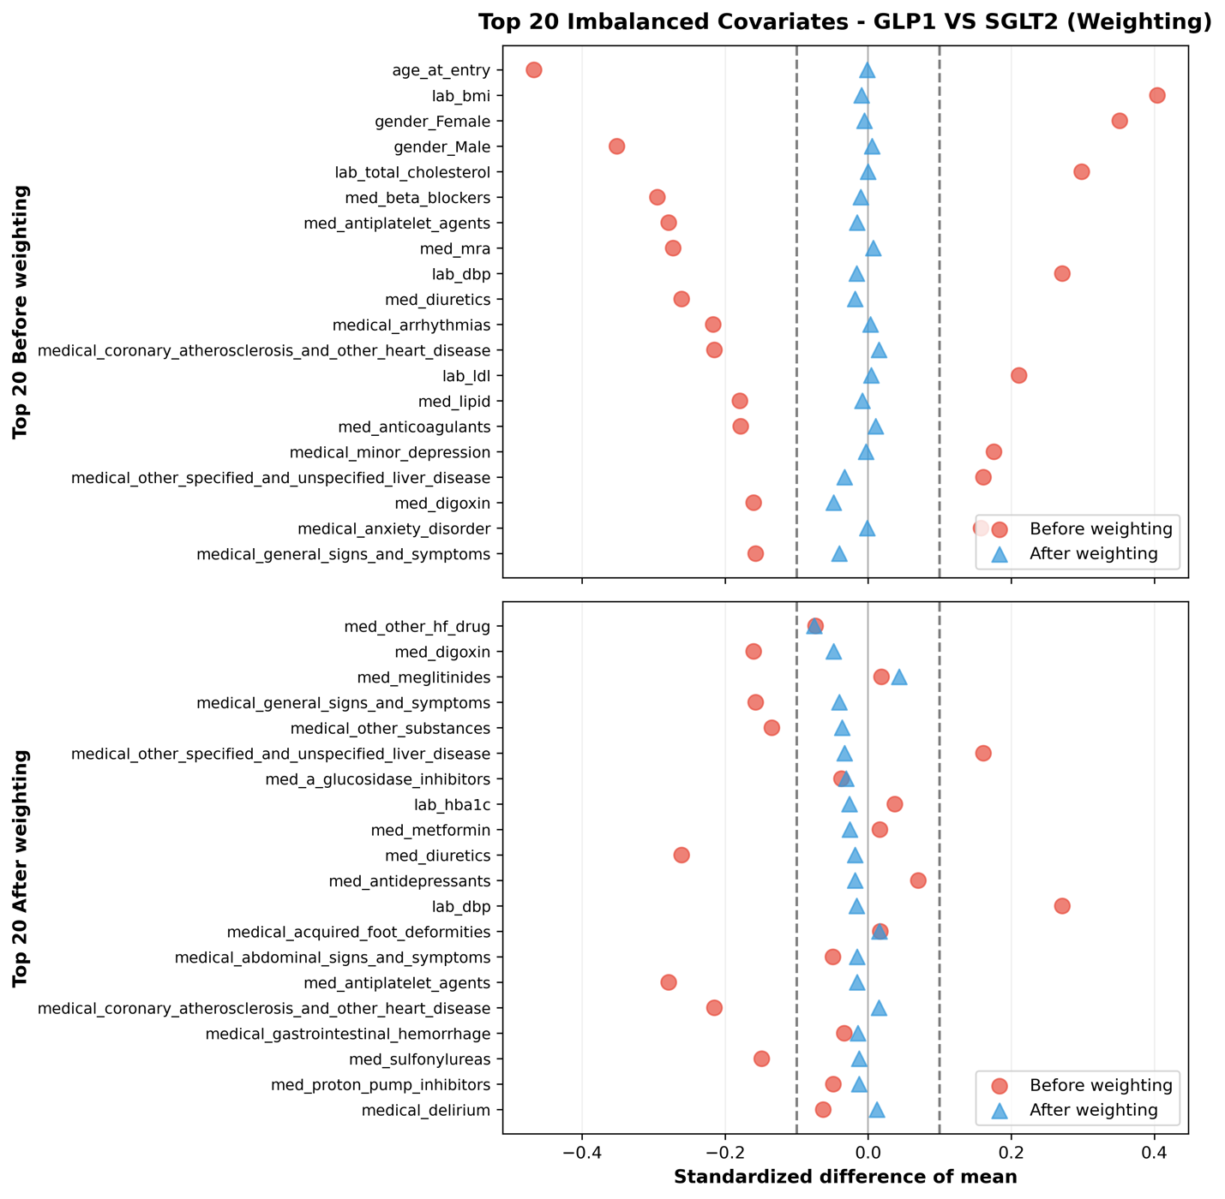
Figure S4-e-2. Covariate balance before and after propensity score weighting for UT Southwestern Medical Center (UTSW). Standardized mean differences (SMDs) for the 20 covariates with the largest absolute imbalance before propensity score weighting for the GLP-1RA versus SGLT2i comparison. Open symbols show pre-weighting SMDs; filled symbols show post-weighting SMDs. The vertical dashed lines at SMD = ±0.1 indicate the threshold for acceptable balance.

