Supplementary Information for

THz frequency combs from interfacial spatiotemporal overlap in spintronic multilayers

Je-Ho Shim^{1,2*}, Yunxiu Zhao^{3,4*}, Qoimatul Mustaghfiroh³, Megha Jain³, Jihyeon Hwang³, Palwinder Singh³, Das Priyanka³, Kyungwan Kim^{3†}, Hee Jun Shin⁵, Jaehun Park⁵, Xiao You⁴, Shilong Xiong⁶, Caihua Wan^{6†}, Hong-Guang Piao^{1,2†}, Xiufeng Han⁶, and Dong-Hyun Kim^{2,3†}

¹Department of Physics, College of Science, Yanbian University, Yanji 133002, China
²Institute of Quantum Science and Technology, Yanbian University, Yanji 133002, China
³Department of Physics, Chungbuk National University, Cheongju 28644, South Korea
⁴School of Engineering, Westlake University, Hangzhou 310024, China
⁵Pohang Accelerator Laboratory, POSTECH, Pohang 37673, South Korea
⁶Beijing National Laboratory for Condensed Matter Physics, Institute of Physics, University of Chinese Academy of Sciences, Chinese Academy of Sciences, Beijing 100190, China

* Je-Ho Shim and Yunxiu Zhao contributed equally to this work.

† Corresponding author Emails:
hgpiao@ybu.edu.cn (Hong-Guang Piao),
donghyun@cbnu.ac.kr (Dong-Hyun Kim),
wancaihua@iphy.ac.cn (Caihua Wan),
kyungwan@chungbuk.ac.kr (Kyungwan Kim),
Section 1. MOKE hysteresis loops of the [Pt/Co/MgO]_{n} and [Pt/Co/W/MgO]_{n} multilayers
To verify the magnetic properties of the multilayer samples used in this study, longitudinal MOKE hysteresis loops were measured for both [Pt/Co/MgO]_{n} and [Pt/Co/W/MgO]_{n} series.

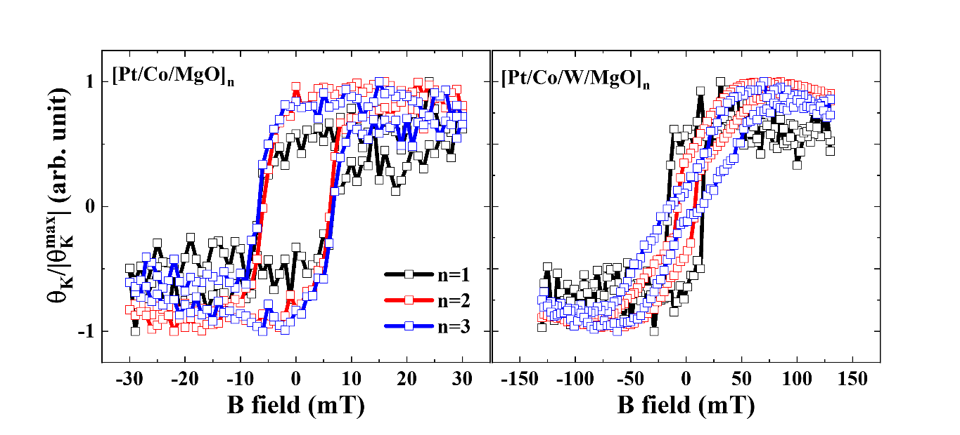
Fig. S1 | MOKE hysteresis loops of the multilayer samples. Longitudinal MOKE hysteresis loops measured for the [Pt/Co/MgO]ₙ (red) and [Pt/Co/W/MgO]ₙ (blue) multilayers.

Section 2. Fitting parameters of the three-mode decomposition at F_{P} = 1.6 mJ cm⁻²
To quantify the mode decomposition used in the main text, the THz emission waveforms measured at F_{P} = 1.6 mJ cm⁻² were fitted using a Gaussian-modulated cosine function:
$$E_{y}^{\text{mode}}\left[t\right]=A Exp\left[{-4ln2 \left(\frac{t-t_{0}}{T}\right)}^{2}\right] \cos\left[2πf_{\text{mode}}t-φ\right],$$
where $A$ is the mode amplitude, $f_{mode}$ is the center frequency, $T$ is the full width at half maximum of the Gaussian envelope, $t_{0}$ is the temporal center of the wave packet, and $φ$ is the phase. The extracted fitting parameters and their standard errors are summarized in Supplementary Table S1. The amplitude $A$ is reported as a positive magnitude; when a negative fitted amplitude was obtained, the phase was shifted by $π$. All phases are reported within the range $0≤φ<2π$.

Sample | Mode  (THz) | $$f_{\text{mode}}$$  (THz) | $$A$$  - u.) | $$T$$  (ps) | $$t_{\text{0}}$$  (ps) | $$φ$$(rad)
[Pt/Co/MgO]₃ | ~0.4 | $0.349±$0.013 | $0.244±$0.024 | $1.702±$0.077 | $2.448±$0.032 | $1.378±$0.134
[Pt/Co/MgO]₃ | ~0.8 | $0.765±$0.040 | $0.988±$0.072 | $0.684±$0.038 | $2.776±$0.011 | $6.128±$0.718
[Pt/Co/MgO]₃ | ~2.0 | $1.946±$0.022 | $0.071±$0.007 | $1.637±$0.144 | $3.350±$0.086 | $1.865±$0.477
[Pt/Co/W/MgO]₁ | ~0.4 | $0.378±$0.011 | $0.366±$0.034 | $1.658±$0.071 | $2.463±$0.034 | $1.542±$0.120
[Pt/Co/W/MgO]₁ | ~0.8 | $0.822±$0.025 | $1.413±$0.072 | $0.754±$0.033 | $2.795±$0.011 | $0.862±$0.444
[Pt/Co/W/MgO]₁ | ~2.0 | $1.911±$0.017 | $0.127±$0.011 | $1.632±$0.114 | $3.255±$0.064 | $1.135±$0.369
[Pt/Co/W/MgO]₂ | ~0.4 | $0.414±$0.007 | $0.107±$0.011 | $1.885±$0.092 | $2.584±$0.039 | $1.803±$0.103
[Pt/Co/W/MgO]₂ | ~0.8 | $0.863±$0.017 | $0.447±$0.019 | $0.840±$0.034 | $2.833±$0.013 | $1.566±$0.316
[Pt/Co/W/MgO]₂ | ~2.0 | $1.903±$0.022 | $0.063±$0.005 | $1.322±$0.091 | $3.128±$0.043 | $1.120±$0.443
[Pt/Co/W/MgO]₃ | ~0.4 | $0.418±$0.008 | $0.181±$0.019 | $1.840±$0.088 | $2.574±$0.040 | $1.893±$0.101
[Pt/Co/W/MgO]₃ | ~0.8 | $0.860±$0.018 | $0.747±$0.032 | $0.839±$0.033 | $2.845±$0.011 | $1.603±$0.321
[Pt/Co/W/MgO]₃ | ~2.0 | $1.906±$0.022 | $0.104±$0.008 | $1.302±$0.088 | $3.152±$0.043 | $1.274±$0.436
Table S1 | Fitting parameters for the three-mode decomposition at high fluence. The THz emission waveforms measured at F_{P} = 1.6 mJ cm⁻² were fitted using a Gaussian-modulated cosine function. The table summarizes the extracted center frequency $f_{mode}$, amplitude $A$, temporal width $T$, temporal center $t_{0}$, and phase $φ$ for the ~0.4, ~0.8, and ~2.0 THz modes in the four samples exhibiting frequency-comb formation. Values are given as estimate ± standard error obtained from the nonlinear least-squares fit. The uncertainties represent fitting-derived standard errors for the averaged waveforms and do not correspond to statistical variations over repeated measurements. $T$ is reported as an absolute value, $A$ as a positive magnitude, and $φ$ within the range $0≤φ<2π$.
Section 3. Mode separation of THz emission signal at F_{P} = 0.8 mJ cm⁻²
To examine the low-fluence regime in which no pronounced THz frequency-comb structure is observed, the measured THz waveforms at F_{P} = 0.8 mJ cm⁻² were decomposed into the three principal low-frequency modes.

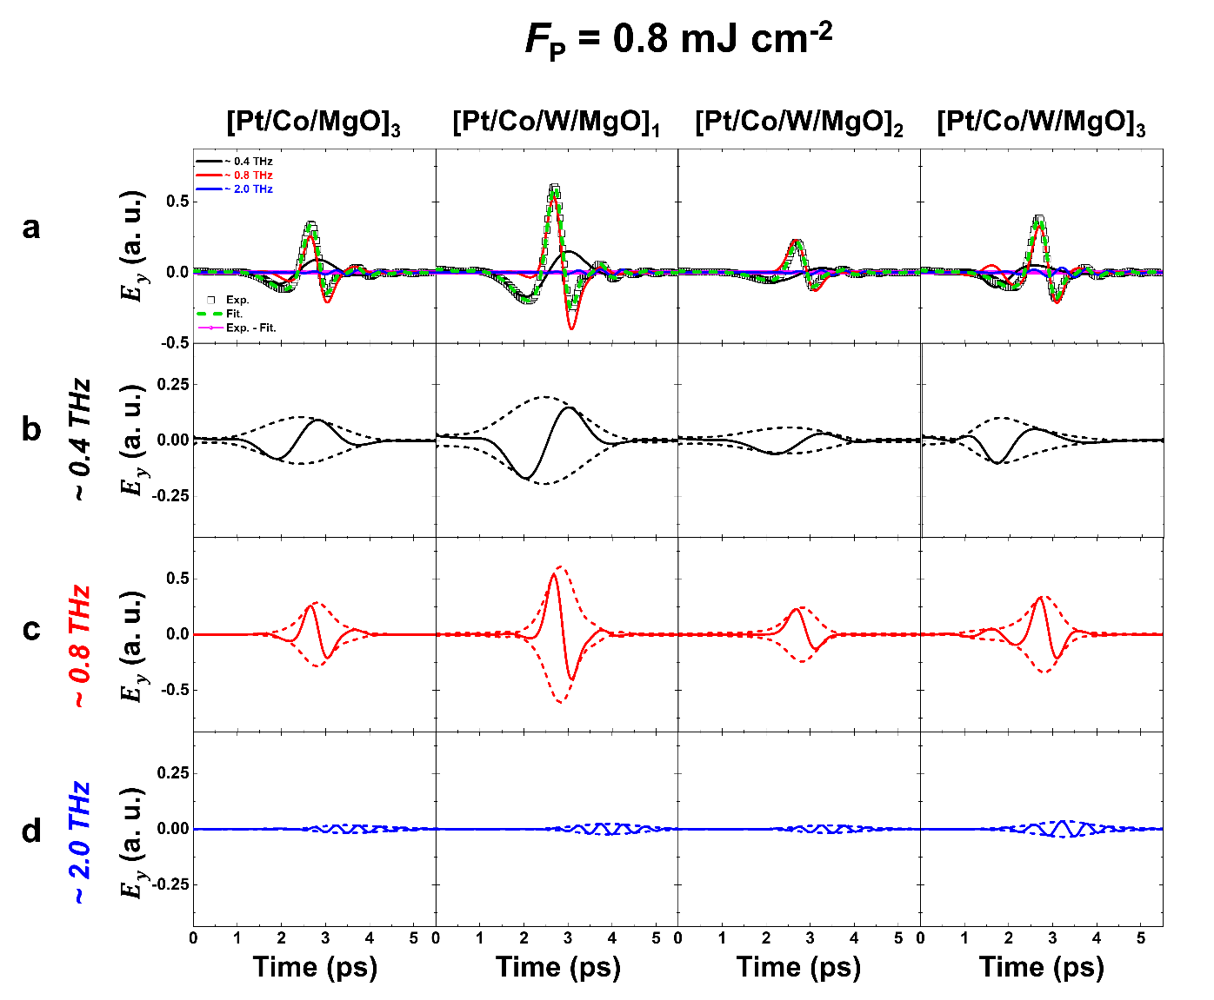
Fig. S2 | Mode decomposition and overlap analysis at low fluence (0.8 mJ cm⁻²). a, Measured THz waveforms (open dots) for [Pt/Co/MgO]₃, and [Pt/Co/W/MgO]_{n}, together with fitted components below 3 THz (black ~ 0.4 THz; red ~ 0.8 THz; blue ~ 2 THz). The green curve shows the summed envelope of all fitted modes below 3 THz, while the magenta curve indicates the residual part (Exp – Fit.). b–d, The three separated components and their envelopes obtained from Gaussian-modulated cosine fitting. Band-pass filtering of the residual signal around 0.4, 0.8, and 2.0 THz confirms that the remaining oscillations are near the noise level, demonstrating that the coherent response is fully captured by the three principal modes. The weak residual oscillations indicate that higher-order nonlinear mixing is strongly suppressed at low fluence.

Section 4. FFT validation of mode decomposition
To verify the accuracy of the time-domain decomposition described in Fig. 5 of the main text and Section 2, we performed a frequency-domain comparison between the measured data and the fitted results. Figure S3 shows the Fourier spectra of the experimental waveforms and their fitted components for both low (0.8 mJ cm⁻²) and high (1.6 mJ cm⁻²) pump fluences in [Pt/Co/MgO]₃ and [Pt/Co/W/MgO]_{n} multilayers. The spectra below 3 THz are well reproduced by the sum of the three characteristic modes: ~ 0.4 THz (black), ~ 0.8 THz (red), and ~ 2 THz (blue). This agreement confirms that these components account for the dominant coherent response of the emission.
Figure S4 provides a more detailed comparison of the FFT spectra on both linear and log scales. The fitted curves reproduce the experimental amplitudes and spectral shapes with high fidelity, and the residual traces reveal weak periodic modulation that matches the comb contribution. These results confirm that the fitting model successfully isolates the three coherent spin-dynamic modes and that the remaining spectral features arise from higher-order nonlinear mixing, which is responsible for comb generation.

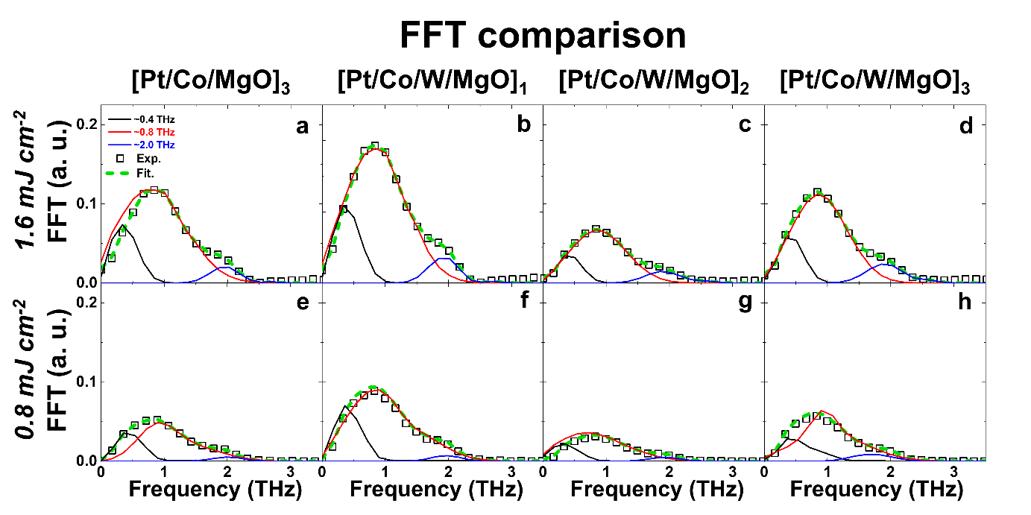
Fig. S3 | Fourier spectra of experimental and fitted components below 3 THz. Fourier-transformed spectra of [Pt/Co/MgO]₃ and [Pt/Co/W/MgO]ₙ multilayers measured at pump fluences of 1.6 mJ cm⁻² (upper row) and 0.8 mJ cm⁻² (lower row). Open squares represent the experimental data, while colored curves denote the fitted components corresponding to ultrafast demagnetization (UDM, black dashed ≈ 0.4 THz), spin–charge conversion (SCC, red ≈ 0.8 THz), and exchange recovery (Exch, blue ≈ 2 THz). The summed fit (green lines) accurately reproduces the measured spectra below 3 THz, confirming that these three modes account for the dominant coherent emission.

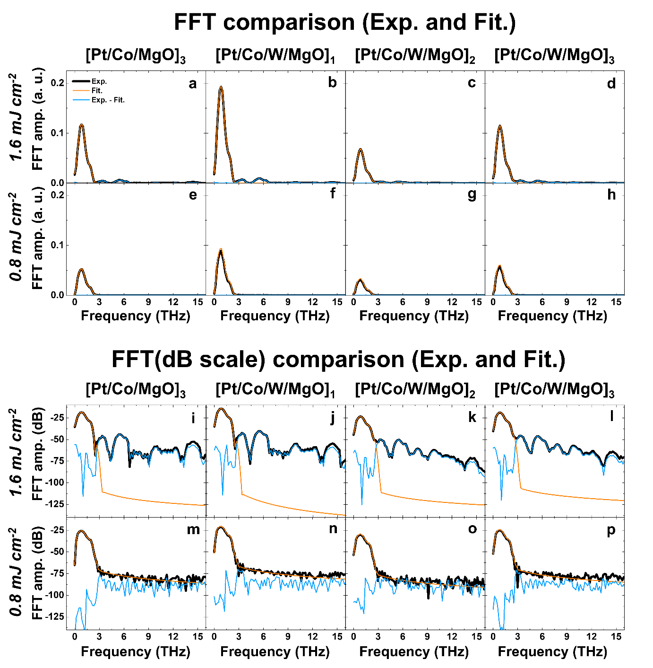
Fig. S4 | Frequency-domain comparison between experimental, fitted, and comb components. Fourier-transformed spectra of [Pt/Co/MgO]₃ and [Pt/Co/W/MgO]_{n} multilayers measured at pump fluences of 1.6 mJ cm⁻² (upper rows) and 0.8 mJ cm⁻² (lower rows). Black curves represent the experimental data, orange curves show the fitted spectra obtained from the time-domain decomposition, and sky-blue curves correspond to the residual (Exp – Fit) that defines the comb component. Panels (a-h) display the spectra on a linear amplitude scale, while (i-p) present them on a logarithmic (dB) scale.

Section 5. Reconstruction of low-fluence comb-order components at F_{P} = 0.8 mJ cm⁻²
To compare with the high-fluence comb analysis presented in the main text, the low-fluence THz signal at F_{P} = 0.8 mJ cm⁻² was also decomposed into individual comb-order components. Although comb orders up to $m=6$ are displayed for consistency, only the first-order component remains clearly discernible at low fluence, whereas higher-order contributions are strongly suppressed. This behavior contrasts with the high-fluence case in the main text, where the first- and second-order components are both significantly enhanced, and supports the view that pronounced comb formation requires stronger nonlinear activation under higher excitation.

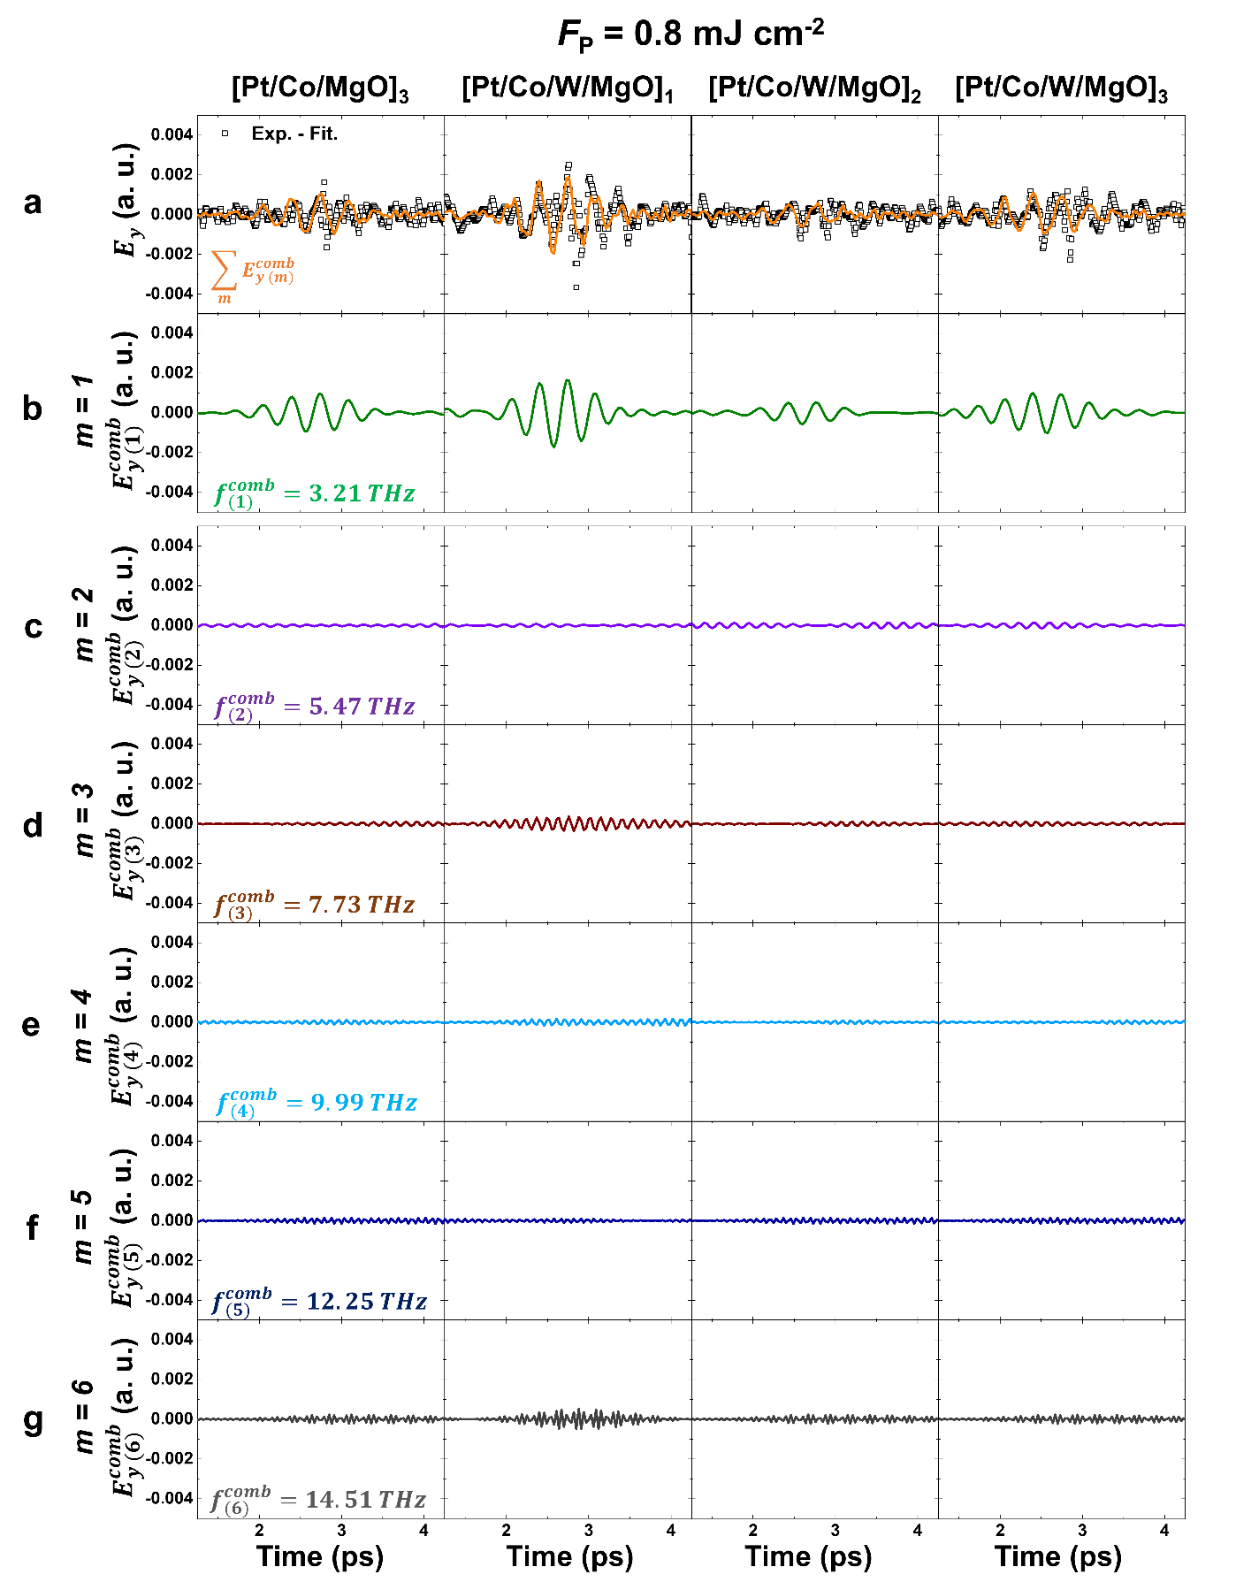
Fig. S5 | Decomposition of the THz frequency comb at a pump fluence of 0.8 mJ cm⁻². a, Measured THz emission signal (white dots) and reconstructed signal obtained from the sum of extracted comb components (orange line). b–g, Band-pass-filtered time-domain signals corresponding to individual comb orders $m$ = 1–6, with center frequencies of 3.21, 5.47, 7.73, 9.99, 12.25, and 14.51 THz, respectively.

