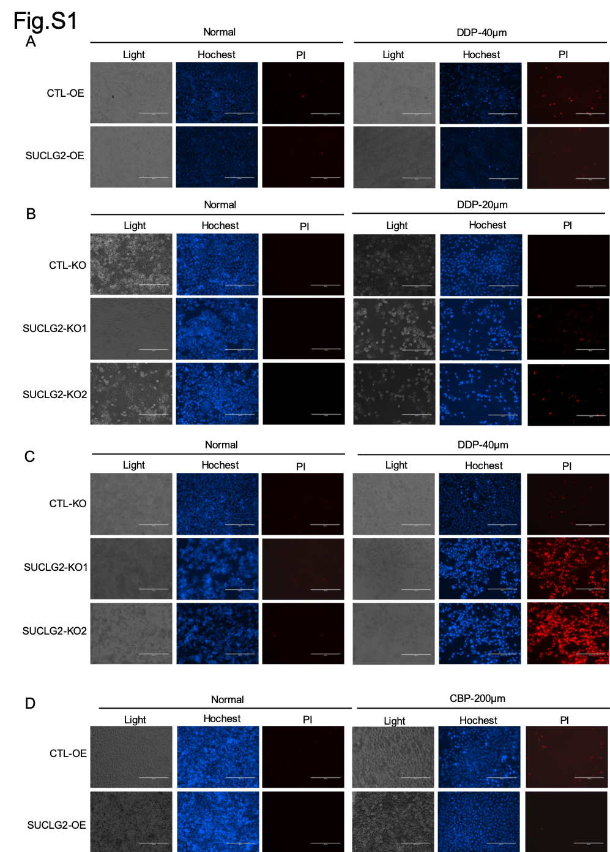

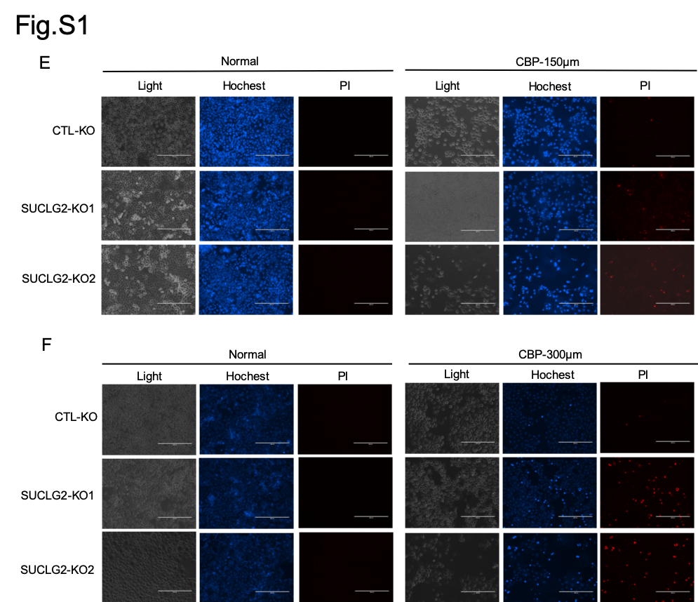

Figure S1. SUCLG2 confers resistance to platinum-based drugs as assessed by PI staining assay. (A) SUCLG2-OE and CTL-OE H1299 cells were treated with DDP (40 μM) for 24 h. Cell death was analyzed using PI staining assay. (B and C) SUCLG2-KO A549 (B) and H1299 (C) cells were treated with the indicated concentrations of DDP for 24 h. Cell death was analyzed using PI staining assay. (D) SUCLG2-OE and CTL-OE A549 cells were treated with CBP (200 μM) for 24 h, followed by cell death analysis using PI staining assay. (E and F) SUCLG2-KO A549 (E) and H1299 (F) cells were treated with the indicated concentrations CBP for 24 h. Cell death was analyzed using PI staining assay.
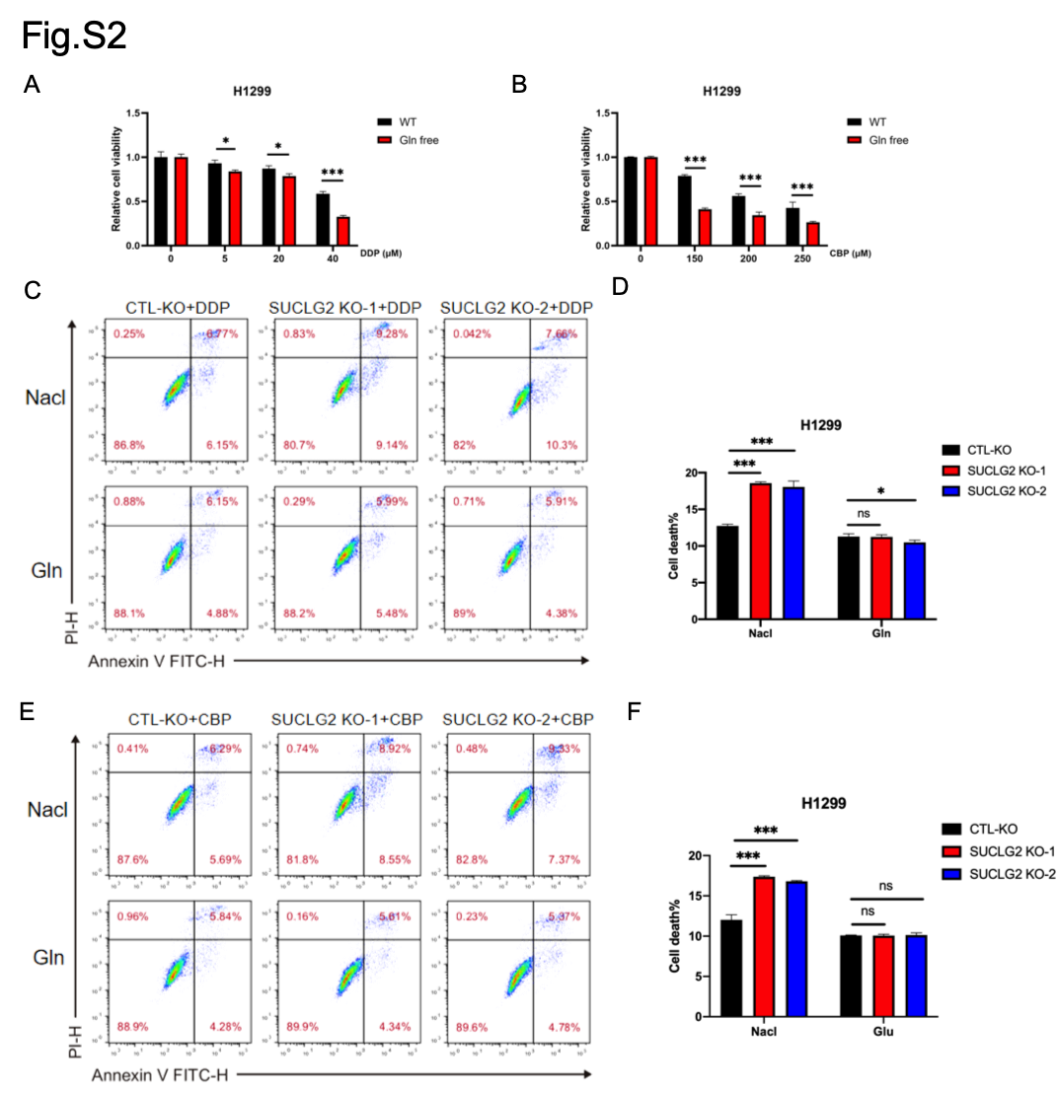
Figure S2. Glutamine metabolism is critical for platinum resistance in cancer cells. (A and B) H1299 cells cultured under glutamine-deprived or normal conditions were treated with indicated doses of DDP (A) or CBP (B), followed by cell viability analysis using CCK-8 assay. (C and D) Apoptosis levels in SUCLG2-KO and CTL-KO H1299 cells treated with DDP and supplemented with glutamine were assessed by flow cytometry. Data represent mean ± SD of three independent experiments. ns: not significant (p > 0.05); *p < 0.05; ***p < 0.001. (E and F) Apoptosis levels in SUCLG2-KO and CTL-KO H1299 cells treated with CBP and supplemented with glutamine were assessed by flow cytometry. Data represent mean ± SD of three independent experiments. ns: not significant (p > 0.05); ***p < 0.001.

Figure S3. K311 site of GAC is a critical residue mediating platinum resistance. (A) A549 cells overexpressing the GAC-WT or GAC-K164R plasmids were prepared, and co-IP and western blot were used to detect the succinylation of protein. (B) A549 cells overexpressing SIRT5 and GAC-K311R plasmids were prepared, and co-IP and western blot were used to detect the succinylation of protein. (C) A549 and H1299 cells overexpressing the GAC-WT or GAC-K164R plasmids were prepared, and co-IP and GLS activity kit were used to detect the activity of GAC. (D and E) H1299 cells overexpressing GAC-WT or GAC-K311R were treated with indicated concentrations of DDP (C) or CBP (D) for 24 h, followed by cell viability analysis using CCK-8 assay.

