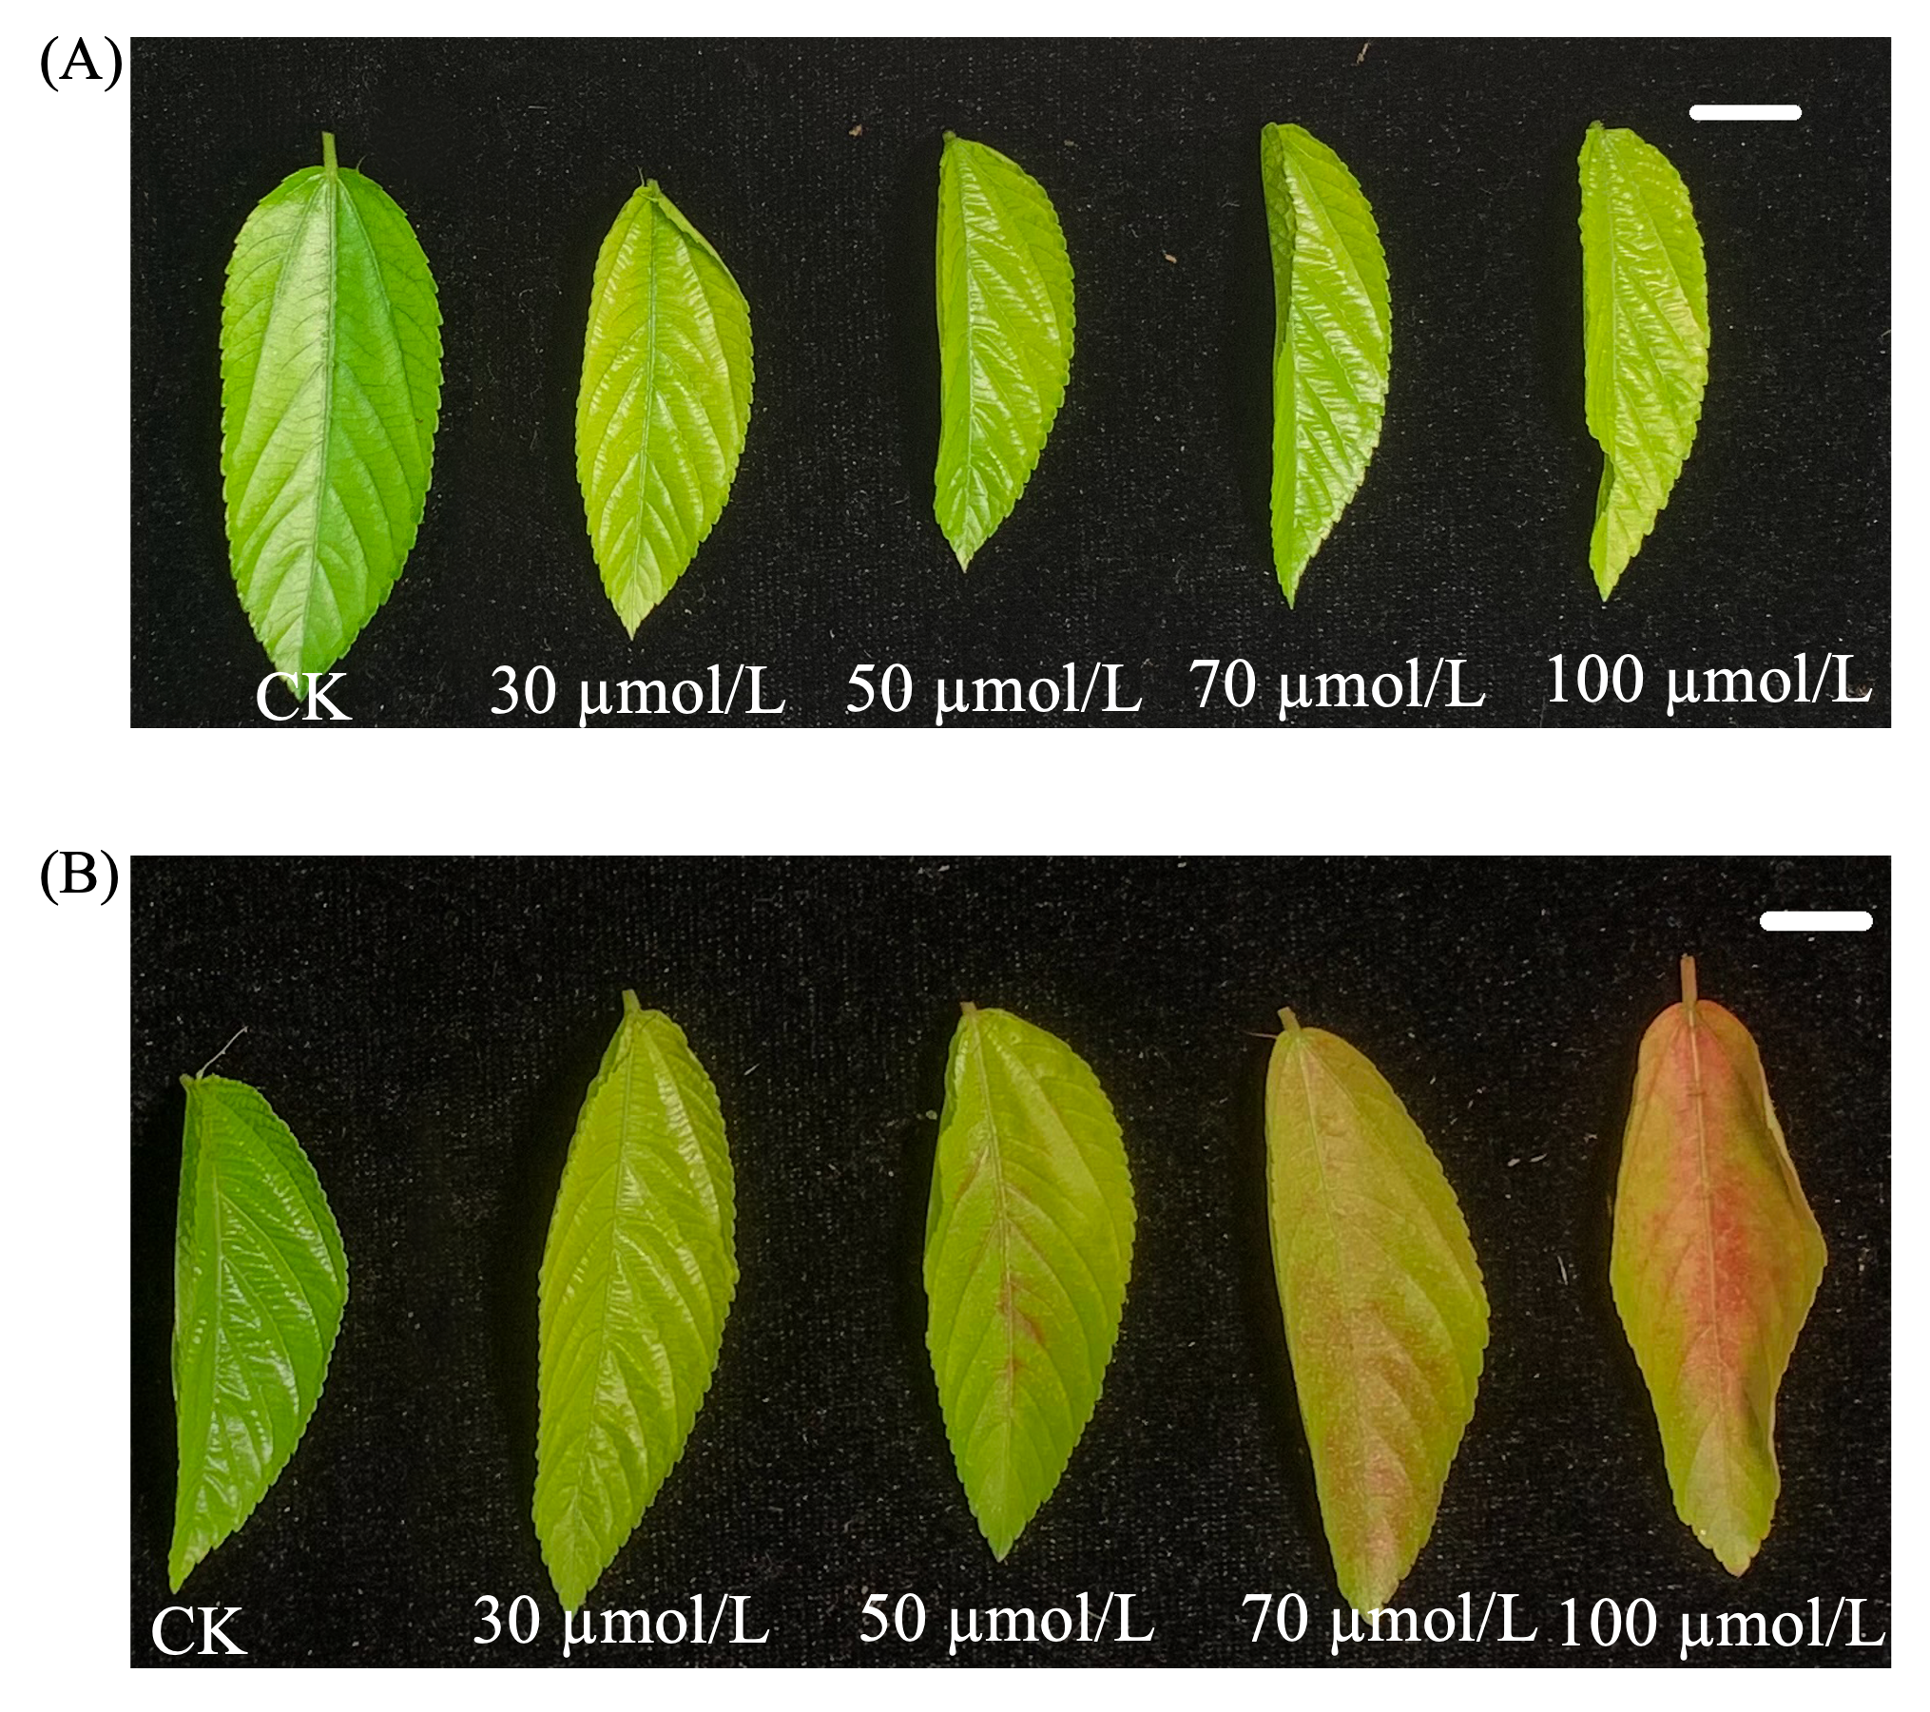
Fig. S1 Leaf phenotype responses of two dark jute parental lines under a cadmium concentration gradient.
(A) CO57 and (B) CO83 leaves after exposure to Cd (0, 30, 50, 70, and 100 μmol/L); representative leaves show Cd-induced color changes relative to the control (CK).

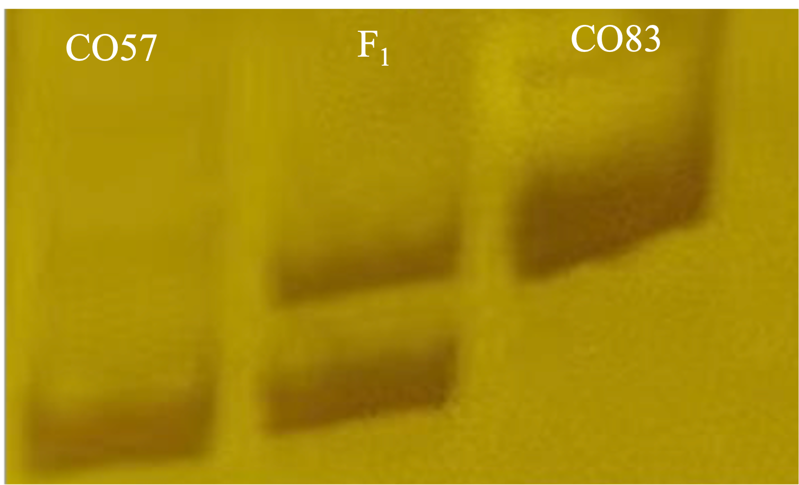
Fig. S2 Confirmation of F₁ hybridization between CO57 and CO83.
Representative marker banding patterns for CO57, the F₁ individual, and CO83 showing the F₁ carries parental alleles consistent with successful hybridization.

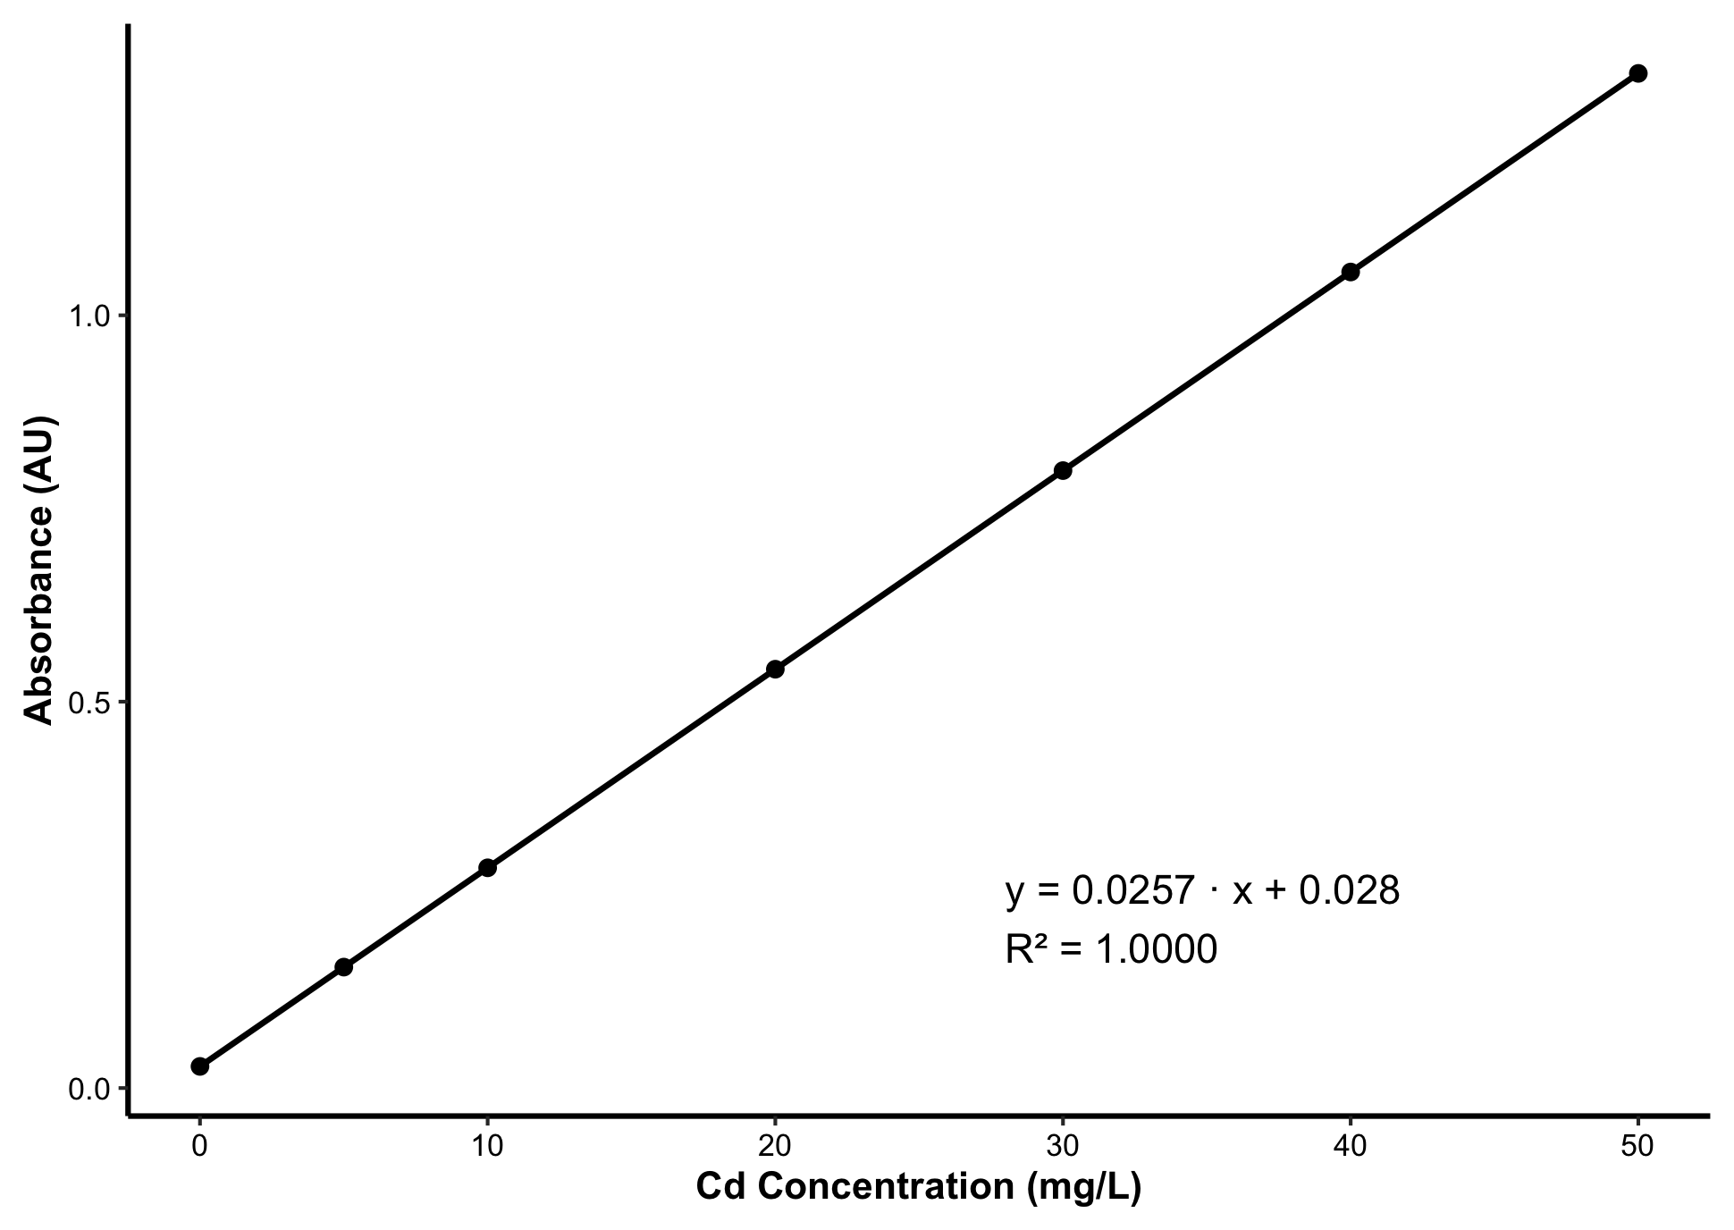
Fig. S3 Calibration curve for cadmium (Cd) quantification.
Standard curve generated using Cd standard solutions across concentration gradients for ICP-OES measurement.

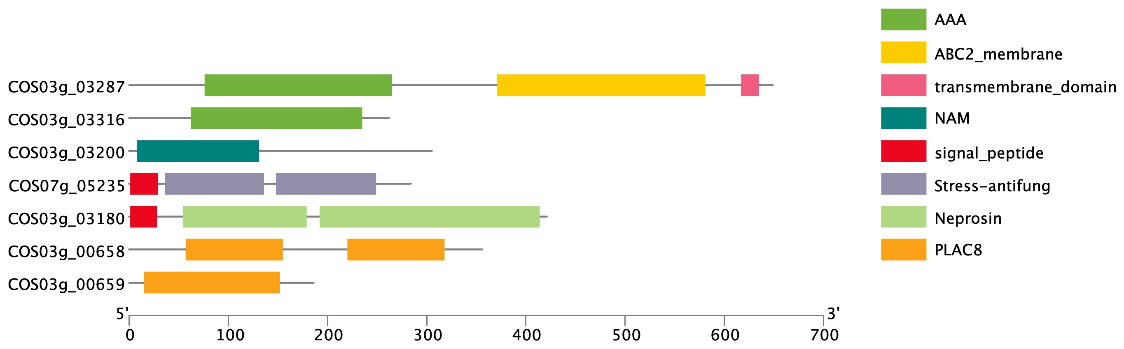

Fig. S4 Conserved domain architectures of prioritized candidate proteins predicted by NCBI Batch CD-Search.

