SUPPLEMENTAL INFORMATION

TREM2 Targeted ⁸⁹Zr-ImmunoPET Visualizes Microglial Activation during the Inflammatory Response
Evanta Kabir^{a†}, Onder Otlu^{a#†}, Taylor M. Brinsonª, Ronnie The Phong Trinh^{b}, Wei Xiong^{c}, Yaima L. Lightfoot ^{b}, William J. Ray ^{b}, Zhiqiang An^{c} , Ningyan Zhang ^{c}, Federica Pisaneschi ^{a*}

ª Center for Translational Cancer Research, Institute of Molecular Medicine, The University of Texas Health Science Center at Houston

^{b} The Belfer Neurodegeneration Consortium (BNDC). Therapeutics Discovery Division, The University of Texas MD Anderson Cancer Center, Houston, Texas, US.

^{c} Texas Therapeutics Institute, Institute of Molecular Medicine, The University of Texas Health Science Center at Houston

* Federica.Pisaneschi@uth.tmc.edu

† These two authors contributed equally

# current affiliation: Medical Biochemistry Department, School of Medicine, Malatya Turgut Ozal University, Malatya, Türkiye

Supplemental Figures
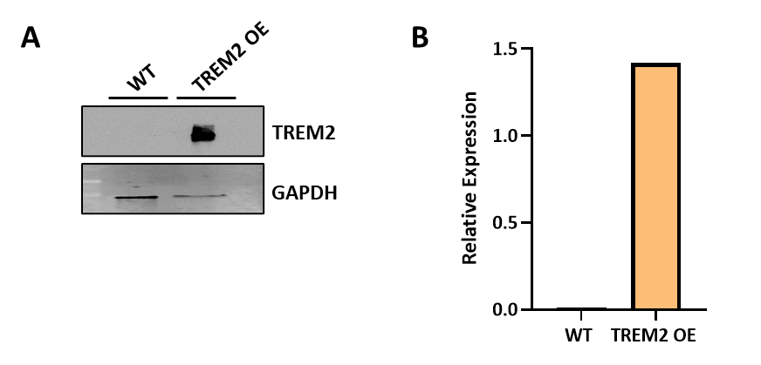
Supplemental Figure 1: Western Blot with HEK293T WT and TREM2 OE cell lines, using TREM2 and GAPDH antibodies. A) Western Blot image of TREM2 protein expression in HEK293T WT and TREM2 OE cell lines. B) Quantification of TREM2 levels in the TREM2 and WT parental controls.
The Western Blot displays a high level of TREM2 protein expression in TREM2 OE cell lysates compared to the WT controls (Supplemental Figure 1 A), with the quantification showing a 1.4-fold difference (Supplemental Figure 1 B).

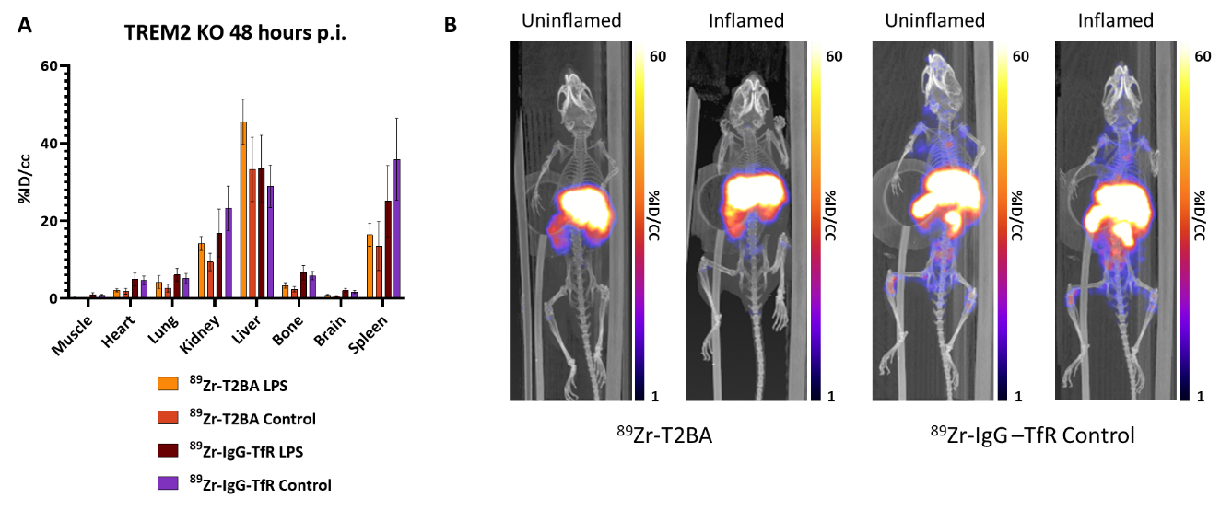
Supplemental Figure 2: ⁸⁹Zr-T2BA and ⁸⁹Zr-IgG-TfR biodistribution. A) Uptake by organ in TREM2 KO LPS-inflamed and uninflamed mice at 48 hours p.i. B) Whole body maximum intensity projection (MIP) PET images of WT and TREM2 KO LPS-inflamed mice at 48 hours p.i.
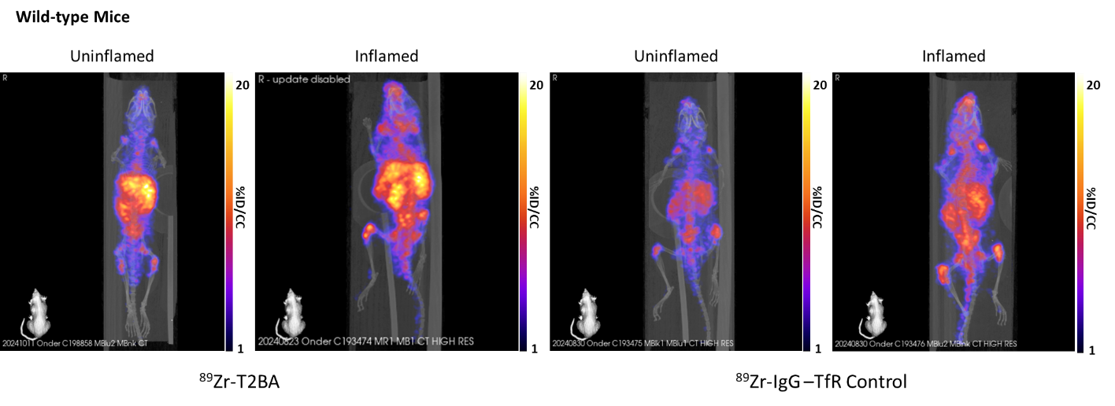
Supplemental Figure 3: Maximum intensity projections (MIPs) for ⁸⁹Zr-T2BA and ⁸⁹Zr-IgG-TfR biodistribution in WT mice, including uninflamed and LPS-inflamed mice.
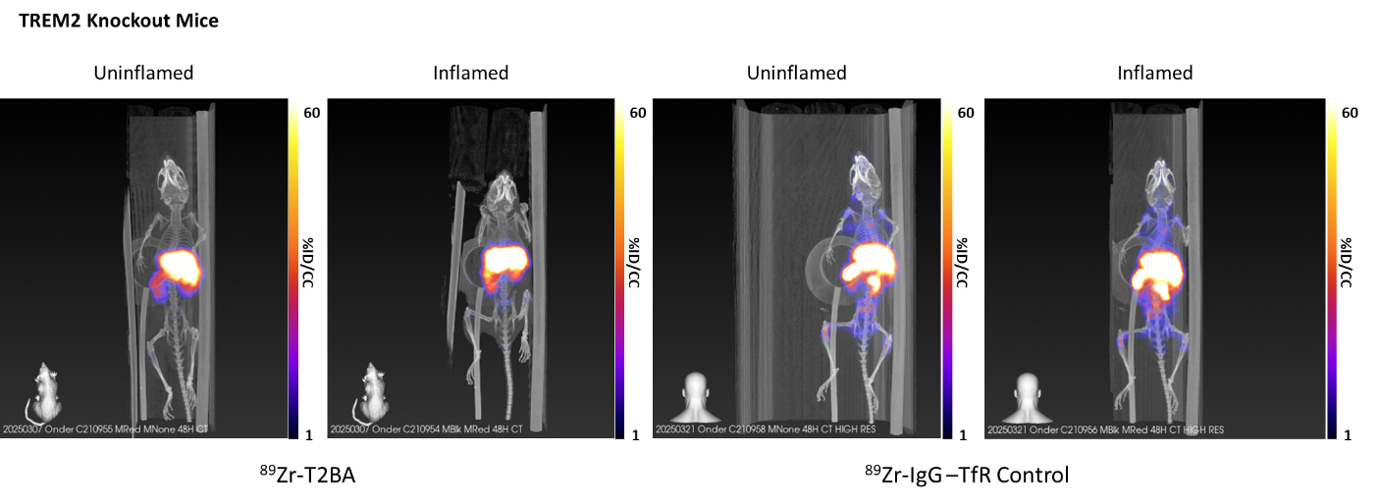
Supplemental Figure 4: Maximum intensity projections (MIPs) for ⁸⁹Zr-T2BA and ⁸⁹Zr-IgG-TfR biodistribution in KO mice, including uninflamed and LPS-inflamed mice.

