Journal: Scientific Reports

Supplementary Information (SI)

Potential impact of small-scale SST structures on air-sea coupling in the Western Mediterranean

Camilo Melo-Aguilar¹, and Gabriel Jordà²
Corresponding authors:
C. Melo-Aguilar
cmelo@socib.es
G. Jordà
gabriel.jorda@ieo.csic.es

¹Sistema de Observación y Predicción Costero de Las Illes Balears
²Centre Oceanogràfic de les Balears (Spanish Institute of Oceanography IEO-CSIC)

ORCID
Camilo Melo-Aguilar: 0000-0003-0060-1853
Gabriel Jordà: 0000-0002-2782-8727

Figures

SI1: spatial pattern correlation

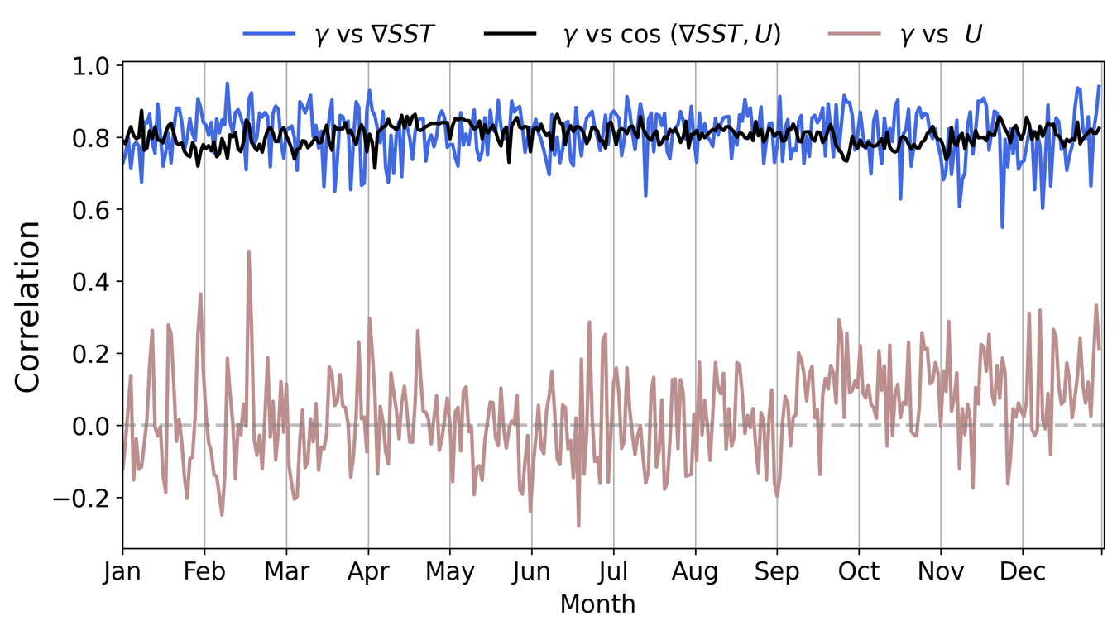
Figure S1 Time evolution of the spatial pattern correlation of 𝛾 vs SST gradient, cos(theta) and wind speed for the Ligurian Sea (6°–9° W, 41.5°–44° N). The results are shown for the year 2014 as an example, but similar results are obtained for other years.
SI2: Seasonal 1% Percentile of 𝛾

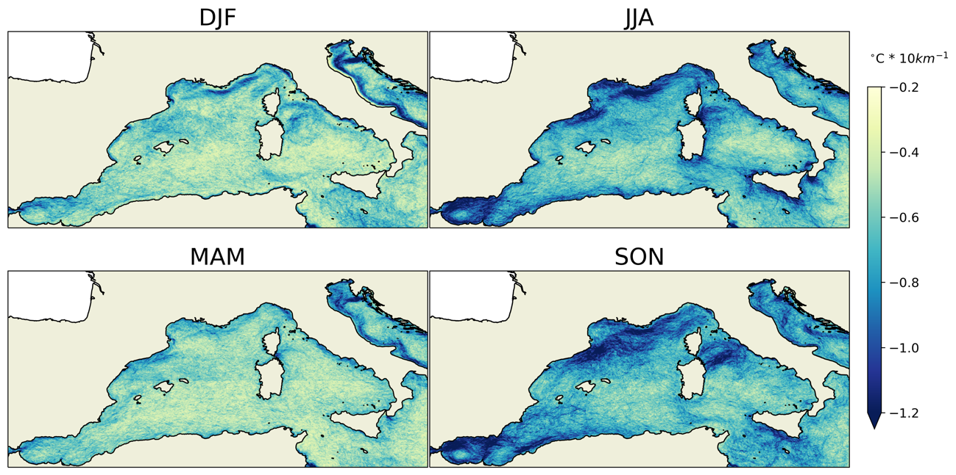
Figure S2 Seasonal 1% Percentile of 𝛾 for the period 2010-2019

SI3: ensemble RMSE, std, and NSR for the JJA season

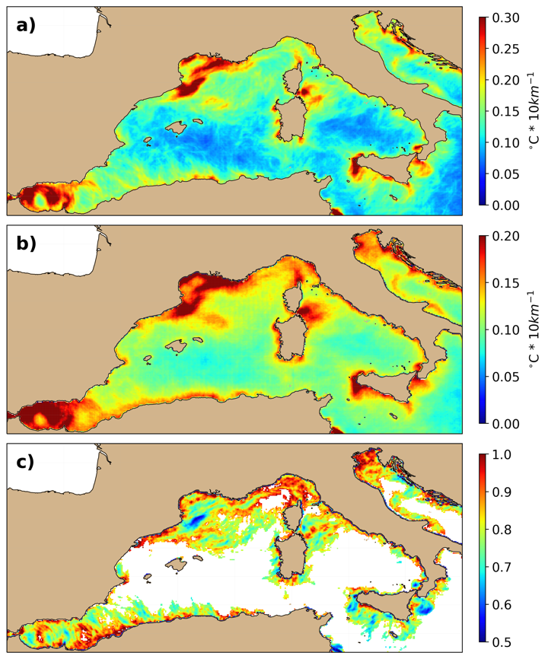
Figure S3 ensemble RMS (a), standard deviation (b) and noise-to-signal ratio (c) between 𝛾 obtained using different HRSST products for the JJA season (all products regridded to the OSTIA grid). In all cases the COSMO-REA6 winds are used for the estimation of 𝛾.

SI34 ensemble RMSE, std, and NSR for the SON season
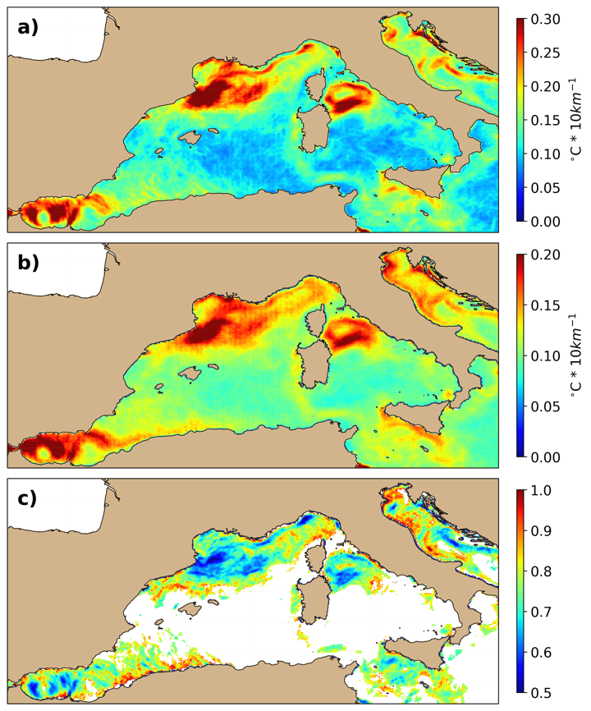
Figure S4 ensemble RMS (a), standard deviation (b) and noise-to-signal ratio (c) between 𝛾 obtained using different HRSST products for the SON season (all products regridded to the OSTIA grid). In all cases the COSMO-REA6 winds are used for the estimation of 𝛾.

