FIGURES

SUPPLEMENTAL / EXTRA FIGURES
Figure S1
a
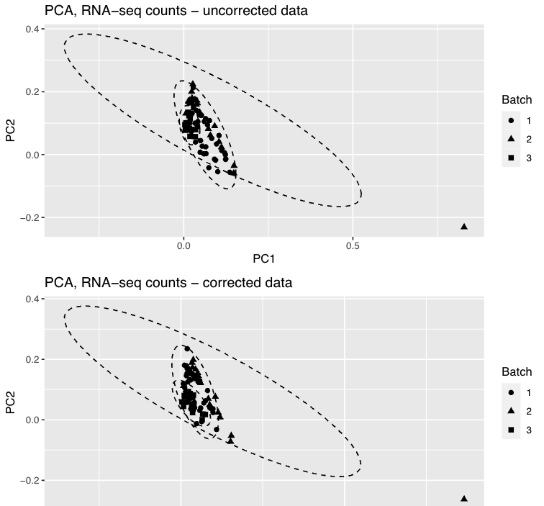
b
Fig.S1. Batch correction of gene expression data. Principial component analysis (PCA) of normalized log-transformed gene expression counts was performed by DESeq2. Confidence ellipses represent the normal distribution boundaries of sample clusters and were calculated using the stat_ellipse function in the ggplot2 R package. (A) PCA plot prior to batch correction. Three samples did not cluster with the main cohort, as visualized by their position outside the confidence ellipses. (B) PCA plot following batch correction using ComBat-Seq. Two of the previously divergent samples clustered with the overall group and were retained for analysis; the remaining sample remained an outlier and was excluded.

Figure S2
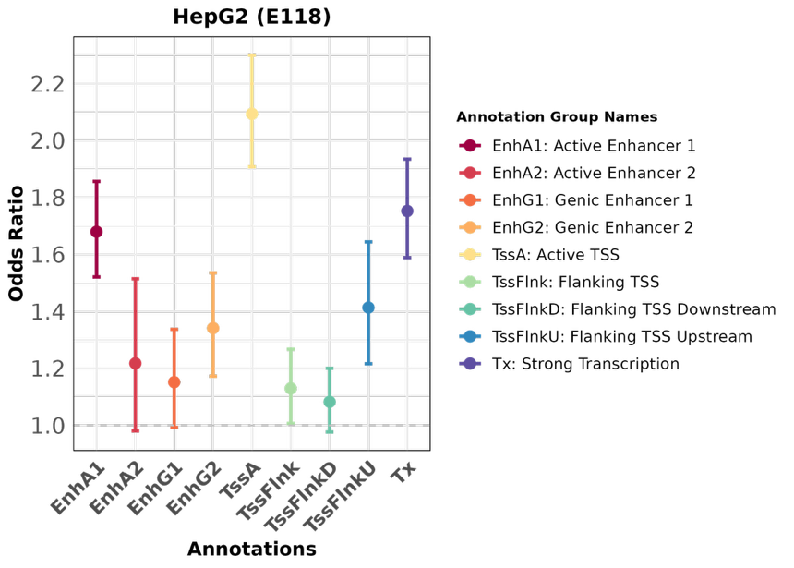
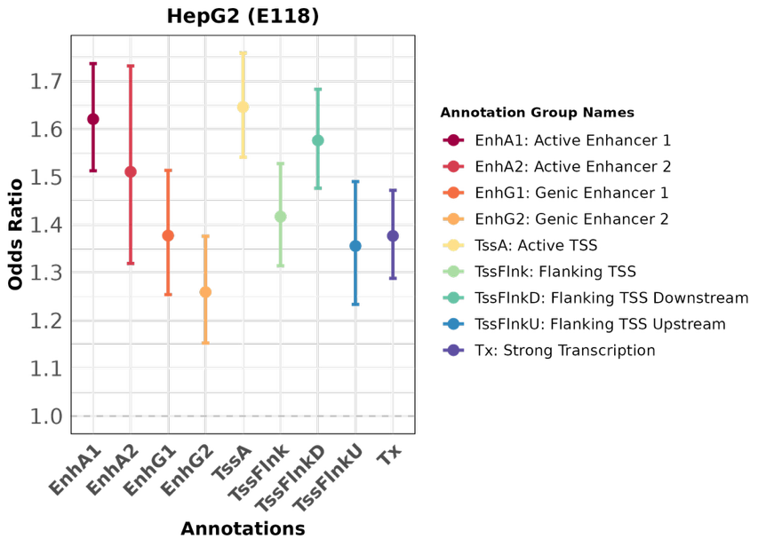
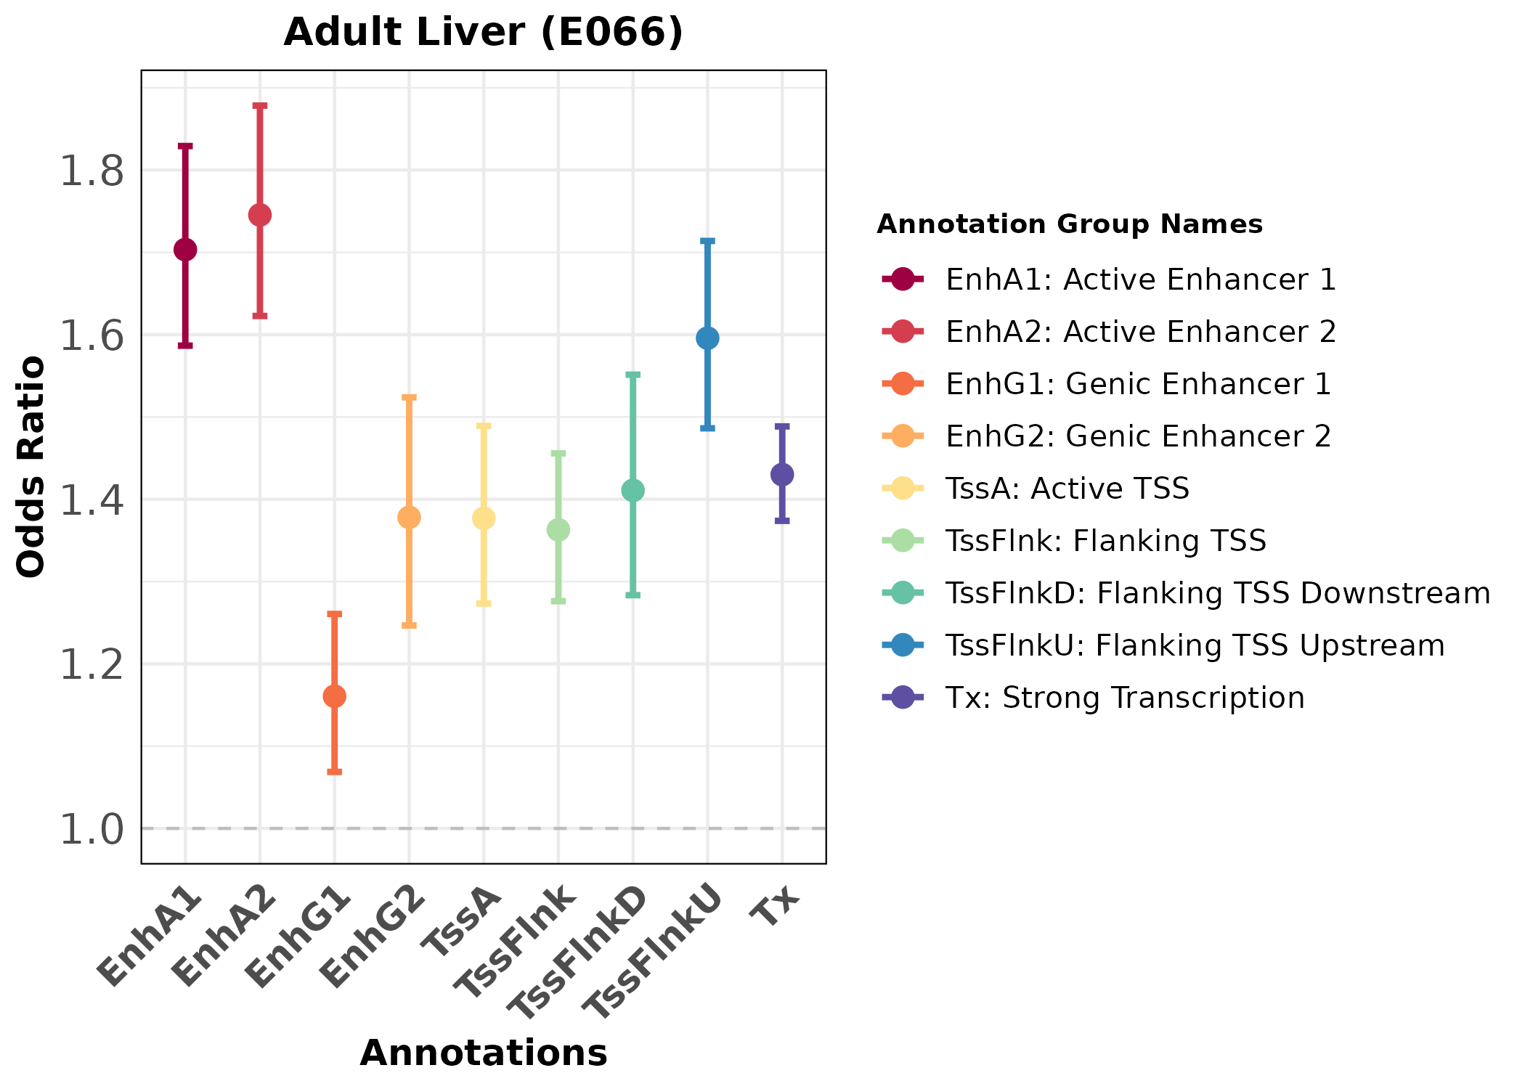
a
c
b
GTEx Liver
GTEx Liver
AA Hepatocyte

Fig. S2 Enrichment analysis of African American hepatocyte and GTEx liver cis-eQTLs within active regulatory regions defined by the ChromHMM 18-state model inliver-relevant cell systems. Chromatin states classified as active (TssA, TssFlnkD/U, Tx, EnhG1/2, EnhA1/2) from Roadmap HepG2 (E118) dataset were used as annotations. Enrichment was calculated relative to 1,000 matched null SNP sets, stratified by MAF, LD score, and TSS distance. Fisher’s exact test was used to assess significance, and p-values were corrected using the Bonferroni method. (A) AA-hepatocyte in HepG2 cells (B) GTEx liver in adult liver (C) GTEx liver in HepG2 cells.

Figure S3

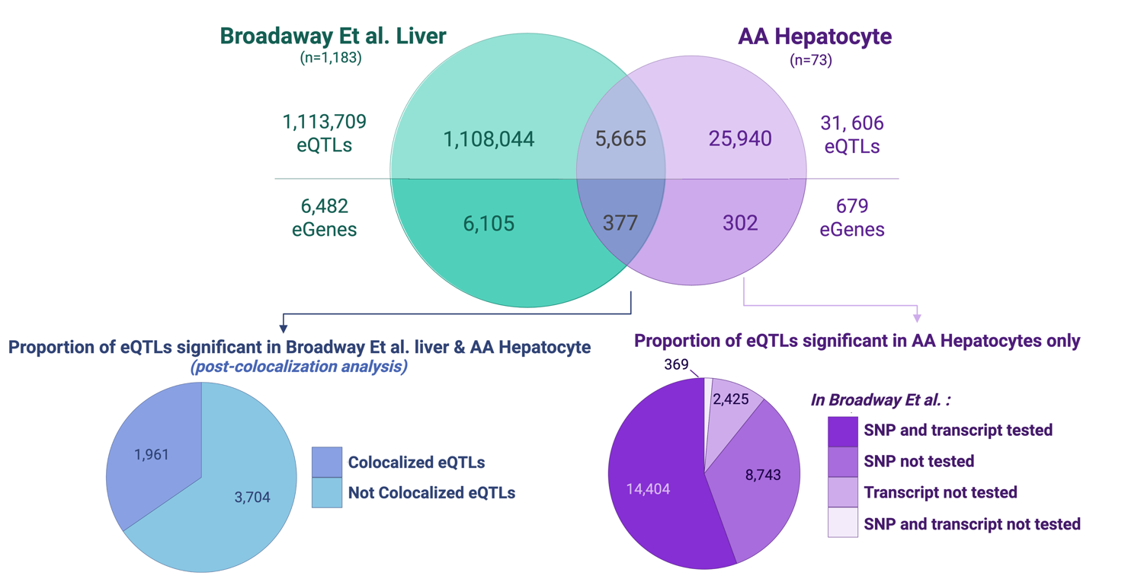
Fig. S3 General comparison of African American hepatocyte eQTLs with Broadaway et al. liver eQTLs.. Venn diagrams summarize comparisons between significant results from African American (AA) hepatocytes and the Broadaway et al. liver dataset. The main diagram shows the overlap in eQTLs and eGenes between the two datasets. The bottom left diagram highlights how many of the overlapping eQTLs colocalized using the coloc method (posterior probability for colocalization, PP4 > 0.80, and credible set cumulative SNP.PP.H4 > 0.95). The bottom right diagram depicts the proportions of AA-specific eQTLs that were included in the Broadaway et al.-liver dataset and not significant vs. not tested in Broadaway et al.

