Supplementary material
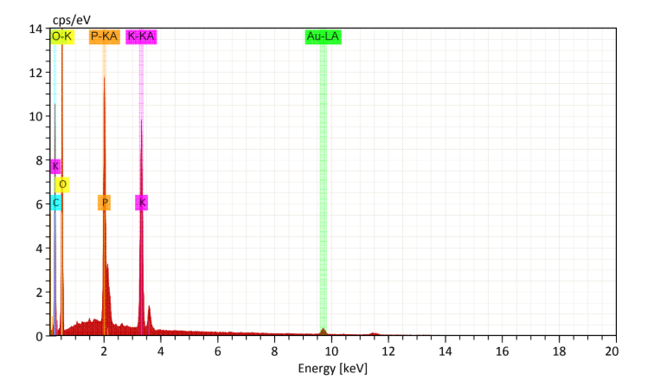
Fig. S1. EDS mapping of BC-1 sample.
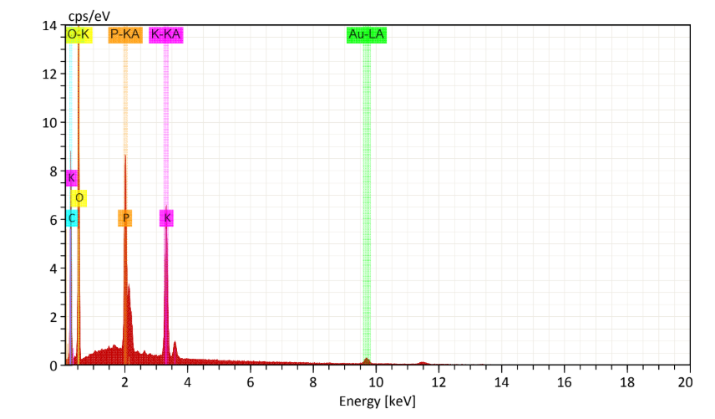
Fig. S2. EDS mapping of BC-2 sample.
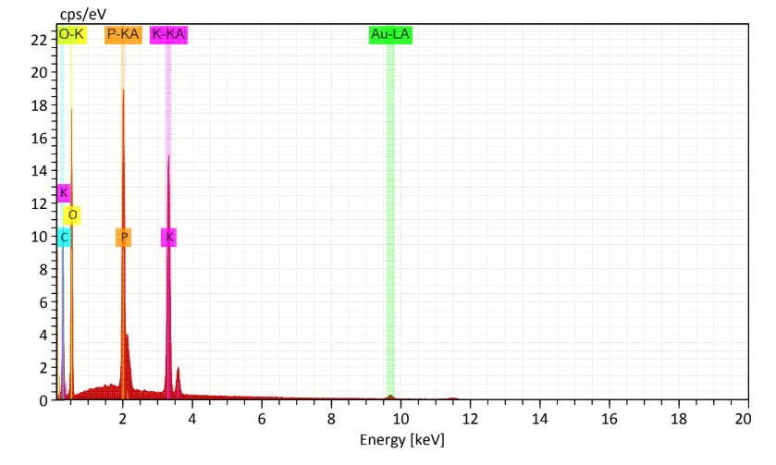
Fig. S3. EDS mapping of BC-3 sample.
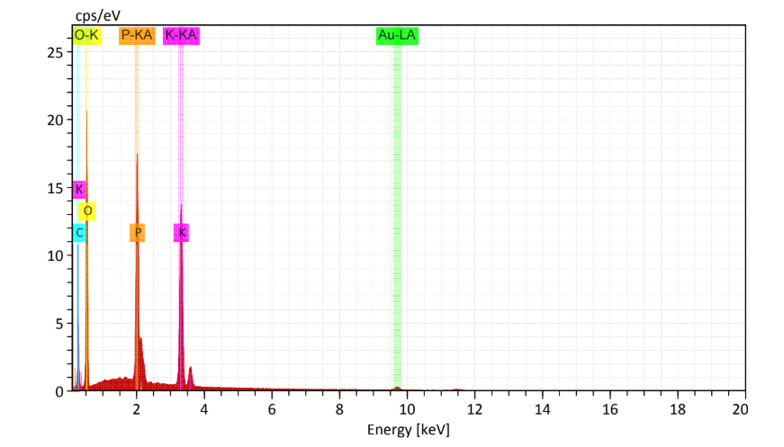
Fig. S4. EDS mapping of BC-4 sample.
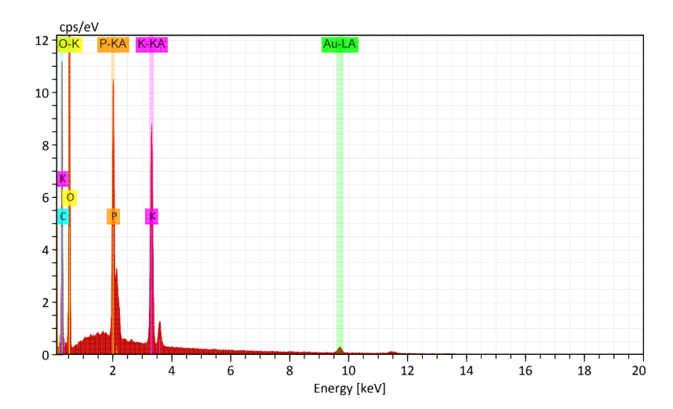
Fig. S5. EDS mapping of BC-5 sample.
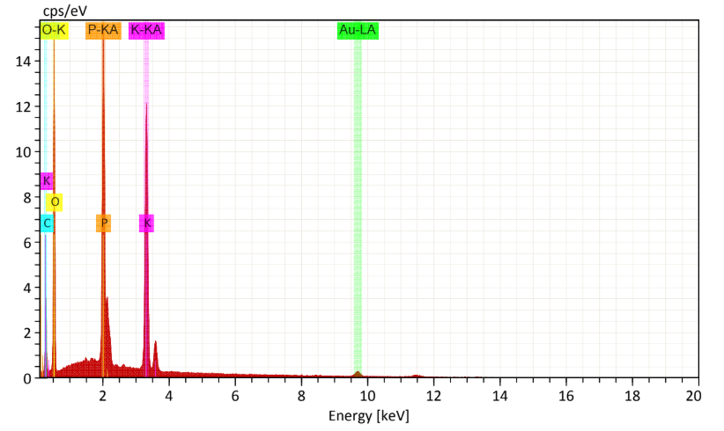
Fig. S6. EDS mapping of BC-6 sample.
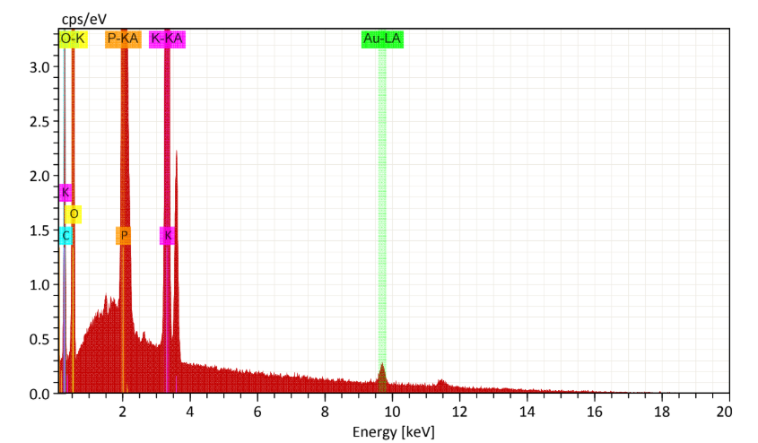
Fig. S7. EDS mapping of BC-7 sample.
Table. S1. Chemical composition of BCs samples.
Atom (%)
Samples | Carbon | Oxygen | Potassium | Phosphorus
BC-1 | 41.29 | 51.75 | 4.10 | 2.85
BC-2 | 39.39 | 54.83 | 3.18 | 2.60
BC-3 | 39.12 | 51.19 | 5.65 | 4.03
BC-4 | 23.76 | 64.66 | 6.69 | 4.89
BC-5 | 40.90 | 53.14 | 3.52 | 2.44
BC-6 | 20.70 | 63.89 | 7.66 | 5.75
BC-7 | 20.43 | 63.58 | 9.33 | 6.66

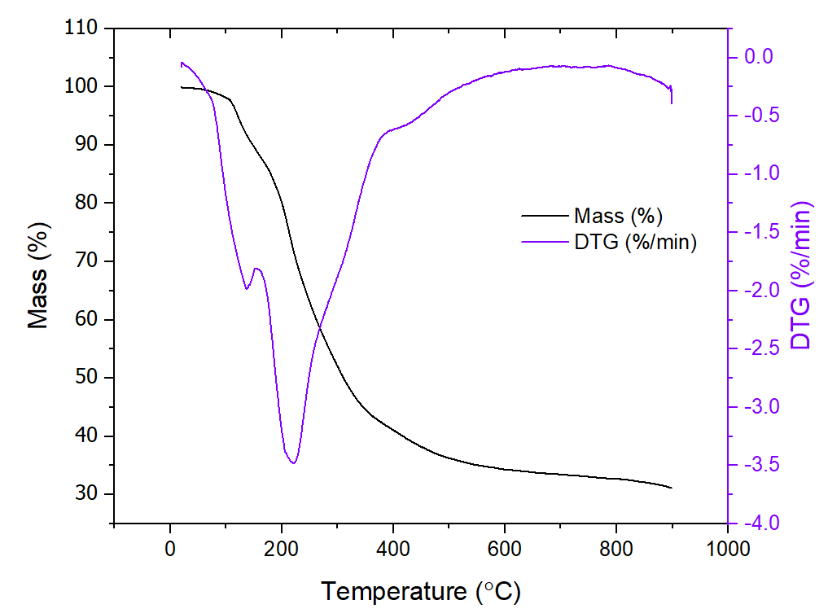
Fig. S8. Thermogravimetric curve for BC-1.
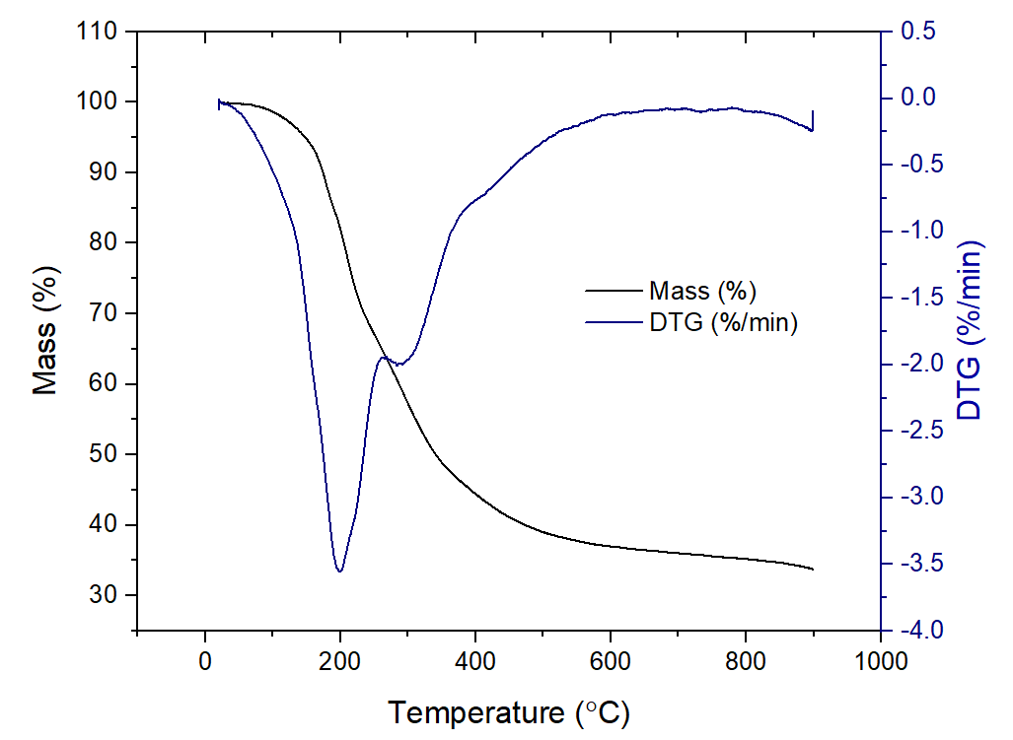 Fig. S9. Thermogravimetric curve for BC-2.
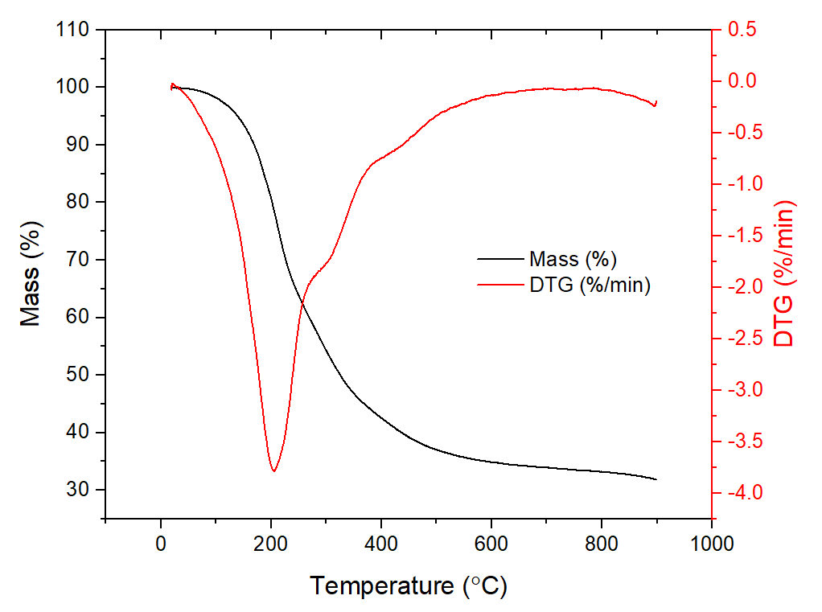
Fig. S9. Thermogravimetric curve for BC-3.
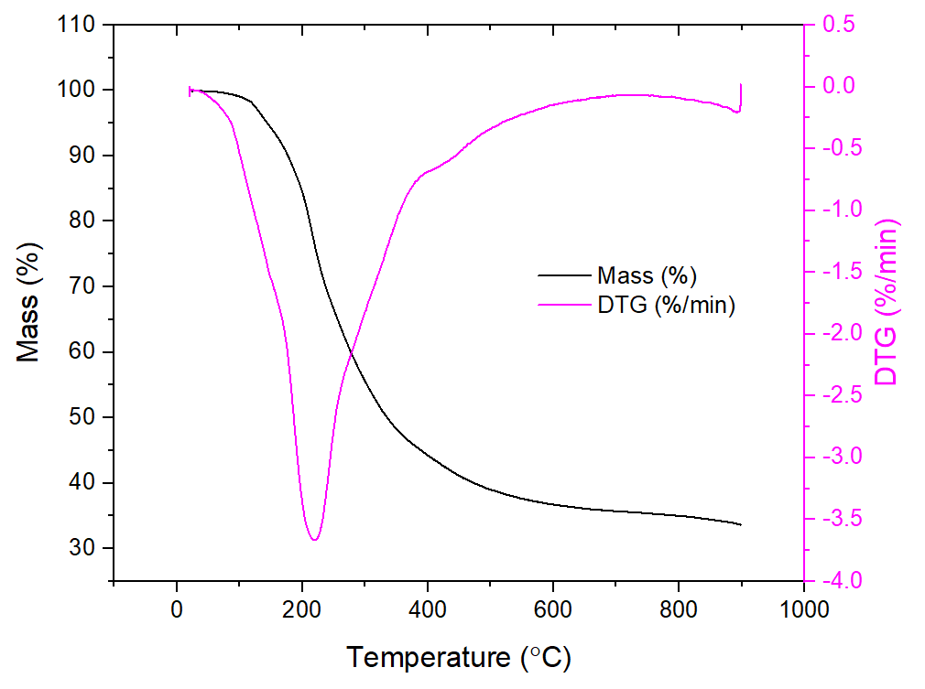
Fig. S10. Thermogravimetric curve for BC-4.
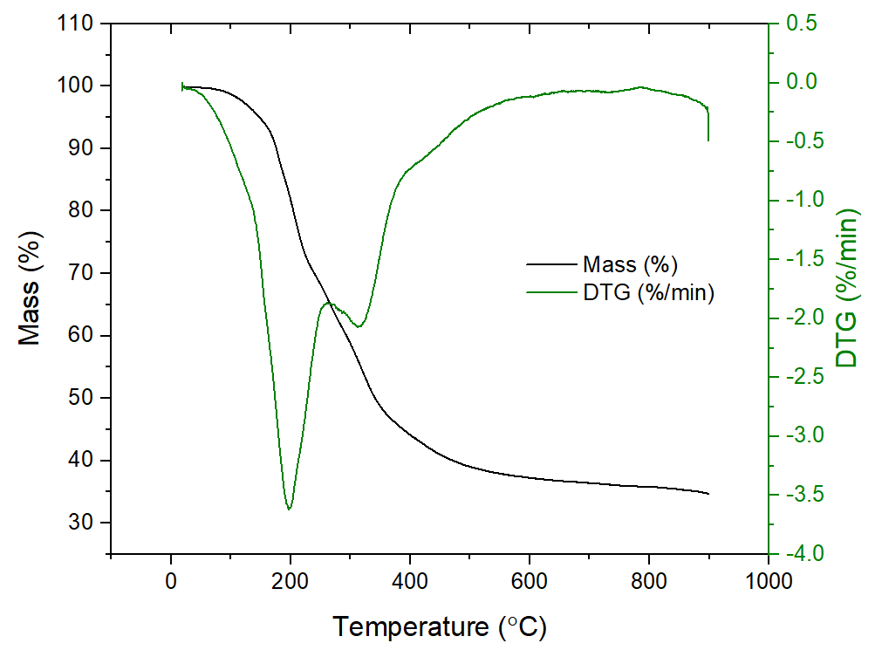
Fig. S11. Thermogravimetric curve for BC-6.
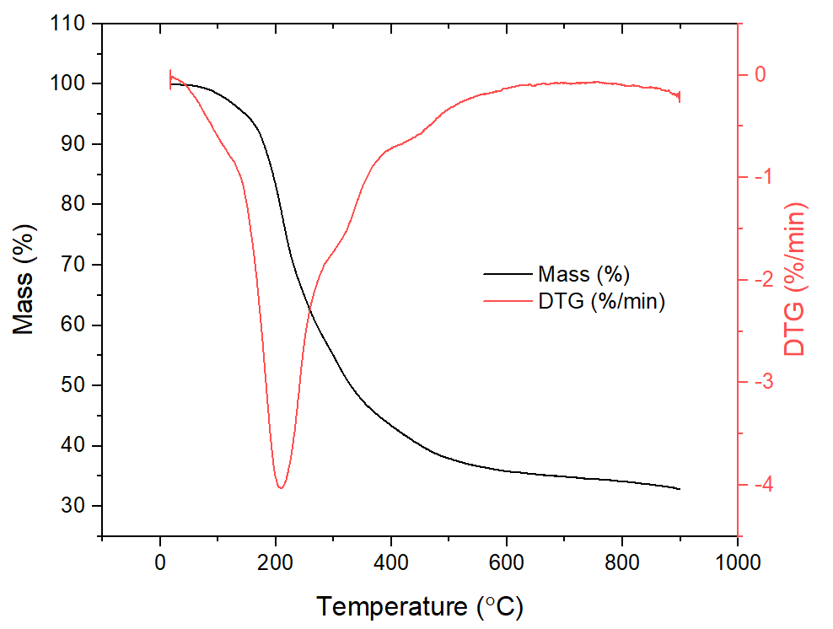
Fig. S12. Thermogravimetric curve for BC-7.

Table S2. Kinetic parameters for the adsorption of SY using BC adsorbents.
 | BC-1 | BC-2 | BC-3 | BC-4 | BC-5 | BC-6 | BC-7
PFO
q₁ (mg g⁻¹) | 8.147 | 49.412 | 31.228 | 27.107 | 51.097 | 49.836 | 10.204
k₁ (min⁻¹) | 0.046 | 0.053 | 0.049 | 0.049 | 0.066 | 0.062 | 0.065
R² | 0.822 | 0.995 | 0.966 | 0.972 | 0.990 | 0.990 | 0.920
R² _{adj} | 0.792 | 0.994 | 0.960 | 0.967 | 0.988 | 0.989 | 0.907
ARE (%) | 17.142 | 4.074 | 8.933 | 8.910 | 4.683 | 4.786 | 9.353
SSE | 12.989 | 12.480 | 32.184 | 20.067 | 25.435 | 23.540 | 8.602
AIC | 15.878 | 15.558 | 23.136 | 19.357 | 21.254 | 20.634 | 12.580
MSE | 1.624 | 1.560 | 4.023 | 2.508 | 3.179 | 2.943 | 1.075
PSO
q₂ (mg g⁻¹) | 9.874 | 58.699 | 37.267 | 32.238 | 59.050 | 58.100 | 12.048
k₂ (g mg⁻¹ min⁻¹) | 0.005 | 0.001 | 0.001 | 0.002 | 0.001 | 0.001 | 0.006
h₀ (mg g⁻¹ min⁻¹) | 0.498 | 3.445 | 2.055 | 1.808 | 4.707 | 4.219 | 0.863
R² | 0.869 | 0.999 | 0.989 | 0.992 | 0.998 | 0.998 | 0.953
R²_{adj} | 0.847 | 0.999 | 0.987 | 0.990 | 0.997 | 0.998 | 0.945
ARE (%) | 13.399 | 1.321 | 4.782 | 4.736 | 1.685 | 1.606 | 6.756
SSE | 9.565 | 2.190 | 10.855 | 5.810 | 5.641 | 4.245 | 5.072
AIC | 13.429 | 1.636 | 14.441 | 9.441 | 9.205 | 6.931 | 8.354
MSE | 1.196 | 0.274 | 1.357 | 0.726 | 0.705 | 0.531 | 0.634
GO
q_{n} (mg g⁻¹) | 33.606 | 55.145 | 72.077 | 61.522 | 57.785 | 55.145 | 29.776
k_{n} (min⁻¹ (g mg⁻¹)^{n−1} | 1.6E-19 | 3.9E-03 | 7.9E-12 | 2.5E-11 | 2.3E-03 | 3.9E-03 | 9.0E-14
n (-) | 12.219 | 1.677 | 6.215 | 6.140 | 1.873 | 1.677 | 8.928
h₀ (mg g⁻¹ min⁻¹) | 0.715 | 3.244 | 2.780 | 2.455 | 4.570 | 3.244 | 1.295
R² | 0.894 | 0.999 | 0.996 | 0.998 | 0.998 | 0.999 | 0.966
R²_{adj} | 0.852 | 0.999 | 0.994 | 0.997 | 0.997 | 0.999 | 0.952
ARE (%) | 13.868 | 1.319 | 2.026 | 2.218 | 1.581 | 1.216 | 7.128
SSE | 7.710 | 1.538 | 4.094 | 1.590 | 5.524 | 31.805 | 3.709
AIC | 13.704 | 0.807 | 8.641 | 1.076 | 11.037 | 25.042 | 7.850
MSE | 0.964 | 0.192 | 0.512 | 0.199 | 0.690 | 3.976 | 0.464

Table S3. Equilibrium parameters for the SY adsorption on BCs.
Parameter | BC-1 | BC-2 | BC-3 | BC-4 | BC-5 | BC-6 | BC-7
Langmuir
q_{m} (mg g⁻¹) | 21.678 | 182.743 | 86.122 | 77.388 | 229.487 | 208.934 | 27.490
K_{L} (L mg⁻¹) | 0.026 | 0.247 | 0.068 | 0.053 | 0.613 | 0.318 | 0.031
R² | 0.884 | 0.976 | 0.983 | 0.989 | 0.958 | 0.989 | 0.938
R²_{adj} | 0.865 | 0.972 | 0.981 | 0.987 | 0.951 | 0.987 | 0.928
ARE (%) | 56.412 | 12.866 | 14.422 | 10.371 | 50.318 | 21.485 | 29.039
SSE | 55.564 | 950.911 | 126.188 | 65.512 | 2437.448 | 552.930 | 44.612
AIC | 21.905 | 44.624 | 28.467 | 23.222 | 52.154 | 40.286 | 20.148
MSE | 6.946 | 118.864 | 15.773 | 8.189 | 304.681 | 69.116 | 5.576
Freundlich
K_{F} (mg g⁻¹)(mg L⁻¹)^{-1/nF} | 0.031 | 0.057 | 0.044 | 0.033 | 0.07 | 0.036 | 0.017
n_{F} (-) | 3.301 | 3.719 | 3.472 | 2.93 | 4.314 | 3.342 | 2.54
R² | 0.733 | 0.944 | 0.942 | 0.945 | 0.823 | 0.908 | 0.804
R²_{adj} | 0.689 | 0.935 | 0.933 | 0.935 | 0.794 | 0.893 | 0.771
ARE (%) | 94.041 | 47.298 | 20.214 | 19.340 | 92.777 | 66.575 | 55.299
SSE | 127.839 | 2217.824 | 436.744 | 322.650 | 10246.676 | 4698.892 | 142.096
AIC | 14.171 | 36.999 | 23.999 | 21.577 | 49.242 | 43.005 | 15.016
MSE | 15.980 | 277.228 | 54.593 | 40.331 | 1280.834 | 587.362 | 17.762
Sips
q_{s} (mg g⁻¹) | 18.7 | 207.656 | 90.151 | 81.582 | 221.897 | 215.937 | 24.143
K_{S} (L mg⁻¹) | 0.031 | 0.146 | 0.062 | 0.047 | 0.804 | 0.277 | 0.038
n_{s} (-) | 2.797 | 0.648 | 0.842 | 0.835 | 1.920 | 0.847 | 2.038
R² | 0.974 | 0.994 | 0.984 | 0.991 | 0.998 | 0.992 | 0.984
R²_{adj} | 0.964 | 0.991 | 0.978 | 0.987 | 0.998 | 0.988 | 0.977
ARE (%) | 9.824 | 17.200 | 13.791 | 9.152 | 11.961 | 23.596 | 3.878
SSE | 12.381 | 256.830 | 118.254 | 55.421 | 94.765 | 410.688 | 11.885
AIC | 15.494 | 39.752 | 33.547 | 27.484 | 31.776 | 43.507 | 15.167
MSE | 1.548 | 32.104 | 14.782 | 6.928 | 11.846 | 51.336 | 1.486

Table S4. Kinetic parameters for the adsorption of DCP using BC adsorbents.
 | BC-1 | BC-2 | BC-3 | BC-4 | BC-5 | BC-6 | BC-7
PFO
q₁ (mg g⁻¹) | 45.214 | 39.283 | 41.356 | 44.724 | 36.919 | 41.099 | 341.238
k₁ (min⁻¹) | 0.011 | 0.023 | 0.018 | 0.010 | 0.033 | 0.016 | 0.001
R² | 0.991 | 0.991 | 0.991 | 0.985 | 0.953 | 0.988 | 0.994
R² _{adj} | 0.990 | 0.990 | 0.990 | 0.982 | 0.946 | 0.986 | 0.993
ARE (%) | 10.791 | 7.686 | 8.464 | 17.252 | 12.940 | 10.000 | 14.172
SSE | 8.552 | 11.797 | 11.693 | 13.511 | 56.524 | 13.891 | 5.765
AIC | 6.934 | 9.507 | 9.437 | 10.593 | 22.042 | 10.814 | 3.779
MSE | 1.069 | 1.475 | 1.462 | 1.689 | 7.065 | 1.736 | 0.721
PSO
q₂ (mg g⁻¹) | 69.707 | 52.978 | 58.683 | 69.105 | 45.323 | 59.438 | 684.574
k₂ (g mg⁻¹ min⁻¹) | 1.1E-04 | 3.7E-04 | 2.4E-04 | 1.0E-04 | 7.8E-04 | 2.1E-04 | 5.9E-07
h₀ (mg g⁻¹ min⁻¹) | 0.525 | 1.044 | 0.829 | 0.490 | 1.611 | 0.725 | 0.276
R² | 0.993 | 0.994 | 0.992 | 0.986 | 0.973 | 0.989 | 0.994
R²_{adj} | 0.991 | 0.992 | 0.990 | 0.984 | 0.969 | 0.987 | 0.993
ARE (%) | 9.838 | 5.349 | 6.686 | 12.227 | 9.570 | 8.360 | 14.149
SSE | 7.427 | 8.579 | 10.789 | 12.504 | 32.504 | 12.738 | 5.771
AIC | 5.806 | 6.959 | 8.793 | 9.973 | 17.615 | 10.121 | 3.788
MSE | 0.928 | 1.072 | 1.349 | 1.563 | 4.063 | 1.592 | 0.721
GO
q_{n} (mg g⁻¹) | 247.926 | 159.995 | 140.908 | 211.037 | 143.412 | 225.196 | 31.014
k_{n} (min⁻¹ (g mg⁻¹)^{n−1} | 7.8E-23 | 6.2E-20 | 2.2E-14 | 4.8E-19 | 6.1E-24 | 3.0E-25 | 2.1E-01
n (-) | 9.128 | 8.752 | 6.338 | 7.762 | 10.928 | 10.382 | 0.085
h₀ (mg g⁻¹ min⁻¹) | 0.560 | 1.205 | 0.906 | 0.522 | 2.263 | 0.795 | 0.283
R² | 0.993 | 0.994 | 0.992 | 0.987 | 0.985 | 0.990 | 0.995
R²_{adj} | 0.991 | 0.992 | 0.989 | 0.982 | 0.980 | 0.986 | 0.992
ARE (%) | 9.094 | 3.746 | 5.559 | 11.407 | 6.427 | 6.875 | 14.967
SSE | 6.542 | 7.738 | 10.540 | 11.529 | 17.615 | 12.022 | 5.229
AIC | 10.391 | 11.734 | 14.206 | 14.924 | 18.314 | 15.259 | 8.599
MSE | 0.818 | 0.967 | 1.318 | 1.441 | 2.202 | 1.503 | 0.654

Table S5. Equilibrium parameters for the DCP on BC adsorbents.
 | BC-1 | BC-2 | BC-3 | BC-4 | BC-5 | BC-6 | BC-7
Model Hill
q_{m} (mg g⁻¹) | 430.654 | 178.257 | 237.836 | 261.104 | 150.866 | 318.884 | 758.520
K_{H} (L mg⁻¹) | 94266.7 | 42987.6 | 51728.2 | 22916.3 | 97565.5 | 64808.5 | 29200.9
n (-) | 3.303 | 3.735 | 3.480 | 2.935 | 4.328 | 3.347 | 2.540
R² | 0.997 | 0.991 | 0.997 | 0.994 | 0.987 | 0.996 | 0.993
R²_{adj} | 0.994 | 0.985 | 0.995 | 0.990 | 0.979 | 0.994 | 0.988
ARE (%) | 12.249 | 17.742 | 8.857 | 14.178 | 16.952 | 12.798 | 19.215
SSE | 42.954 | 117.180 | 42.954 | 69.669 | 169.097 | 47.770 | 84.682
AIC | 29.810 | 35.832 | 29.810 | 32.712 | 38.032 | 30.448 | 33.883
MSE | 7.159 | 19.530 | 7.159 | 11.612 | 28.183 | 7.962 | 14.114
Model Sips
q_{s} (mg g⁻¹) | 431.8 | 178.974 | 238.737 | 262.075 | 151.107 | 320.204 | 757.286
K_{S} (L mg⁻¹) | 0.031 | 0.057 | 0.044 | 0.033 | 0.070 | 0.036 | 0.017
n_{s} (-) | 3.301 | 3.719 | 3.472 | 2.930 | 4.314 | 3.342 | 2.540
R² | 0.997 | 0.991 | 0.997 | 0.994 | 0.987 | 0.996 | 0.993
R²_{adj} | 0.994 | 0.985 | 0.995 | 0.990 | 0.979 | 0.994 | 0.988
ARE (%) | 12.277 | 17.929 | 8.942 | 14.250 | 17.094 | 12.862 | 19.210
SSE | 42.954 | 117.165 | 42.951 | 69.668 | 169.086 | 47.769 | 84.682
AIC | 29.810 | 35.831 | 29.810 | 32.712 | 38.032 | 30.448 | 33.883
MSE | 7.159 | 19.528 | 7.159 | 11.611 | 28.181 | 7.961 | 14.114

Table S6. Data sheet of adsorption capacity before and after adsorbent regeneration.
Cycle | Solution concentration (mg L⁻¹) | Adsorption capacity (mg g⁻¹)
SY
Adsorption (4 h) | 163.4 | 163.8
Desorption (NaOH 0.5 M) | - | 106.7
1st reuse | 169.3 | 33.8
2nd reuse | 173.5 | 73.2
3rd reuse | 183.6 | 74.9
4th reuse | 171.1 | 77.4
5th reuse | 157.1 | 83.3
DCP
Adsorption (4 h) | 129.1 | 121.40
Desorption (NaOH 0.5 M) | - | 76.5
1st reuse | 136.5 | 38.5
2nd reuse | 139.5 | 46.6
3rd reuse | 155.0 | 68.8
4th reuse | 142.5 | 89.2
5th reuse | 138.0 | 38.1

