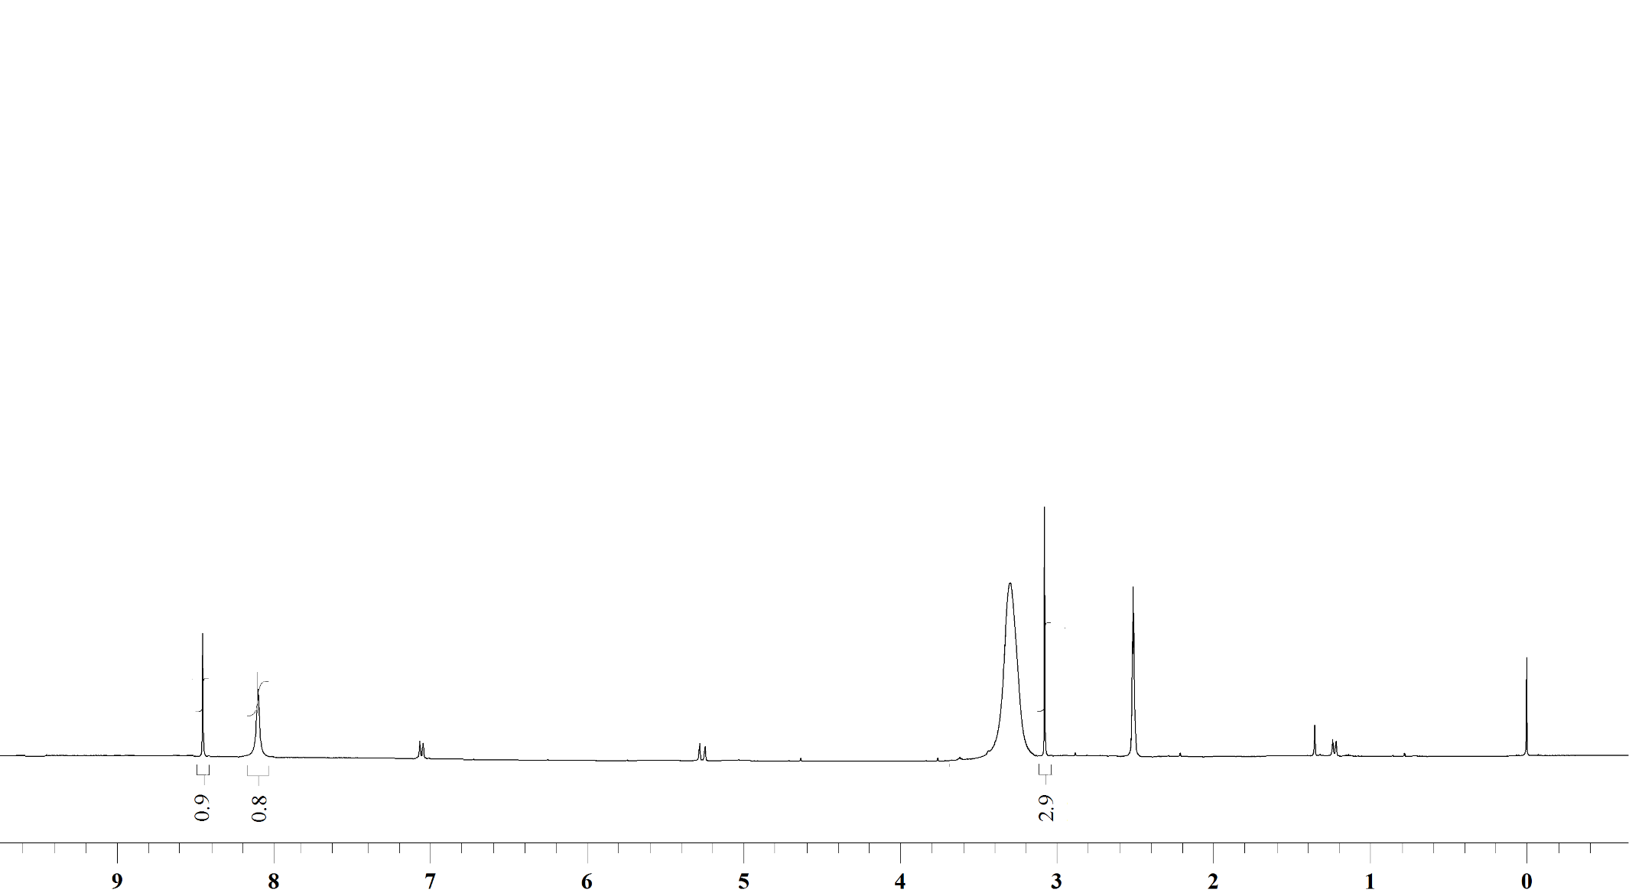

¹H NMR Spectrum of compound 21 in DMSO-d₆ (400 MHz)

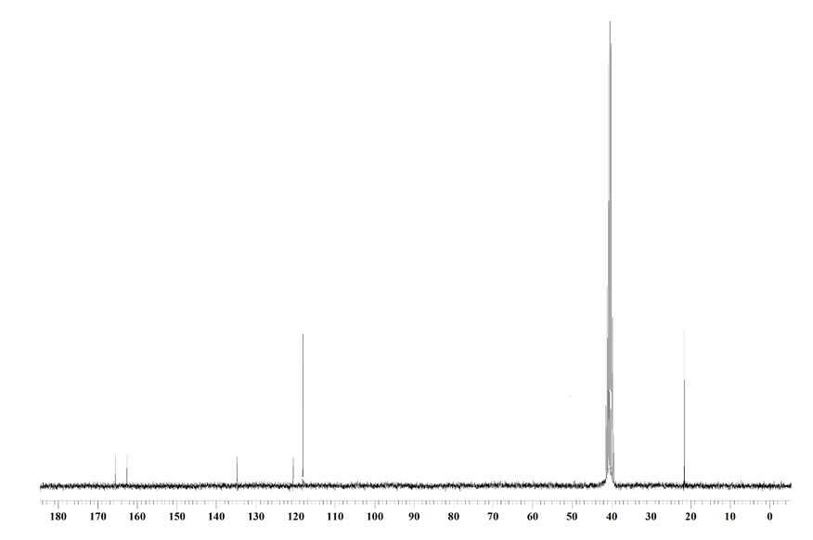

¹³C NMR Spectrum of compound 21 in DMSO-d₆ (100 MHz)

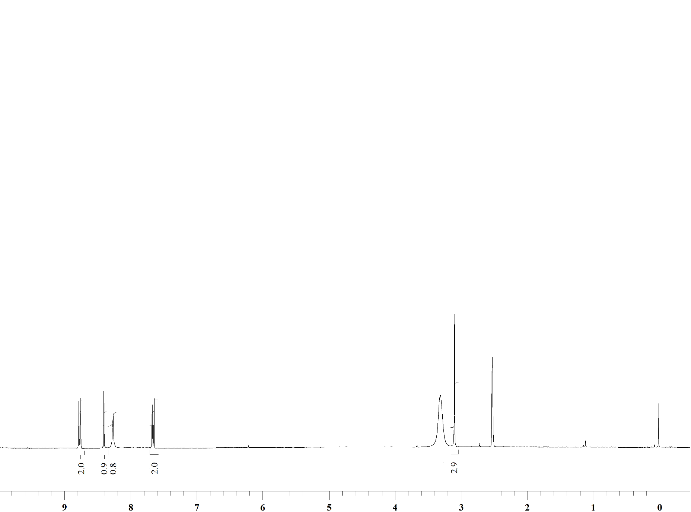

¹H NMR Spectrum of compound 23 in DMSO-d₆ (400 MHz)

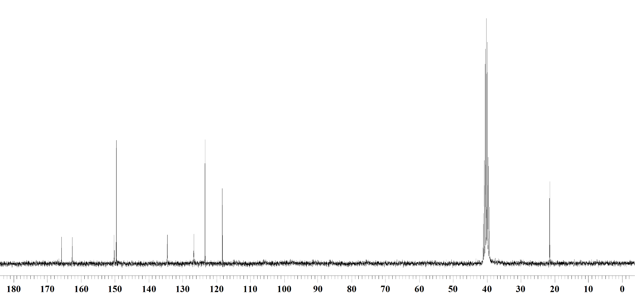

¹³C NMR Spectrum of compound 23 in DMSO-d₆ (100 MHz)

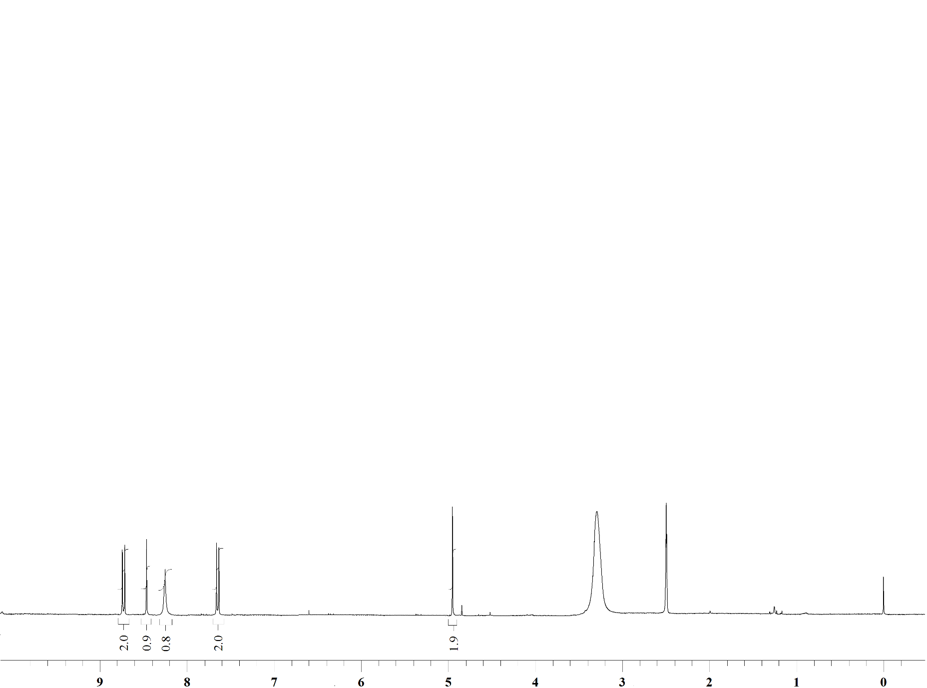

¹H NMR Spectrum of compound 24 in DMSO-d₆ (400 MHz)

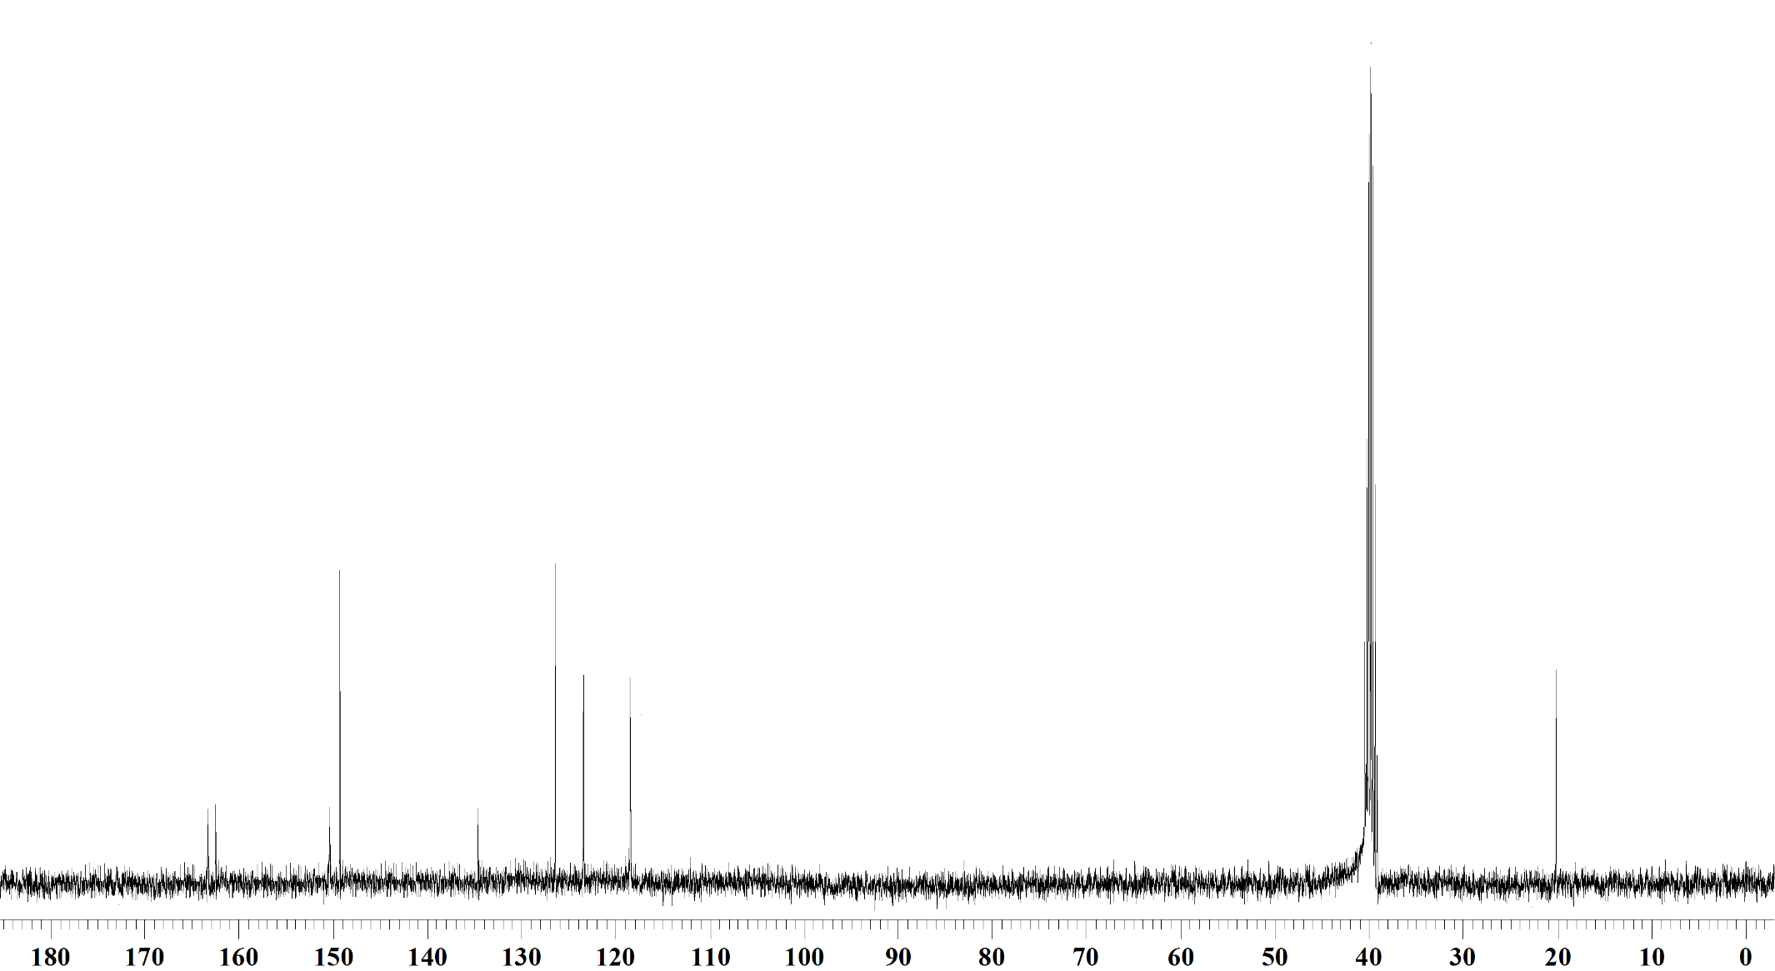

¹³C NMR Spectrum of compound 24 in DMSO-d₆ (100 MHz)

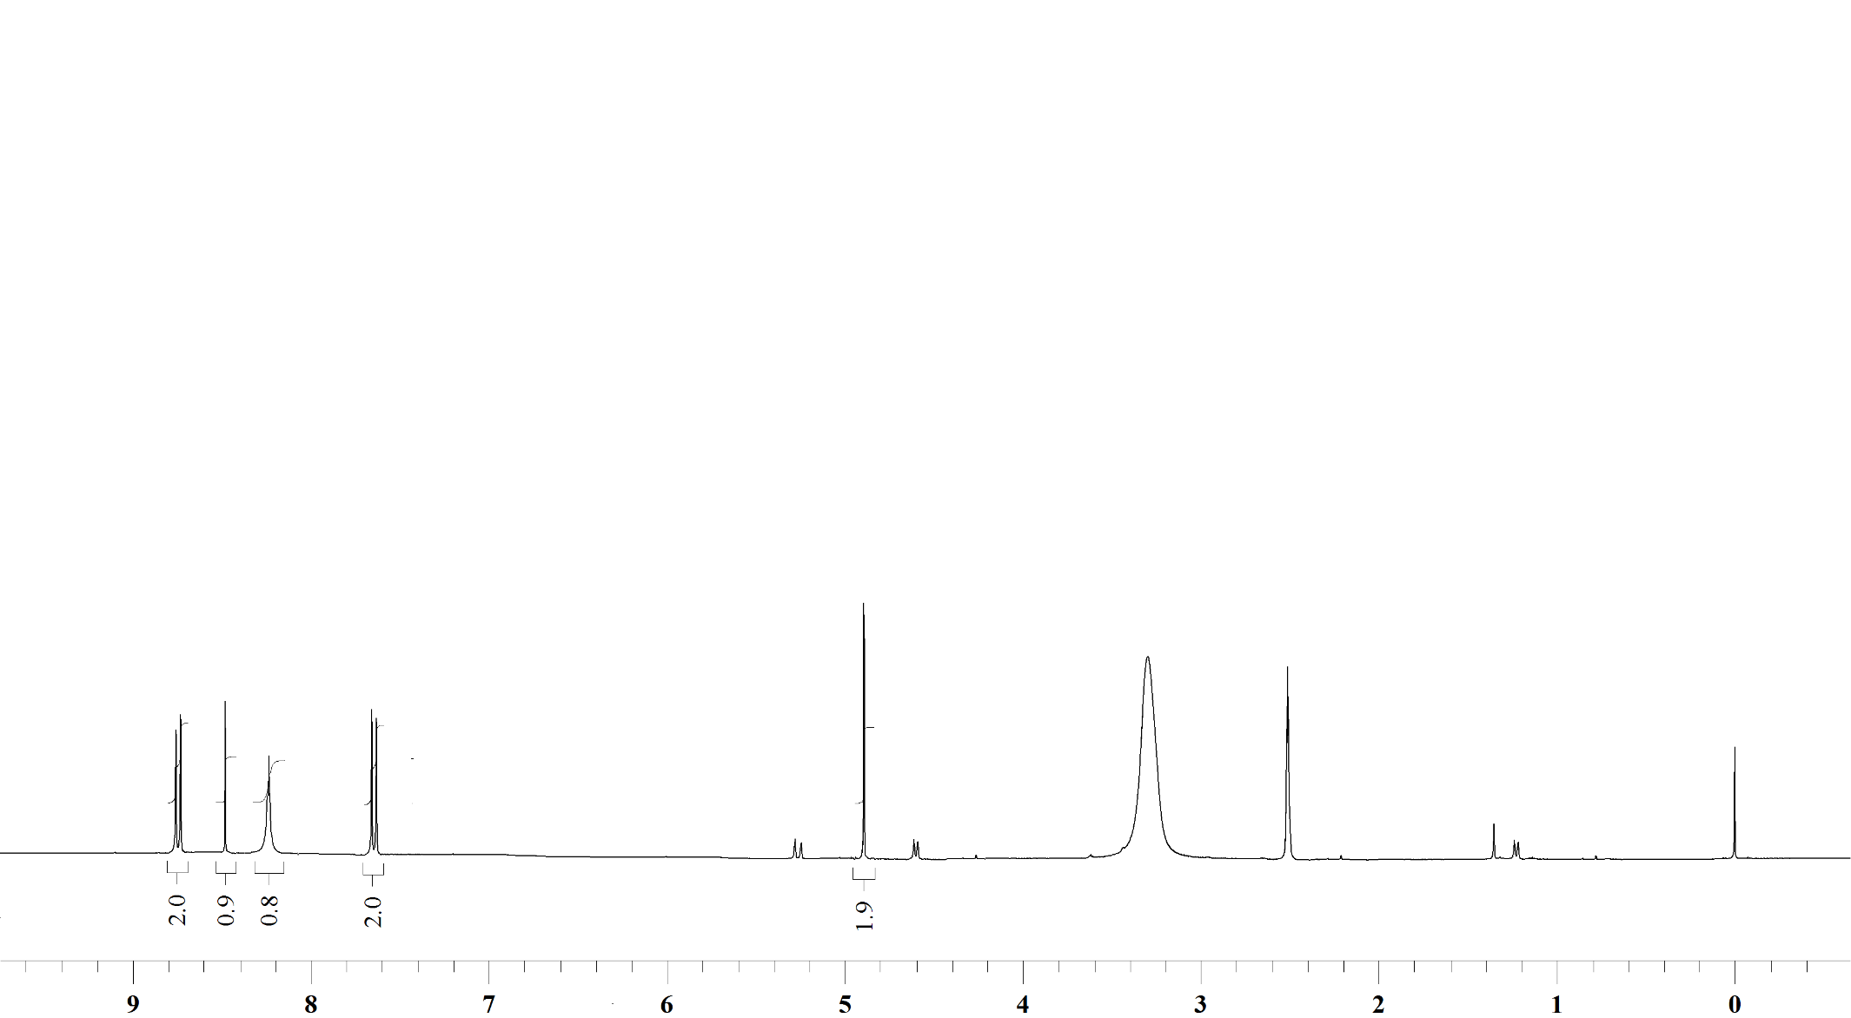

¹H NMR Spectrum of compound 25 in DMSO-d₆ (400 MHz)

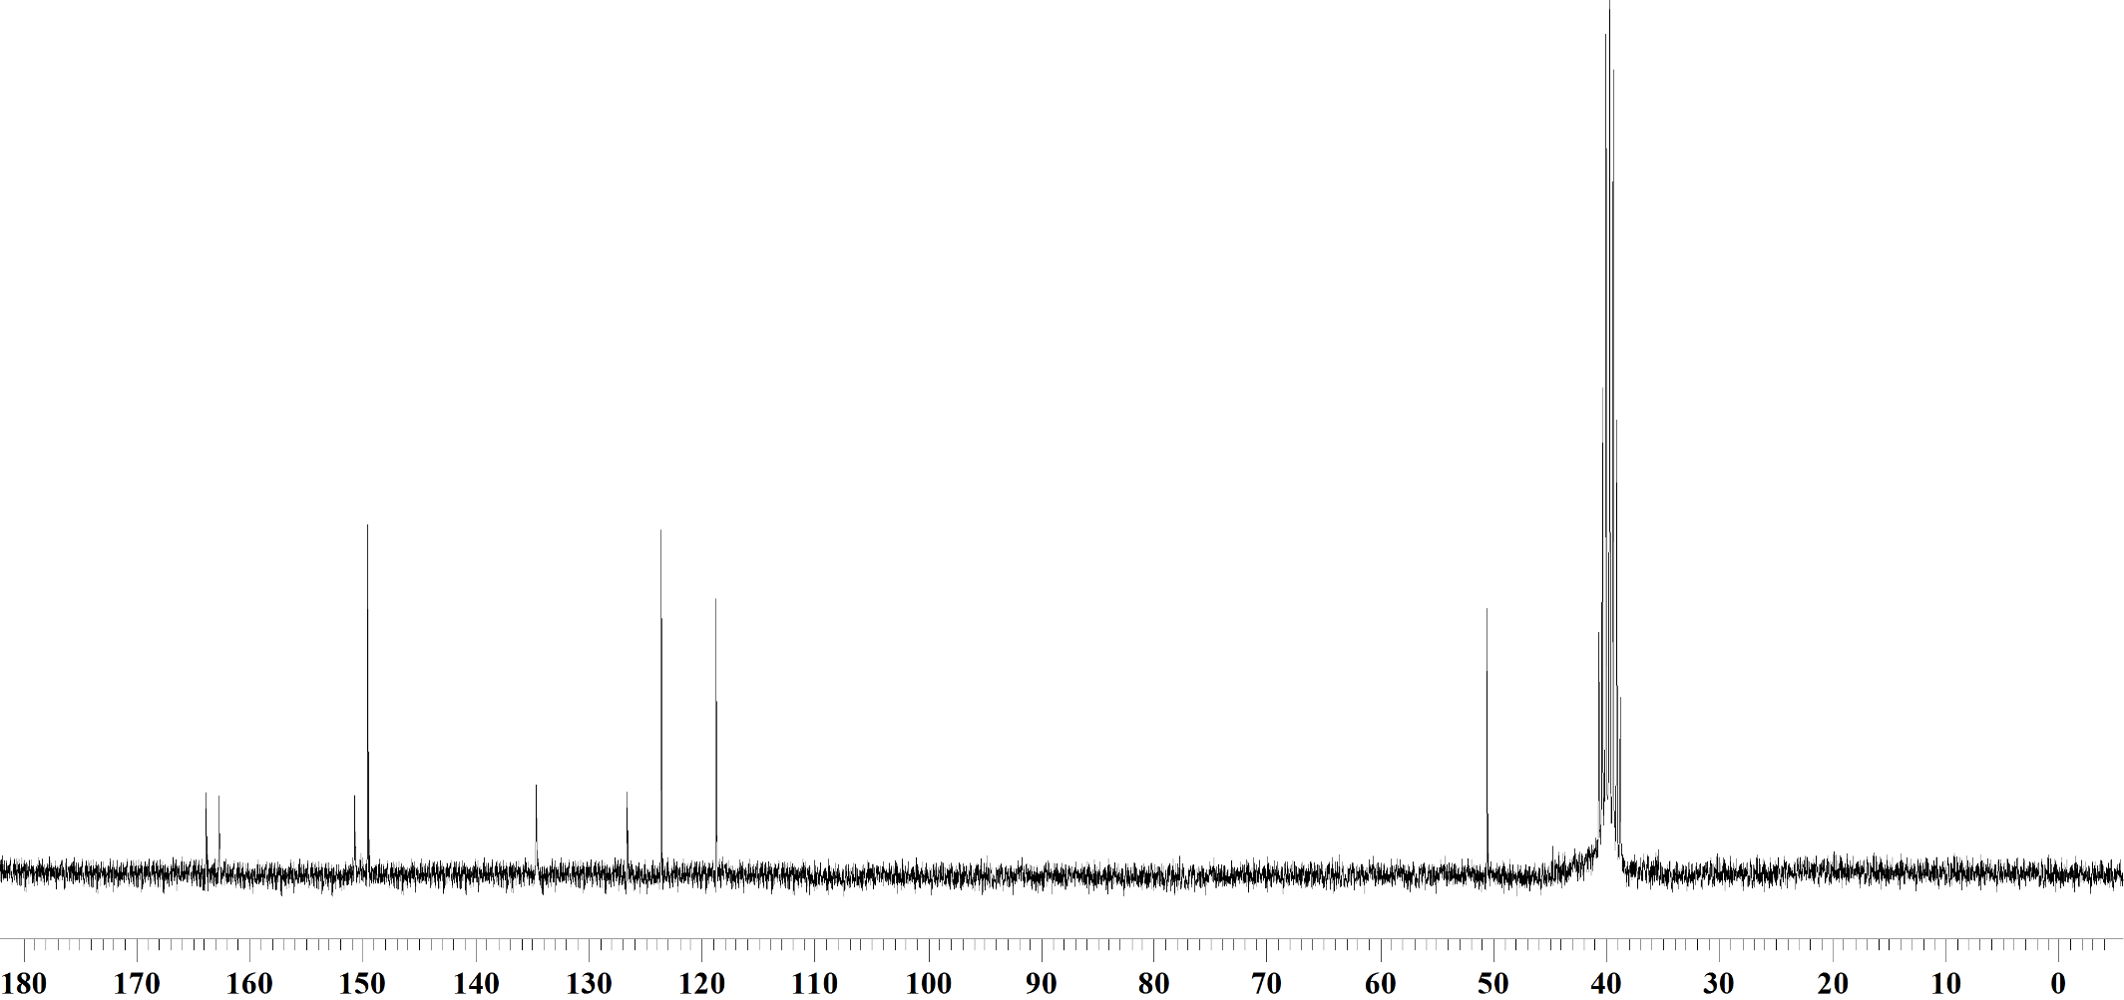

¹³C NMR Spectrum of compound 25 in DMSO-d₆ (100 MHz)

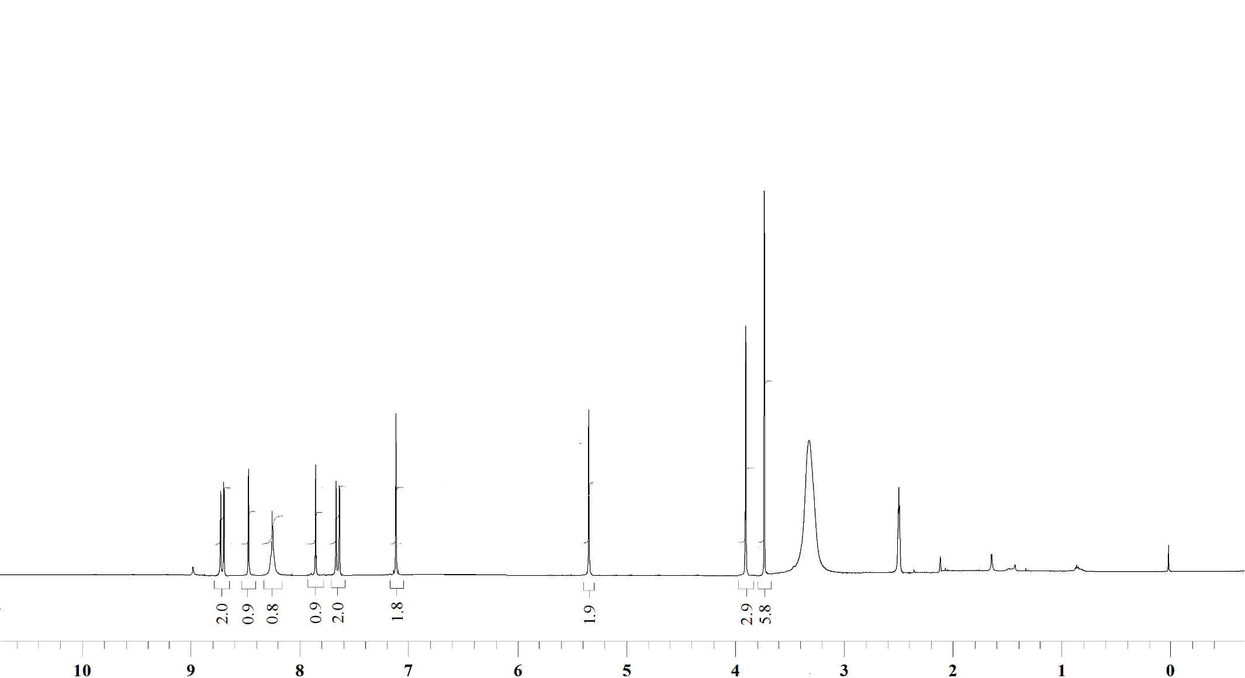

¹H NMR Spectrum of compound 27a in DMSO-d₆ (400 MHz)

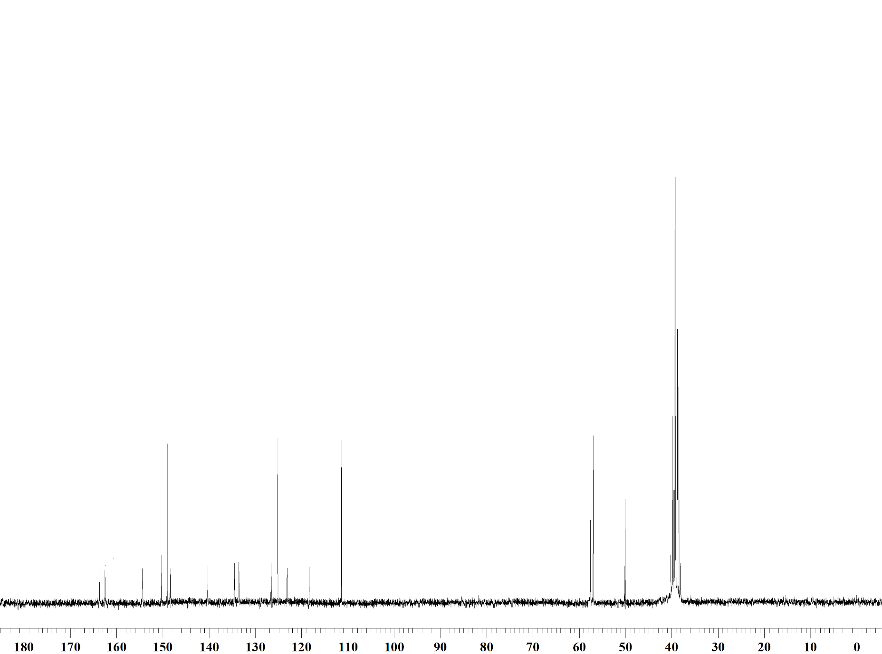

¹³C NMR Spectrum of compound 27a in DMSO-d₆ (100 MHz)

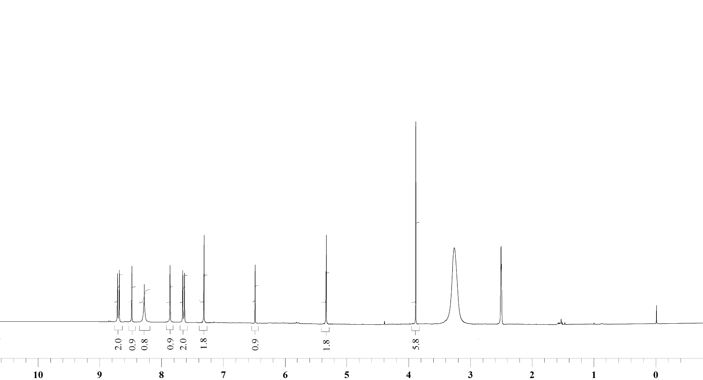

¹H NMR Spectrum of compound 27b in DMSO-d₆ (400 MHz)

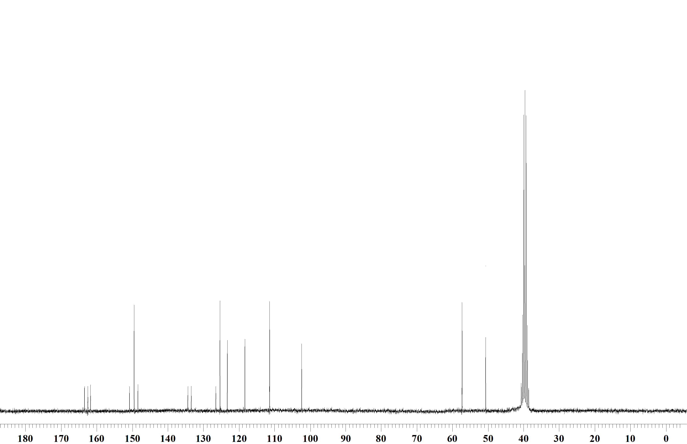

¹³C NMR Spectrum of compound 27b in DMSO-d₆ (100 MHz)

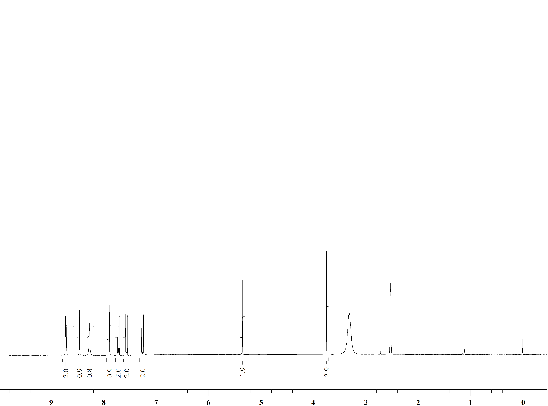

¹H NMR Spectrum of compound 27c in DMSO-d₆ (400 MHz)

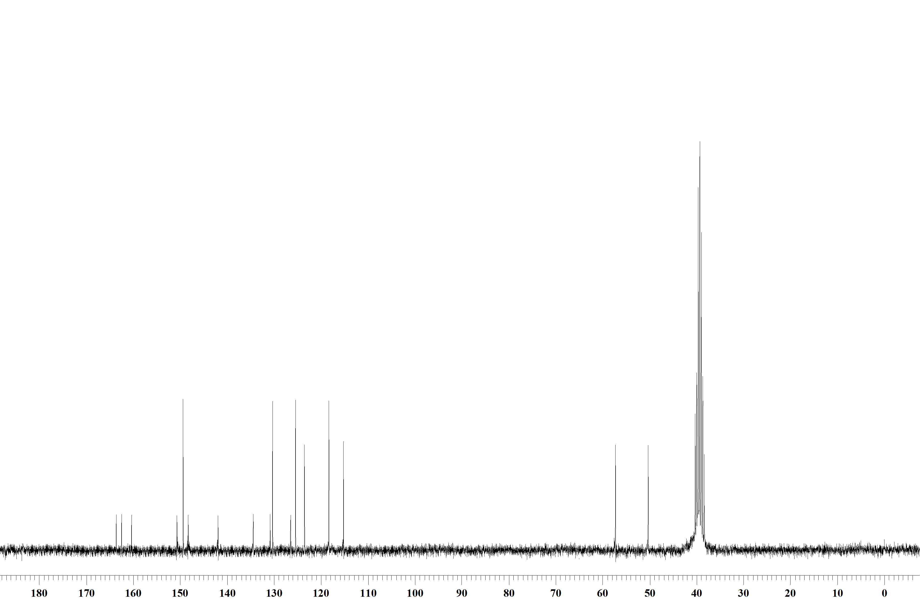

¹³C NMR Spectrum of compound 27c in DMSO-d₆ (100 MHz)

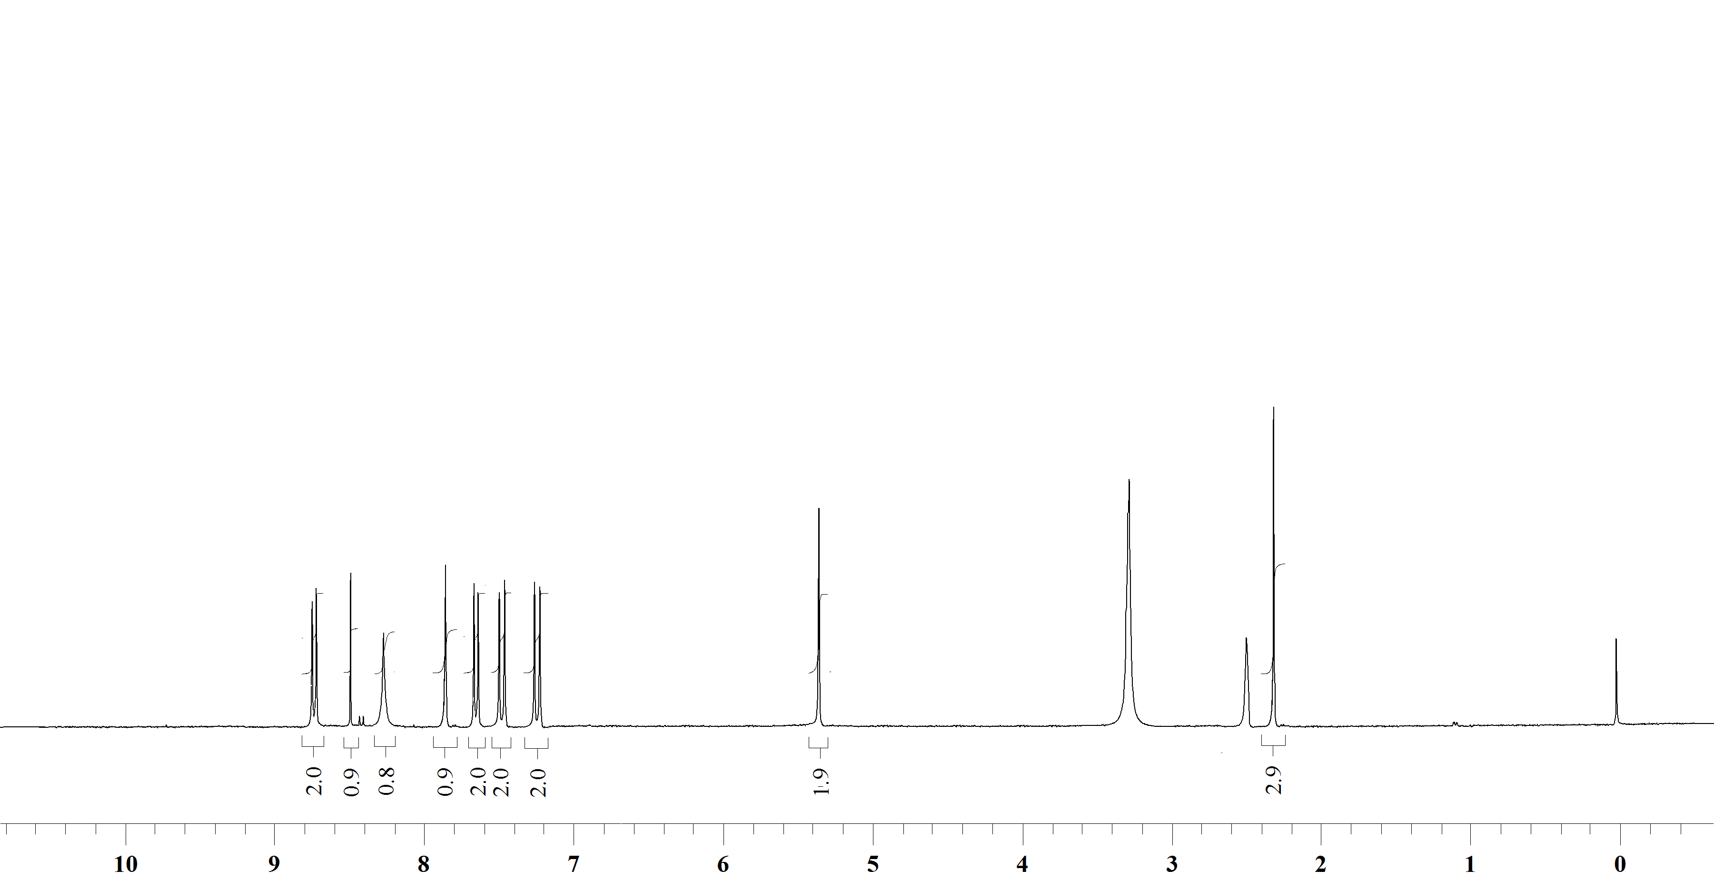

¹H NMR Spectrum of compound 27d in DMSO-d₆ (400 MHz)

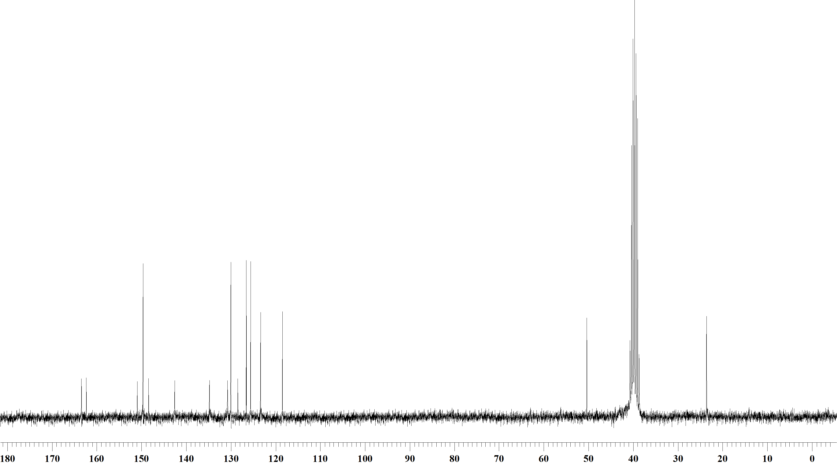

¹³C NMR Spectrum of compound 27d in DMSO-d₆ (100 MHz)

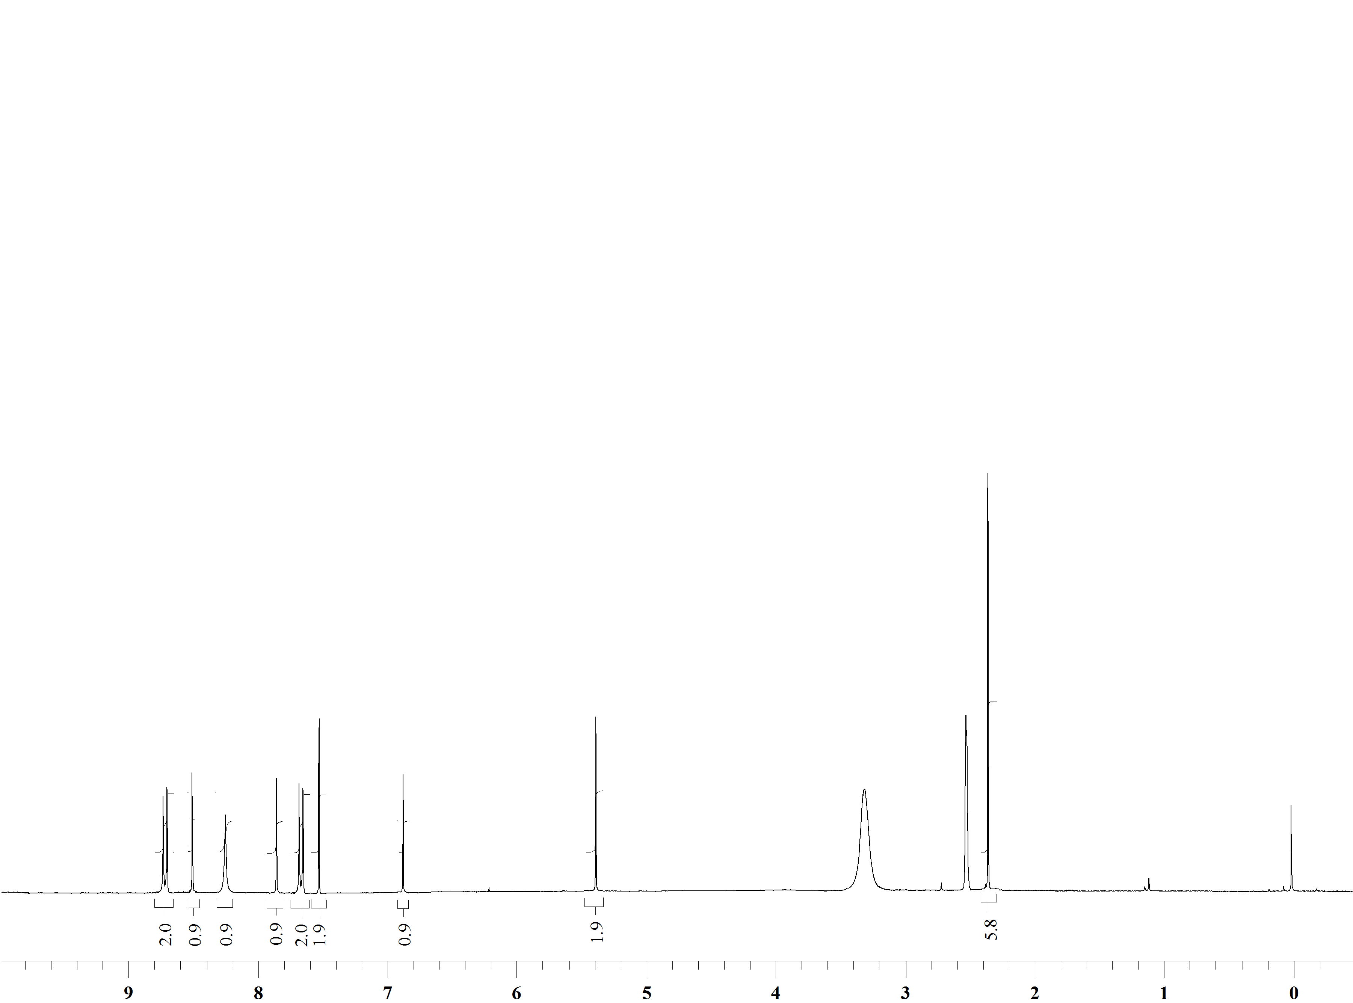

¹H NMR Spectrum of compound 27e in DMSO-d₆ (400 MHz)

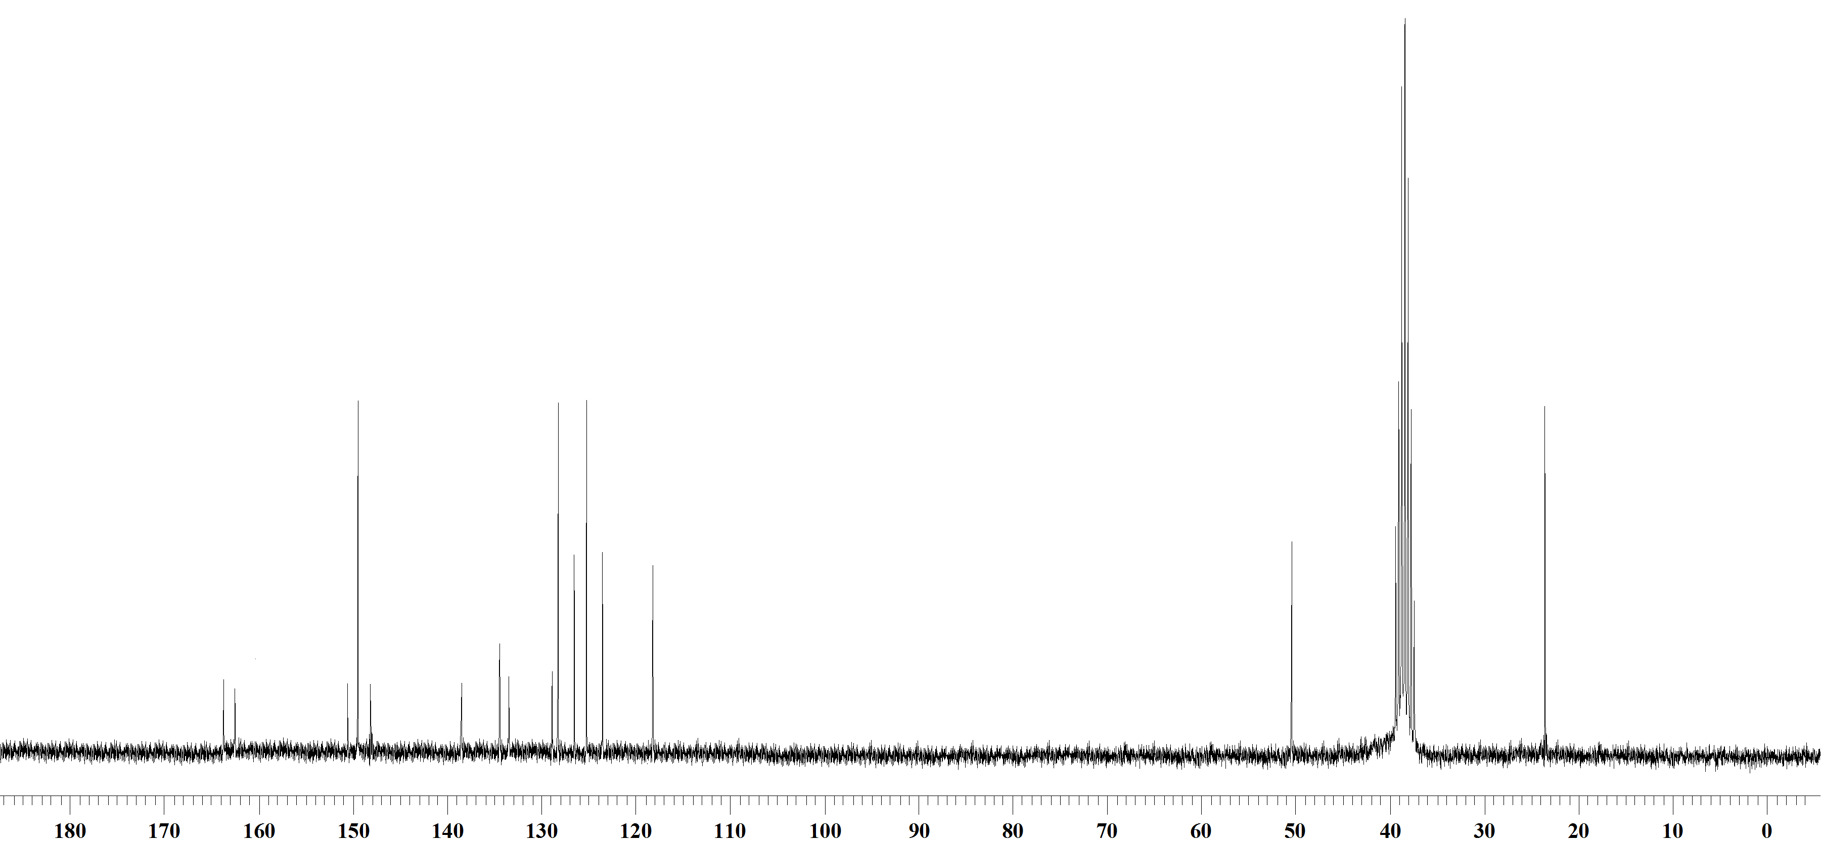

¹³C NMR Spectrum of compound 27e in DMSO-d₆ (100 MHz)
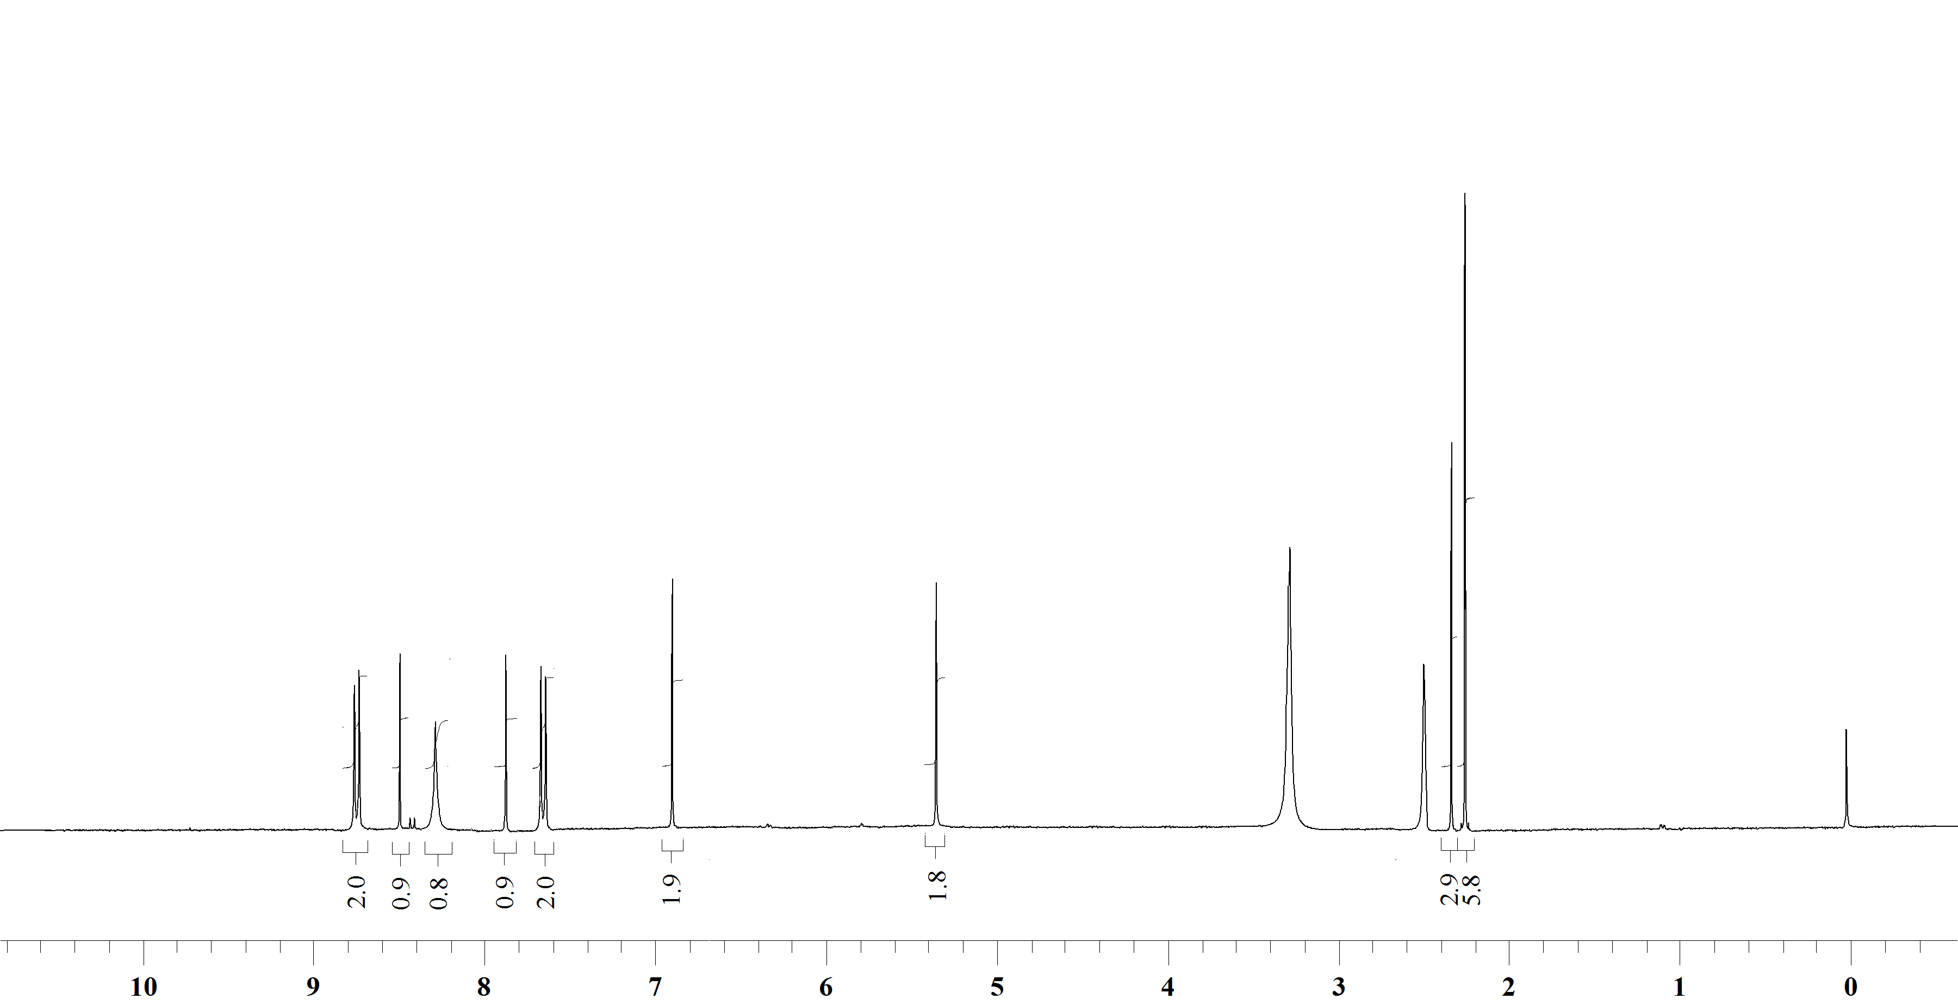

¹H NMR Spectrum of compound 27f in DMSO-d₆ (400 MHz)

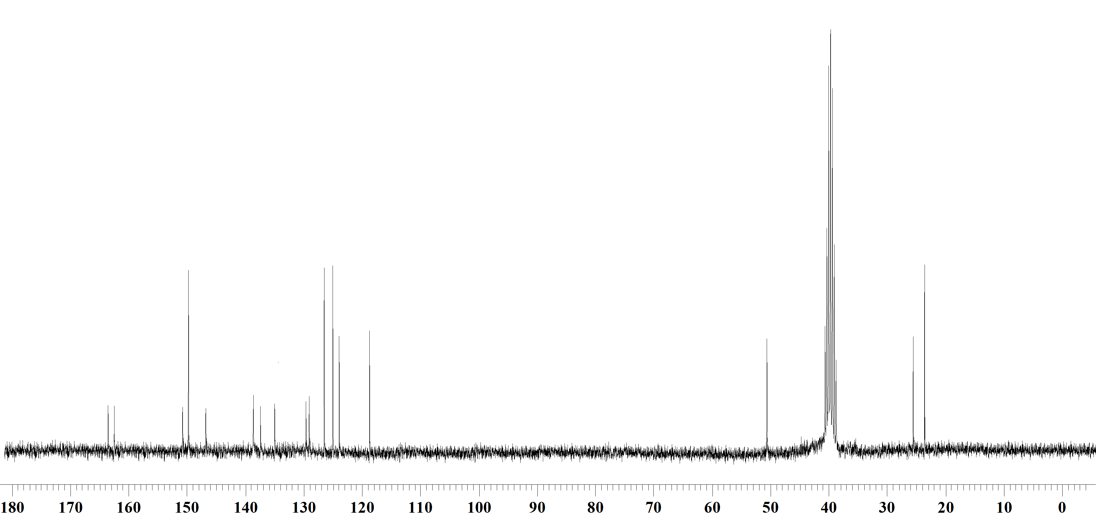

¹³C NMR Spectrum of compound 27f in DMSO-d₆ (100 MHz)

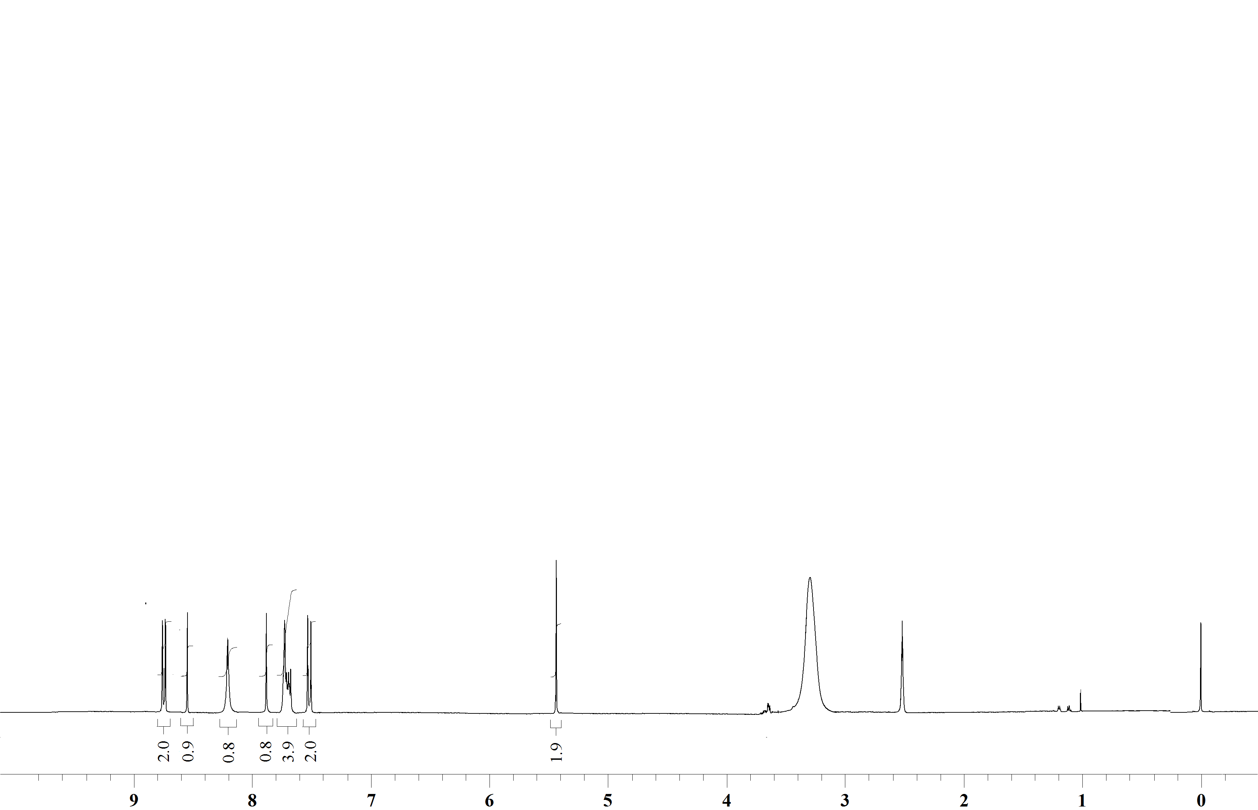

¹H NMR Spectrum of compound 27g in DMSO-d₆ (400 MHz)

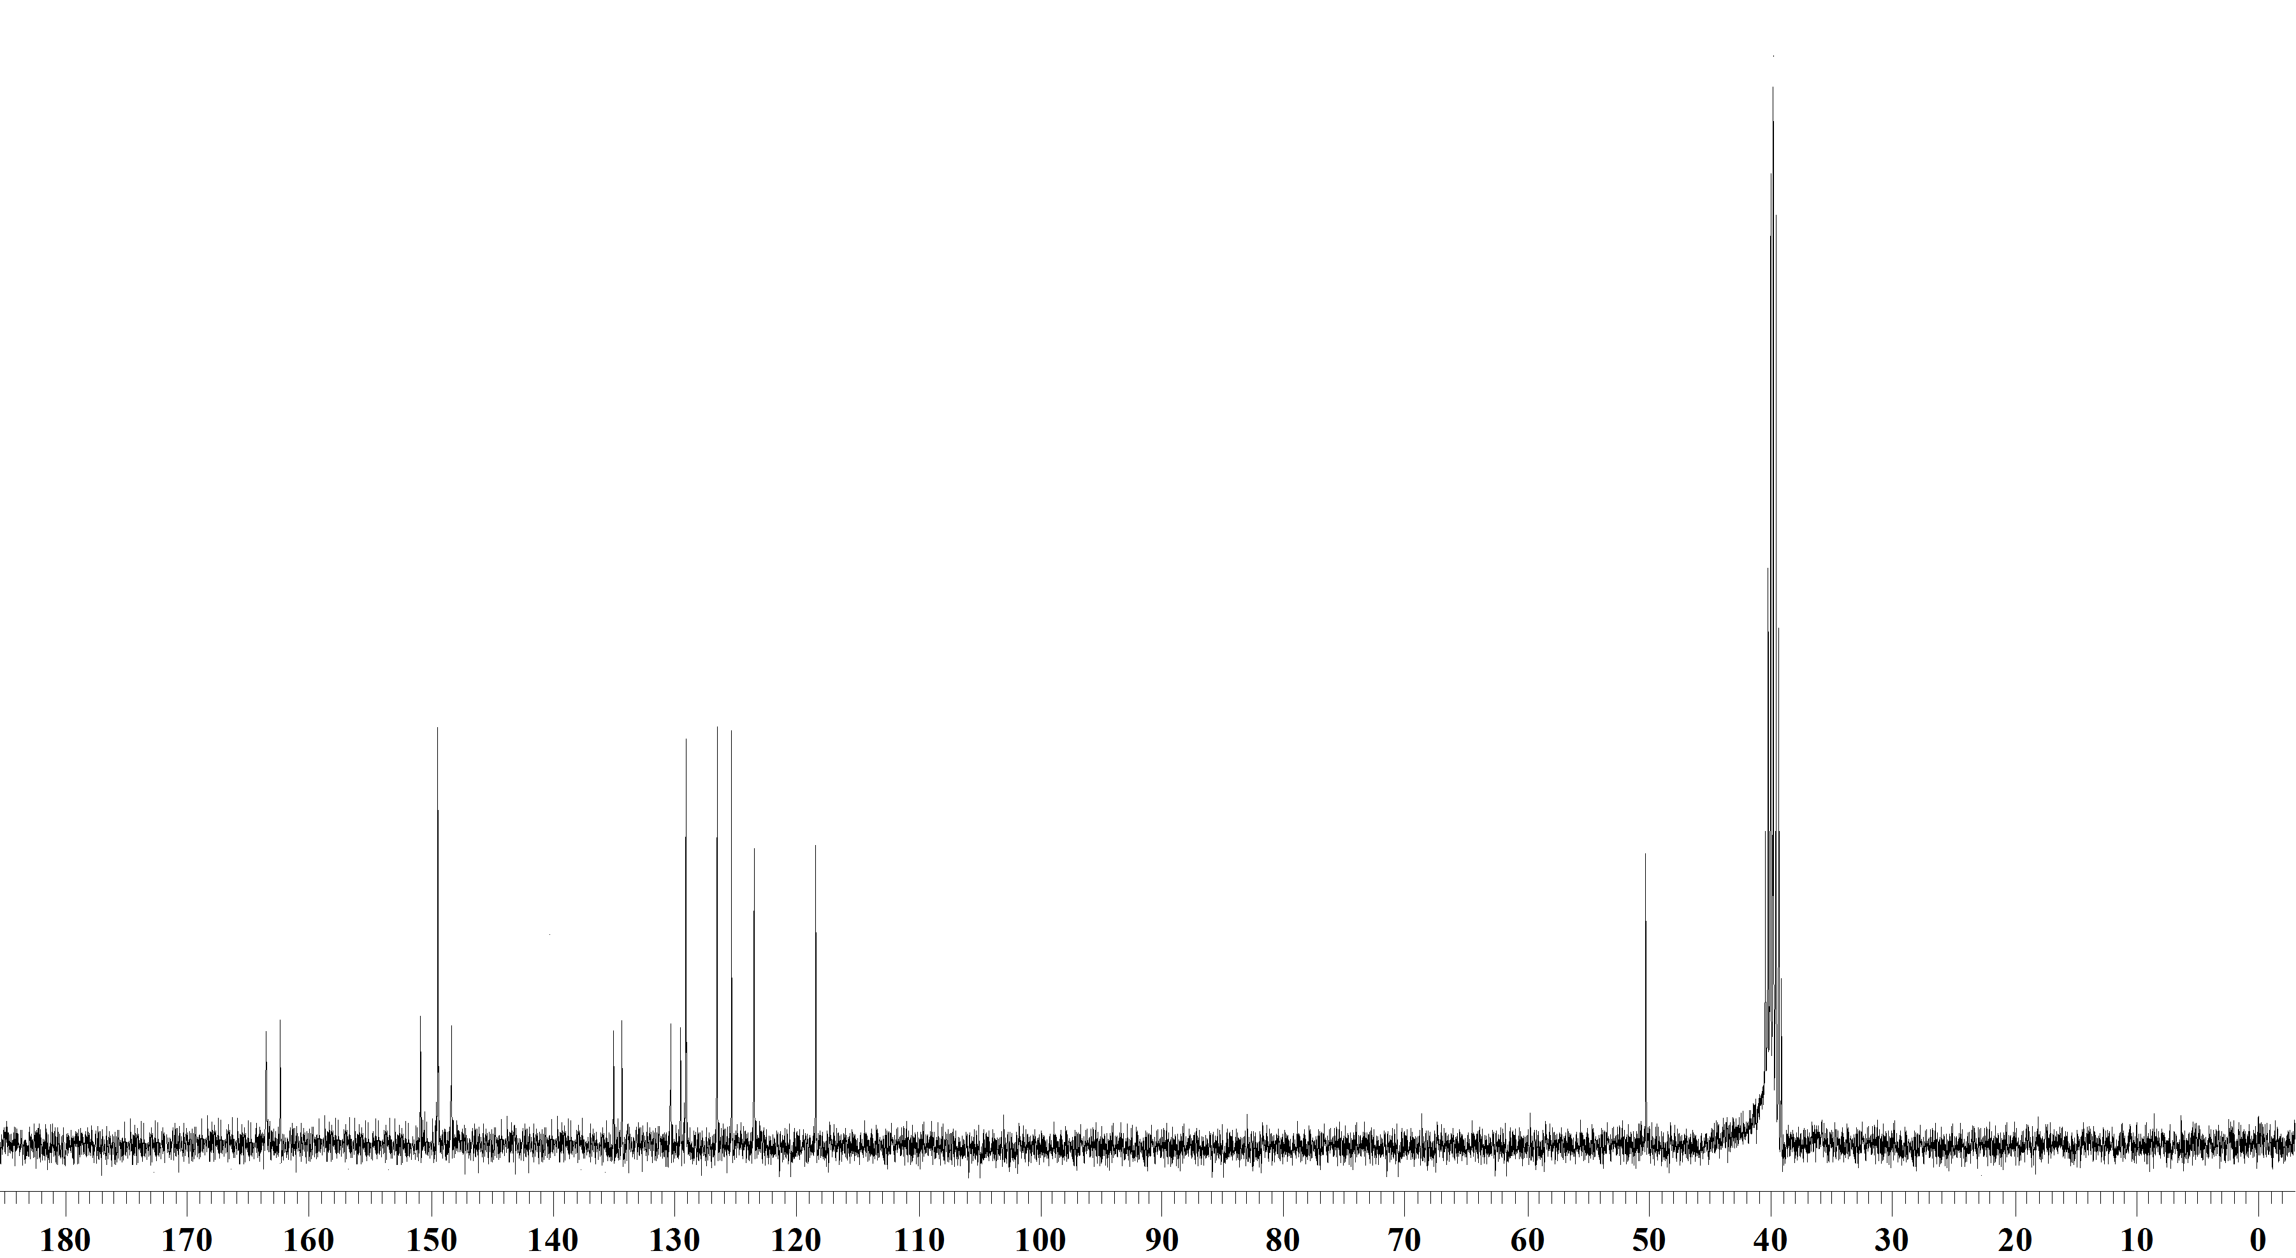

¹³C NMR Spectrum of compound 27g in DMSO-d₆ (100 MHz)

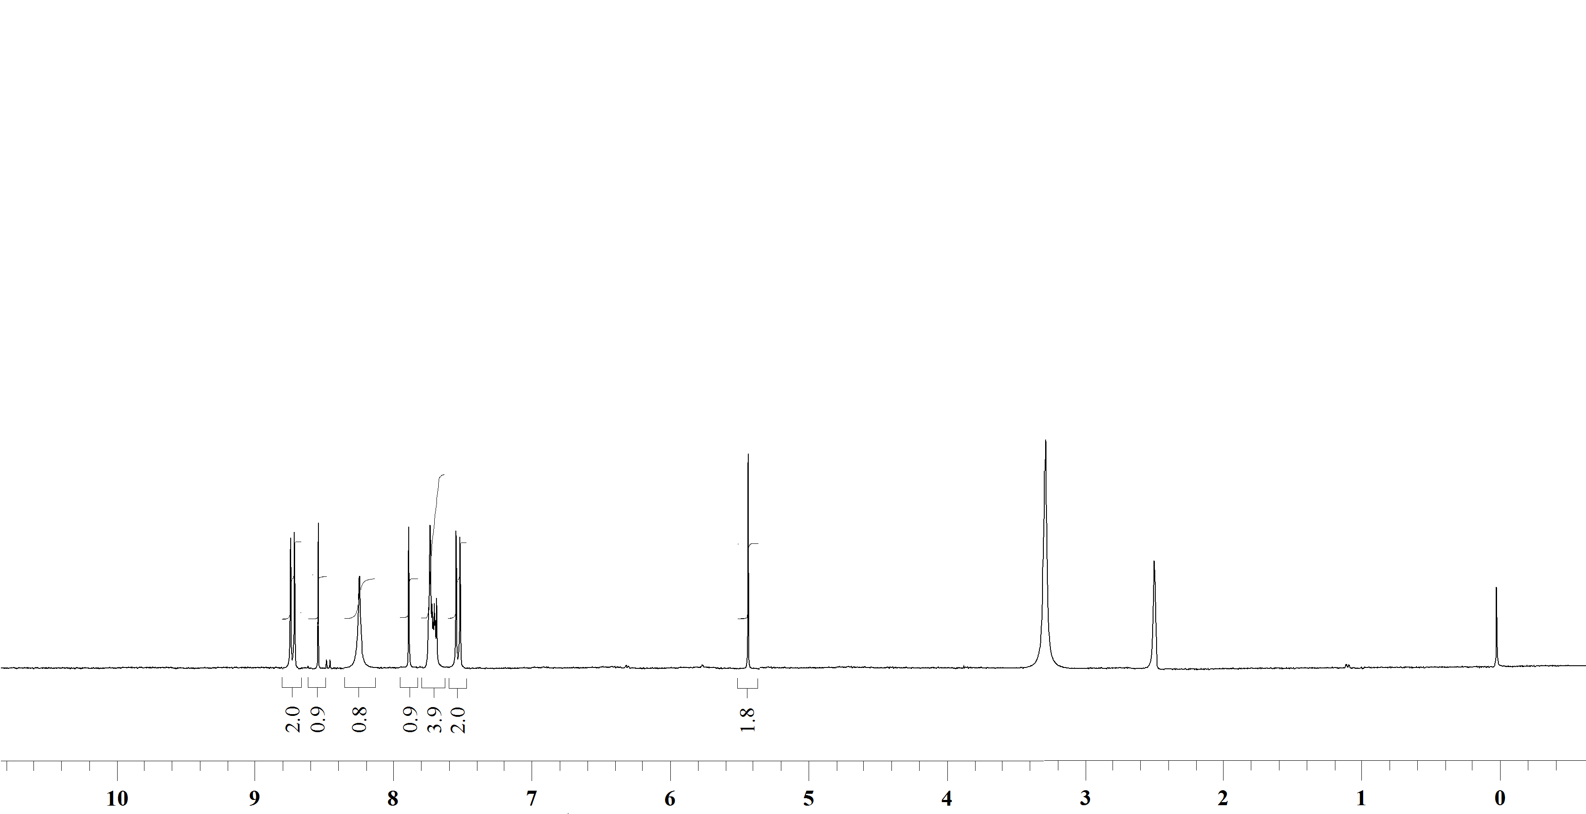

¹H NMR Spectrum of compound 27h in DMSO-d₆ (400 MHz)

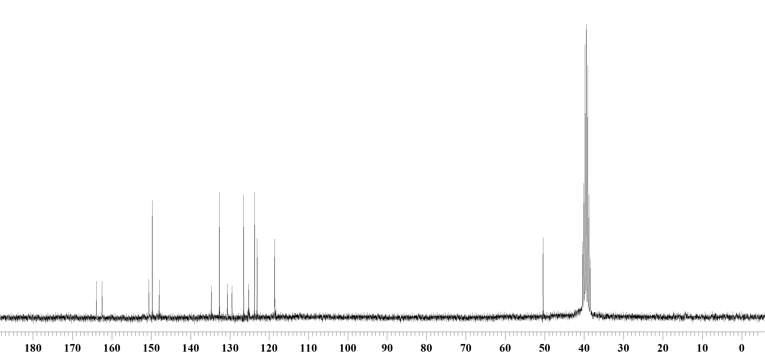

¹³C NMR Spectrum of compound 27h in DMSO-d₆ (100 MHz)

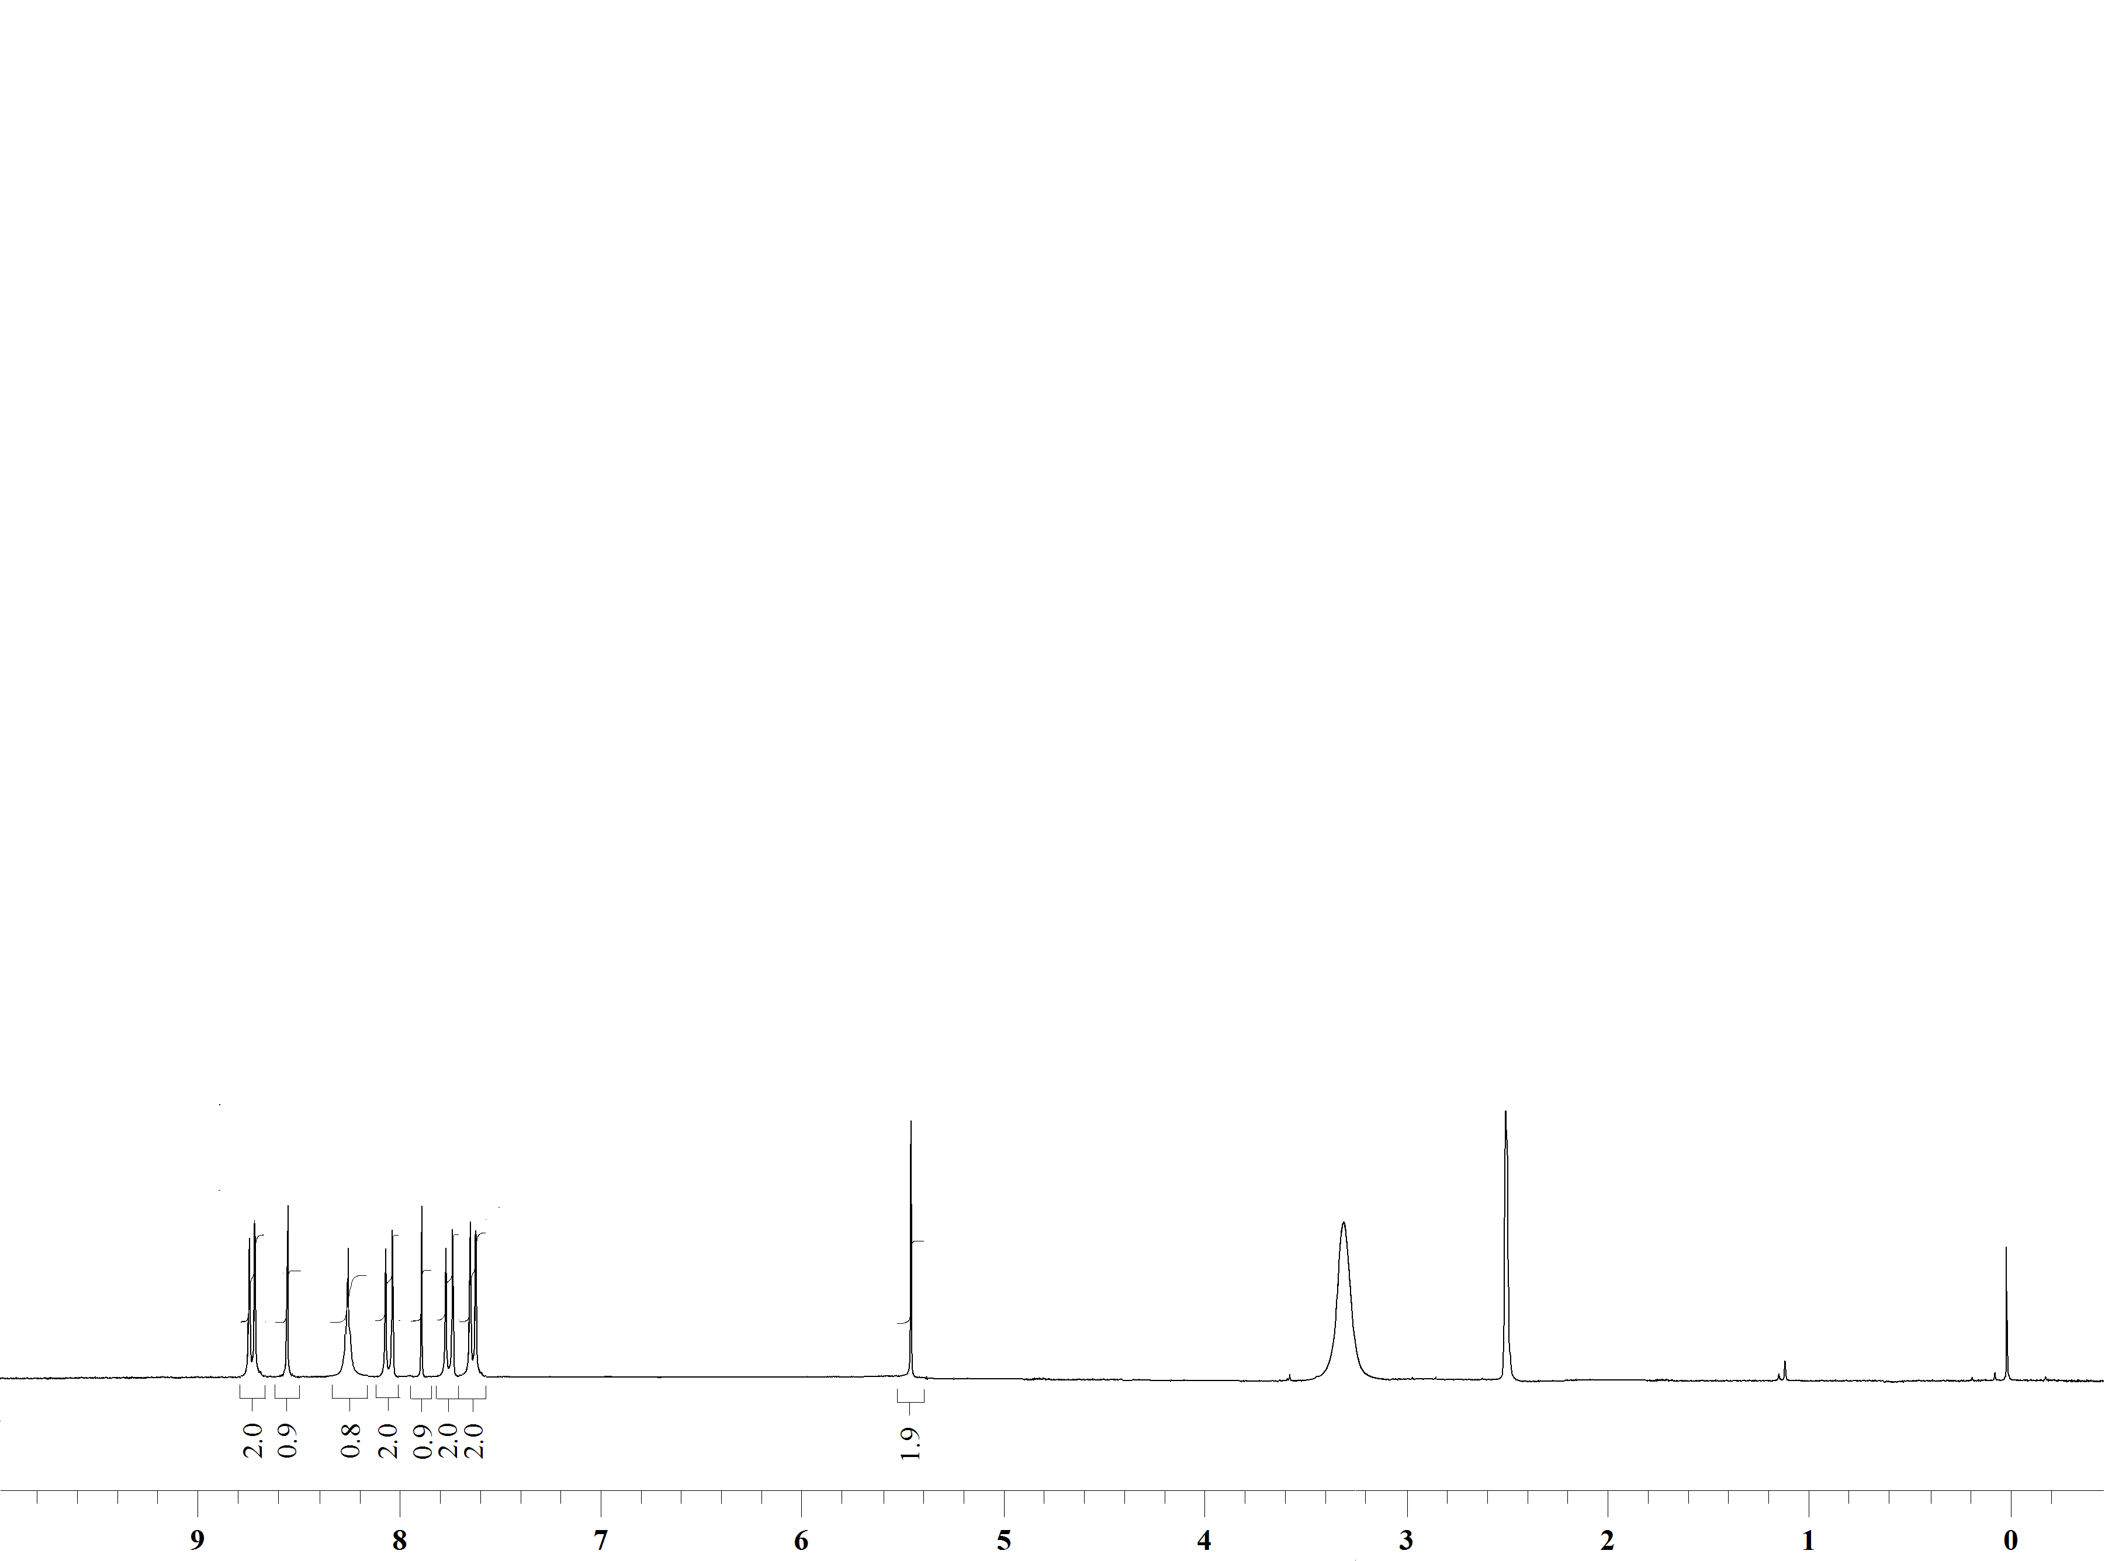

¹H NMR Spectrum of compound 27i in DMSO-d₆ (400 MHz)

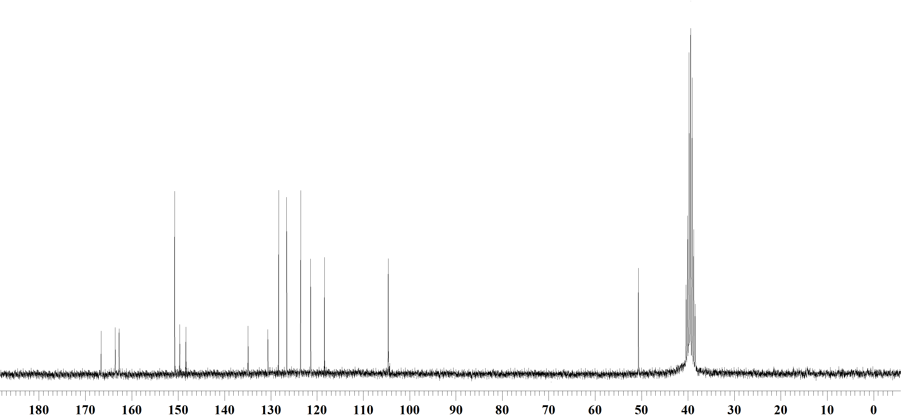

¹³C NMR Spectrum of compound 27i in DMSO-d₆ (100 MHz)

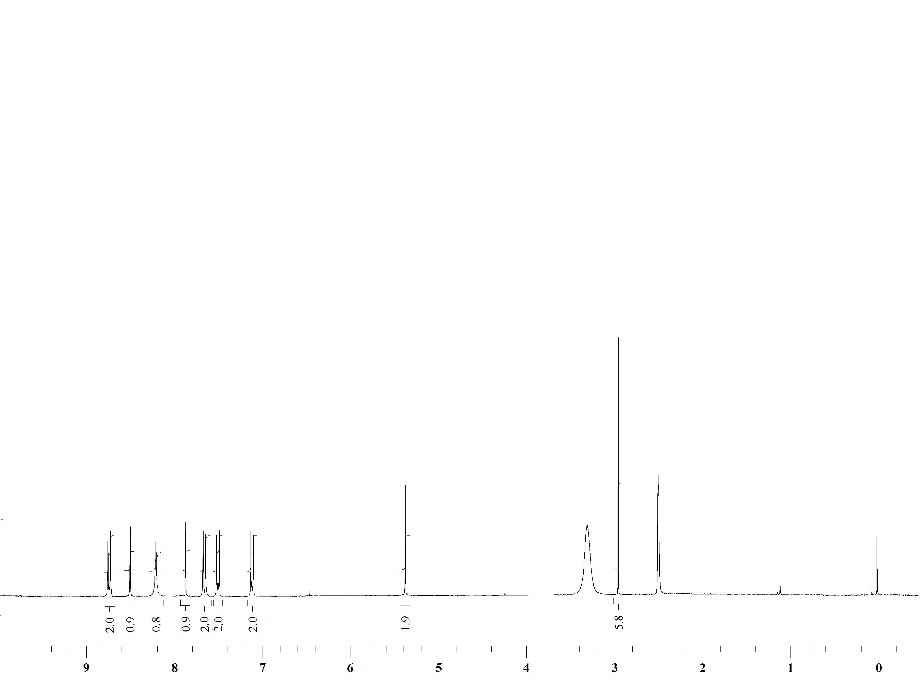

¹H NMR Spectrum of compound 27j in DMSO-d₆ (400 MHz)

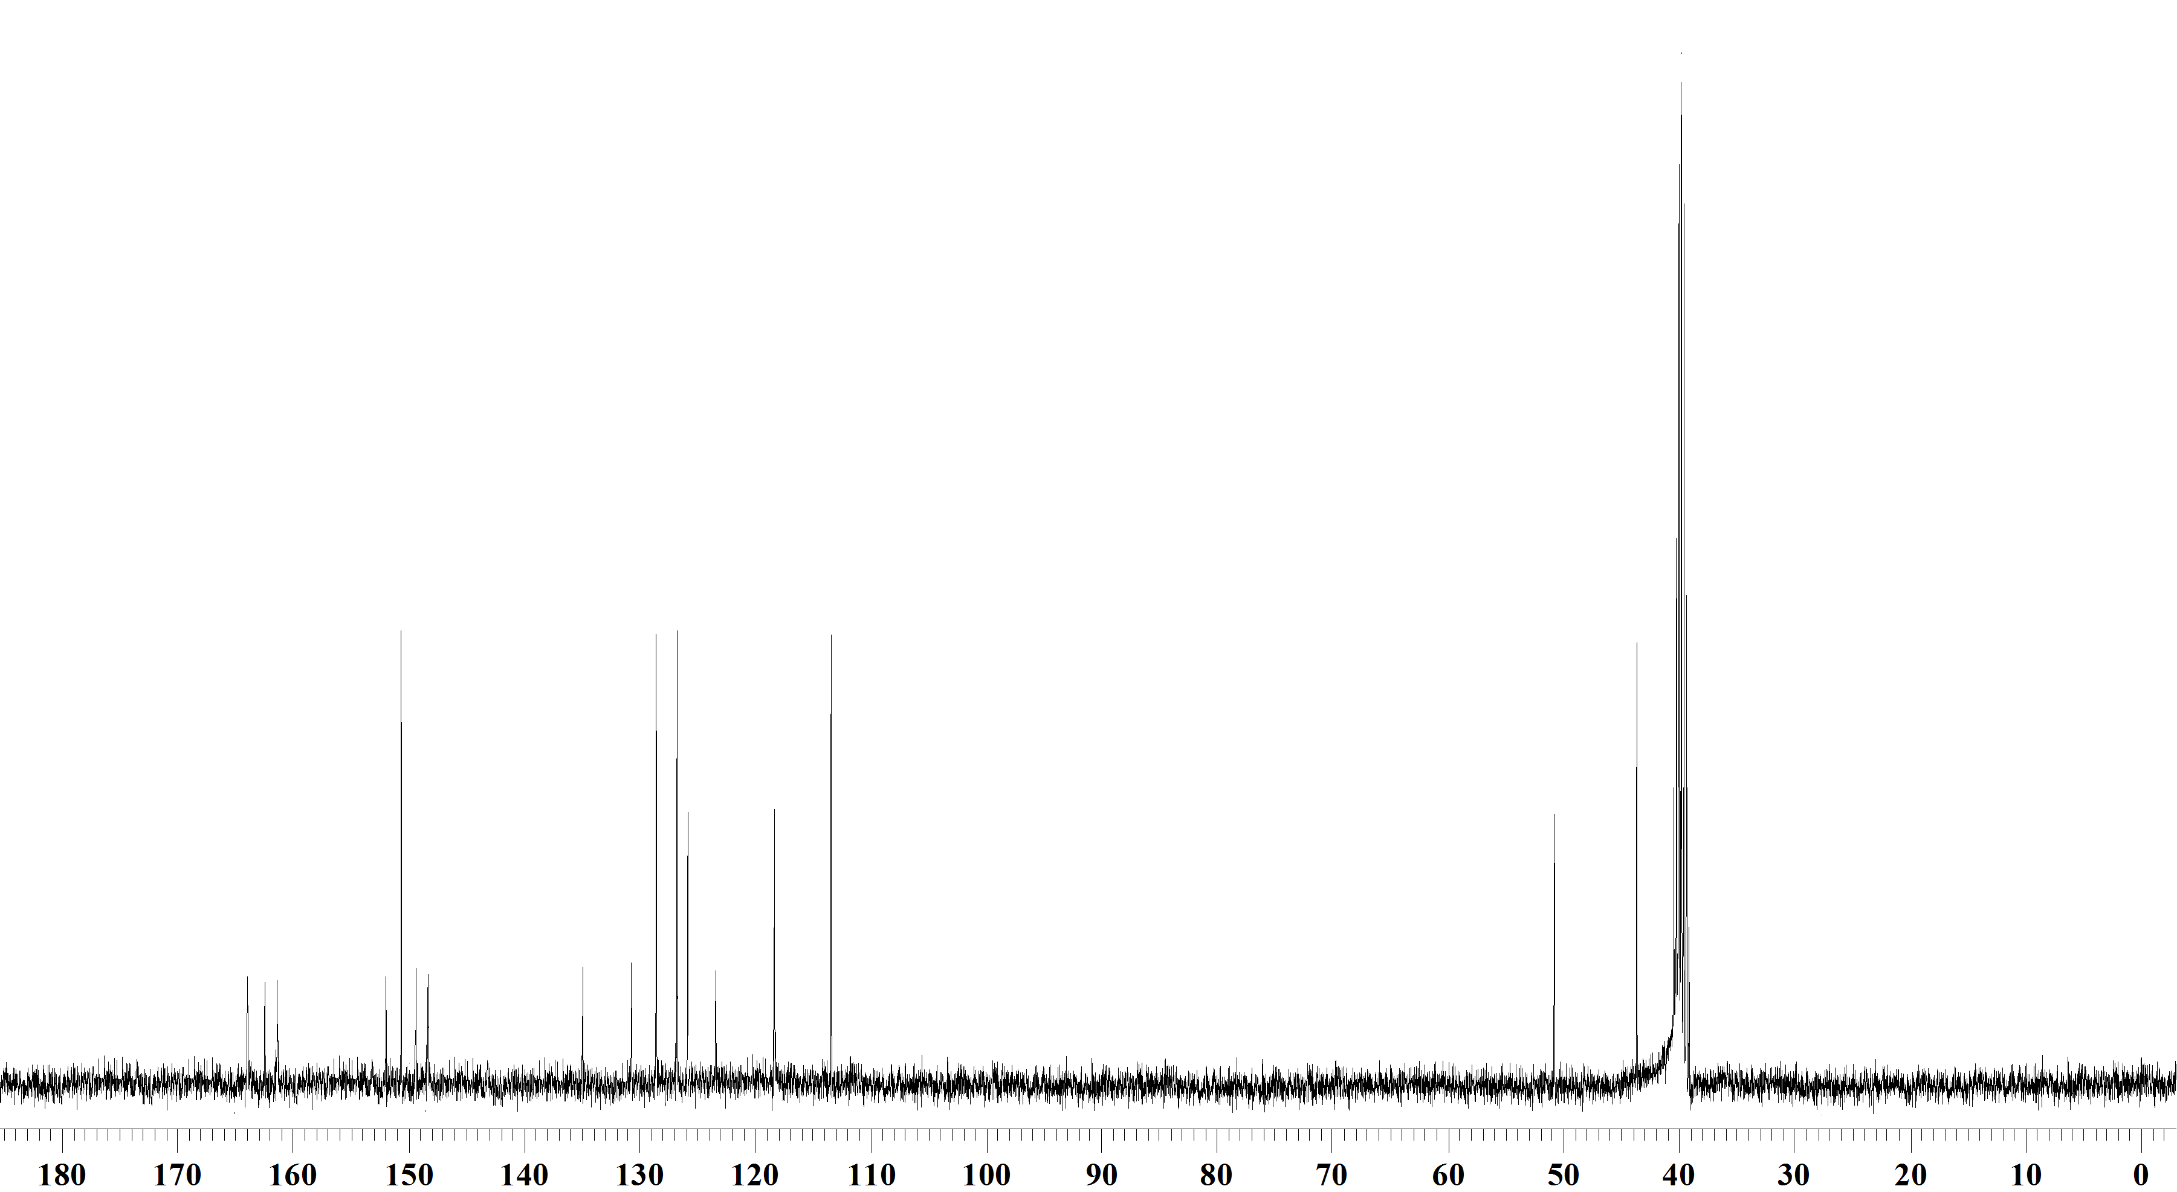

¹³C NMR Spectrum of compound 27j in DMSO-d₆ (100 MHz)

