Supplemental - Phase Complexity and Structural Evolution of the Al-Ni System under Shock Loading: A Molecular Dynamics Study
  - Logan Nagy, Adib J. Samin
Department of Engineering Physics, Air Force Institute of Technology, 2950 Hobson Way, Wright-Patterson Air Force Base, OH, 45433, USA
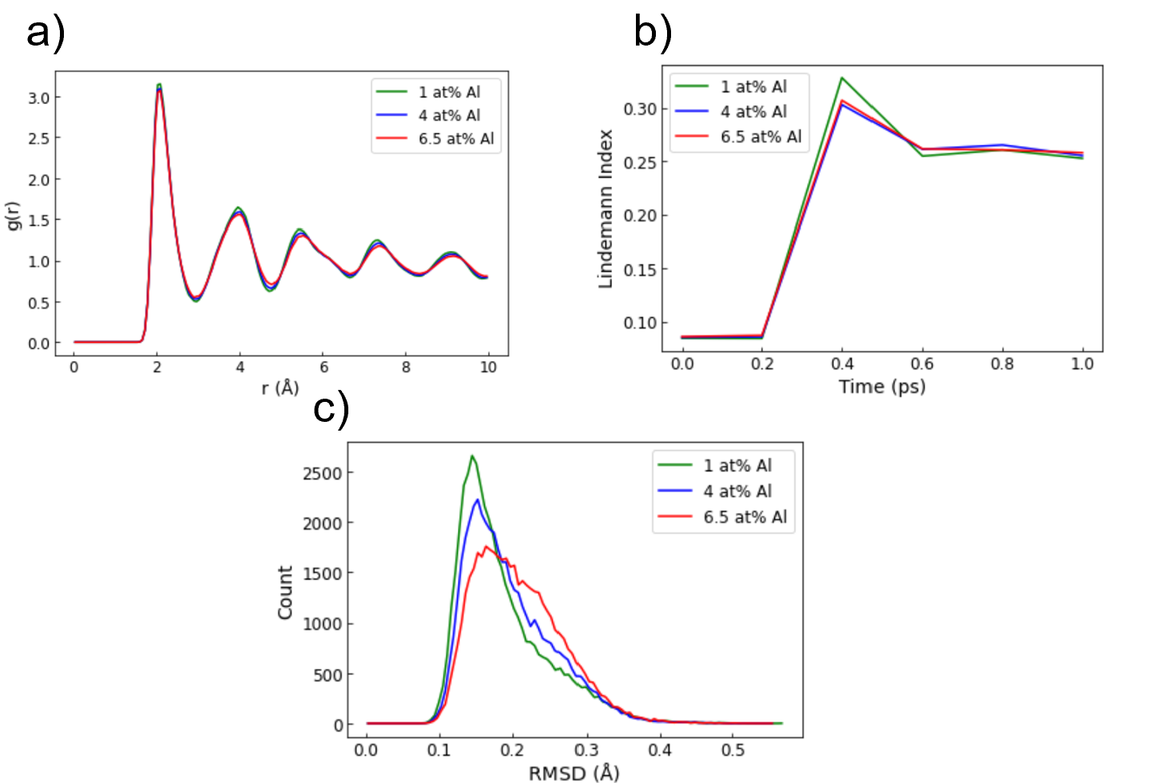
- Solid Solution Melting

Figure S1: (a) Radial distribution function (RDF), (b) Lindemann Index, and root mean square deviation (RMSD) of solid solutions
The initial measurement observed to identify the onset of melting is the radial distribution function (RDF). The Expression Selection feature in OVITO is used to select bins 5-6 of the supercell, and the evolution of the RDF is observed over time. In this study, the onset of melting is qualitatively defined as peaks that show g(r) converging to 1, while still showing peaks with solid behavior. This allows us to identify solid-liquid coexistence in the supercell as opposed to identifying the purely liquid phase. Identifying this distribution is evident, as lower particle speeds never bring the RDF to converge, and higher particle speeds immediately converge to g(r) = 1.
From the RDF, the Lindemann Index can be derived. The Lindemann Index is a measure of atomic disorder, making it suitable for melting detection. The index is proportional to the root mean square deviation (RMSD) and full-width half maximum (FWHM) of the RDF []. The Lindemann Index is first derived using the RDF [38]:
$q_{i} = \frac{\text{FWHM}}{{\text{d}}_{\text{0}}}$ (2)

where $\text{FWHM}$ is the full-width half maximum of the first peak in g(r) and ${\text{d}}_{\text{0}}$ is the distance r of the first peak, corresponding to the mean interatomic distance. Using this method, we can observe how the Lindemann Index evolves over time.

To further validate the onset of melting, RMSD spatial profiles were calculated. The spatial profiles were derived in OVITO and can be defined as [40]:
$RMSD= \sqrt{〈r^{2}(t)〉}= \sqrt{〈\frac{1}{N} \sum_{i=0}^{N}{{(r_{i}\left(t\right)- r_{i}\left(0\right))}^{2}}〉}$ (3)
where $r\left(t\right)$ is the position of the particle at time $t$ and $N$ is the number of particles.

The RMSD values can also confirm melting through recalculating the Lindemann Index for bins 5 and 6. This study calculates the Lindemann Index using the RMSD to verify the values derived from the RDF. This allows us to also derive the Lindemann Index using [41]:
$q_{i}= \frac{1}{N - 1} \sum_{j≠i}{\frac{\sqrt{〈r_{ij}^{2}〉- {〈r_{ij}〉}^{2}}}{〈r_{ij}〉}}$ (4)
where $N$ is the number of interacting particles for the calculation, and $r_{ij}$ is the distance between atoms i and j. The Lindemann index values derived provide comparable values to those derived from the RDF. Both calculations yield an index of 0.26, verifying that melting first occurs at u_{p} = 3.5 km/s for the solid solutions.

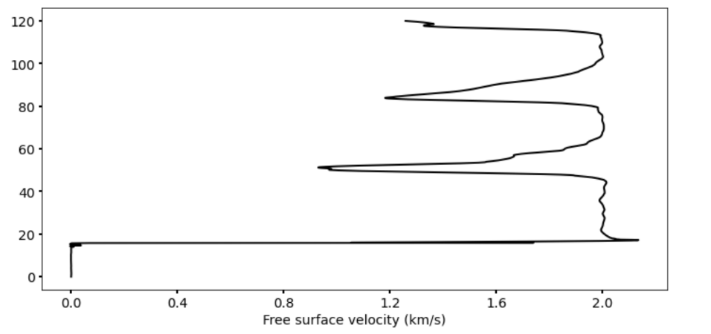
- Solid Solution Spallation
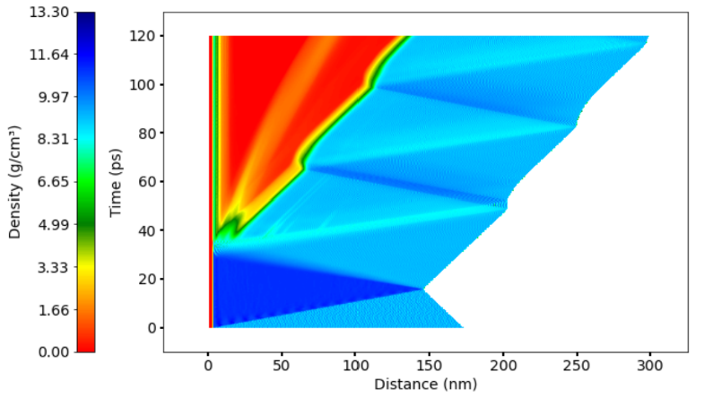
Figure S2: (a) Density heat map of pure nickel during spallation and (b) corresponding free surface velocity profile
Another indicator of spallation within the supercell is the free-surface velocity. For these simulations, 3 Å bins were used to analyze the free-surface velocity of the farthest z-boundary of the supercell. Shown in Figure S2, the free-surface velocity is stagnant while the supercell is being compressed and increases upon release. Once spallation occurs in the supercell, the free surface velocity oscillates with a smaller range between its maximum and minimum values.

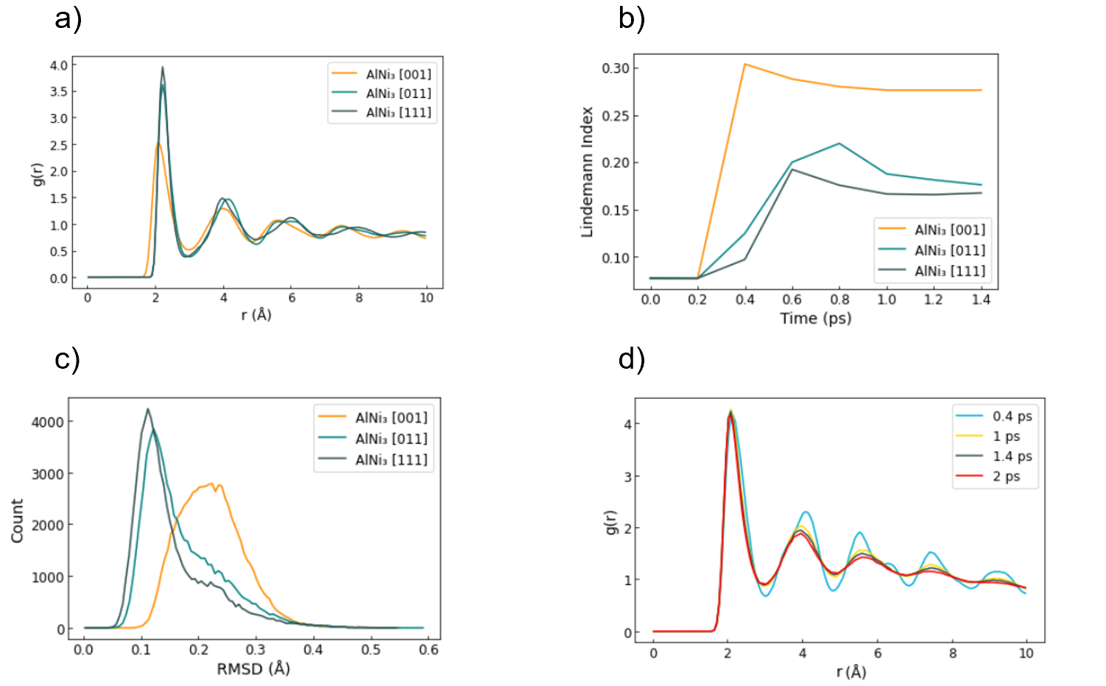
- Intermetallic Melting

Figure S3: (a) RDF, (b) Lindemann Index and (c) RMSD of oriented AlNi₃. (d) Evolution of RDF for AlNi₃ oriented in the [001] direction at u_{p} = 3.5 km/s

As seen in Figure S3a, the different orientations exhibit differences in the first peak of the RDF due to the different particle velocities applied. AlNi₃ in the [001] direction does not exhibit melting till a much higher particle velocity. This results in the first peak having a significantly lower g(r) value. Even with the difference in particle velocities and first peak values, all three orientations show convergence to g(r) = 1 by r = 10 Å, with approximately equal g(r) oscillations occurring after r = 4 Å.
The Lindemann indices of the oriented intermetallics in Figure S3b allow us to quantify the disorder taking place in the RDF in Figure S3a. AlNi₃ exhibits much greater disorder than both the [011] and [111] directions. The disorder in the [001] direction also takes place approximately 0.3 ps prior to the other orientations. An interesting comparison is seen between AlNi₃ in the [011] and [111] directions. The applied particle velocity is 1.75 km/s for AlNi₃ [011] and 2.0 km/s for AlNi₃ [111]. However, the [011] orientation exhibits significantly more disorder given the slower particle velocity. This gives us insight into how prone each orientation is to disturbances.
Figure S3c illustrates the RMSD values for each orientation, which align with the RDF and Lindemann index (Figures S3a-b). AlNi₃ [001] exhibits an RMSD distribution that is almost entirely liquid-like. However, all lower particle velocities observed for the [001] orientation showed completely solid-like behavior. Comparable to the Lindemann index (Figure S3b), the [011] orientation exhibits more liquid phase than the [111]. The skewing of the distributions away from the peak signifies melting occurring within the supercells.
Figure S3d presents the evolution of the RDF for AlNi₃ in the [001] direction. The largest difference is seen between 0.4 ps and 1 ps right after the bins are introduced to the shock. After this, the RDF slowly converges to g(r) = 1 between 1 and 2 ps.

- Intermetallic Spallation
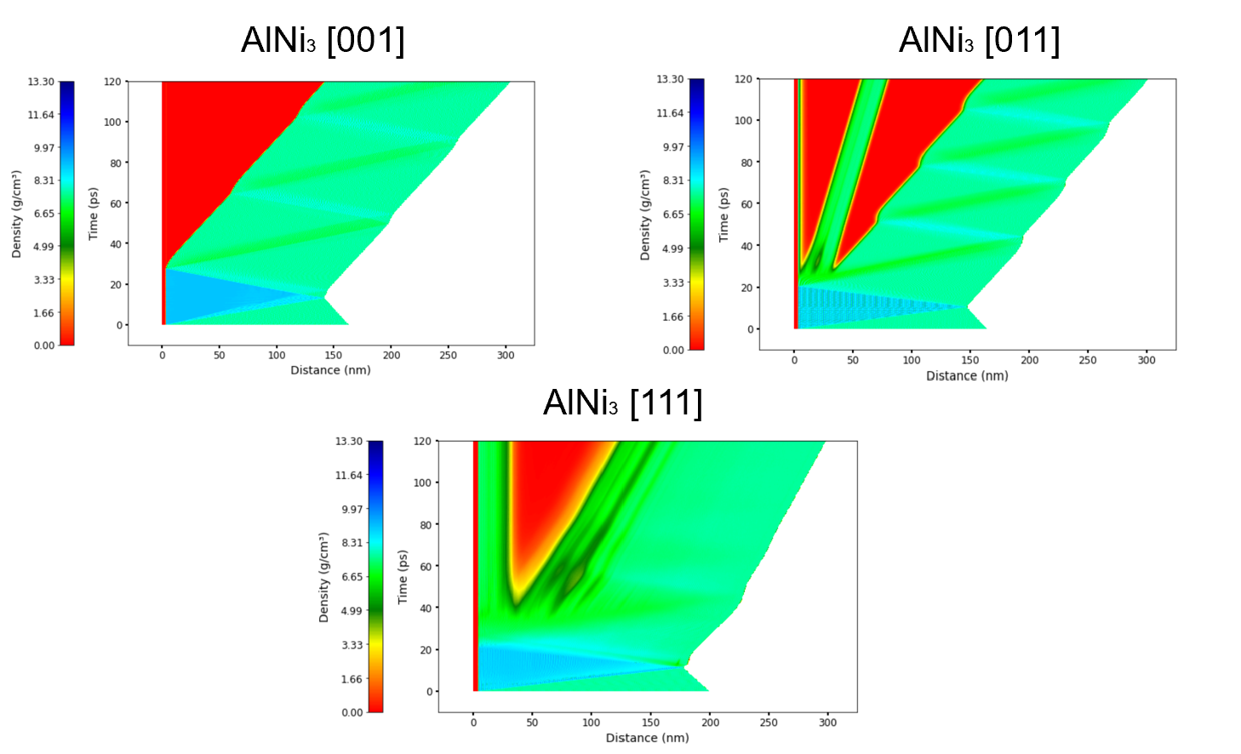
Spallation was observed in the oriented intermetallics. The density maps reflect the difference in composition between the Ni matrix and the less dense intermetallic compound AlNi₃.

Figure S4: Density heat maps of oriented AlNi₃ during spallation

As shown in Figure S4, the position and evolution of AlNi₃ spallation varies significantly with orientation. All three orientations exhibit spallation at different positions and with varying intensities. The overall intensity of the spallation is also reflected in the initial compression of the cell. The initial compression stage of the simulation is located at the blue triangle between 0 and 20 ps of the heat map in Figure S4. The density of the compressed stage for AlNi₃ [001] is much higher than the other two, while the [111] orientation yields a much smaller compressed density.

Composition Spall Time (ps) $∆V_{fs}$ (km/s)
AlNi₃ [001] 28.1 0.561
AlNi₃ [011] 29.8 0.963
AlNi₃ [111] 47.8 0.987
Table S1: Spall time and change in free surface velocity ($∆V_{fs}$) of oriented AlNi₃

The intermetallics have the same density regardless of orientation. However, the bulk sound velocity changes drastically with orientation. To eliminate the uncertainty in calculating the bulk sound velocity for each orientation, the difference in free surface velocity is reported in Table S1, presenting the variation in spall behavior. Generally, a greater range in free surface velocity indicates a higher spall strength. The compression and release stage of the simulation also occur at drastically different times for the three orientations. This is due to the differences observed in the velocity profile.

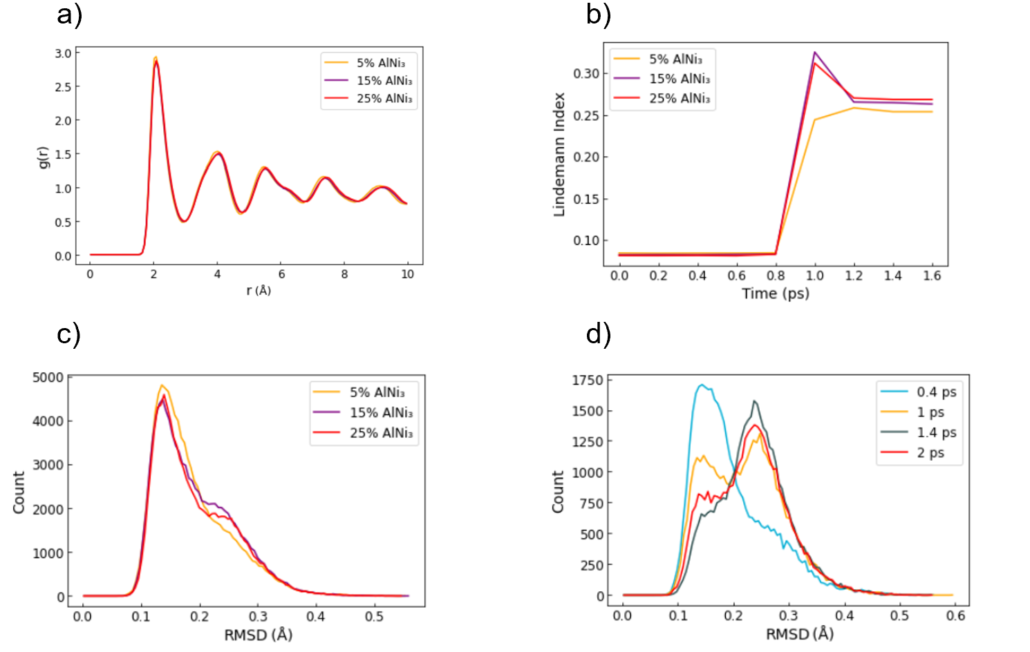
- Size-Varying Precipitates Melting Frameworks
Figure S5: (a) RDF, (b) Lindemann Index and (c) RMSD of size varying precipitate supercells. (d) Evolution of root mean square deviation (RMSD) for supercell containing 25 vol% AlNi₃

Shown in Figure S5a, the three precipitate percentages exhibit nearly identical peaks in the RDF. The peaks are also very analogous to those seen in the solid solutions RDF (Figure S1a). The RDF exhibits solid-liquid coexistence where the peaks show solid behavior, but later peaks converge to g(r) = 1.

Although the RDF peaks are almost identical for the size-varying precipitate supercells, the disorder taking place at the atomic level is drastically different between the compositions. In Figure S5b, the 15% AlNi₃ has the largest peak, approximately qi = 0.32, followed by the 25% AlNi₃, which peaks at approximately qi = 0.30. The 5% concentration does not exhibit a prominent peak and plateaus at qi = 0.25. Once the supercells are settled post-shock, a positive correlation is observed between precipitate size and Lindemann index value.

Aligned with the Lindemann indices, the melting concentration presented in Figure S5c shows the higher precipitate concentrations yielding more atomic deviation. The 25% AlNi₃ at 1 ps shifted the most towards an RMSD of 0.25 Å, with the 15% closely following. The 5% AlNi₃ exhibits the most solid behavior, with slight skewing towards a more liquid state.

Figure S5d shows the evolution of the RMSD for the 25% AlNi₃ supercell. For this observation, only bin 10 was observed instead of bins 10 and 11. This allowed for a more precise observation of the RMSD evolution over time. At 0.4 ps, the RMSD reflects the behavior seen for bins 10-11 at 1 ps in Figure S5c. At 1 ps, two peaks are presented, indicating a clear transition from the solid to the liquid phase. After 1 ps, the RMSD shifts and slowly normalizes around a value of 0.25 Å.

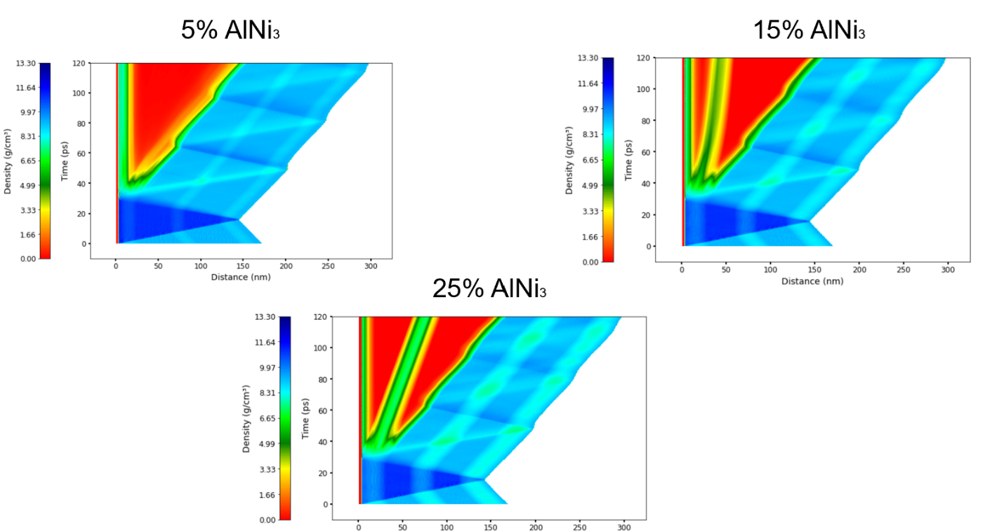
- Size-Varying Precipitates Spallation

Figure S6: Density heat maps of size varying precipitate supercells during spallation

As shown in Figure S6, the position and evolution of spallation for the precipitate-containing supercells changes with increasing AlNi₃ concentrations. The 5% AlNi₃ supercell exhibits a density map similar to that of the solid solutions. However, once the concentration is increased to 15%, spallation begins to separate at the base positions of the first two precipitates. Once the concentration is increased to 25%, the spallation starts to evenly distribute among the two precipitates at the front of the supercell.

Composition Spall Time (ps) Spall Strength (GPa)
5% AlNi₃ 43.7 27.4
15% AlNi₃ 46.7 24.8
25% AlNi₃ 41.7 23.3

Table S2: Spall time and strength of size varying precipitate supercells

Comparable to the solid solutions, larger precipitate ratios (higher Al concentrations) result in a decrease in spall strength. As seen in Table S2, the decrease from 5% to 15% AlNi₃ is ~ 1 GPa larger than the decrease from 15% to 25% AlNi₃. The range for the time of spall between the size-varying precipitates is 5 ps.

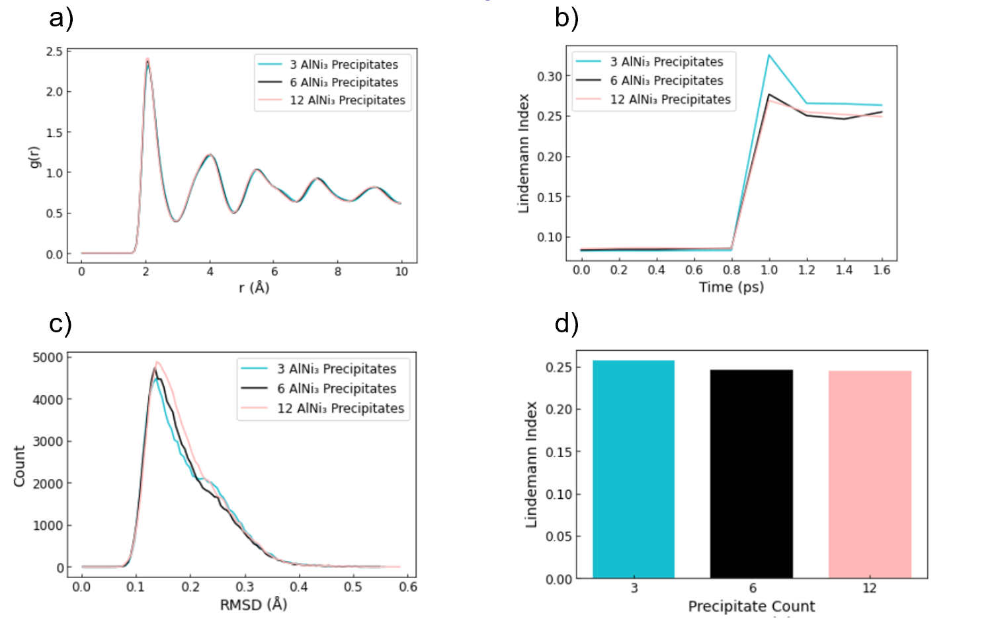
- Varying Precipitate Count Melting Frameworks

Figure S7: (a) RDF, (b) Lindemann Index and (c) RMSD of varying precipitate count supercells. (d) Lindemann indices of varying precipitate count supercells at time of full compression (8.2 ps into the simulation)

For the varying precipitate count supercells, bins 10 and 11 were analyzed for melting. Shown in Figure S7a, the varying precipitate count supercells exhibit nearly identical peaks in the RDF. The peaks are also very analogous to the peaks seen in the solid solutions and size-varying precipitate RDFs (Figures S1a & S5a). The RDF exhibits solid-liquid coexistence where the peaks show solid behavior, but later peaks are converging to g(r) = 1.

Shown in Figure S7b, the dispersion of precipitates has a direct effect on the amount of disorder taking place during shock loading. The 3-precipitate supercell exhibits the largest Lindemann index peak, followed by the 6- and 12-precipitate supercells. This behavior is also observed once the Lindemann indices converge post-shock. The results indicate that the dispersion of precipitates lessens the disorder of atoms at a given particle velocity.

Aligned with the results from Figure S7b, the RMSD in Figure S7c presents the deviation of atoms to a lesser extent. While all three RMSD curves exhibit primarily solid behavior, the skewing of the distribution towards 0.25 Å is indicative of melting. It is also seen that deviation is negatively correlated to the number of precipitates within the supercell.

In Figure S7d, the Lindemann indices of the varying precipitate count supercells were analyzed at 8.2 ps when the supercell reached maximum compression. This was observed to verify that the ranking of disorder remained constant under the highest stress period. Figure S7d shows that the 3 AlNi₃ precipitate supercell still has the largest index value, while the 12-precipitate supercell marginally has the lowest index value.

- Varying Precipitate Count Spallation
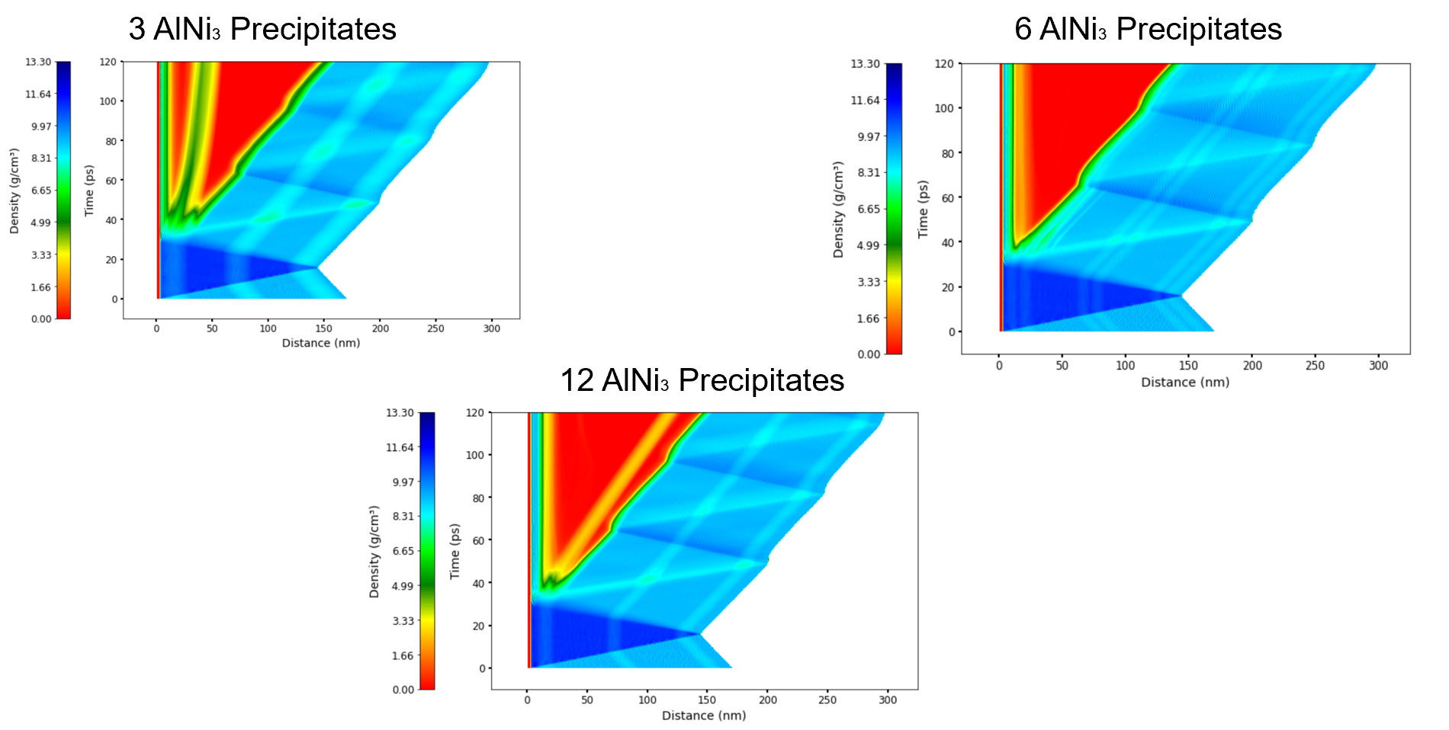

Figure S8: Density heat maps of varying precipitate count supercells during spallation
As seen in Figure S8, the dispersion of precipitates parallel to the shock wave has more of an impact on spallation than perpendicular dispersion. The spall time and strength were found and calculated for the supercell. The supercells all have the same density and approximately the same bulk sound velocity. This means that the only dependent variable among the three compositions is the difference in free surface velocity.

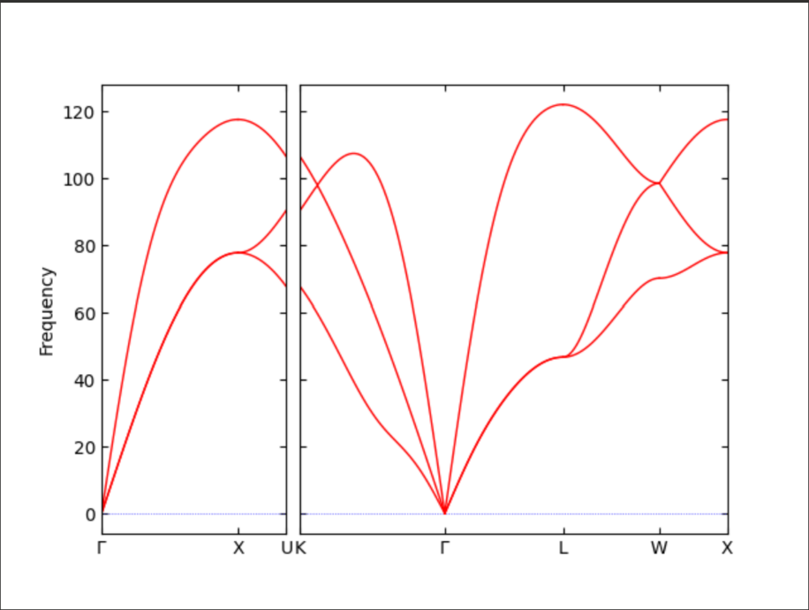

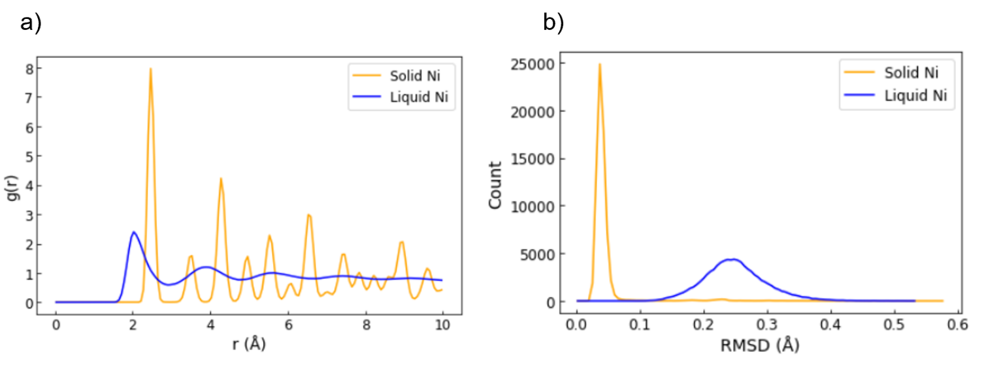
Figure S9: Phonon Dispersion of pure FCC Ni at V_{p} = 3.5 km/s

Figure S10: (a) Radial distribution function (RDF) and (b) root mean square deviation (RMSD) of solid and liquid nickel

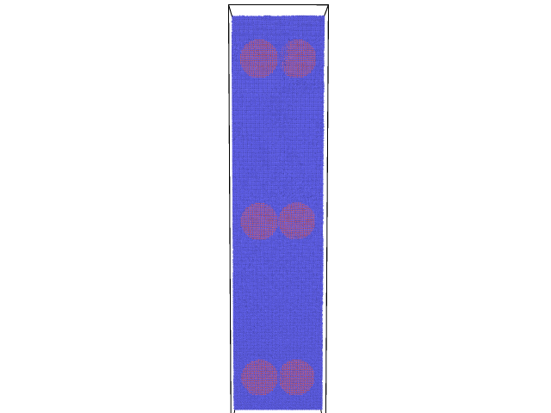
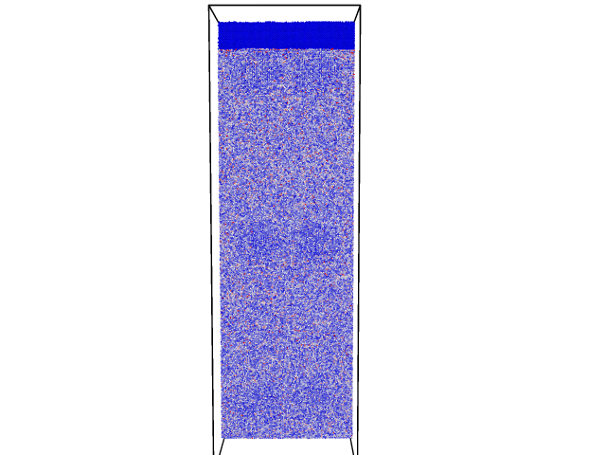

Figure S11: Color-coded kinetic energy per atom of 6 precipitate system post-shock

