Supplemental Materials & Methods
1. Cell Lines
Human Group 3 medulloblastoma cell lines D556 and MB002 were obtained from ATCC; both were engineered to stably express GFP and firefly luciferase (ffLuc) to permit noninvasive longitudinal monitoring of tumor burden by IVIS bioluminescence imaging in vivo. D556 cells grew as an adherent monolayer in vitro, whereas MB002 cells grew primarily in suspension clusters, thereby providing complementary culture phenotypes for expansion, manipulation, and downstream in vivo studies. The murine GL261 glioma cell line was obtained from the Leibniz Institute DSMZ-German Collection of Microorganisms and Cell Cultures. The PG13 producer cell lines encoding the virally encapsulated human-derived CAR constructs were obtained from ATCC. The human embryonic kidney cell line 293T (HEK 293T, RRID: CVCL-0063) and murine embryonic fibroblast packaging cell line GPE-86 (CRL-9642) were obtained from ATCC. All cell lines were screened for mycoplasma contamination every 3-4 months using the MycoAlert Mycoplasma Detection Kit (Lonza), maintained in culture for no longer than 2 months or 12 passages before replacement with lower-passage stocks, and authenticated by IDEXX BioAnalytics.
2. Human CAR T Cell Generation and Functional Characterization
Human CAR T cells were generated by retroviral transduction of primary human T cells derived from commercially obtained healthy donor peripheral blood mononuclear cells (PBMCs) (STEMCELL Technologies catalog no. 70025.2). PBMCs were thawed and maintained in complete T-cell medium composed of RPMI supplemented with 10% FBS and 1% GlutaMAX. T-cell activation was performed using pure functional-grade anti-human CD3 and anti-human CD28 antibodies (Miltenyi Biotec, cat. 130-093-387 and 130-093-375, respectively) according to the manufacturer’s instructions. After 48 hours of activation, cells were transduced with CAR-encoding retroviral supernatant derived from PG13 producer cells on RetroNectin-coated (Takara, cat. T100B) plates. Sorted, CAR-expressing PG-13 producer cells (ATCC; CRL-3597) cultured in IMDM supplemented with 10% FBS and 1% GlutaMAX were also adopted to derive viral supernatant for use in transduction workflows. Transduced cells were harvested 48 hours later and expanded in medium supplemented with recombinant human IL-7 and IL-15 (PeproTech, cat. 200-07 and 200-15, respectively) for downstream experiments. CAR surface expression was also assessed by flow cytometry before use in functional studies.
Human CAR constructs utilized in our experimental framework included a control CAR expressing a CD8 transmembrane domain, a CD28 co-stimulatory domain, and a truncated endo-domain, in addition to effector CARs expressing a non-mutated functional CD3ζ intracellular signaling domain, along with variations of CD8 or CD28 transmembrane domains paired with a CD28 co-stimulatory domain, and another variant incorporating an extra-CAR transmembrane 4-1BB ligand.
Phenotypic characterization of human CAR T cells was also acquired using a CytoFLEX Flow Cytometer. Cells were stained with antibodies against CD69 (BioLegend, Cat. 310934), CD4 (BioLegend, Cat. 317438), CD8 (BioLegend, Cat. 344708), CD45RO (BioLegend, Cat. 304224), CD45RA (BioLegend, Cat. 304112), and CCR7 (BioLegend, Cat. 353216). Within the CD4+ and CD8+ T-cell compartments, memory subsets were defined using CCR7, CD45RA, and CD45RO expression: naïve T cells as CCR7+CD45RA+CD45RO−, central memory T cells as CCR7+CD45RA−CD45RO+, effector memory T cells as CCR7−CD45RA−CD45RO+, and TEMRA cells as CCR7−CD45RA+CD45RO−.
To extend translational relevance, parallel experiments were performed using human-derived D556 & MB002 G3MB tumor models in combination with human B7-H3 CAR constructs. These included 2:1 CAR-T: tumor co-culture assays, MTS cytotoxicity assays, and IL-2 & IFN-y ELISAs (R&D catalog #s D2050; DIF50C). These assays allowed verification of CAR efficacy across both murine and human systems, thereby providing a comprehensive evaluation of therapeutic potential.
3. Murine T cell Flow Cytometry-based Characterization
Flow cytometry was performed to evaluate the phenotype and transduction efficiency of murine CAR-T cells. Flow cytometry data were acquired using a CytoFLEX Flow Cytometer (Beckman Coulter, Brea, CA, USA). Preliminary signal inspection, quality control, and acquisition-level gating were performed using CytExpert software (Beckman Coulter) during sample acquisition. Subsequent data processing, gating, and downstream analyses were conducted using FlowJo software (BD Biosciences, Ashland, OR USA). Live cells were identified using the LIVE/DEAD™ Fixable Aqua Dead Cell Stain Kit (405 nm excitation, L34966). CAR expression was determined with Alexa Fluor® 647 AffiniPure F(ab′)₂ Fragment Goat Anti-Human IgG, F(ab′)₂ fragment specific (Jackson ImmunoResearch, 109-606-006), using non-transduced cells as negative controls. Phenotypic characterization included staining with CD4 (BD Pharmingen, Cat. 552051), CD8a (Pharmingen Cat. 553030), CD44 (Pharmingen; Cat. 553134, CD62L (Pharmingen; Cat. 560513, TIM-3 (BioLegend, Cat. 134019), TIGIT (BioLegend, Cat. 142106), and CD279 (PD-1) (BioLegend, Cat. 135220). Data acquisition was performed with standard fluorescence compensation, and analysis was conducted through sequential gating to ensure accurate assessment of viability, CAR transduction, lineage, memory phenotype, and exhaustion profiles.
4. MRI
To non-invasively assess the development and progression of brain tumors, in vivo magnetic resonance imaging (MRI) of the mice was performed in the Preclinical Imaging Research Laboratory at the Georgetown University Medical Center in a 7-Tesla horizontal Bruker 7T/30 AVANCE NEO spectrometer run by ParaVision 360 software. For imaging, animals were anesthetized with isoflurane in oxygen (3% for induction and 1-2% for maintenance) and placed in a custom-manufactured (ASI Instruments, Warren, MI) stereotaxic device with built-in temperature and cardio-respiratory monitoring, as previously described ^{1,2} compatible with a 23 mm transmit-receive mouse brain coil. A T2-weighted TURBO RARE sequence was run in the coronal and axial orientations. The parameters for the coronal scan were TR: 3000 ms, TE: 45 ms, FA: 180, FOV: 20 x 17 mm, matrix: 256 x 256, averages: 5, and slice thickness: 0.6 mm, scan time: 9 minutes. The axial scan was run with TR: 3000 ms, TE: 40 ms, FA: 180, FOV: 20 x 20 mm, matrix: 256 x 256, averages: 5, and slice thickness: 0.4 mm, scan time: 10 minutes. Scans were no more than10 minutes long, and the mice were allowed to recover in a warm chamber.
5. Bioluminescence (IVIS) imaging
Mice were injected intraperitoneally with D-luciferin potassium salt (Gold Biotechnology, St. Louis, MO, USA; cat. no. LUCK-10G) (5 mM in PBS; 100 µL per mouse) 5 minutes before imaging, anesthetized with isoflurane (2.5% delivered in 100% O₂ at 0.5 L/min), and imaged with a IVIS Imaging System Series III (Perkin Elmer, Shelton, CT). The photons emitted from the luciferase-expressing cells were quantified using Living Image software (Caliper Life Sciences, Waltham, MA). Mice were imaged 4 and 7 days post-implantation and then weekly to track tumor burden. Then, one day prior to CAR-T cell injection, IVIS was also conducted to assess tumor burden across all mouse samples in the cohort, facilitating equivalent sample distribution across the experimental groups. 4 and 7 days after treatment, IVIS was also condcted to track therapeutic response in these mice. Finally, they are imaged every week after that to assess long-term responses.
6. Bone Marrow-Derived Macrophage (BMDM) Studies
Bone marrow cells were isolated from femurs and tibias of C57BL/6 mice and differentiated into macrophages in vitro using M-CSF-supplemented (Peprotech, cat. 315-02) DMEM media (ThermoFisher; cat. 11966025). When required for differential flow analysis, M0 BMDMs were polarized to M2 with IL4 (Peprotech, cat. AF-214-14) and IL13 (Peprotech, cat. 210-13) or to M1 with E.Coli LPS (Sigma, L6529) and recombinant IFN-gamma protein (Peprotech, cat. 315-05).
For in vitro assays, mature BMDMs were plated and treated with escalating doses of ResiPOx. Cells were harvested at defined time points post-treatment to capture temporal changes in gene expression. Total RNA was extracted, and cDNA was generated for downstream quantitative real-time PCR analysis of selected immunoregulatory genes. Total RNA was isolated and quality-assessed prior to library preparation. Sequencing libraries were generated using a standard poly(A) enrichment workflow and sequenced on an Illumina platform. Reads were processed using established pipelines, aligned to the human reference genome, and summarized at the gene level for downstream analyses.
These approaches were designed to evaluate the molecular effects of ResiPOx on macrophage polarization and to define gene expression programs associated with reprogramming toward a pro-inflammatory phenotype.
7. ResiPOx Synthesis and nano-formulation
Synthesis of amphiphilic Poly(2-oxazoline) block copolymer
We synthesized amphiphilic poly(2-oxazoline) triblock copolymer, P(MeOx)₂₀-b-P(BuOx)₂₄-b-P(MeOx)₁₉ (POx), by living cationic ring-opening polymerization as previously described ¹. The polymerization of the first block was initiated by combining 1 equivalent (eq) of methyl trifluoromethanesulfonate with 20 eq of 2‑methyl‑2‑oxazoline in acetonitrile under anhydrous conditions. The reaction mixture was stirred at 60 °C for two days to allow complete polymerization of the first block. The degree of polymerization (DP) was monitored using a 400 MHz ¹H NMR spectrometer (Bruker, Billerica, MA, USA). Once the first block reached the desired DP, 24 eq of 2‑butyl‑2‑oxazoline and 19 eq of 2‑methyl‑2‑oxazoline were sequentially added under the same reaction conditions to propagate the subsequent blocks. The polymerization was terminated by adding 3 eq of piperidine to reaction mixture, followed by stirring at 40 °C for 4 hr. After completion of the reaction, the reaction mixture was dissolved in acetone and filtered through nylon membrane filter (pore size 0.2 μm). The filtered polymer solution was further purified via dialysis (molecular weight cut-off 3.4 kDa) against deionized water for one week, with dialysate changed twice a day. After dialysis, polymer solution was lyophilized and stored at 4 °C with desiccant until use.
Preparation of ResiPOx nanoformulation
The resiquimod nanoformulation was prepared by the thin-film method². We first prepared stock solutions of resiquimod and POx in anhydrous ethanol at a concentration of 10 mg mL⁻¹. A 10:4 w/w mixture was prepared by mixing 100 µL of POx solution with 40 µL of Res solution in a 1.5 mL centrifuge tube. The mixture was dried under nitrogen flow at 60 °C to obtain a thin film. The formation of ResiPOx was induced by adding 200 µL of saline to the dried film, followed by vigorous vortexing until the entire surface of the film was completely hydrated. The ResiPOx solution was subsequently subjected to lyophilization, and the lyophilized formulation was stored at 4 °C in the dark under desiccation until use. For reconstitution of the lyophilized formulation, we added 200 uL µL of ultrapure water preheated to 37 °C. Hydrodynamic diameter (d_{h}) and polydispersity index (Đ) of the formulation before (d_{h} = 16.4 ± 0.53 nm, Đ = 0.19 ± 0.024) and after (d_{h} = 16.4 ± 0.32 nm, Đ = 0.23 ± 0.021) lyophilization were determined by dynamic light scattering at 25 °C using Zetasizer Nano DS (Malvern Panalytical, Malvern, UK). The final utilized formulation was ResiPOx2 10:4 (P2S-based).
For in-vivo experimental purposes: ResiPOx (poly(2-oxazoline)–encapsulated resiquimod) was administered intraperitoneally according to an optimized three-dose regimen on days 13, 15, and 17 following tumor implantations. The target dose was 5 mg ResiPOx per kg body weight; based on typical mouse weights of 20–25 g, each dose delivered approximately 0.1 mg per animal. Lyophilized POx-R was reconstituted in sterile distilled water (100 µL), fully dissolved, and then diluted with an additional 100 µL to a final volume of 200 µL, yielding a stock concentration of 4 mg/mL resiquimod (0.8 mg total per vial). Appropriate volumes were prepared fresh for each administration.
8. Flow Analysis
Panel Design and Implementation:
Both the 35-Color and 21-Color panel were provided by collaborators and antibodies were ordered from their respective vendors (Table 1a and b). The panels were validated on a Cytek Aurora 5 Laser (UV-V-B-YG-R) using primary cells isolated from murine brain tissue to replicate experimental conditions. Single color controls were generated from both cells and beads, providing a unique unmixing profile of cells and beads for both panels (Table 2a and b). Unmixing was confirmed using full stained samples that were used for the single-color control generation.
Sample Staining: 36-Color Panel
Samples were provided post CD45+ purification to enhance the CD45+ population within the sample. Cells were resuspended at 1e6 cells per mL in 5mL FACS tubes. The 36-color panel was taken directly for staining while the 21-color panel was incubated at 37 degrees C for 4 hours to allow for accumulation of intracellular cytokines (Figure 1a and b). Cells were washed in 2mL of PBS and centrifuged at 400xg for 5 minutes. Supernatant was decanted and cells were resuspended in a 1:150 working solution of 200uL UV Blue viability dye and incubated for 30 minutes on ice. After incubation, cells were washed in 2mL of MACS quant running buffer at 400xg for 5 minutes. Supernatant was decanted and cells were resuspended in 100uL of MACS quant buffer with 5uL of True Stain FCR Block and incubated for 30 minutes in the dark on ice. While cells were incubating in FCR block, the 36-color surface master mix was made according to the dilutions in table 3a. After incubation, cells were stained directly with 104uL of the master mix and incubated for 30 minutes in the dark on ice. Cells were then washed with 2mL of MACS quant buffer at 400xg for 5 minutes, resuspended in 500uL of MACS quant and collected on the Cytek Aurora.
Sample Staining: 22-Color Panel
After 4 hours incubation, cells were washed with 2mL of PBS and stained with UV Blue viability dye and FCR block as previously described. A surface master mix was made according to the dilutions in Table 3b. Cells were stained with 69uL of the surface mix and incubated for 30 minutes in the dark on ice. Cells were then washed with 2mL of MACs quant running buffer at 400xg for 5 minutes and the supernatant discarded. Cells were resuspended in 1mL of 1x Fix Concentrate (Biolegend Cat#73158), incubated at room temperature in the dark for 45 minutes, then washed twice with 2mL of True Nuclear 1x Perm Buffer (Biolegend Cat#73162) at 400xg for 5 minutes. The intracellular master mix was made according to the dilutions in Table 3c, and cells were stained with 68uL of the intracellular mix. Cells were incubated at room temperature in the dark for 30 minutes, washed twice with 2mL of True Nuclear 1x Perm Buffer at 400xg for 5 minutes, resuspended in 500uL of Perm Buffer and collected on the Cytek Aurora.
OMIQ Analysis:
Samples were collected following QC and calibration of the Aurora and assessment of unstained samples. Once the samples were collected, the unmixing profile was applied and the data exported as unmixed FCS files. These files were then uploaded into OMIQ.ai for further analysis. Once in OMIQ, samples were evaluated by gating for Cells/Singlets/Live/Dead/CD45+ cells. Once CD45+ cells were identified, subsampling was performed to eliminate all debris and non CD45+ cells. This population of cells was analyzed using T-distributed Stochastic Neighbor Embedding (tSNE) and clustering to investigate subsets of CD45+ cells. Using the tSNE and clustering software, both cluster identification, as well as relative abundance of each cluster between samples, can be answered.
Table 1a. 35-Color Surface Panel.
 | Marker | Color | Manufacture | Catalog #
1 | CD45 | BUV395 | BD | 564279
2 | CD80 | BV510 | Biolegend | 104741
3 | CD4 | Spark Blue 574 | Biolegend | 100489
4 | MHC II | PE Fire 810 | Biolegend | 107667
5 | CD8a | Spark Violet | Biolegend | 155019
6 | Ly6G | PerCP | Biolegend | 127653
7 | CD123 | APC | Invitrogen | 17-1231-82
8 | CD25 | PerCP eF710 | Invitrogen | 46-0251-82
9 | CD69 | Spark NIR 685 | Biolegend | 104557
10 | CD86 | BV605 | BD | 563055
11 | CD209a | PE | Biolegend | 833003
12 | LAG3 | APC Fire 750 | Biolegend | 125239
13 | CD11b | BUV661 | BD | 612977
14 | F4/80 | Spark YG 593 | Biolegend | 157311
15 | NK1.1 | APC Fire 810 | Biolegend | 156519
16 | CD206 | BV711 | Biolegend | 141727
17 | CD276 | PE Dazzle 594 | Biolegend | 135611
18 | CD163 | BV421 | Biolegend | 155309
19 | CD127 | PECy5 | Biolegend | 135015
20 | CD24 | BUV496 | BD | 612953
21 | CD62L | eF450 | Invitrogen | 48-0621-80
22 | XCR1 | BV785 | Biolegend | 148225
23 | CD49b | PECy5.5 | Invitrogen | 35-5971-80
24 | CD103 | BUV805 | BD | 741948
25 | CD19 | Spark Blue 550 | Biolegend | 115565
26 | TIM3 | PECy7 | Biolegend | 119715
27 | CTLA-4 | APC R700 | BD | 565778
28 | CD3 | BV480 | BD | 741562
29 | PD-1 | BB700 | BD | 566515
30 | CD44 | BUV563 | BD | 741227
31 | CD11c | BUV615 | BD | 751265
32 | CD64a/b | BV650 | BD | 740622
33 | CD90.1 | BV750 | BD | 746961
34 | Viability | UV Blue | Invitrogen | L23105
35 | Ly6C | BV570 | Biolegend | 128030
Table 1b. 21 Color Intracellular Panel (ICS Panel).
 | Marker | Color |  | Vendor |  | Catalog #
1 | F4/80 | BV711 |  | BD |  | 565612
2 | IL-10 | PECy7 |  | Biolegend |  | 505025
3 | IL-6 | PE |  | Biolegend |  | 504503
4 | AHR | PE-CF594 |  | BD |  | 565790
5 | IFNg | BUV737 | BD |  | 612769
6 | CD25 | BV510 |  | Biolegend |  | 102041
7 | RORgt | BV421 |  | BD |  | 562894
8 | TCRb | BV605 |  | BD |  | 562840
9 | TNFa | BV650 |  | Biolegend |  | 506333
10 | B220 (CD45R) | AF700 |  | Invitrogen |  | 56-0452-80
11 | CD11b | BV570 |  | Biolegend |  | 101233
12 | ILI7A | BUV395 |  | BD |  | 565246
13 | FoxP3 | PerCPCy5.5 |  | Invitrogen |  | 45-5773-82
14 | CD8 | BV786 |  | BD |  | 563332
15 | ARG1 | APC |  | Invitrogen |  | 17-3697-80
16 | CD3 | BUV661 |  | BD |  | 741562
17 | CD45 | BUV496 |  | BD |  | 749889
18 | CD90.1 | BV750 |  | BD |  | 746961
19 | CD4 | BUV805 |  | BD |  | 612900
20 | CD11c | BUV615 |  | BD |  | 751265
21 | Viability | UV Blue |  | Invitrogen |  | L23105

Table 2a. 35-Color Unmixing Profile.
Cells | Beads
CD45 BUV395 | CD24 BUV496
Live Dead Blue | CD44 BUV563
CD11c BUV615 | CD11b BUV661
CD62L eFluor450 | CD103 BUV805
CD3 BV480 | CD163 BV421
CD8 Spark Violet 538 | CD80 BV510
Ly6C BV570 | CD206 BV711
CD86 BV605 | CD90.1 BV750
CD64ab BV650 | CD276 PE-Dazzle 594
XCR1 BV786 | MHCII PE-Fire 810
CD19 Spark Blue 550 | CD123 APC
CD4 Spark Blue 574 | CD69 Spark NIR 685
Ly6G PerCP
PD-1 BB700
CD25 PerCP-eFluor710
CD209a PE
F4/80 Spark YG 593
CD127 PE-Cy5
CD49b PE-Cy5.5
TIM-3 PE-Cy7
CTLA-4 APC-R700
LAG-3 APC-Fire 750
NK1.1 APC-Fire 810

Table 2b. 2-Color Unmixing Profile.
Cells | Beads
Live Dead Blue | 1L-17A BUV395
CD11c BUV615 | CD45 BUV496
CD3 BUV661 | IFNγ BUV737
CD4 BUV805 | RORγt BV421
CD11b BV570 | CD25 BV510
TCRβ BV605 | TNFα BV650
F4/80 BV711 | CD90.1 BV750
CD8 BV786 | IL6 PE
FOXP3 PerCP | 1L10 PE-Cy7
AHR PE-CF594 | ARG1 APC
B220 AF700

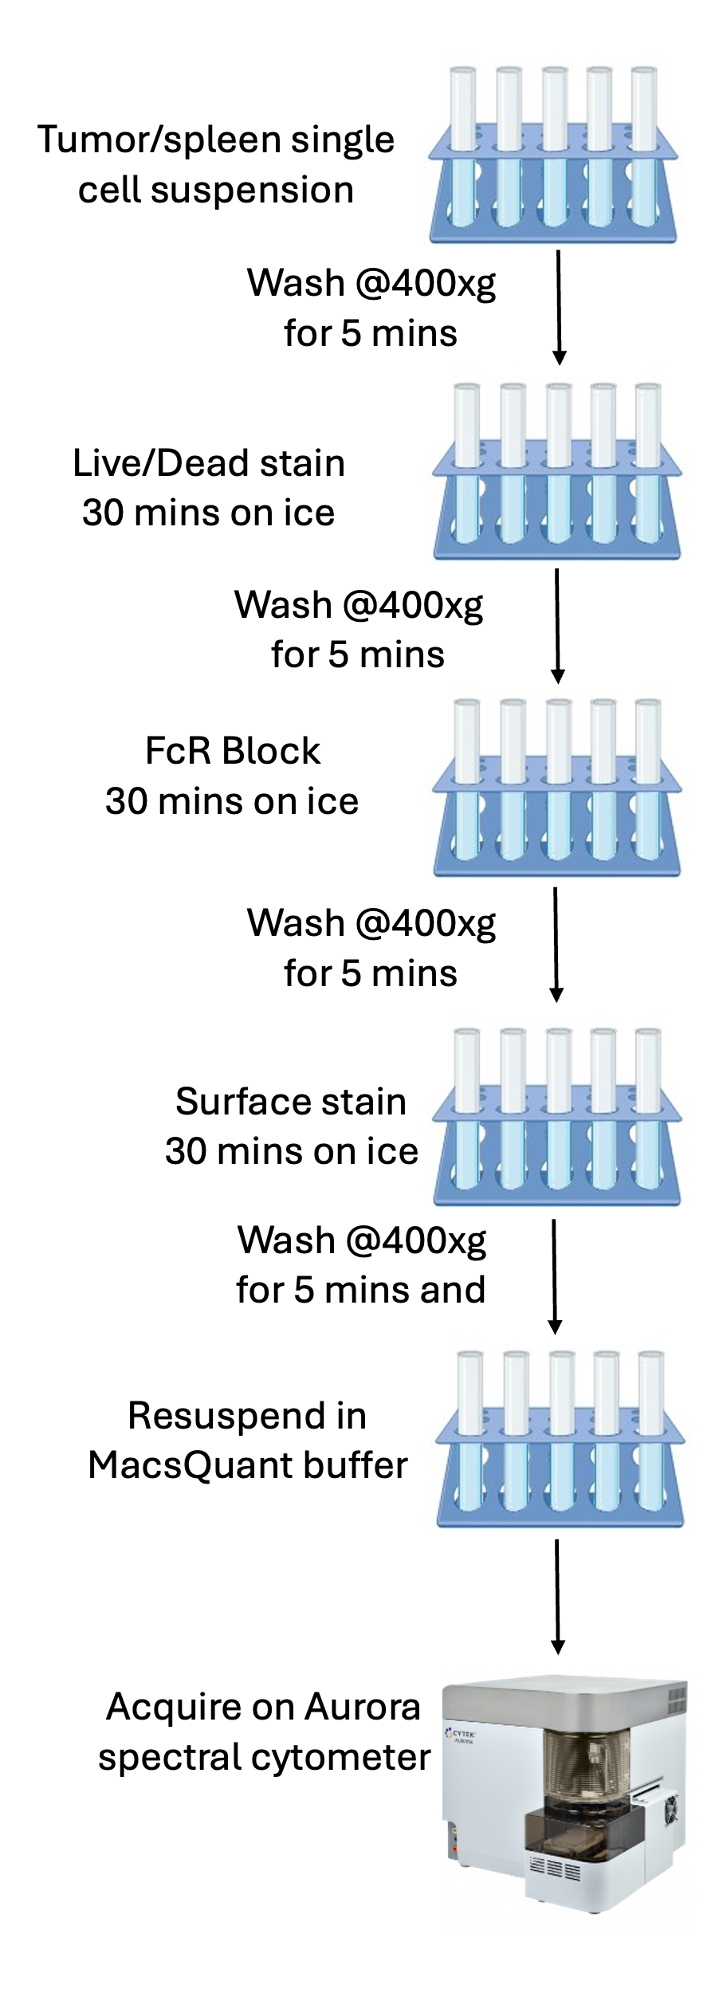
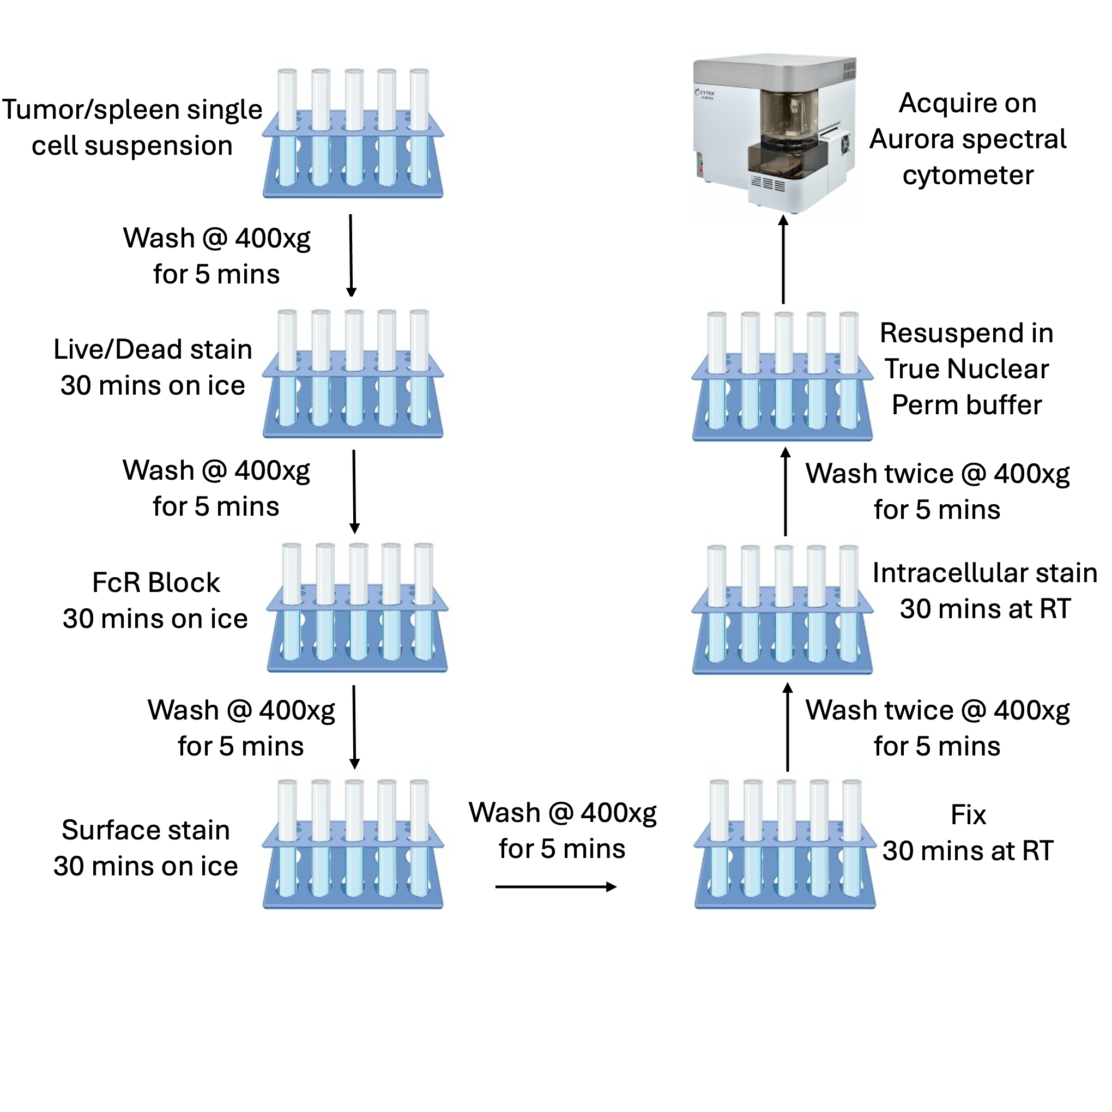
B
A
Figure 1. Staining graphic of A. 35-color surface panel and B. 22-color surface and intracellular panel

Table 3a 36-Color master mix.
Marker | Color | Vol  for 100uL | Dilution
CD45 | BUV396 | 0.5 | 1:200
Live/Dead | LD Blue |  | 1:150
CD24 | BUV496 | 0.2 | 1:500
CD44 | BUV563 | 0.33 | 1:300
CD11c | BUV615 | 1 | 1:100
CD11b | BUV661 | 1 | 1:100
CD103 | BUV805 | 2 | 1:50
CD163 | BV421 | 2 | 1:50
CD62L | eF450 | 1 | 1:100
CD3 | BV480 | 5 | 1:20
CD80 | BV510 | 1 | 1:100
CD8 | Spark Vio538 | 1 | 1:100
Ly6C | BV570 | 1 | 1:100
CD86 | BV605 | 2 | 1:50
CD64a/b | BV650 | 2 | 1:50
CD206 | BV711 | 2 | 1:50
CD90.1 | BV750 | 0.4 | 1:250
XCR1 | BV786 | 3.3 | 1:30
CD19 | Spark Blu550 | 1 | 1:100
CD4 | Spark Blue574 | 2 | 1:50
Ly6G | PerCP | 1 | 1:100
PD1 | BB700 | 2 | 1:50
CD25 | PerCP e710 | 2 | 1:50
CD209a | PE | 2 | 1:50
F4-80 | Spark YG593 | 1 | 1:100
CD276 | PE Dazzle594 | 2 | 1:50
CD127 | PE Cy5 | 2 | 1:50
CD49b | PE Cy5.5 | 1 | 1:100
TIM3 | PE Cy7 | 2 | 1:50
MHCII | PE Fire810 | 0.1 | 1:1200
CD123 | APC | 0.625 | 1:160
CD69 | Spark NIR685 | 2 | 1:50
CTLA-4 | APC R700 | 1 | 1:100
LAG3 | APC Fire750 | 1 | 1:100
NK.1.1 | APC Fire810 | 1 | 1:100
Monocyte Blocking Buffer |  | 5 | 1:20
Brilliant Buffer |  | 50 | 1:2

Table 3b. 22-Color Surface Master mix.
Marker | Color | Vol  for  100uL | Dilution
Live Dead | LD Blue |  | 1:150
CD45 | BUV496 | 0.33 | 1:300
CD11c | BUV615 | 1 | 1:100
CD3 | BUV661 | 5 | 1:20
CD4 | BUV805 | 0.5 | 1:200
CD25 | BV510 | 1.7 | 1:60
CD11b | BV570 | 0.5 | 1:200
TCRb | BV605 | 1 | 1:100
F4-80 | BV711 | 2 | 1:50
CD90.1 | BV750 | 0.4 | 1:250
CD8 | BV786 | 1 | 1:100
B220 | Alexa700 | 1 | 1:100
Monocyte Blocking Buffer |  | 5 | 1:20
Brilliant Buffer |  | 50 | 1:2

Table 3c. 22-Color Intracellular Master mix.
Marker | Color | Vol  for 100uL | Dilution
IL17A | BUV396 | 2 | 1:50
IFNy | BUV737 | 2 | 1:50
RORgt | BV421 | 2 | 1:50
TNFa | BV650 | 2 | 1:50
FOXP3 | PerCP | 2 | 1:50
IL6 | PE | 2 | 1:50
AHR | PE-CF594 | 2 | 1:50
IL10 | PE Cy7 | 2 | 1:50
ARG1 | APC | 2 | 1:50
Brilliant Buffer |  | 50 | 1:2

9. scRNA-seq Analysis Workflow
Raw 10X flex v2 sequencing data were processed with CellRanger (10X Genomics, v9.0.1). The sequenced reads were mapped to Chromium Mouse Transcriptome Probe Set v1.1.1 with GRCm39-2024-A as reference transcriptome, targeting 19,070 genes.
Ambient RNA contamination was corrected per sample using SoupX (v1.6.2), with the contamination fraction estimated using pre-defined non-expressing marker genes without cluster guidance and capped at a maximum of 0.35. Genes detected in fewer than 2 cells and cells with fewer than 50 detected features were excluded during count matrix construction. Cell doublets were identified and removed using DoubletFinder (v2.0.6), with the expected multiplet rate estimated from 10x Genomics recovery guidelines and the pK parameter optimized via parameter sweep. All downstream processing and analyses were conducted using Seurat (v5.4.0). Cells with mitochondrial read fractions exceeding 10% were excluded. Adaptive per-sample quality filtering was then applied to remove outliers based on UMI counts and detected genes: lower thresholds were set to the 2nd percentile (with floors of 100 UMIs and 50 genes) and upper thresholds to the 99.5th percentile. Filtered expression data were subsequently normalized using default parameters, and the top 2,000 highly variable genes were identified using the variance-stabilizing transformation (vst) method. To mitigate batch effects across samples, canonical correlation analysis (CCA)-based integration was performed using Seurat's IntegrateLayers function. The top 30 components of the integrated embedding were used to construct a shared nearest neighbor (SNN) graph, and clustering was performed using the Louvain algorithm at a resolution of 0.5. Data were visualized in two dimensions using Uniform Manifold Approximation and Projection (UMAP).
Automated cell type annotation was performed using SingleR (v2.8.0) with two reference datasets from the celldex package (v1.16.0): the Mouse RNA-seq reference (MouseRNAseqData) for broad cell type labels and the Immunological Genome Project (ImmGen) reference for immune cell subtype resolution. Final cluster annotations were refined and corroborated based on the expression of canonical marker genes and evidence from the literature. Differentially expressed marker genes per lineage were identified using the FindAllMarkers function with a minimum detection fraction of 50% and a log fold-change threshold of 0.5.
Three lineages of interest, myeloid cells (macrophages, microglia, and monocytes), NK/T cells, and dendritic cells, were individually subset from the full annotated data and reprocessed independently. Subtype identities were assigned based on the expression of marker genes and supporting evidence from the literature. Differential subtype composition across CAR-T conditions was tested using sccomp (v2.1.27), a Bayesian model that accounts for the compositional and overdispersed nature of single-cell proportion data. Subtype proportions were modeled as a function of treatment condition, with 41BB-L set as the reference, and statistical significance was assessed using FDR-corrected credible intervals. To characterize transcriptional differences between conditions within each subtype, raw counts were aggregated per sample to generate pseudobulk count matrices and differential expression was performed using DESeq2 (v1.46.0). Genes were ranked by the Wald statistic and gene set enrichment analysis was performed using fgsea (v1.32.4) against the MSigDB Hallmark gene sets (mouse orthologs; gene set size 15–500). TLR7/8 signaling activity in myeloid cells was assessed by scoring curated gene sets representing key components of the TLR pathway using UCell (v2.10.1). Differentially expressed genes were identified using the Seurat R package. Gene set enrichment analysis (GSEA) was performed using gene sets from the Molecular Signatures Database (MSigDB) accessed through the msigdbr package ³. Enriched pathways with a nominal P value < 0.05 were considered significant and ranked based on the number of genes contributing to each term. Cell-cell communication within the scRNA-seq dataset was inferred using the CellChat R package ⁴. Analyses were conducted using the curated mouse ligand–receptor interaction database, and intercellular communication was inferred at the signaling pathway level to enable aggregation of ligand–receptor interactions. The most influential cell population was defined as the cluster exhibiting the highest overall interaction strength as a signaling sender.
This workflow was applied to decipher data garnered from experiments designed to quantify treatment-associated shifts in immune composition, including macrophage and microglial polarization, and to assess CAR T cell infiltration, phenotype, and persistence across therapeutic conditions.
Reproducible code for single cell analyses and figure generation is openly available at https://github.com/childrens-bti/haydar-tme-cart-mb.
References
1. Speidell, A. P. et al. Development of a Human APOE Knock-in Mouse Model for Study of Cognitive Function After Cancer Chemotherapy. Neurotox. Res. 35, 291–303 (2019).
2. Liggett, J. R. et al. Oral N-acetylcysteine decreases IFN-γ production and ameliorates ischemia-reperfusion injury in steatotic livers. Front. Immunol. Volume 13-2022, (2022).
3. Dolgalev I. msigdbr: MSigDB gene sets for multiple organisms in a tidy data
format. R package version 7.2. 1. [Internet]; 2020.
4. Jin S, Guerrero-Juarez CF, Zhang L, Chang I, Ramos R, Kuan C-H, et al. Inference
and analysis of cell-cell communication using CellChat. Nat Commun 2021;12:
1088.

