Figure S1 Performance of background binding energy and Hfq binding propensity modeling
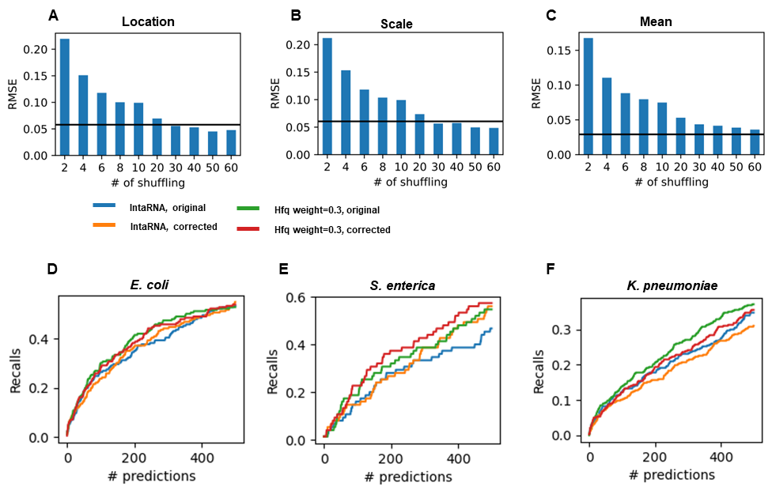
A-C. The RMSE (Root mean square error) of dinucleotide composition-based using Gumbel distribution parameters fitted on 100 times dinucleotide shuffled sequence as ground truth. A: the RMSE of location parameters, B: the RMSE of scale parameters, C: mean of Gumbel distribution (derived from location and scale parameters).
D-F. Performance of single species-based scoring on three species using difference energy normalization methods and Hfq weights.

Figure S2 The impact of phylogenetic marker, noise variance and signal rate
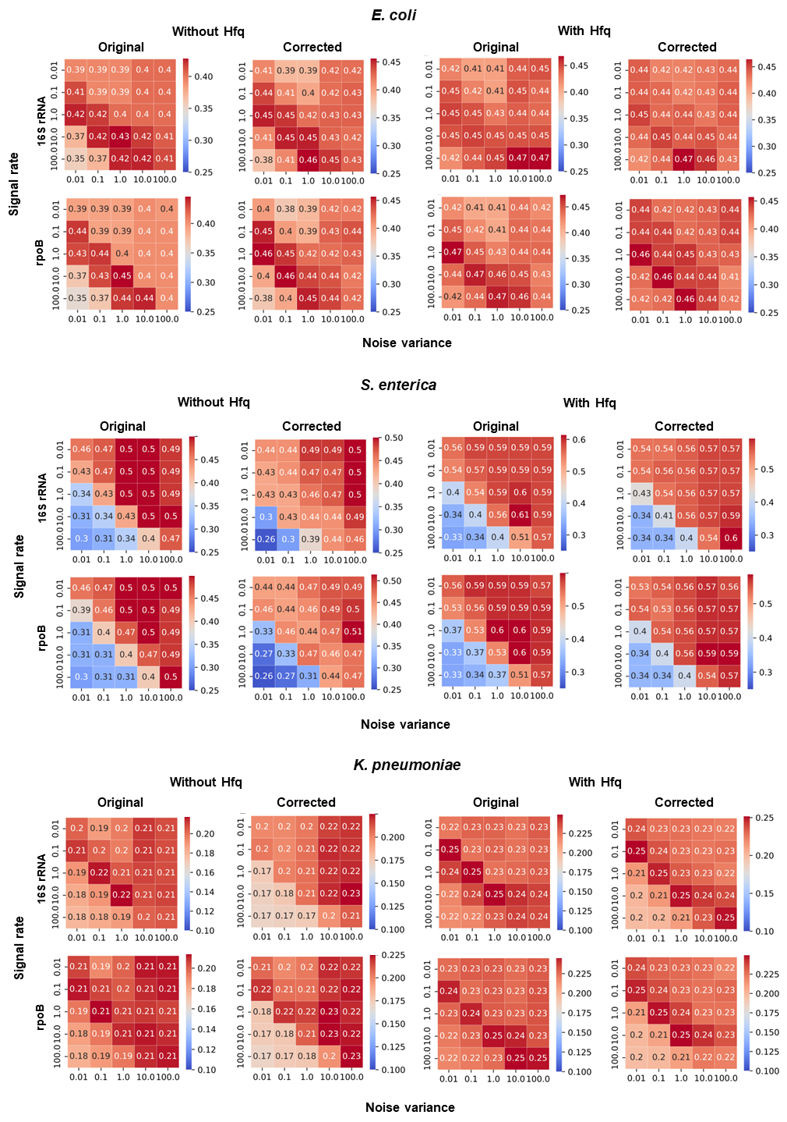
The performance of CMDTarget, measured by recall at the top 200 prediction, was evaluated on different settings (whether considering predicted Hfq binding scores, whether corrected for dinucleotide compositions, whether using 16S rRNA or rpoB gene for phylogenetic modeling, using different signal rates, and using different noise variances).

Figure S3. The conservation of known sRNA-target interactions

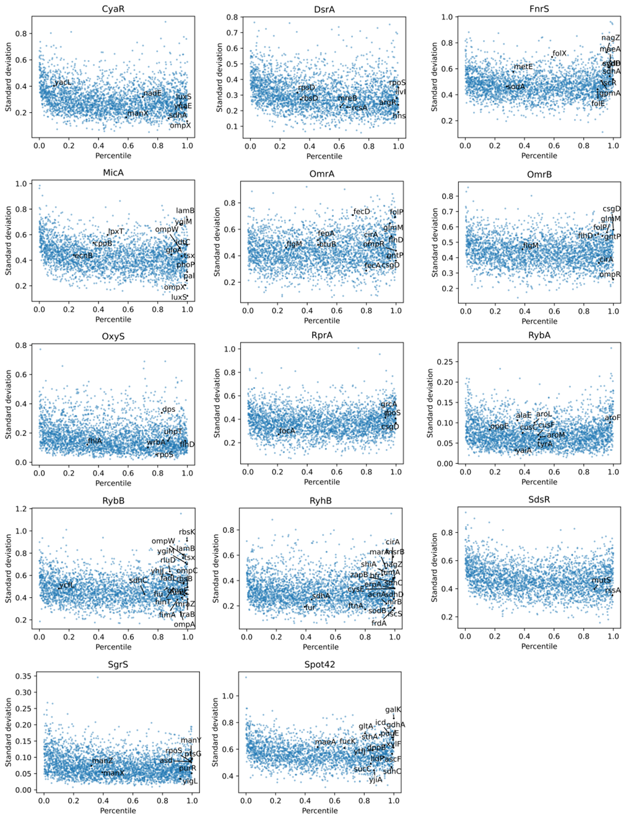
The relationship between the percentiles of denoised scores in E. coli and standard deviations of denoised scores across difference species in 14 conserved sRNAs in Enterobacteriaceae clade. Known targets of different sRNAs were labeled.

