Volatile-mediated microbiome recruitment by Streptomyces albidoflavus G1 enhances suppression of apple ring rot pathogen Botryosphaeria dothidea
Shengzhi Guo^{1†}, Arneeb Tariq¹†, Yarong Luo¹, Xianyu Li¹, Zixu Wang¹, Zhinan Du¹, Qi Cheng¹, Jiangbo Qi¹, Junfeng Pan¹, Lingfang Zhu^{1*}, Xihui Shen^{1*}
1 State Key Laboratory for Crop Stress Resistance and High-Efficiency Production, Shaanxi Key Laboratory of Agricultural and Environmental Microbiology, College of Life Sciences, Northwest A&F University, Yangling, Shaanxi 712100, China
* Corresponding author:
Lingfang Zhu (E-mail: lingfangzhu@nwafu.edu.cn)
Xihui Shen (E-mail: xihuishen@nwafu.edu.cn)

†Shengzhi Guo and Arneeb Tariq contributed equally to this work.

S1: Whole genome sequencing
A pure culture of G1 was grown overnight in ISP2 media for 96 h at 30◦C in a shaker at 180 rpm. Following incubation, the tube was centrifuged for 10 min at 4500 rpm. The resulting supernatant was discarded, and the bacterial cells were sent to Magigene Biotechnology for DNA extraction, sequencing library preparation, and whole-genome shotgun sequencing (WGS) using their protocol. Genomic DNA was extracted with a commercial TIANamp Bacteria DNA Kit (Tiangen Biotech Co., Beijing, China). Whole-genome sequencing was conducted by Magigene (Guangdong), employing Illumina and Nanopore technologies. Subsequent data, encompassing reads from both second- and third-generation sequences, were processed for assembly using Unicycler v.0.4.8. Coding gene prediction was executed through Glimmer 3. Non-coding tRNA and rRNA were identified through the application of tRNAscan SE 2.0 and rRNAmmer-1.2, respectively. For sRNA prediction, initial alignment to the Rfam database was followed by further refinement via the cmsearch program. The presence of prophages was assessed via the PHAST software. Genome sequence annotation was performed through RAST (http://rast.nmpdr.org/). The prediction of antibiotic resistance and carbohydrate-active enzymes drew upon public resources such as the Comprehensive Antibiotic Resistance Database (CARD) and the Carbohydrate-Active Enzymes Database (CAZy). The identification of secondary metabolite biosynthetic gene clusters was accomplished through antiSMASH 7.0. The construction of a phylogenomic tree based on complete genomes was reconstructed using the CVTree v.4 method. ANI was employed to determine the average nucleotide identity among selected species within the Paenibacillus genus by EZ BioCloud ANI calculator. All the databases were accessed in March 2025. The final genome assembly was deposited in NCBI under accession number JBWCIU000000000.
S2: Assessment of apple quality parameters
Change in fresh weight was determined by measuring fruit weight before and after incubation. The color difference in apples of different treatment groups was measured using a PCE-CSM 1 colorimeter (PCE Instruments, UK). Fruit hardness, chewiness, springiness, and fracturability were measured using a TA.XTPlusC texture analyzer (Stable Micro Systems, UK). Titratable acidity (TA) of apple juice was determined by titration with a standardized NaOH solution and expressed as the percentage of malic acid calculated using the formula:
TA (g/100 mL) = V × C × 0.67,
where V is the volume difference between the initial and endpoint. Total soluble solids (TSS) were quantified in Brix using a digital refractometer (BM04-Nohawk, Shenzhen, China) after extracting juice from apple tissues. Aroma-related changes associated with ripening and treatment effects were evaluated using an electronic nose system (PEN3, Airsense, Germany). The e-nose was used to generate volatile fingerprint profiles, and multivariate analyses were applied to distinguish differences among treatments.

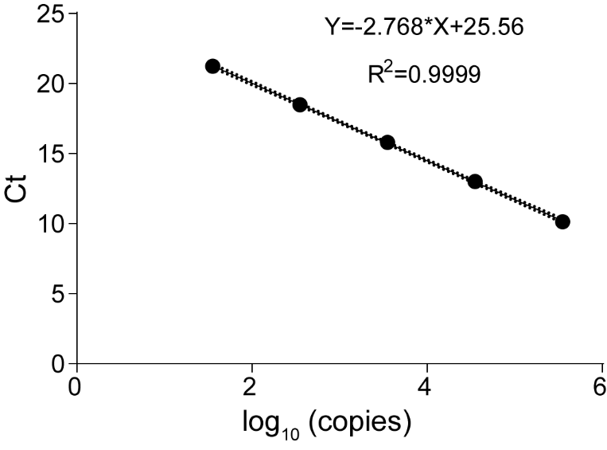
Fig. S1: Standard curve for the absolute quantification of Botryosphaeria dothidea via qPCR. The linear relationship between the cycle threshold (C_{t}) values and the log10 of the plasmid copy number is shown. The regression equation is Y = -2.768X + 25.56, with a coefficient of determination (R²) of 0.9999, indicating high amplification efficiency and technical reliability for quantifying pathogen load in apple samples.

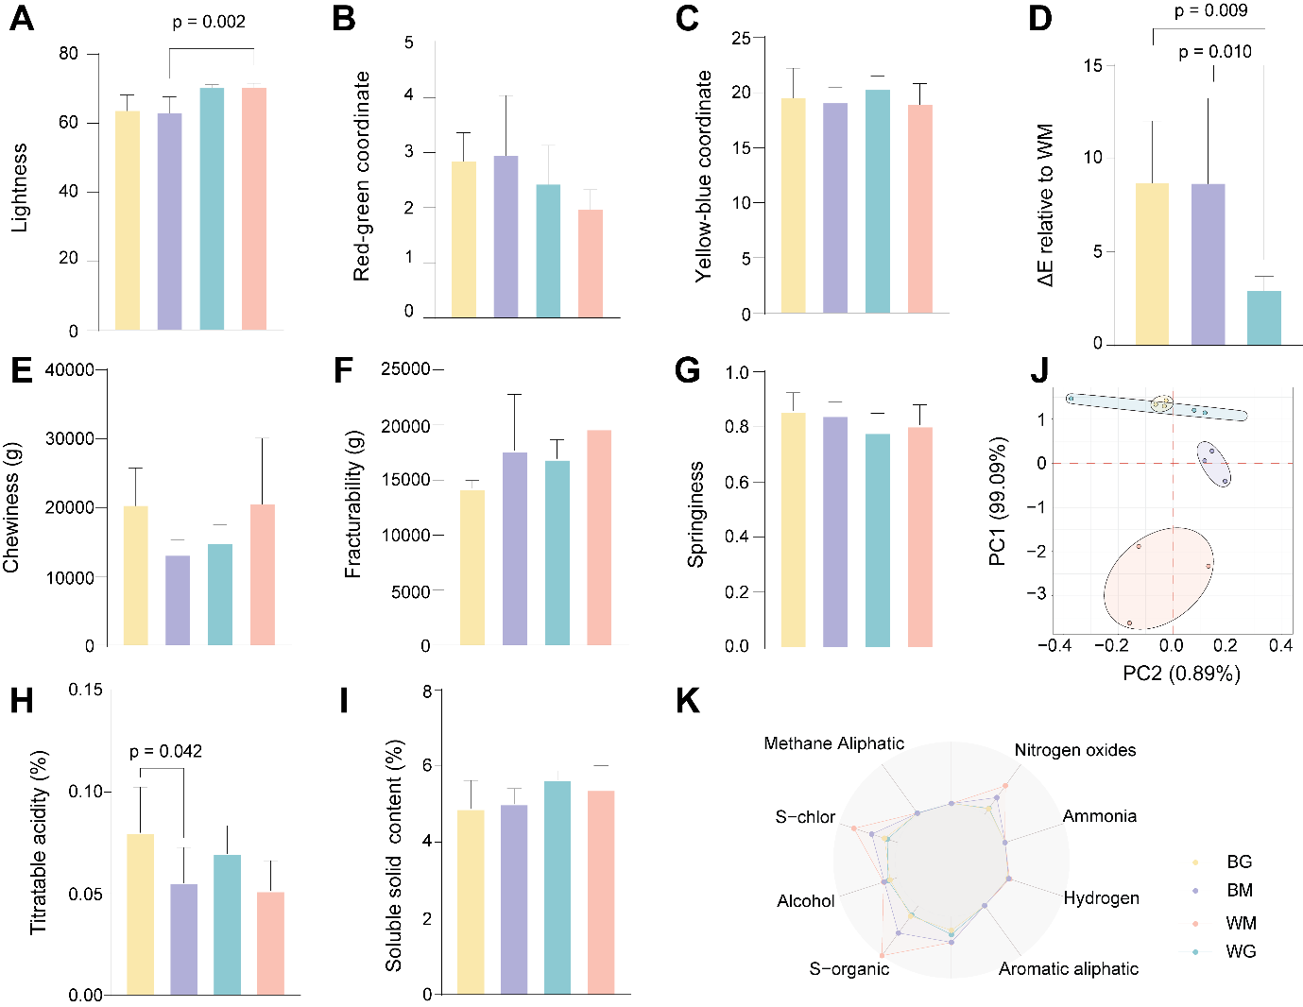
Fig. S2: Comprehensive assessment of apple fruit quality and VOC profiles across treatment groups. (A–C) Colorimetric analysis indicating variations in lightness, red-green, and yellow-blue coordinates. (D) Total color difference (ΔE) relative to the WM group, showing significant shifts in BG and BM groups. (E–G) Texture profile analysis measurements including chewiness, fracturability, and springiness. (H–I) Biochemical evaluation of titratable acidity and soluble solid content. (J) Principal Component Analysis (PCA) of VOC profiles, illustrating distinct clustering based on treatment. (K) Radar plot of electronic nose sensor responses, highlighting differences in volatile emission patterns. Data are presented as mean SD; p-values indicate significant differences determined by ANOVA or Student’s t-test.

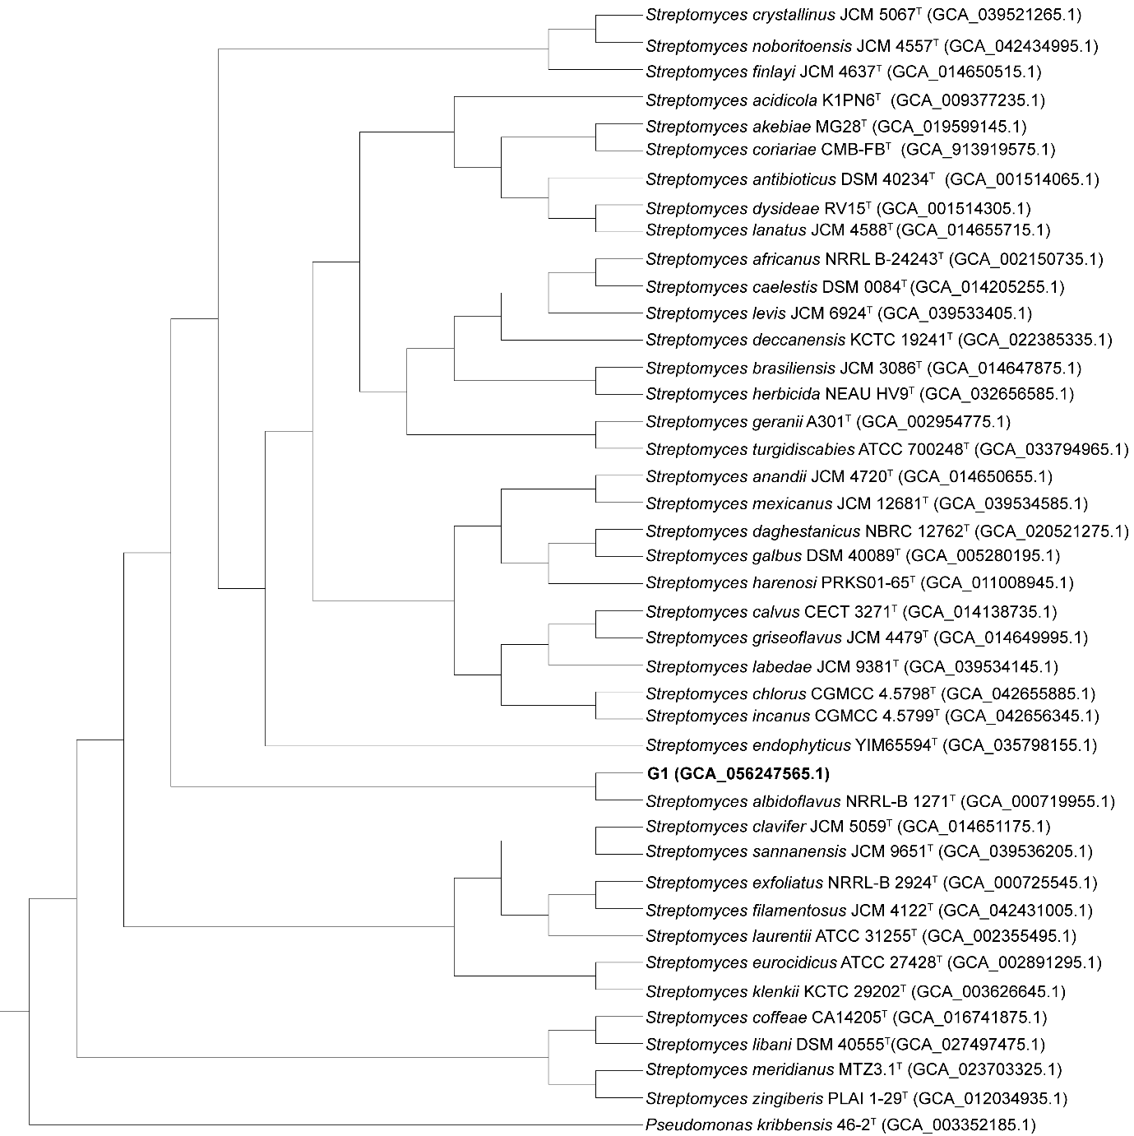
Fig. S3: Whole-genome-based phylogenetic analysis of strain G1. The phylogenetic tree illustrates the taxonomic positioning of G1 within the genus Streptomyces. Strain G1 clusters closely with Streptomyces albidoflavus NRRL-B-1271ᵀ, supporting its identification through high sequence homology. Pseudomonas kribbensis 46-2ᵀ is included as the outgroup. GenBank accession numbers for the genome assemblies are provided in parentheses.

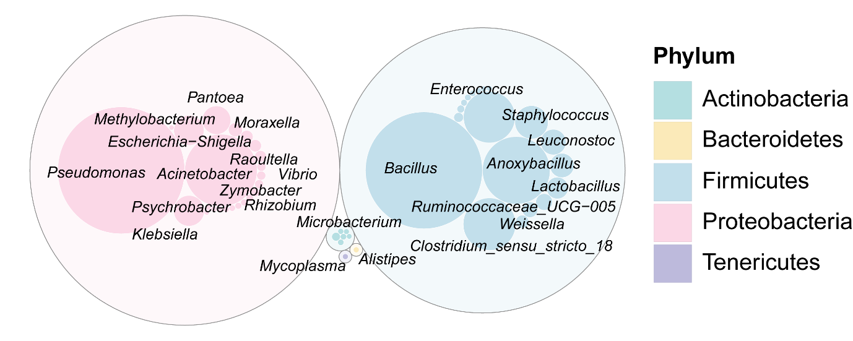
Fig. S4: Taxonomic distribution and abundance of the apple fruit microbiome at the genus level. Bubble plot displaying the relative abundance of dominant bacterial genera. Circle size corresponds to abundance, with taxa color-coded by phylum. Proteobacteria (e.g., Pseudomonas, Pantoea) and Firmicutes (e.g., Bacillus, Staphylococcus) represent the most prevalent phyla within the microbial community.

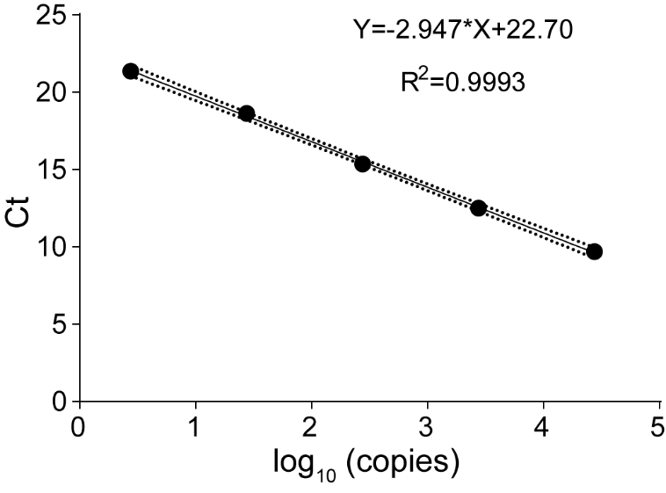
Fig. S5: Plasmid-based standard curve for the absolute quantification of Pseudomonas in apple samples via qPCR. The linear regression demonstrates the relationship between cycle threshold (Ct) values and the log10 of the plasmid copy number. The equation Y = -2.947X + 22.70 with an R² of 0.9993 confirms high amplification efficiency and technical precision for microbial load assessment. Dotted lines indicate the 95% confidence interval.
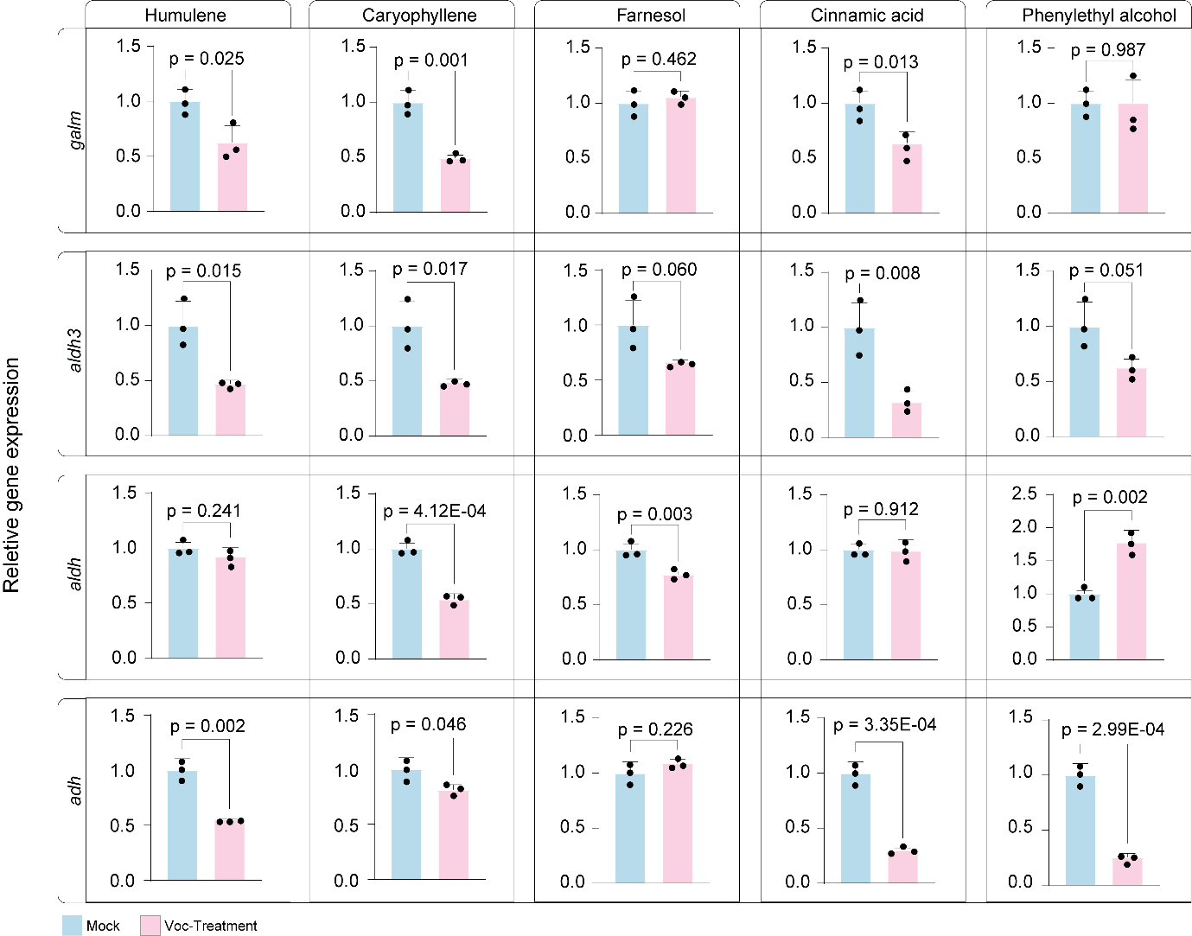
Fig. S6: Relative expression of defense-related genes in B. dothidea following exposure to specific VOCs. qPCR analysis of galm, aldh3, aldh, and adh expression levels in fungal mycelia treated with humulene, caryophyllene, farnesol, cinnamic acid, and phenylethyl alcohol. Most VOC treatments resulted in significant downregulation of target genes compared to the mock control, suggesting interference with fungal metabolic and defense pathways. Data are mean ± SD (n=3); p-values indicate significance via Student’s t-test.
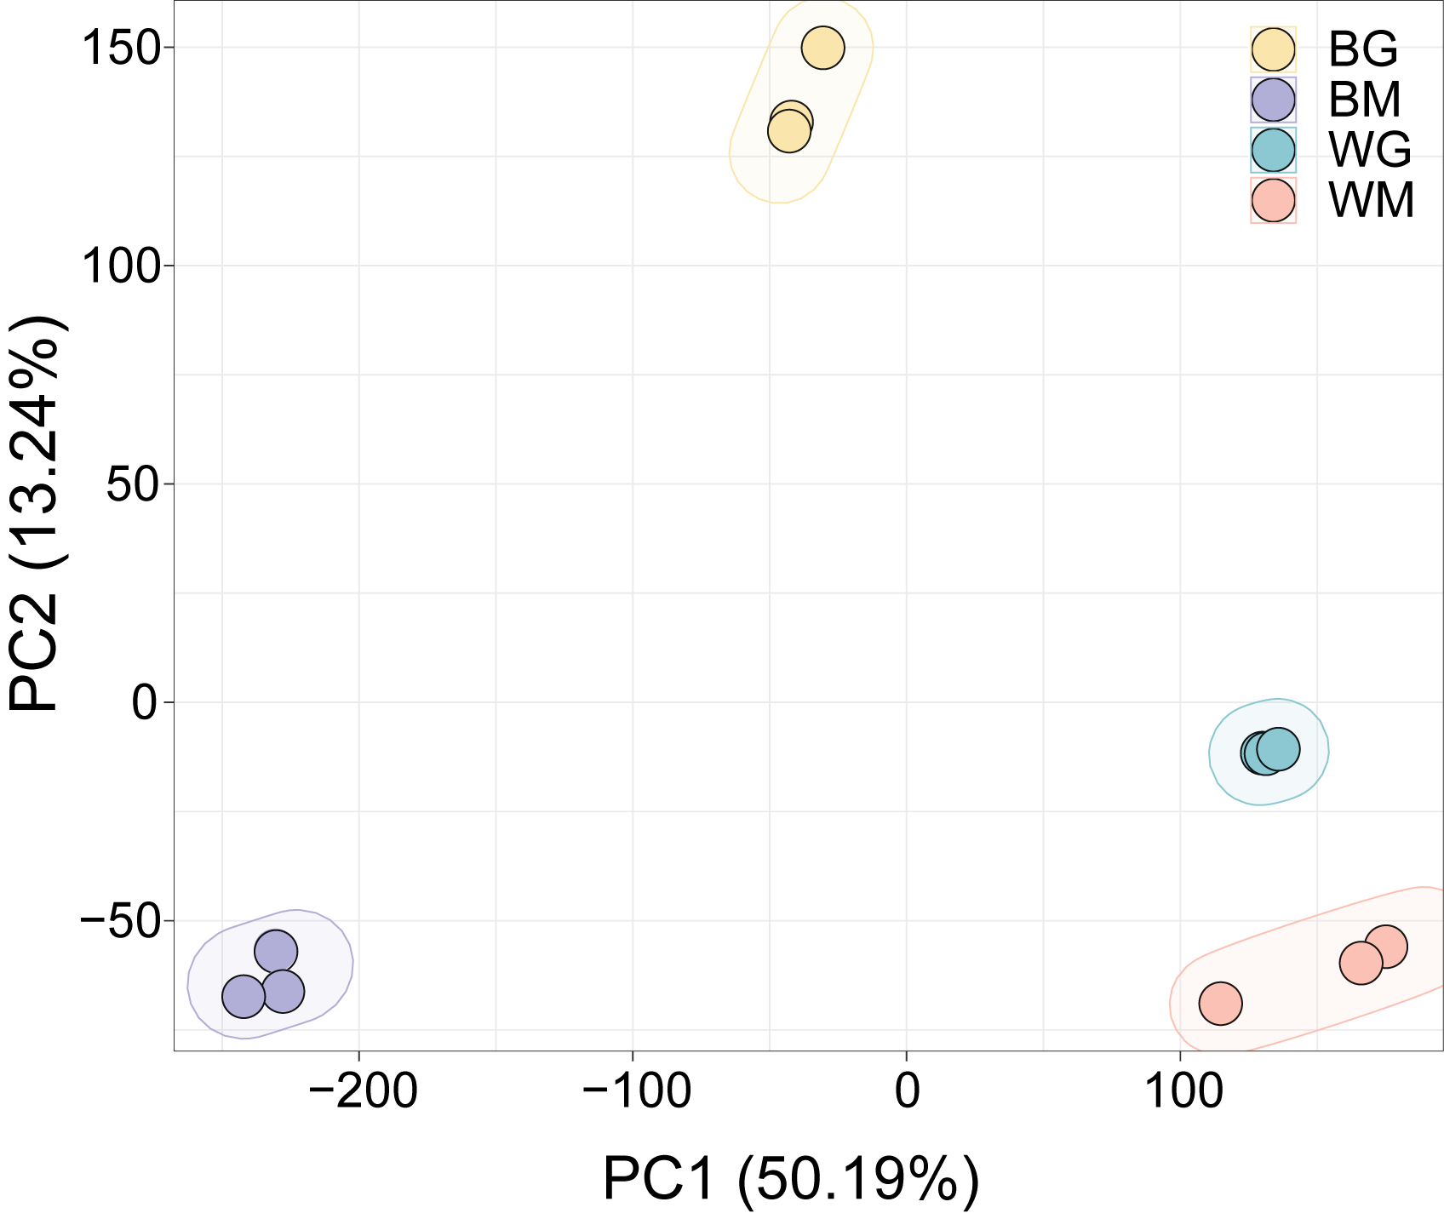

Fig. S7: Principal component analysis of RNA-seq profiles in apple fruit
PCA of global transcriptome data reveals distinct sample clustering, with PC1 (50.19%) and PC2 (13.24%) accounting for the majority of the total variance. Tight clustering confirms high reproducibility across biological replicates (n = 3), with ellipses representing 95% confidence intervals.

