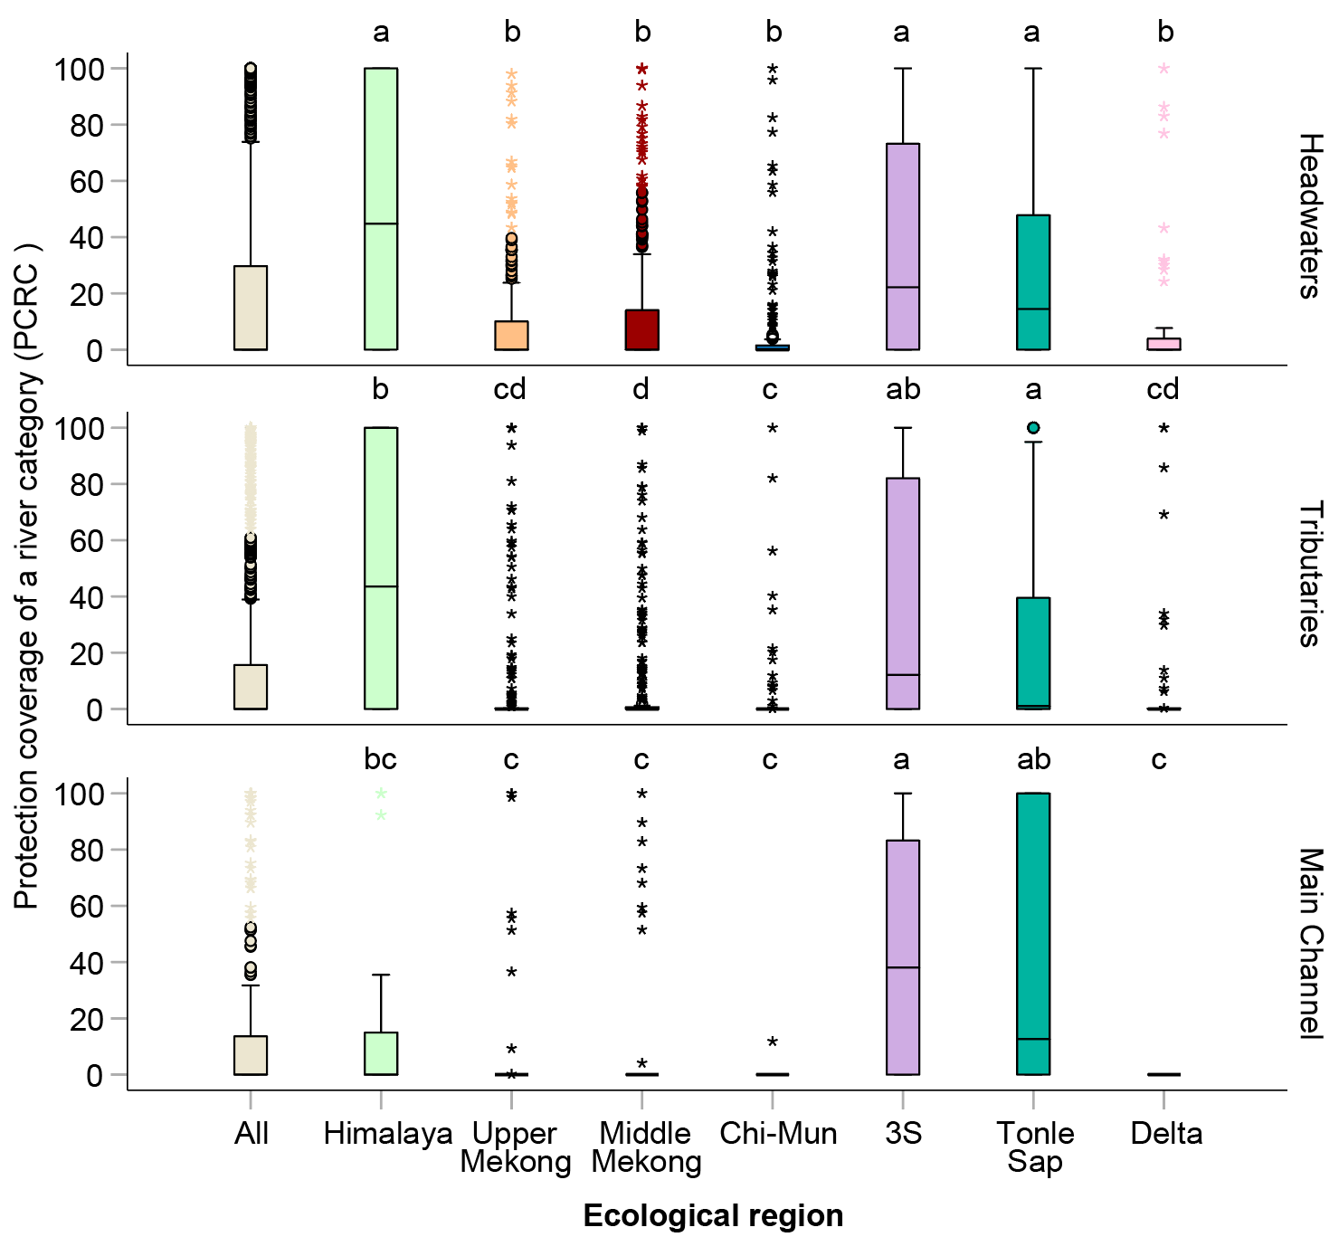
Figure S1. Boxplots showing the protection coverage of river categories (PCRC) for headwaters, tributaries, and main channels across sub-basins within the seven ecological regions of the Mekong Basin (Himalaya, Upper Mekong, Middle Mekong, Chi-Mun, 3S, Tonle Sap, and Delta) and across the entire basin (All). Each boxplot represents variability among sub-basins within a given region, and the horizontal line within each box indicates the median.

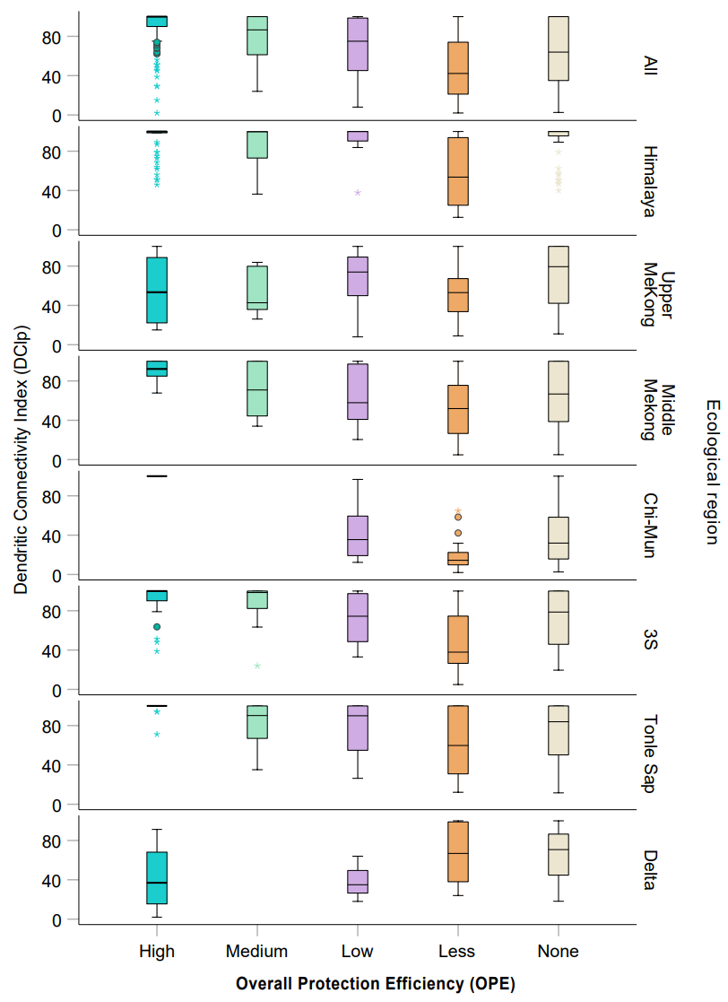
Figure S2. DCIp across OPE classes in the Mekong Basin. Boxplots illustrate the distribution of sub-basin DCIp values across five OPE classes (High, Medium, Low, Less, and None) for the entire basin and for each ecological region. Each boxplot represents variability among sub-basins within a given OPE class. The line within each box marks the median; boxes indicate the interquartile range; whiskers and points represent the spread of values and outliers, respectively.

