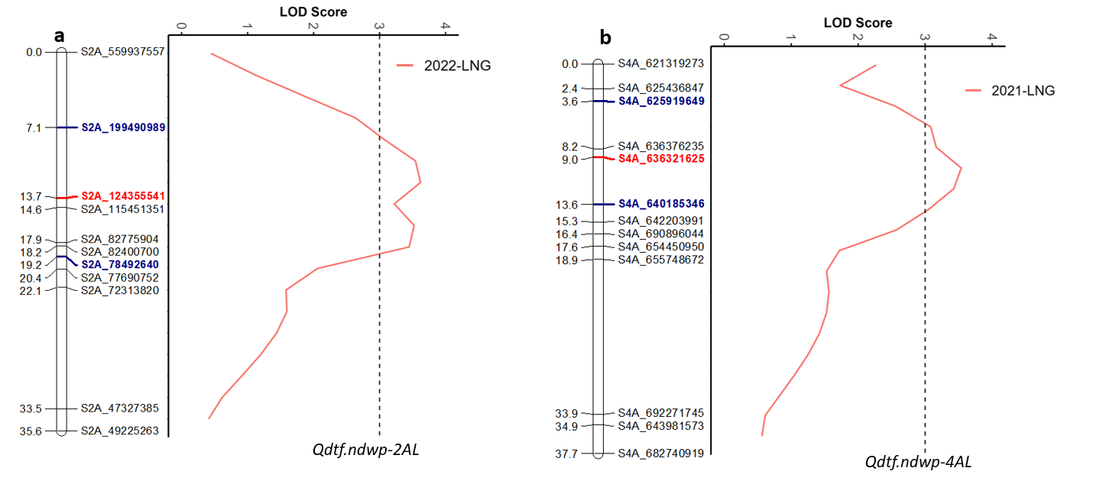
Supplementary Fig. 1. Regions of linkage maps for chromosomes 2A (a) and 4A (b) harboring QTL for days to flowering (DTF) detected in 10FARJA population. Both QTL for DTF were derived from the ‘Joppa’ parent. The genetic distance (centimorgan, cM) between SNP marker loci and the physical positions of the SNP markers are shown on the left and right sides of the linkage maps, respectively. The LOD significance threshold 3.0 is represented by a vertical dashed line. Peak markers or the markers closely linked to QTL, and the flanking markers of QTL are in bold red and blue colors, respectively. Both QTL were detected in the field experiments conducted in Langdon in 2021 and 2022 (2021-LNG and 2022-LNG).

Supplementary Table 1. Summary of SNP markers assigned to each chromosome and used in linkage analysis, including the number of markers, number of linkage groups, total genetic distance, and marker densities in the mapping population.
Chromosome | Total no. of SNPs | No. of SNPs with < 30% missing values | No. of distorted SNPs (%) | No. of mapped SNPs | No. of unmapped SNPs | No. of linkage groups (LGs)* | Marker density (cM/marker)** | No. of unique mapped loci in LGs | LGs | Genetic distance (cM)
1A | 3,171 | 464 | 17 (3.6) | 444 | 3 | 1 | 1.48 | 50 | 1A_LG1 | 73.93
1B | 4,093 | 589 | 111 (18.8) | 477 | 1 | 2 | 1.23 | 57 | 1B_LG1 | 27.81
 |  |  |  |  |  |  |  | 57 | 1B_LG2 | 42.20
2A | 1,776 | 271 | 40 (14.7) | 228 | 3 | 1 | 1.62 | 22 | 2A_LG1 | 35.62
2B | 1,979 | 272 | 19 (6.9) | 252 | 1 | 3 | 2.02 | 48 | 2B_LG1 | 22.13
 |  |  |  |  |  |  |  | 48 | 2B_LG2 | 64.47
 |  |  |  |  |  |  |  | 48 | 2B_LG3 | 10.29
3A | 3,700 | 839 | 115 (13.7) | 723 | 1 | 2 | 1.17 | 159 | 3A_LG1 | 168.62
 |  |  |  |  |  |  |  | 159 | 3A_LG2 | 17.95
3B | 2,183 | 309 | 18 (5.8) | 288 | 3 | 2 | 1.62 | 60 | 3B_LG1 | 58.26
 |  |  |  |  |  |  |  | 60 | 3B_LG2 | 39.15
4A | 1,790 | 349 | 14 (4) | 335 | 0 | 2 | 1.68 | 37 | 4A_LG1 | 37.71
 |  |  |  |  |  |  |  | 37 | 4A_LG2 | 24.52
4B | 1,941 | 199 | 19 (9.5) | 178 | 2 | 1 | 2.25 | 39 | 4B_LG1 | 87.57
5A | 1,292 | 128 | 7 (5.4) | 120 | 1 | 1 | 1.43 | 18 | 5A_LG1 | 25.80
5B | 2,450 | 347 | 48 (13.8) | 297 | 2 | 2 | 2.02 | 69 | 5B_LG1 | 98.57
 |  |  |  |  |  |  |  | 69 | 5B_LG2 | 41.13
6A | 1,416 | 192 | 45 (23.4) | 145 | 2 | 3 | 1.92 | 29 | 6A_LG1 | 25.06
 |  |  |  |  |  |  |  | 29 | 6A_LG2 | 12.46
 |  |  |  |  |  |  |  | 29 | 6A_LG3 | 18.17
6B | 4,044 | 773 | 55 (7.1) | 716 | 2 | 2 | 0.86 | 84 | 6B_LG1 | 22.36
 |  |  |  |  |  |  |  | 84 | 6B_LG2 | 49.23
7A | 1,945 | 302 | 28 (9.2) | 272 | 2 | 2 | 1.46 | 39 | 7A_LG1 | 12.46
 |  |  |  |  |  |  |  | 39 | 7A_LG2 | 44.38
7B | 2690 | 315 | 24 (7.6) | 290 | 1 | 1 | 1.69 | 46 | 7B_LG1 | 77.77
A genome | 15,090 | 2,545 | 266 (10.4) | 2,267 | 12 | 12 | 1.40 | 354 | - | 496.68
B genome | 19,380 | 2,804 | 294 (10.4) | 2,498 | 12 | 13 | 1.59 | 403 | - | 640.94
Total | 34,470 | 5,349 | 560 (10.4) | 4,765 | 24 | 25 | 1.50 | 757 | - | 1,137.62
*Linkage groups (LGs) shorter than 10 cM were excluded from the table and QTL analysis.
Marker density values were calculated by dividing the genetic distance (cM) by the number of unique mapped loci in each linkage group (LG).

Supplementary Table 2. LOD value thresholds (at significant levels of α = 0.05 and 0.01) determined by permutation test for QTL detected for FHB resistance, resistance to Fusarium damaged kernel (FDK) and days to flowering (DTF).
Experiment | 1B | 2A | 3A1 | 3A2 | 4A | 5B1 | 5B2 | 6A | 6B | 7B
 | α = 0.05/0.01 | α = 0.05/0.01 | α = 0.05/0.01 | α = 0.05/0.01 | α = 0.05/0.01 | α = 0.05/0.01 | α = 0.05/0.01 | α = 0.05/0.01 | α = 0.05/0.01 | α = 0.05/0.01
2021-GH1 | - | - | 3.04 / 3.76** | - | - | 2.81 / 3.60* | - | - | - | -
2021-GH2 | - | - | - | - | - | - | - | - | - | -
2022-GH | 3.00 / 3.75** | - | - | - | - | 3.00 / 3.75** | - | - | - | -
2023-GH | 3.02 / 3.63* | - | 3.02 / 3.63* | - | - | 3.02 / 3.63** | - | 3.03 / 3.70**(FDK) | 3.02 / 3.63* - 3.03 / 3.70*ª | -
2021-FAR | 2.90 / 3.79* | - | - | - | - | - | - | - | 2.95 / 3.40* | -
2021-LNG | 2.75 / 3.21* | - | 3.05 / 3.81* | - | 2.85 / 3.56*^{b} | - | - | - | - | -
2022-FAR | 2.77 / 3.46* | - | - | 3.12 / 3.77** | - | - | 2.82 / 3.48* | - | 3.12 / 3.77** | -
2022-LNG | - | 3.03 / 3.82* (DTF) | - | - | - | - | - | - | - | 2.94 / 3.54*
* QTL significant at α = 0.05, ** QTL significant at α = 0.01

Supplementary Table 3. LOD scores, additive effects, and R² values of the identified quantitative trait loci for FHB resistance in the population.
QTL | Experiment | LOD |  |  |  | Additive Effect |  |  |  | R²
QTL | Experiment | 2021-FAR | 2021-LNG | 2022-FAR | 2022-LNG | 2021-FAR | 2021-LNG | 2022-FAR | 2022-LNG | 2021-FAR | 2021-LNG | 2022-FAR | 2022-LNG
Qfhb.ndwp-1BL | Field | 3.10 | 3.16 | 3.17 | 2.78^{ns} | 3.07 | 2.32 | 2.83 | - | 0.074 | 0.76 | 0.075 | -
Qfhb.ndwp-3AS | Field | - | 3.74 | - | 2.24 ^{ns} | - | 1.86 | - | - | - | 0.088 | - | -
Qfhb.ndwp-3AL | Field | - | - | 5.42 | 2.38 ^{ns} | - | - | 3.56 | 2.51 | - | - | 0.126
Qfhb.ndwp-5BS | Field | - | - | - | - | - | - | - | - | - | - | - | -
Qfhb.ndwp-5BL | Field | - | - | 3.35 | - | - | - | 4.26 | - | - | - | 0.08 | -
Qfhb.ndwp-6BL | Field | 3.18 | - | 4.8 | - | 4.81 | - | 4.01 | - | 0.088 | - | 0.106 | -
Qfhb.ndwp-7BL | Field | - | - | - | 3.00 | - | - | - | -2.93JP | - | - | - | 0.072
 |  | LOD |  |  |  | Additive Effect |  |  |  | R²
 |  | 2021-GH1 | 2021-GH2 | 2022-GH | 2023-GH | 2021-GH1 | 2021-GH2 | 2022-GH | 2023-GH | 2021-GH1 | 2021-GH2 | 2022-GH | 2023-GH
Qfhb.ndwp-1BL | Greenhouse | 2.11 ^{ns} | 1.91 ^{ns} | 6.14 | 3.08 | - | - | 6.87 | 6.48 | - | - | 0.141 | 0.07
Qfhb.ndwp-3AS | Greenhouse | 8.98 | - | 2.32 ^{ns} | 3.80 | 5.92 | - | 3.22 | 6.15 | 0.20 | - | 0.03 | 0.09
Qfhb.ndwp-3AL | Greenhouse | - | - | - | - | - | - | - | - | - | - | - | -
Qfhb.ndwp-5BS | Greenhouse | 3.38 | - | 4.01 | 6.03 | 3.84 | - | 6.82 | 7.67 | 0.08 | - | 0.095 | 0.139
Qfhb.ndwp-5BL | Greenhouse | - | - | - | - | - | - | - | - | - | - | - | -
Qfhb.ndwp-6BL | Greenhouse | - | - | 3.2 | 3.5 | - | - | 4.9 | 6.61 | - | - | 0.076 | 0.083
Qfhb.ndwp-7BL | Greenhouse | - | - | - | - | - | - | - | - | - | - | - | -
^{ns} the marker peaked at QTL region but failed the permutation test and were considered non-significant. A positive additive effect indicates a reduction in FHB severity due to the alleles contributed by the LPA-4 parent. A negative additive effect marked with “JP” indicates a reduction in disease severity due to Joppa-derived QTL.

