Supplementary Figures

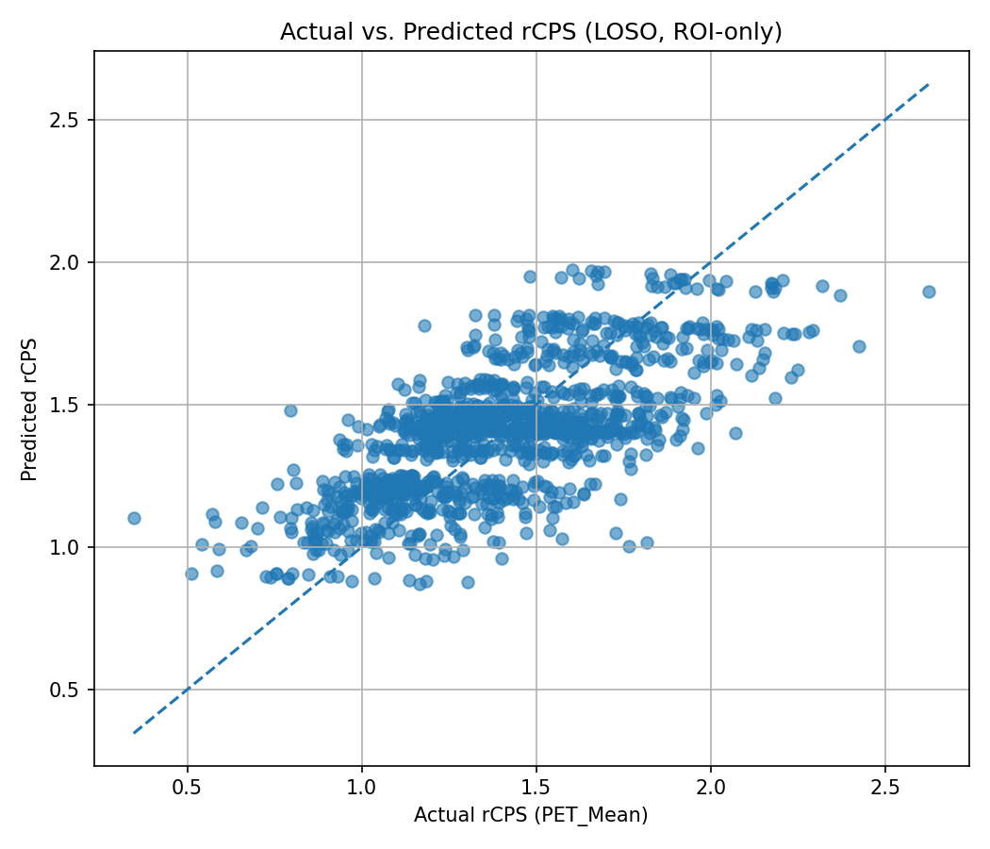
Figure S1: ROI-only baseline diagnostic plot (StructName only). The dashed diagonal denotes identity.
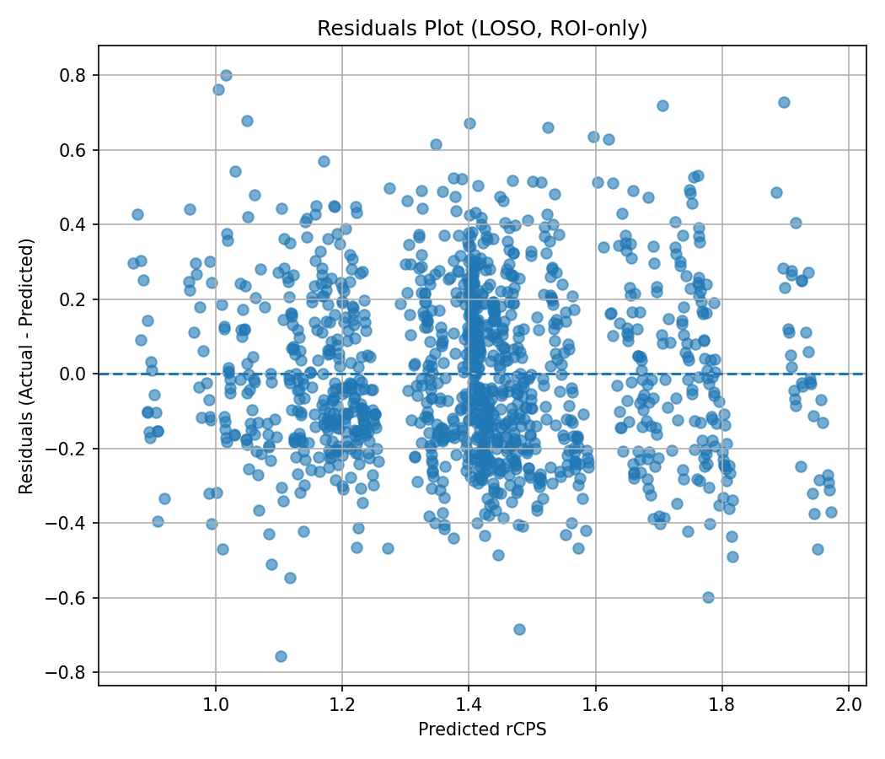
Figure S2: ROI-only baseline residual diagnostics. The dashed horizontal line denotes zero error.
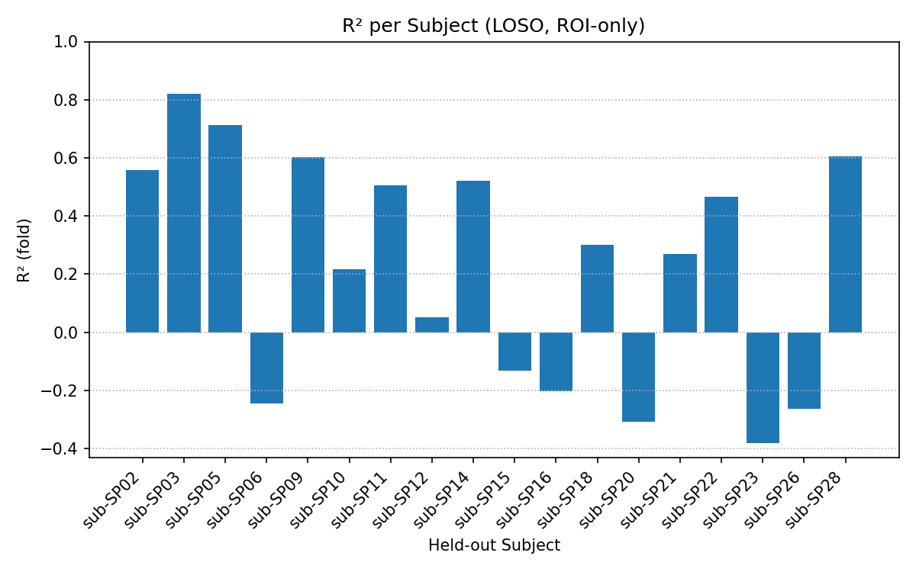
Figure S3: Fold-wise R² values across LOSO folds for the ROI-only model.

