Supplemental Digital Content (SDC) (in order of appearance in main text)

Table of Contents:

Supplemental Digital Content 1: CONSORT checklist (table)
Supplemental Digital Content 2: Cluster allocation (table)
Supplemental Digital Content 3: Screenshot of DKA simulator (figure)
Supplemental Digital Content 4: Method and time period of data collection (figure)
Supplemental Digital Content 5: DKA Study Questionnaires

SDC 1: CONSORT 2010 checklist of information to include when reporting a cluster randomized trial
**Note: SDC = Supplemental Digital Content
Section/Topic | Item No | Standard Checklist item | Extension for cluster designs | Page No *
Title and abstract
 | 1a | Identification as a randomised trial in the title | Identification as a cluster randomised trial in the title | 1
 | 1b | Structured summary of trial design, methods, results, and conclusions (for specific guidance see CONSORT for abstracts) | See table 2 | 4
Introduction
Background and objectives | 2a | Scientific background and explanation of rationale | Rationale for using a cluster design | 6-8
Background and objectives | 2b | Specific objectives or hypotheses | Whether objectives pertain to the the cluster level, the individual participant level or both | 8
Methods
Trial design | 3a | Description of trial design (such as parallel, factorial) including allocation ratio | Definition of cluster and description of how the design features apply to the clusters | 8, 9, SDC 2
Trial design | 3b | Important changes to methods after trial commencement (such as eligibility criteria), with reasons |  | n/a
Participants | 4a | Eligibility criteria for participants | Eligibility criteria for clusters | 9
Participants | 4b | Settings and locations where the data were collected |  | 9
Interventions | 5 | The interventions for each group with sufficient details to allow replication, including how and when they were actually administered | Whether interventions pertain to the cluster level, the individual participant level or both | 11, 12
Outcomes | 6a | Completely defined pre-specified primary and secondary outcome measures, including how and when they were assessed | Whether outcome measures pertain to the cluster level, the individual participant level or both | 12
Outcomes | 6b | Any changes to trial outcomes after the trial commenced, with reasons |  | n/a
Sample size | 7a | How sample size was determined | Method of calculation, number of clusters(s) (and whether equal or unequal cluster sizes are assumed), cluster size, a coefficient of intracluster correlation (ICC or k), and an indication of its uncertainty | 10
Sample size | 7b | When applicable, explanation of any interim analyses and stopping guidelines |  | n/a
Randomisation:
Sequence generation | 8a | Method used to generate the random allocation sequence |  | 10
Sequence generation | 8b | Type of randomisation; details of any restriction (such as blocking and block size) | Details of stratification or matching if used | 10, 11
Allocation concealment mechanism | 9 | Mechanism used to implement the random allocation sequence (such as sequentially numbered containers), describing any steps taken to conceal the sequence until interventions were assigned | Specification that allocation was based on clusters rather than individuals and whether allocation concealment (if any) was at the cluster level, the individual participant level or both | 10, 11
Implementation | 10 | Who generated the random allocation sequence, who enrolled participants, and who assigned participants to interventions | Replace by 10a, 10b and 10c | 10, 11
 | 10a |  | Who generated the random allocation sequence, who enrolled clusters, and who assigned clusters to interventions | 10, 11
 | 10b |  | Mechanism by which individual participants were included in clusters for the purposes of the trial (such as complete enumeration, random sampling) | 10, 11
 | 10c |  | From whom consent was sought (representatives of the cluster, or individual cluster members, or both), and whether consent was sought before or after randomisation | 10
Blinding | 11a | If done, who was blinded after assignment to interventions (for example, participants, care providers, those assessing outcomes) and how |  | 10, 11
Blinding | 11b | If relevant, description of the similarity of interventions |  | 10, 11
Statistical methods | 12a | Statistical methods used to compare groups for primary and secondary outcomes | How clustering was taken into account | 13
Statistical methods | 12b | Methods for additional analyses, such as subgroup analyses and adjusted analyses |  | 13
Results
Participant flow (a diagram is strongly recommended) | 13a | For each group, the numbers of participants who were randomly assigned, received intended treatment, and were analysed for the primary outcome | For each group, the numbers of clusters that were randomly assigned, received intended treatment, and were analysed for the primary outcome | 13, 14, Figure 1
Participant flow (a diagram is strongly recommended) | 13b | For each group, losses and exclusions after randomisation, together with reasons | For each group, losses and exclusions for both clusters and individual cluster members | Figure 1
Recruitment | 14a | Dates defining the periods of recruitment and follow-up |  | SDC 4
Recruitment | 14b | Why the trial ended or was stopped |  | n/a
Baseline data | 15 | A table showing baseline demographic and clinical characteristics for each group | Baseline characteristics for the individual and cluster levels as applicable for each group | Table 1
Numbers analysed | 16 | For each group, number of participants (denominator) included in each analysis and whether the analysis was by original assigned groups | For each group, number of clusters included in each analysis | 14, 15, Table 2
Outcomes and estimation | 17a | For each primary and secondary outcome, results for each group, and the estimated effect size and its precision (such as 95% confidence interval) | Results at the individual or cluster level as applicable and a coefficient of intracluster correlation (ICC or k) for each primary outcome | 14, 15
Outcomes and estimation | 17b | For binary outcomes, presentation of both absolute and relative effect sizes is recommended |  | n/a
Ancillary analyses | 18 | Results of any other analyses performed, including subgroup analyses and adjusted analyses, distinguishing pre-specified from exploratory |  | 15
Harms | 19 | All important harms or unintended effects in each group (for specific guidance see CONSORT for harms) |  | n/a
Discussion
Limitations | 20 | Trial limitations, addressing sources of potential bias, imprecision, and, if relevant, multiplicity of analyses |  | 17
Generalisability | 21 | Generalisability (external validity, applicability) of the trial findings | Generalisability to clusters and/or individual participants (as relevant) | 17
Interpretation | 22 | Interpretation consistent with results, balancing benefits and harms, and considering other relevant evidence |  | 15-17
Other information
Registration | 23 | Registration number and name of trial registry |  | 5
Protocol | 24 | Where the full trial protocol can be accessed, if available |  | 8-13
Funding | 25 | Sources of funding and other support (such as supply of drugs), role of funders |  | 3
* Note: page numbers optional depending on journal requirements

SDC 2: Cluster Allocation
GIM Teaching site | Block 1 | Block 2 | Block 3 | Block 4 | Block 5 | Block 6 | Block 7 | Block 8 | Block 9 | Block 10
St. George Campus:
St. Michael’s Hospital | Cluster 1 |  | Cluster 2 |  | Cluster 3 |  | Cluster 4 |  | Cluster 5
St. Michael’s Hospital | 7 CC3  2 PGY1 | 2 PGY1 | 7 CC3  2 PGY1 | 2 PGY1 | 7 CC3  2 PGY1 | 2 PGY1 | 7 CC3 |  | 7 CC3
Toronto General Hospital | Cluster 6 |  | Cluster 7 |  | Cluster 8 |  | Cluster 9 |  | Cluster 10
Toronto General Hospital | 7 CC3  2 PGY1 | 2 PGY1 | 7 CC3  2 PGY1 | 2 PGY1 | 7 CC3  2 PGY1 | 2 PGY1 | 7 CC3 |  | 7 CC3
Toronto Western Hospital | Cluster 11 |  | Cluster 12 |  | Cluster 13 |  | Cluster 14 |  | Cluster 15
Toronto Western Hospital | 7 CC3  2 PGY1 | 2 PGY1 | 7 CC3  2 PGY1 | 2 PGY1 | 7 CC3  2 PGY1 | 2 PGY1 | 7 CC3 |  | 7 CC3
Mount Sinai Hospital | Cluster 16 |  | Cluster 17 |  | Cluster 18 |  | Cluster 19 |  | Cluster 20
Mount Sinai Hospital | 7 CC3  2 PGY1 | 2 PGY1 | 7 CC3  2 PGY1 | 2 PGY1 | 7 CC3  2 PGY1 | 2 PGY1 | 7 CC3 |  | 7 CC3
Sunnybrook Hospital | Cluster 21 |  | Cluster 22 |  | Cluster 23 |  | Cluster 24 |  | Cluster 25
Sunnybrook Hospital | 7 CC3  2 PGY1 | 2 PGY1 | 7 CC3  2 PGY1 | 2 PGY1 | 7 CC3  2 PGY1 | 2 PGY1 | 7 CC3 |  | 7 CC3
Mississauga Campus:
Credit Valley Hospital | Cluster 26 |  | Cluster 27 |  | Cluster 28 |  | Cluster 29 |  | Cluster 30
Credit Valley Hospital | 4 CC3 |  | 4 CC3 |  | 4 CC3 |  | 4 CC3 |  | 4 CC3
Trillium Health Centre | Cluster 31 |  | Cluster 32 |  | Cluster 33 |  | Cluster 34 |  | Cluster 35
Trillium Health Centre | 4 CC3 |  | 4 CC3 |  | 4 CC3 |  | 4 CC3 |  | 4 CC3

SDC 3: Screenshot of DKA simulator
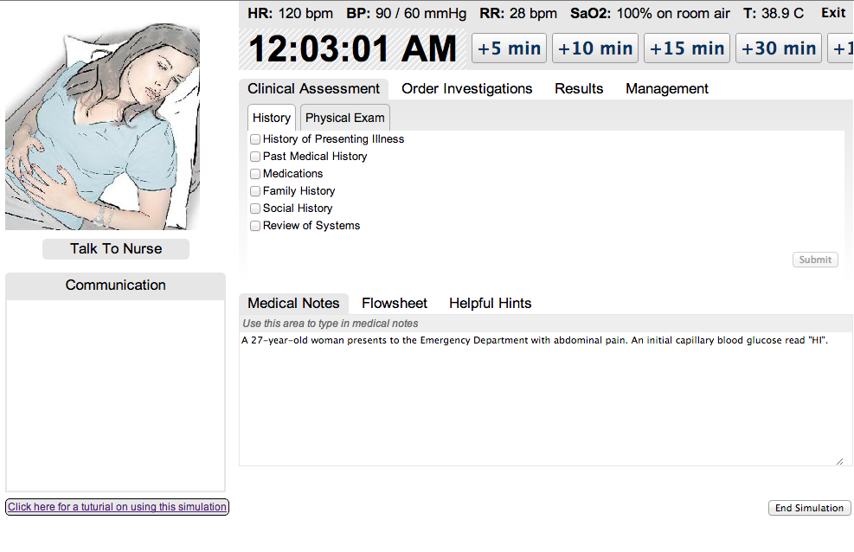
Appendix B 1 - Clinical Assessment

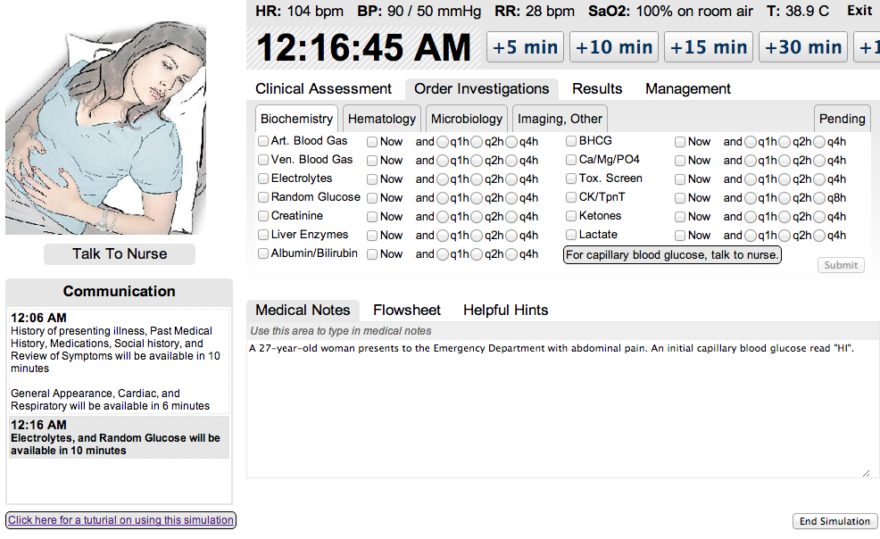
Appendix B 2 - Order Investigations

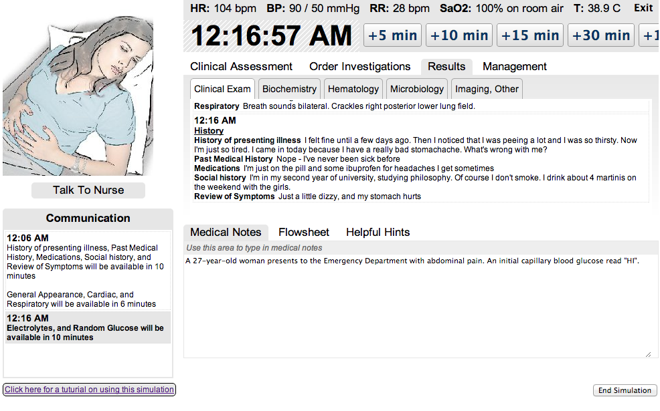
Appendix B 3 - Results

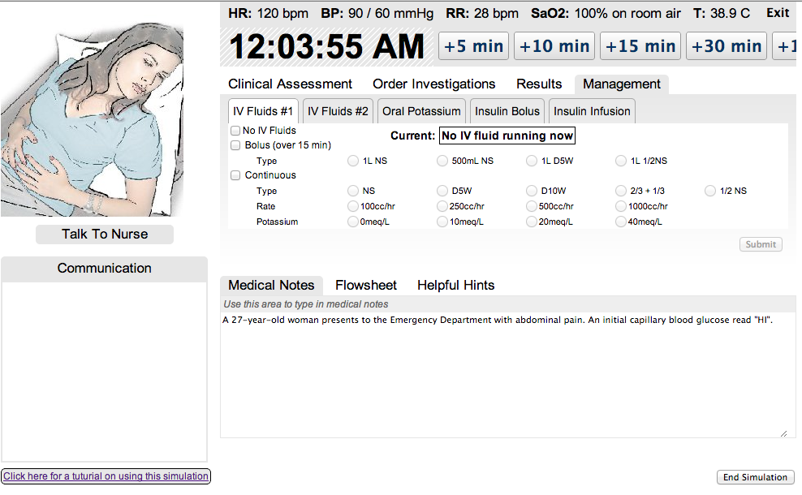
Appendix B 4 - Management

SDC 4: Method and time period of data collection
2014 |  |  |  |  |  |  |  |  |  |  |  | 2015
Jan/ Feb | March/  April | May | June |  | July | Aug | Sept |  | Oct | Nov | Dec | Jan | Feb | March | April | May | June | July
Engaging Internal Medicine site directors and Undergraduate representatives
Recruiting chief medical residents and endocrine fellows
Collection of baseline measures
Intervention: Cohorts A,B,C,D
Measurement of simulation usage
 |  |  |  |  |  | Participant testing on the DKA simulator—Immediately after, 3 and 6 months post-intervention
 |  |  |  |  |  |  |  |  |  |  |  |  |  |  |  |  |  | Data analysis

SDC 5: Demographics and Comfort with DKA Management Questionnaires

DKA Simulator – Demographics Questionnaire
Participant ID: ____________________
Date: ____________________
- Please enter your USER ID as provided in the email (e.g., USER2)
________________
- Gender
- ☐ Male
- ☐ Female
- ☐ Non-binary
- ☐ Prefer not to answer
- ☐ Other: ______
- Age
- ☐ <21
- ☐ 21–30
- ☐ 31–40
- ☐ 41–50
- ☐ >50
- Education (select all that apply)
- ☐ No degree prior to medical school
- ☐ Undergraduate degree
- ☐ Master’s degree
- ☐ PhD
- ☐ Other professional degree: ______
- Is English your first language?
- ☐ Yes
- ☐ No
- Comfort with managing diabetes
- ☐ Very uncomfortable
- ☐ Uncomfortable
- ☐ Neutral
- ☐ Comfortable
- ☐ Very comfortable
- Clinical experience with DKA: Number of DKA patients treated
- ☐ 0 patients
- ☐ 1–5 patients
- ☐ 6–10 patients
- ☐ >10 patients
- Please select educational sessions/resources already attended or used (select all that apply)
- ☐ Bedside/Informal Case teaching
- ☐ Emergency lecture series topic on Hyperglycemic Emergencies
- ☐ Other Formal Rounds or Seminar
- ☐ UpToDate topic: Treatment of diabetic ketoacidosis and hyperglycemic state in adults
- ☐ Canadian Diabetes Association Clinical Practice Guidelines
- ☐ Other: ______
- ☐ None

DKA Simulator – Comfort with DKA Questionnaire*
*Presented at each study timepoint: Pre-study, After Case 4, After Case 5, After Test 1, After Test 2, After Test 3
Participant ID: ____________________
Date: ____________________
- Please enter your USER ID as provided in the email (e.g., USER2)
________________
- Rate your comfort with DKA management
- ☐ Very uncomfortable
- ☐ Uncomfortable
- ☐ Neutral
- ☐ Comfortable
- ☐ Very comfortable

