Supplementary Information

Table S1: List of CMIP6 climate models used in this study. Including the contributing institution, release year, transient climate response (TCR; degrees C), and reference. TCR values are taken from Beck et al. (2023).
Model | Instituting | Release year | TCR (°C) | Reference
ACCESS-CM2 | CSIRO-ARCCSS | 2019 | 1.97 | [1]
AWI-CM-1-1-MR | AWI | 2018 | 2.05 | [2]
CNRM-CM6-1 | CNRM-CERFACS | 2017 | 2.25 | [3]
CNRM-CM6-1-HR | CNRM-CERFACS | 2017 | 2.49 | [4]
CNRM-ESM2-1 | CNRM-CERFACS | 2017 | 1.86 | [5]
FGOALS-g3 | CAS | 2017 | 1.4 | [6]
GFDL-ESM4 | NOAA-GFDL | 2018 | 1.49 | [7]
INM-CM4-8 | INM | 2016 | 1.33 | [8]
INM-CM5-0 | INM | 2016 | 1.39 | [9]
MIROC-ES2L | MIROC | 2018 | 1.52 | [10]
MIROC6 | MIROC | 2017 | 1.58 | [11]
MPI-ESM1-2-LR | MPI-M AWI DKRZ DWD | 2017 | 1.86 | [12]
MRI-ESM2-0 | MRI | 2017 | 1.67 | [13]

Table S2: Summary statistics of geographic analogue distances and novel climate area. Area-weighted summary statistics for geographic analogue distance (km) and the fraction of land classified as novel climate (%), stratified by future period and scenario. N denotes the number of non-novel land grid cells included. Quartiles (first quartile [Q1] and third quartile [Q3])) are computed after weighting by grid-cell area.
Period | Scenario | N | Mean (km) | Median (km) | Q1 (km) | Q3 (km) | novel area (%)
2041.2070 | SSP126 | 349963 | 180.26 | 103.99 | 52.94 | 195.74 | 0.88
2041.2070 | SSP245 | 339827 | 340.12 | 155.45 | 78.24 | 290.99 | 5.20
2041.2070 | SSP585 | 307991 | 569.23 | 240.79 | 115.68 | 446.21 | 18.23
2071.2100 | SSP126 | 349426 | 190.03 | 109.98 | 55.60 | 200.77 | 1.10
2071.2100 | SSP245 | 306138 | 582.63 | 246.31 | 119.03 | 454.00 | 18.80
2071.2100 | SSP585 | 185161 | 947.82 | 403.00 | 194.45 | 784.87 | 62.14

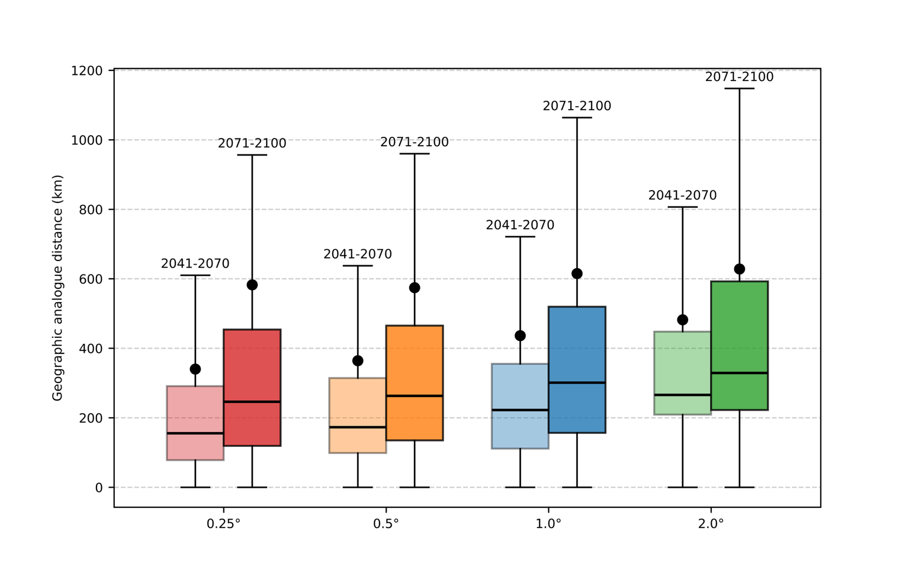
Fig. S1: Geographic Analogue distance distributions across spatial resolutions. Boxplots summarize the distribution of geographic analogue distances (km) computed at four spatial resolutions (0.25, 0.5, 1.0, and 2.0 degrees) for SSP2-4.5 in 2041-2070 and 2071-2100. Black points indicate area-weighted mean distances. Coarser resolutions were derived by re-gridding 0.25-degree ensemble-mean fields (including future mean and standard deviation) and the historical ERA5 baseline before recalculating analogue distances.

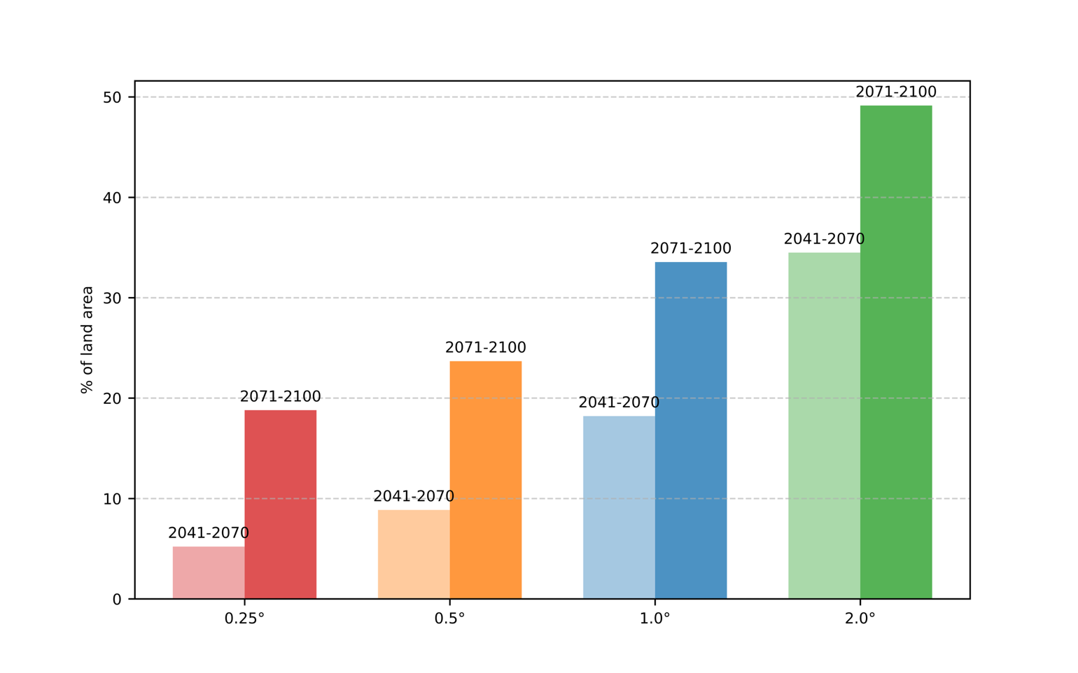
Fig. S2: Novel climate across spatial resolutions. Proportion of land area classified as novel climate (%) at four spatial resolutions (0.25, 0.5, 1.0, and 2.0 degrees) under SSP2-4.5 for 2041-2070 and 2071-2100.

Table S3: Geographic Analogue distance and novelty statistics by resolution. Area-weighted statistical summary (mean, median, first quartile [Q1], third quartile [Q3]) of geographic analogue distance (km) and novel climate area (%) for four spatial resolutions (0.25, 0.5, 1.0, and 2.0 degrees) under SSP2-4.5, reported separately for 2041-2070 and 2071-2100. N denotes the number of non-novel land grid cells at each resolution.
Period | Resolution (°) | Number | Mean (km) | Median (km) | Q1 (km) | Q3 (km) | NovelArea(%)
2041.2070 | 0.25 | 339827 | 340.12 | 155.45 | 78.24 | 290.99 | 5.20
2041.2070 | 0.5 | 79331 | 364.14 | 173.01 | 98.63 | 314.21 | 8.86
2041.2070 | 1.0 | 17974 | 436.35 | 222.39 | 111.20 | 355.18 | 18.21
2041.2070 | 2.0 | 3697 | 482.03 | 265.96 | 208.98 | 448.03 | 34.49
2071.2100 | 0.25 | 306138 | 582.63 | 246.31 | 119.03 | 454.00 | 18.80
2071.2100 | 0.5 | 70233 | 574.36 | 263.22 | 135.09 | 465.12 | 23.67
2071.2100 | 1.0 | 15489 | 615.13 | 301.21 | 156.58 | 519.50 | 33.55
2071.2100 | 2.0 | 3037 | 628.26 | 329.13 | 222.39 | 592.54 | 49.14

Table S4 : Cluster-level summaries of analogue displacement. Cluster-specific aggregates from the k-means analysis, including mean geographic analogue distance (km), cluster area as a percentage of total land area, and mean geographic coordinates (latitude, longitude) of future target locations and their historical analogue locations. Cluster 0 denotes grid cells classified as novel climate; for this cluster, coordinates correspond to the location of minimum standardized Euclidean distance (SED_{min}) rather than an assigned analogue.
Period | cluster | mean_dist (km) | area (%) | Target_lat (°) | Target_lon (°) | analogue_lat (°) | analogue_lon (°)
2041.2070 | 0 | 106.42 | 0.88 | 19.69 | 8.97 | 19.53 | 9.36
Scenario | 1 | 122.76 | 9.25 | 30.3 | 103.66 | 29.86 | 103.57
ssp126 | 2 | 226.19 | 6.39 | -3.54 | -63.29 | -3.54 | -62.3
 | 3 | 66.65 | 2.17 | -79.21 | -111.24 | -79.16 | -110.64
 | 4 | 200.54 | 5.62 | 56.1 | 28.2 | 55.04 | 26.66
 | 5 | 159.41 | 5.3 | 53.08 | -114.82 | 52.2 | -114.32
 | 6 | 3773 | 0.08 | 67.34 | 129.18 | 63.65 | -111.75
 | 7 | 195.25 | 7.14 | -20.88 | 133.2 | -20.47 | 132.83
 | 8 | 13883.38 | 0.11 | 11.4 | -95.25 | 12.35 | 131.61
 | 9 | 251.47 | 5.96 | 62.5 | 88.44 | 61.35 | 87.34
 | 10 | 133.52 | 8.52 | 26.83 | 46.81 | 26.62 | 47.07
 | 11 | 64.98 | 3.71 | -74.17 | 115.85 | -74.08 | 115.79
 | 12 | 80.62 | 3.51 | -83.45 | 18.33 | -83.33 | 9.69
 | 13 | 112.82 | 4.93 | 32.82 | -102.91 | 32.44 | -103.04
 | 14 | 139.18 | 2.22 | 75.01 | -50.69 | 74.6 | -51.49
 | 15 | 139.56 | 8.7 | -10.46 | 26.82 | -10.4 | 26.79
 | 16 | 142.48 | 7.5 | 53.45 | 116.67 | 53.1 | 116.68
 | 17 | 93.38 | 5.47 | -27.1 | -57.87 | -26.78 | -58.05
 | 18 | 229.73 | 8.85 | 20.54 | 4.08 | 20.41 | 4.41
 | 19 | 629.28 | 0.04 | -77.9 | -167.31 | -77.48 | 173.93
 | 20 | 198.07 | 3.64 | 61.81 | -99 | 60.71 | -99.04
Period | 0 | 731.49 | 5.2 | 20.05 | 28.7 | 19.64 | 28.13
2041.2070 | 1 | 324.43 | 6.92 | 22.02 | 0.97 | 21.76 | 1.61
Scenario | 2 | 156.2 | 8.38 | 30 | 103.99 | 29.48 | 103.87
ssp245 | 3 | 92.33 | 3.72 | -74.2 | 115.79 | -74.11 | 114.94
 | 4 | 14434.7 | 0.49 | 10.59 | -88.85 | 11.21 | 119.73
 | 5 | 178.04 | 6.51 | 37.82 | -104.57 | 37.16 | -104.06
 | 6 | 13677.42 | 0.03 | -10.38 | 135.51 | -11.08 | -18.89
 | 7 | 381.13 | 5.24 | 62.56 | 88.22 | 60.78 | 86.7
 | 8 | 249.61 | 6.5 | 58.49 | -107.6 | 57.09 | -107.18
 | 9 | 111.62 | 2.17 | -79.17 | -112.62 | -79.11 | -101.73
 | 10 | 3420 | 0.38 | 69.81 | 129.8 | 66.12 | -116.67
 | 11 | 330.91 | 5.9 | -4.02 | -62.1 | -4.03 | -60.12
 | 12 | 111.86 | 3.52 | -83.46 | 17.56 | -83.27 | 6.68
 | 13 | 309.92 | 6.56 | -21.56 | 133.5 | -20.88 | 132.92
 | 14 | 307.79 | 5.7 | 56.31 | 29.43 | 54.58 | 27.09
 | 15 | 224.12 | 5.84 | 54.58 | 122.21 | 54.07 | 121.96
 | 16 | 273.46 | 5.8 | -15.57 | 26.29 | -15.25 | 26.95
 | 17 | 128.3 | 4.83 | -28.45 | -58.5 | -27.9 | -58.72
 | 18 | 225.94 | 2.54 | 74.39 | -55.17 | 73.49 | -55.9
 | 19 | 196.5 | 6.58 | 35.28 | 59.48 | 34.9 | 59.11
 | 20 | 300.61 | 7.17 | 12.56 | 29.37 | 12.5 | 29.29
Period | 0 | 1644.71 | 18.23 | 24.42 | 29.58 | 23.59 | 32.28
2041.2070 | 1 | 544.51 | 6.86 | 23 | 5.18 | 22.46 | 5.51
Scenario | 2 | 129.69 | 3.7 | -74.19 | 115.9 | -74.09 | 111.45
ssp585 | 3 | 233.08 | 8.46 | 33.65 | 105.47 | 32.73 | 105.49
 | 4 | 4764.3 | 0.25 | 61.89 | -146.46 | 60.28 | 90.89
 | 5 | 378.41 | 5.84 | 58.47 | -104.93 | 56.2 | -104.83
 | 6 | 3905.9 | 0.73 | 66.27 | 125.92 | 62.21 | -114.12
 | 7 | 17865.4 | 0.7 | -6.36 | -71.28 | -3.82 | 118.65
 | 8 | 455.93 | 5.93 | -22.37 | 134.06 | -21.37 | 132.46
 | 9 | 431.13 | 3.5 | -3.33 | -63.55 | -3.51 | -60.69
 | 10 | 619.32 | 0.08 | -79.84 | -158.57 | -78.89 | 167.29
 | 11 | 435.67 | 6.61 | 55.2 | 103.86 | 53.67 | 102.45
 | 12 | 159.62 | 2.13 | -79.21 | -110.19 | -79.17 | -108.13
 | 13 | 295.5 | 6.32 | 28.18 | 46.26 | 27.78 | 46.29
 | 14 | 516.59 | 7.45 | 59.24 | 46.18 | 56.38 | 43.35
 | 15 | 321.23 | 2.55 | 73.87 | -52.81 | 72.6 | -53.81
 | 16 | 152.86 | 3.5 | -83.46 | 18.61 | -83.21 | 2.86
 | 17 | 219.3 | 5.82 | 38.8 | -104.64 | 37.68 | -104.79
 | 18 | 315.22 | 6.71 | -9.82 | 27.07 | -9.44 | 26.64
 | 19 | 8974.75 | 0.25 | -1.88 | 20.45 | 1.08 | 104
 | 20 | 186.73 | 4.39 | -28.44 | -58.12 | -27.47 | -58.58
Period | 0 | 150.33 | 1.1 | 20.59 | 21.14 | 20.38 | 21.04
2071.2100 | 1 | 98.97 | 5.52 | -26.97 | -57.82 | -26.66 | -57.93
Scenario | 2 | 208.63 | 7.43 | 21.68 | 1.02 | 21.56 | 1.51
ssp126 | 3 | 215.41 | 7.11 | -20.94 | 133.24 | -20.53 | 132.7
 | 4 | 77.46 | 2.19 | -79.2 | -112.4 | -79.15 | -105.73
 | 5 | 271.84 | 5.43 | 63.23 | 89.77 | 61.98 | 88.7
 | 6 | 17498.71 | 0.1 | -3.67 | -75.15 | -1.7 | 123.01
 | 7 | 112.3 | 6.67 | 37.04 | -104.24 | 36.57 | -104.32
 | 8 | 214.63 | 5.75 | 55.94 | 28.8 | 54.78 | 27.27
 | 9 | 131.32 | 6.36 | -15.36 | 26.18 | -15.27 | 26.15
 | 10 | 171.73 | 2.57 | 74.38 | -55.43 | 73.68 | -56.31
 | 11 | 93.71 | 3.52 | -83.46 | 17.89 | -83.32 | 8.07
 | 12 | 3535.75 | 0.14 | 70.19 | 126.68 | 65.99 | -108.26
 | 13 | 75.84 | 3.72 | -74.19 | 115.82 | -74.09 | 115.81
 | 14 | 136.19 | 6.96 | 35.33 | 60.46 | 35.03 | 60.35
 | 15 | 3848.96 | 0.04 | 60.02 | -152.11 | 59.94 | 103.14
 | 16 | 146.59 | 6.11 | 55.48 | 123.8 | 55.11 | 123.88
 | 17 | 188.62 | 6.77 | 58.39 | -108.37 | 57.36 | -108.09
 | 18 | 227.06 | 6.35 | -3.4 | -63.46 | -3.34 | -62.5
 | 19 | 191.01 | 7.4 | 12.98 | 30.26 | 12.91 | 30.32
 | 20 | 132.16 | 8.79 | 30.2 | 104.17 | 29.74 | 104.04
Period | 0 | 1544.14 | 18.8 | 24.84 | 29.69 | 24 | 30.88
2071.2100 | 1 | 170.49 | 3.52 | -83.48 | 16.86 | -83.21 | 0.51
Scenario | 2 | 573.47 | 5.19 | 58 | 82.56 | 55.44 | 81.11
ssp245 | 3 | 221.99 | 5.86 | 37.37 | -103.3 | 36.29 | -103.45
 | 4 | 17704.02 | 0.75 | -6.81 | -71.05 | -4.38 | 119.37
 | 5 | 466.59 | 5.77 | -22.68 | 134.54 | -21.6 | 132.76
 | 6 | 341.71 | 2.45 | 74.16 | -54.81 | 72.81 | -55.48
 | 7 | 299.58 | 6.25 | 26.63 | 43.54 | 26.34 | 43.8
 | 8 | 287.83 | 7.76 | -18.24 | -59.72 | -17.76 | -58.8
 | 9 | 4374.11 | 0.42 | 66.74 | 106.54 | 60.24 | -102.07
 | 10 | 5078 | 0.24 | 61.2 | -142.86 | 59.41 | 86.58
 | 11 | 211.69 | 6.12 | 29.1 | 104.14 | 28.3 | 103.99
 | 12 | 145.59 | 3.71 | -74.21 | 115.72 | -74.02 | 113.12
 | 13 | 495.11 | 5.8 | 58.52 | 35.33 | 55.67 | 30.59
 | 14 | 9059.82 | 0.23 | -2.84 | 19.42 | -0.02 | 104.35
 | 15 | 3127.81 | 0.32 | 65.57 | 154.25 | 65.07 | -130.7
 | 16 | 318.59 | 6.08 | 48.96 | 111 | 48.11 | 110.56
 | 17 | 328.69 | 6.38 | -10.08 | 26.97 | -9.66 | 26.63
 | 18 | 200.53 | 2.21 | -78.91 | -112.23 | -78.86 | -94.89
 | 19 | 534.17 | 6.25 | 22.72 | 4.23 | 22.27 | 4.53
 | 20 | 376.33 | 5.88 | 58.16 | -105.09 | 55.84 | -104.97
Period | 0 | 2584.57 | 62.14 | 29.71 | 20.76 | 27.61 | 22.56
2071.2100 | 1 | 355.48 | 2.02 | -10.04 | 32.25 | -9.62 | 32.12
Scenario | 2 | 377.85 | 1.86 | -78.82 | -110.8 | -78.92 | -110.85
ssp245 | 3 | 612.34 | 3.01 | 51.49 | -90.69 | 47.27 | -92.38
 | 4 | 13431.07 | 0.18 | -26.49 | -70.11 | -21.87 | 134.63
 | 5 | 914.44 | 2.59 | -24.41 | 136.5 | -21.82 | 132.24
 | 6 | 1266.52 | 0.18 | -80.3 | 134.47 | -82.53 | -66.34
 | 7 | 768.57 | 2.59 | 28.62 | 12.53 | 27.32 | 11.3
 | 8 | 410.58 | 3.48 | 35.6 | 106.38 | 33.83 | 108.23
 | 9 | 4267.54 | 0.18 | 69.04 | 122.82 | 63.02 | -119.21
 | 10 | 6317.45 | 0.2 | 60.13 | -120.17 | 59.26 | 58.46
 | 11 | 9821.4 | 0.62 | -11.47 | 28.26 | -7.79 | 121.32
 | 12 | 9724.34 | 0.57 | -2.55 | 33.4 | -2.56 | -59.19
 | 13 | 315.04 | 3.29 | -83.66 | 17.4 | -83 | -13.76
 | 14 | 317.08 | 2.54 | -29 | -60.12 | -27.36 | -61.04
 | 15 | 279.16 | 1.83 | 28.01 | -98.3 | 26.96 | -98.67
 | 16 | 1522.95 | 0.36 | -80.4 | -100.98 | -78.46 | 153.16
 | 17 | 631.95 | 3.49 | 41.85 | 65.13 | 40.35 | 60.68
 | 18 | 242.09 | 3.27 | -73.62 | 114.54 | -73.3 | 118.51
 | 19 | 992.91 | 4.15 | 58.99 | 34 | 52.94 | 28.44
 | 20 | 398.99 | 1.47 | 73.68 | -41.63 | 73.17 | -38.28

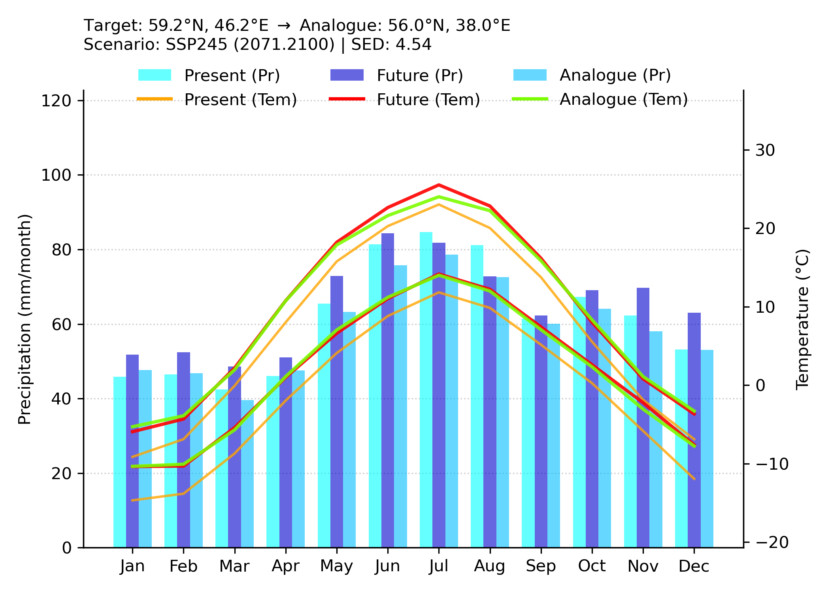
Fig. S3 : Hythergraph example for Moscow, Russia. Hythergraph summarizing monthly temperature and precipitation for Moscow, Russia. The plot compares (i) the historical baseline at the target location (1995-2024), (ii) the projected future climate at the same location (2071-2100 under SSP2-4.5), and (iii) the historical climate at the identified analogue location (56.00° N, 38.00° E). Bars show monthly precipitation; lines show monthly mean daily maximum (upper) and minimum (lower) temperatures.

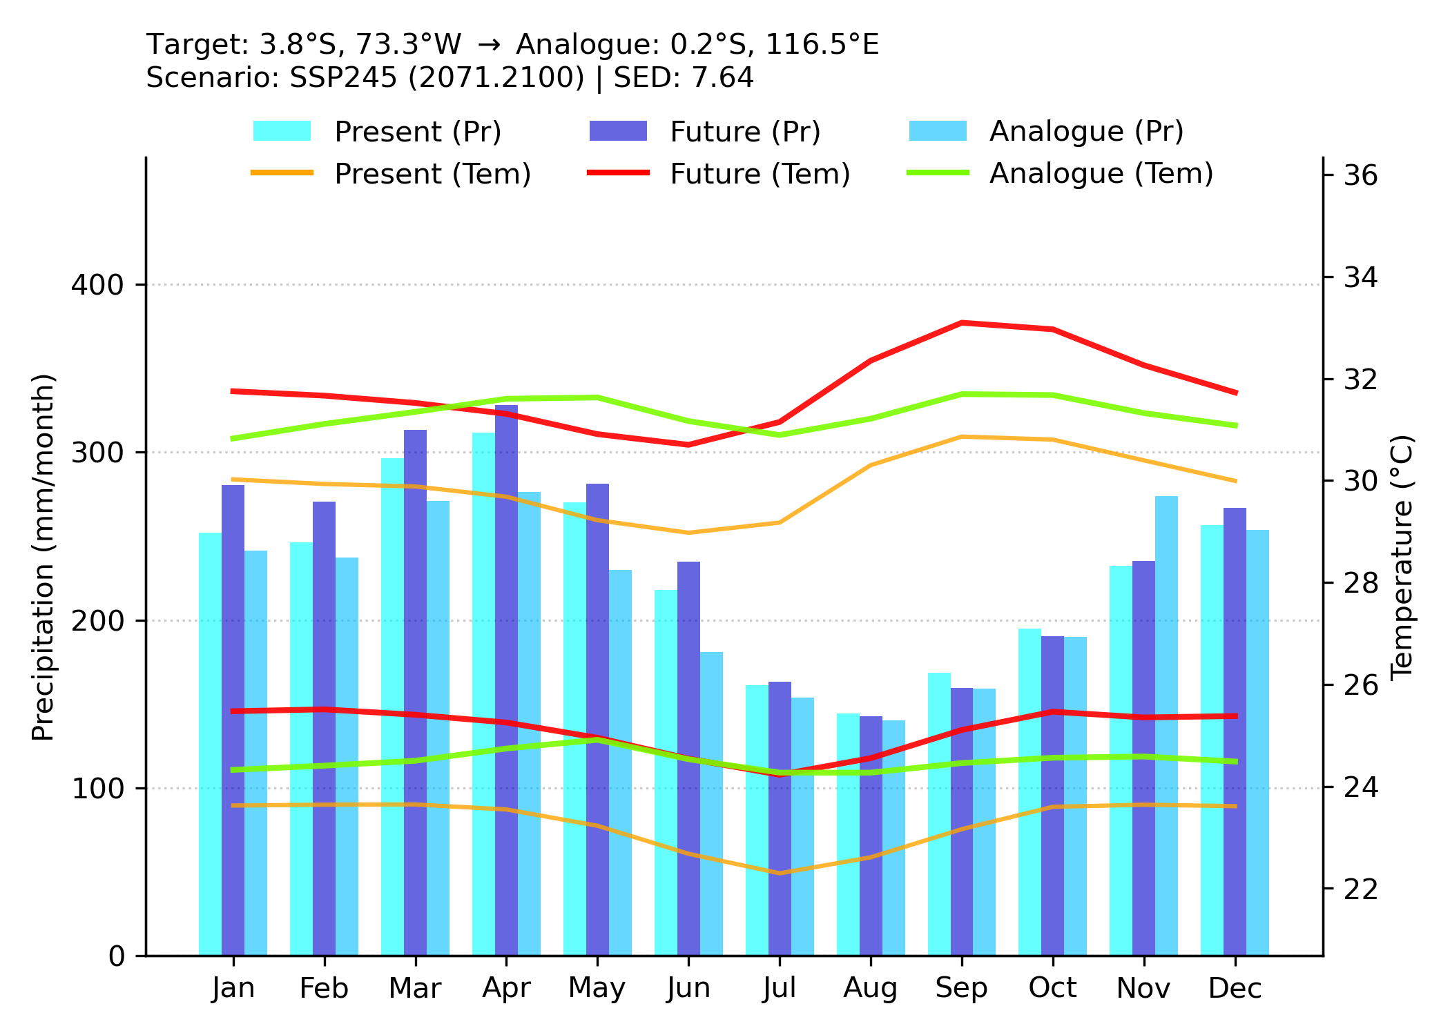
Fig. S4 : Hythergraph example for Iquitos, Peru. Hythergraph summarizing monthly temperature and precipitation for Iquitos (historical baseline 1995-2024), the projected future at the same location (2071-2100 under SSP2-4.5), and the historical climate at the identified analogue location (0.2° S, 116.5° E). Bars show monthly precipitation totals; lines show monthly mean daily maximum (upper) and minimum (lower) temperatures. The analogue location is 0.2° S, 116.5° E, illustrating a long-distance analogue linkage.

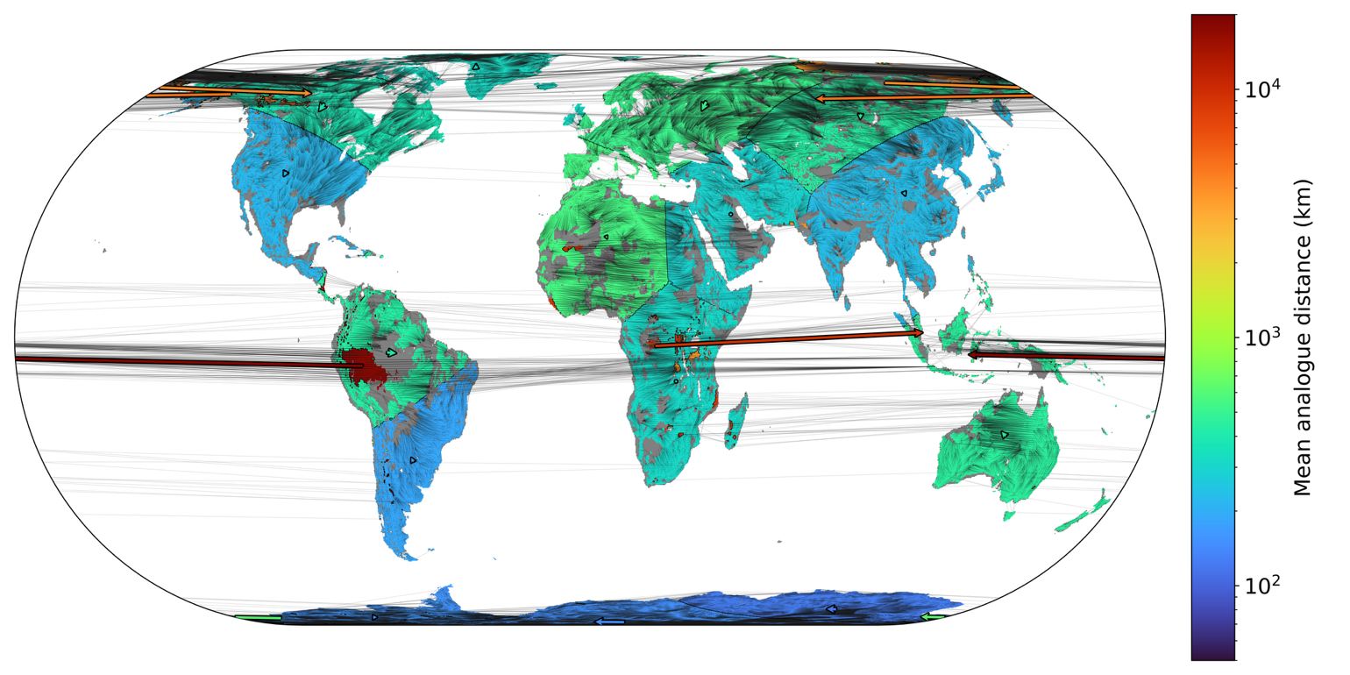
Fig. S5 : Overlay of target-to-analogue linkages on Fig. 2. Supplementary rendering of Fig. 2 for SSP5-8.5 (2041-2070) in which the full set of grid-cell-level linkages from each future target cell to its historical analogue cell are additionally drawn as thin black lines. This show within-cluster variability in analogue link length and direction, including cases where individual links diverge from the cluster-mean displacement vector. It highlights that cluster-level vectors can mask substantial heterogeneity and may not fully represent the true spatial analogue shifts within a cluster.

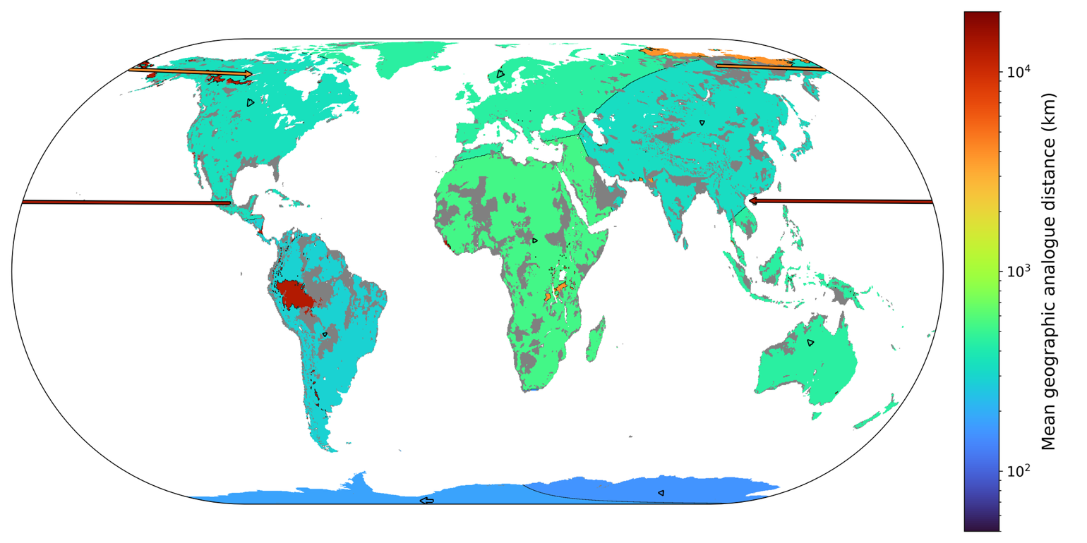
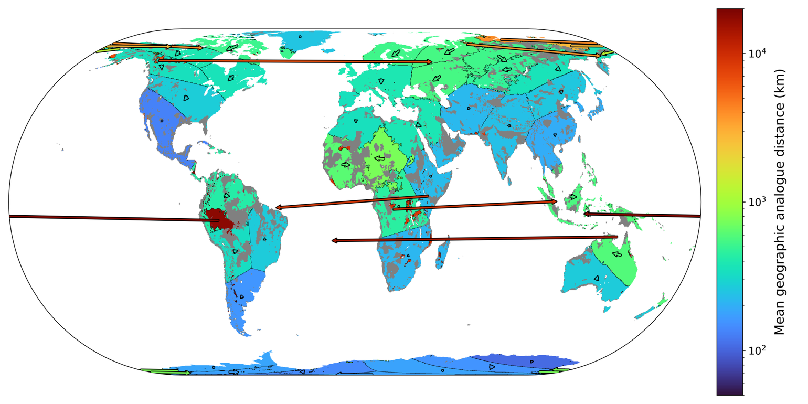
Fig. S6: Sensitivity of clustered displacement patterns to cluster number. Global maps of clustered analogue displacement patterns for SSP2-4.5 (2071-2100) using two k-means configurations: 10 clusters (top) and 50 clusters (bottom). Comparing these solutions shows that increasing the cluster number resolves finer-scale structure in analogue-distance gradients and displacement directions, whereas fewer clusters emphasize broad-scale, aggregated patterns.

Table S5 : Coastal vs inland novelty and analogue distance. Mean and median SED_{min}, and the proportion of land classified as novel climate, for coastal (within 100 km of the coastline) and inland (more than 100 km from the coastline) regions. Results are reported for 2041-2070 and 2071-2100 under SSP1-2.6, SSP2-4.5, and SSP5-8.5. Area totals ($km^{2}$) are included to indicate the spatial coverage of each mask.
Coast (km²) | 150213785.4 | Inland (km²) | 438640207.0
Period | 2041.2070 | Scenario | ssp126
Region | Mean_SEDmin | Median_SEDmin | novel (%)
Coastal | 4.93 | 4.66 | 2.71
Inland | 4 | 3.81 | 0.25
Period | 2071.2100 | Scenario | ssp126
Region | Mean_SEDmin | Median_SEDmin | novel (%)
Coastal | 5.03 | 4.76 | 3.19
Inland | 4.08 | 3.86 | 0.38
Period | 2041.20700 | Scenario | ssp245
Region | Mean_SEDmin | Median_SEDmin | novel (%)
Coastal | 5.84 | 5.45 | 11.25
Inland | 4.86 | 4.59 | 3.13
Period | 2071.2100 | Scenario | ssp245
Region | Mean_SEDmin | Median_SEDmin | novel (%)
Coastal | 7.34 | 6.85 | 25.86
Inland | 6.33 | 5.92 | 16.39
Period | 2041.2070 | Scenario | ssp585
Region | Mean_SEDmin | Median_SEDmin | novel (%)
Coastal | 7.24 | 6.72 | 24.83
Inland | 6.3 | 5.9 | 15.96
Period | 2071.2100 | Scenario | ssp585
Region | Mean_SEDmin | Median_SEDmin | novel (%)
Coastal | 11.42 | 10.26 | 65.97
Inland | 10.98 | 9.9 | 60.83

Table S6 : Land-area fractions by novel climate category. Land-area proportions of novel climate categories: Warmer (higher temperature), Thermoseasonal (greater interannual temperature variability), Cooler (lower temperature), Wetter (higher precipitation), Pluviseasonal (greater interannual precipitation variability), and Drier (lower precipitation). Results are reported for 2041-2070 and 2071-2100 under SSP1-2.6, SSP2-4.5, and SSP5-8.5. For each category, values are reported as % of total land area, with the corresponding share of the novel area shown in parentheses (i.e., % of total novel area)
Period | Scenario | Warmer (%) | Thermoseasonal (%) | Cooler (%) | Wetter (%) | Pluviseasonal (%) | Drier (%)
2041.2070 | ssp126 | 0.5 (85.6) | 0.0 (3.7) | 0.0 (3.0) | 0.0 (5.1) | 0.0 (0.7) | 0.0 (1.8)
2041.2070 | ssp245 | 2.5 (74.0) | 0.2 (7.2) | 0.1 (4.1) | 0.3 (9.1) | 0.1 (2.1) | 0.1 (3.4)
2041.2070 | ssp585 | 8.4 (67.4) | 1.4 (11.0) | 0.5 (4.3) | 1.3 (10.6) | 0.4 (3.1) | 0.4 (3.6)
2071.2100 | ssp126 | 0.6 (82.7) | 0.0 (3.8) | 0.0 (3.7) | 0.0 (6.7) | 0.0 (1.0) | 0.0 (2.1)
2071.2100 | ssp245 | 8.7 (66.7) | 1.4 (10.9) | 0.6 (4.5) | 1.4 (10.9) | 0.4 (3.1) | 0.5 (3.9)
2071.2100 | ssp585 | 27.0 (57.1) | 9.3 (19.6) | 2.1 (4.5) | 5.7 (12.0) | 1.6 (3.3) | 1.6 (3.4)

Table S7 : Zero precipitation handling in monthly fields. Minimum non-zero precipitation (mm/day) and the prevalence of zero values in monthly precipitation fields for the 1995-2024 baseline. The table reports the minimum positive value, the percentage of grid cells with zero precipitation, and the corresponding numbers of zero precipitation data, for ERA5 and each CMIP6 model (SSP1-2.6). Statistics are computed over all grid cells (including ocean) and across 12 monthly values for each of 30 years.
Model | MinPositive (mm/day) | Zero (%) | Zero_Count
ERA5 | 9.70E-04 | 1.192 | 4.50E+06
MRI-ESM2-0 | 9.20E-19 | 0 | 0.00E+00
MPI-ESM1-2-LR | 1.20E-13 | 0 | 0.00E+00
MIROC6 | 1.27E-10 | 0 | 0.00E+00
MIROC-ES2L | 1.90E-08 | 0 | 0.00E+00
INM-CM5-0 | 1.09E-19 | 0 | 0.00E+00
INM-CM4-8 | 1.00E-33 | 0 | 0.00E+00
GFDL-ESM4 | 1.60E-29 | 0.002 | 4.30E+02
FGOALS-g3 | 6.60E-18 | 0 | 0.00E+00
CNRM-ESM2-1 | 3.30E-22 | 0 | 0.00E+00
CNRM-CM6-1-HR | 1.00E-23 | 0 | 0.00E+00
CNRM-CM6-1 | 2.80E-22 | 0 | 0.00E+00
AWI-CM-1-1-MR | 1.40E-13 | 0 | 0.00E+00
ACCESS-CM2 | 2.00E-15 | 0.066 | 6.50E+03

