Supplementary Figure
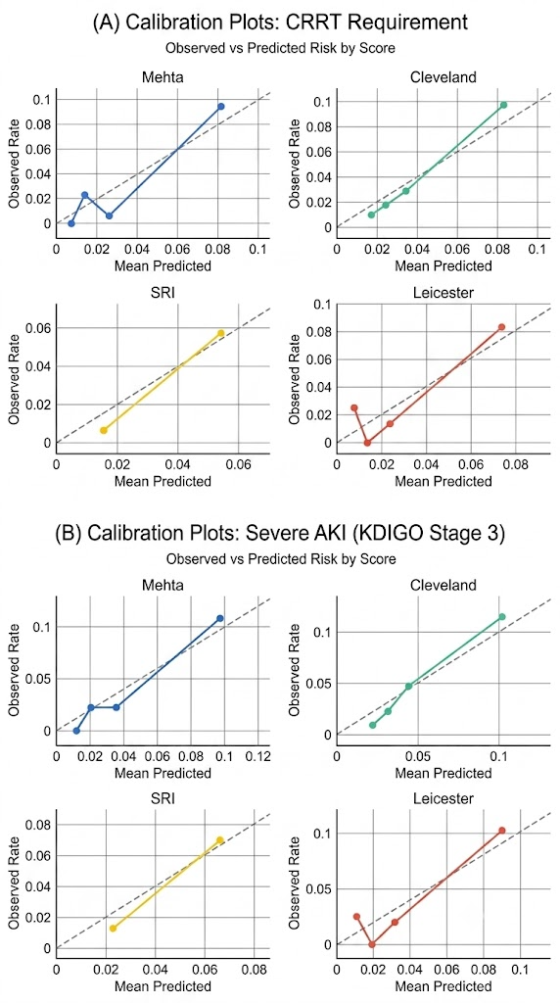
Supplementary Figure S1 Calibration Plots for Each Scores

