Complete de novo assembly of yeast genomes using enzyme-free, dense optical genome mapping
Supplementary Information
Luis Mario Leal-Garza¹, Hanna Zachrisson¹, Albertas Dvirnas^{1,2}, Gaurav Goyal¹, Ikenna Obi³, Sriram KK¹, Nasim Sabouri^{3,4}, Tobias Ambjörnsson⁵ and Fredrik Westerlund^{1*}
¹Department of Life Sciences, Chalmers University of Technology, Gothenburg, Sweden,
²Department of Mathematics and Mathematical Statistics, Umeå University, Umeå, Sweden.
³Department of Medical Biochemistry and Biophysics, Umeå University, Umeå, Sweden
⁴Science for Life Laboratory, Umeå University, Umeå, Sweden
⁵Centre for Environmental and Climate Science, Lund University, Lund, Sweden
∗Corresponding author: fredrikw@chalmers.se
Supplementary Methods
Supplementary Methods 1. Quality control of barcode extraction
To ensure accurate barcode generation, quality control procedures were applied to remove artifacts arising from DNA dynamics within nanochannels and from imaging constraints.
Due to the lack of complete immobilization in nanochannels, DNA molecules require a relaxation period to reach their equilibrium extension. This relaxation time scales with the square of the DNA contour length[1], causing longer molecules to exhibit a transient “shrinking” behavior prior to stabilization. Barcodes extracted from such non-equilibrated kymographs may contain distorted or overlapping features, compromising downstream analysis.
To address this, a shrink-filtering algorithm was applied prior to kymograph alignment to identify and exclude molecules that had not reached equilibrium. A detailed description of this procedure is provided in previous studies [2].
Following shrink filtering, kymographs were processed using a custom QC pipeline to identify and merge molecules spanning multiple fields of view (multi-FoV) (Supplementary Fig. 1). Candidate barcode pairs were identified based on acquisition metadata and subsequently aligned using local barcode-to-barcode alignment. Overlapping regions of at least 130 pixels near the molecule ends were required. Merged barcodes were generated by averaging normalized intensity profiles across the aligned region. This approach enables reconstruction of molecules exceeding the imaging field of view (~500 kbp), improving representation of long DNA fragments.
Supplementary Methods 2. Detection and masking of repetitive barcode regions
To reduce the impact of repetitive sequence content on alignment and assembly, repetitive regions within barcodes were identified and masked prior to downstream analysis. The presence and location of repetitive regions within barcodes was identified using a custom algorithm based on autocorrelation for periodicity analysis, frequency domain validation and local similarity for segmentation.
For each barcode, the autocorrelation function (ACF) was calculated using autocorr (Supplementary Fig. 2x.i). Sinusoidal curves in ACF emerge when the barcode is either fully periodic or partially periodic, but non periodic regions in a barcode can hinder the interpretation of ACF. To facilitate this, only the first 110 lags of the ACF are analyzed, and the ACF is detrended using detrend. Peaks in ACF were then detected using findpeaks and the repeat unit length was estimated as the mean distance between the first six peaks. Periodicity was considered significant only if the spacing between them was consistent, quantified as a coefficient of variation lower than 20%. Barcodes failing this criterion were classified as non-periodic. If, on the other hand, a consistent repeat unit length is estimated, the barcode is flagged as repetitive and proceeds to the rest of the analysis.
The repeat unit length estimate is then validated in the frequency domain using a Fast Fourier Transform (FFT) (Supplementary Fig. 2x.ii). To do this, FFT is calculated using fft and peaks representing the possible repetitive unit’s frequency are detected using findpeaks (MinPeakProminence=5). The frequency with the maximum amplitude detected in the FFT is then compared to the length of the repetitive unit calculated from the ACF to determine if the repetition’s size is consistent. FFT-estimated repeat unit length should be within 10% of the value of ACF-estimated repeat unit length. Failure of this consistency check would render barcodes as non-repetitive.
For barcodes passing this consistency check, the location of repetitive regions was determined using a rolling-window correlation analysis (Supplementary Fig. 2x.iii). A window size corresponding to the estimated repeat unit was used to compute correlations between adjacent segments along the barcode, yielding a position-dependent similarity profile. The findchangepts function was then used on the rolling-window correlation (MaxNumChanges=2) to try to find segments of the molecule that have higher self-correlation than others. To facilitate interpretation, we limit the sensitivity of repetitive region detection to three sections for each barcode, each of which can be repetitive or non-repetitive. This limitation was chosen since at most, we have observed that barcodes can contain up to two non-repetitive regions separated by a repetitive one.
Each segment was classified as repetitive or non-repetitive based on its mean correlation value, using a threshold of 0.4. Contiguous segments exceeding both this threshold and a minimum length of five repeat units were defined as repetitive regions. Barcodes were further categorized as fully repetitive if non-repetitive regions were shorter than 150 pixels, corresponding to the overlap window size used during pairwise barcode comparison in the assembly process; otherwise, they were classified as partially repetitive (Supplementary Fig. 2x.iv).
The output of this algorithm provides a categorical flag indicating non-repetitive, partially repetitive, or fully repetitive barcodes (rep_check = 0, 1, or 2 respectively), and a positional mask identifying repetitive regions within each barcode (rep_mask). These masks were used to exclude repetitive regions during alignment and assembly while preserving their positions for downstream analysis. All thresholds were empirically selected to balance sensitivity to periodic structure with robustness to noise and barcode length variability. All the algorithms mentioned above were performed using default parameters for all the functions unless explicitly stated and executed using MATLAB R2023b Update 7 (23.2.0.2515942).
Supplementary Figures
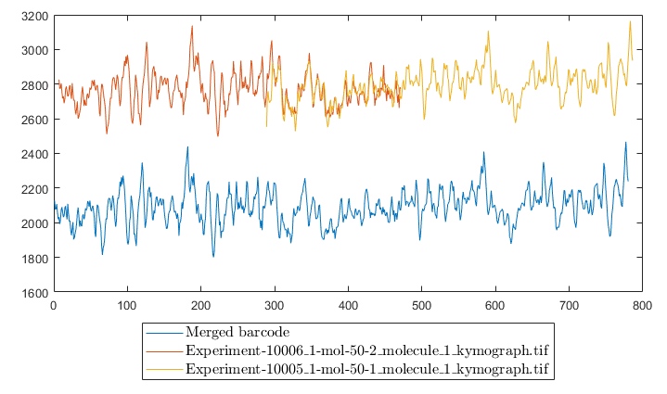
Supplementary Fig. 1 | Multi-FoV barcode merging. Two experimental barcodes (red and yellow) derived from imaging of a single 792 kbp DNA molecule across overlapping fields of view. Local alignment of the overlapping regions enables merging into a single consensus barcode (blue), which is used for downstream analysis.
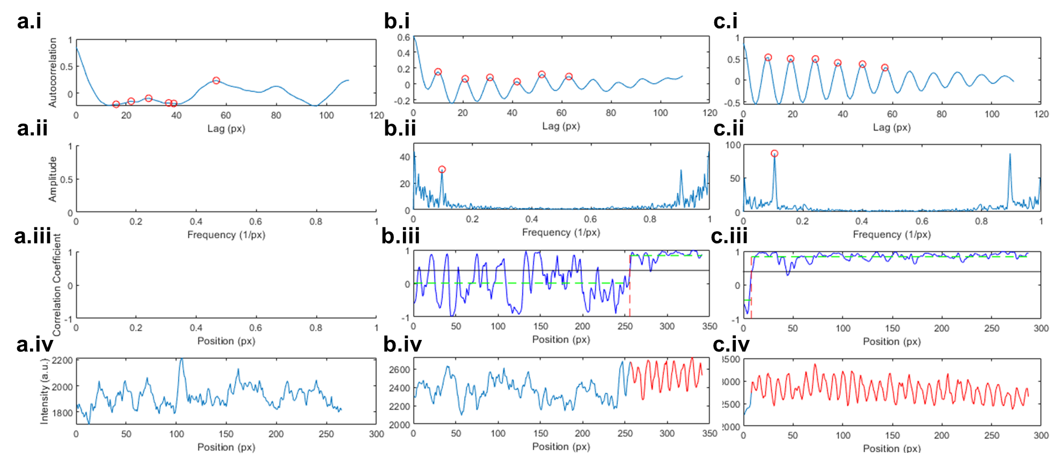
Supplementary Fig. 2 | Repetitive Finder. a A non-repetitive, b a partially repetitive and c a full repetitive molecule are shown to illustrate the workflow. i Autocorrelation analysis used to detect periodic signal patterns and estimate repeat size. Process is halted and molecule regarded as non-repetitive if no periodic signal is detected here. ii Validation of repeat periodicity using FFT. iii Rolling-window correlation and segmentation using change-point detection (findchangepts) function. iv Final detection and classification of repetitive (red) and non-repetitive (blue) regions in barcodes.
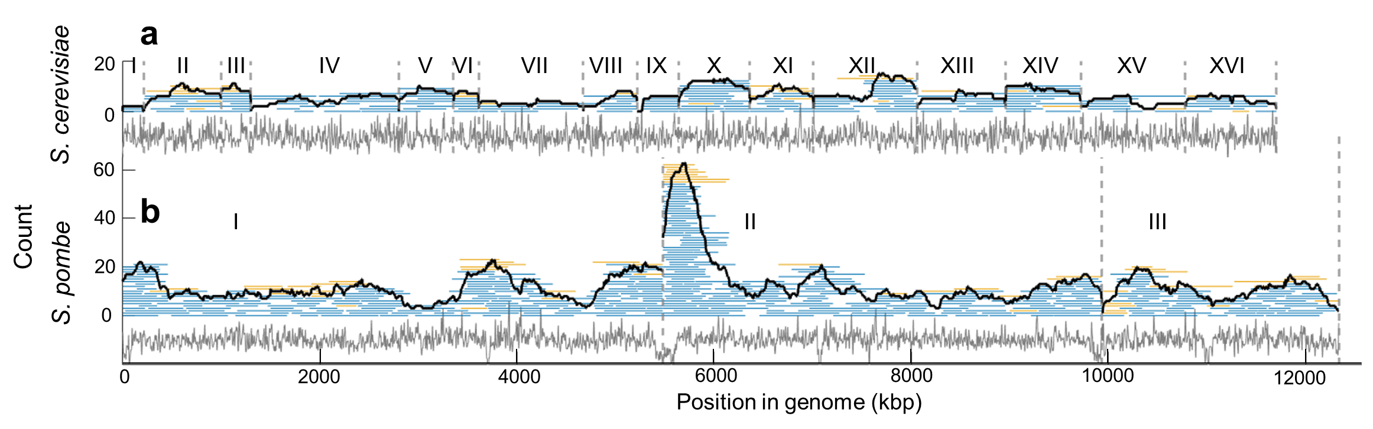
Supplementary Fig. 3 | Alignment of barcodes passing QC to reference genomes. Alignment of QC-filtered barcodes to reference genomes of a S. cerevisiae and b S. pombe. Correct species alignments are shown in blue and incorrect alignments in yellow. Black lines indicate coverage depth.
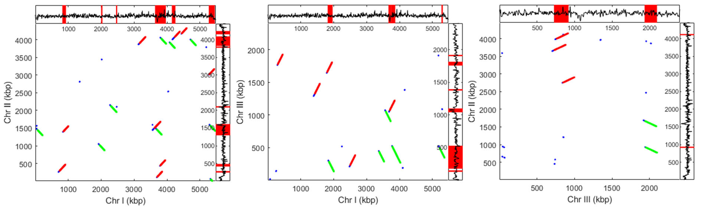
Supplementary Fig. 4 | Intragenomic self-similarity analysis. Alignment start points (blue) were identified for segments ≥150 kbp with CC ≥ 0.75. Regions with ≥10 consecutive matches were extended by 150 kbp and classified as forward (red) or reverse (green) matches. Regions with multiple overlapping matches are indicated as similarity hotspots.

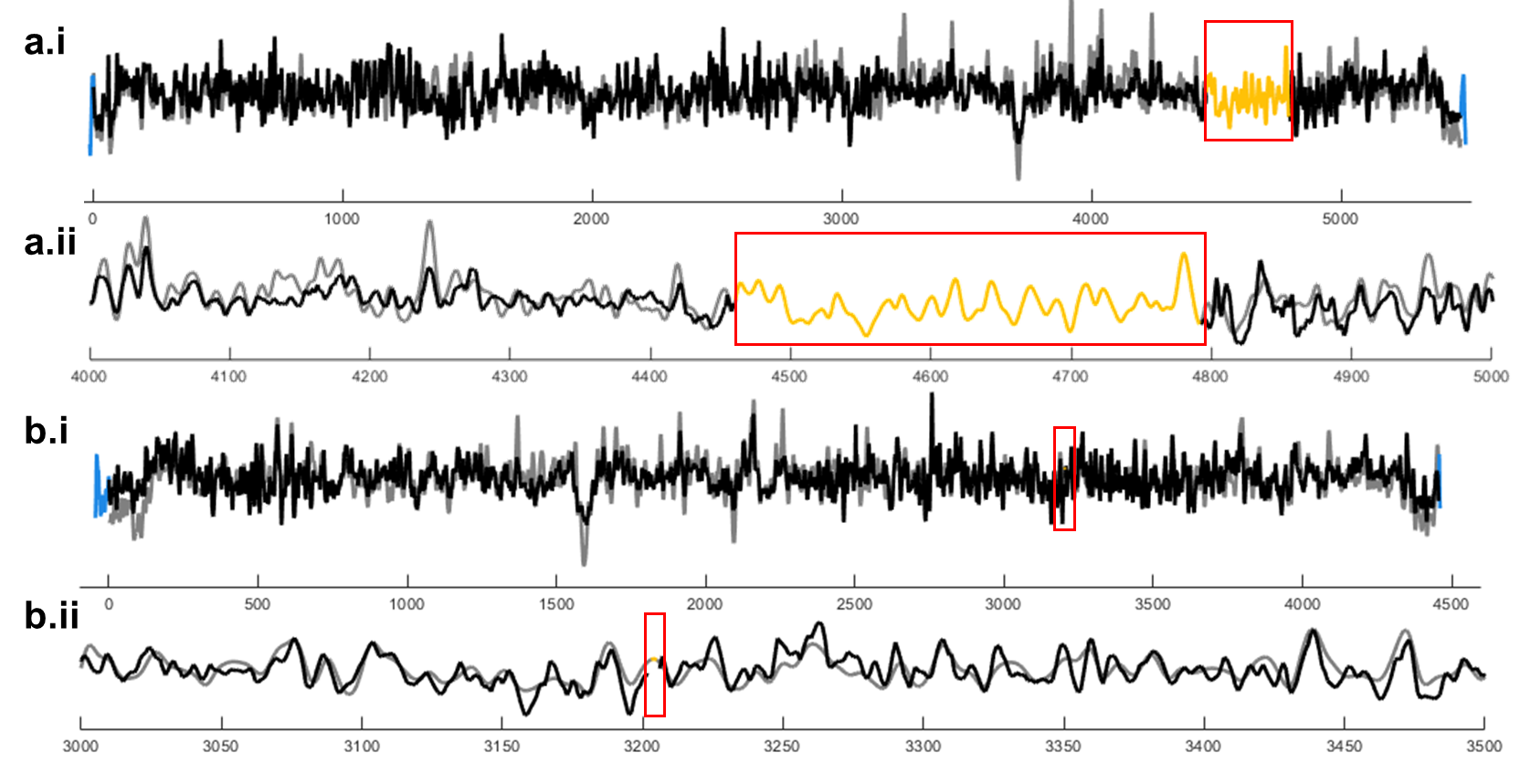
Supplementary Fig. 5 | Contiguity gaps in assembled genomes. Gaps in contiguity (yellow) observed after aligning assembled bargroups (black) to reference barcodes (gray) a for chromosome I and b chromosome II of S. pombe. Full chromosome views are shown in a.i, b.i, with corresponding zoomed-in regions of 1 Mbp and 0.5 Mbp in a.ii, b.ii, respectively, highlighting representative gaps (red boxes). Bargroup segments extending beyond reference boundaries are shown in blue.
Supplementary Tables
Supplementary Table 1 | Parameters used for DOGMA assembly, including stretch tolerance, positional tolerance, overlap window size, and statistical thresholds.
Variable | Description | Value
w | overlap window | 150px
sF_{step} | length re-scale step | 0.01
sFmax | max re-scaling factor | 0.15
scDiffSetting | allowed scale factor difference | 0.05
pxDiffSetting | allowed pixel difference | 10px
$$p_{thresh}^{local}$$ | p-value local threshold | 0.05
$$p_{thresh}^{leftover}$$ | p-value leftover threshold | 0.05
Supplementary Table 2 | Null-model parameters used for bargroup formation across barcode classes (non-repetitive, partially repetitive, and fully repetitive). Values are fitted using the parametrization.m script which uses the experimental data as input.
Variable | Non-repetitive | Semi-repetitive | Full-repetitive
α_{v} | 0.1749 | 0.1689 | 0.0533
α_{N} | 0.1461 | 0.1618 | 0.0734
β_{v} | 0.2415 | 0.1773 | 0.0200
β_{N} | 0.0144 | 0.0254 | 0.0371
Supplementary Table 3 | Quality metrics (meanCC, stdCC, SNR) for bargroups included in the final assemblies.
References
[1] Reisner W, Pedersen JN, Austin RH. DNA confinement in nanochannels: Physics and biological applications. Reports on Progress in Physics 2012;75. https://doi.org/10.1088/0034-4885/75/10/106601.
[2] Dvirnas A, Leal-Garza LM, Abbaspour Z, Fröbrant E, Frykholm K, Wrande M, et al. DOGMA: de novo assembly of densely labelled optical DNA maps using a matrix profile approach. PLoS One 2025;20:e0335633-.

