Supplementary S1

S1.1 PECBMS data
The PECBMS dataset integrates 30 national and subnational common bird monitoring schemes, each of which systematically monitors breeding birds annually at fixed sites. The PECBMS dataset we used comprised a total of 70,388,184 individual bird observations from 454 species counted at 28,766 survey sites located in 25 countries. We used the counts from the PECBMS data as an index of abundance. The survey methods vary by contributing monitoring scheme as survey design is done at the country level¹.

S1.2 Species classification
We assigned species to a vegetation structure based habitat association group representing their association to either based on an adaptation of the “habitat density” variable from the AVONET bird trait database², which distinguishes between “dense”, “semi-open”, and “open” habitats. Our adjustments to this categorization, creating new habitat association categories, reflected three differences between the AVONET “habitat density” variable and our objectives. First, the habitat density variable does not distinguish forest from dense shrub habitat. Second, the AVONET trait database is global, but some species use specific vegetation structures in the European part of their range, in comparison to their global range. Third, similarly, vegetation structures in European habitats only cover a subset of the diversity of habitats available to species that have supra-continental ranges. We adjusted based on habitat descriptions for the European breeding range in Birds of the World Online³ combined with authors’ expert judgement. Therefore, we created three categories of vegetation structure that birds can be affiliated with. First, “forest”, which includes the species specifically associated with mature forest and woodland vegetation structure (n = 44). Second, “shrubland and edge” (n = 30), which included species associated with shrubs, individual trees, or small woody cover formations in mostly open habitats. Third, “open” (n = 33), which included species associated with purely open vegetation structures with nearly no woody vegetation or only low shrubs.
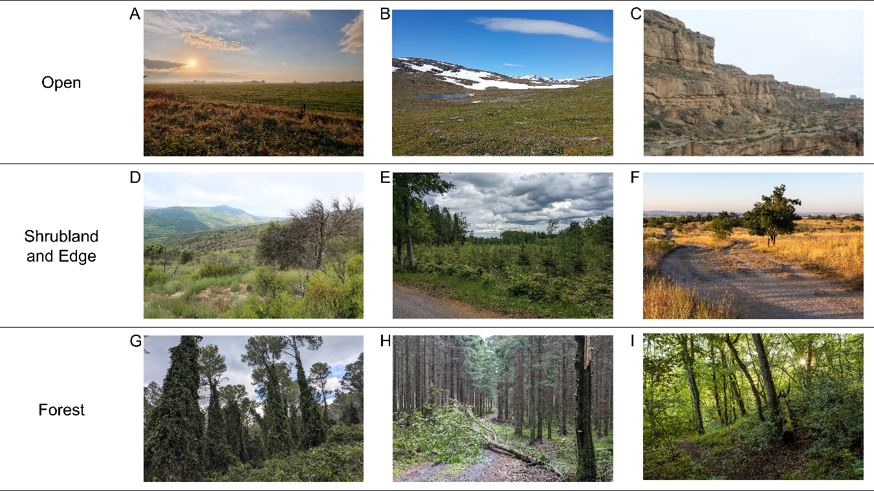
Figure S1. Examples of open (A, B, C), shrubland and edge (D, E, F) and forest (G, H, I) vegetation structures associated with the studied bird species. (A) Farmed grassland in Noord-Holland, the Netherlands. (B) Mixed alpine grasslands and arctic shrub heathland in Norrbotten, Sweden. (C) Sparsely vegetated land in Aragon, Spain. (D) Post-fire abandoned almond orchard in Catalonia, Spain. (E) Young Norway Spruce plantation in Kronoberg, Sweden. (F) Grassland with trees in South Moravia, Czechia. (G) Semi-open pine forest in Catalonia, Spain. (H) Norway Spruce plantation forest in Scania, Sweden. (I) Broadleaved forest in South Moravia, Czechia. Photos by Tristan Bakx, Océane Bartholomee, Jan Grünwald, and Sergi Herrando.

S1.3 Forest disturbance regimes
We quantified the proportion of disturbances by area for each disturbance type in each of the countries included in our study. We did this by quantifying the frequency of disturbance types between 1985 and 2023 for each country. The disturbance types were timber harvest, fire, and wind/bark beetle complex. Some sites were disturbed multiple times during that period by different disturbances, and this was mapped separately as well.
The EFDA⁴ distinguishes disturbances into three categories: fire, harvest, and windthrow or bark beetles. Windthrow and bark beetles could not reliably be distinguished from each other because of methodological limitations in the EFDA creation and, besides, windthrow can follow damage by bark beetles.
Between 1985 and 2023, generally, harvests were most common in the Northern latitudes, followed by the eastern parts of Europe⁴ (see the share of area disturbed by timber harvest, fire, wind/bark beetle, and repeat disturbances by country in Fig. S2). On the other hand, fires were most common in the southern latitudes, especially in Spain. Wind and bark beetle disturbances were less prevalent but occurred mainly in Germany, France, and Sweden. Bark beetle damage increased strongly in the last decade because of growing vulnerability to pests of monospecific Norway Spruce (Picea abies) plantations outside of the species’ natural range under climate change (Hlásny et al. 2021, Patacca et al. 2023).
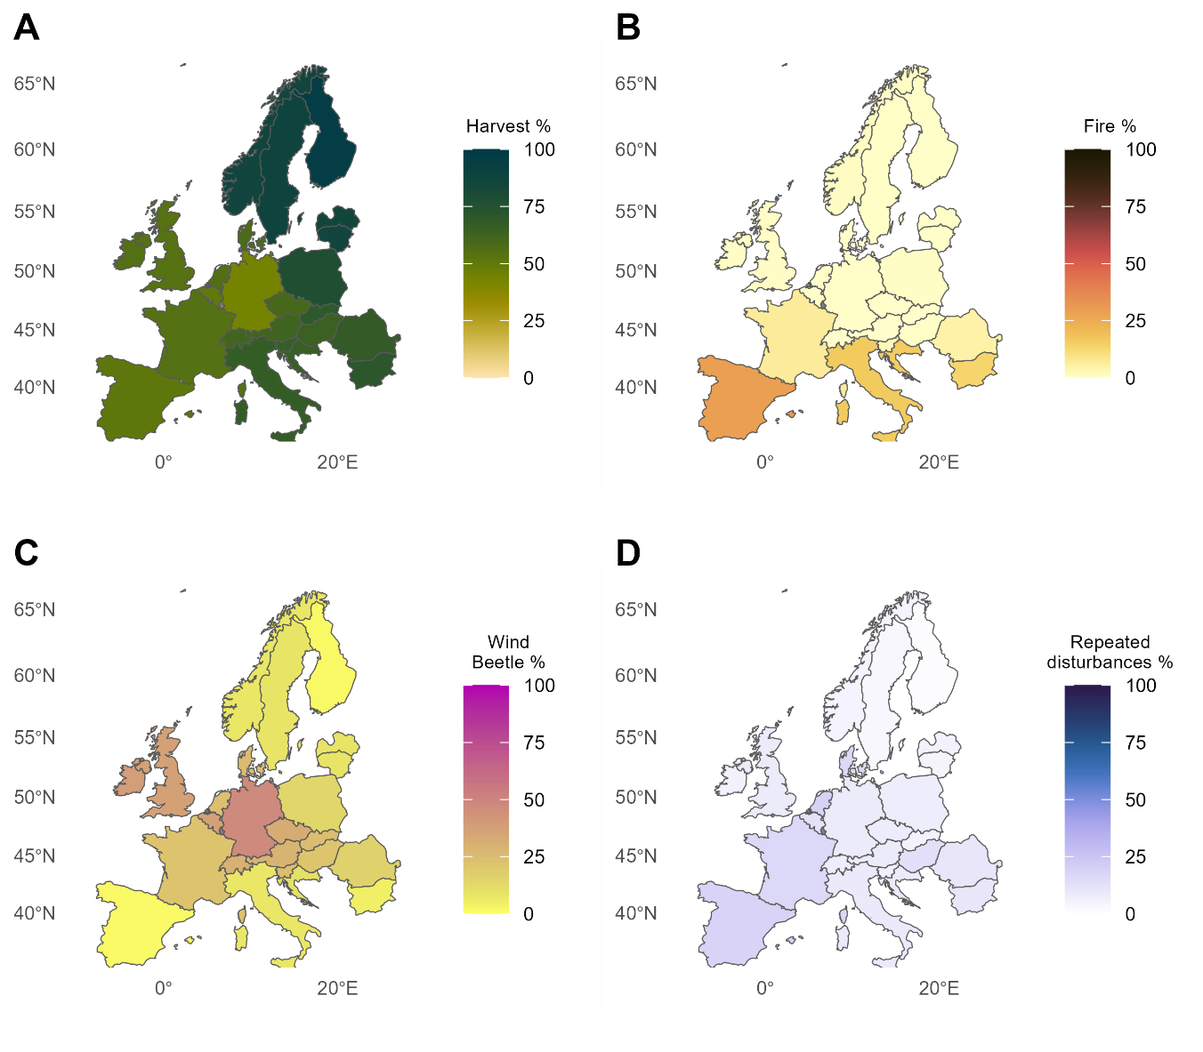
Figure S2. Proportion of disturbance type by area at a country level for the study area between 1985-2023. Proportion of disturbed area that was due to (A) harvest, (B) fire, (C) wind or bark beetle, (D) repeated disturbances in the same location.

S1.4 Model fitting procedure
We fitted models using the sdmTMB R-package (⁵). Models were fitted with a Tweedie distribution with a log-link function because it allows for non-normal distributions with zeroes and positive continuous values, which was the case for the scaled counts. Models had the following base structure:
count_sd ~ disturb_percent_total:forest_mask_percent +
disturb_percent_total_one:forest_mask_percent +
disturb_percent_total_two:forest_mask_percent +
forest_mask_percent + (1 | site_id)
With standardized abundances as the response variable and predictors including the interaction between the percentage of potential forest cover and the percentage of total area comprised of disturbed forest across the three age classes as well as the main effect of forest cover. As random effects, we included a site-level random effect to account for differences between sites and survey schemes. Further, we accounted for spatiotemporal autocorrelation using a Gaussian Markov Random Field using an Stochastic Partial Differential Equations (SPDE) mesh for the spatial component and a first-order autoregressive component as the assumption for the spatiotemporal autocorrelation (⁶).
Mesh distance in the SPDE mesh was species-specific and determined by the spatial density of survey sites and the extent of the bounding box around the sites in which species were present. We set the mesh spacing to half the average distance between sampling points. As a lower bound for the mesh spacing we set it to 1/1000th of the average of the bounding box dimensions. We used half the average bounding box dimensions as the maximum mesh spacing so that there would always be multiple mesh nodes in each spatial dimension.
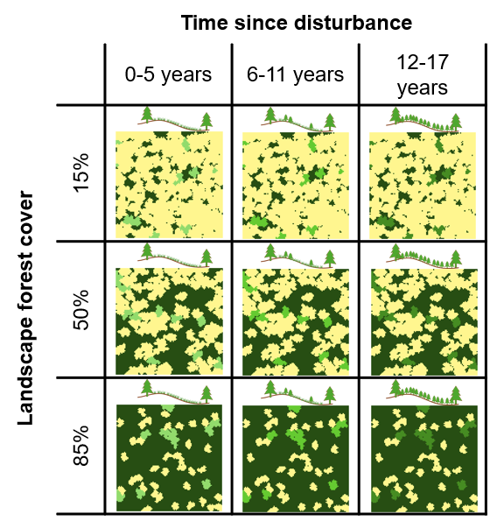
Figure S3. The nine combinations of forest cover levels and time since disturbance for which we predicted the effect of forest disturbances on bird abundance for each species. The drawings of forest canopy gaps in each top-right diagonal panel represent expected successional stages following disturbance progressing from herbaceous dominated, shrub-dominated, to young forest. The dark green in the maps in each bottom left diagonal panel represents the forest cover in the landscape, yellow indicates non-forested land, lighter shades of green represent disturbed areas where vegetation develops with time since disturbance.

S1.5 Model evaluation
To ensure that models were technically sound we tested several aspects of the fitted model and incorporated solutions in case of issues: First, we checked whether the Hessian matrix was positive definite, eigenvalues were not extreme, if the nlminb optimizer did not converge, and if parameter gradients were not close to zero. In case of such issues, we increased the number of fitting iterations from 1000 to 3000. If the same issues persisted we increased the iterations to 5000 and changed the spatiotemporal structure from first-order autoregressive to independent and identically distributed. If the same problems persisted, we increased the iterations to 6000 and removed the spatiotemporal component. If the spatial range parameter was extreme, we multiplied the mesh resolution by 0.8 and 1.2 and selected the model with the best range parameter. If the random effect variance parameters were zero or extremely large, we simplified the autoregressive component from first-order autoregressive to independent and identically distributed. If standard errors of estimated parameters were very large, very small, or missing, we simplified the model by turning off the spatiotemporal random effects. Finally, we saved the model with the least (usually zero) technical issues.
Models were only included in the further analysis if the Nakagawa R² of the model was >0.1, and if there were no issues with the Hessian matrix, eigenvalues, optimizer convergence, and gradients.
We were unable to fit satisfactory models for Cyanopica cooki, Dryobates minor, Glaucidium passerinum, Lanius excubitor, Picus canus, Surnia ulula, Sylvia conspicillata, and Tyto alba.

S1.6 Goodness of fit and check for trait-group models
This supplementary information contains the model goodness of fit and check for the vegetation affiliation trait-group responses to forest canopy gaps.
Trait models at continental scale
85% forest cover
Model performance:
AIC | AICc | BIC | R2 | R2_adjusted | Sigma
1,260.4 | 1,261.2 | 1,296.1 | 0.8 | 0.8 | 21.0

Model check:
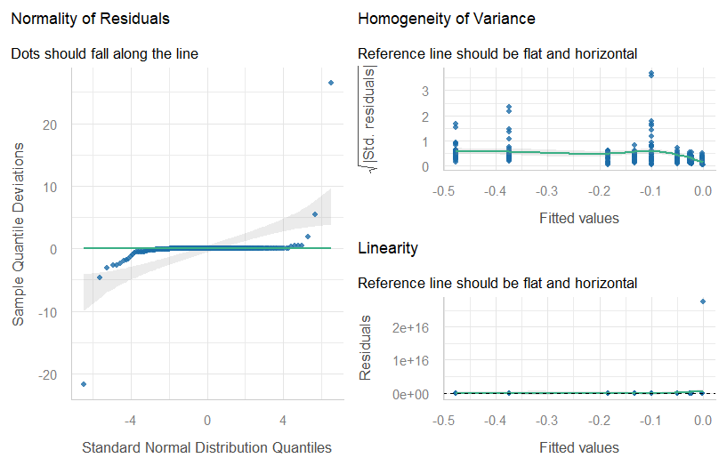

50% forest cover
Model performance:
AIC | AICc | BIC | R2 | R2_adjusted | Sigma
411.2 | 412.1 | 447.0 | 0.5 | 0.5 | 8.7

Model check:
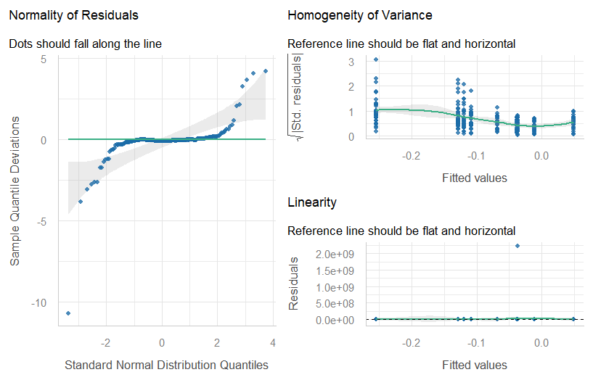

15% forest cover
Model performance:
AIC | AICc | BIC | R2 | R2_adjusted | Sigma
42.8 | 43.7 | 78.6 | 0.3 | 0.2 | 24.6

Model check:
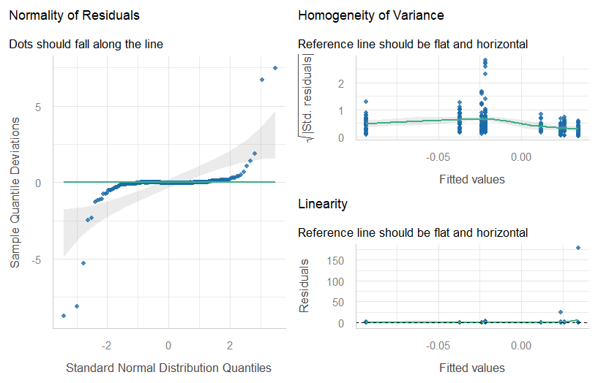

Trait models at Regional scale
85% forest cover – Northern Latitudes
Model performance:
AIC | AICc | BIC | R2 | R2_adjusted | Sigma
496.1 | 497.6 | 526.8 | 0.3 | 0.3 | 6.2

Model check:
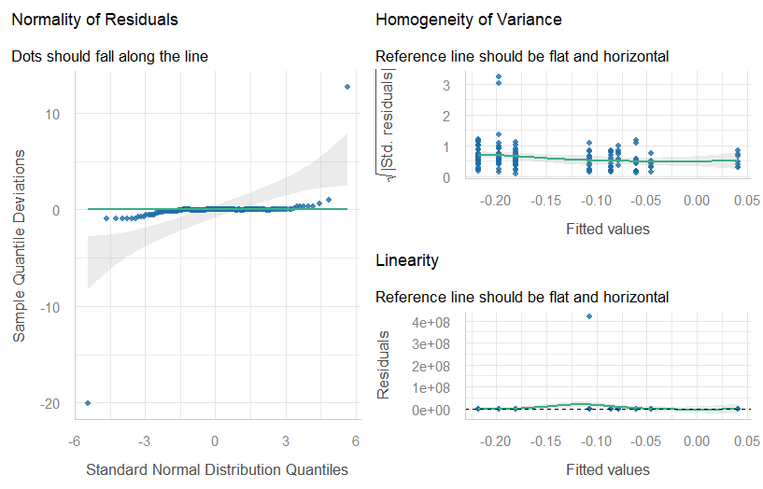

50% forest cover – Northern latitudes
Model performance:
AIC | AICc | BIC | R2 | R2_adjusted | Sigma
213.3 | 214.7 | 244.0 | 0.0 | 0.0 | 5.9

Model check:
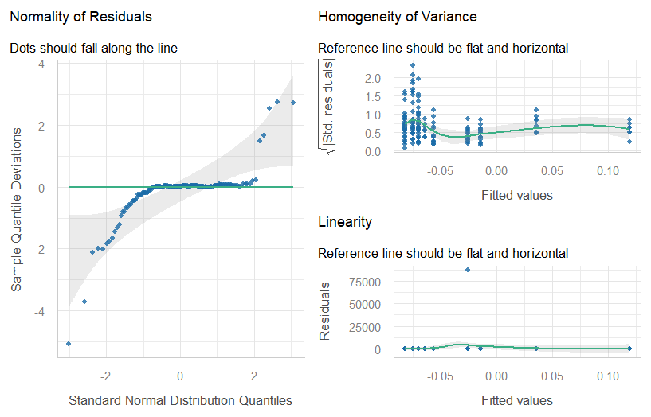
15% forest cover – Northern latitudes
Model performance:
AIC | AICc | BIC | R2 | R2_adjusted | Sigma
−154.5 | −153.0 | −123.8 | 0.2 | 0.2 | 10.3

Model check:
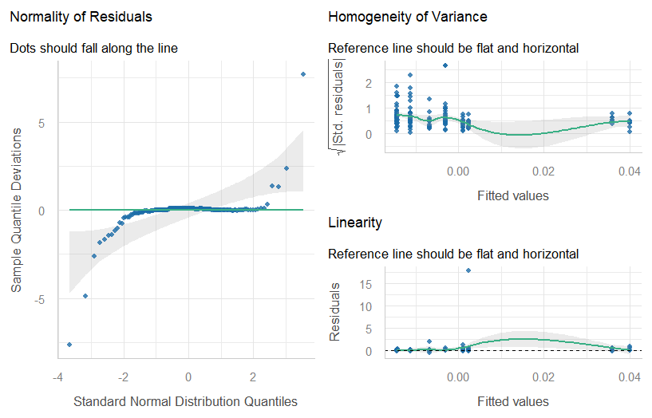
85% forest cover – Mid latitudes
Model performance:
AIC | AICc | BIC | R2 | R2_adjusted | Sigma
1,974.8 | 1,975.7 | 2,009.6 | 0.7 | 0.7 | 22.1

Model check:
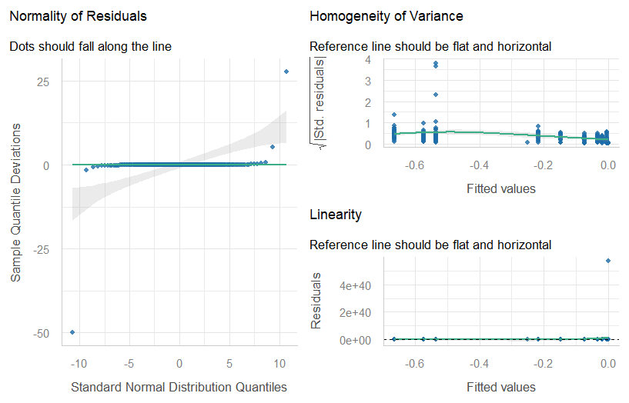
50% forest cover – Mid latitudes
Model performance:
AIC | AICc | BIC | R2 | R2_adjusted | Sigma
751.9 | 752.8 | 786.7 | 0.4 | 0.4 | 5.8

Model check:
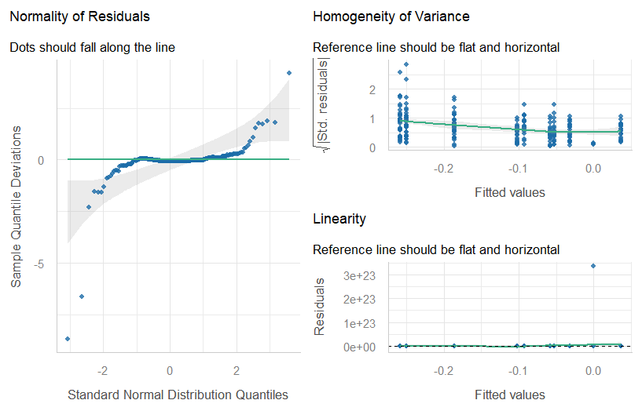
15% forest cover – Mid latitudes
Model performance:
AIC | AICc | BIC | R2 | R2_adjusted | Sigma
164.9 | 165.8 | 199.7 | 0.6 | 0.6 | 15.2

Model check:
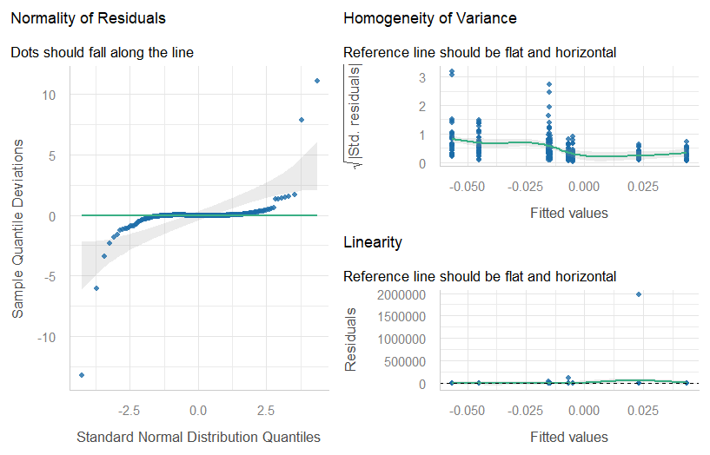
85% forest cover – Southern latitudes
Model performance:
AIC | AICc | BIC | R2 | R2_adjusted | Sigma
796.8 | 798.0 | 829.2 | 0.9 | 0.9 | 4.2

Model check:
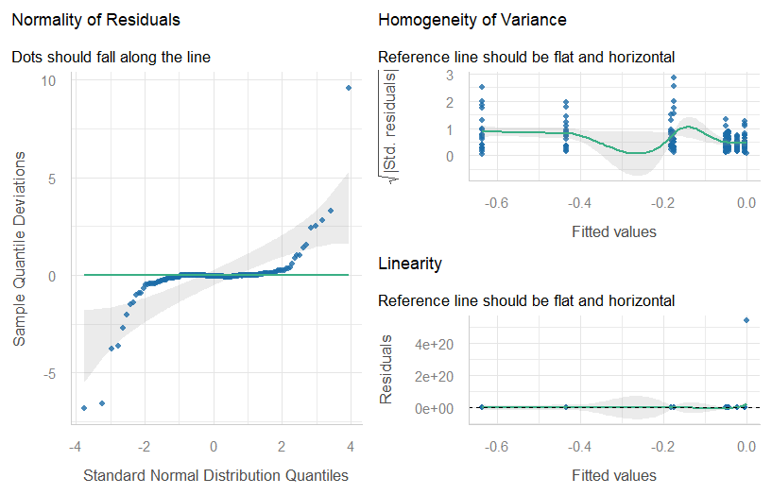
50% forest cover – Southern latitudes
Model performance:
AIC | AICc | BIC | R2 | R2_adjusted | Sigma
262.1 | 263.3 | 294.5 | 0.8 | 0.8 | 2.6

Model check:
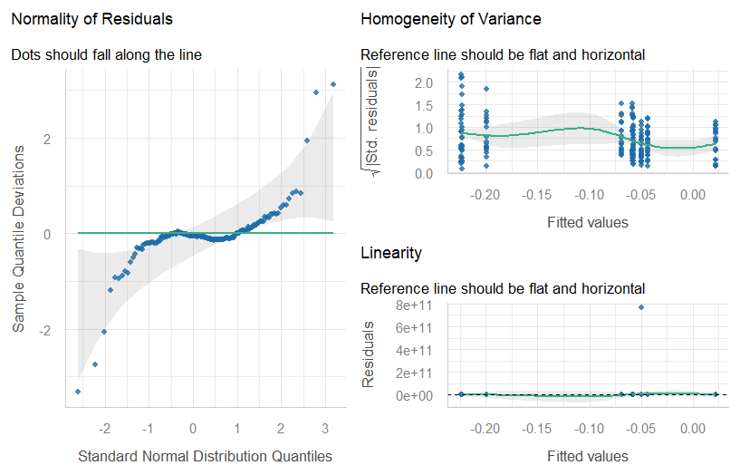
15% forest cover – Southern latitudes
Model performance:
AIC | AICc | BIC | R2 | R2_adjusted | Sigma
−45.2 | −43.9 | −12.7 | 0.3 | 0.3 | 6.6

Model check:
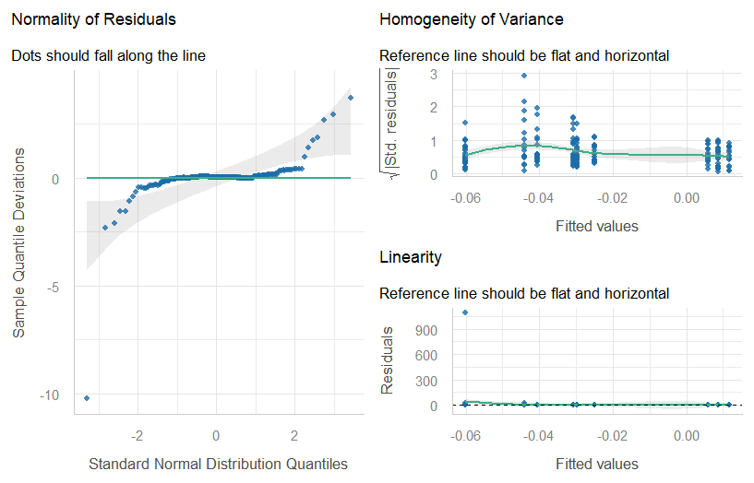
References
1. PECBMS. PECBMS Methods. https://pecbms.info/methods/pecbms-methods/ (2025).
2. Tobias, J. A. et al. AVONET: morphological, ecological and geographical data for all birds. Ecology Letters 25, 581–597 (2022).
3. Billerman, S. M., Keeney, B. K., Rodewald, P. G. & Schulenberg, T. S. Birds of the World. (Cornell Laboratory of Ornithology, Ithaca, NY, USA. https://birdsoftheworld.org/, 2022).
4. Viana-Soto, A. & Senf, C. The European Forest Disturbance Atlas: a forest disturbance monitoring system using the Landsat archive. Earth System Science Data 17, 2373–2404 (2025).
5. Anderson, S. C., Ward, E. J., English, P. A., Barnett, L. A. K. & Thorson, J. T. sdmTMB: An R Package for Fast, Flexible, and User-Friendly Generalized Linear Mixed Effects Models with Spatial and Spatiotemporal Random Fields. 2022.03.24.485545 Preprint at https://doi.org/10.1101/2022.03.24.485545 (2024).
6. Lindgren, F., Rue, H. & Lindström, J. Explicit Link between Gaussian Fields and Gaussian Markov Random Fields: The Stochastic Partial Differential Equation Approach. Journal of the Royal Statistical Society Series B: Statistical Methodology 73, 423–498 (2011).

