Whole-genome sequencing of two Streptomyces strains isolated from sand dunes of Sahara

Chahira Zerouki ^{1,2*}, Farid Bensalah², Suvi Kuittinen¹, Ari Pappinen¹ and Ossi Turunen¹

Affiliations
¹ School of Forest Sciences, University of Eastern Finland, FI-80101 Joensuu, Finland
² Laboratory of Microbial Genetics, Department of Biology, ORAN 1 University, Oran, Algeria
*Corresponding author: Chahira Zerouki, chahira.zerouki@uef.fi

Additional file 1.
A

B
Figure S1. A) Comparison of the metabolic reconstruction of Streptomyces sp. Babs14 as reference sequence against Streptomyces sp. Osf17 using Rast Seed Viewer version 2.0. The result lists the genes of the reference organism in chromosomal order and display hits on the comparison organisms accordingly. B) The color codes of comparison circles for Figs. S1, S2 and S3.

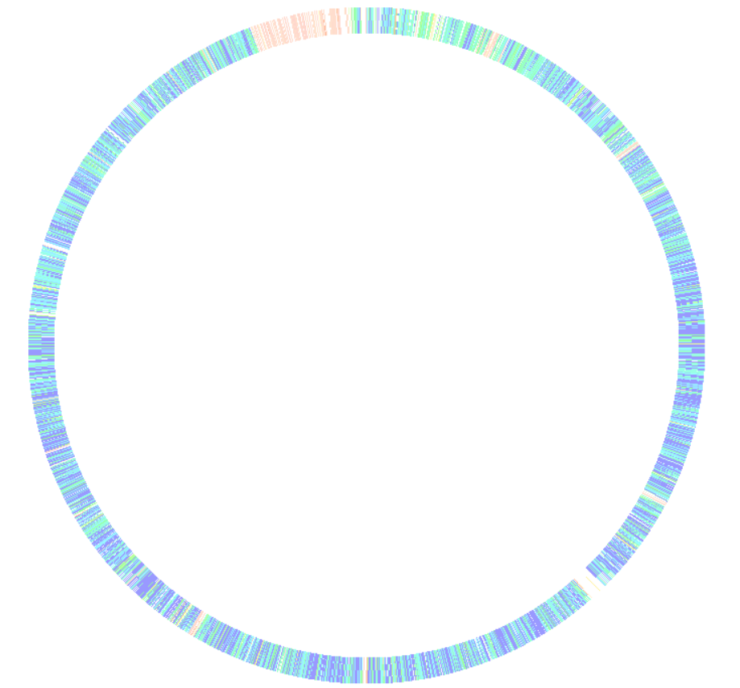

Figure S2. Alignment of Streptomyces sp. Babs14 as reference sequence against Streptomyces sp. SGAir 0924 (CP027297.1) using Rast Seed Viewer version 2.0.

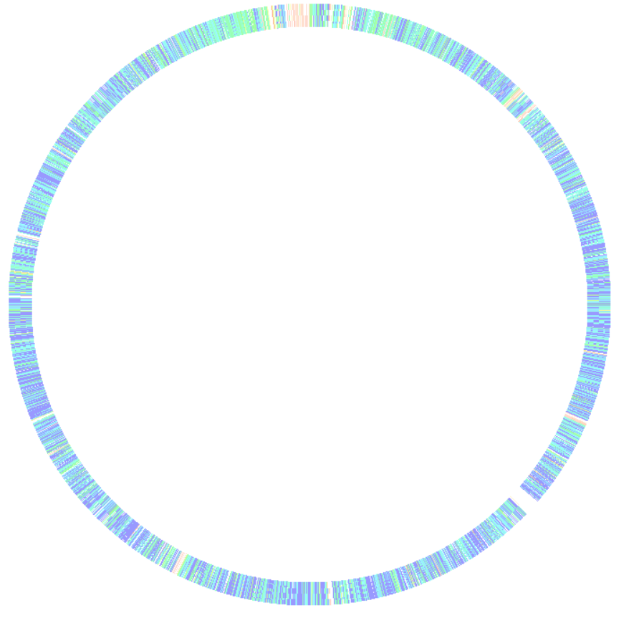
Figure S3. Alignment of Streptomyces sp. Osf17 against Streptomyces sp. SS52 (NZ_CP039123) using Rast Seed Viewer version 2.0.

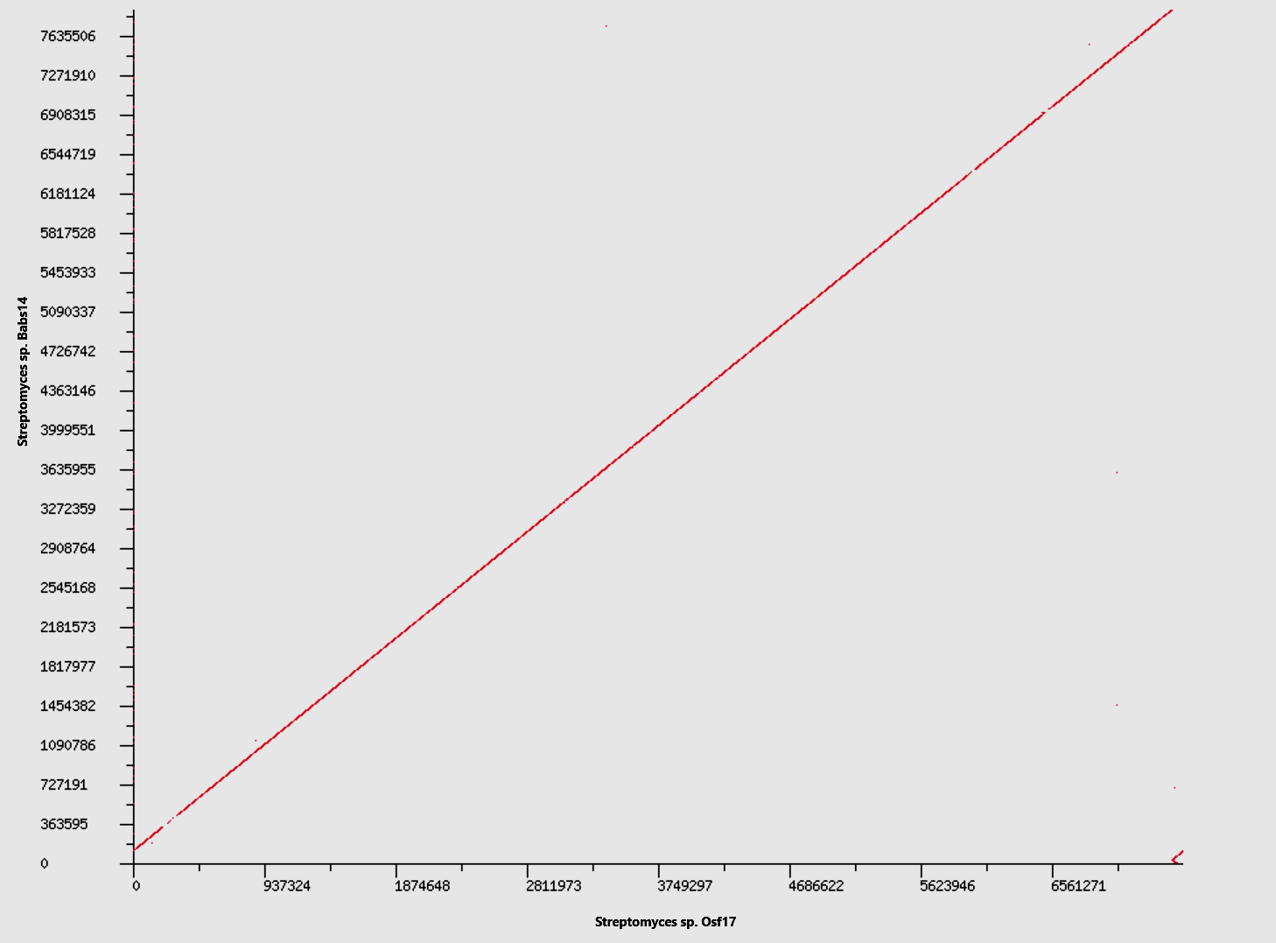

Figure S4: Dot plot matches of Streptomyces sp. Babs14 with Streptomyces sp. Osf17 generated from SEED Viewer Version 2.0 using Rast subsystem technology.

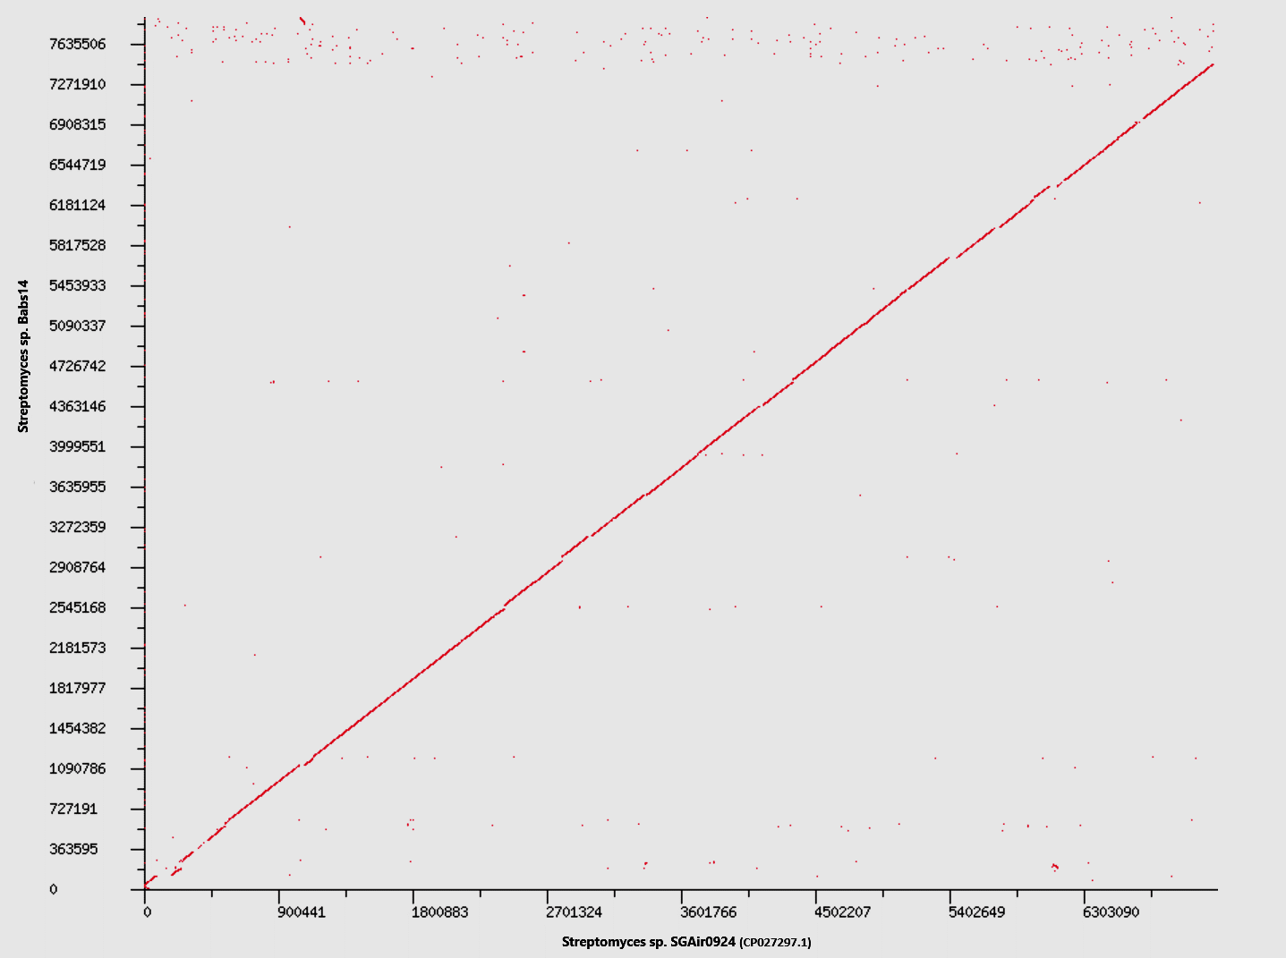

Figure S5: Dot plot matches of Streptomyces sp. Babs14 with Streptomyces sp. SGAir0924 (CP027297.1) generated from SEED Viewer Version 2.0 using Rast subsystem technology.

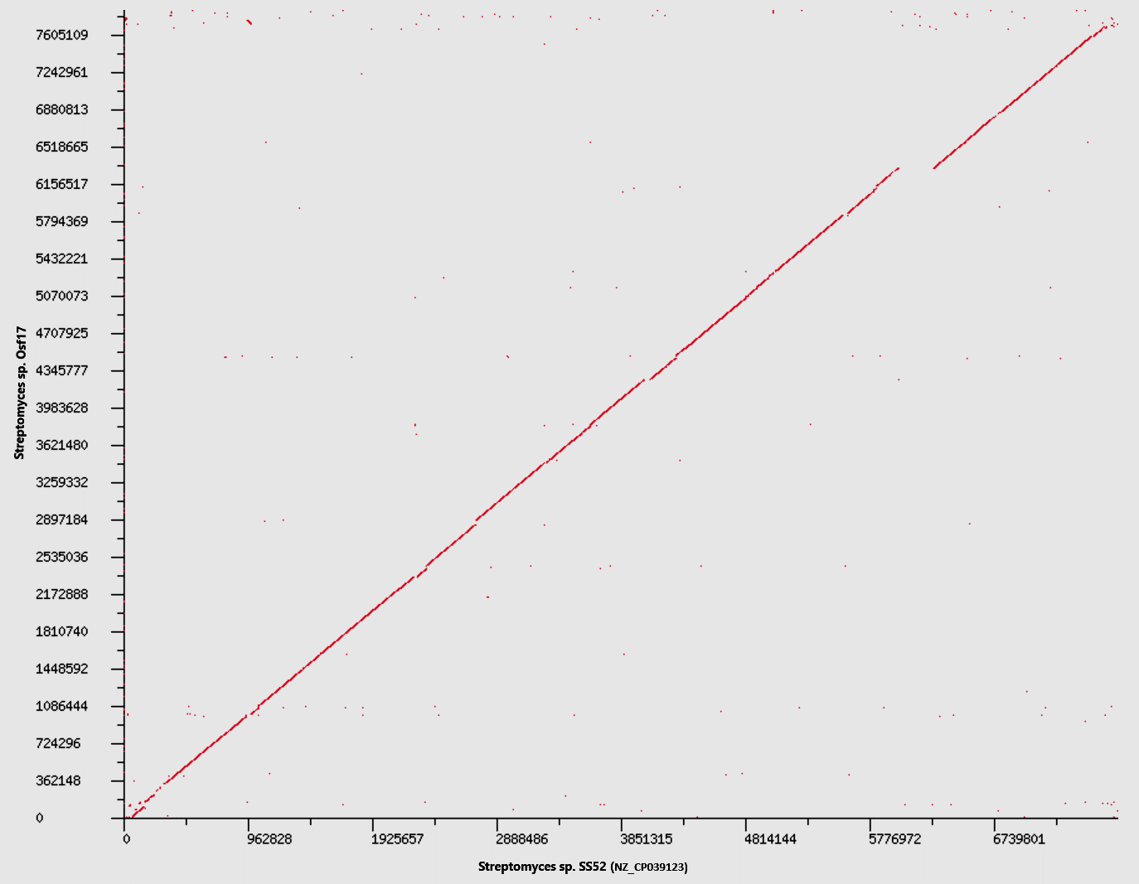

Figure S6: Dot plot matches of Streptomyces sp. Osf17 with Streptomyces sp. SS52 (NZ_CP039123) generated from SEED Viewer Version 2.0 using Rast subsystem technology.

A
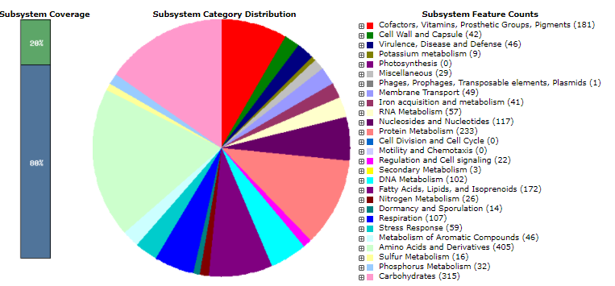
B
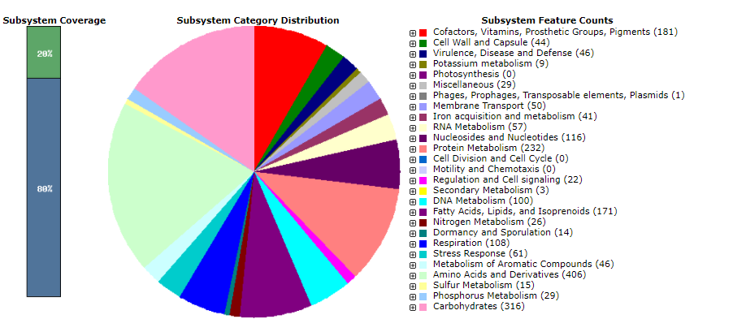

Figure S7. Subsystem feature distirbutions the strains Babs14 and Osf17 using SEED Viewer version 2.0. on RAST subsystem technology (A) features assigned to the strain Babs14, (B) feattures assigned to Osf17

Additional file 2.
Table S1. Biological process of the 284 protein clusters shared by the strains Babs14 and Osf17 using Orthovenn2 webserver.
Biological functions | Amount of protein clusters
carbohydrate metabolic process | 5
polysaccharide metabolic process | 1
organic acid metabolic process | 5
generation of precursor metabolites and energy | 1
nucleobase-containing compound metabolic process | 12
DNA metabolic process | 4
DNA modification | 1
protein folding | 1
cellular protein modification process | 1
lipid metabolic process | 3
cellular aromatic compound metabolic process | 12
one-carbon metabolic process | 1
phosphorus metabolic process | 3
nitrogen compound metabolic process | 15
transport | 1
biological_process | 22
metabolic process | 21
nucleoside metabolic process | 1
nucleotide metabolic process | 3
nucleotide-sugar metabolic process | 1
genetic transfer | 1
amine metabolic process | 1
cellular process | 10
cellular component organization | 1
RNA metabolic process | 3
transposition | 3
developmental process | 1
cellular component morphogenesis | 1
macromolecule metabolic process | 8
cellular metabolic process | 18
primary metabolic process | 14
cellular lipid metabolic process | 1
heterocycle metabolic process | 12
response to stimulus | 3
cofactor metabolic process | 2
establishment of localization | 1
biological regulation | 4
nucleobase-containing compound metabolic process | 1
cellular protein modification process | 1
cellular aromatic compound metabolic process | 1
phosphorus metabolic process | 1
nitrogen compound metabolic process | 1
biological_process | 3
metabolic process | 2
cellular process | 2
RNA metabolic process | 1
protein metabolic process | 1
macromolecule metabolic process | 2
cellular metabolic process | 2
primary metabolic process | 2
heterocycle metabolic process | 1
response to stimulus | 1
biological regulation | 2
nucleobase-containing compound metabolic process | 1
DNA modification | 1
cellular aromatic compound metabolic process | 1
one-carbon metabolic process | 1
vitamin metabolic process | 1
nitrogen compound metabolic process | 2
transport | 1
biological_process | 3
metabolic process | 2
cellular process | 2
RNA metabolic process | 1
macromolecule metabolic process | 1
cellular metabolic process | 2
primary metabolic process | 1
heterocycle metabolic process | 2
response to stimulus | 1
establishment of localization | 1
biological regulation | 1

Table S2. Genomic islands of Streptomyces sp. Babs14 using IslandViewer 4.
Streptomyces sp. Babs14 | Start | End | Size
GEI 1 | 101,722 | 130,375 | 28,653
GEI 2 | 180,896 | 193,844 | 12,948
GEI 3 | 255,258 | 266,874 | 11,616
GEI 4 | 3,012,900 | 3,027,508 | 14,608
GEI 5 | 3,796,351 | 3,806,565 | 10,214
GEI 6 | 3,888,663 | 3,900,718 | 12,055
GEI 7 | 3,979,956 | 3,998,867 | 18,911
GEI 8 | 4,548,970 | 4,558,433 | 9,463
GEI 9 | 6,072,410 | 6,078,730 | 6,32
GEI 10 | 7,484,990 | 7,494,684 | 9,694
GEI 11 | 7,913,239 | 7,944,593 | 31,354
GEI 12 | 7,954,470 | 7,993,252 | 38,782

Table S3. Genomic islands of Streptomyces sp. Osf17 using
IslandViewer 4.
Streptomyces sp. Osf17 | Start | End | Size
GEI 1 | 3,127 | 13,084 | 9,957
GEI 2 | 66,27 | 78,193 | 11,923
GEI 3 | 139,607 | 151,223 | 11,616
GEI 4 | 2,897,047 | 2,911,655 | 14,608
GEI 5 | 3,680,019 | 3,690,233 | 10,214
GEI 6 | 3,772,330 | 3,781,749 | 9,419
GEI 7 | 3,863,624 | 3,882,535 | 18,911
GEI 8 | 4,229,463 | 4,237,964 | 8,501
GEI 9 | 4,419,771 | 4,442,087 | 22,316
GEI 10 | 5,956,056 | 5,962,376 | 6,32
GEI 11 | 7,368,637 | 7,378,331 | 9,694
GEI 12 | 7,797,021 | 7,828,375 | 31,354
GEI 13 | 7,838,252 | 7,904,054 | 65,802

Table S4. Prophage regions predicted in Babs14 and Osf17 using PHASTER.
Strains | Region length | Completeness | Score (%) | Amount of CDSs | Region position | Possible phage |  | GC % | Accession
Babs14 | 10.9 Kb | incomplete | 40 | 17 | 2906194-2917100 | Phage Rhodococcus REQ1 | 72.40 |  | NC_016655
Osf17 | 8.4 Kb | incomplete | 30 | 9 | 1870238-1878727 | Phage Bacillus G | 72.43 |  | NC_023719
Osf17 | 25.5 Kb | incomplete | 30 | 36 | 2905990-2931526 | Phage Gordonia Nymphadora | 71.78 |  | NC_031061
Osf17 | 8.6 Kb | incomplete | 30 | 10 | 6774978-6783629 | Phage Erwinia vB EamM EarlPhillipI | 73.93 |  | NC_031007

Table S5. The potential gene clusters encoding secondary metabolites of Babs14 predicted by antiSMASH version 5.1.1.
Region | Type | From | To | Most similar known cluster | Similarity  %
Cluster 1C | terpene | 18,337 | 42,741 | isorenieratene |  | 100
Cluster 2 | NRPS,T1PKS,NRPS-like,hglE-KS | 159,773 | 369,779 | candicidin |  | 95
Cluster 3 | terpene | 388,546 | 409,134 | lysolipin I |  | 4
Cluster 4 | indole | 713,952 | 735,073 | 5-isoprenylindole-3-carboxylate β-D-glycosyl ester |  | 33
Cluster 5 | terpene | 793,773 | 817,176 | carotenoid |  | 54
Cluster 6 | T3PKS | 1,284,413 | 1,325,519 | herboxidiene |  | 8
Cluster 7 | ectoine | 1,985,299 | 1,995,697 | ectoine |  | 100
Cluster 8 | melanin | 2,930,499 | 2,941,107 | melanin |  | 60
Cluster 9 | siderophore | 3,027,662 | 3,038,619 | desferrioxamin B / desferrioxamine E |  | 83
Cluster 10 | NRPS-like | 4,035,802 | 4,078,834 | alanylclavam / 2-hydroxymethylclavam / 2-formyloxymethylclavam / clavam-2-carboxylate |  | 12
Cluster 11 | lanthipeptide | 4,297,384 | 4,318,612 | catenulipeptin |  | 60
Cluster 12 | NRPS | 4,545,665 | 4,608,045 | ansamitocin P-3 |  | 7
Cluster 13 | terpene | 5,271,650 | 5,292,271 | albaflavenone |  | 100
Cluster 14 | T2PKS | 5,335,903 | 5,408,499 | spore pigment |  | 66
Cluster 15 | siderophore | 5,851,047 | 5,861,175 | -
Cluster 16 | bacteriocin | 6,095,284 | 6,105,691 | -
Cluster 17 | terpene | 6,121,923 | 6,141,888 | geosmin |  | 100
Cluster 18 | siderophore | 6,295,834 | 6,309,007 | paulomycin |  | 9
Cluster 19 | NRPS | 6,325,885 | 6,404,464 | CDA1b / CDA2a / CDA2b / CDA3a / CDA3b / CDA4a / CDA4b |  | 72
Cluster 20 | terpene | 6,738,819 | 6,764,741 | hopene |  | 100
Cluster 21 | T1PKS | 6,874,946 | 6,969,876 | streptovaricin |  | 31
Cluster 22 | terpene | 7,097,617 | 7,118,648 | versipelostatin |  | 5
Cluster 23 | bacteriocin | 7,131,633 | 7,141,848 | informatipeptin |  | 42
Cluster 24 | NRPS | 7,401,716 | 7,452,300 | coelichelin |  | 100
Cluster 25 | NRPS | 7,545,386 | 7,597,798 | coelibactin |  | 100
Cluster 26 | lanthipeptide | 7,597,857 | 7,620,346 | -
Cluster 27 | lanthipeptide | 7,632,588 | 7,655,170 | SapB |  | 100
Cluster 28 | NRPS | 7,822,785 | 7,884,453 | streptothricin |  | 91
Cluster 29 | T2PKS, butyrolactone | 53,536 | 114,649 | fluostatins M-Q |  | 67

Table S6. The potential gene clusters encoding secondary metabolites of Osf17predicted by antiSMASH version 5.1.1.
Clusters | Type | From |  | To | Most similar known cluster | Similarity (%)
Cluster1C | terpene | 18,069 |  | 42,739 | isorenieratene |  | 100
Cluster 2 | NRPS,T1PKS,NRPS-like,hglE-KS | 159,771 |  | 369,557 | levorin A3 / C06690 / FR-008-III / candicidin A / UNII-AP5PEF5W7U |  | 95
Cluster 3 | terpene | 388,316 |  | 408,904 | lysolipin I |  | 4
Cluster 4 | indole | 713,719 |  | 734,840 | 5-isoprenylindole-3-carboxylate β-D-glycosyl ester |  | 33
Cluster 5 | terpene | 793,540 |  | 816,943 | carotenoid |  | 54
Cluster 6 | T3PKS | 1,284,163 |  | 1,325,269 | herboxidiene |  | 8
Cluster 7 | ectoine | 1,985,056 |  | 1,995,454 | ectoine |  | 100
Cluster 8 | melanin | 2,930,295 |  | 2,940,753 | melanin |  | 60
Cluster 9 | siderophore | 3,027,458 |  | 3,038,415 | desferrioxamin B / desferrioxamine E |  | 83
Cluster 10 | NRPS-like | 4,035,113 |  | 4,078,145 | alanylclavam / 2-hydroxymethylclavam / 2-formyloxymethylclavam / clavam-2-carboxylate |  | 12
Cluster 11 | lanthipeptide | 4,296,694 |  | 4,317,922 | catenulipeptin |  | 60
Cluster 12 | NRPS | 4,544,782 |  | 4,607,348 | ansamitocin P-3 |  | 7
Cluster 13 | terpene | 5,270,962 |  | 5,291,583 | albaflavenone |  | 100
Cluster 14 | T2PKS | 5,335,216 |  | 5,407,812 | spore pigment |  | 66
Cluster 15 | siderophore | 5,850,347 |  | 5,860,474
Cluster 16 | bacteriocin | 6,094,576 |  | 6,104,985
Cluster 17 | terpene | 6,121,214 |  | 6,141,179 | geosmin |  | 100
Cluster 18 | siderophore | 6,295,129 |  | 6,308,302 | paulomycin |  | 9
Cluster 19 | NRPS | 6,325,180 |  | 6,403,758 | CDA1b / CDA2a / CDA2b / CDA3a / CDA3b / CDA4a / CDA4b |  | 72
Cluster 20 | terpene | 6,738,113 |  | 6,764,035 | hopene |  | 100
Cluster 21 | T1PKS | 6,874,238 |  | 6,969,171 | streptovaricin |  | 31
Cluster 22 | terpene | 7,096,916 |  | 7,117,947 | versipelostatin |  | 5
Cluster 23 | bacteriocin | 7,130,932 |  | 7,141,147 | informatipeptin |  | 42
Cluster 24 | NRPS | 7,401,011 |  | 7,451,595 | coelichelin |  | 100
Cluster 25 | NRPS | 7,544,681 |  | 7,597,089 | coelibactin |  | 100
Cluster 26 | lanthipeptide | 7,597,148 |  | 7,619,637
Cluster 27 | lanthipeptide | 7,631,879 |  | 7,654,461 | SapB |  | 100
Cluster 28 | NRPS | 7,822,216 |  | 7,883,883 | streptothricin |  | 87
Cluster 29 | T2PKS,butyrolactone |  | 22,257 | 83,375 | fluostatins M-Q | % | 67

Table S7. Stress responses of Streptomyces sp. Babs14 and Streptomyces sp. Osf17 using the SEED Viewer version 2.0. (A): Streptomyces sp. Babs14, (B): Streptomyces sp. Osf17.
Presence | Category | Subcategory | subsystem | Proteins | Active For A | Active for B
A and B | Stress Response | Detoxification | Uptake of selenate and selenite | DedA protein | yes | yes
A and B | Stress Response | Osmotic stress | Choline and Betaine Uptake and Betaine Biosynthesis | Betaine aldehyde dehydrogenase (EC 1.2.1.8) | yes | yes
A and B | Stress Response | Osmotic stress | Choline and Betaine Uptake and Betaine Biosynthesis | Glycine betaine ABC transport system, ATP-binding protein OpuAA (EC 3.6.3.32) | yes | yes
A and B | Stress Response | Osmotic stress | Choline and Betaine Uptake and Betaine Biosynthesis | Glycine betaine ABC transport system, glycine betaine-binding protein OpuAC | yes | yes
A and B | Stress Response | Osmotic stress | Choline and Betaine Uptake and Betaine Biosynthesis | Glycine betaine ABC transport system, permease protein OpuAB | yes | yes
A and B | Stress Response | Osmotic stress | Choline and Betaine Uptake and Betaine Biosynthesis | Glycine betaine transporter OpuD | yes | yes
A and B | Stress Response | Osmotic stress | Osmoregulation | Glycerol uptake facilitator protein | yes | yes
A and B | Stress Response | Osmotic stress | Osmoregulation | Outer membrane protein A precursor | yes | yes
A and B | Stress Response | Oxidative stress | Glutathione: Biosynthesis and gamma-glutamyl cycle | Gamma-glutamyltranspeptidase (EC 2.3.2.2) | yes | yes
A and B | Stress Response | Oxidative stress | Glutathione: Biosynthesis and gamma-glutamyl cycle | Glutamate--cysteine ligase (EC 6.3.2.2) | yes | yes
A and B | Stress Response | Oxidative stress | Glutathione: Redox cycle | Glutathione peroxidase (EC 1.11.1.9) | yes | yes
A and B | Stress Response | Oxidative stress | Glutathionylspermidine and Trypanothione | Similarity with glutathionylspermidine synthase (EC 6.3.1.8), group 1 | yes | yes
A and B | Stress Response | Oxidative stress | Oxidative stress | Alkyl hydroperoxide reductase subunit C-like protein | yes | yes
A and B | Stress Response | Oxidative stress | Oxidative stress | Ferric uptake regulation protein FUR | yes | yes
A and B | Stress Response | Oxidative stress | Oxidative stress | Nitrite-sensitive transcriptional repressor NsrR | yes | yes
A and B | Stress Response | Oxidative stress | Oxidative stress | Organic hydroperoxide resistance protein | yes | yes
A and B | Stress Response | Oxidative stress | Oxidative stress | Organic hydroperoxide resistance transcriptional regulator | yes | yes
A and B | Stress Response | Oxidative stress | Oxidative stress | Redox-sensitive transcriptional activator SoxR | yes | yes
A and B | Stress Response | Periplasmic Stress | Periplasmic Stress Response | Intramembrane protease RasP/YluC, implicated in cell division based on FtsL cleavage | yes | yes
A and B | Stress Response | no subcategory | Bacterial hemoglobins | Hemoglobin-like protein HbO | yes | yes
A and B | Stress Response | no subcategory | Dimethylarginine metabolism | NG,NG-dimethylarginine dimethylaminohydrolase 1 (EC 3.5.3.18) | yes | yes
A and B | Stress Response | no subcategory | Dimethylarginine metabolism | Ornithine aminotransferase (EC 2.6.1.13) | yes | yes
A and B | Stress Response | no subcategory | SigmaB stress responce regulation | Anti-sigma B factor RsbT | yes | yes
A and B | Stress Response | no subcategory | SigmaB stress responce regulation | Anti-sigma B factor antagonist RsbV | yes | yes
A and B | Stress Response | no subcategory | SigmaB stress responce regulation | RNA polymerase sigma factor SigB | yes | yes
A and B | Stress Response | no subcategory | SigmaB stress responce regulation | RsbS, negative regulator of sigma-B | yes | yes
A and B | Stress Response | no subcategory | SigmaB stress responce regulation | Serine phosphatase RsbU, regulator of sigma subunit | yes | yes
A and B | Stress Response | no subcategory | SigmaB stress responce regulation | Serine-protein kinase RsbW (EC 2.7.11.1) | yes | yes

