Supplementary Material

Response of Copeptin Levels to Empagliflozin in Patients with Recent Acute Coronary Syndrome and Newly Detected Dysglycaemia

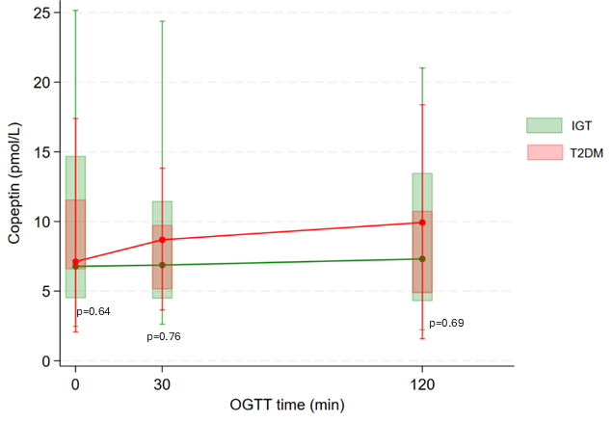

Supplementary Figure 1 Copeptin levels during the OGTT at baseline by glycaemic group (empagliflozin and placebo group together).

Abbreviations: OGTT, oral glucose tolerance test; IGT, impaired glucose tolerance; T2DM, type 2 diabetes.

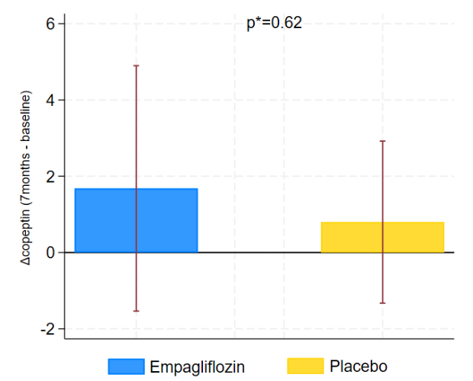
A)

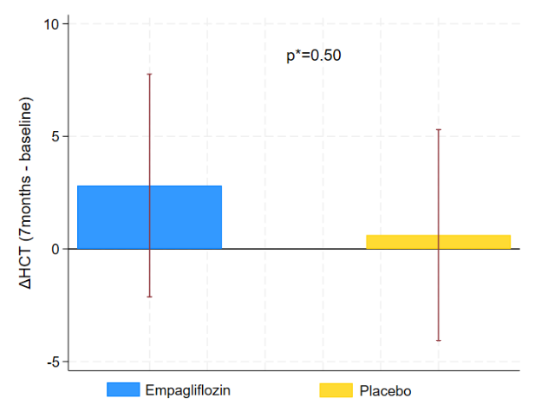
B)

Supplementary Figure 2 Δ values of A) copeptin and B) haematocrit from baseline to after seven months on study drug. *P-values are by Mann-Whitney U Test.
Abbreviations: HCT, haematocrit.

Supplementary Table 1 Evolution of the number of patients using diuretic agents and changes of diuretic doses throughout the entire follow-up period.

 |  | Empagliflozin |  |  |  | Placebo
 | Baseline | 7 months |  | 10 months |  | Baseline | 7 months |  | 10 months
Any diuretic agents | 7 | 6 |  | 6 |  | 3 | 3 |  | 3
 |  | ↑dose | ↓ dose | ↑dose | ↓ dose |  | ↑dose | ↓ dose | ↑dose | ↓ dose
Loop/Thiazid | 7 | 0 | 0 | 0 | 0 | 3 | 0 | 0 | 0 | 0
MRA | 2 | 1 | 0 | 0 | 0 | 0 | 0 | 0 | 0 | 0
 |  | Empagliflozin |  |  |  | Placebo
 | Baseline | 7 months |  | 10 months |  | Baseline | 7 months |  | 10 months
ACEis/ARBs | 17 | 16 |  | 16 |  | 18 | 16 |  | 16
β-Blockers | 19 | 18 |  | 18 |  | 21 | 20 |  | 20
Ca-Inhibitors | 5 | 4 |  | 4 |  | 4 | 4 |  | 4

Abbreviations: ACE, angiotensin converting enzyme; ARB, angiotensin receptor blocker; β-blockers, Beta blockers; Ca-blockers, Calcium channel blockers; MRA, Mineralcorticoid antagonists.

Supplementary Table 2 Spearman correlations of copeptin changes from baseline and 7 months with insulin sensitivity indexes, hydro-electrolyte balance variables and cardiac magnetic resonance parameters, in the empagliflozin and placebo groups

 | ΔCopeptin
 | Empagliflozin |  | Placebo
Variable | r_{s} | p-value | r_{s} | p-value
ΔFPG | -0.21 | 0.44 | 0.33 | 0.18
Δ2h-PG | -0.02 | 0.93 | -0.15 | 0.54
ΔHOMA-IR | 0.15 | 0.58 | -0.21 | 0.40
ΔMCR Stumvoll | -0.08 | 0.79 | -0.28 | 0.26
ΔHCT | 0.05 | 0.86 | 0.05 | 0.85
ΔNa | 0.49 | 0.08 | 0.55 | 0.02
ΔK | 0.12 | 0.67 | 0.45 | 0.06
ΔLVEDVi | 0.02 | 0.17 | -0.16 | 0.53
ΔLVESVi | -0.25 | 0.44 | -0.16 | 0.53
ΔLVEF | 0.27 | 0.39 | -0.05 | 0.84
ΔLVSVi | 0.30 | 0.34 | -0.10 | 0.70
ΔLVM | 0.33 | 0.27 | 0.35 | 0.17
ΔECV | 0.36 | 0.27 | 0.31 | 0.24
ΔaPWV | -0.22 | 0.47 | 0.42 | 0.10
Abbreviations: FPG, fasting plasma glucose; 2h-PG, 2-hour post-load glucose; HOMA-IR, Homeostatic assessment model – Insulin Resistance); MCR, Metabolic clearance rate; LVSVi, left ventricular systolic volume indexed; LVEDVi, left ventricular end-diastolic volume indexed; LVESVi, left ventricular end-systolic volume indexed; LVEF, left ventricular ejection fraction; aPWV, arterial pulse wave velocity; ECV, extracellular volume; LVMi, left ventricular mass indexed; Na, Sodium; K, Potassium; HCT, haematocrit.

Supplementary Table 3 Variation in copeptin levels between empagliflozin and placebo group during the OGTT throughout the entire study duration.

Copeptin | Empa | Placebo | P* | P_{I}
Baseline
0 min | 7.18 (5.46,11.62) | 6.72 (5.09, 15.21) | 0.78
30 min | 8.69 (4.96, 9.74) | 7.82 (4.51, 13,48) | 0.84
120 min | 9.21 (4.73,10.76) | 7.82 (4.51, 13.48) | 1.00
7 months
0 min | 11.51 (5.92, 16.3) | 8.42 (5.00, 19.01) | 0.63
30 min | 9.71 (5.70, 12.57) | 7.38 (14.90) | 0.53
120 min | 10.70 (5.67, 13.17) | 7.01 (4.92, 16.37) | 0.39
10 months
0 min | 6.67 (5.36, 10.67) | 8.22 (5.94, 13.66) | 0.50 | 0.64
30 min | 5.65 (4.98, 9.00) | 6.88 (4.97, 10.12) | 0.66 | 0.23
120 min | 6.52 (5.66, 9.77) | 6.31 (4.58, 11.21) | 0.73 | 0.34

Data are median (Q1-Q3). P* = p-value by Mann-Whitney U-test. P_{I}= P for interaction between treatment allocation and visit time (baseline, 7 months and 10 months) in the repeated measures ANOVA model after log transformation for each OGTT time point.
Abbreviations: OGTT, oral glucose tolerance test.

