Online Resource 5 – Wright Maps for Interpretation of the CMTS Continuum
Article Title:
“Critical Mathematical Thinking as an Integrated Evaluative Reasoning.”
Journal Name:
Educational Studies in Mathematics
Author, Affiliation & Email:
Michael Erotoma Omuvwie¹
¹University of Hull, Hull, UK
m.e.omuvwie@hull.ac.uk
5.1 Purpose and interpretive scope
Online Resource 5 provides a set of Wright maps to support substantive interpretation of the Critical Mathematical Thinking Skills (CMTS) continuum beyond the single map presented in the main text. These maps are included to enhance transparency and to illustrate how different task features contribute to the same underlying latent construct.
The Wright maps presented here are intended as supplementary interpretive resources. They are not designed to establish additional dimensions, nor to extend the formal analyses reported in the main Results section. Instead, they provide complementary visualisations that clarify the integrated nature of CMTS by showing how items informed by different task features are distributed along a common continuum.
5.2 OR5.1 Wright map for the combined CMTS scale
5.2.1 Description
The Wright map for the combined CMTS scale displays student person measures on the left and item difficulty estimates on the right, aligned on the same Rasch logit scale. Higher locations on the scale correspond to stronger evaluative mathematical reasoning.
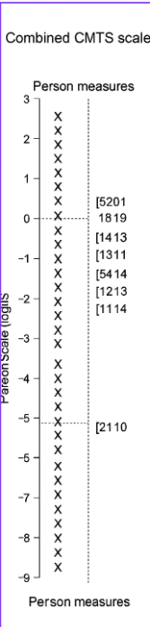
Fig. 5.1 Wright map for the combined CMTS scale
Caption
This Wright map displays the distribution of student person measures (left side) and item difficulty estimates (right side) for the combined CMTS scale on the Rasch logit scale. Higher positions correspond to stronger evaluative mathematical reasoning. Items lower on the scale involve recognition of clearly implausible or internally inconsistent claims, whereas items higher on the scale require coordination of multiple quantitative relationships and contextual interpretation. The alignment between person and item distributions indicates that the instrument captures a meaningful range of Critical Mathematical Thinking Skills across the sample.
5.2.2 Interpretive notes
Items located toward the lower end of the scale typically involve recognition of clearly implausible, weakly justified, or internally inconsistent quantitative claims. Items located higher on the CMTS continuum require more sophisticated coordination of quantitative relationships, contextual constraints, and evaluative judgement. The broad overlap between person measures and item difficulties indicates that the instrument captures a substantive range of evaluative mathematical reasoning within the sampled population.

5.3 OR5.2 Wright map for items informed primarily by mathematical-thinking features
5.3.1 Description
This Wright map presents person measures and item difficulty estimates for the subset of CMTS items informed primarily by mathematical-thinking features, such as quantitative structuring, relational reasoning, interpretation of representations, and attention to mathematical constraints.
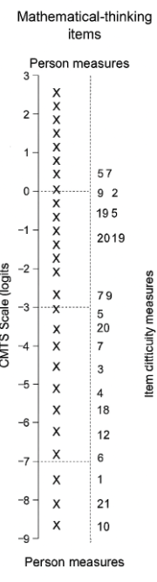

Fig. 5.2 Wright map for items informed primarily by mathematical-thinking features
Caption
This Wright map shows person measures and item difficulty estimates for the subset of CMTS items informed primarily by mathematical-thinking features, including quantitative structuring, relational reasoning, and interpretation of mathematical representations. Item difficulties span a wide range on the logit scale, suggesting that mathematically structured reasoning contributes meaningfully to variation in students’ evaluative mathematical thinking. Items are distributed across the same continuum as the combined CMTS scale, supporting the interpretation of mathematical structuring as an integral component of integrated evaluative reasoning.
5.3.2 Interpretive notes
Items associated with mathematical-thinking features span a wide range of difficulty on the CMTS continuum rather than clustering at a single level. This pattern indicates that mathematically structured reasoning contributes to evaluative judgement across the full range of CMTS rather than being confined to either lower- or higher-level reasoning. Importantly, these items occupy positions that overlap substantially with items from the combined CMTS scale, reinforcing the interpretation of mathematical structuring as integral to integrated evaluative reasoning rather than as a separate dimension.
  - OR5.3 Wright map for items informed primarily by critical-thinking features
5.4.1 Description
This Wright map displays person measures and item difficulty estimates for the subset of CMTS items informed primarily by evaluative-judgement features, such as scrutiny of assumptions, assessment of plausibility, and evaluation of claims in contextualised quantitative situations.
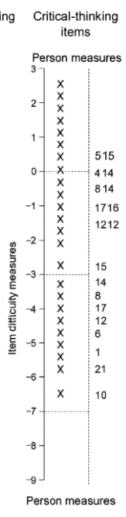

Fig. 5.3 Wright map for items informed primarily by critical-thinking features
Caption
This Wright map presents person measures and item difficulty estimates for the subset of CMTS items informed primarily by evaluative-judgement features, including assessment of plausibility and scrutiny of assumptions. Items appear across the CMTS continuum rather than forming a separate cluster, indicating that evaluative judgement operates in coordination with mathematical structuring rather than as an independent dimension. This pattern provides further support for the integrated CMTS construct.
5.5 Interpretive notes
Items associated with evaluative-judgement features are distributed across the CMTS continuum rather than clustering at specific levels. This pattern suggests that evaluative judgement is not confined to either basic or advanced reasoning, but operates throughout the continuum in coordination with quantitative interpretation. The overlap between evaluative-judgement-informed items and mathematically-informed items provides further evidence that CMTS reflects an integrated form of evaluative mathematical reasoning.
5.6 Summary interpretation across Wright maps
Across all three Wright maps, items informed by mathematical-thinking and evaluative-judgement features are distributed along a common latent continuum rather than separating into distinct regions. This convergence supports the central interpretation advanced in the main text: Critical Mathematical Thinking Skills represent an integrated form of evaluative reasoning in which quantitative structuring and evaluative judgement function conjointly when learners engage with contextualised mathematical claims.
5.7 Editorial note
These Wright maps are provided as supplementary interpretive resources and are not intended to establish additional dimensions beyond those reported in the main Results section. Their purpose is to illustrate how different task features contribute to the same underlying CMTS continuum.

