Supplementary Information

Resolving the issue of non-specific substrate oxidation in nanozyme-assisted colorimetric assays

Anastasia Novokshonova, Mikhail Rayev, Pavel Khramtsov

Institute of Ecology and Genetics of Microorganisms, Urals Branch of Russian Academy of Sciences, 614081, Perm, Russia

Table S1. Literature examples of high non-specific oxidation of TMB in the absence of nanozymes
No | Buffer | pH | TMB, mmol/L | H₂O₂, mmol/L | Additives | Background (wavelength, nm) | Reference
1 | 6 mmol/L Na-acetate | 3.5 | 1.66 | 3.33 | No | ≈0.15 (450) | 10.3390/bios13020225
2 | Na-acetate | 4.0 | 1 | 10 | No | ≈0.2 (652) | - 10.1016/j.redox.2024.103217
3 | NS¹ | NS | 3 | 0.1 | No | ≈0.15 (652) | - 10.1002/smll.202003496
4 | 100 mmol/L Na-acetate | 4.0 | 0.5 | 6.6 | No | ≈0.1 (652) | 10.3390/molecules28124573
5 | Na-acetate | 3.0 | NS | NS | No | ≈0.25 (652) | 10.1007/s00604-020-04391-8
6 | 100 mmol/L Na-acetate | 4.0 | NS | NS | No | ≈0.15 (652) | 10.1007/s44211-023-00411-8
7 | 180 mmol/L Na-acetate | 4.0 | 0.166 | 3.3 | No | ≈0.1 (652) | 10.3390/foods13233788
8 | 100 mmol/L Na-acetate | 4.0 | 0.5 | 6.6 | No | ≈0.1 (652) | 10.3389/fchem.2021.774486
9 | 100 mmol/L Na-acetate | 3.5 | 0.12 | NS | No | ≈0.1 (652) | - 10.1007/s00604-017-2509-4
10 | 50 mmol/L Na-acetate | 4.5 | 1.4 | 0.074 | No | ≈0.15 (652) | - 10.1007/s00604-019-3489-3
11 | 62 mmol/L phosphate | 5.0 | 8.3 | 8.3 | No | ≈0.25 (652) | 10.1007/s00604-022-05480-6
12 | NS | NS | 10 | 1000 | No | ≈0.2 (652) | 10.3762/bjnano.15.9
13 | NS | 4.0 | 0.32 | 20 | No | ≈0.1 (652) | 10.1080/09205063.2020.1716298
14 | NS | 4.0 | 2 | 50 | No | ≈0.25 (652) | 10.1016/j.inoche.2024.112580
15 | 186 mmol/L Na-acetate | 4.5 | 0.5 | 10 | No | ≈0.1 (652) | 10.1016/j.microc.2024.111363
16 | 200 mmol/L Na-acetate | 4.0 | 0.167 | 327 | No | ≈0.15 (652) | - 10.1007/s10853-018-2657-x
17 | 10 mmol/L Na-acetate | 4.0 | 1.5 | 10 | No | ≈0.1 (652) | 10.1002/cbic.201800471
18 | 200 mmol/L Na-acetate | 3.5 | 0.8 | 50 | No | ≈0.15 (652) | 10.1039/C1CC11943E
19 | 200 mmol/L Na-acetate | 4.0 | 0.48 | 5 | No | ≈0.1 (652) | - 10.3390/chemistry5020088
20 | 150 mmol/L Na-acetate | 3.5 | 1 | 0.1 | No | ≈0.06 (652) | 10.1039/C7TB02434G
21 | NS | NS | NS | NS | No | ≈0.15 (652) | - 10.1186/s13036-019-0220-1
22 | NS | 4.0 | 0.1 | 20 | No | ≈0.15 (652) | 10.3390/bios12050260
23 | PBS | 3.5 | 1 | 0.1 | No | ≈0.1 (652) | 10.1039/D3AY01666H
24 | 10 mmol/L  PBS | 4.0 | 4 | 0.5 | No | ≈0.1 (652) | 10.3390/molecules27134262
26 | 180 mmol/L Na-acetate | 4.0 | 0.166 | 3.33 | No | ≈0.1 (652) | 10.3390/foods13233788
27 | NS | NS | 0.416 | 0.416 | No | ≈0.2 (652) | 10.1016/j.aca.2025.343981
28 | 180 mmol/L Na-acetate | 4.0 | 0.25 | 0.5 | No | ≈0.1 (652) | 10.1016/j.chphma.2023.12.001
29 | Na-citrate-phosphate | NS | 0.5 | 30 | No | ≈0.15 (652) | 10.1177/00368504251362318
30 | Na-acetate | 4.0 | 1 | 5 | No | ≈0.1 (652) | - 10.1016/j.colsurfb.2022.112531
31 | Na-acetate | 4.0 | 1.2 | 1200 | No | ≈0.25 (652) | - 10.3390/bios15010030
32 | 180 mmol/L Na-acetate | 4.0 | 0.166 | 3.33 | No | ≈0.1 (652) | 10.3390/foods15030479
33 | 30 mmol/L Na-acetate | 4.0 | 0.444 | 22 | No | ≈0.2 (652) | 10.3390/biom15071002
34 | 9 mmol/L Na-acetate | 4.0 | 0.45 | 300 | No | ≈0.1 (652) | 10.3390/foods14081311
35 | Na-acetate | 4.0 | 0.5 | 50 | No | ≈0.1 (652) | 10.3390/molecules29215097
36 | Na-acetate | 3.6 | NS | NS | No | ≈0.1 (652) | 10.3390/nano14131090
37 | PBS | 7.4 | NS | NS | No | ≈0.1 (652) | 10.3390/bios14020062
38 | 133 mmol/L Na-acetate | 4.0 | 0.666 | 5 | No | ≈0.15 (652) | 10.3390/ma16186212
39 | 100 mmol/L Na-acetate | 4.0 | NS | NS | No | ≈0.1 (652) | 10.3390/molecules28166064
40 | Na-acetate | NS | 0.307 | 0.307 | No | ≈0.1 (652) | 10.3390/polym15143002
41 | 60 mmol/L Na-acetate | 3.0 | 0.1 | 0.1 | No | ≈0.2 (652) | 10.3390/molecules28093736
42 | 33 mmol/L Na-acetate | 4.0 | 2.5 | 166 | No | ≈0.25 (652) | 10.3390/foods12020291
43 | Na-acetate | 5.2 | 0.4 | 6.25 | No | ≈0.15 (652) | 10.3390/bios12100874
44 | Na-acetate | NS | NS | NS | No | ≈0.25 (652) | 10.3390/s21238050
45 | 10 mmol/L PBS | 4.0 | 1 | 25 | No | ≈0.15 (652) | 10.3389/fchem.2021.681566
46 | 90 mmol/L Na-acetate | 3.0 | 0.9 | 1.8 | No | ≈0.25 (652) | 10.3389/fchem.2022.1093073
47 | 160 mmol/L Na-acetate | 3.6 | 0.2 | 1 | No | ≈0.1 (652) | 10.3389/fchem.2020.564968
48 | 180 mmol/L Na-acetate | 3.6 | NS | NS | No | ≈0.1 (652) | 10.3389/fchem.2021.812083
49 | 100 mmol/L Na-acetate | 4.0 | 0.5 | 6.6 | No | ≈0.1 (652) | 10.3389/fchem.2021.774486
50 | 80 mmol/L Na-acetate | 3.0 | 1 | 20 | No | ≈0.1 (652) | 10.1016/j.snb.2026.139474
51 | NS | 7.0 | 0.8 | 0.1 | No | ≈0.1 (652) | - 10.1007/s11427-017-9261-9
52 | 16 mmol/L Na-acetate | 3.6 | 0.66 | 6.66 | No | ≈0.2 (652) | - 10.1016/j.saa.2026.127562
53 | 85 mmol/L Na-acetate | 4.0 | 1 | 980 | No | ≈0.1 (652) | 10.3390/app16041858
54 | Na-acetate | 3.5 | 1.6 | 2 | No | ≈0.15 (652) | 10.1007/s00604-025-07614-y
55 | 100 mmol/L Na-acetate | 4.0 | 0.5 | 0.75 | No | ≈0.1 (652) | 10.1007/s00604-025-07738-1
56 | 200 mmol/L Na-acetate | 4.0 | 0.15 | 1.89 | No | ≈0.4 (652) | 10.1007/s00604-025-07400-w
57 | 20 mmol/L Na-acetate | 3.0 | 0.8 | 50 | No | ≈0.4 (652) | 10.1007/s00604-025-07720-x
58 | Na-acetate | 4.0 | 0.66 | 0.33 | No | ≈0.2 (652) | 10.1007/s00604-025-07361-0
59 | 54 mmol/L Na-acetate | 4.0 | 2.18 | 0.072 | No | ≈0.1 (652) | 10.1007/s00604-024-06873-5
60 | 140 mmol/L Na-acetate | 4.0 | 1 | 0.1 | No | ≈0.1 (652) | 10.1007/s12274-022-5328-9
61 | 100 mmol/L Na-acetate | 5.0 | 1 | 2 | No | ≈0.1 (652) | 10.1007/s00604-023-06070-w
62 | Na-acetate | 4.0 | 0.5 | 6 | No | ≈0.15 (450) | 10.1007/s44211-024-00655-y
63 | Na-acetate | 4.0 | NS | NS | No | ≈0.4 (652) | 10.1007/s13738-026-03360-x
64 | Na-acetate | 4.0 | 1.25 | 1.25 | No | ≈0.2 (652) | 10.1007/s00604-024-06562-3
65 | 70 mmol/L Na-acetate | 4.0 | 10 | 20 | No | ≈0.3 (652) | 10.1007/s41664-024-00296-0
66 | 90 mmol/L Na-acetate | 3.5 | 0.3 | 20 | No | ≈0.2 (652) | 10.1007/s13369-022-07489-8
67 | 180 mmol/L Na-acetate | 4.0 | 0.166 | 3.333 | No | ≈0.15 (652) | 10.1007/s00604-024-06402-4
68 | 200 mmol/L Na-acetate | 4.0 | 0.5 | 1 | No | ≈0.2 (652) | 10.1007/s44211-023-00387-5
69 | 200 mmol/L Na-acetate | 4.0 | 0.5 | 0.4 | No | ≈0.3 (652) | 10.1007/s00604-024-06264-w
70 | Na-acetate | NS | NS | NS | No | ≈0.2 (652) | 10.1007/s00604-025-07531-0
71 | 100 mmol/L Na-acetate | 4.0 | 10 | 100 | No | ≈0.15 (652) | 10.1007/s00604-023-05757-4
72 | Na-acetate | 3.5 | 0.4 | 1000 | No | ≈0.1 (652) | 10.1007/s00604-023-06073-7
73 | 180 mmol/L Na-acetate | 3.2 | 0.5 | 10 | No | ≈0.1 (652) | 10.1007/s40242-022-2259-7
74 | 50 mmol/L Na-acetate | 4.0 | NS | NS | No | ≈0.1 (652) | 10.1007/s44211-023-00339-z
75 | 200 mmol/L Na-acetate | 4.0 | 0.1 | 5 | No | ≈0.15 (652) | 10.1007/s00604-024-06718-1
76 | Na-acetate | 2.5 | 5 | 2.76 | No | ≈1.1 (652) | 10.1007/s13399-023-04036-9
77 | Na-acetate | 4.5 | 0.188 | 94 | No | ≈0.2 (652) | 10.1007/s00604-025-07742-5
78 | Na-acetate | 3.5 | 0.3 | 0.3 | No | ≈0.25 (652) | 10.1007/s00216-022-04164-7
79 | 10 mmol/L Na-acetate | 3.5 | 0.1 | 4 | No | ≈0.1 (652) | 10.1007/s44211-026-00879-0
80 | 20 mmol/L Na-acetate | 3.5 | 0.2 | 10 | No | ≈0.1 (652) | 10.1007/s00604-022-05227-3
81 | Na-acetate | 4.0 | 1.25 | 1.25 | No | ≈0.4 (652) | 10.1007/s00604-025-07243-5
82 | 100 mmol/L Na-acetate | 4.0 | 20 | 25 | No | ≈0.1 (652) | 10.1002/slct.202101660
83 | 170 mmol/L Na-acetate | 3.5 | 0.5 | 0.5 | No | ≈0.25 (652) | 10.1016/j.cej.2020.125130
84 | 100 mmol/L Na-acetate | 3.5 | 0.048 | 0.303 | No | ≈0.1 (652) | - 10.1007/s11051-019-4662-7
85 | 200 mmol/L Na-acetate | 3.0 | 1 | 0.05 | No | ≈0.15 (652) | - 10.1021/acsami.0c15900
86 | 180 mmol/L Na-acetate | 4.2 | 0.8 | 5 | No | ≈0.15 (652) | 10.1021/acssuschemeng.0c06325
87 | Na-acetate | 3.5 | 0.5 | 0.1 | No | ≈0.1 (652) | 10.1039/C9RA03111A
88 | Na-acetate | 3.6 | 0.35 | 0.59 | No | ≈0.1 (652) | 10.1021/acsomega.3c05748
89 | 75 mmol/L Na-acetate | 4.0 | 0.5 | 15 | No | ≈0.5 (652) | 10.1021/acs.langmuir.2c00911
90 | NS | NS | NS | NS | No | ≈0.5 (652) | 10.1016/j.electacta.2026.148214
91 | PBS | 6.0 | 0.2 | 0.33 | No | ≈0.2 (652) | 10.1039/d4ra05976j
92 | NS | 4.0 | 2 | 100 | No | ≈0.2 (652) | 10.1016/j.inoche.2024.112580
93 | 70 mmol/L Na-acetate | 4.0 | 1.8 | 0.2 | No | ≈0.5 (652) | 10.1016/j.microc.2024.110529
94 | 70 mmol/L Na-acetate | 4.0 | 0.38 | 1 | No | ≈0.1 (652) | 10.1016/j.cej.2024.152663
95 | Na-acetate | 4.0 | 2 | 0.6 | No | ≈0.1 (652) | 10.1016/j.apsusc.2024.159695
96 | Na Phosphate-citrate | 4.0 | 0.5 | 50 | No | ≈0.4 (652) | 10.1039/d3na00210a
97 | Na-acetate | 4.0 | 0.125 | 0.125 | No | ≈0.4 (652) | 10.1016/j.microc.2023.109381
98 | 90 mmol/L Na-acetate | 3.5 | 0.044 | 0.6 | No | ≈0.1 (652) | 10.1016/j.talanta.2023.124407
99 | PBS | 5.0 | 1.7 | 1.29 | No | ≈0.35 (652) | 10.3389/fbioe.2024.1364700
100 | 180 mmol/L Na-acetate | 4.0 | 0.166 | 3.33 | No | ≈0.1 (652) | 10.1016/j.lwt.2023.115260
101 | 172 mmol/L Na-acetate | 4.4 | 1.23 | 0.061 | No | ≈0.15 (652) | 10.1016/j.microc.2024.111504
102 | 10 mmol/L Na-acetate | 5.0 | 0.5 | 4 | No | ≈0.35 (652) | 10.1016/j.talanta.2024.126345
103 | NS | 4.0 | 0.5 | 1 | No | ≈0.1 (652) | 10.1016/j.talanta.2023.124967
104 | NS | NS | NS | NS | No | ≈0.15 (652) | 10.1016/j.foodres.2024.115272
105 | 200 mmol/L Na-acetate | 4.0 | NS | NS | No | ≈0.25 (652) | 10.1016/j.jfca.2024.106628
106 | 90 mmol/L Na-acetate | 4.0 | 0.2 | 0.245 | No | ≈0.35 (652) | 10.1007/s11696-025-04121-5
107 | NS | NS | NS | NS | No | ≈0.4 (652) | 10.1016/j.aca.2024.343115
108 | 100 mmol/L Na-acetate | 4.0 | 0.17 | 0.34 | No | ≈0.1 (652) | 10.1016/j.microc.2023.109842
109 | 200 mmol/L Na-acetate | 4.0 | 1 | 1 | No | ≈0.2 (652) | 10.1016/j.colsurfa.2024.134955
110 | 100 mmol/L Na-acetate | 4.0 | 2 | 0.1 | No | ≈0.2 (652) | 10.1016/j.aca.2024.342225
¹ Not specified

Table S2. Literature examples of low non-specific oxidation (A₄₅₀ < 0.1) of TMB in the absence of nanozymes
No | Buffer | pH | TMB, mmol/L | H₂O₂, mmol/L | Additives | Reference
1 | 33 mmol/L Na-acetate | 3.5 | 0.166 | 33 | No | 10.1021/acs.nanolett.2c04235
2 | Na-acetate | 4.0 | 0.4 | 0.66 | No | - 10.1016/j.sbsr.2023.100595
3 | 10 mmol/L Na-acetate | 4.0 | 1 | 0.4 | No | - 10.1016/j.aca.2024.342715
4 | 10 mmol/L Na-acetate | 5.0 | 0.1 | 10 | No | 10.3390/molecules30020423
5 | 100 mmol/L Na-acetate | 4.0 | 0.1 | 10 | No | 10.3390/bios14120563
6 | NS¹ | 4.0 | 0.5 | 5 | No | 10.3390/bios13080827
7 | 50 mmol/L Na-acetate | 5.0 | 0.2 | 2 | No | 10.3390/bios13060583
8 | Water | NS | 0.75 | 10 | No | 10.3390/molecules28010070
9 | Water | 7.0 | 2.5 | 0.0025 | No | - 10.3390/catal12101105
10 | 20 mmol/L PBS | 3.5 | 0.8 | 4 | No | - 10.3390/nano8070451
11 | Na-acetate | 4.0 | 0.24 | 0.2 | No | 10.3390/s16040584
12 | 10 mmol/L PBS | 5.35 | 0.2 | NS | No | 10.1038/s41598-025-26164-0
13 | 14 mmol/L PBS | 4.0 | 0.3 | 3.75 | No | 10.1007/s00604-024-06571-2
14 | NS | 4.5 | 0.05 | NS | No | 10.1007/s00216-024-05317-6
15 | Na-acetate | 4.5 | NS | NS | No | 10.1007/s12598-025-03349-0
16 | 100 mmol/L Na-acetate | 3.6 | 0.2 | 2 | No | - 10.1007/s00216-024-05440-4
17 | 0.7 mmol/L Na-acetate | 3.8 | 0.47 | 0.47 | No | 10.1007/s00604-025-06961-0
18 | NS | 4.0 | 0.75 | 10 | No | 10.1007/s00604-025-07428-y
19 | 30 mmol/L PBS | 4.0 | 0.8 | 1 | No | - 10.1007/s00604-025-07112-1
20 | Na-acetate | 2.5 | 0.54 | 0.007 | No | 10.1007/s10904-025-04082-y
21 | 9.4 mmol/L Na-acetate | 5.0 | 0.2 | 0.9 | No | - 10.1007/s00216-025-05904-1
22 | Na-acetate | 4.0 | 0.33 | 1.6 | No | 10.1007/s00604-025-07324-5
23 | 10 mmol/L Na-acetate | 4.0 | 0.25 | 65 | No | 10.1007/s00604-025-07056-6
24 | 180 mmol/L Na-acetate | 4.0 | 0.25 | 5 | No | 10.1007/s00216-022-04453-1
25 | TRIS-HCl | 7.0 | NS | NS | No | - 10.1007/s00216-024-05234-8
26 | 20 mmol/L PBS | 4.0 | 0.8 | 2 | No | 10.1007/s10904-025-03887-1
27 | 160 mmol/L Na-acetate | 4.0 | 0.73 | 2.9 | No | 10.1007/s00604-025-07356-x
28 | Na-acetate | 4.0 | 0.5 | 50 | No | 10.1007/s11144-025-02856-6
29 | Na-acetate | 4.0 | 0.24 | 20 | No | 10.1007/s00604-025-07185-y
30 | 100 mmol/L Na-acetate | 3.5 | 0.25 | 0.1 | No | 10.1007/s00216-024-05196-x
31 | 20 mmol/L Na-acetate | 4.0 | 0.1 | 2 | No | 10.1007/s00604-023-06127-w
32 | Na-acetate | 4.5 | 1.25 | 12.5 | No | 10.1007/s10895-026-04745-0
33 | 160 mmol/L Na-acetate | 3.6 | 0.032 | 4 | No | 10.1007/s00604-025-07082-4
34 | 100 mmol/L Na-acetate | 5.0 | 0.6 | 80 | No | 10.1007/s00216-023-04590-1
35 | 5 mmol/L Na-acetate | 4.0 | 0.1 | 10 | No | 10.1007/s10895-024-04057-1
36 | 200 mmol/L Na-acetate | 4.0 | 0.5 | 0.1 | No | 10.1007/s00604-025-07501-6
37 | 100 mmol/L Na-acetate | 4.0 | 0.1 | 0.1 | No | 10.1007/s00604-025-07824-4
38 | PBS | 5.0 | 3 | 0.1 | No | 10.1038/s41598-025-32611-9
39 | Na-acetate | 4.0 | 0.145 | 0.58 | No | 10.1007/s11696-025-03931-x
40 | Na-acetate | 3.0 | 1.38 | 1.38 | No | 10.1007/s00604-025-07368-7
41 | Na-acetate | 4.0 | 0.25 | NS | No | 10.1016/j.microc.2024.110962
42 | Na-acetate | 3.8 | 0.45 | 9.1 | No | 10.1016/j.talanta.2024.126621
43 | 55 mmol/L Na-acetate | 4.0 | 0.444 | 0.222 | No | 10.1016/j.microc.2024.111040
44 | 10 mmol/L Na-acetate | 4.0 | 0.1 | 25 | No | 10.1016/j.clay.2024.107507
45 | 88 mmol/L Na-acetate | 4.0 | 0.272 | 136 | No | 10.1016/j.cej.2024.149913
46 | 90 mmol/L Na-acetate | 4.0 | 0.3 | 0.1 | No | 10.1016/j.talanta.2024.126490
47 | 10 mmol/L Na-acetate | 3.5 | 0.2 | 5 | No | 10.1016/j.snb.2024.136246
48 | Na-acetate | 4.0 | 0.375 | 7.5 | No | 10.1016/j.snb.2024.136012
49 | 185 mmol/L Na-acetate | 4.0 | 0.166 | 3.3 | No | 10.1016/j.microc.2024.112033
50 | NS | NS | 0.5 | 2 | No | 10.1016/j.talanta.2024.125852
51 | 76 mmol/L Na-acetate | 3.5 | 0.5 | 1.2 | No | 10.1016/j.saa.2023.123156
52 | 50 mmol/L Na-acetate | 3.0 | 0.161 | 32 | No | 10.1002/smll.202101907
53 | 100 mmol/L Na-acetate | 4.0 | 0.5 | 10 | No | 10.1002/smll.202005865
54 | 160 mmol/L Na-acetate | 3.0 | 0.25 | 150 | No | - 10.1007/s00604-017-2235-y
55 | 150 mmol/L Na Phosphate-citrate | 4.5 | 0.5 | 1 | No | 10.1007/s00216-023-04975-2
56 | 100 mmol/L Na Phosphate-citrate | 3.0 | 1 | 326 | No | 10.34133/2022/9831012
57 | NS | NS | 2 | 10 | No | 10.1016/j.aca.2024.343150
58 | 50 mmol/L Na-acetate | 4.0 | 1 | 1 | No | 10.1016/j.talanta.2022.123451
59 | 20 mmol/L Na-citrate | 5.0 | 1 | 1 | No | 10.3389/fmicb.2021.791227
60 | 17 mmol/L Na-acetate | 4.0 | 0.82 | 51 | No | 10.1007/s42114-025-01583-9
61 | Na-acetate | 3.5 | 0.5 | 0.1 | No | 10.1007/s10876-023-02447-2
62 | 4.6 mmol/L PBS | 7.4 | 8 | 8 | No | 10.1007/s00604-023-06087-1
63 | Na-citrate–phosphate | 5.0 | 1 | 980 | No | 10.1007/s00216-025-06125-2
64 | 3.8 mmol/L Na-citrate | 5.5 | 0.2 | 10 | No | 10.1007/s00604-024-06263-x
65 | 125 mmol/L Na-phosphate | 5.0 | 3 | 0.333 | No | 10.1038/s41531-025-00875-7
66 | Na-acetate | 4.0 | 0.5 | 0.1 | No | 10.1007/s41664-022-00241-z
67 | 7.2 mmol/L Na-acetate | 5.5 | 0.6 | NS | No | 10.1186/s12951-023-01946-8
68 | Na-acetate | 3.8 | 0.166 | NS | No | 10.1007/s12161-023-02519-z
69 | 200 mmol/L Na-acetate | 3.0 | NS | NS | No | 10.1007/s00604-024-06946-5
70 | Na-acetate | NS | 0.015 | 0.105 | No | 10.1007/s00604-025-07519-w
71 | 170 mmol/L Na-acetate | 5.0 | 0.33 | 3.3 | No | 10.1007/s00604-023-05636-y
72 | Na-acetate | 5.0 | 0.1 | 0.024 | No | 10.1007/s00216-022-04404-w
73 | Na-acetate | 4.0 | 0.2 | 0.2 | No | 10.1038/s41598-025-01998-w
74 | Na-acetate | 4.0 | 10 | 10 | No | 10.1007/s00604-025-07580-5
75 | 100 mmol/L Na-acetate | NS | 0.3 | 20 | No | 10.1016/j.microc.2022.107514
76 | 100 mmol/L Na-acetate | 4.0 | 2 | 7.5 | No | 10.1016/j.aca.2022.340493
77 | Citrate | NS | 0.4 | 0.8 | No | 10.1016/j.snb.2024.136484
78 | 180 mmol/L Na-acetate | 3.0 | 0.2 | 0.2 | No | 10.1039/D4SC00469H
79 | Tris-HCl | 7.0 | 0.166 | 1.66 | No | 10.1016/j.jpba.2023.115922
80 | NS | NS | 2 | 0.216 | No | 10.1016/j.aca.2024.342701
81 | 200 mmol/L Na-acetate | 5.0 | 0.3 | 0.8 | No | 10.1016/j.bios.2024.116271
82 | 20 mmol/L Na-acetate | 4.0 | 1 | 0.1 | No | 10.1016/j.colsurfb.2023.113640
83 | 20 mmol/L Na-acetate | 4.0 | 2 | 0.1 | No | 10.1016/j.jmat.2022.04.011
84 | Na-acetate | 3.8 | 0.5 | 2.5 | No | 10.1016/j.cej.2024.155144
85 | 200 mmol/L Na-acetate | 4.0 | 5 | 5 | No | - 10.1016/j.microc.2024.110523
86 | 41.3 mmol/L Na-acetate | 4.0 | 1.18 | 11.8 | No | 10.1016/j.cej.2024.153326
87 | Phosphate | 4.0 | 0.25 | 50 | No | 10.1007/s00604-022-05576-z
88 | 158 mmol/L Na-acetate | 4.0 | 0.026 | 5.26 | No | 10.1007/s00216-022-04074-8
89 | 85 mmol/L Na-acetate | 5.0 | 0.33 | 16.6 | No | 10.1007/s00604-025-07432-2
90 | Na-acetate | 4.0 | 0.1 | 25 | No | 10.1007/s00216-022-04100-9
91 | Na-acetate | 2.0 | 0.38 | 0.011 | No | 10.1007/s00604-024-06261-z
92 | 90 mmol/L Na-acetate | 4.2 | 1 | 0.01 | No | 10.1007/s00604-022-05556-3
93 | 10 mmol/L PBS | 4.0 | 0.8 | 8 | No | 10.1007/s10853-024-09991-w
94 | 90 mmol/L Na-acetate | 4.0 | 0.5 | 2.5 | No | 10.1016/j.foodchem.2023.137946
95 | H₂O | NS | 0.131 | 6.58 | No | 10.1016/j.foodchem.2024.138788
96 | NS | 4.0 | 0.5 | 10 | No | 10.1016/j.aca.2020.08.015
97 | H₂O | NS | 1.11 | 4.44 | No | 10.1021/acsomega.2c04129
98 | Na-Phosphate | 4.0 | 0.8 | 100 | No | - 10.1007/s00604-018-2957-5
99 | 30 mmol/L Na-acetate | 3.6 | 0.64 | 1.28 | No | 10.3390/nano10102045
100 | Phosphate | 4.0 | 0.1 | NS | No | 10.3390/molecules29092117
101 | 176 mmol/L Na-acetate | 4.0 | 0.176 | 0.006 | No | 10.1007/s10876-024-02646-5
102 | Na-acetate | NS | 0.146 | 2.38 | No | 10.1007/s00604-024-06444-8
103 | 90 mmol/L Na-acetate | 4.0 | 1 | 1 | 1 mmol/L DTPA | 10.3390/app16041858
¹ Not specified

Table S3. pH values in papers reporting high and low non-specific oxidation of TMB with acetate buffer: descriptive statistics for Fig. XA
Non-specific oxidation | High | Low
Number of values | 86 | 70
Minimum | 2.5 | 2
25% Percentile | 3.5 | 3.8
Median | 4 | 4
75% Percentile | 4 | 4
Maximum | 5.2 | 5.5
Mean | 3.872 | 3.989
Std. Deviation | 0.4495 | 0.6159
Std. Error of Mean | 0.04847 | 0.07361

Table S4. TMB concentrations in papers reporting high and low non-specific oxidation of TMB with acetate buffer: descriptive statistics for Fig. XB
Non-specific oxidation | High | Low
Number of values | 79 | 71
Minimum | 0.04400 | 0.01500
25% Percentile | 0.2500 | 0.1760
Median | 0.5000 | 0.3000
75% Percentile | 1.000 | 0.5400
Maximum | 20.00 | 10.00
Mean | 1.354 | 0.6415
Std. Deviation | 2.823 | 1.315
Std. Error of Mean | 0.3176 | 0.1560

Table S5. H₂O₂ concentrations in papers reporting high and low non-specific oxidation of TMB with acetate buffer: descriptive statistics for Fig. XC
Non-specific oxidation | High | Low
Number of values | 78 | 68
Minimum | 0.050 | 0.006
25% Percentile | 0.500 | 0.206
Median | 3.330 | 2.440
75% Percentile | 10.00 | 10.00
Maximum | 1200 | 150.0
Mean | 46.59 | 12.83
Std. Deviation | 181.1 | 27.66
Std. Error of Mean | 20.50 | 3.354

Equation S1. Regression model for the factors influencing non-specific TMB oxidation
$$A_{450}=0.2081+0.9745×X_{1}-0.002593×X_{2}-0.0419×X_{3}+0.000052×X_{4}+0.000005×X_{2}^{2}-0.1818×X_{1}×X_{3}+ +0.000431×X_{2}×X_{3}-0.000001×X_{2}×X_{4}$$
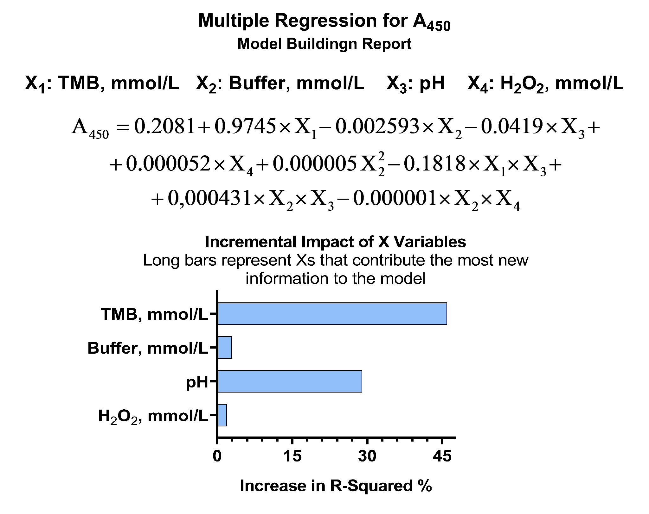
Fig. S1. Relative importance of factors influencing non-specific TMB oxidation. Data are presented as the relative contribution of each variable to the total variance in the regression model.

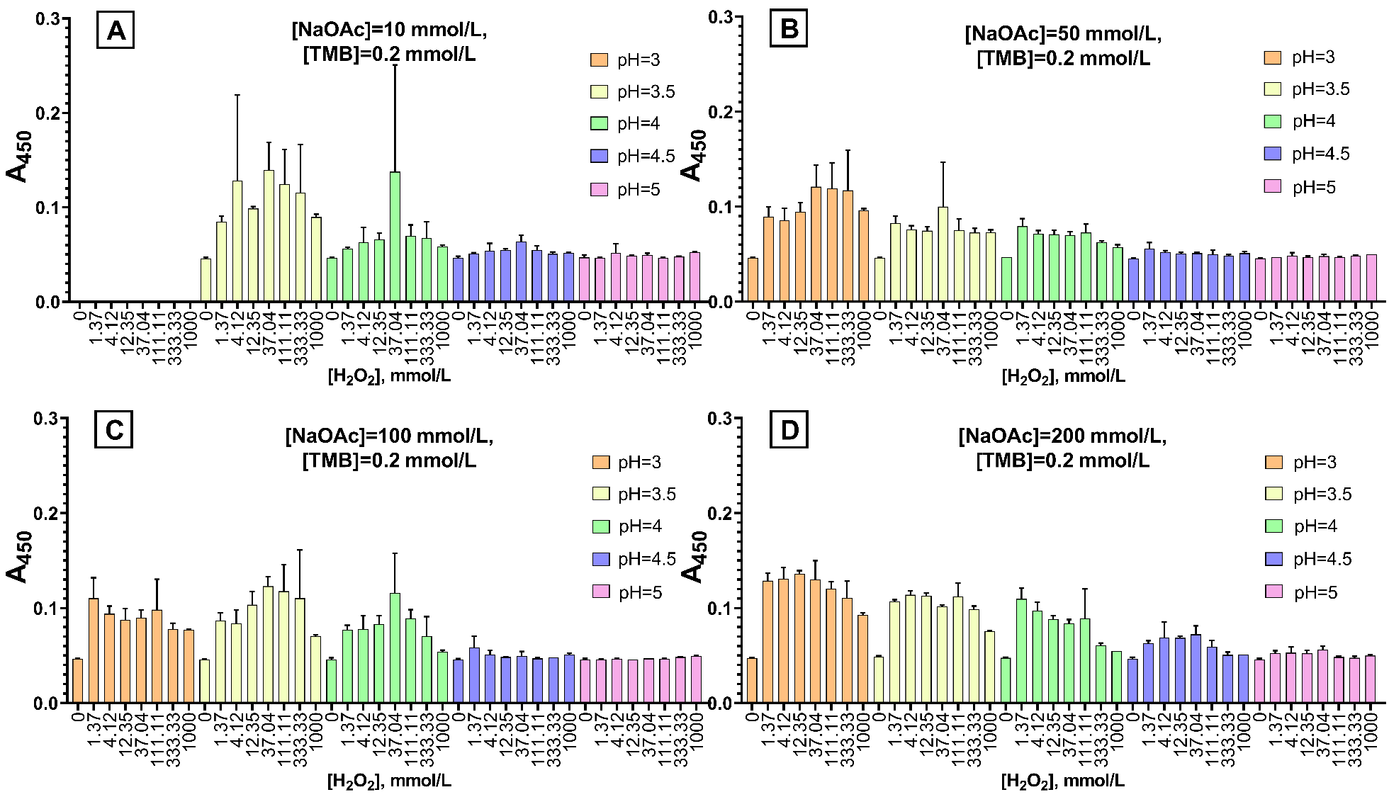
Fig. S2. The effect of buffer concentration on non-specific TMB oxidation. The influence of sodium acetate buffer molarity was tested at a fixed [TMB] of 0.2 mmol/L, [H₂O₂] of 100 mmol/L, pH 4.0, and 10% DMSO (v/v). Data are presented as the mean ± standard deviation (n = 3) for the following buffer concentrations: A 10 mmol/L, B 50 mmol/L, C 100 mmol/L, and D 200 mmol/L.

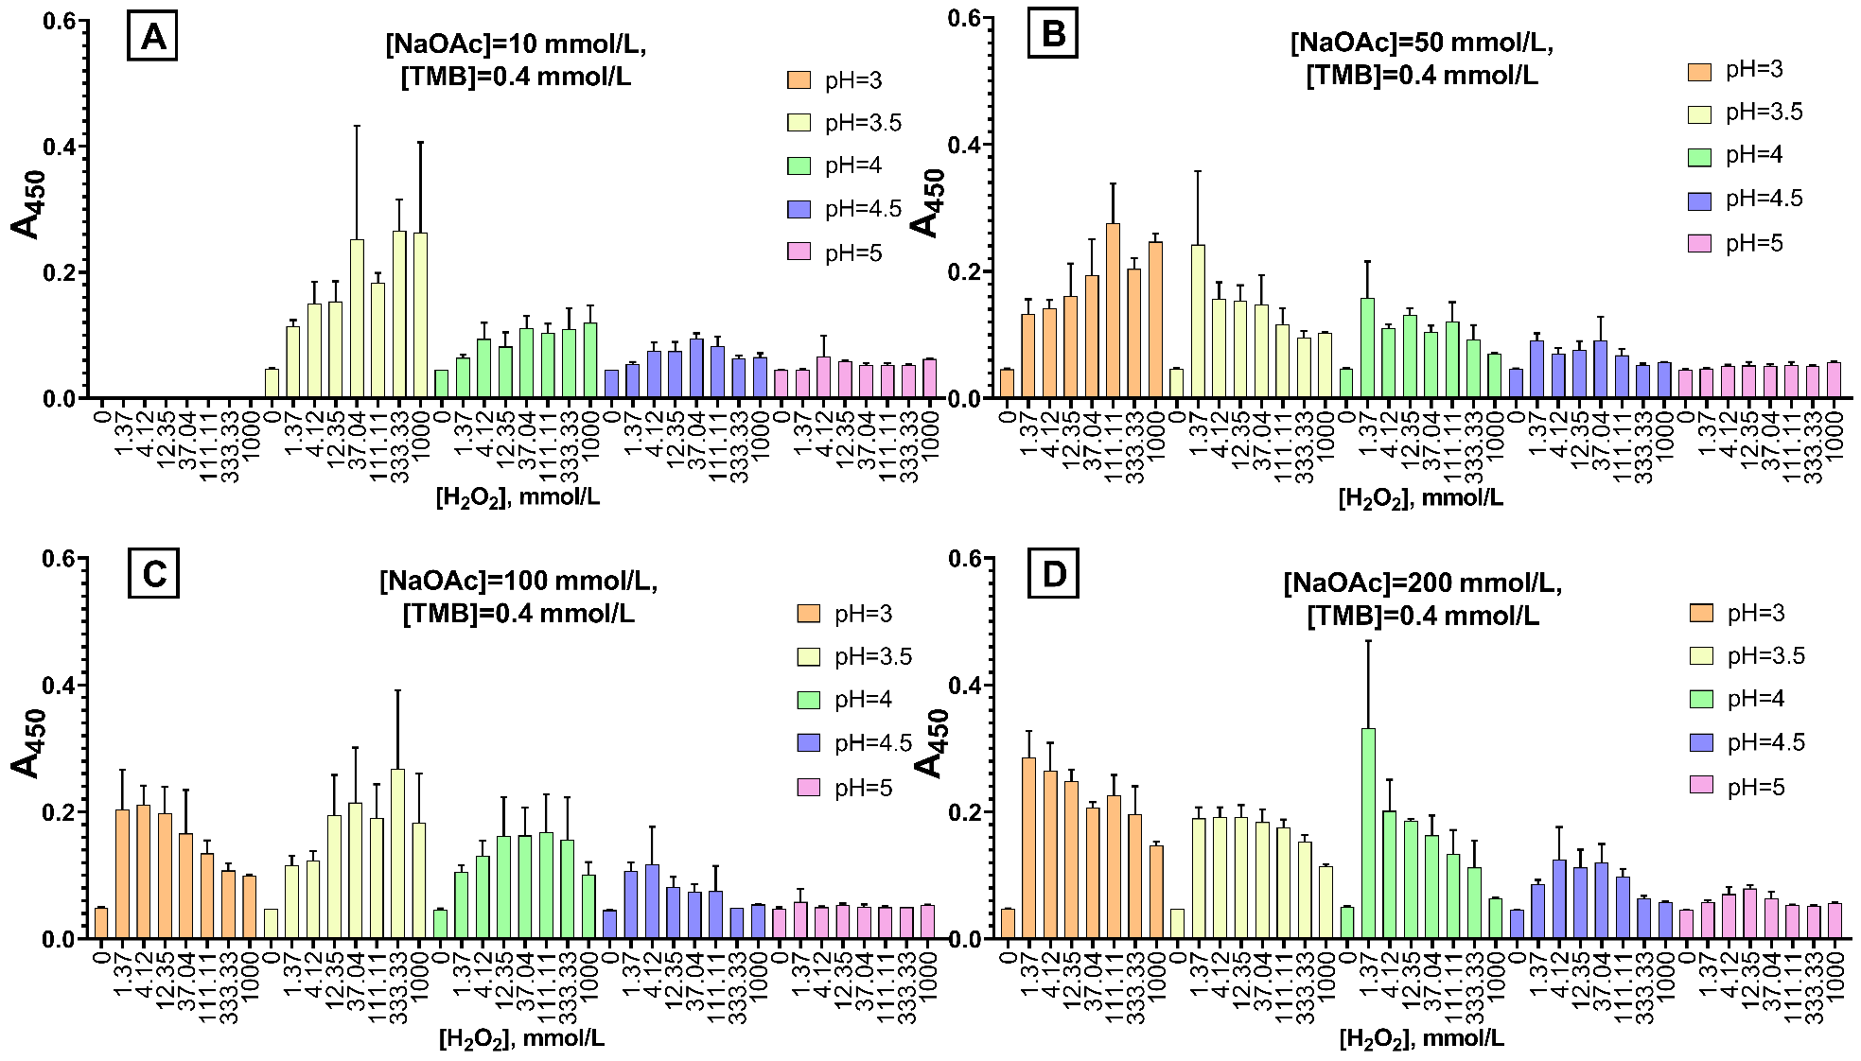
Fig. S3. The effect of buffer concentration on non-specific TMB oxidation. The influence of sodium acetate buffer molarity was tested at a fixed [TMB] of 0.4 mmol/L, [H₂O₂] of 100 mmol/L, pH 4.0, and 10% DMSO (v/v). Data are presented as the mean ± standard deviation (n = 3) for the following buffer concentrations: A 10 mmol/L, B 50 mmol/L, C 100 mmol/L, and D 200 mmol/L.

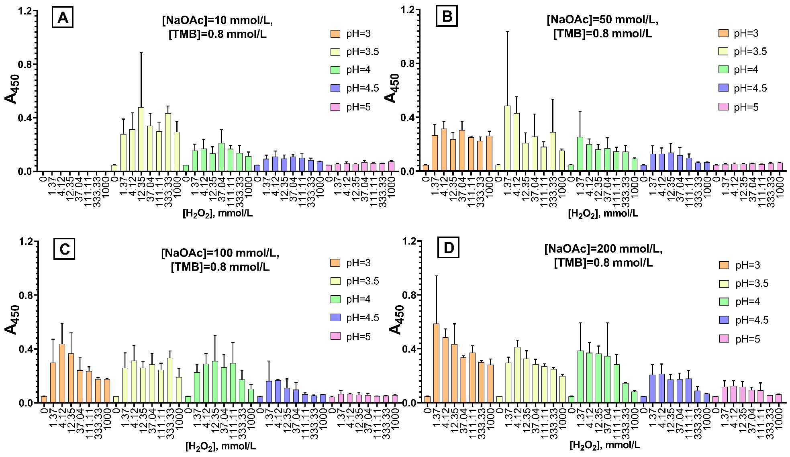
Fig. S4. The effect of buffer concentration on non-specific TMB oxidation. The influence of sodium acetate buffer molarity was tested at a fixed [TMB] of 0.8 mmol/L, [H₂O₂] of 100 mmol/L, pH 4.0, and 10% DMSO (v/v). Data are presented as the mean ± standard deviation (n = 3) for the following buffer concentrations: A 10 mmol/L, B 50 mmol/L, C 100 mmol/L, and D 200 mmol/L.

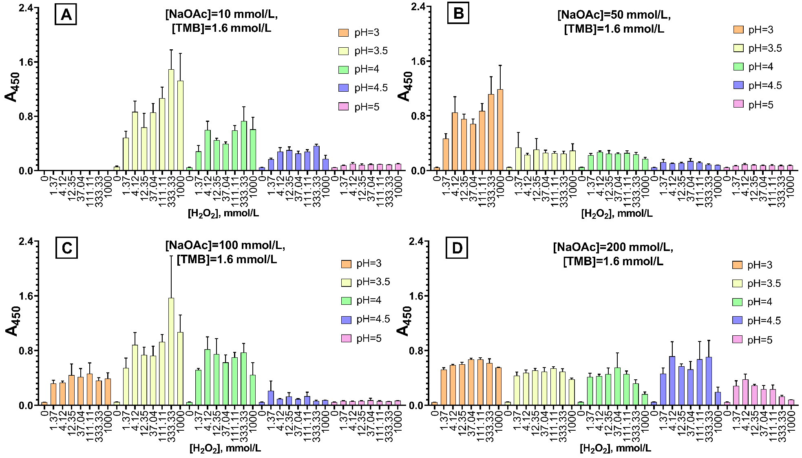
Fig. S5. The effect of buffer concentration on non-specific TMB oxidation. The influence of sodium acetate buffer molarity was tested at a fixed [TMB] of 1.6 mmol/L, [H₂O₂] of 100 mmol/L, pH 4.0, and 10% DMSO (v/v). Data are presented as the mean ± standard deviation (n = 3) for the following buffer concentrations: A 10 mmol/L, B 50 mmol/L, C 100 mmol/L, and D 200 mmol/L.

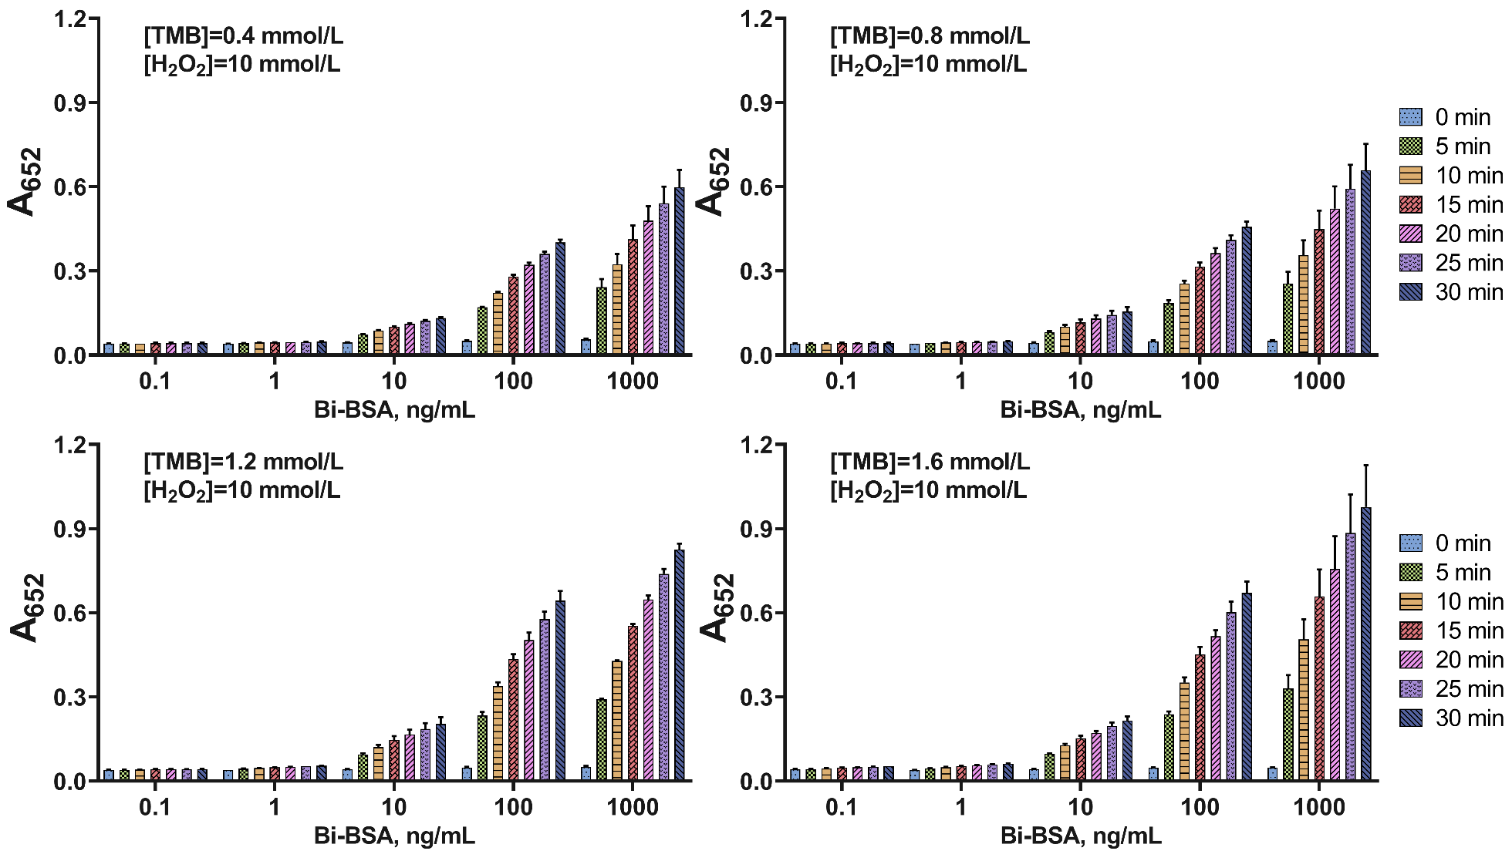
Fig. S6. Assay kinetics for the detection of Bi-BSA using Pt/Str conjugates. Signal intensity was recorded in 5-minute intervals after TMB addition. Composition of TMB solution: [TMB] = 0.4–1.6 mmol/L, [H₂O₂] = 10 mmol/L, 200 mmol/L Na-citrate buffer (pH 4.0), 10% DMSO (v/v). Data represent the mean ± SD (n = 3).

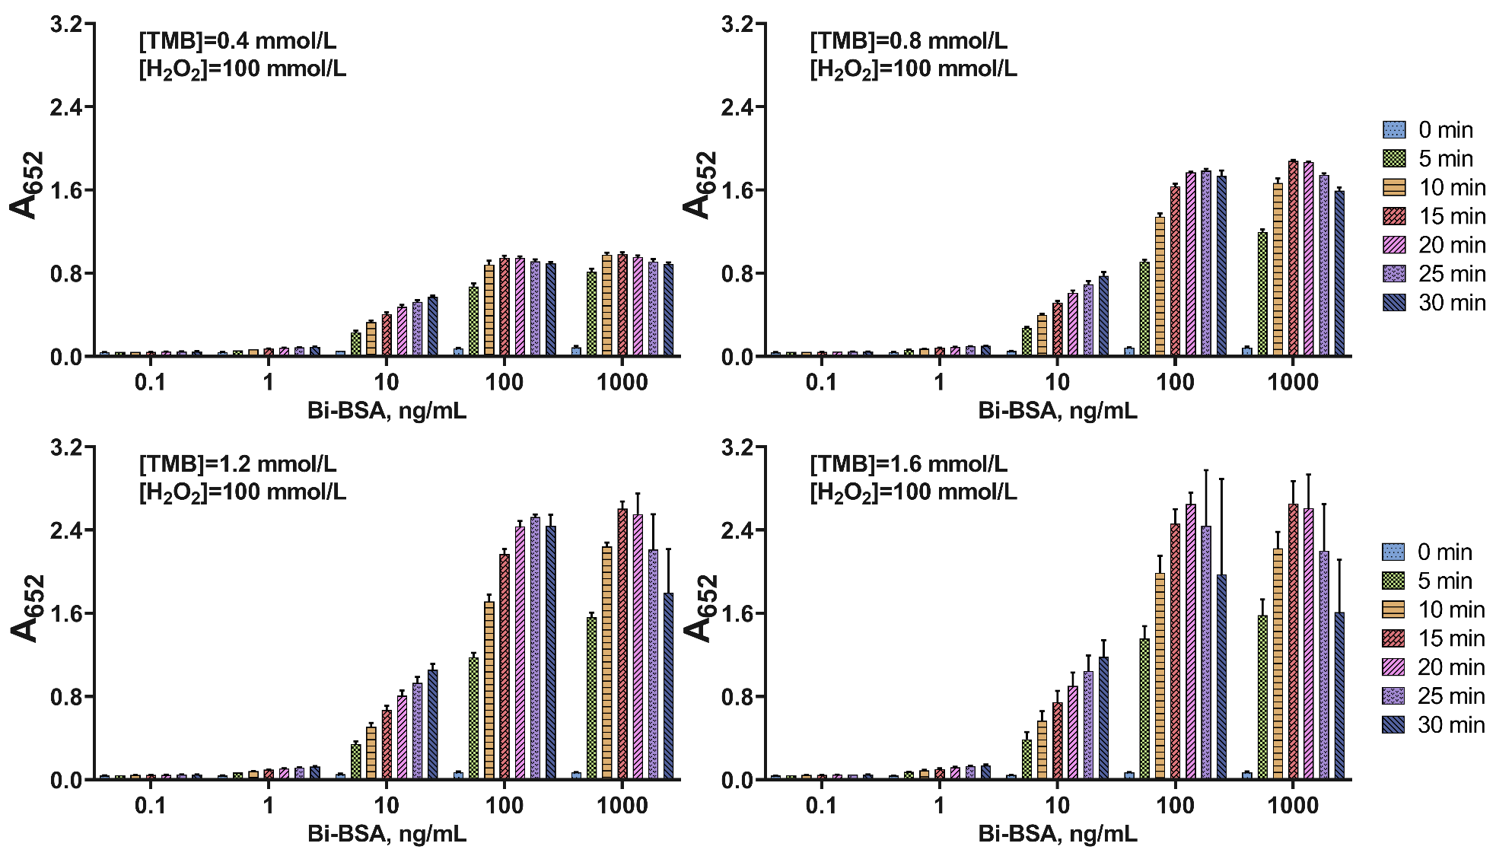
Fig. S7. Assay kinetics for the detection of Bi-BSA using Pt/Str conjugates. Signal intensity was recorded in 5-minute intervals after TMB addition. Composition of TMB solution: [TMB] = 0.4–1.6 mmol/L, [H₂O₂] = 100 mmol/L, 200 mmol/L Na-citrate buffer (pH 4.0), 10% DMSO (v/v). Data represent the mean ± SD (n = 3).

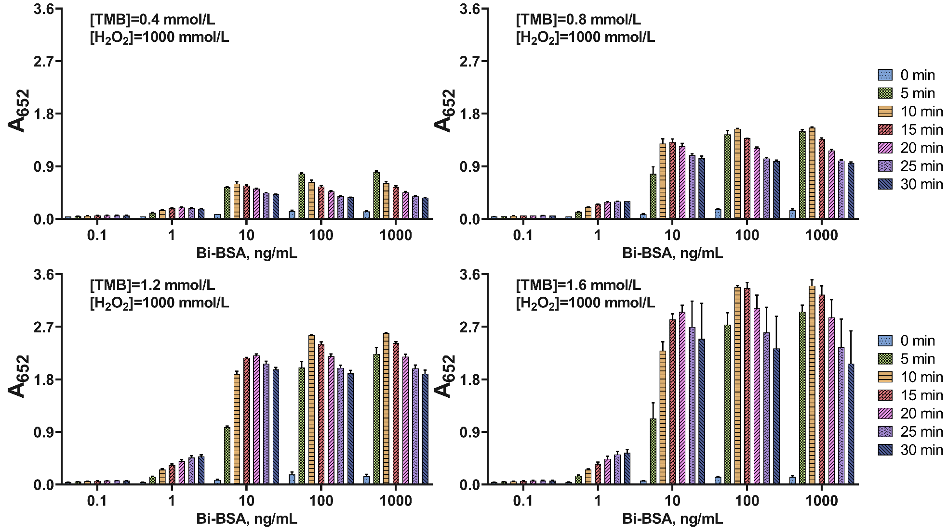

Fig. S8. Assay kinetics for the detection of Bi-BSA using Pt/Str conjugates. Signal intensity was recorded in 5-minute intervals after TMB addition. Composition of TMB solution: [TMB] = 0.4–1.6 mmol/L, [H₂O₂] = 1000 mmol/L, 200 mmol/L Na-citrate buffer (pH 4.0), 10% DMSO (v/v). Data represent the mean ± SD (n = 3).

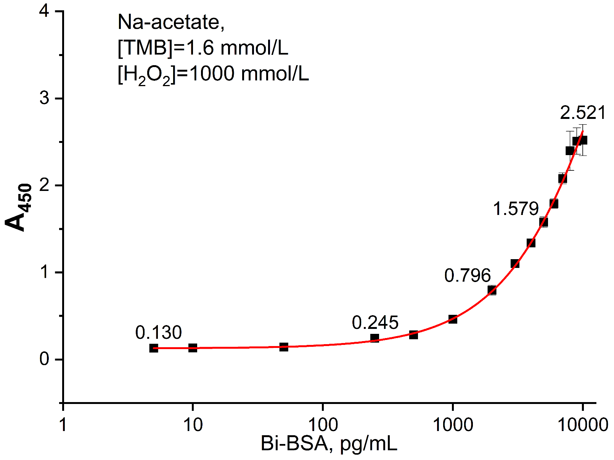
Fig. S9. Standard curve for the Bi-BSA assay. The curve was generated by fitting the calibration data to a four-parameter logistic model. The assay was performed under the following optimized reaction conditions: 100 mmol/L sodium acetate buffer (pH 4.0), [TMB] = 1.6 mmol/L, [H₂O₂] = 1000 mmol/L, and 10% DMSO (v/v). Data represent the mean ± standard deviation (n = 6).

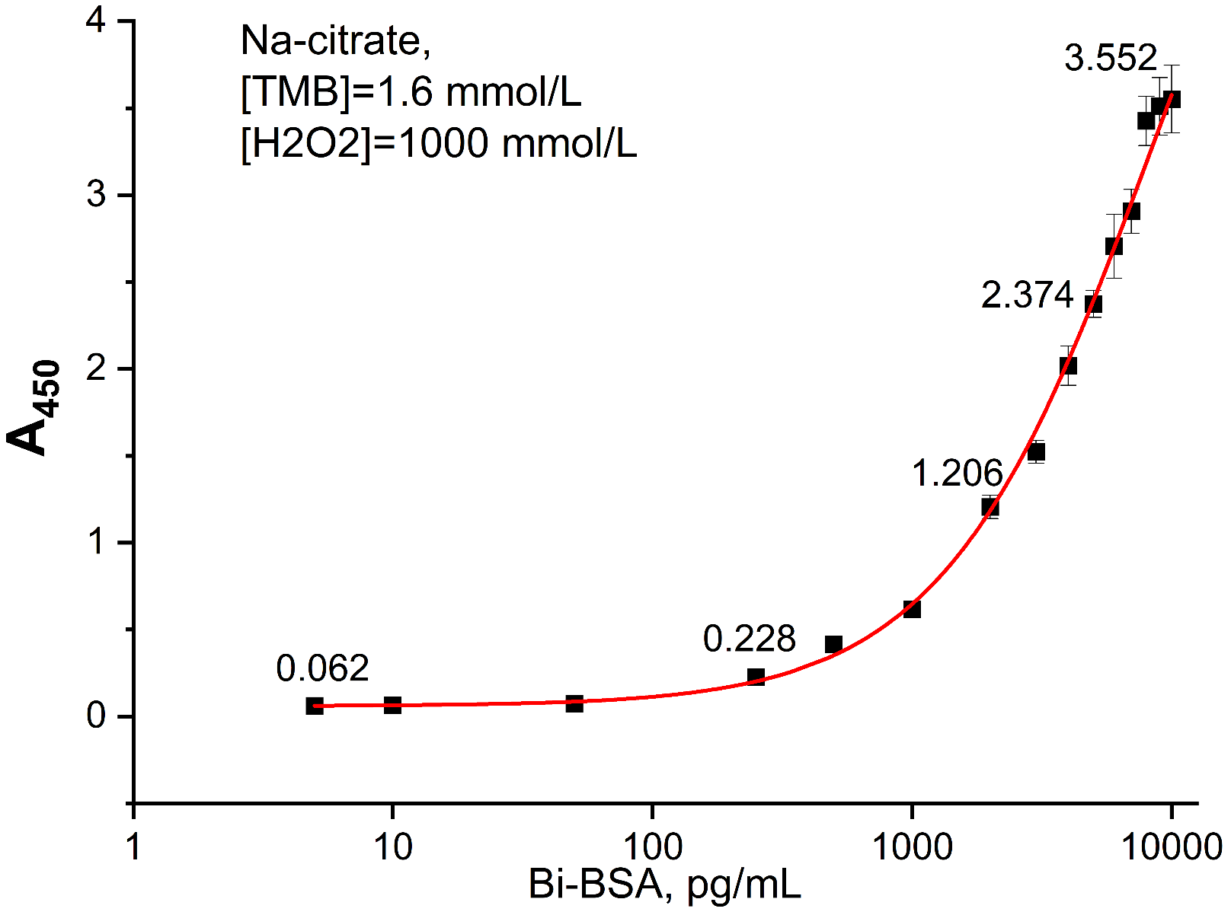
Fig. S10. Standard curve for the Bi-BSA assay. The curve was generated by fitting the calibration data to a four-parameter logistic model. The assay was performed under the following optimized reaction conditions: 100 mmol/L sodium citrate buffer (pH 4.0), [TMB] = 1.6 mmol/L, [H₂O₂] = 1000 mmol/L, and 10% DMSO (v/v). Data represent the mean ± standard deviation (n = 6).

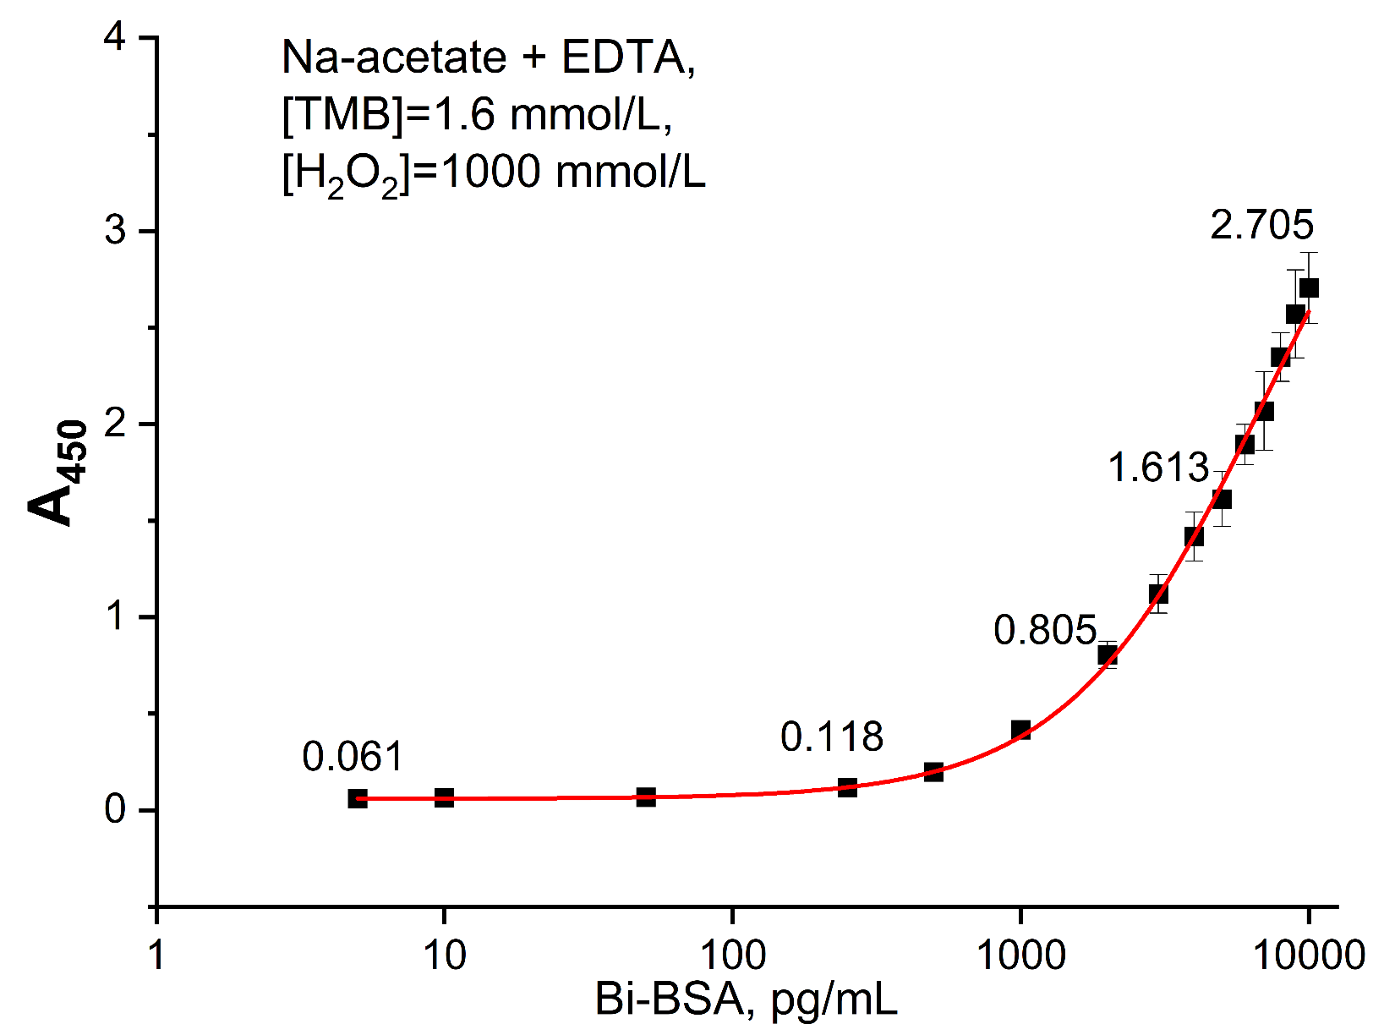
Fig. S11. Standard curve for the Bi-BSA assay. The curve was generated by fitting the calibration data to a four-parameter logistic model. The assay was performed under the following optimized reaction conditions: 100 mmol/L sodium acetate buffer (pH 4.0), [Na₂EDTA] = 100 μmol/L, [TMB] = 1.6 mmol/L, [H₂O₂] = 1000 mmol/L, and 10% DMSO (v/v). Data represent the mean ± standard deviation (n = 6).

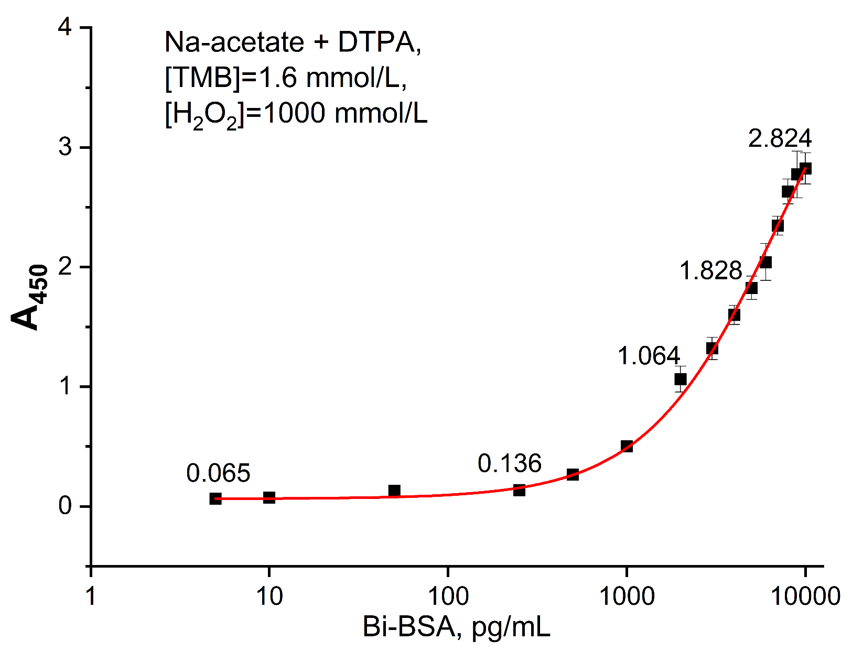
Fig. S12. Standard curve for the Bi-BSA assay. The curve was generated by fitting the calibration data to a four-parameter logistic model. The assay was performed under the following optimized reaction conditions: 100 mmol/L sodium acetate buffer (pH 4.0), [DTPA] = 100 μmol/L, [TMB] = 1.6 mmol/L, [H₂O₂] = 1000 mmol/L, and 10% DMSO (v/v). Data represent the mean ± standard deviation (n = 6).

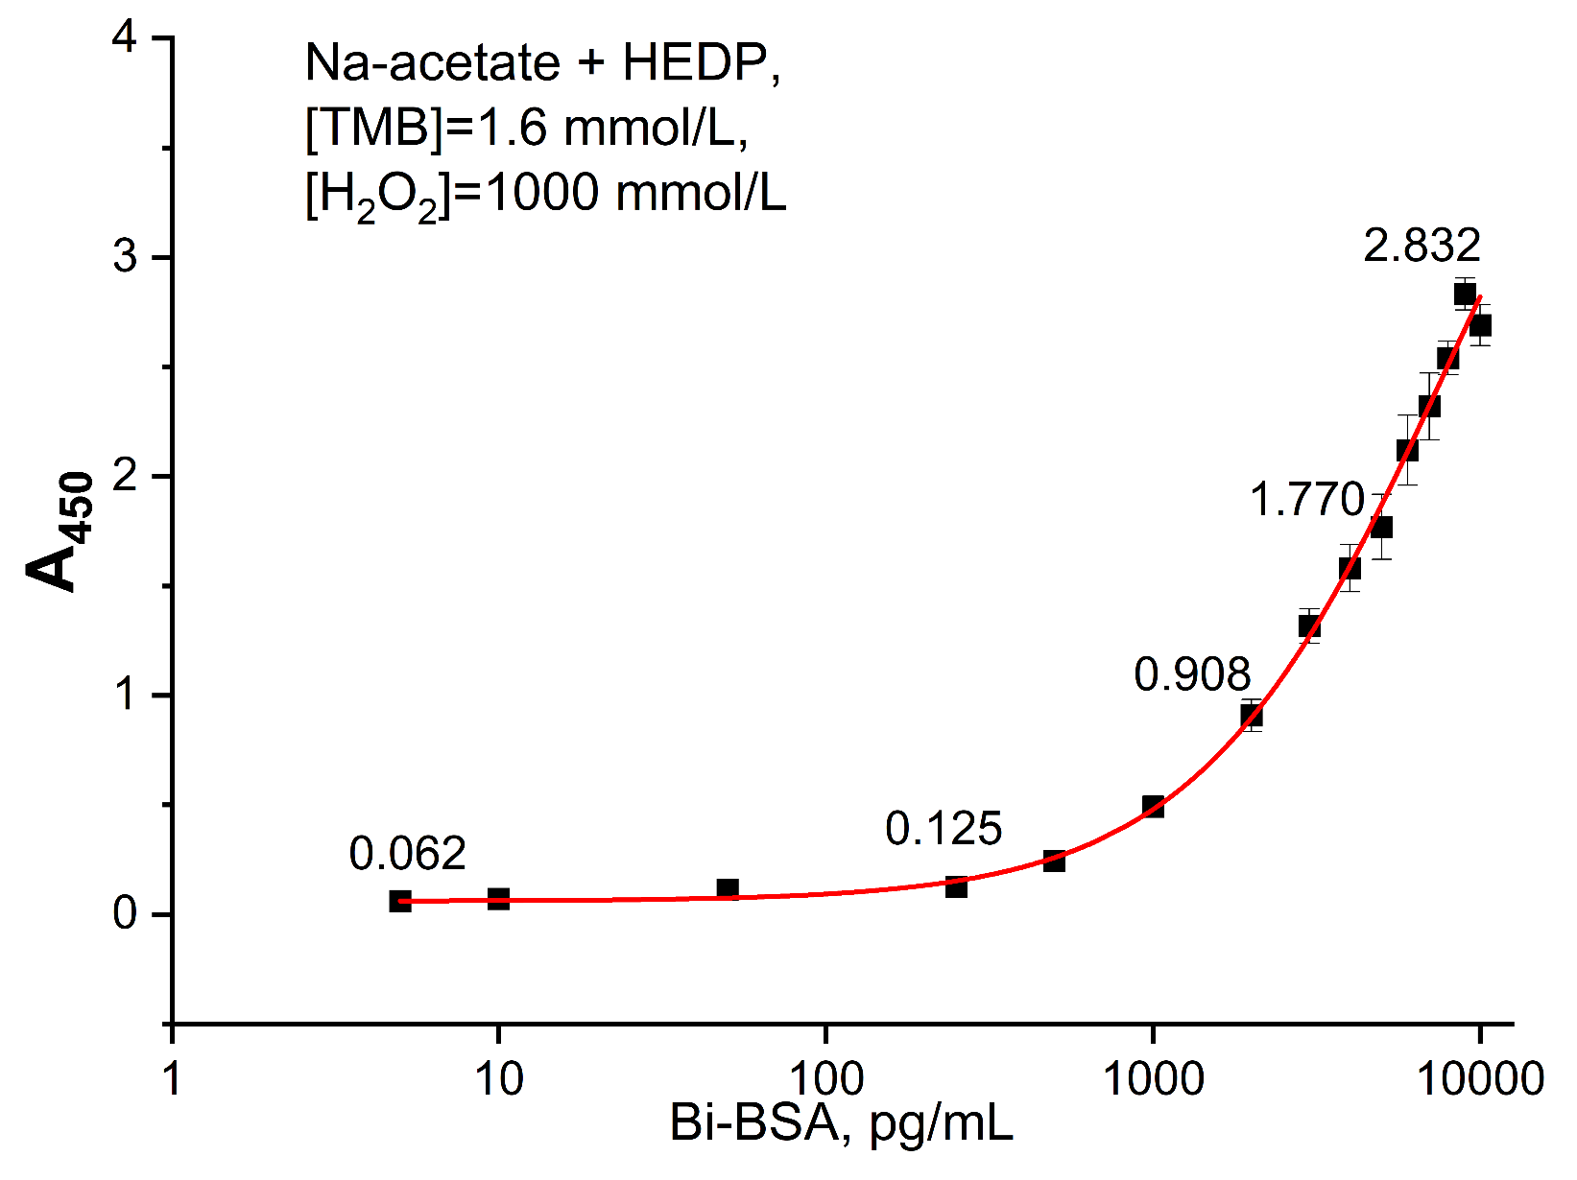
Fig. S13. Standard curve for the Bi-BSA assay. The curve was generated by fitting the calibration data to a four-parameter logistic model. The assay was performed under the following optimized reaction conditions: 100 mmol/L sodium acetate buffer (pH 4.0), [HEDP] = 100 μmol/L, [TMB] = 1.6 mmol/L, [H₂O₂] = 1000 mmol/L, and 10% DMSO (v/v). Data represent the mean ± standard deviation (n = 6).

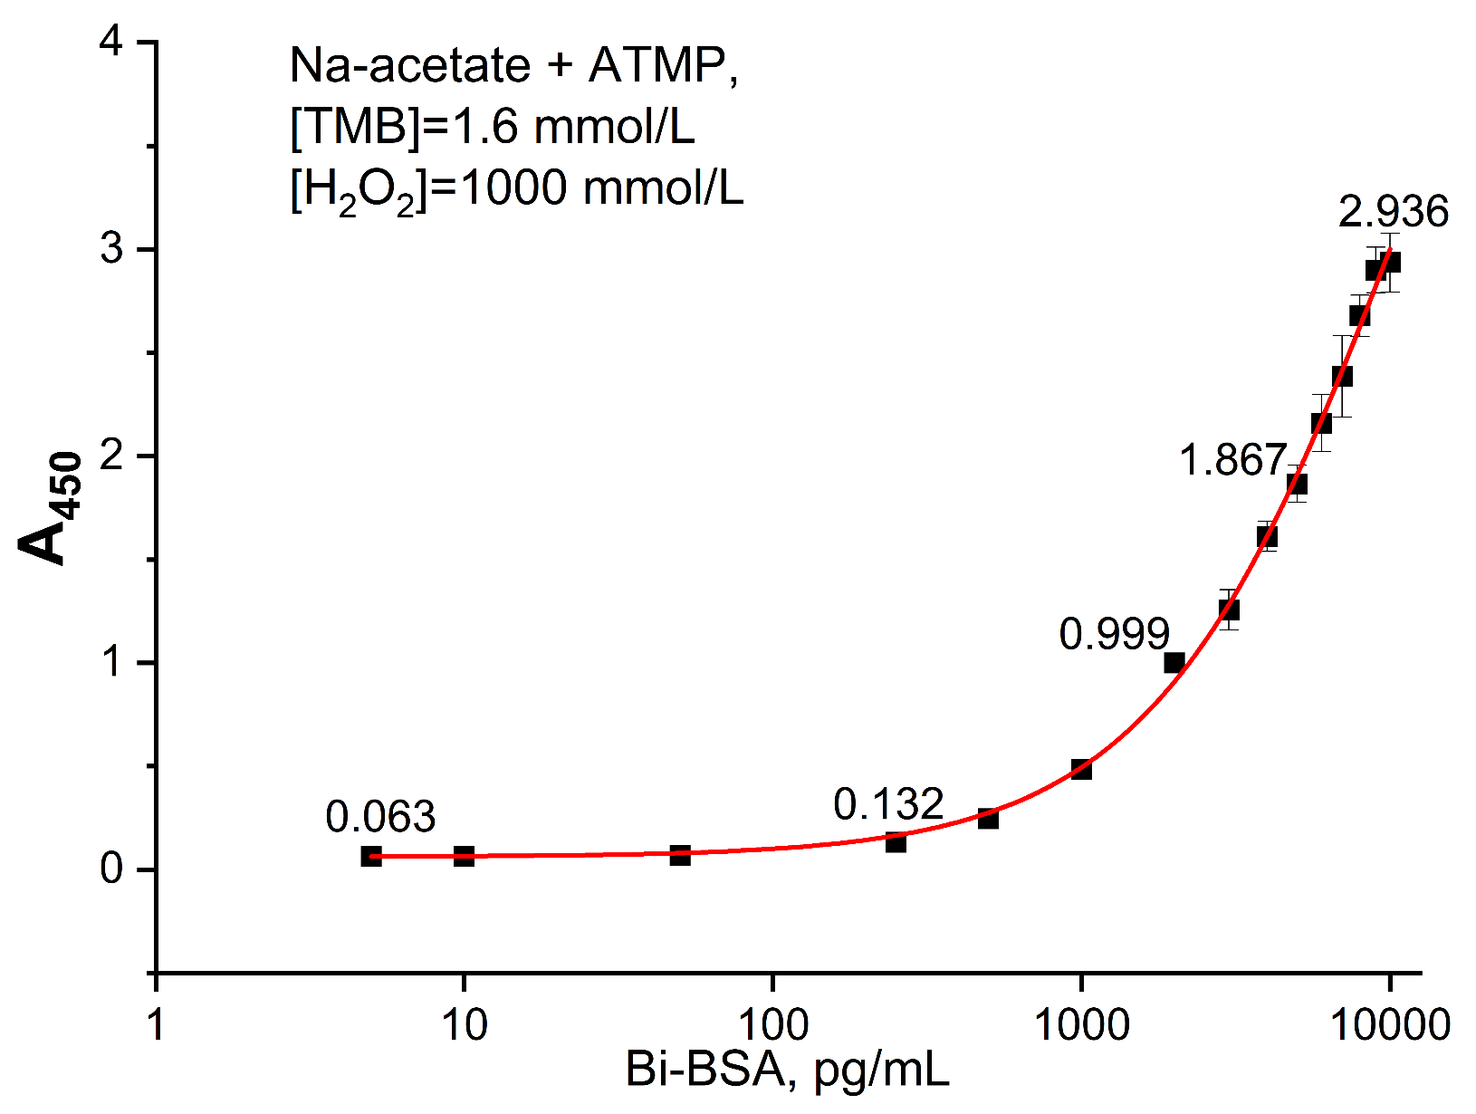
Fig. S14. Standard curve for the Bi-BSA assay. The curve was generated by fitting the calibration data to a four-parameter logistic model. The assay was performed under the following optimized reaction conditions: 100 mmol/L sodium acetate buffer (pH 4.0), [ATMP] = 100 μmol/L, [TMB] = 1.6 mmol/L, [H₂O₂] = 1000 mmol/L, and 10% DMSO (v/v). Data represent the mean ± standard deviation (n = 6).

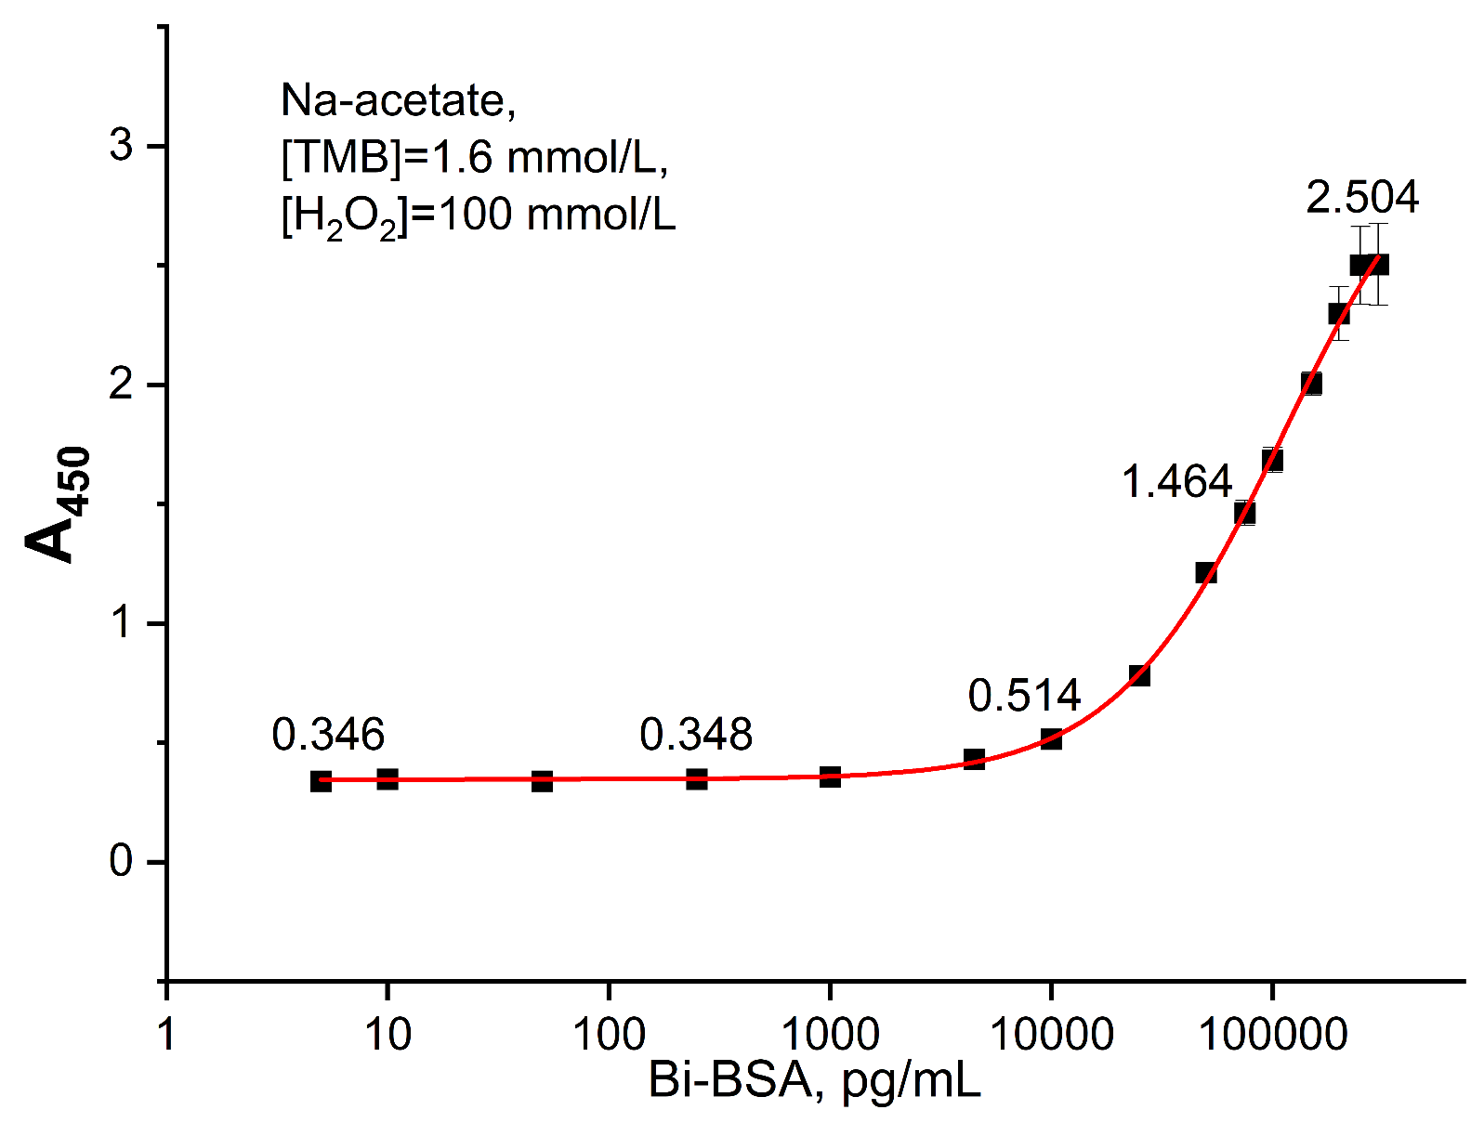

Fig. S15. Standard curve for the Bi-BSA assay. The curve was generated by fitting the calibration data to a four-parameter logistic model. The assay was performed under the following optimized reaction conditions: 100 mmol/L sodium acetate buffer (pH 4.0), [TMB] = 1.6 mmol/L, [H₂O₂] = 100 mmol/L, and 10% DMSO (v/v). Data represent the mean ± standard deviation (n = 6).

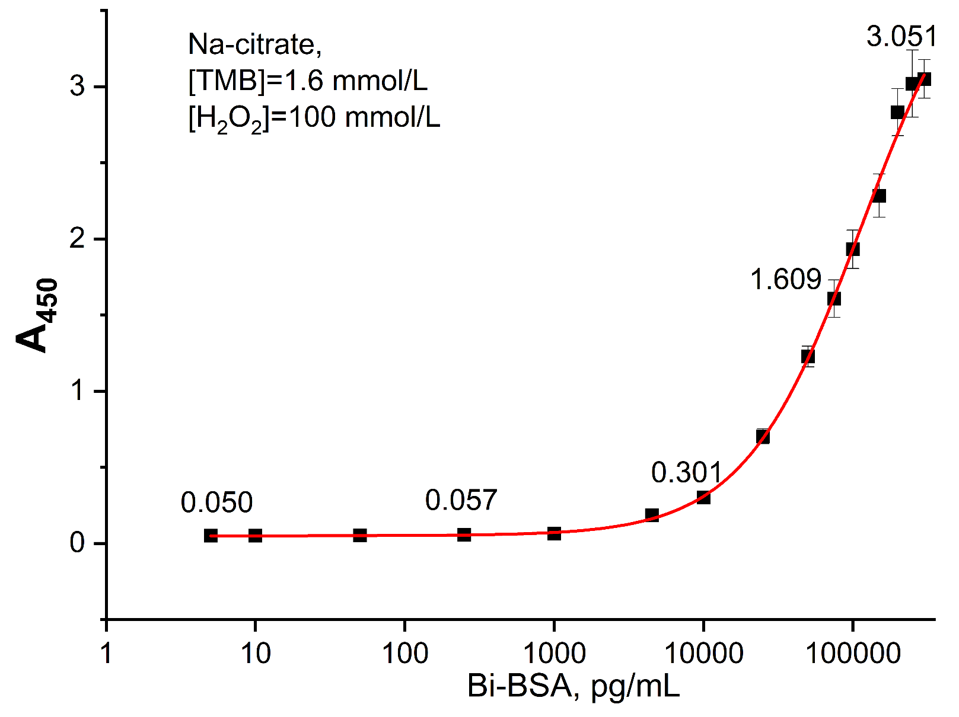
Fig. S16. Standard curve for the Bi-BSA assay. The curve was generated by fitting the calibration data to a four-parameter logistic model. The assay was performed under the following optimized reaction conditions: 100 mmol/L sodium citrate buffer (pH 4.0), [TMB] = 1.6 mmol/L, [H₂O₂] = 100 mmol/L, and 10% DMSO (v/v). Data represent the mean ± standard deviation (n = 6).

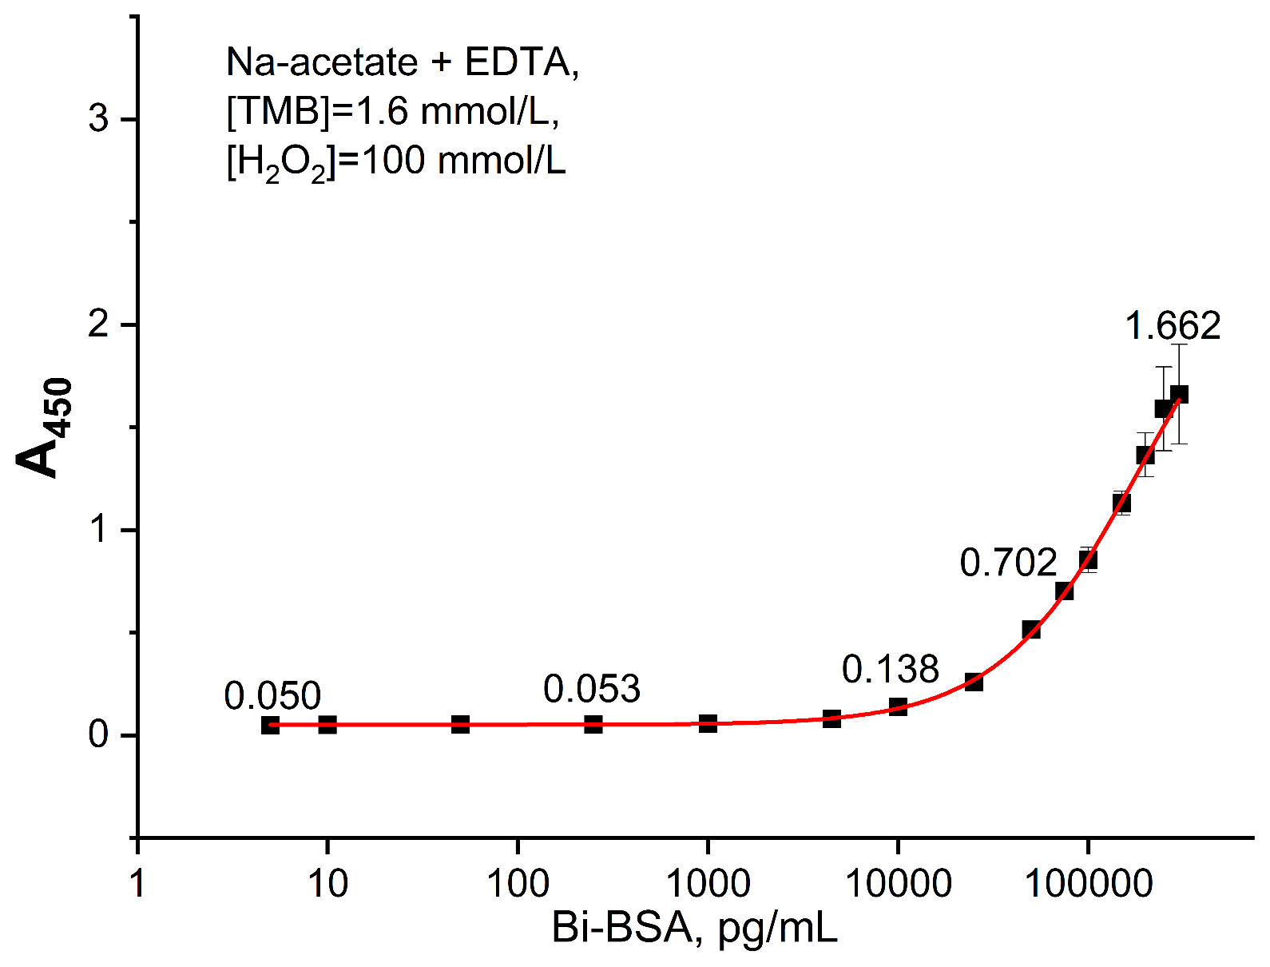
Fig. S17. Standard curve for the Bi-BSA assay. The curve was generated by fitting the calibration data to a four-parameter logistic model. The assay was performed under the following optimized reaction conditions: 100 mmol/L sodium acetate buffer (pH 4.0), [Na₂EDTA] = 100 μmol/L, [TMB] = 1.6 mmol/L, [H₂O₂] = 100 mmol/L, and 10% DMSO (v/v). Data represent the mean ± standard deviation (n = 6).

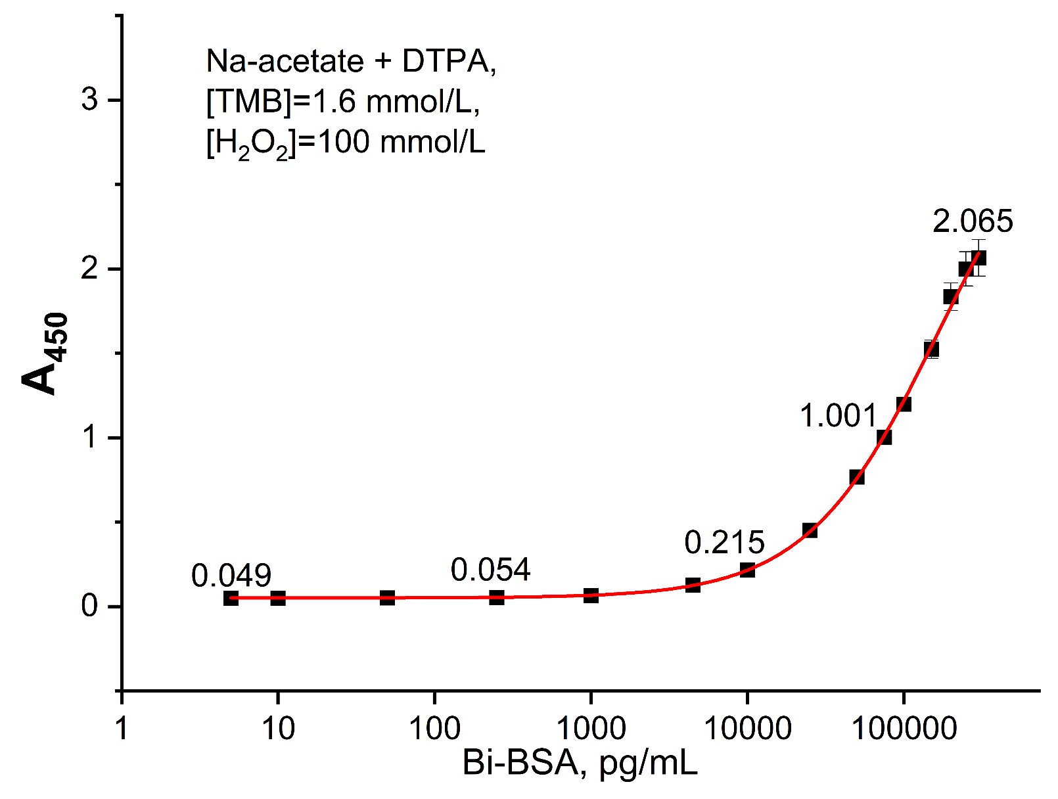
Fig. S18. Standard curve for the Bi-BSA assay. The curve was generated by fitting the calibration data to a four-parameter logistic model. The assay was performed under the following optimized reaction conditions: 100 mmol/L sodium acetate buffer (pH 4.0), [DTPA] = 100 μmol/L, [TMB] = 1.6 mmol/L, [H₂O₂] = 100 mmol/L, and 10% DMSO (v/v). Data represent the mean ± standard deviation (n = 6).

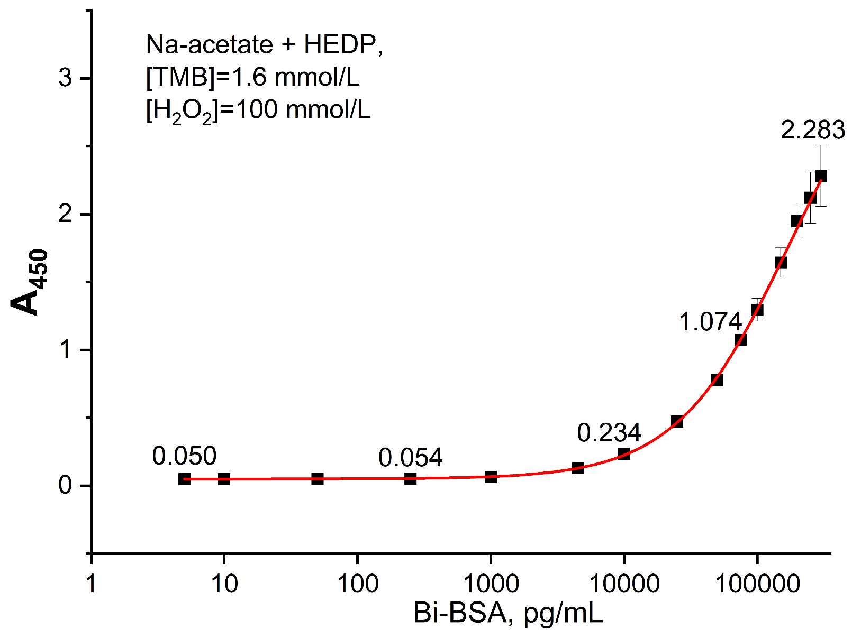
Fig. S19. Standard curve for the Bi-BSA assay. The curve was generated by fitting the calibration data to a four-parameter logistic model. The assay was performed under the following optimized reaction conditions: 100 mmol/L sodium acetate buffer (pH 4.0), [HEDP] = 100 μmol/L, [TMB] = 1.6 mmol/L, [H₂O₂] = 100 mmol/L, and 10% DMSO (v/v). Data represent the mean ± standard deviation (n = 6).

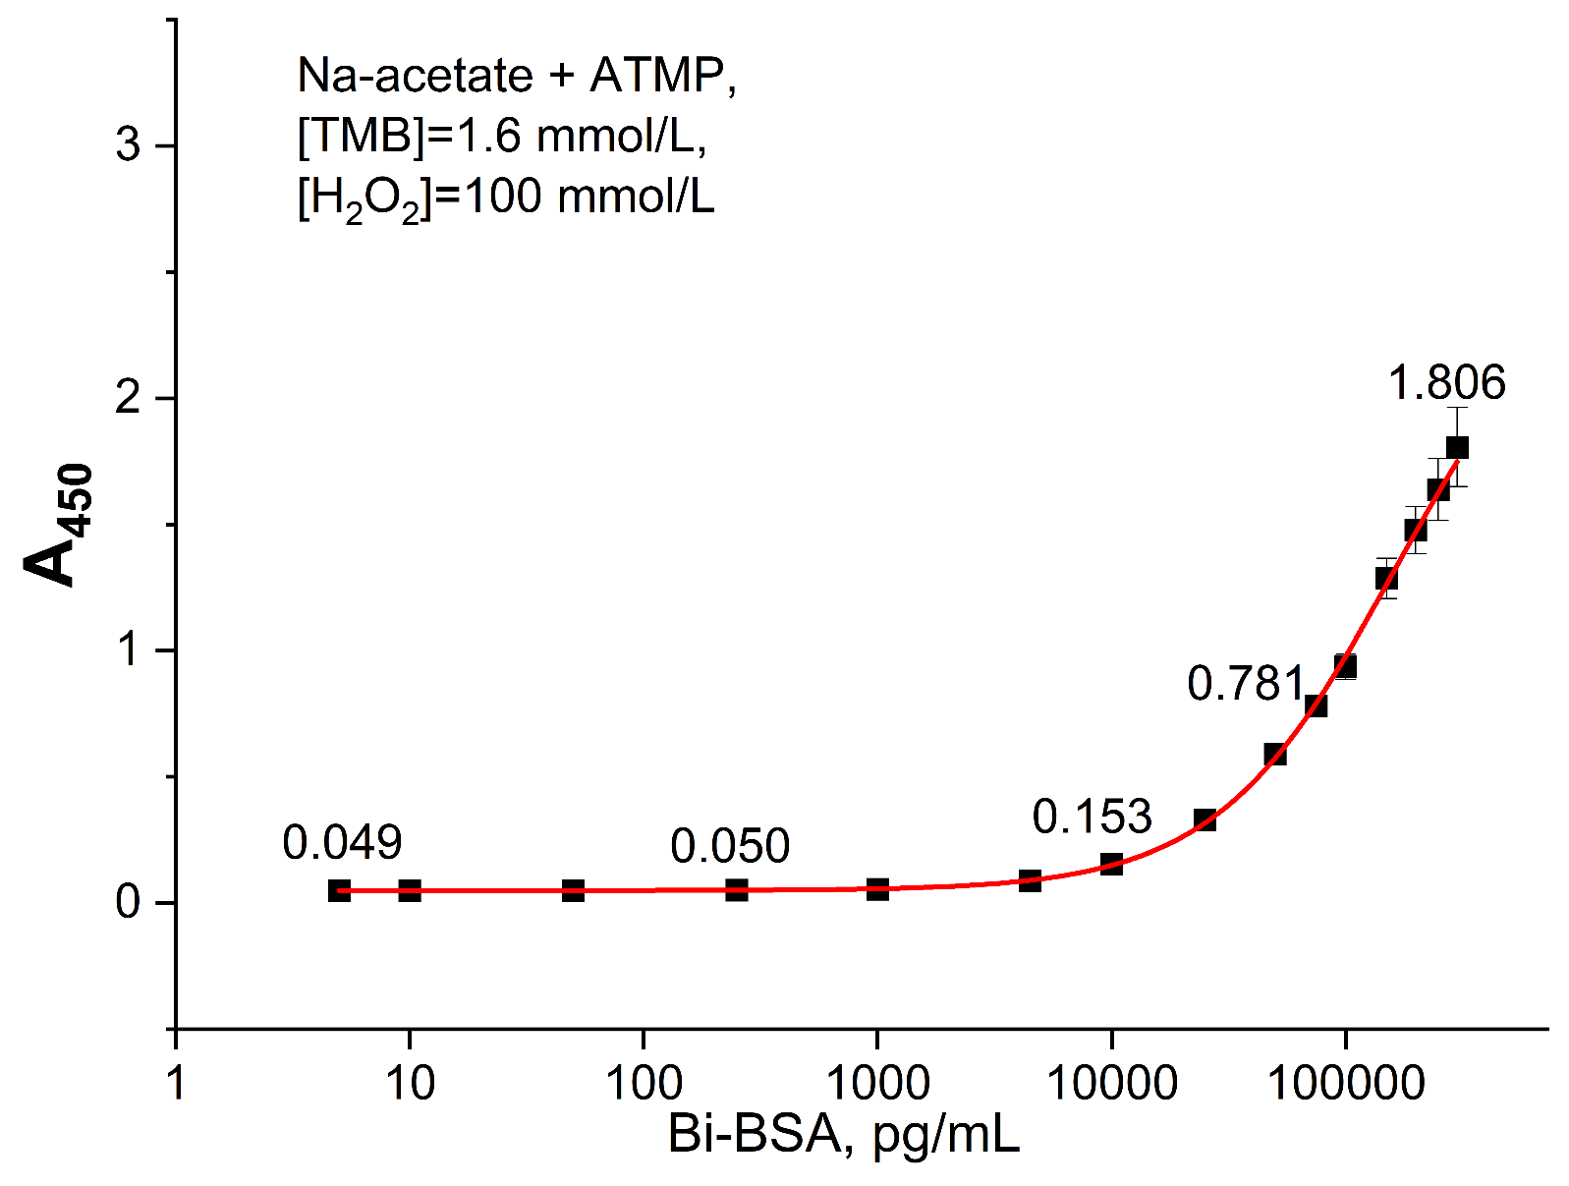
Fig. S20. Standard curve for the Bi-BSA assay. The curve was generated by fitting the calibration data to a four-parameter logistic model. The assay was performed under the following optimized reaction conditions: 100 mmol/L sodium acetate buffer (pH 4.0), [ATMP] = 100 μmol/L, [TMB] = 1.6 mmol/L, [H₂O₂] = 100 mmol/L, and 10% DMSO (v/v). Data represent the mean ± standard deviation (n = 6).

Supplementary Information The online version contains supplementary material available at https://doi.org/XXXXX

