Supplementary Figures
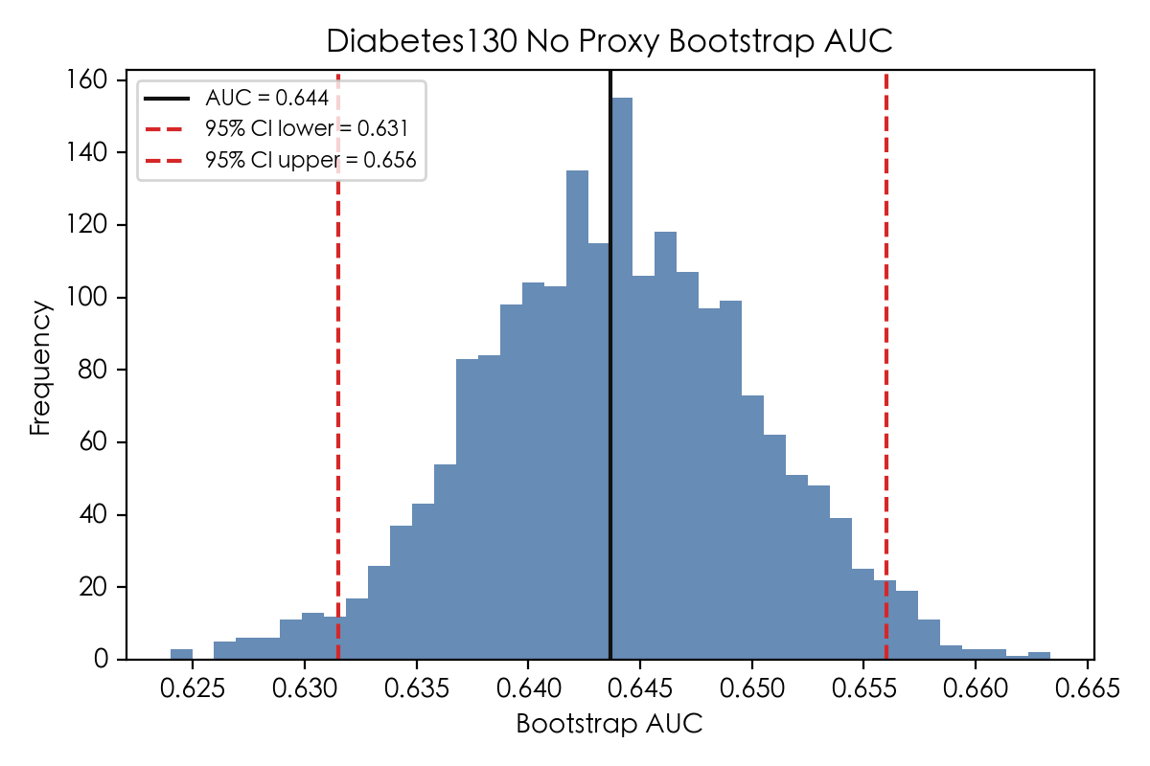
Supplementary Figure S1. Bootstrap distribution of the area under the receiver operating characteristic curve (AUC) for the primary model (main_no_proxy). The solid black line indicates the point estimate AUC (0.644). The dashed red lines indicate the 2.5th and 97.5th percentiles of the bootstrap distribution, corresponding to the 95% confidence interval (0.632 to 0.656). Bootstrap resampling was performed 2000 times on the held-out test set (n = 20,354) with replacement.

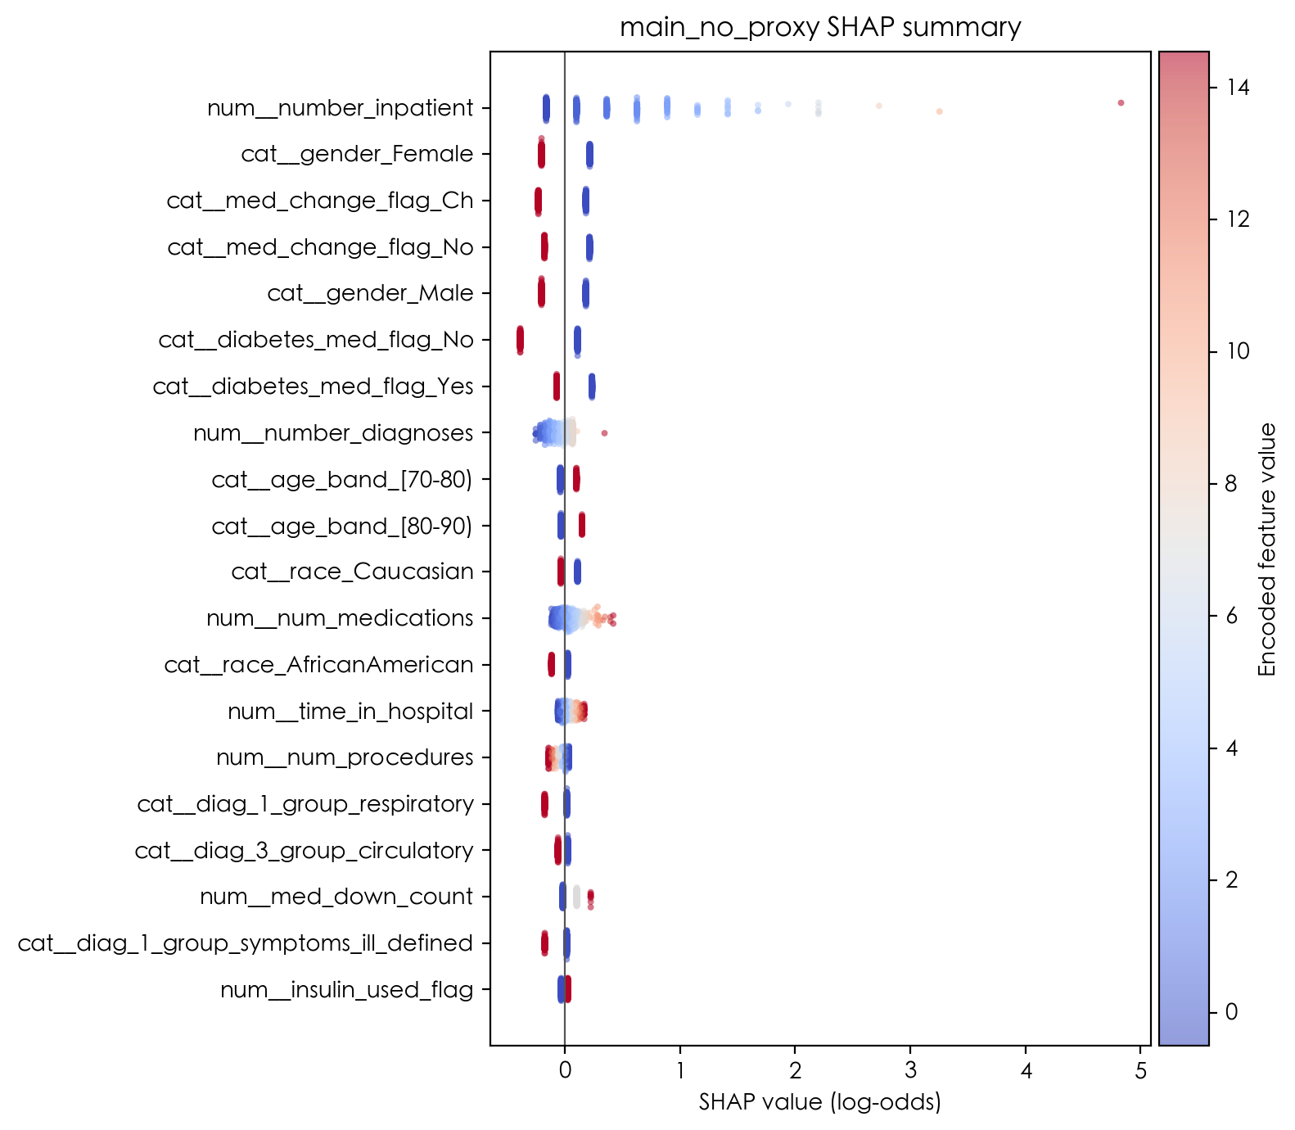
Supplementary Figure S2. SHAP summary plot (beeswarm) for the primary model showing the top 20 encoded features ranked by mean absolute SHAP value. Each dot represents a single patient in the test set sample (n = 2000). The horizontal position indicates the SHAP value (log-odds scale), with positive values increasing predicted readmission risk and negative values decreasing it. Color indicates the encoded feature value (red = high, blue = low). Prior inpatient admissions (num__number_inpatient) exhibited the widest SHAP value range, with higher values consistently associated with increased readmission risk. Note that categorical variables appear as separate one-hot encoded indicators (e.g., cat__gender_Female, cat__gender_Male); interpretation should be aggregated to the original variable level.

