Fluorescence-Gated Flow Cytometry Approach for Measuring Lipid Flippase Activity in Mammalian Cells
Klara T. Scholtissek¹ ² (0000-0002-2053-7572), Chris Van den Haute² ³ ⁴ (0000-0002-6650-3845), Filip K. Pamula*¹ ² (0000-0002-1765-8218), Joseph A. Lyons*¹ ² ⁵ (0000-0003-0218-4862)

¹ Department of Molecular Biology and Genetics, Aarhus Universitet, Aarhus, Denmark
²Aligning Science Across Parkinson’s (ASAP) Collaborative Research Network, Chevy Chase, MD, 20815
³ Laboratory for Neurobiology and Gene Therapy, KU Leuven, Leuven, Belgium
⁴ Leuven Viral Vector Core, KU Leuven, Leuven, Belgium
⁵ Interdisciplinary Nanoscience Center (iNANO), Aarhus Universitet, Aarhus, Denmark

email Joseph A. Lyons: lyons@inano.au.dk
email Filip Pamula: fpamula@mbg.au.dk

The Journal of Membrane Biology
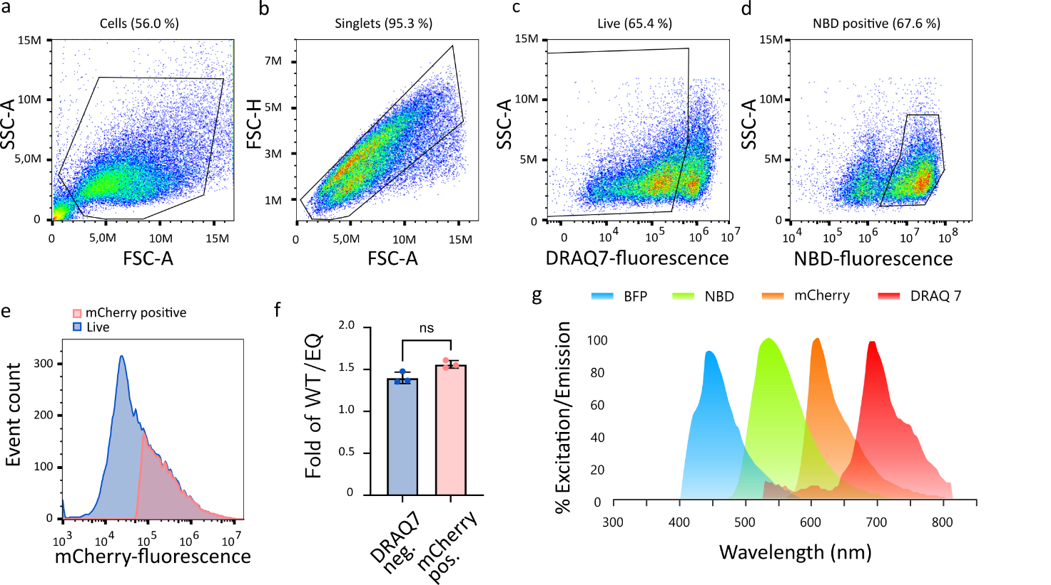
Supplementary Information

Supplementary Fig. 1 Classical gating strategy compared with expression-based gating for HeLa-CDC50A cells transfected with ATP11C-mCherry. (a) FSC-A vs SSC-A in million (M) dot plot showing all events measured and the cell gate (threshold FSC-A 150,000). (b) FSC-A vs FSC-H in million (M) dot plot showing all events from the cell gate (Cells) and the singlet gate (Singlets). (c) DRAQ7 fluorescence vs SSC-A fluorescence in million (M) of singlets with a live gate selecting DRAQ7 negative cells. (d) NBD-fluorescence of live cells vs SSC-A fluorescence in million (M) with NBD-positive gate. (e) Histogram of mCherry-fluorescence of live population (blue; 21,706 events) vs mCherry positive population, defined in Fig. 2b and c, (red; 8,465 events). f: Fold of NBD-PS uptake by HeLa-CDC50A cells transfected with ATP11C-mCherry over ATP11C-EQ-mCherry. Comparison between DRAQ7 negative population (blue) and mCherry positive population (red) with a paired student’s t test performed. Significance is indicated by asterisks, ns p>0.05, N=3. (g) Emission spectra of the four fluorophores used in the experimental set up.
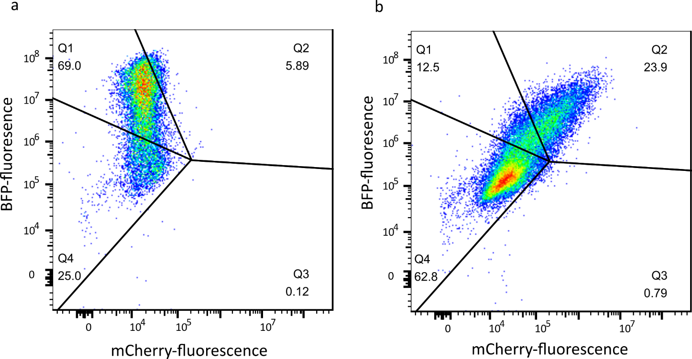
Supplementary Fig. 2 Gating strategy to select cells expressing the targets of interest. Dot plots of DRAQ7-negative events with mCherry-fluorescence (x-axis) vs BFP-fluorescence (y-axis), using the same quadrant gating strategy as in Fig. 3. Samples shown are: a) VAMP3-BFP, b) ATP11C-mCherry + VAMP3-BFP.

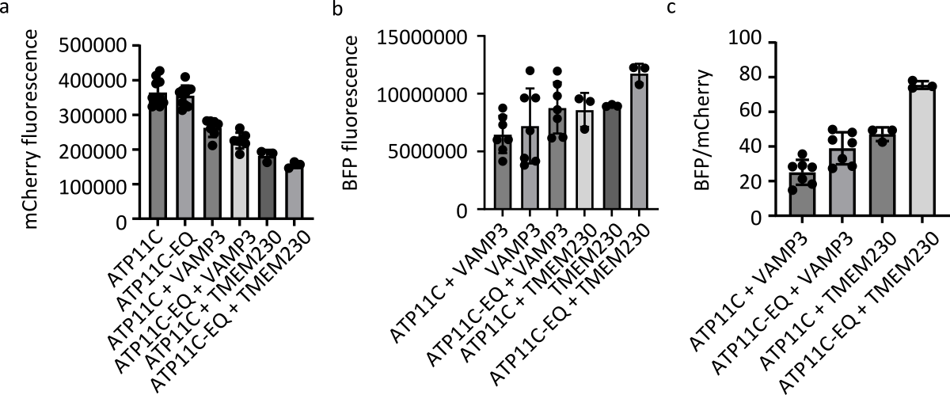
Supplementary Fig. 3 Expression of ATP11C-mCherry in comparison to VAMP3-BFP and BFP-TMEM230 within the expression gate. Analysis was performed on DRAQ7‑negative events within the expression gate defined in Fig. 3. a: Median mCherry-A fluorescence intensity. b: Median BFP-A fluorescence intensity. c: Ratio of BFP over mCherry fluorescence for the indicated conditions.

Supplementary Table 1 Overview of plasmids used and generated in this study.
Plasmid name | Plasmid backbone | Insert | Reference
N-mCherry-TMEM230 | pcDNA3.1 | TMEM230 N-terminally tagged with mCherry | This work
C-mCherry-TMEM230 | pcDNA3.1 | TMEM230 C-terminally tagged with mCherry | This work
N-BFP-TMEM230 | pcDNA3.1 | TMEM230 N-terminally tagged with BFP | This work
C-BFP-TMEM230 | pcDNA3.1 | TMEM230 C-terminally tagged with BFP | This work
C-BFP-VAMP3 | pcDNA3.1 | VAMP3 C-terminally tagged with BFP | This work
ATP11C-mCherry | pcDNA3.1 | ATP11C C-terminally tagged with mCherry | This work
ATP11C-EQ-mCherry | pcDNA3.1 | ATP11C E184Q mutant C-terminally tagged with mCherry | This work
pEGFP VAMP3 | pEGFP-C3 | VAMP3 | Ref PubMed 9614185 [1]
pCAG/ATP11C-HA | pCAG | ATP11C C-terminally HA tagged | Ref PubMed 21914794 [2]
pCAG/ATP11C(E184Q)-HA | pCAG | ATP11C(E184Q) C-terminally HA tagged | Ref PubMed 21914794 [2]

Supplementary Table 2 Overview of primers used in this study.
Name | Target | Sequence
Oligo1 | BFP ORF | 5’-GAATTCAGCGAGCTGATTAAG-3’
Oligo2 | BFP ORF | 5’-GCCATTAAGTTTGTGCCC-3’
Oligo3 | BFP ORF | 5’-GAATTCAGCGAGCTGATTAAG-3’
Oligo4 | BFP ORF | 5’- GAATTCATTAAGTTTGTGCCC-3’
Oligo5 | N-mCherry-TMEM230 | 5’-GCACAAACTTAATGGCGGCGGAAGCAG-3’
Oligo6 | N-mCherry-TMEM230 | 5’-CTTAATCAGCTCGCTGAATTCGCCGCTGCTG-3’
Oligo7 | C-mCherry-TMEM230 | 5’-GCACAAACTTAATGAATTCGGCAGCGGTAG-3’
Oligo8 | C-mCherry-TMEM230 | 5’-CTTAATCAGCTCGCTGAATTCGCCGGAGCTG-3’
Oligo9 | pEGFP plasmid | 5’- CCAAGCTGGCTAGCGGATCCATGTCTACAGGTCC -3’
Oligo10 | pEGFP plasmid | 5’-ATAGCACCTCCAGGGCGCCTGAAGAGACAACCC --3’

Supplementary Table 3 Overview of fluorophores and the lasers used to excite them in combination with the filters used for detection on NovoCyte Quanteon Flow Cytometer.
Fluorophore | Laser Wavelength used for excitation | Filter used for detection
Blue-fluorescent protein (BFP) | 405nm | 445/45nm
7‑nitrobenz‑2‑oxa‑1,3‑diazol‑4‑yl (NBD) | 488nm | 530/30nm
mCherry | 561nm | 615/20nm
DRAQ7 | 637nm | 725/40nm

References
- Galli, T., A. Zahraoui, V.V. Vaidyanathan, et al., (1998) A novel tetanus neurotoxin-insensitive vesicle-associated membrane protein in SNARE complexes of the apical plasma membrane of epithelial cells. Mol Biol Cell. 9(6): 1437–48. https://doi.org/10.1091/mbc.9.6.1437
- Takatsu, H., K. Baba, T. Shima, et al., (2011) ATP9B, a P4-ATPase (a putative aminophospholipid translocase), localizes to the trans-Golgi network in a CDC50 protein-independent manner. J Biol Chem. 286(44): 38159–38167. https://doi.org/10.1074/jbc.M111.281006

