Molecular Characterization and In Vitro Lytic Activity of LysLm680, an Endolysin Derived from Temperate Listeria Phages
Fatma Neslihan ÖZDEMİR, İrem AYAN, Ayşenur YÜCEFAYDALI, Segâh YETİŞKİN, Filiz YENİKÖYLÜ, Yeşim SOYER
ªDepartment of Food Engineering, Faculty of Engineering, Middle East Technical University, Ankara, Türkiye
*Corresponding author: Yeşim SOYER (E-mail: ysoyer@metu.edu.tr)
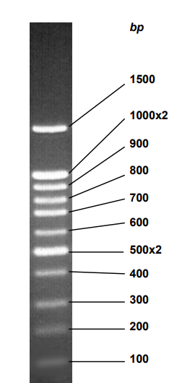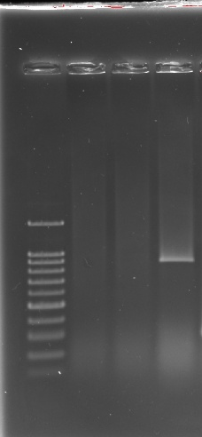
1 2 3 4
Fig. S1 PCR gel image performed to validate transformants containing the endolysin gene region. The following wells contain the PCR product for pET28a(+) + LysLm680: 1: Ladder; 2: PZR Negative Control; 3: Negative (untransformed) transformant; 4: Positive transformant.

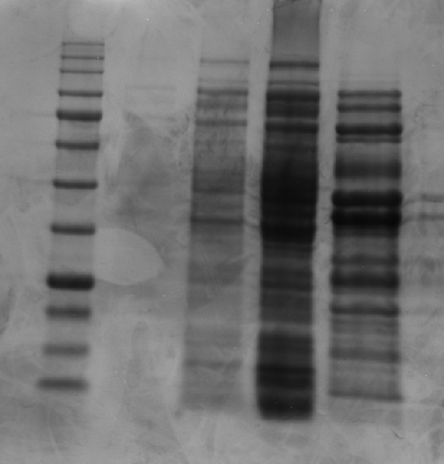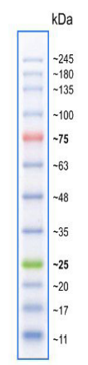
1 2 3 4 5
Fig. S2 SDS–PAGE analysis of LysLm680 expression and purification. 1: protein ladder; 2: non-induced E. coli Lemo21(DE3) cell lysate; 3: IPTG-induced E. coli Lemo21(DE3) cell lysate; 4: clarified lysate of IPTG-induced E. coli Lemo21(DE3); 5: purified LysLm680.

