SUPPLEMENTAL INFORMATION

Figure S1: Additional measures in mice, related to Figure 2

Additional measures in mice from the 3 independent experiments described in Figure 2. (A) Body weight. (B) Liver weight. (C) Intestinal length. (D) Intestinal cholesterol concentration. (E) Intestinal triglycerides concentration.

For mice force-fed cholecalciferol at 0.84 mg/kg: (F) cholecalciferol measured in intestinal segments at the end of the postprandial phase; (G) cholecalciferol total intestinal content.; (H) Plasma cholecalciferol was monitored up to 6h after force-feeding; (I) area under the curve of cholecalciferol postprandial plasma responses; (J) Postprandial plasma cholecalciferol responses corrected by plasma lipids (triglycerides + cholesterol), (K) Area under the curve of cholecalciferol postprandial responses after correction by lipids; (L) Hepatic cholecalciferol measured at the end of the postprandial phase; (M) Gene expression in intestinal segments; (N) Hepatic and (O) Plasma calcifediol concentrations in mice force-fed cholecalciferol.

Data are presented as means ± SEM. For each independent experiment: Unpaired two-tailed t-test for A, B, C, G and L and one-tailed for I and K. Geisser-Greenhouse corrected Repeated Measures Two-way ANOVA with Šidák’s multiple comparison test for D, E, F, H, J, M, N and O. Ns non-significant, *p < 0.05, **p < 0.01, ***p < 0.001 and ****p < 0.0001. For panel P, are reported p-values associated with main effects Intestinal Segment (S) and Control or AI-3d Groups (AI), no significant interaction was detected for each gene in each experiment. Asterisks or values close to *p < 0.05 significance reported in the Heatmap corresponds to differences between Control and AI-3d Group in one segment.

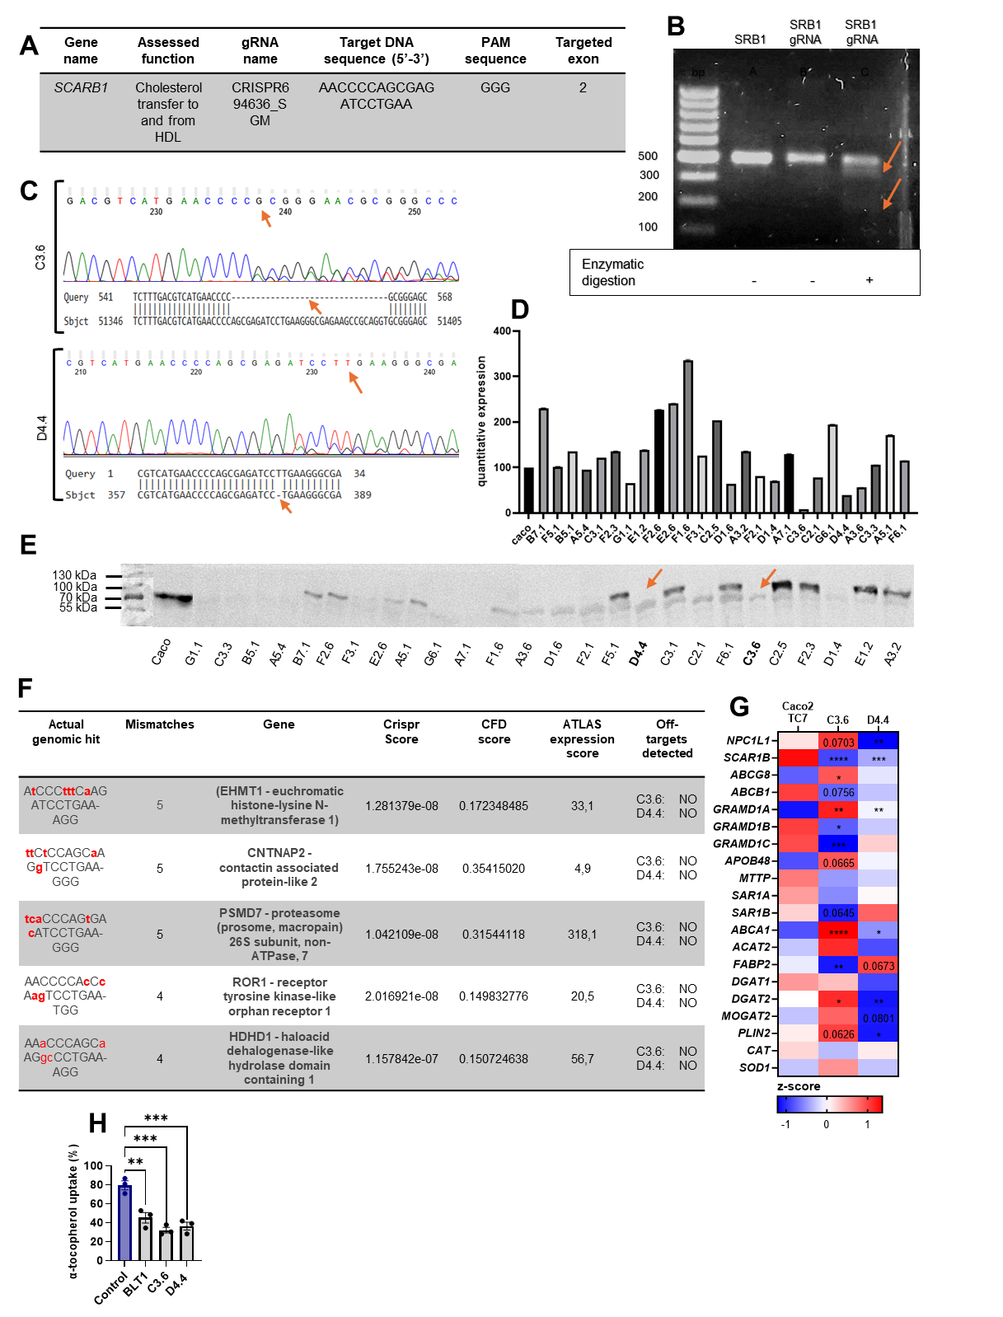

Figure S2 Validation of SR-BI-KO Caco-2 C3.6 and D4.4, related to Figure 3

Several clones were produced and two, named C3.6 and D4.4 were kept. (A) DNA sequence targeted by guide-RNA used in CRISPRCas9 experiment. (B) Assessment of SR-BI gRNA efficiency in Caco-2 TC7. (C) Example of the targeted region in the SCAR1B gene. (D) Quantitative analysis of SR-BI gene expression in SR-BI-mutated Caco-2/TC7 clones. (E) SR-BI protein expression in SR-BI-mutated Caco-2 TC7 clones. (F) Off-target analysis of SR-BI-mutated Caco-2 TC7 clones. (G) Z-score of gene expression (n=4 per condition), with Brown-Forsythe and Welch ANOVA with Dunnett’s multiple comparison test for each gene. *p < 0.05, **p < 0.01, ***p < 0.001 and ****p < 0.0001 compared to Caco-2 TC7. (H) Secreted α-tocopherol by differentiated Caco-2 TC7 and SCARB1-KO exposed 20 h to micelles containing α-tocopherol at 37.6 ± 0.3 µM (0.1 mM cholesterol), One-way ANOVA with Dunnett’s multiple comparison test compared to Control, **p < 0.01, ***p < 0.001.

Figure S3 SNP selection flowchart (Vitamin E and vitamin D bioavailability).

Vitamin E bioavailability (n=37)
26 SNPs
Univariate analysis and adjustment of confounding factors
75 SNPs
95 SNPs
HWE (chi-squared test, p < 0.05), SNPs with single genotype and SNPs with call rate <95% were removed (n=18)
113 SNPs
Tag SNPs selection and removal of SNPs in linkage disequilibrium (R²>0.8) (n=20)
Removal of SNPs with fewer than 5 observations per genotype (n=49)
28 SNPs
75 SNPs
95 SNPs
HWE (chi-squared test, p < 0.05), SNPs with single genotype and SNPs with call rate <95% were removed (n=18)
113 SNPs
Tag SNPs selection and removal of SNPs in linkage disequilibrium (R²>0.8) (n =20)
Removal of SNPs with fewer than 5 observations per genotype (n=47)
Vitamin D bioavailability (n=39)
Univariate analysis and adjustment of confounding factors

