Supplementary Information

Red Blood Cells in Polycythemia Vera:
Alterations in Hemoglobin Structure and Oxygen Affinity

Jakub Dybas^{1,*}, Weronika Lebowa^{2,3}, Ewa Szczesny-Malysiak¹, Amanda Bartkowiak¹,
Marta Targosz-Korecka⁴, Tomasz Sacha^{2,5,#}, Stefan Chlopicki^{1,6,#}
¹Jagiellonian Center for Experimental Therapeutics, Jagiellonian University,
14 Bobrzynskiego St., 30-348 Krakow, Poland
²Department of Haematology, Jagiellonian University Hospital,
2 Jakubowskiego St., 30-688 Krakow, Poland
³Doctoral School of Medical and Health Sciences, Jagiellonian University Medical College,
16 Sw. Lazarza, 31-530 Krakow, Poland
⁴Faculty of Physics, Institute of Astronomy and Applied Computer Science, Jagiellonian University,
11 Lojasiewicza St., 30-348 Krakow, Poland
⁵Chair of Haematology, Faculty of Medicine, Jagiellonian University Medical College,
12 Sw. Anny St., 30-008 Krakow, Poland
⁶Chair of Pharmacology, Faculty of Medicine, Jagiellonian University Medical College,
16 Grzegorzecka St., 31-531 Krakow, Poland

*Corresponding author
Email: jakub.dybas@uj.edu.pl

#These authors share senior authorship

ORCID numbers
Jakub Dybas – 0000-0003-2202-5068
Weronika Lebowa – 0000-0002-8609-0478
Ewa Szczesny-Malysiak – 0000-0002-6356-6453
Amanda Bartkowiak – 0000-0002-7890-5665
Marta Targosz-Korecka – 0000-0001-5650-7255
Tomasz Sacha – 0000-0002-7207-6595
Stefan Chłopicki – 0000-0002-2878-3858

Keywords
Hemoglobin structure, red blood cells, Polycythemia Vera

 |  |  | Study sample |  |  |  | p value
 |  |  | Research group (PV) |  |  | Control group | p value
Group size* |  |  | 17 |  |  | 16
Sex | Female, n (%) |  | 11 (64.7) |  |  | 11 (68.8)
Sex | Male, n (%) |  | 6 (35.3) |  |  | 5 (31.2)
Age | Distribution** |  | normal |  |  | normal
Age | Mean (SD) |  | 55.4 (14.8) |  |  | 45.5 (18.6) | 0.107
Blood count
RBC (red blood cells)  [x 10⁶/ µl] |  | Median (Q1; Q3) |  | 4.8 (4.5; 5.2) |  | 4.5 (4.3; 4.7) | 0.03
Hgb (hemoglobin) [g/dl] |  | Median (Q1; Q3) |  | 14.8 (13.8; 15.8) |  | 13.3 (12.8; 14.0) | <0.001
Hct (hematocrit) [%] |  | Median (Q1; Q3) |  | 42.9 (39.3; 46.3) |  | 39.7 (38.6; 41.3) | 0.02
RDW-SD (red blood cell distribution width – standard deviation) [fl] |  | Median (Q1; Q3) |  | 48.5 (45.4; 52.6) |  | 40.8 (38.8; 43.8) | <0.001
RDW-CV (red blood cell distribution width – coefficient of variation) [%] |  | Median (Q1; Q3) |  | 14.6 (13.6; 16.6) |  | 12.6 (12; 13.6) | 0.007
MCV (mean corpuscular volume) [fl] |  | Median (Q1; Q3) |  | 88.8 (84; 100.9) |  | 88.3 (85.3; 89.8) | 0.363
WBC (white blood cells)  [x 10³/ µl] |  | Median (Q1; Q3) |  | 5.4 (4.5; 8.8) |  | 6.8 (4.8; 9.1) | 0.711
PLT (platelets) [x 10³/ µl] |  | Median (Q1; Q3) |  | 289 (258; 359.5) |  | 254 (227.5; 277.5) | 0.1
Ferritin [µg/l] |  | Median (Q1; Q3) |  | 176 (65; 221) |  | 103 (48; 150) | 0.089
Characteristics of the research group
High-risk PV***; n (%) |  |  |  |  | 7 (41.2)
Thrombotic event; n (%) |  |  |  |  | 3 (17.6)
Type of treatment; n (%)  Ropeginterferon alfa 2b  Peginterferon alfa 2a  Ruxolitinib  Hydroxyurea |  |  |  |  | 7 (41.2)  3 (17.6)  1 (5.9)  6 (35.3)
Table S1. Demographic and clinical characteristics of the patients with PV (research group) and healthy subjects (control group). *In the research group, blood samples were taken at two different time points in 3 patients (there were a total of 20 research samples); **Based on the Shapiro-Wilk test; ***Age over 60 years and/ or history of thrombotic event

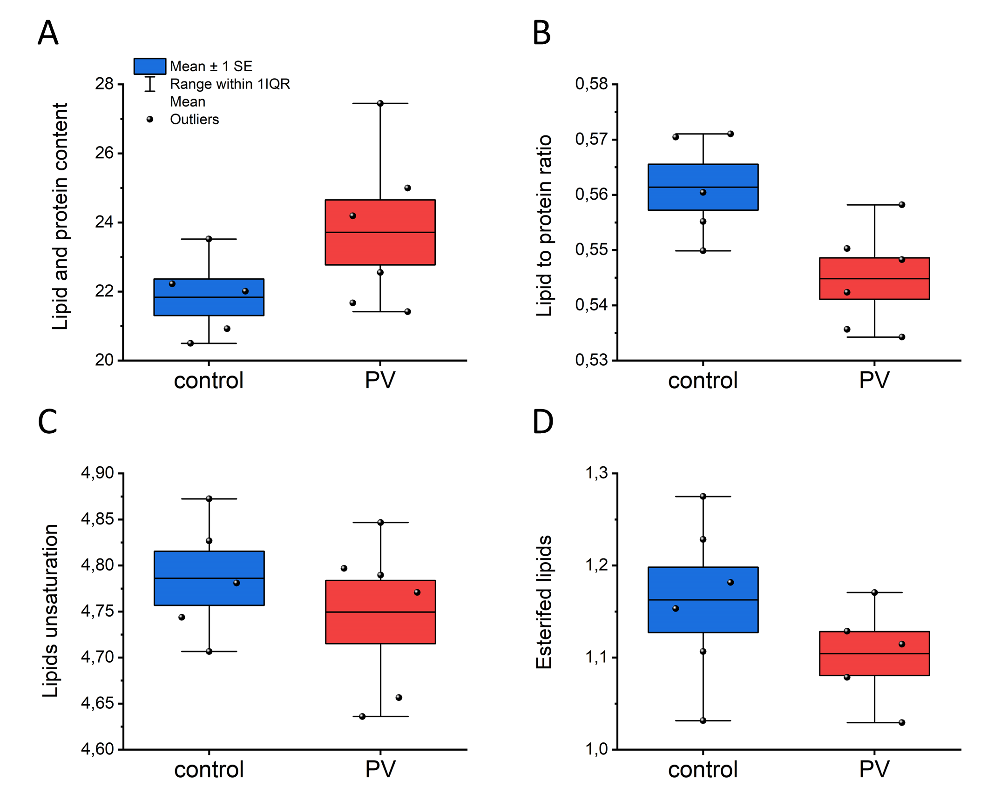
Figure S1. Ratios calculated for the integral intensities in Raman spectra of the isolated RBC membranes (ghost RBCs) – control sample (blue boxes) and PV sample (red boxes). The integration regions and band assignments used to construct the boxes were described in detail by Dybas et al.²⁴. Boxes are presented as mean values with standard error (SE), and whiskers correspond to the interquartile range.
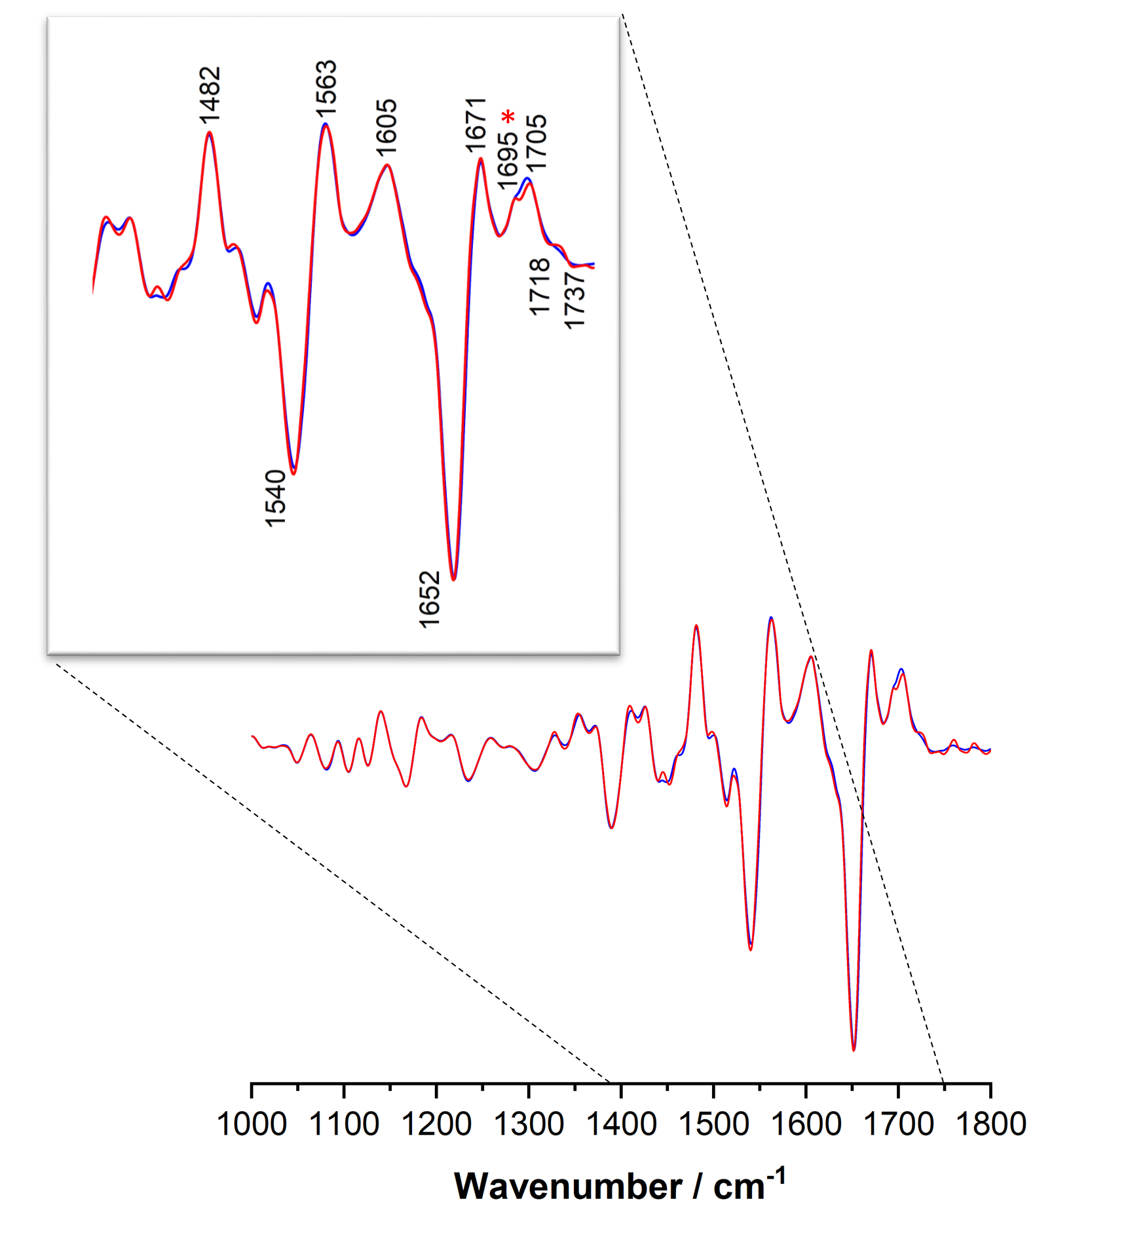
Figure S2. Averaged second derivatives of FTIR-ATR spectra of studies studied isolated RBC samples – control sample (blue line, healthy subject) and test sample (red line, patient with polycythemia vera). The spectra were averaged from six independent samples (N=6), within each measurement was repeated three times using 5 µl of isolated RBCs, and are presented within the 1000 – 1800 cm^{–1} range.

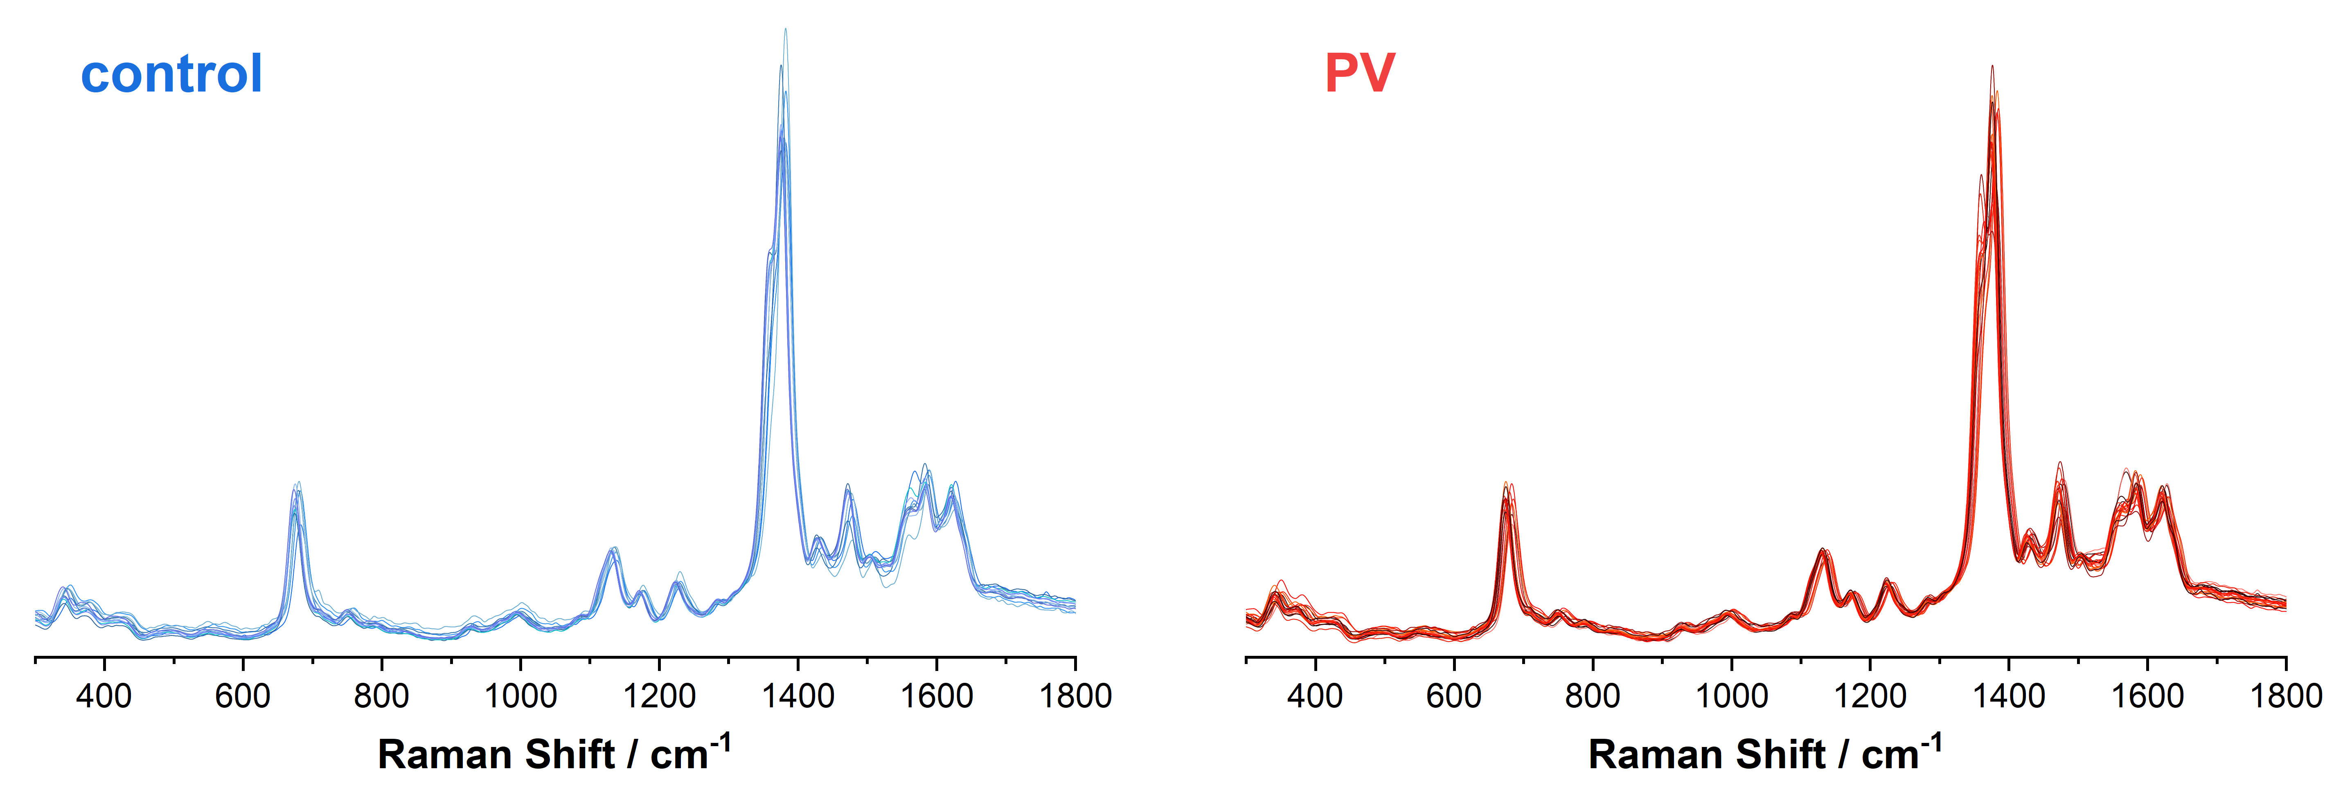
Figure S3. Average RR spectra of the isolated RBC – control sample (blue lines, healthy subjects) and PV sample (red lines, patients with polycythemia vera). Each spectrum corresponds to one patient and represents an average from approximately 100 single erythrocytes measured with 405 nm excitation and 0.1 mW laser power. The spectra were normalized and are presented within the 300 – 1700 cm^{–1} spectral range.

Figure S4. Quantification of methemoglobin from the EPR spectra. Data was acquired from N=9–15. Boxes are presented as mean values with standard error (SE), and whiskers correspond to the interquartile range.

