Supplementary Materials for

Discovery of α-PtO₂ nanoparticles in deep-sea ferromanganese deposits: a hidden platinum sink

Jianlin Liao et al.

*Corresponding author. Email: jianlin.liao@esrf.fr, alain.manceau@ens-lyon.fr

This PDF file includes:

Supplementary Text
Figs. S1 to S14
Tables S1 to S4
Data S1 to S10

Supplementary Text
Glitches in HERFD‑EXAFS
The Indian and Atlantic FeMn crusts contain 256 ppm and 358 ppm arsenic (As), respectively (Data S2–4, no As data available for the Pacific nodule). The As K edge is at 11867 eV, which is 303 eV above the Pt L₃-edge. The As edge occurs at k =9 Å^{–1} in the Pt-EXAFS spectra (Fig. S6). The As fluorescence line should normally be filtered by the spectrometer in HERFD measurement mode. Still, Fig. 7A and S6 show that the As line is not totally extinct and appears as a “glitch” at k = 9 Å⁻¹ on the EXAFS spectra. The XANES of As-sorbed δ-MnO₂ has a white line when measured in conventional mode with a solid-state detector (Fig. S12). In HERFD measurements, the As white line is sharply enhanced, further minimizing the absorption jump in the EXAFS region. This sharpening effect is illustrated in Fig. S13 with α-PtO₂ (no equivalent data for As is available). Consequently, the As glitch at k = 9 Å⁻¹ (Fig. 7A and S6) is so narrow that it appears as a Dirac delta perturbation in k-space. The As-EXAFS oscillations have near-zero intensity in the Pt-EXAFS spectra. The Fourier transform of a Dirac delta function is a constant, and therefore the As glitch does not introduce any spurious peaks on the radial structure functions (RSFs) of the Pt-EXAFS spectra for the crusts/nodules, nor modifies the amplitude and phase of the structural peaks.
Immunity of the data analysis to the As glitch was verified by fitting the Pt_{FeMn} EXAFS spectrum in the extended 3.2–12 Å⁻¹ k-range that includes the As glitch (Fig. S14A–B), and in the 3.2–8.5 Å⁻¹ k-range that excludes the As glitch (Fig. S14C–D). The two data sets differ only in the widths of the RSF peaks, without modifying the peak positions and phases, in agreement with theory. The fitted bond distances are nearly identical in the two analyses (Table S3).
Supplementary Figures
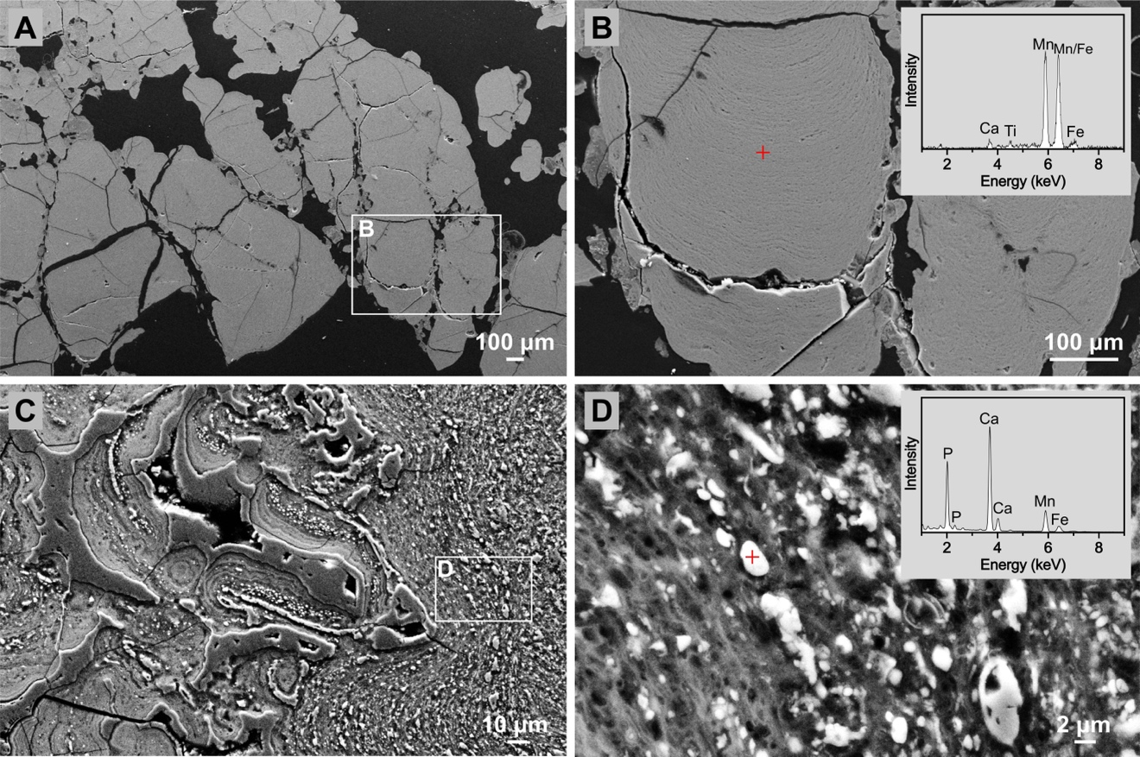
Fig. S1. Comparison of microstructure in non-phosphatized and phosphatized FeMn deposits. (A–B) SEM images of the non-phosphatized FeMn crust from the Indian Ocean. The image in B is a zoomed-in view of the area in A outlined by a rectangle. The EDS spectrum from the spot marked with a red cross indicates high levels of Fe and Mn, with no signs of phosphorous. (C–D) SEM images showing the intergrowth of apatite and FeMn layers in the phosphatized Pacific nodule. The EDS spectrum in (D) from the red cross spot shows phosphorous and calcium, consistent with apatite.
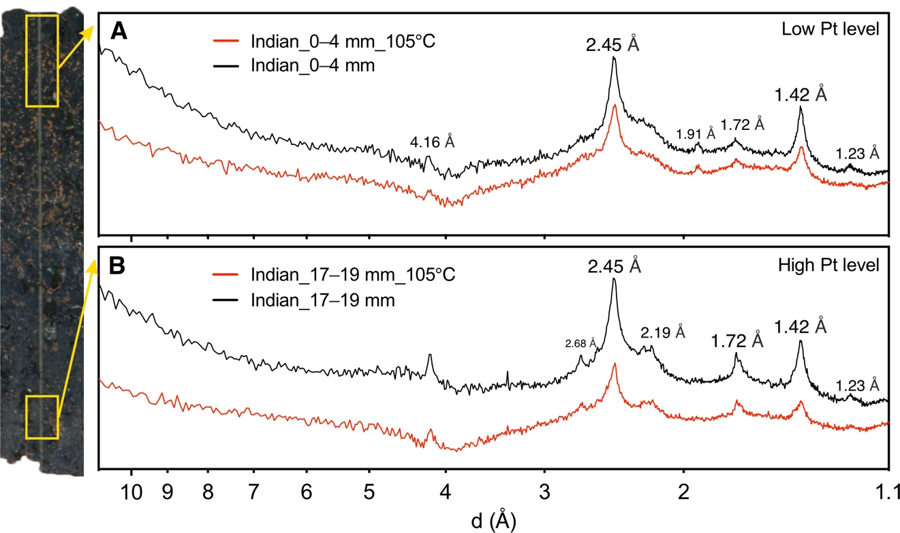
Fig. S2. XRD patterns of the non-phosphatized FeMn crust from the Indian Ocean. (A) Sample depth: 0–4 mm. (B) Sample depth: 4–20 mm. The samples were divided into two batches. One was analyzed without treatment (black), and the other was heated at 105℃ for 8 hours and loaded in a sealed capillary for XRD analysis (red). The Indian FeMn crust consists of Fe-vernadite with main diffraction peaks at 2.45 Å and 1.42 Å and no basal reflection. The peak at 4.16 Å is from goethite.

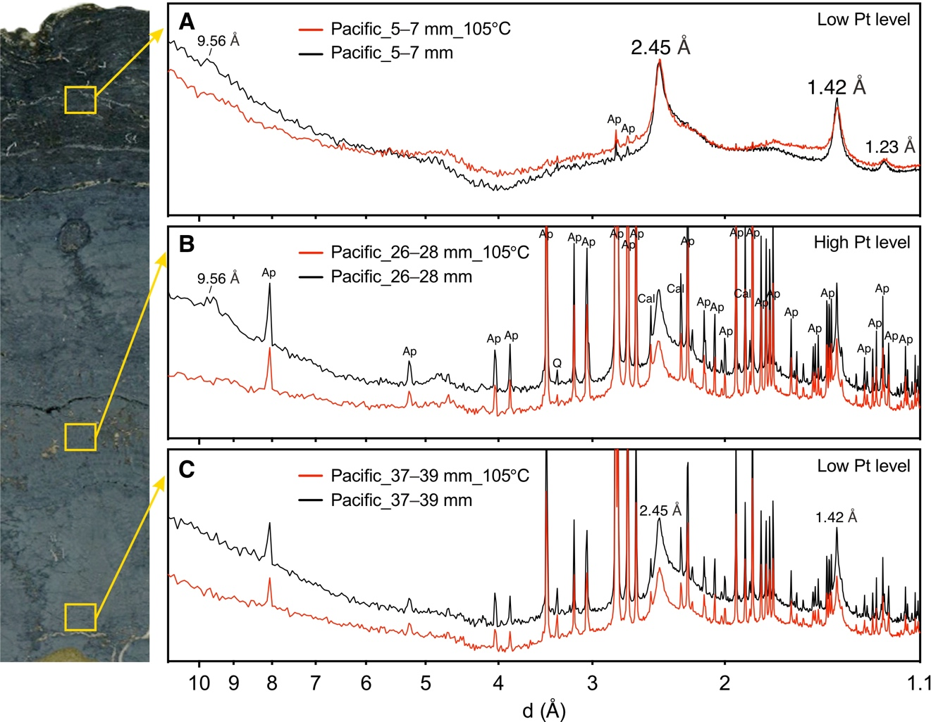
Fig. S3. XRD patterns of the phosphatized FeMn nodule from the Pacific Ocean. (A) Sample depth: 5–7 mm. (B) Sample depth: 26–28 mm. (C) Sample depth: 37–39 mm. The FeMn layers consist of Fe-vernadite with main peaks at 2.45 Å and 1.42 Å. The broad peak at 9.56 Å disappeared after heating (A and B), indicating that it originated from 10 Å-vernadite (39). The older FeMn layers in the nodule's inner region contain apatite (Ap) and calcite (Cal), resulting from ancient phosphatization events.

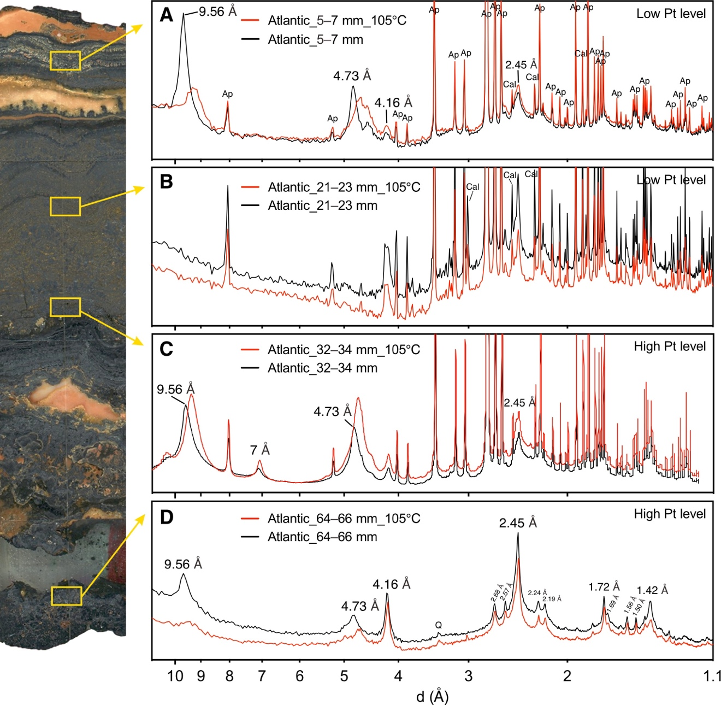
Fig. S4. XRD patterns of the phosphatized FeMn crust from the Atlantic Ocean. (A) Sample depth: 5–7 mm. (B) Sample depth: 21–23 mm. (C) Sample depth: 32–34 mm. (D) Sample depth: 65–67 mm. The diffraction peaks from apatite (Ap) and calcite (Cal) indicate the presence of finely intergrown phosphorite layers within the FeMn layers. The 001 reflection at 9.56 Å originates from 10 Å manganates (e.g., 10 Å-vernadite, todorokite). Its shifts to 9.2 Å and not to 7 Å after heating implies the presence of todorokite (39). Some 10 Å-vernadite is detected in the Atlantic crust at 32–34 mm depth. Todorokite is commonly found in phosphatized FeMn crusts (39, 47). The peak at 4.73 Å corresponds to the 002 reflection of todorokite. It behaves similarly to the 001 reflection at 9.56 Å. The peak at 4.16 Å is from goethite. Q: quartz.
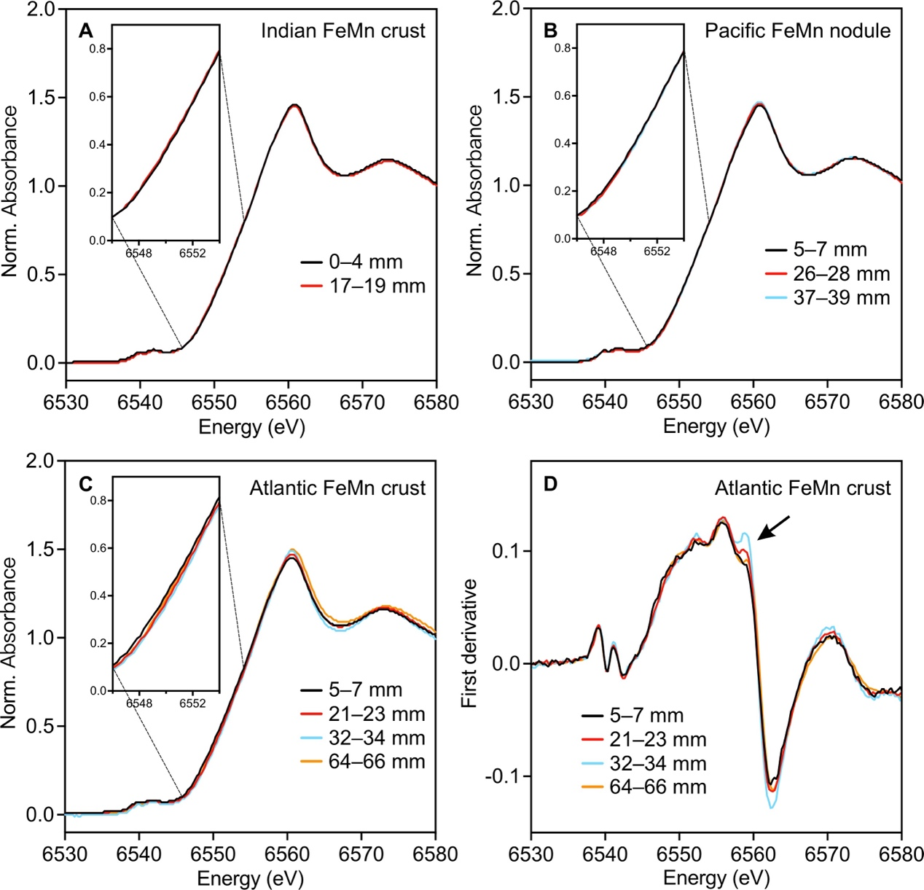
Fig. S5. Mn K-edge XANES spectra. (A) Normalized XANES spectra of the FeMn layers from the Indian crust. (B) Normalized XANES spectra of the FeMn layers from the Pacific nodule. (C–D) Normalized XANES spectra (C) and first derivatives (D) of the FeMn layers from the Atlantic crust.

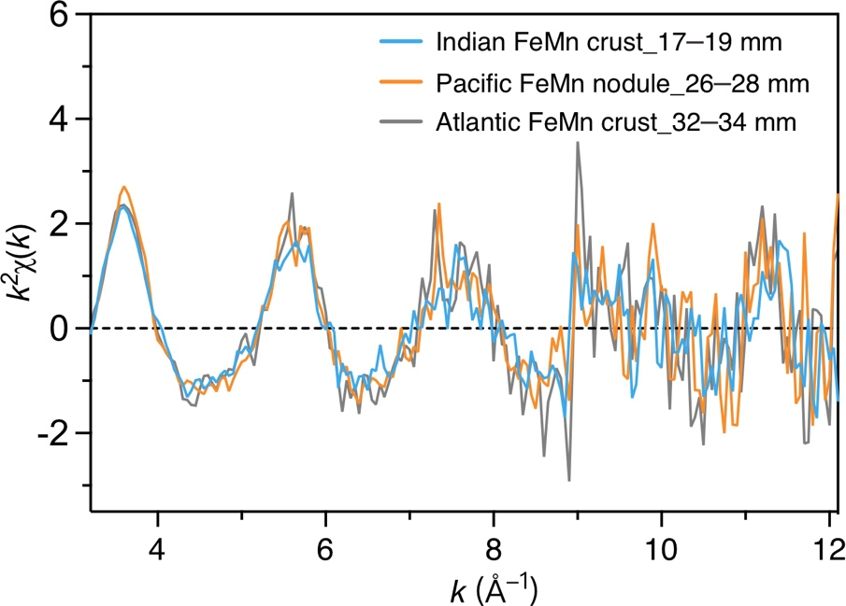
Fig. S6. Pt L₃-edge EXAFS spectra of the Pt-rich layers for the three FeMn crusts and nodules. The three EXAFS spectra are statistically identical, indicating that the chemical form of Pt is similar. The EXAFS data are provided in Data S8.
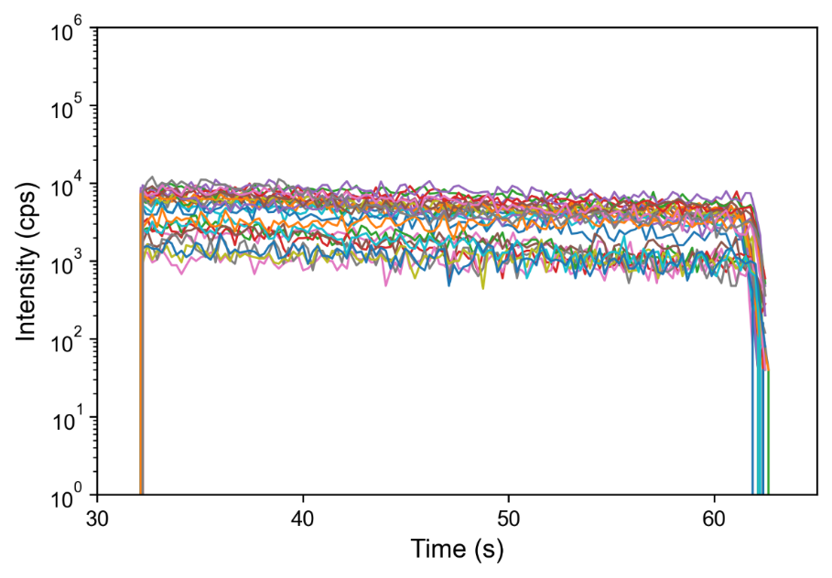
Fig. S7. Time profiles of the Pt signal from spots analyzed by LA-ICP-MS. The uniform intensity negates the occurrence of Pt nuggets, and indicates that Pt is homogenously distributed throughout the sample depth. The probed depth varied from approximately 30 to 40 µm.
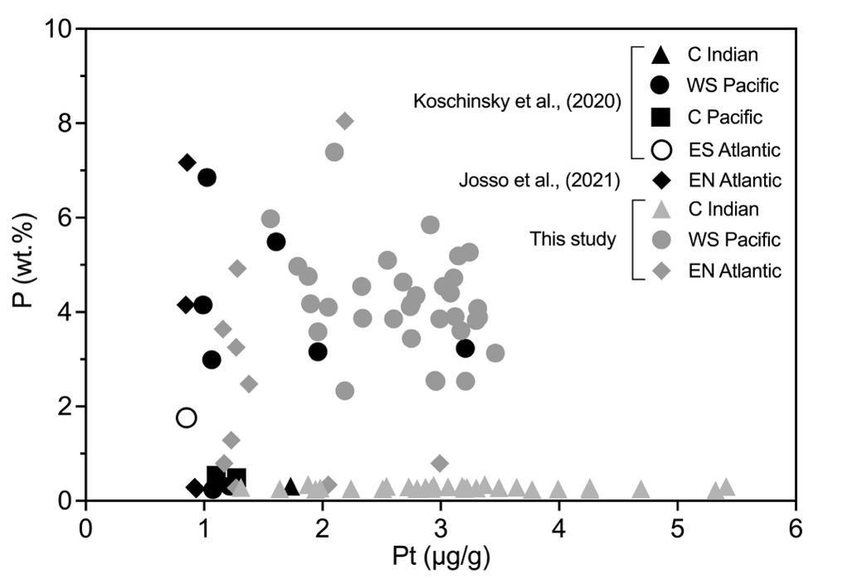
Fig. S8. Relationship between the Pt and P concentrations in FeMn crusts. Some of data were adapted from references (11, 12). C Indian: Ninety East Ridge, Central Indian Ocean; WS Pacific: Manihiki Plateau, Western South Pacific Ocean; C Pacific: Central Pacific; ES Atlantic: Walvis Ridge, Eastern South Atlantic Ocean; EN Atlantic: Tropic Seamount, Eastern North Atlantic Ocean.
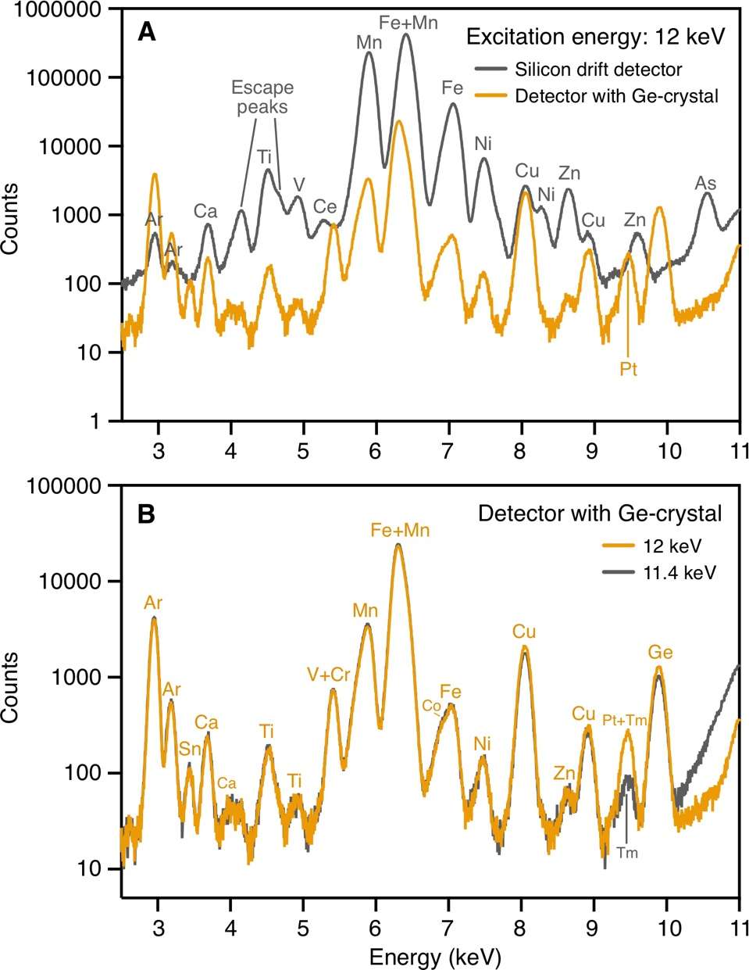
Fig. S9. Comparisons of the X-ray fluorescence (XRF) spectra measured with different settings. (A) XRF spectra of the Indian FeMn crust obtained with (orange) and without (gray) a Ge(110) five-crystal analyzer and measured at an excitation energy of 12 keV. The Pt fluorescence (L₃-M₅ line) is only detected when using the spectrometer. (B) XRF spectra of the Indian FeMn crust measured below (11400 eV) and above (12000 eV) the Pt L₃-edge (11564 eV). The Pt line in (A) and (B) is composed of the Pt (L₃-M₅) fluorescence line at 9442 eV and the Tm (L₂-N₄) fluorescence line at 9441.5 eV. The parasitic Tm fluorescence line increases the background level of the Pt L₃-edge X-ray absorption measurement, which increases the detection limit of Pt.
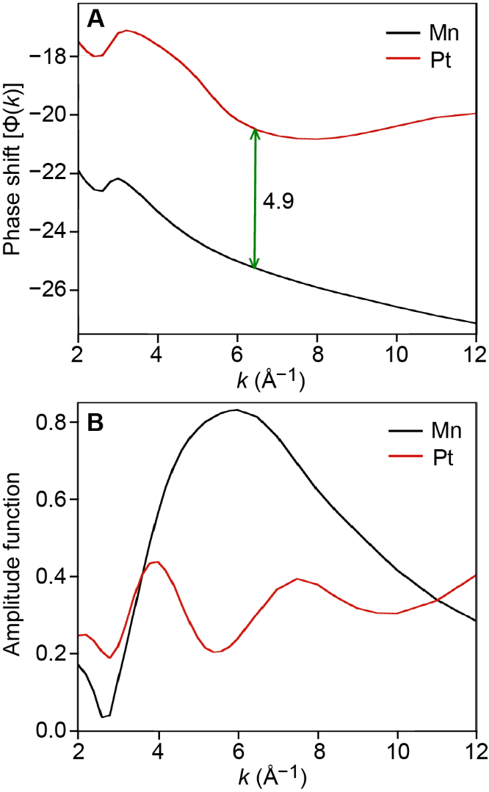
Fig. S10. Graphs of the phase shift functions and scattering amplitudes for the Pt-Mn and Pt-Pt pairs in the EXAFS function. (A) Phase shifts functions. (B) Backscattering amplitudes.
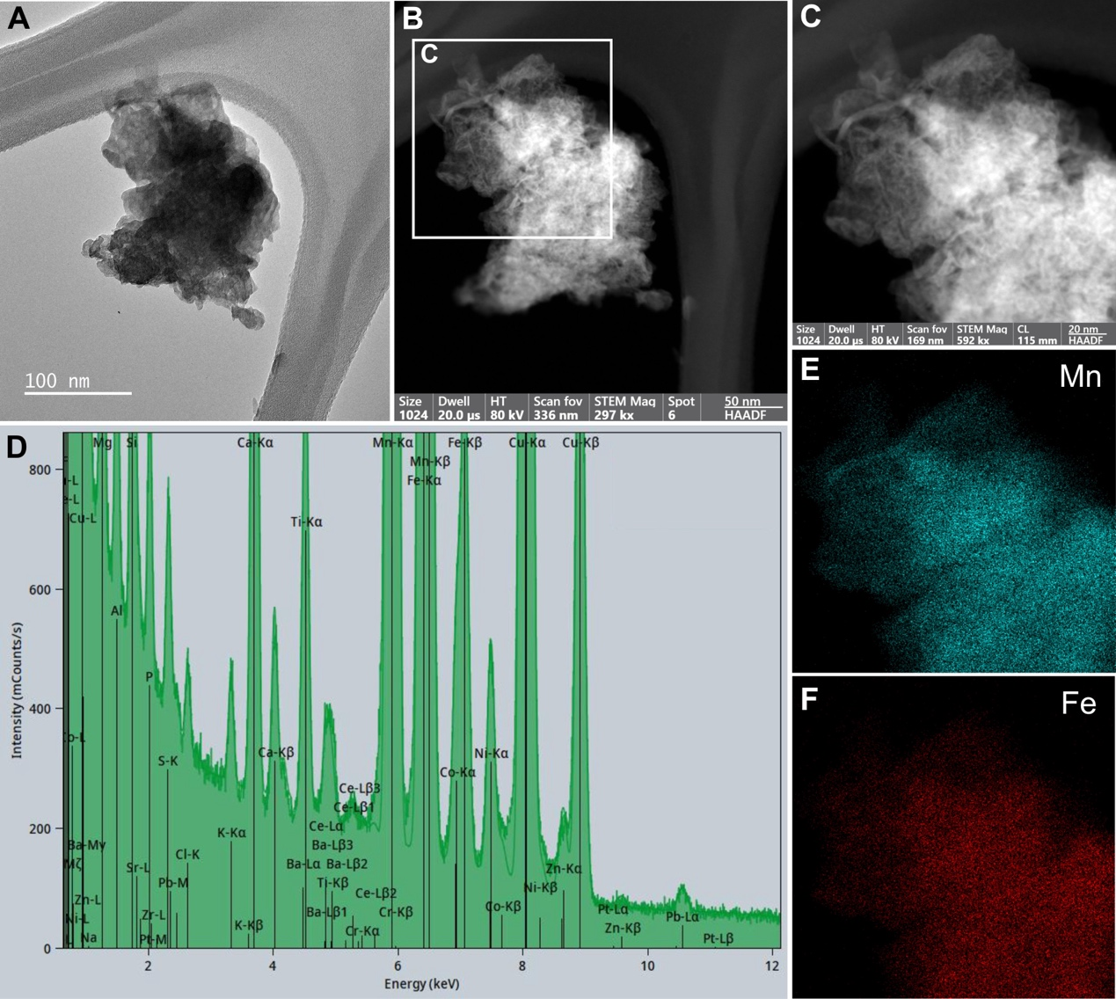
Fig. S11. Transmission electron micrographs and microanalyses of an FeMn oxide aggregate from the Pacific FeMn nodule (sample depth: 26–28 mm). (A) Image in TEM mode; (B–C) Images in STEM-HAADF mode; (D) EDS spectrum of the area shown in (C). (E) EDS mapping of the distribution of Mn in (C); (F) EDS mapping of the distribution of Fe in (C). The Pt(Lα1) fluorescence line (9442 eV) cannot be distinguished from the Zn(Kβ1) fluorescence line (9570 eV).
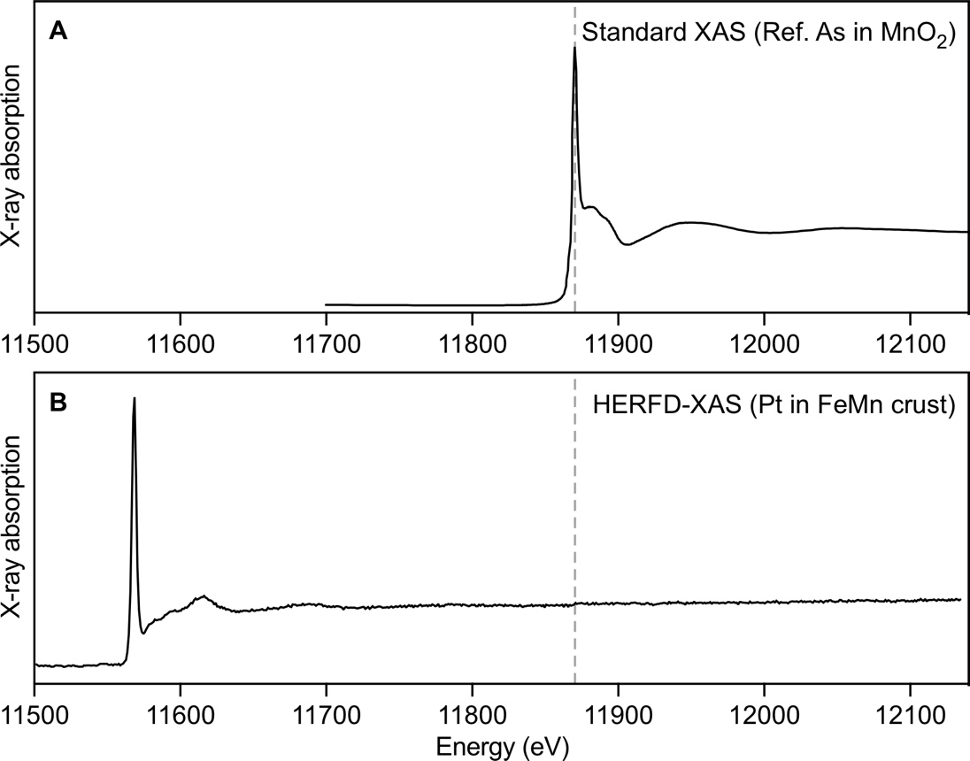
Fig. S12. X-ray absorption spectra. (A) As K-edge XAS spectrum of As-sorbed δ-MnO₂ (86). (B) Pt L₃‑edge HERFD‑XAS spectrum of the FeMn crust from the Indian Ocean. The gray lines indicate the position of the As white line.

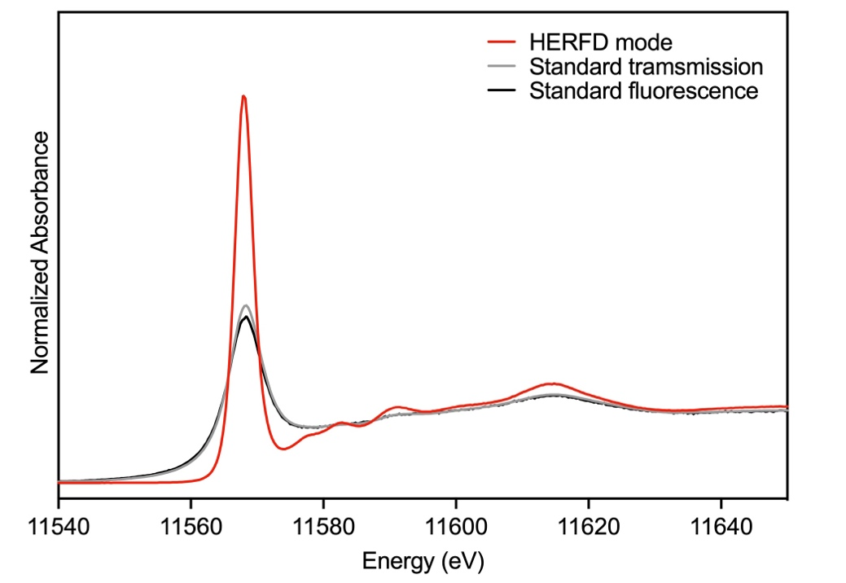
Fig. S13. Pt L₃‑edge XAS spectra of α-PtO₂. Measurements in HERFD (red), standard transmission (gray), and standard fluorescence (black) modes, showing the sharpening and enhancement of the edge in HERFD.

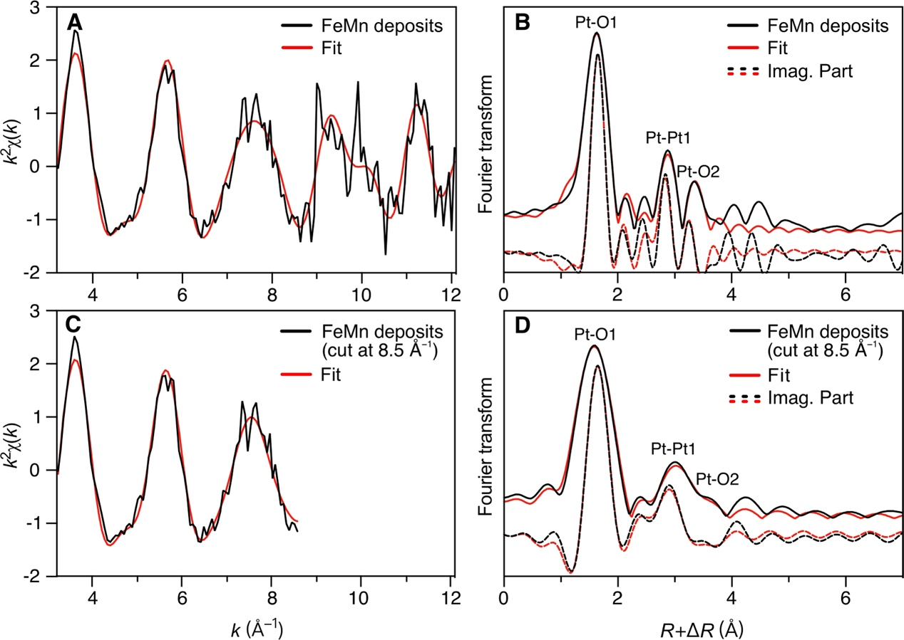
Fig. S14. Comparison of two independent EXAFS analyses with and without glitch. (A–B) Pt_{FeMn} EXAFS spectrum (A) and Fourier transform (FT, B) of the marine FeMn deposits (Pt_{FeMn}) fitted in the 3.2 Å^{–1} ≤ k ≤ 12.1 Å^{–1} interval (including the glitch). (C–D) Pt_{FeMn} EXAFS spectrum (C) and FT (D) fitted in the 3.2 Å^{–1} ≤ k ≤ 8.5 Å^{–1} interval (excluding the glitch).

Supplementary Tables
Table S1. Sampling information
 | Indian Ocean | Pacific Ocean | Atlantic Ocean
Sample ID | KNOX06RR_D20-1 | SO193_TVG71-5 | SO83_116DK
Sample type | FeMn crust | FeMn nodule | FeMn crust
Method | Dredge | TV-grab | Dredge
Research vessel | Roger Revelle | Sonne | Sonne
Cruise ID | KNOX06RR | SO193 | SO83
Location | Ninety East Ridge | High Plateau, Manihiki Plateau | Tropic Seamount
Latitude | 13°5.50′ S–13°6.08′ S | 9°30.02′ S | 23.°54.11′ N
Longitude | 87°50.40′ E–87°51.50′ E | 162°4.42′ W | 20°43.69′ W
Water depth | 3,859–3,236 m | 1,222 m | 1,380 m

Table S2. Fractional amounts of manganese oxidation states and average manganese oxidation states (AMOS) in the FeMn crusts and nodule. The Mn data were obtained by linear combination fitting of the XANES derivatives. The Mn XANES data are provided in Data S6. The sample depth, description of phosphatization, and Pt content are presented in Fig. 2.
Sample ID | Location | Sample depth | Phosphatization | Pt content  (μg/g) | Mn⁴⁺ | Mn³⁺ | Mn²⁺ | AMOS
 |  |  |  |  | (%) | (%) | (%) | AMOS
KNOX06RR_D20-1 | Indian Ocean | 0–4 mm | No | <1 | 94 | 2 | 3 | 3.91 ± 0.04
KNOX06RR_D20-1 | Indian Ocean | 17–19 mm | No | Up to 6 | 92 | 4 | 4 | 3.89 ± 0.04
SO193_TVG71-5 | Pacific Ocean | 5–7 mm | No | Up to 2 | 97 | 0 | 3 | 3.93 ± 0.04
SO193_TVG71-5 | Pacific Ocean | 26–28 mm | Yes | Up to 5 | 96 | 1 | 3 | 3.93 ± 0.04
SO193_TVG71-5 | Pacific Ocean | 37–39 mm | Yes | Up to 2 | 96 | 1 | 3 | 3.94 ± 0.04
SO83_116DK | Atlantic Ocean | 5–7 mm | Yes | Up to 1.5 | 84 | 15 | 1 | 3.83 ± 0.04
SO83_116DK | Atlantic Ocean | 21–23 mm | Yes | <1 | 89 | 10 | 0 | 3.89 ± 0.04
SO83_116DK | Atlantic Ocean | 32–34 mm | Yes | Up to 5 | 91 | 9 | 0 | 3.91 ± 0.04
SO83_116DK | Atlantic Ocean | 64–66 mm | No | Up to 4 | 93 | 4 | 3 | 3.90 ± 0.04

Table S3. EXAFS fitting parameters for the α-PtO₂ reference and Pt_{FeMn}ª
Sample |  | Path | d (Å) | CN^{e} | R (Å) | σ² (Å²)
α-PtO₂^{b} |  | Pt-O1 | 2.07^{d} | 6 | 2.02 | 0.003
 |  | Pt-Pt1 | 3.10^{d} | 6 | 3.10 | 0.003
 |  | Pt-O2 | 3.60^{d} | 6 | 3.64 | 0.002
 |  | Pt-O3 | 3.73^{d} | 6 | 3.77 | 0.002
 |  | Pt-Pt1-Pt4_MS(3)^{c} |  | 6 | 6.20^{f} | 0.009^{g}
 |  | Pt-Pt1-Pt4_MS(4)^{c} |  | 6 | 6.20^{f} | 0.009^{g}
α-PtO₂^{h} | Pt-O1 |  |  | 6 | 2.02 | 0.003
 | Pt-Pt1 |  |  | 6 | 3.10 | 0.003
 | Pt-O2 |  |  | 12 | 3.70 | 0.007
Pt_{FeMn}^{i} |  | Pt-O1 | - | 6 | 2.00 | 0.001
 |  | Pt-Pt1 | - | 4.6 | 3.17 | 0.002
 |  | Pt-O2 | - | 12 | 3.66 | 0.004
Pt_{FeMn}^{j} |  | Pt-O1 | - | 6^{k} | 2.00 | 0.001
 |  | Pt-Pt1 | - | 4.6^{k} | 3.18 | 0.007
 |  | Pt-O2 | - | 12^{k} | 3.66 | 0.005
ª The Pt_{FeMn} EXAFS spectrum is the weighted average of the spectra from the three marine FeMn crust/nodule samples.
^{b} S₀² = 1.0, 3.2 ≤ k ≤ 16.0 Å⁻¹, 1.2 ≤ R + ΔR ≤ 6.7 Å, ∆E₀ = 3.2 eV, 9 variable parameters, R-factor = 0.094, with 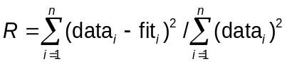.
^{c} Three- and four-legs multiple scattering paths. The two paths have similar intensity, based on FEFF 8.20 calculation (77).
^{d} Crystallographic distances for α-PtO₂, the reference material numbered as 1537410 in the Crystallography Open Database (56).
^{e} Coordination numbers (CN) fixed to those of α-PtO₂, except for the Pt-Pt pair of Pt_{FeMn}.
^{f} Distance constrained to two times the Pt-Pt1 distance.
^{g} Parameters co-varied.
^{h} S₀² = 1.0, 3.2 ≤ k ≤ 12.1 Å⁻¹, 1.2 ≤ R + ΔR ≤ 3.7 Å, ∆E₀ = 3.4 eV, 7 variable parameters, R-factor = 0.049.
^{i} S₀² = 1.0, 3.2 ≤ k ≤ 12.1 Å⁻¹, 1.2 ≤ R + ΔR ≤ 3.7 Å, ∆E₀ = 2.6 eV, 7 variable parameters, R-factor = 0.148.
^{j} S₀² = 1.0, 3.2 ≤ k ≤ 8.5 Å⁻¹, 1.2 ≤ R + ΔR ≤ 3.7 Å, ∆E₀ = 3.3 eV, 7 variable parameters, R-factor = 0.032.
^{k} Value fixed to that of Pt_{FeMn} (3.2 ≤ k ≤ 12.1 Å⁻¹).

Table S4. Thermodynamic constants of Pt(Ⅱ) complexation reaction with hydroxyl and chloride ligands at 25℃ (28)
Reaction | logK
$${\text{Pt}}^{\text{2+}}\text{ + }{\text{OH}}^{\text{–}}\text{ ↔}{\text{ PtOH}}^{\text{+}}$$ | 16.45
$${\text{Pt}}^{\text{2+}}\text{ + }{\text{2OH}}^{\text{–}}\text{ ↔} {\text{Pt}\left(\text{OH}\right)}_{\text{2}\left(\text{aq}\right)}$$ | 32.42
$${\text{Pt}}^{\text{2+}}\text{ + }{\text{Cl}}^{\text{–}}\text{ ↔ }{\text{PtCl}}^{\text{+}}$$ | 8.68
$${\text{Pt}}^{\text{2+}}\text{ + 2}{\text{Cl}}^{\text{–}}\text{ ↔ }{\text{PtCl}}_{\text{2(aq)}}$$ | 15.49
$${\text{Pt}}^{\text{2+}}\text{ + 3}{\text{Cl}}^{\text{–}}\text{ ↔ }{\text{PtCl}}_{\text{3}}^{\text{–}}$$ | 18.49
$${\text{Pt}}^{\text{2+}}\text{ + 4}{\text{Cl}}^{\text{–}}\text{ ↔ }{\text{PtCl}}_{\text{4}}^{\text{2}\text{–}}$$ | 20.01

Supplementary Data (separate file)
Data S1: Elemental profiles of the three FeMn crusts/nodules from EPMA.
Data S2: Elemental profiles of the Indian FeMn crust (KNOX06RR_D20-1) from LA-ICP-MS (line scanning mode).
Data S3: Elemental profiles of the Pacific FeMn nodule (SO193_TVG71-5) from LA-ICP-MS (line scanning mode).
Data S4: Elemental profiles of the Atlantic FeMn crust (SO83_116DK) from LA-ICP-MS (line scanning mode).
Data S5: Element contents from LA-ICP-MS (spot mode).
Data S6: Mn XANES data of the FeMn layers from the FeMn crusts and nodules.
Data S7: Pt XANES data of the references and the Pt-rich layers from the FeMn crusts and nodules.
Data S8: Pt EXAFS data of the references and the Pt-rich layers from the FeMn crusts and nodules.
Data S9: Coordinates of the DFT model with Mn atoms replaced by Pt in the MnO₂ layers.
Data S10: Coordinates of the DFT model with a Pt₁₉O₃₈ nanoplatelet growing on the MnO₂ layers.

