Supplementary Material
Supplemental videos
Video | Description | Link | Videographer
SV 1 | West Salt Creek Landslide Headscarp Drone Video |  | Julian Chesnutt, Paul Byrne & Karl Wegmann
SV 2 | West Salt Creek Runout from Headscarp Drone Video |  | Julian Chesnutt, Paul Byrne & Karl Wegmann
SV 3 | West Salt Creek Landslide Runout from Toe Drone Video |  | Julian Chesnutt, Paul Byrne & Karl Wegmann
SV 4 | Grand Mesa from East to West Cessna Video |  | Rex Cole & Mike Wiley

Supplemental Tables
Supp. Table ST 1. Style of activity for GMSA landslides. Modified from Cruden et al. (2011).
Style of Activity | Description
Single | Consists of a single movement of displaced material, often as an unbroken block. Contrasts with other movement styles require disrupting displaced mass or the independent motion of portions of the mass.
Multiple | Shows repeated movements of the same type, often following the enlargement of the rupture surface. The newly displaced masses are in contact with previously displaced masses and frequently share a rupture surface.
Successive | Movement is identical in type to an earlier movement, but it does not share displaced material or a rupture surface, unlike the Multiple class.
Complex | Exhibit at least two different types of movements in sequence.
Composite | Exhibit different types of movement in different areas of the displaced mass, sometimes simultaneously. These areas of the displaced mass show different sequences of movements.

Supp. Table ST 2. Grand Mesa geochronology. All calibrated ages are referenced to 1950 CE (present), except for those dated by eyewitness accounts and historical imagery, denoted by an asterisk (*) and referenced to 2022 CE. Values in parentheses in the calibrated age column indicate the probability percentage that the actual sample age falls within the specified age range. All ages calibrated using IntCal20 calibration curve.
Field ID | Lab ID | Material Dated / Tech | Lat | Long | Elev (m) | Lab Reported Age (¹⁴C yr BP at 1 σ) | Calibrated Age (cal yr BP at 2σ)
GM-1  Bull Creek Slide 3rd Bench | D-AMS 027606 | Wood  ¹⁴C | 39.09387 | -108.04530 | 2914 | 13,116 ± 49 | 15,911 – 15,562
GM-2  Bull Creek Slide 1st Bench | D-AMS 027607 | Wood  ¹⁴C | 39.08667 | -108.03994 | 2942 | 25,507 ± 115 | 30,054 – 29,454 (89.4%)  29,439 – 29,322 (6.0%)
GM-3 Pinedale South Moraine | D-AMS 027608 | Wood  ¹⁴C | 39.01023 | -108.01604 | 3072 | 8,013 ± 35 | 9,010 – 8,753 (93.1%)  8,744 – 8,724 (2.4%)
GM-4 Cottonwood Creek Landslide 1st Bench | D-AMS 027610 | Wood  ¹⁴C | 39.10714 | -108.00288 | 2868 | 1,415 ± 27 | 1,353 – 1,291
GM-5  Rapid Creek Landslide | D-AMS 035174 | Shells  ¹⁴C | 39.09085 | -108.24066 | 2606 | 3,204 ± 29 | 3,461 – 3,369
GM-6 Palisade Landslide | D-AMS 035173 | Shells  ¹⁴C | 39.08277 | -108.25204 | 2430 | 1,307 ± 27 | 1,293 – 1,176
GM-7 Powderhorn Landslide | D-AMS 034598 | Shells  ¹⁴C | 39.06778 | -108.14389 | 2511 | 408 ± 29 | 516 – 431  (81.0%)  363 – 328  (14.5%)
GM-8  West Salt Creek Landslide | n/a | Eyewitness | 39.18184 | -107.85353 | 2834 | n/a | *11 (2014 CE)
GM-9  Andy Gump Landslide | n/a | Eyewitness | 39.0081 | -107.9400 | 2833 | n/a | *21 (2005 CE)

Supplemental Figures
Supp. Fig. SF 1 Landslide parameters recorded for each inventory feature. Schematic illustrating geometric, kinematic, and environmental variables used in analysis.

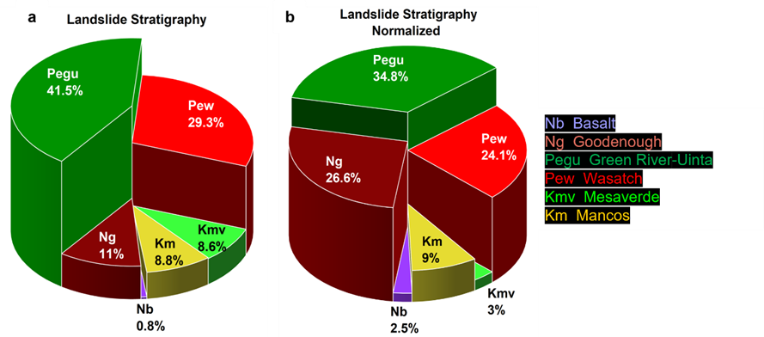 Supp. Fig. SF 2 GMSA landslide frequency pie charts. a) Stratigraphy, b) Stratigraphy normalized by the stratigraphic unit thickness
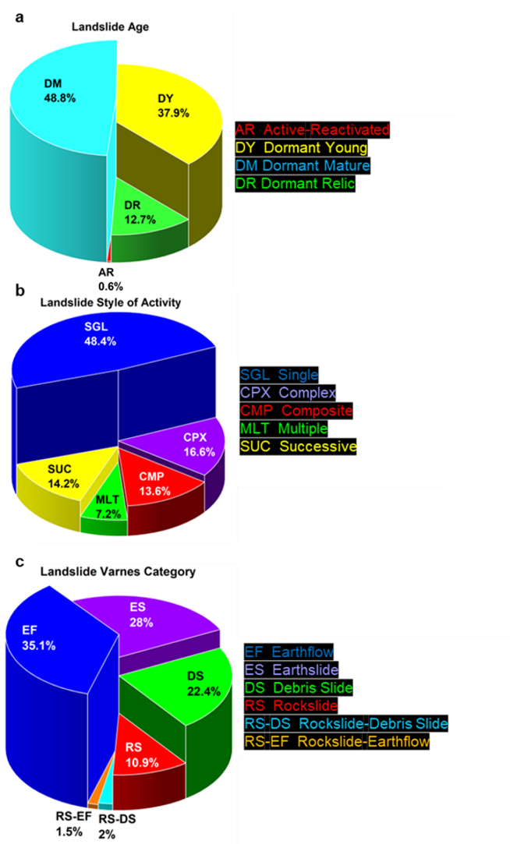
Supp. Fig. SF 3 GMSA landslide frequency pie charts. a) State of activity
(geomorphic age), b) Style of activity, and c) Varnes type.

.

Supp. Fig. SF 4 GMSA landslide histograms. a) Mobility index, b) Headscarp maximum elevation,
c) Pre-initiation slope, d) Headscarp slope, e) pre-and post-initiation headscarp slope difference

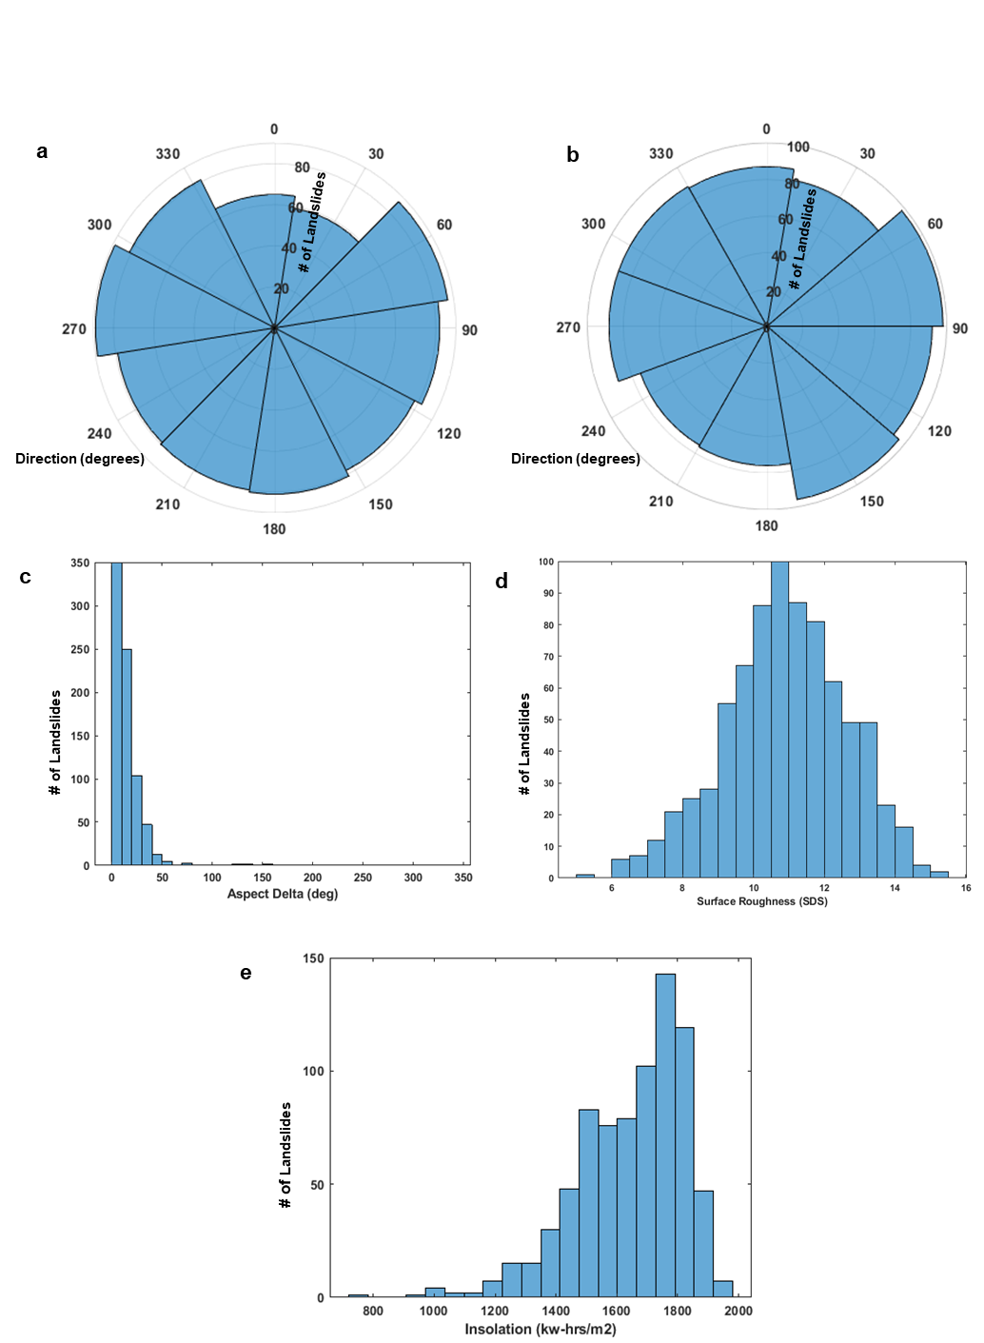
Supp. Fig. SF 5 Landslide polar histograms and histograms. a) Headscarp aspect, b) Aspect pre-initiation, c) Pre- and post-initiation aspect change, d) Standard deviation of slope, e) Insolation.

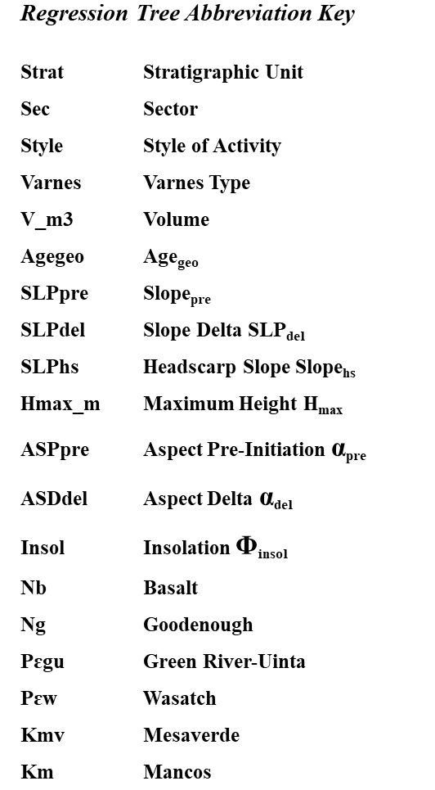

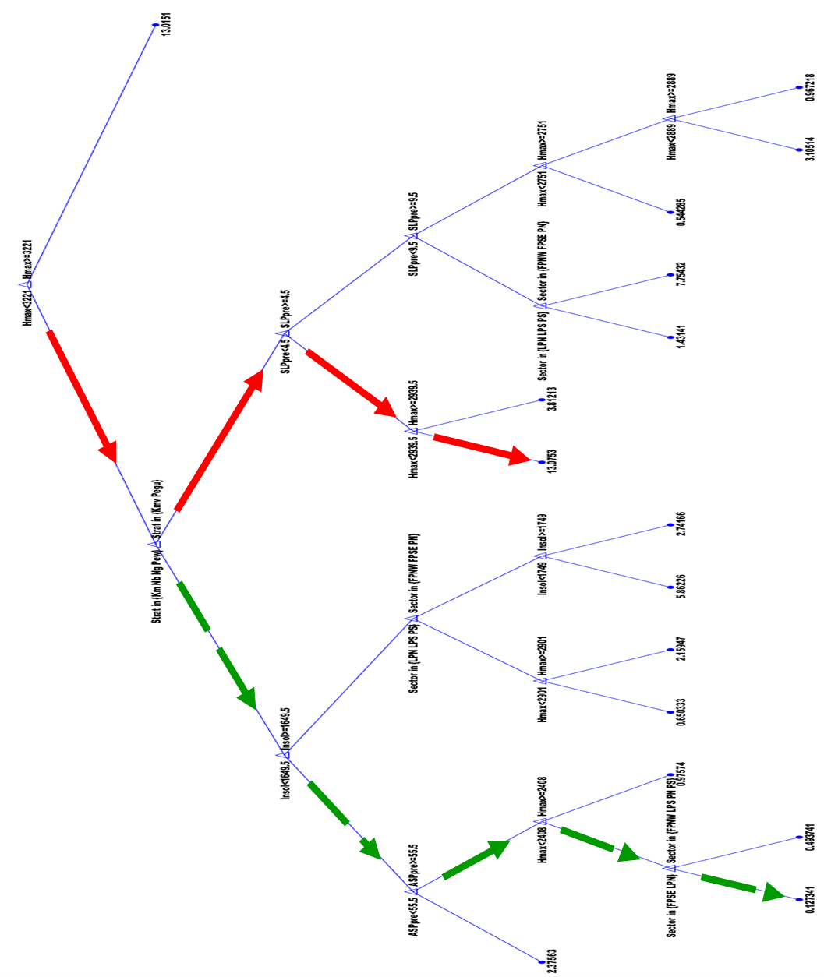
Supp. Fig. SF 6 Pre-initiation volume response regression tree. The red arrows mark the regression toward the strongest volume response, i.e., the largest-volume landslides. The green arrows mark the regression toward the weakest volume response, i.e., the smallest-volume landslides.
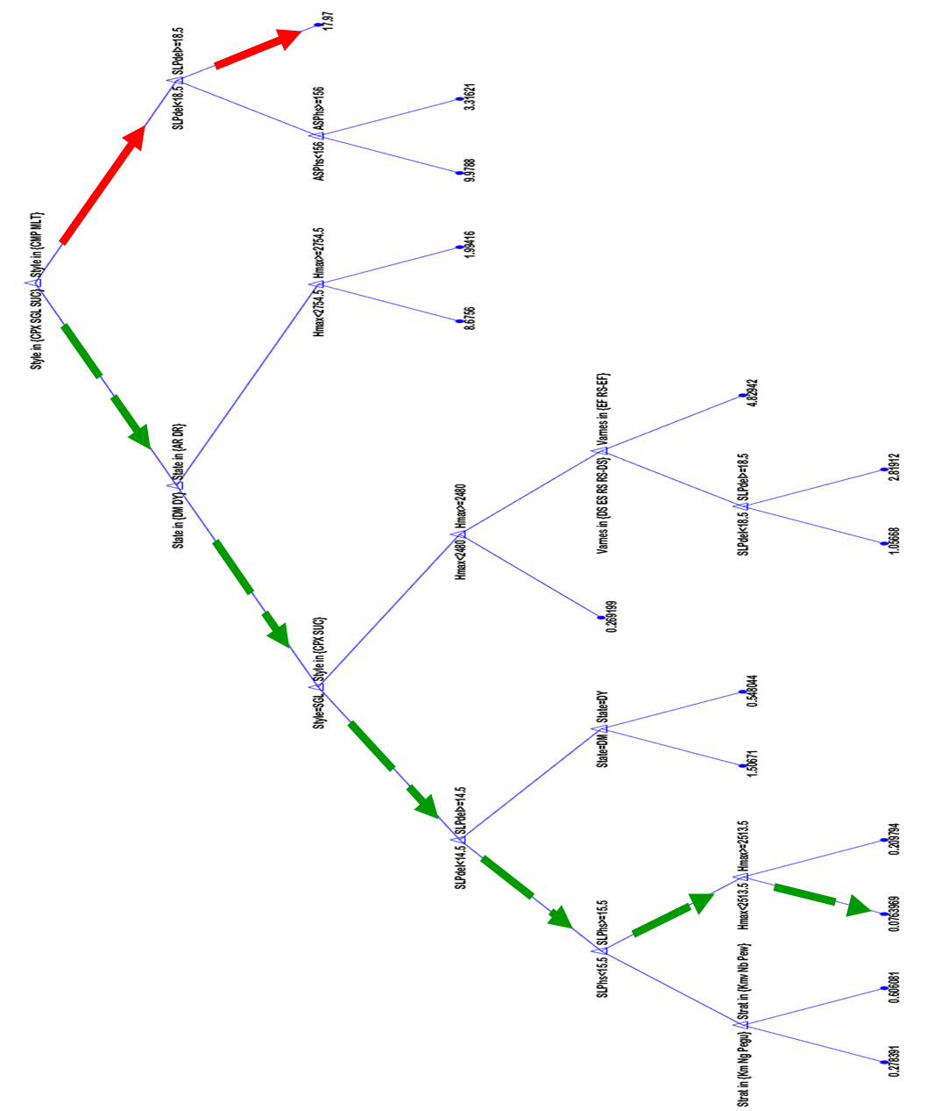
Supp. Fig. SF 7 Post-initiation volume response regression tree. The red arrows indicate regression toward the strongest-volume response, i.e., the largest-volume landslides. The green dashed arrows denote regression toward the smallest-volume landslides.

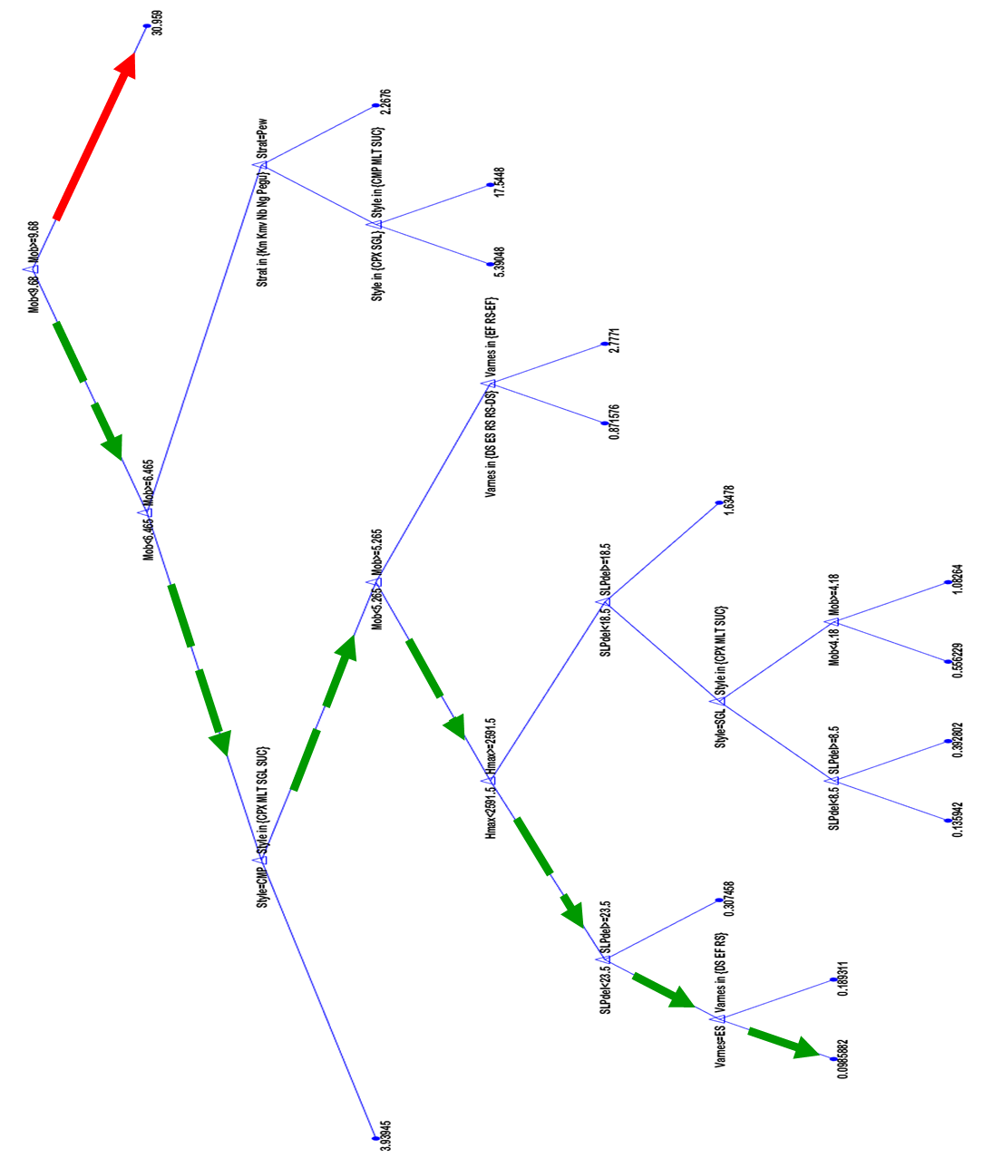
Supp. Fig. SF 8. Post-initiation volume response regression tree, mobility included as a predictor. The red arrows mark the regression to the strongest volume response, aka largest volume landslides. The green dashed arrows mark the regression to the weakest volume response, aka smallest volume landslides.
. 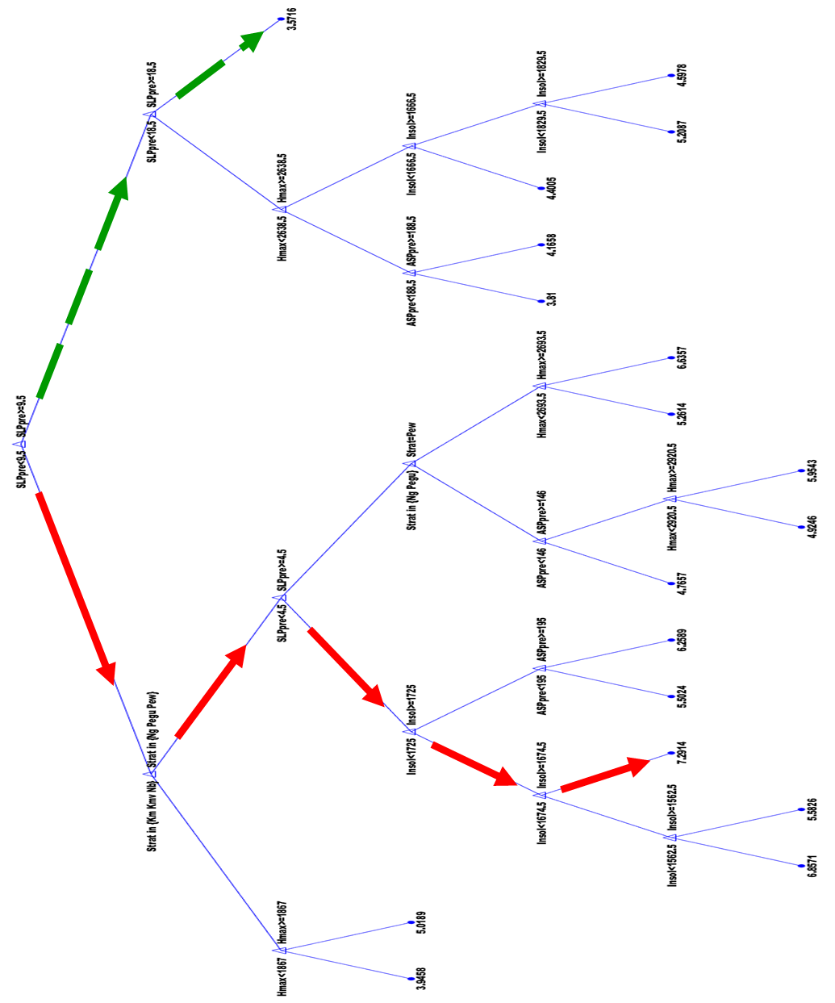
Supp. Fig. SF 9 Pre-initiation mobility response regression tree. The red arrows mark the regression to the highest mobility response, aka longest runout landslides. The green arrows mark the regression to the lowest mobility response, aka shortest runout landslides.
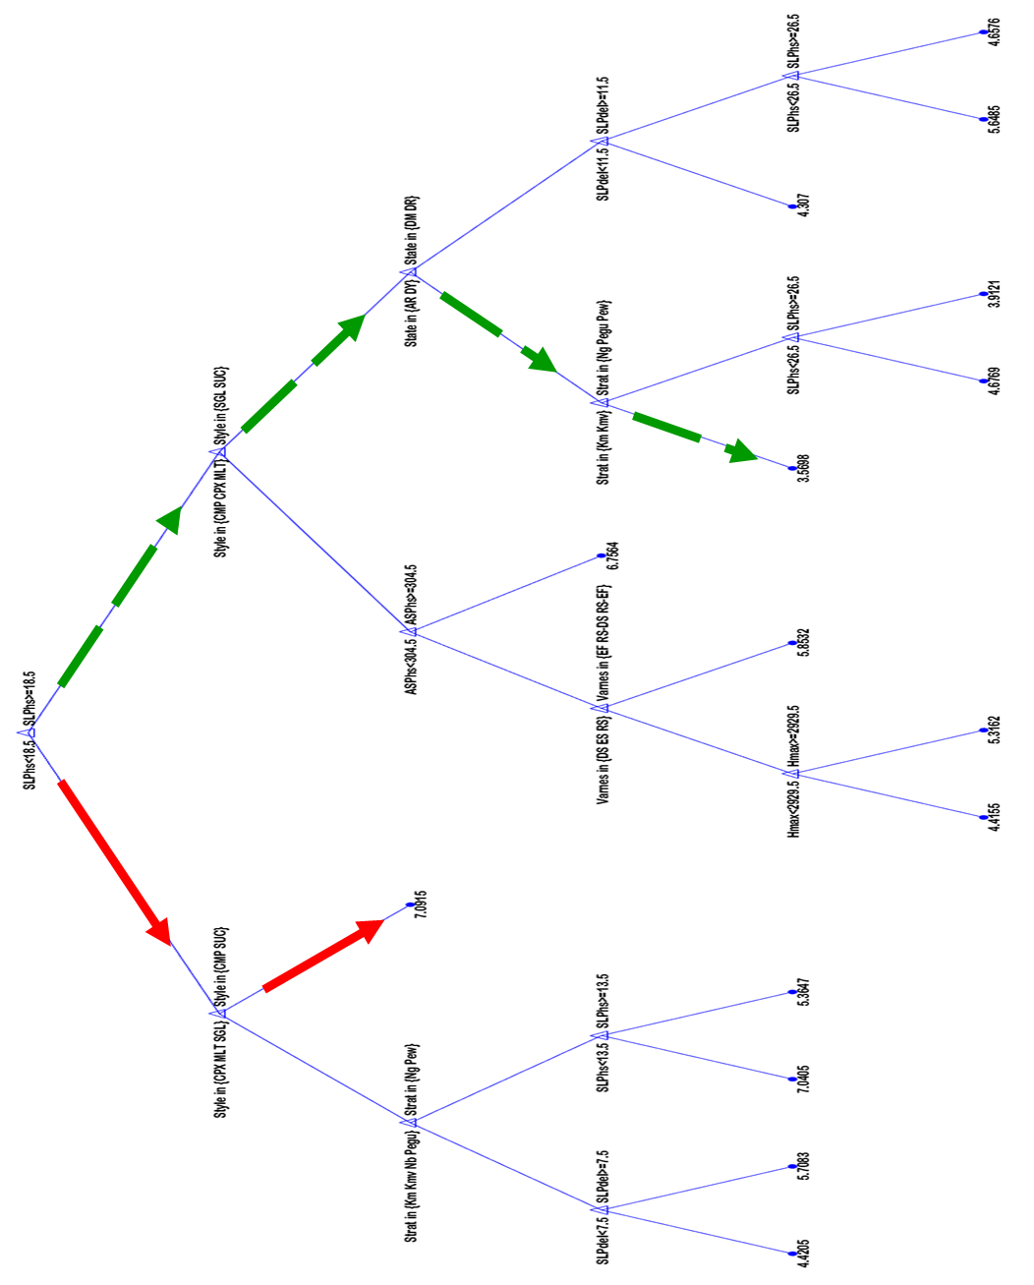
Supp. Fig. SF 10 Post-initiation mobility response regression tree. The red arrows mark the regression to the highest mobility response, aka longest runout landslides. The green arrows mark the regression to the lowest mobility response, aka shortest runout landslides.

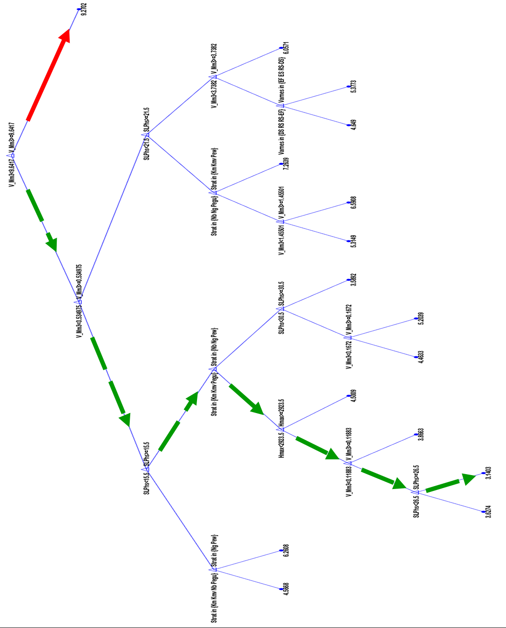
Supp. Fig. SF 11. Post-initiation mobility response regression tree, volume included as a predictor. The red arrows mark the regression to the highest mobility response, aka longest runout landslides. The green arrows mark the regression to the lowest mobility response, aka shortest runout landslides.
Supplemental References. Map and well references. These maps and wells were used to determine the stratigraphy and thickness of the stratigraphic units in the GMSA.
Source
Carrara PE (2000) Geologic map of the Palisade quadrangle, Mesa County, Colorado. US Geological Survey Miscellaneous Field Studies Map MF-2326, scale 1:24,000

Carrara PE (2001) Geologic map of the Clifton quadrangle, Mesa County, Colorado. US Geological Survey Miscellaneous Field Studies Map MF-2359, scale 1:24,000
Donnell JR, Yeend WE, Smith MC (1984) Preliminary geologic map of the Mesa quadrangle, Mesa County, Colorado. US Geological Survey Miscellaneous Field Studies Map MF-1698, scale 1:24,000
Donnell JR, Yeend WE, Smith MC (1985a) Preliminary geologic map of the Collbran quadrangle, Mesa County, Colorado. US Geological Survey Miscellaneous Field Studies Map MF-1825, scale 1:24,000

Donnell JR, Yeend WE, Smith MC (1985b) Preliminary geologic map of the Molina quadrangle, Mesa County, Colorado. US Geological Survey Miscellaneous Field Studies Map MF-1784, scale 1:24,000

Dunrud CR (1989) Geologic map and coal stratigraphic framework of the Cedaredge area, Delta County, Colorado. US Geological Survey Coal Investigations Map C-116, scale 1:50,000
Ellis MS, Freeman VL (1984) Geologic map and cross section of the Carbondale 30′ × 60′ quadrangle, west-central Colorado. US Geological Survey Coal Investigations Map C-97-A, scale 1:100,000

Ellis MS, Gabaldo V (1989) Geologic map and cross sections of parts of the Grand Junction and Delta 30′ × 60′ quadrangles, west-central Colorado. US Geological Survey Coal Investigations Map C-124, scale 1:100,000

Gov #1 well (1973) API 05-077-08013, Great Western Drilling Co, Location 39.095275°N, 107.890706°W. ECMC Well Information Database

Hail WJ Jr (1972) Reconnaissance geologic map of the Cedaredge area, Delta County, Colorado. US Geological Survey Miscellaneous Geologic Investigations Map I-697, scale 1:48,000
Johnson RC, Granica MP, Dessenberger NC (1979a) Cross section A–A′ of Upper Cretaceous and Lower Tertiary rocks, southern Piceance Creek Basin, Colorado. US Geological Survey Miscellaneous Field Studies Map MF-1130-A, scale 1:63,800

Johnson RC, Granica MP, Dessenberger NC (1979b) Cross section C–C′ of Upper Cretaceous and Lower Tertiary rocks, southern Piceance Creek Basin, Colorado. US Geological Survey Miscellaneous Field Studies Map MF-1130-C, scale 1:63,800

Kenny Creek C-1 well (1981) API 05-077-08295, Exxon Mobil Corp, Location 39.115515°N, 107.788423°W. ECMC Well Information Database
Leon Lake #1 well (2010) API 05-029-06048, Gunnison Energy Corp, Location 39.025946°N, 107.852014°W. ECMC Well Information Database
Mickelson Federal #1 well (1973) Great Western Drilling Co, Location 39.090013°N, 107.892485°W. ECMC Well Information Database
Summerville #1 well (1996) API 05-077-08271, Dyco Petroleum Corp, Location 39.060194°N, 108.201025°W. ECMC Well Information Database

