Supplementary Material

Supplementary Methods

SVM Classifier
A support vector machine (SVM) classifier was trained to replicate the severe psychosis subtype solution (cluster 5) previously identified in the PsyCourse Study (1) using version 4 of the dataset (n=1,217), and to generate a continuous probability score for subtype membership in the current sample (n=1,320). The severe psychosis subtype is characterized by elevated positive symptoms (hallucinations, delusions), cognitive impairment, and functional disability; further details are provided in the original publication (1).

Input Features and Preprocessing
The feature matrix comprised the same clinical, cognitive, and demographic variables used in the original sparse SVM classifier, with cluster labels serving as the target variable (Supplementary Table 1).
Features with zero variance were removed prior to modelling. Missing values were imputed using a k-nearest neighbours approach (k=7), with median imputation as a fallback for continuous variables. Features were scaled to the range [−1, 1] using min-max normalization. Dimensionality reduction was performed via principal component analysis (PCA), with the number of retained components treated as a tunable hyperparameter (see Hyperparameter Optimisation below).

Model Architecture
Classification was performed using a linear support vector classifier (LinearSVC; L2 penalty, hinge loss, balanced class weights) configured within a one-vs-one multiclass scheme (OneVsOneClassifier). To obtain calibrated probability estimates, the one-vs-one classifier was wrapped in a Platt scaling procedure using 5-fold cross-validation (CalibratedClassifierCV, cv=5). The full preprocessing and classification steps were implemented as a sequential pipeline.

Hyperparameter Optimisation
Two hyperparameters were jointly optimised via grid search: the proportion of PCA variance retained (0.25, 0.50, 0.75, or 1.0) and the SVM regularisation parameter C (2⁻⁶ to 2⁴ in multiplicative steps). Balanced accuracy was used as the scoring criterion to account for class imbalance across the five cluster labels.

Nested Cross-Validation
Model performance was evaluated using nested cross-validation with 10 outer folds and 10 inner folds, both stratified by cluster label (random seed=42). The inner loop performed grid search hyperparameter tuning; the outer loop estimated generalisation performance on held-out data. The final model was selected based on best inner-loop balanced accuracy, then refit on a stratified 70% training partition and evaluated on a held-out 30% test set.

Final Model and Probability Score
Following evaluation, the best-performing pipeline (optimal PCA components and C) was refit on the entire sample (n=1,320). The resulting model generated a calibrated probability score (Platt scaling) for cluster 5 (severe psychosis subtype) membership for each participant, ranging from 0 to 1, which served as the continuous severity outcome in all downstream analyses. Classifier performance (ROC curves, AUC, balanced accuracy) is reported in Supplementary Figure S1.

Genotyping and Polygenic Risk Scores
Participants were genotyped using the Illumina Infinium Global Screening Array-24 Kit (GSA Array, versions 1 and 3; Illumina, San Diego, CA). Quality control and imputation (HRC reference panel v1.1 2016) followed the pipeline described in (2).
We constructed a hypothesis-driven PRS battery encompassing: psychiatric liability — schizophrenia (SCZ; (3)), bipolar disorder (BD; (4)), and major depressive disorder (MDD; (5)); cognitive phenotypes — Alzheimer’s disease (AD; (6)) and educational attainment (EA; (7)); neurodevelopmental traits — autism spectrum disorder (ASD; (8)) and attention-deficit/hyperactivity disorder (ADHD; (9)); and traits relevant to psychosis pathophysiology — Big Five personality traits (10) and sleep duration (11). This yielded 14 PRS in total.
PRS were derived from the summary statistics of recent large-scale genome-wide association studies (GWAS). For each GWAS, variants were retained if they satisfied all of the following criteria: (1) imputation quality score ≥0.6 where available; (2) minor allele frequency ≥0.01 in the 1000 Genomes Phase 3 European reference panel; and (3) presence in both the GWAS summary statistics and the imputed PsyCourse genotype data. Posterior SNP effect sizes were estimated using PRS-CS in auto-settings (12) with the 1000 Genomes European LD reference panel. For protective variants, alleles were re-oriented so that weights were consistently aligned to the risk- or trait-increasing allele. PRS were then computed from these posterior weights and the imputed target-cohort genotypes using PLINK 1.9, and standardized (mean=0, SD=1) prior to inclusion in downstream models.
To construct lipid-metabolism-enriched psychiatric PRS, we used the REACTOME_METABOLISM_OF_LIPIDS gene set from the Molecular Signatures Database (MSigDB v2023.2; (13)), which contains 700 genes involved in lipid biosynthesis, transport, storage, and catabolism. Lipid-related genes were mapped to genomic coordinates using GENCODE (GRCh37). For each psychiatric GWAS, we restricted SNPs to those located within the ±50kb flanking region of these lipid genes, a window that captures promoters and proximal enhancers while maintaining gene-specificity. Critically, PRS-CS was always run on the full set of HapMap3 SNPs for each GWAS to estimate genome-wide posterior effect sizes; the lipid-specific PRS were then obtained by restricting the PLINK scoring step to the subset of SNPs in proximity to lipid genes. This ensures that the posterior effect size estimation is not distorted by restricting the LD reference. All lipid-enriched PRS were standardized before inclusion in downstream models.

Lipidomics
Non-fasting plasma samples were collected between 2013 and 2016 and analyzed between 2018 and 2020. Lipid quantification was performed using liquid chromatography coupled with untargeted mass spectrometry (LC-MS) as previously described in detail (14). Briefly, plasma samples were processed using a Waters Acquity UPLC system coupled to a Q Exactive orbitrap mass spectrometer equipped with a heated electro-spray ionization probe. Separation was performed using a reverse-phase ACQUITY UPLC BEH C8 column. Mass spectra were recorded in both positive and negative ionization modes and analyzed with XCMS software using the centWave method for peak detection. Lipid features were annotated using an in-house spectral library.
Of 1,361 detected lipid features, 394 were annotated to lipid species using an in-house spectral library, spanning 16 lipid classes: triacylglyceride (TAG), acylcarnitine (CAR), phosphatidylcholine (PC), phosphatidylcholine plasmalogen (PC-P), ceramide (Cer), phosphatidylethanolamine (PE), phosphatidylethanolamine plasmalogen (PE-P), fatty acid (FA), sphingomyelin (SM), plasmanylphosphatidylcholine (PC-O), cholesteryl ester (CE), diacylglycerol (DAG), lysophosphatidylcholine (LPC), lysophosphatidylcholine plasmalogen (LPC-P), lysoplasmanylphosphatidylcholine (LPC-O), and lysophosphatidylethanolamine (LPE). Sequential quality control exclusions were applied: (i) 31 lipid species with extreme distributional properties (|skewness| > 1, |kurtosis| > 5); and (ii) 30 lipid species known to be affected by fasting status, primarily fatty acids (14). After accounting for overlap between these categories, 361 lipid species across 16 lipid classes were retained for analysis.
Individual outlier values (z-score > 3 within each lipid species, computed across individuals) were set to missing prior to analysis. Lipid intensities were log2-transformed and z-score standardized across individuals. For lipid class enrichment analyses, class scores were computed as the mean of z-scored species within each class, providing a single aggregate measure of class-level expression per individual. Lipid data were treated as missing not at random (MNAR); no imputation was applied to lipid species values. Covariate missingness, which affected less than 10% of participants, was treated as missing at random (MAR) and handled via imputation using the k-nearest neighbour approach with k=7.

Statistical Analysis

Regression Analysis
Associations between severe psychosis subtype probability and each PRS were tested using ordinary least squares (OLS) linear regression with HC3 heteroscedasticity-consistent (robust) standard errors. The primary PRS model included age, sex, and the first five ancestry principal components as covariates and was fitted in the full genotyped sample (n=1,190). The primary lipid species model included age, sex, body mass index (BMI), duration of illness, and smoking status as covariates and was fitted in the lipidomics subsample (n=428). Sensitivity analyses for lipid models entailed adding diagnosis (SCZ vs. BD) and number of medications by class (antipsychotics, antidepressants, mood stabilizers, tranquilizers) as additional covariates. Missingness in covariates was <10% and imputed by KNN-Median-imputation (k=7).
To assess whether lipid class associations were attributable to individual psychotic or deficit symptom dimensions as captured by conventional rating scales, we additionally adjusted for each PANSS subscale (positive, negative, general, and total) in turn, retaining severe psychosis subtype probability as the outcome. Because PANSS subscales partially contributed to the derivation of the severe psychosis subtype probability score, these analyses are interpreted as decomposition of the lipid signal across symptom dimensions rather than as confounding adjustment in the conventional sense. Additionally, we performed regression analysis for each PANSS subscale as outcome variable.
All models were fitted on complete cases. Multiple testing correction used the Benjamini-Hochberg (BH) false discovery rate (FDR) procedure separately within each analysis. Results with FDR-corrected q-values <0.05 were considered statistically significant.

Lipid Class Enrichment Analysis
To test whether lipid classes showed coordinated directional associations with severe psychosis subtype probability beyond what individual species-level analysis could detect, we applied a gene set enrichment analysis (GSEA) approach adapted for lipidomics. This approach ranks all lipid species by their associations with the outcome and tests whether species belonging to a given class are systematically over-represented at the top or bottom of the ranked list, capturing coordinated class-level signals even when individual species associations do not survive FDR correction.
Lipid species were ranked by their signed regression coefficients (β) from the univariate OLS models, capturing both effect magnitude and direction. An enrichment score was computed for each lipid class containing ≥5 species (15 of 16 classes). Statistical significance was assessed using 5,000 permutations in which lipid species coefficients were randomly shuffled while preserving class membership structure, yielding an empirical null distribution of enrichment scores for each class. We report normalized enrichment scores (NES; normalized by the mean and standard deviation of same-sign permutation scores to enable comparison across classes of different sizes), empirical p-values, and BH FDR-corrected q-values across all tested lipid classes.

Incremental R² Decomposition
To quantify the independent and joint contributions of polygenic risk and plasma lipidomics to severe psychosis subtype probability, we performed an incremental R² decomposition in the subsample with complete data across both modalities. Two parallel approaches were implemented and compared to assess robustness of variance estimates.
Residualized approach. Each feature block was first regressed against its theoretically appropriate covariates: PRS features were residualized against age, sex, and the first five ancestry principal components, consistent with the primary PRS model; lipid class scores were residualized against sex, BMI, duration of illness, and smoking status, consistent with the primary lipid model. The outcome variable was residualized against the union of both covariate sets. Four nested OLS models were then fitted on the residualized features without additional covariates: an intercept-only baseline (M0), PRS block alone (M1), lipid block alone (M2), and both blocks combined (M3).
Traditional approach. Four nested OLS models were fitted on raw (non-residualized) features, with the union covariate set entered explicitly as predictors in each model: covariates only (M0), covariates plus PRS block (M1), covariates plus lipid block (M2), and covariates plus both blocks (M3).
Both approaches yielded five ΔR² estimates of interest: (1) PRS block alone beyond the baseline; (2) lipid block alone beyond the baseline; (3) PRS block conditional on the lipid block; (4) lipid block conditional on the PRS block; and (5) both blocks jointly beyond the baseline. The near-identical results across both approaches confirmed that residualization did not artificially inflate variance estimates and that the covariate specification did not substantially affect block-level R² decomposition.
Statistical significance of each ΔR² was assessed via permutation testing (20,000 permutations), in which the outcome vector was randomly shuffled while preserving all predictor structures, yielding an empirical null distribution against which each observed ΔR² was compared using a one-sided test. The same permutation indices were applied across both approaches within each replicate to enable direct comparison. All ΔR² values reflect block-level explanatory capacity across all features within each block simultaneously and should not be interpreted as effect sizes of individual predictors or as implying orthogonality at the species or variant level.
Individual Predictor ΔR² Analysis. To contextualise the block-level variance estimates, individual ΔR² values were additionally computed for each predictor separately using the same residualized approach. For each predictor, the outcome and predictor were residualized against the block-appropriate covariate set, and ΔR² was computed as R²(M1) − R²(M0) where M1 contains the intercept and single residualized predictor, and M0 is intercept only. Statistical significance was assessed via permutation testing (20,000 permutations) using a one-sided test, consistent with the block-level analysis. Individual lipid class scores were tested in the lipidomics subsample; individual PRS were tested in the PRS sample.

Mediation Analysis
To test whether lipid class alterations statistically mediated the association between polygenic liability and severe psychosis probability, we performed linear mediation analyses in the subsample with available lipidomics and genotyping data (n=428). Separate mediation models were run for each statistically significant PRS (SCZ-PRS, BD-PRS, EA-PRS) as the independent variable (X), crossed with each significantly enriched lipid class from the primary enrichment analysis as the mediator (M), yielding 24 models in total (3 PRS × 8 lipid classes). Severe psychosis subtype probability served as the outcome (Y) throughout.
Prior to analysis, PRS were residualized against age, sex, and the first five ancestry principal components, consistent with the primary PRS models. Lipid class scores were entered as raw mediators rather than pre-residualized variables; age, sex, BMI, duration of illness, and smoking status were instead passed as explicit covariates to the mediation function, ensuring appropriate adjustment of both the b-path (M→Y) and c'-path (X→Y) for lipid-specific confounders. This specification avoids the conflation of mediator and outcome covariate adjustment that arises when the mediator is pre-residualized before entering the model.
Models were estimated with ordinary least squares using pingouin v0.5.5 (Vallat, 2018), yielding estimates of the total effect (c-path; X→Y), direct effect (c'-path; X→Y controlling for M), and indirect effect (a×b; X→M→Y). Confidence intervals and p-values for indirect effects were obtained via non-parametric bootstrapping with 5,000 resamples (α=0.05). Results for all 24 models are reported in Supplementary Table 34 and Supplementary Figure S11.

Canonical Correlation Analysis
Canonical correlation analysis (CCA) identifies linear combinations of variables from two multivariate domains that exhibit maximal mutual correlation, revealing axes of coordinated variation between domains that may not be apparent from univariate analyses. We applied CCA to test for shared axes of variation between the full PRS battery and the lipidomic profile in the joint analysis subsample.
All 14 PRS and all 16 lipid class scores were residualized separately for the covariates of their respective primary models (as described above). All features were z-standardized prior to CCA. We fitted a single-component CCA (1 canonical variate pair) using scikit-learn, capturing the dominant axis of shared variation. The first canonical correlation was assessed for statistical significance via permutation testing (10,000 permutations) in which the lipid block was randomly shuffled while the PRS block and outcome were held fixed.
The resulting PRS canonical score and lipid canonical score were then each tested for association with severe psychosis subtype probability using HC3-robust OLS regression, with statistical significance assessed via permutation testing (20,000 outcome permutations).

All analyses were performed in Python 3.12 with the following packages: NumPy (v2.3.0), pandas (v2.3.0), scikit-learn (v1.7.0), statsmodels (v0.14.4), SciPy (v1.15.2), pingouin (v0.5.5), matplotlib (v3.10.3), and seaborn (v0.13.2). Analysis code is publicly available at https://github.com/anthano/psycourse.

Supplementary Results

Lipid Class Enrichment After Adjustment for each Medication Class
To assess whether the primary lipidomic enrichment signal was confounded by concurrent psychotropic medication, the primary enrichment analysis was repeated with additional covariate adjustment for each medication class in turn (antipsychotics, antidepressants, mood stabilizers, and tranquilizers). Results are summarised below and in Supplementary Table 22-25.
Adjustment for Antipsychotics. Nine lipid classes remained significantly enriched (q<0.05) following adjustment for antipsychotic use. Positive enrichment was retained for PC (NES=+1.40, q=0.001), dSM (NES=+1.54, q=0.001), PC-O (NES=+1.79, q=0.004), TAG (NES=+1.11, q=0.004), dCer (NES=+1.34, q=0.004), PE-P (NES=+1.54, q=0.011), and PE (NES=+1.22, q=0.019). PC-P (NES=−1.83, q=0.001) and LPE (NES=−1.11, q=0.012) showed negative enrichment. CE showed borderline enrichment (NES=+1.51, q=0.056).
Adjustment for Antidepressants. Eight lipid classes remained significantly enriched (q<0.05) following adjustment for antidepressant use. Positive enrichment was observed for PC (NES=+2.52, q=0.001), TAG (NES=+1.11, q=0.001), dSM (NES=+1.84, q=0.001), PE-P (NES=+1.75, q=0.006), dCer (NES=+1.24, q=0.007), CE (NES=+1.59, q=0.023), and PE (NES=+1.13, q=0.036). PC-P showed negative enrichment (NES=−1.39, q=0.001). FA showed borderline positive enrichment (NES=+1.39, q=0.054).
Adjustment for Mood Stabilizers. Nine lipid classes remained significantly enriched (q<0.05) following adjustment for mood stabilizer use. Positive enrichment was observed for PC (NES=+2.27, q=0.001), TAG (NES=+1.16, q=0.001), dSM (NES=+1.50, q=0.001), PE-P (NES=+1.79, q=0.009), and CE (NES=+1.59, q=0.042). Negative enrichment was observed for PC-O (NES=−1.65, q=0.007), PC-P (NES=−1.34, q=0.009), LPC-O (NES=−1.28, q=0.021), and LPE (NES=−1.16, q=0.031). Notably, PC-O reversed direction compared to the primary model (positive enrichment in the unadjusted model), suggesting a potential interaction between ether-linked phosphatidylcholines and mood stabilizer use.
Adjustment for Tranquilizers. Nine lipid classes remained significantly enriched (q<0.05) following adjustment for tranquilizer use. Positive enrichment was observed for PC (NES=+2.34, q=0.001), TAG (NES=+1.09, q=0.001), dSM (NES=+1.58, q=0.001), dCer (NES=+1.29, q=0.008), CE (NES=+1.76, q=0.015), PE-P (NES=+1.50, q=0.018), PE (NES=+1.15, q=0.036), and DAG (NES=+1.40, q=0.048). PC-P showed negative enrichment (NES=−1.46, q=0.001).
Consistency across medication adjustments. The core lipidomic signal showed robust stability across all four medication-adjusted models. PC (positive enrichment), PC-P (negative enrichment), dSM (positive enrichment), TAG (positive enrichment), and PE-P (positive enrichment) reached significance in all four models, closely mirroring the primary unadjusted results. dCer and CE were significant in three of four models. The principal exception was the mood stabilizer-adjusted model, in which PC-O reversed to negative enrichment (NES=−1.65, q=0.007), which was not observed in any other medication-adjusted model. Together, these results indicate that the primary lipidomic enrichment signal is not attributable to psychotropic medication use.

Lipid Class Enrichment After Adjustment for PANSS Subscales
To assess whether primary lipid class enrichment findings were attributable to individual psychotic or deficit symptom dimensions, we repeated the primary enrichment analysis, retaining severe psychosis subtype probability as the outcome, with each PANSS subscale added as an additional covariate in turn. As above, these analyses decompose the lipid-severity association across symptom dimensions rather than removing confounding. Complete sensitivity results for each adjustment are reported in Supplementary Tables 18-21.
After PANSS positive adjustment. Five of the eight primary enriched classes remained significant (q<0.05): PC (NES=2.170, q=0.001), TAG (NES=1.403, q=0.001), dSM (NES=1.639, q=0.001), PC-P (NES=−1.501, q=0.006), and FA (NES=1.268, q=0.021). Three primary classes — PE-P, PE, and CE — did not survive FDR correction after PANSS positive adjustment, suggesting partial overlap between positive symptom severity and these enrichment signals. PC-O, which reversed direction in the diagnosis- and medication-adjusted models, also did not survive, consistent with its instability across sensitivity models.
After PANSS negative adjustment. Nine classes were significant (q<0.05): PC (NES=2.105, q=0.002), dSM (NES=1.707, q=0.002), PE (NES=1.253, q=0.002), PE-P (NES=1.882, q=0.002), FA (NES=1.371, q=0.012), DAG (NES=−1.236, q=0.030), LPC (NES=−1.055, q=0.030), PC-O (NES=1.296, q=0.031), and CAR (NES=−1.183, q=0.035). The re-emergence of CAR negative enrichment after PANSS negative adjustment is consistent with the PANSS negative-as-outcome analysis and suggests that acylcarnitine changes associated with negative symptoms are not fully captured by the multidimensional severity score.
After PANSS general adjustment. Nine classes were significant (q<0.05): PC (NES=2.262, q=0.001), TAG (NES=1.057, q=0.001), dSM (NES=1.578, q=0.001), PC-P (NES=−1.524, q=0.003), FA (NES=1.355, q=0.005), DAG (NES=1.454, q=0.009), CE (NES=1.608, q=0.024), dCer (NES=1.126, q=0.024), and PC-O (NES=−1.565, q=0.040). PE-P did not survive general adjustment.
After PANSS total adjustment. Ten classes were significant (q<0.05), the broadest enrichment across any sensitivity model: PC, PC-P, PE-P, TAG, dSM, LPE, dCer, PE, PC-O, and CE all survived FDR correction. This broad survival is consistent with PANSS total capturing a composite of overlapping symptom dimensions, such that no single dimension is fully decomposed.
Across all four PANSS sensitivity analyses, PC and dSM showed the most consistent enrichment, surviving in all four models. TAG remained significant after positive, general, and total adjustment, but dropped out after negative adjustment, suggesting partial specificity for positive and general symptom dimensions. dCer survived general and total adjustment, was borderline after negative adjustment, but was attenuated to non-significance after positive adjustment. PE-P, which was among the most robust primary findings, did not survive PANSS positive or general adjustment, indicating that a portion of the PE-P enrichment signal overlaps with positive and general symptom severity. The most pronounced attenuation occurred after PANSS positive adjustment, where the number of significant classes dropped from eight to five, consistent with partial overlap between positive symptom severity and the lipidomic signature of the severe psychosis subtype.

Lipid Class Enrichment with PANSS Subscales as Outcome
To examine whether the lipidomic severity signal was driven by specific symptom dimensions, enrichment analyses were repeated using each PANSS subscale (Positive, Negative, General, Total) as the primary outcome, with standard demographic and clinical covariates retained. Results are summarised below and in Supplementary Table 27.
PANSS Positive Score. Nine lipid classes were significantly enriched (q<0.05). Positive enrichment was observed for PE (NES=+1.44, q=0.002), dSM (NES=+1.59, q=0.002), PE-P (NES=+1.84, q=0.002), LPE (NES=+1.30, q=0.004), dCer (NES=+1.57, q=0.006), and PC-O (NES=+1.57, q=0.018). Negative enrichment was observed for PC-P (NES=−1.52, q=0.004), LPC (NES=−1.23, q=0.039), and PC (NES=−1.53, q=0.040). TAG, CAR, CE, and DAG did not survive FDR correction (all q>0.09).
PANSS Negative Score. Six lipid classes were significantly enriched (q<0.05). PC (NES=+2.30, q=0.001), dSM (NES=+2.02, q=0.001), TAG (NES=+1.13, q=0.001), and PE-P (NES=+1.42, q=0.011) showed positive enrichment. PC-P (NES=−1.39, q=0.001) and CAR (NES=−1.22, q=0.001) showed negative enrichment. PC-O, dCer, DAG, PE, and CE did not survive FDR correction (all q>0.08). LPE was not significant (q=1.000).
PANSS General Score. Five lipid classes were significantly enriched (q<0.05), all in the positive direction: PC-O (NES=+1.53, q=0.003), PE-P (NES=+1.64, q=0.003), PE (NES=+1.87, q=0.009), LPE (NES=+1.56, q=0.016), and dCer (NES=+1.49, q=0.025). dSM showed borderline positive enrichment (NES=+1.49, q=0.051). PC, PC-P, TAG, CE, LPC, DAG, CAR, and FA did not survive FDR correction (all q>0.07).
PANSS Total Score. Ten lipid classes were significantly enriched (q<0.05). Positive enrichment was observed for dSM (NES=+2.34, q=0.001), PC (NES=+2.18, q=0.001), PE-P (NES=+1.99, q=0.001), TAG (NES=+1.49, q=0.001), PC-O (NES=+1.84, q=0.004), dCer (NES=+1.49, q=0.003), PE (NES=+1.41, q=0.003), LPE (NES=+1.28, q=0.003), and CE (NES=+1.47, q=0.031). PC-P was the sole negatively enriched class (NES=−1.35, q=0.001). CAR, DAG, LPC-O, LPC, and FA did not survive FDR correction (all q>0.20).
Comparison across subscales. PE-P and dSM were the most consistent findings, reaching significance across all four PANSS subscales. Enrichment breadth was greatest for PANSS Total (10 significant classes) and Positive (9 classes), intermediate for Negative (6 classes), and narrowest for General (5 classes). Several notable divergences were observed. PC showed opposing directions of enrichment between PANSS Positive (negative enrichment, NES=−1.53, q=0.040) and PANSS Negative (positive enrichment, NES=+2.30, q=0.001) and Total (positive enrichment, NES=+2.18, q=0.001), suggesting that PC associations depend on the specific symptom dimension captured by the outcome. CAR was significantly negatively enriched exclusively with PANSS Negative (NES=−1.22, q=0.001) and was non-significant for all other subscales and the multidimensional severity model (all q>0.37). LPE and LPC, both significant with PANSS Positive, did not survive correction for PANSS Negative or General, suggesting these associations are specific to positive symptom variance. CE reached significance only for PANSS Total (q=0.031) and the multidimensional severity model, but not for any individual subscale, suggesting CE enrichment reflects broad severity rather than any single symptom dimension.

Canonical Correlation Analysis
In a post-hoc CCA between residualized PRS and lipid class profiles (1 component), the first canonical correlation was modest and non-significant by permutation testing (r=0.33, p=0.604, 10,000 permutations). Neither the PRS canonical score (b=−0.0003, p=0.978) nor the lipid canonical score (b=−0.0068, p=0.741) was associated with severe psychosis probability in subsequent HC3-robust OLS regression with permutation-based significance assessment (20,000 outcome permutations). Canonical loadings were diffuse across both blocks, with no single PRS or lipid class dominating the first canonical variate (all |loading| ≤0.40), precluding meaningful biological interpretation of the canonical solution. These results are consistent with the near-zero shared variance observed in the R² decomposition (<0.3%), and should be interpreted cautiously given the limited power of CCA at this sample size and feature dimensionality. Full canonical loadings are reported in Supplementary Table 35.

Supplementary Tables
Note: Supplementary Tables 2 to 35 can be found in the accompanying xlsx file.

Table S1. SVM Input Features
Features used to train the support vector machine (SVM) classifier replicating the severe psychosis subtype (cluster 5) from Dwyer et al. (2020). Variables were selected based on the sparse variable set used in the original clustering study. PANSS = Positive and Negative Syndrome Scale; IDSC = Inventory of Depressive Symptomatology Clinician-rated; WHOQOL-BREF = World Health Organization Quality of Life instrument, abbreviated version.
 | Variable Name | Description
1 | suic_attempt | Suicide attempt (lifetime)
2 | severity_suic_ide | Severity of suicidal ideation
3 | suic_methods | Suicidal methods considered
4 | prep_suic_attempt_ord | Preparatory acts for suicide attempt
5 | no_suic_attempt | Number of suicide attempts
6 | ever_suic_ide | Lifetime suicidal ideation
7 | suic_note | Suicide note written
8 | suic_attempt_note | Suicide attempt note
9 | panss_p1 | PANSS P1: Delusions
10 | panss_p2 | PANSS P2: Conceptual disorganization
11 | panss_n1 | PANSS N1: Blunted affect
12 | panss_sum_pos | PANSS positive subscale score
13 | panss_sum_neg | PANSS negative subscale score
14 | panss_sum_gen | PANSS general subscale score
15 | panss_total_score | PANSS total score
16 | idsc_5 | IDSC item 5
17 | idsc_15 | IDSC item 15
18 | idsc_16 | IDSC item 16
19 | idsc_total | IDSC total score
20 | whoqol_3 | WHOQOL-BREF item 3: Pain interference
21 | whoqol_6 | WHOQOL-BREF item 6: Positive feelings
22 | whoqol_12 | WHOQOL-BREF item 12: Financial resources
23 | whoqol_13 | WHOQOL-BREF item 13: Access to information
24 | whoqol_14 | WHOQOL-BREF item 14: Leisure activities
25 | whoqol_15 | WHOQOL-BREF item 15: Mobility
26 | whoqol_20 | WHOQOL-BREF item 20: Personal relationships
27 | whoqol_23 | WHOQOL-BREF item 23: Home environment
28 | whoqol_25 | WHOQOL-BREF item 25: Transport
29 | whoqol_env | WHOQOL-BREF environmental domain score
30 | work_impairment | Work impairment
31 | partner | Partnership status
32 | marital_stat_Single | Marital status: Single
33 | outpat_treatment | Outpatient treatment (current)
34 | current_psych_treatment | Current psychiatric treatment
35 | sex | Sex
36 | school | Years of schooling
37 | language_skill_mother tongue | Language skill: mother tongue
38 | fam_hist | Family history of psychiatric illness
39 | smoker_yes | Current smoker
40 | illicit_drugs | Illicit drug use
41 | inf_disease | Infectious disease (current/past)
42 | med_change | Medication change (recent)
43 | adverse_events_curr_medication | Adverse events of current medication
44 | ever_delus | Lifetime delusions
45 | ever_halluc | Lifetime hallucinations

Supplementary Figures

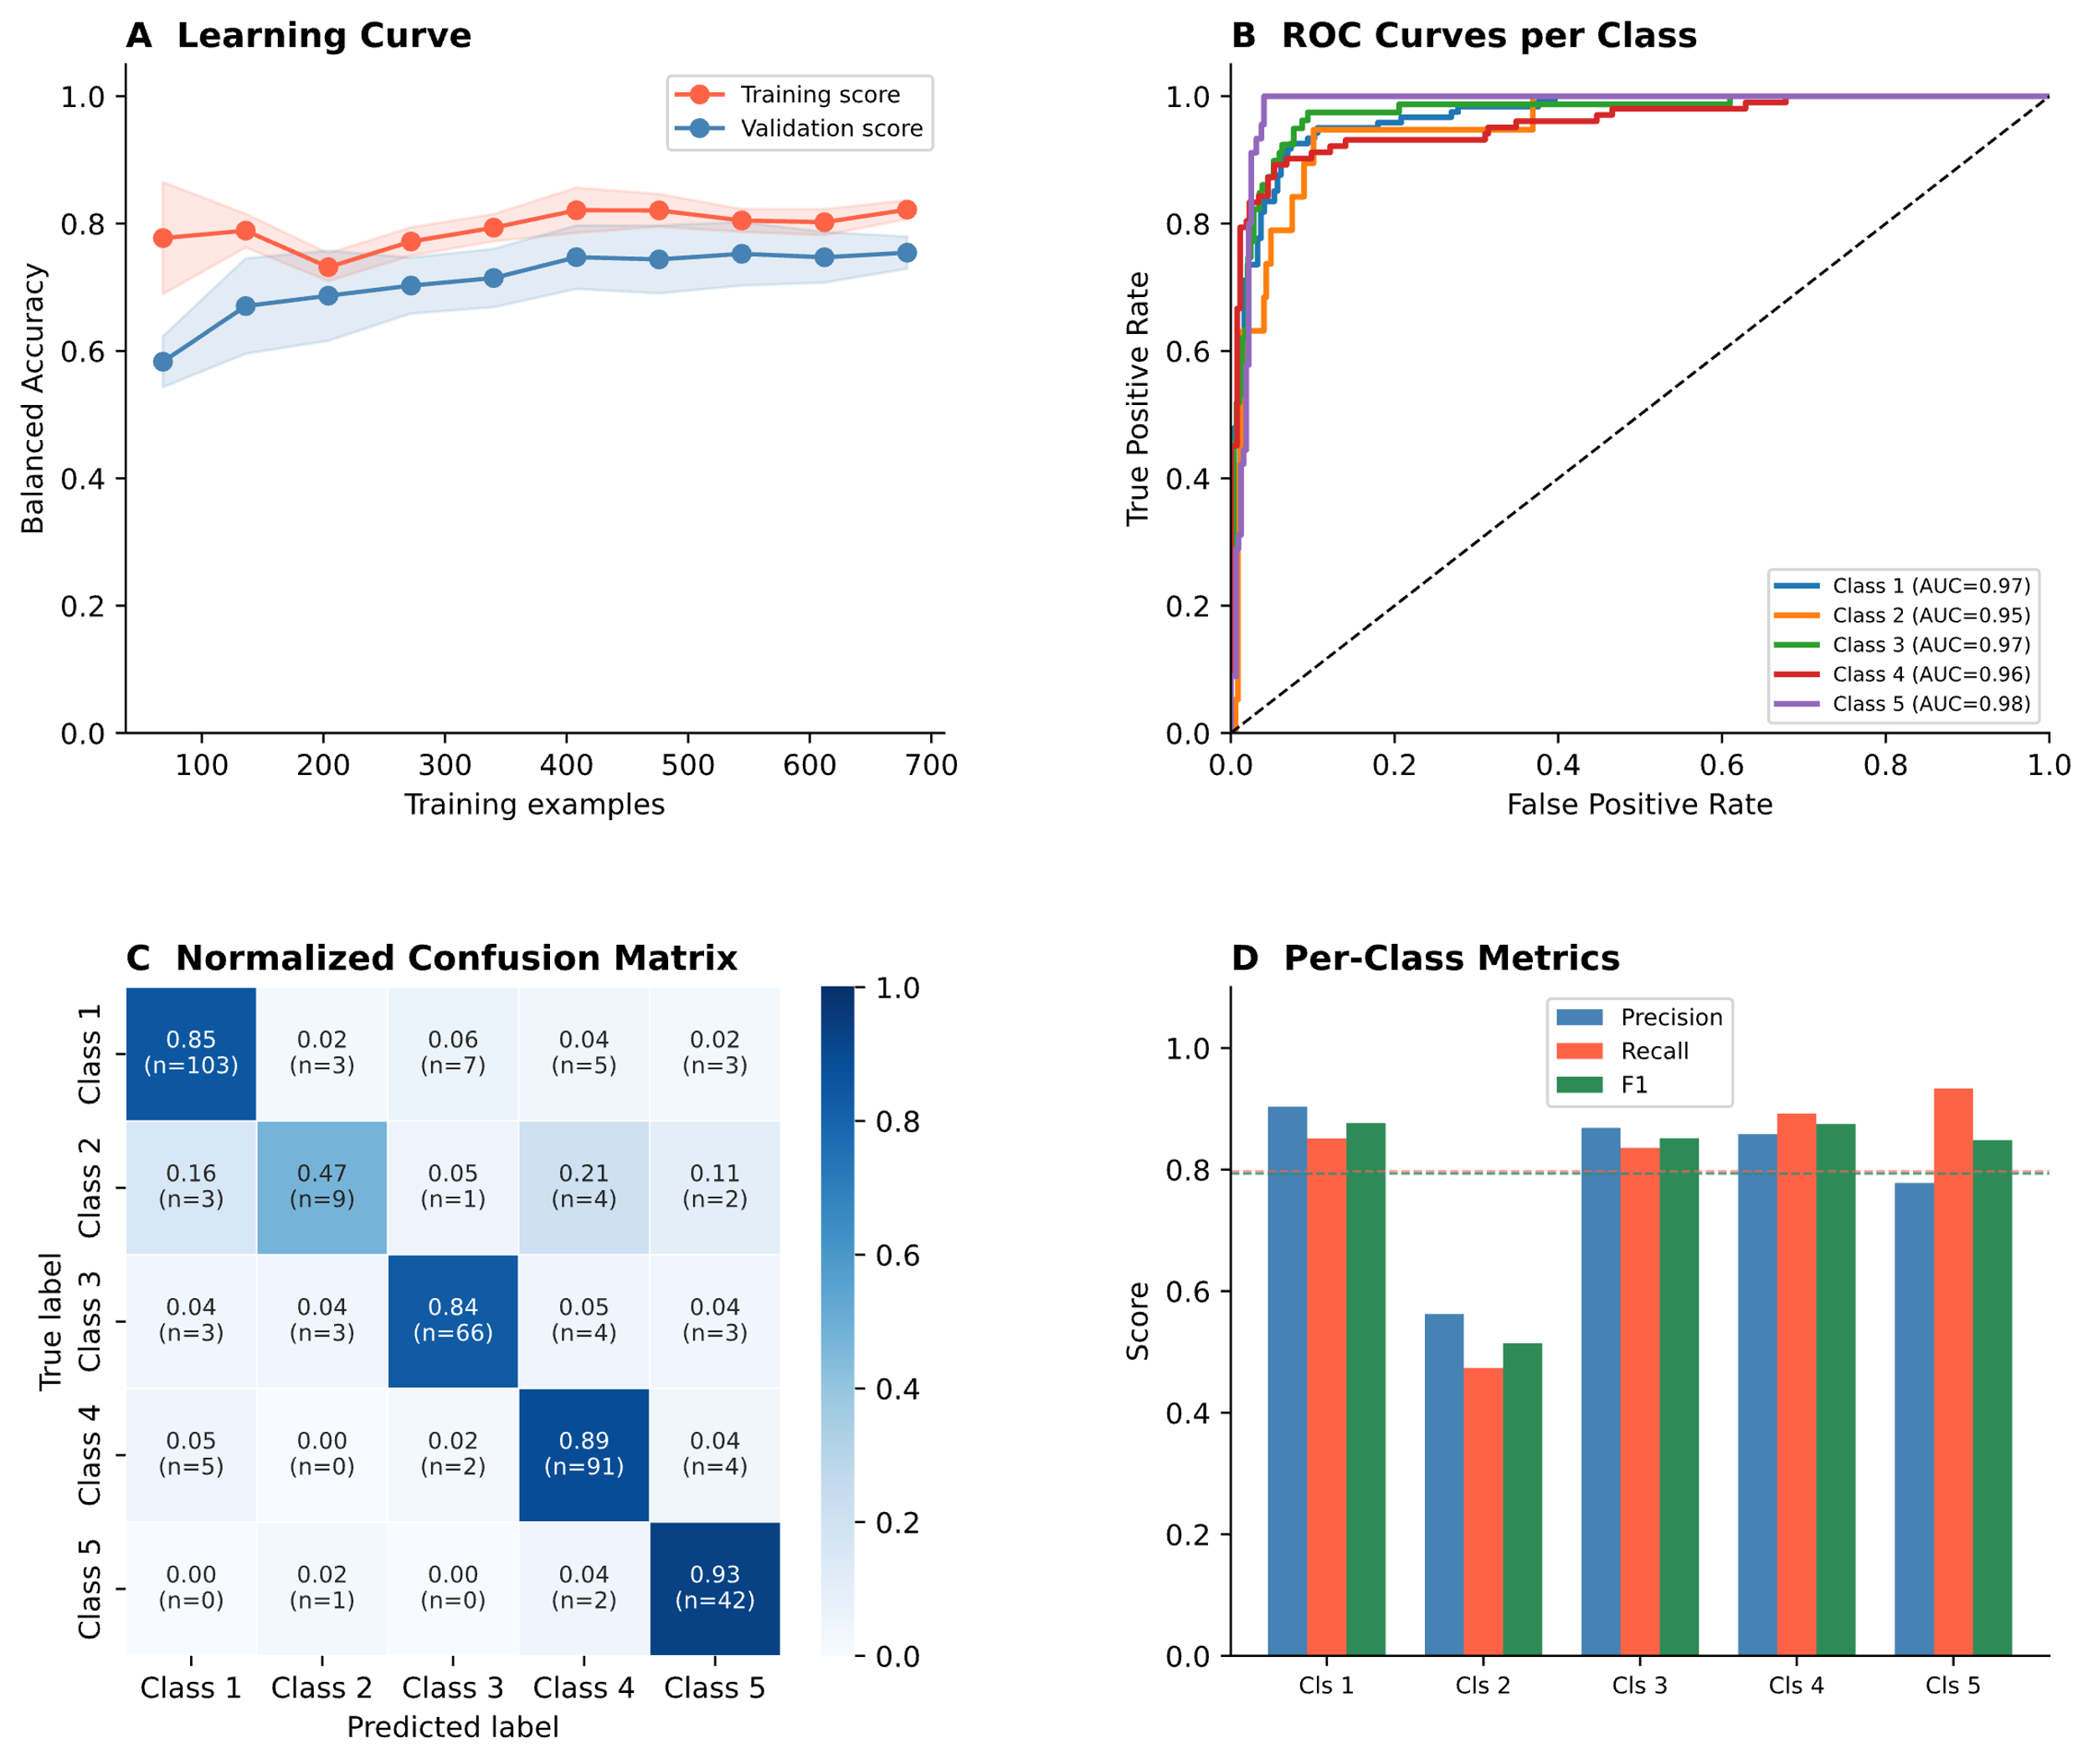
Supplementary Figure S1. SVM classifier performance. (A) Learning curve showing balanced accuracy on training and validation sets across increasing training sample sizes; shading indicates ±1 SD across cross-validation folds. (B) ROC curves for one-vs-one multiclass classification across all five psychosis subtypes; AUC values ranged from 0.95 to 0.98. (C) Normalized confusion matrix on the held-out test set; diagonal values reflect proportion correctly classified per class, with absolute counts in parentheses. (D) Per-class precision, recall, and F1 scores; dashed line indicates 0.80. Class 5 (severe psychosis subtype) achieved the highest AUC (0.98), precision (0.79), recall (0.93), and F1 (0.85).

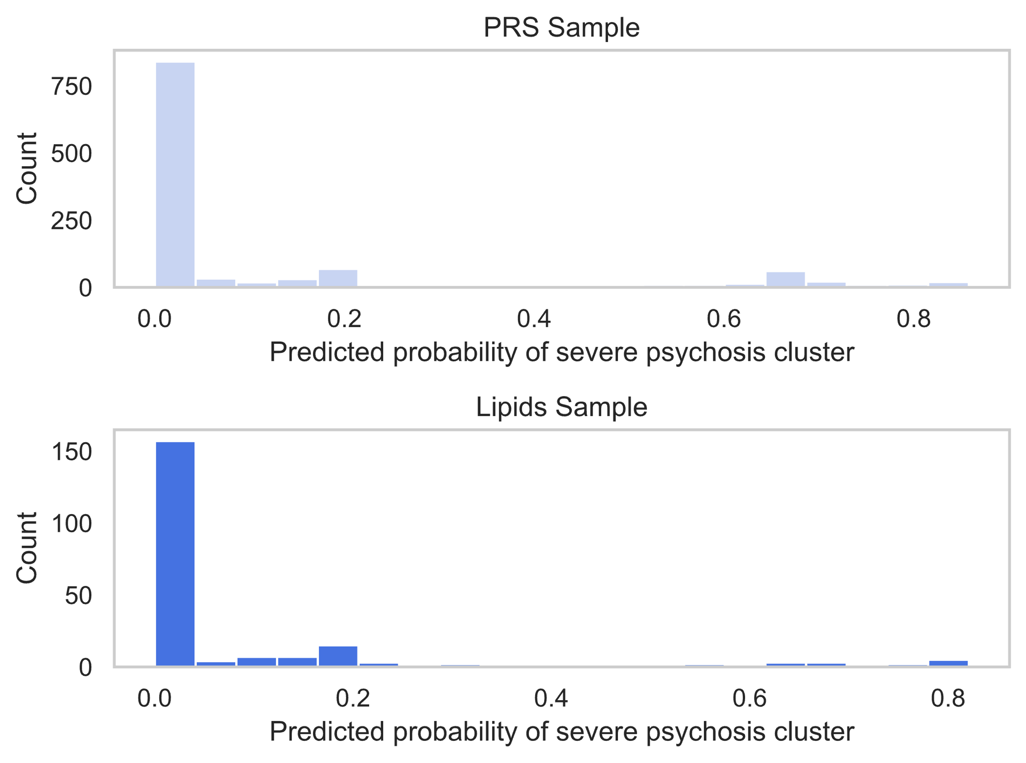
Supplementary Figure S2. Distribution of predicted probability of severe psychosis probability in the PRS sample (n=1,190) and the lipid subsample (n=428). Histograms show the distribution of machine-learning-derived severe psychosis subtype probability scores (0–1) in the PRS sample (n=1,190; top) and the lipidomics subset (n=428; bottom). The right-skewed distribution reflects the low base rate of the severe psychosis subtype in the transdiagnostic PsyCourse cohort. Scores were generated by a calibrated support vector machine classifier replicating the previously identified severe psychosis subtype (1).

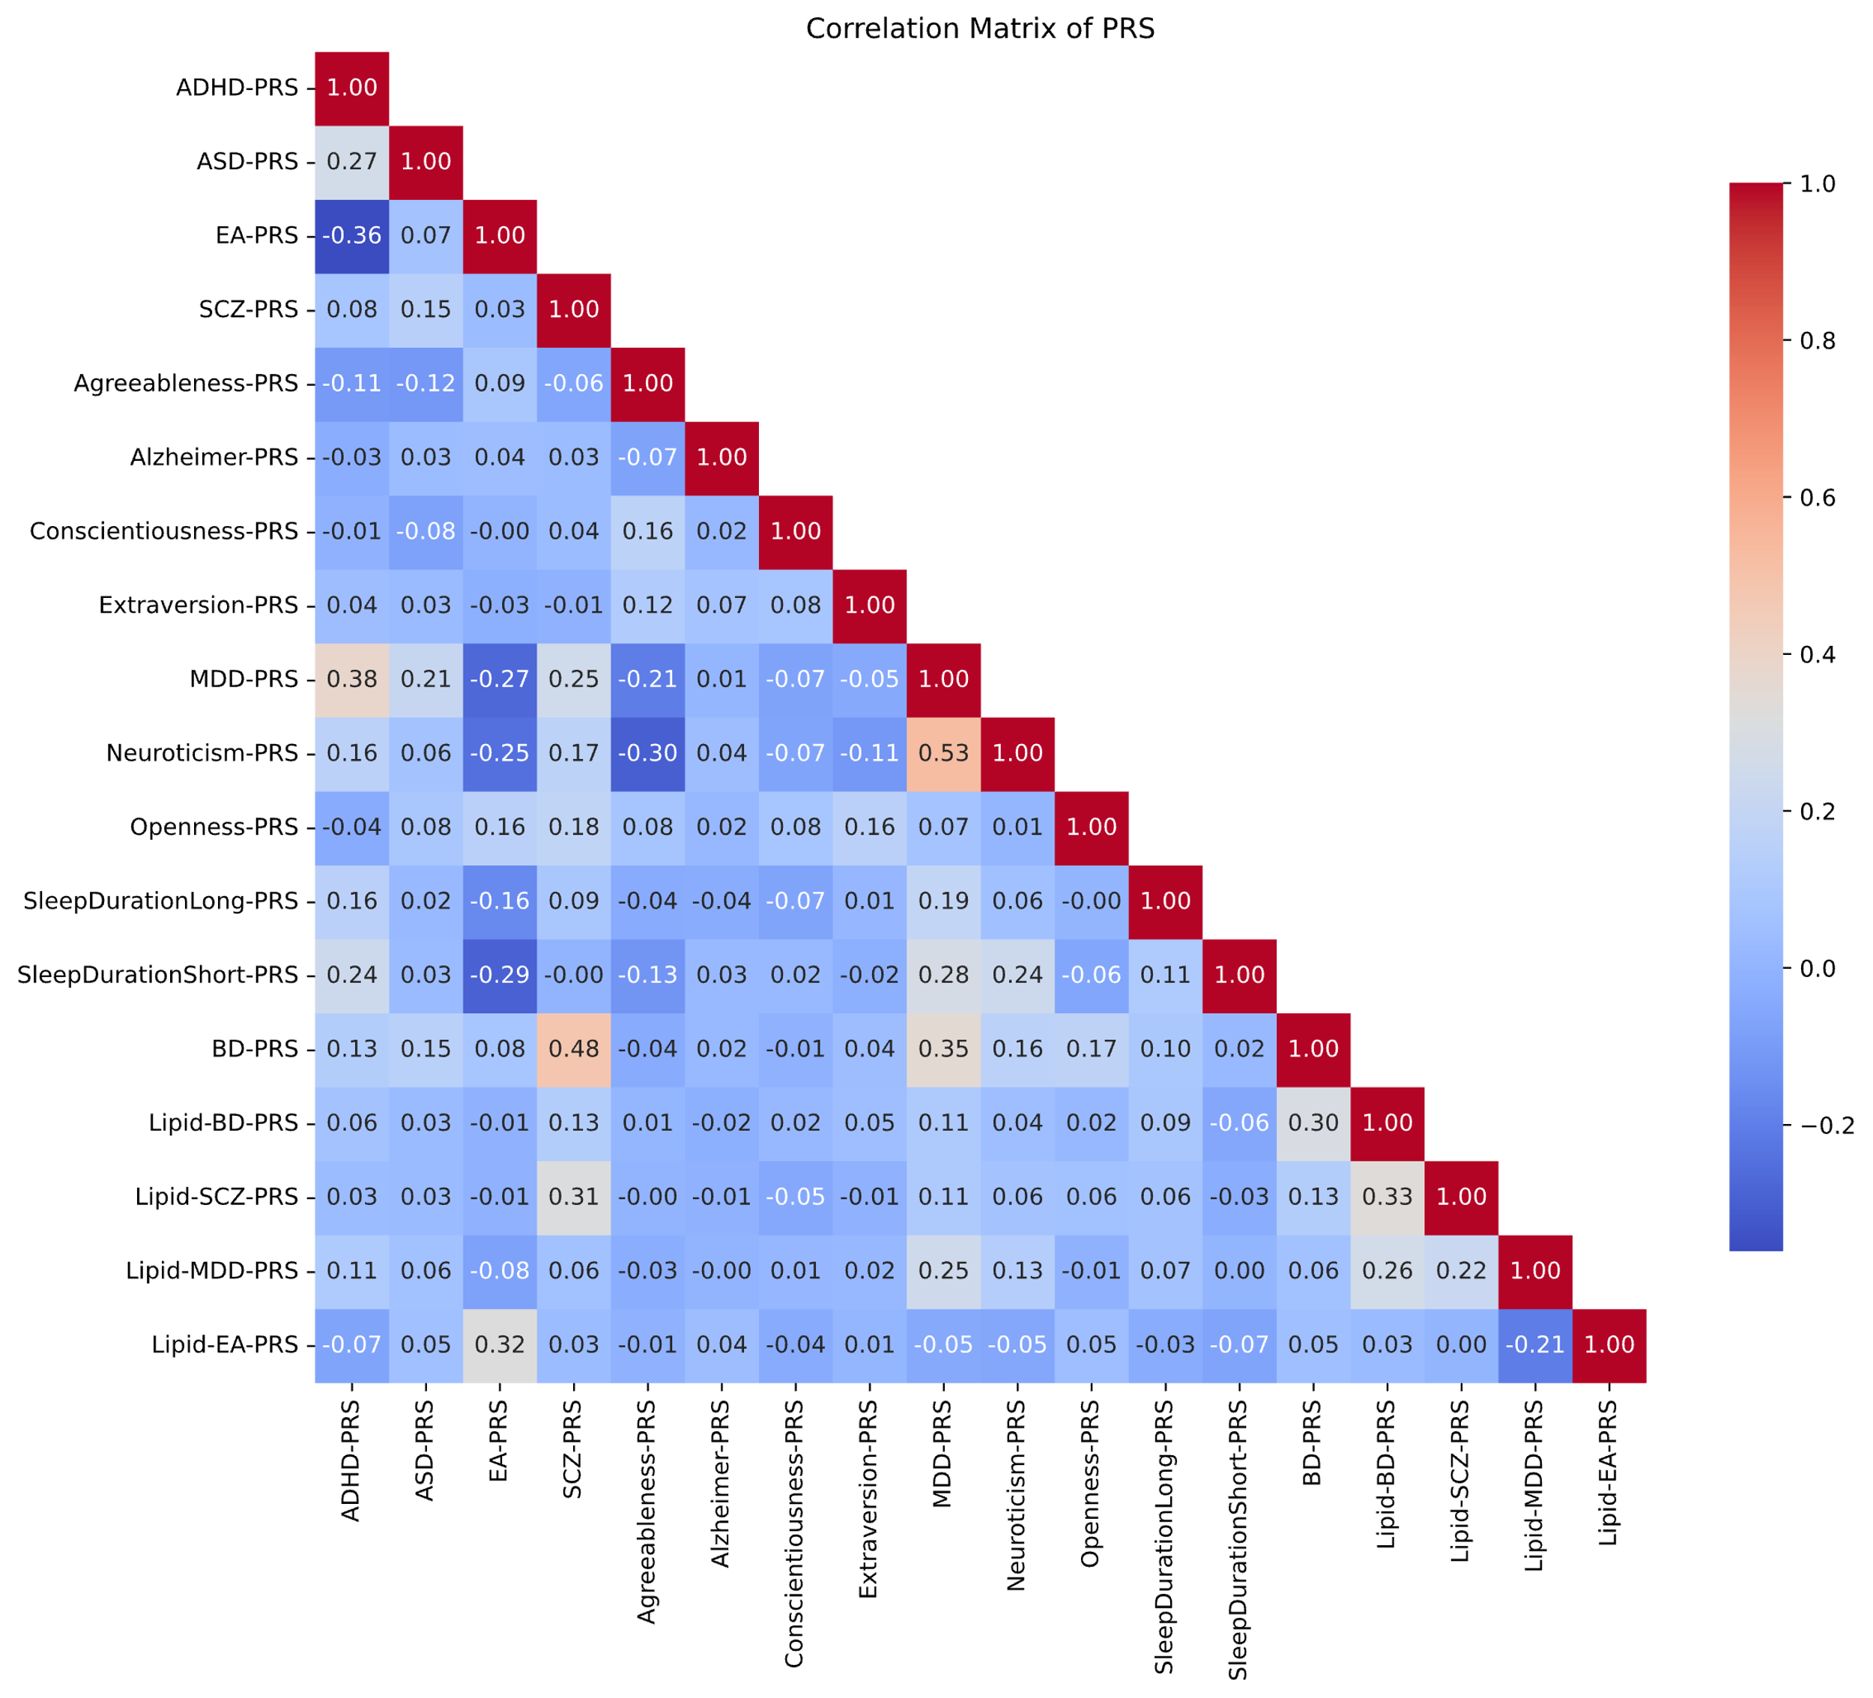
Supplementary Figure S3. Correlation matrix of polygenic risk scores. Pearson correlations between all 14 PRS included in the primary analysis and their four lipid-restricted counterparts (prefixed "Lipid_"). Color intensity reflects correlation magnitude; red = positive, blue = negative. Notable correlations include MDD-PRS and Neuroticism-PRS (r=0.53), SCZ-PRS and BD-PRS (r=0.48), and moderate correlations between each full PRS and its lipid-restricted counterpart (r=0.25–0.33).
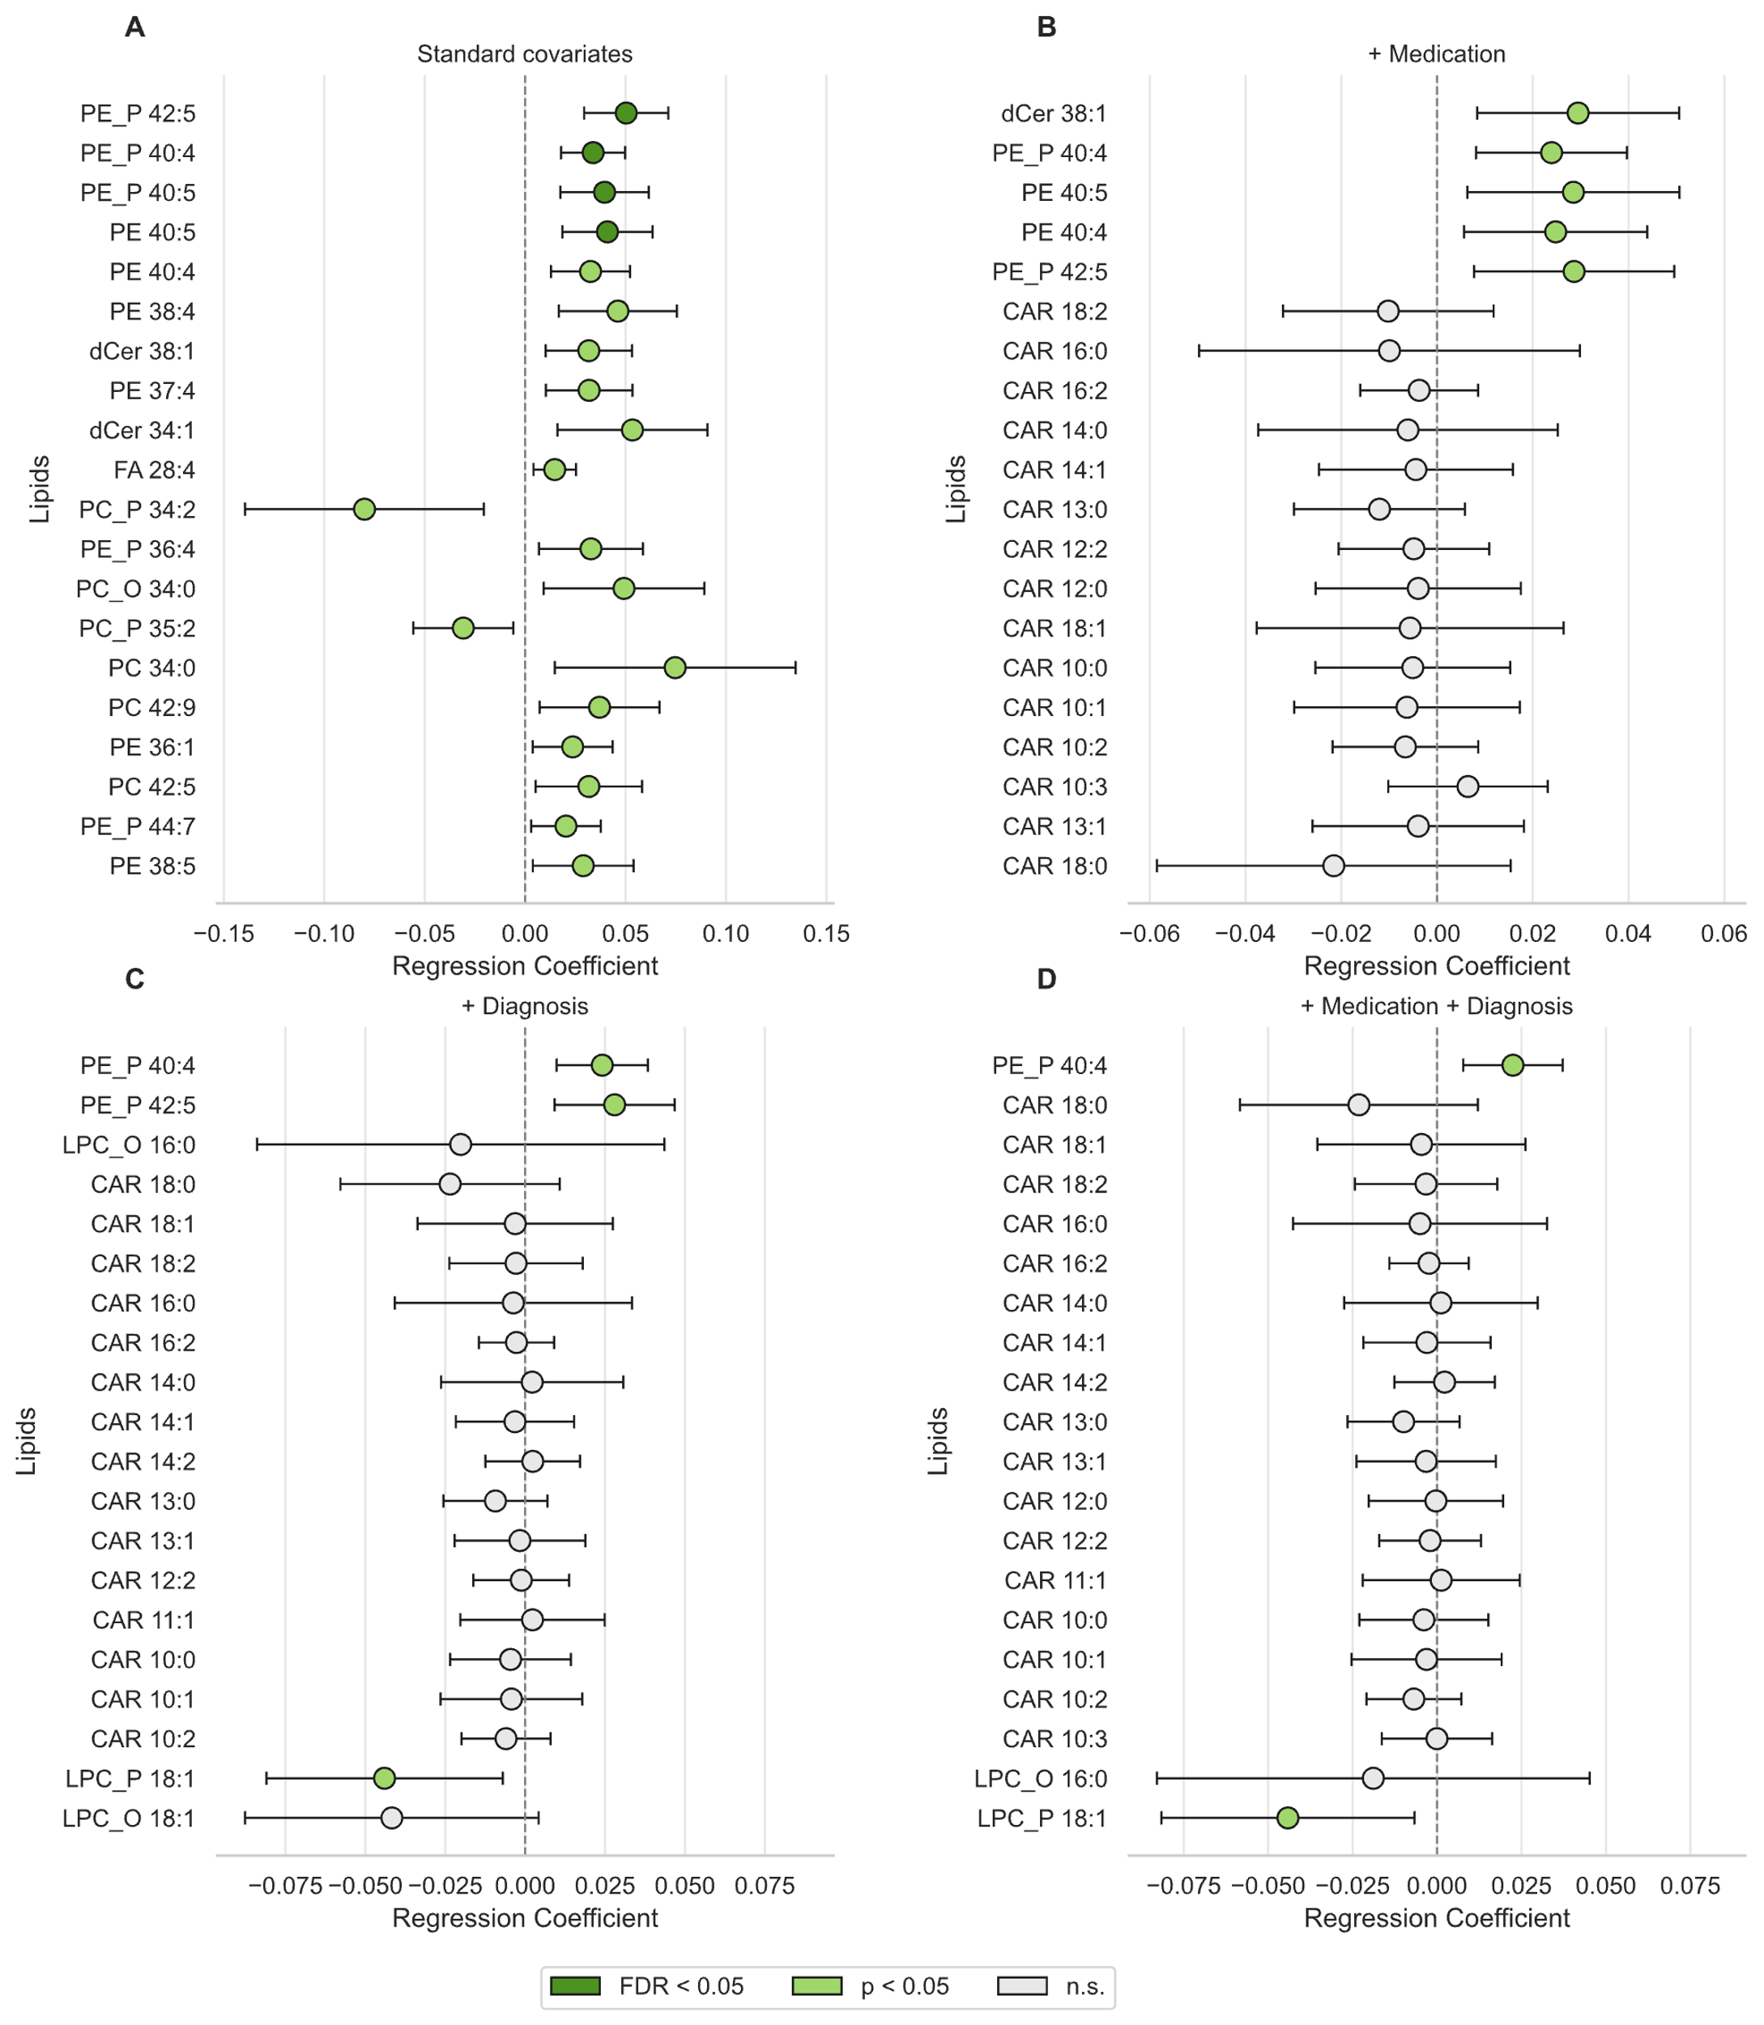
Supplementary Figure S4. Lipid species associations with severe psychosis subtype probability across sensitivity models. Forest plots show OLS regression coefficients (β) with 95% confidence intervals for the top 20 lipid species by absolute effect size in each model. Fill color indicates significance: dark green, FDR < 0.05; light green, p < 0.05 uncorrected; open, not significant. (A) Primary model, adjusted for age, sex, BMI, duration of illness, and smoking status. (B) Additionally adjusted for number of medications. (C) Additionally adjusted for diagnosis. (D) Additionally adjusted for both medication and diagnosis. Full results are in Supplemental Tables 6-9.
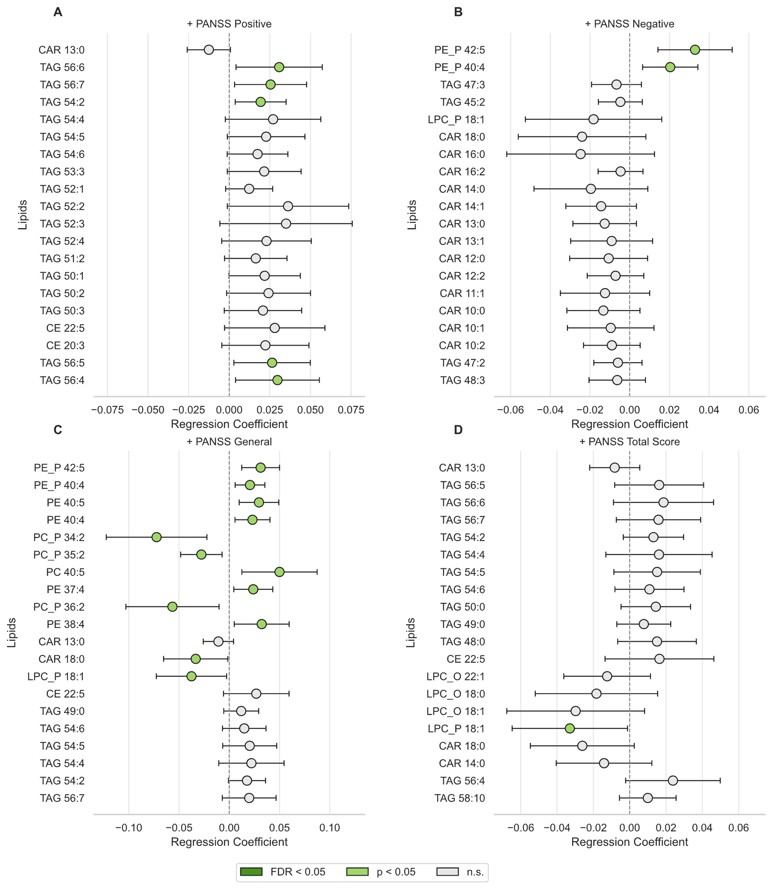
Supplementary Figure S5. Lipid species associations with PANSS subscale scores as covariates. Forest plots show OLS regression coefficients (β) with 95% confidence intervals for the top 20 lipid species by absolute effect size, with PANSS positive (A), negative (B), general (C), and total (D) subscale scores as the outcome variable. All models adjusted for age, sex, BMI, duration of illness, and smoking status. Fill color indicates significance: dark green, FDR < 0.05; light green, p < 0.05 uncorrected; open, not significant.

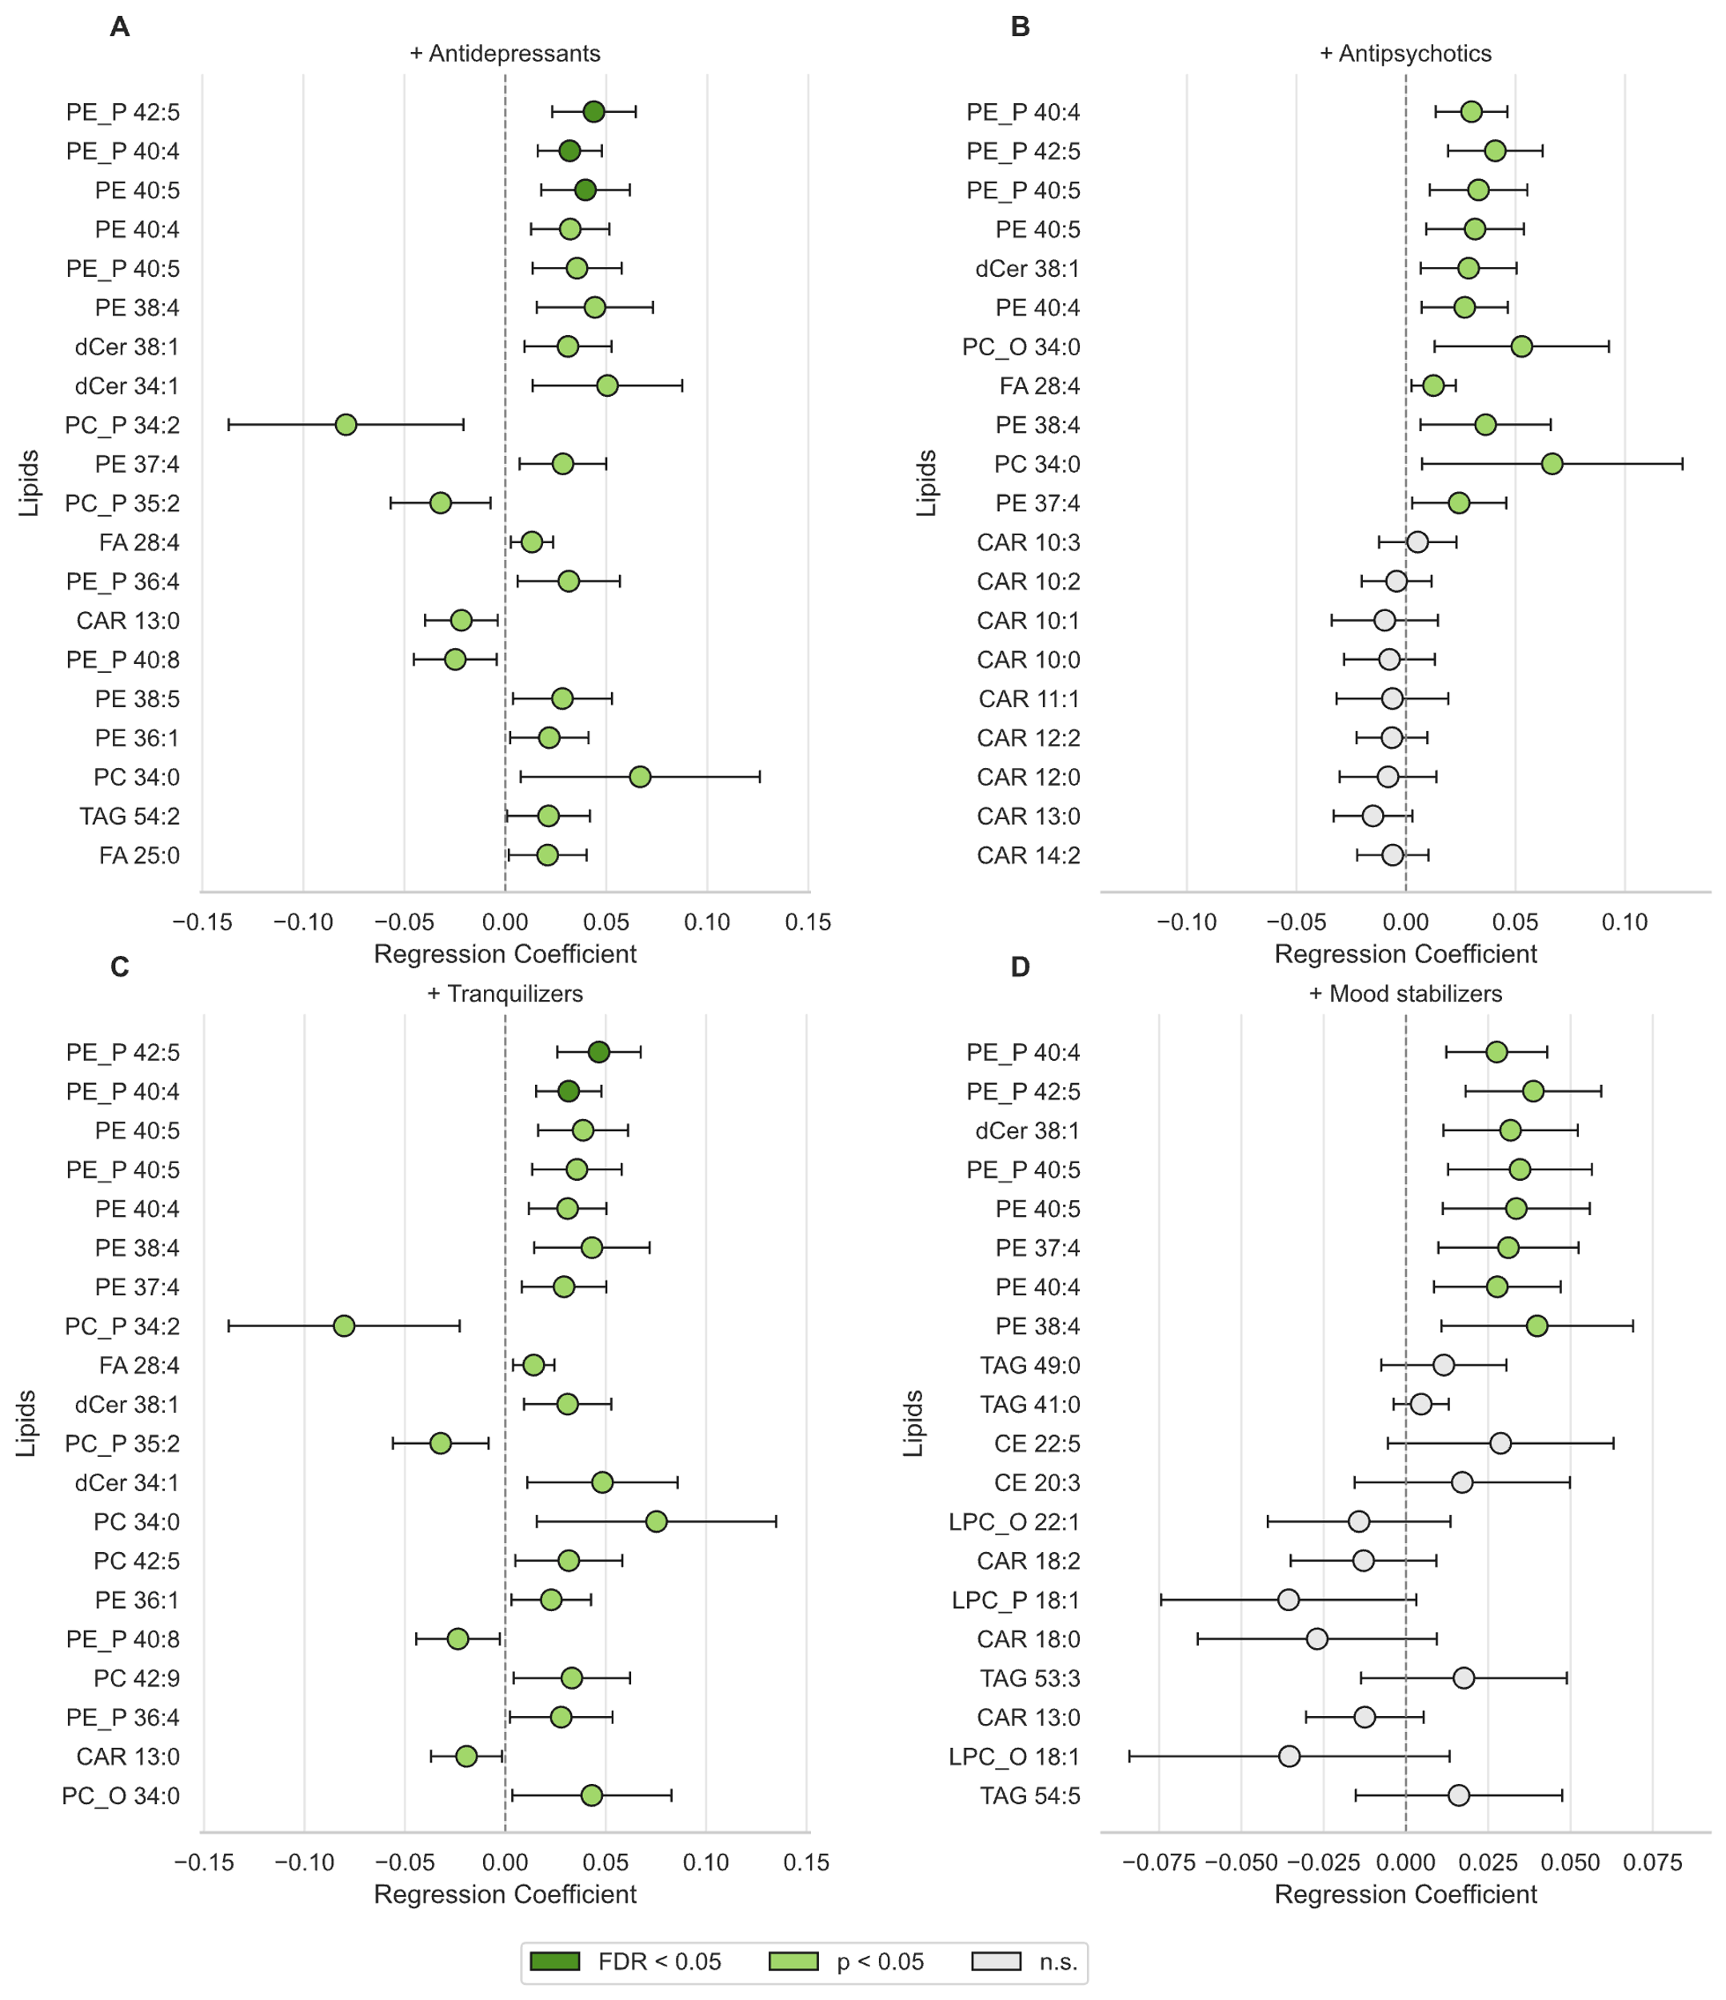
Supplementary Figure S6. Lipid species associations with the number of medications as covariates. Boxplots show distributions of species-level OLS regression coefficients (β) grouped by lipid class, from models additionally adjusting for (A), antidepressants (B), antipsychotics (C) tranquilizers and (D) mood stabilizers as covariates (alongside age, sex, BMI, duration of illness, and smoking status). Dark green boxes indicate lipid classes with FDR-significant enrichment (q < 0.05) from permutation-based enrichment analysis (5,000 permutations); open boxes indicate non-significant classes. The dashed line indicates β = 0; outliers shown as individual points.

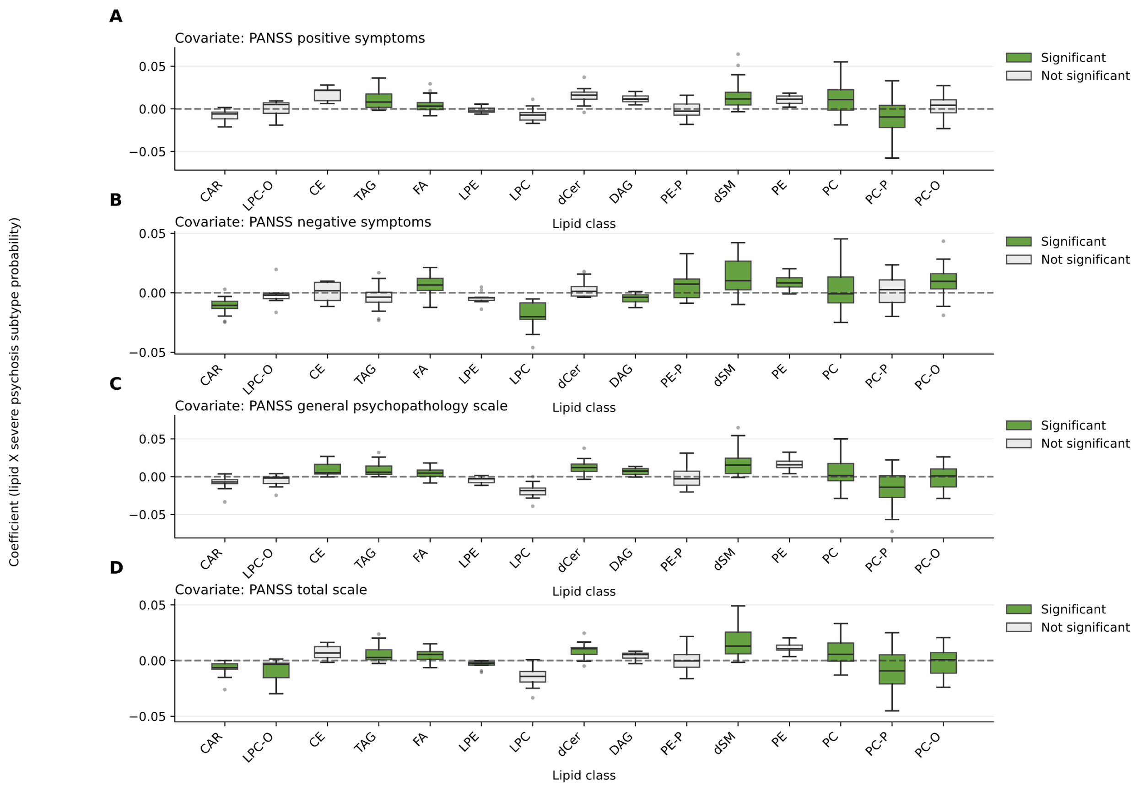
Supplementary Figure S7. Lipid class enrichment in severe psychosis subtype probability after adjustment for PANSS subscales. Boxplots show distributions of species-level OLS regression coefficients (β) grouped by lipid class, from models additionally adjusting for PANSS positive (A), negative (B), general (C), and total (D) subscale scores as covariates (alongside age, sex, BMI, duration of illness, and smoking status). Dark green boxes indicate lipid classes with FDR-significant enrichment (q < 0.05) from permutation-based enrichment analysis (5,000 permutations); open boxes indicate non-significant classes. The dashed line indicates β = 0; outliers shown as individual points.

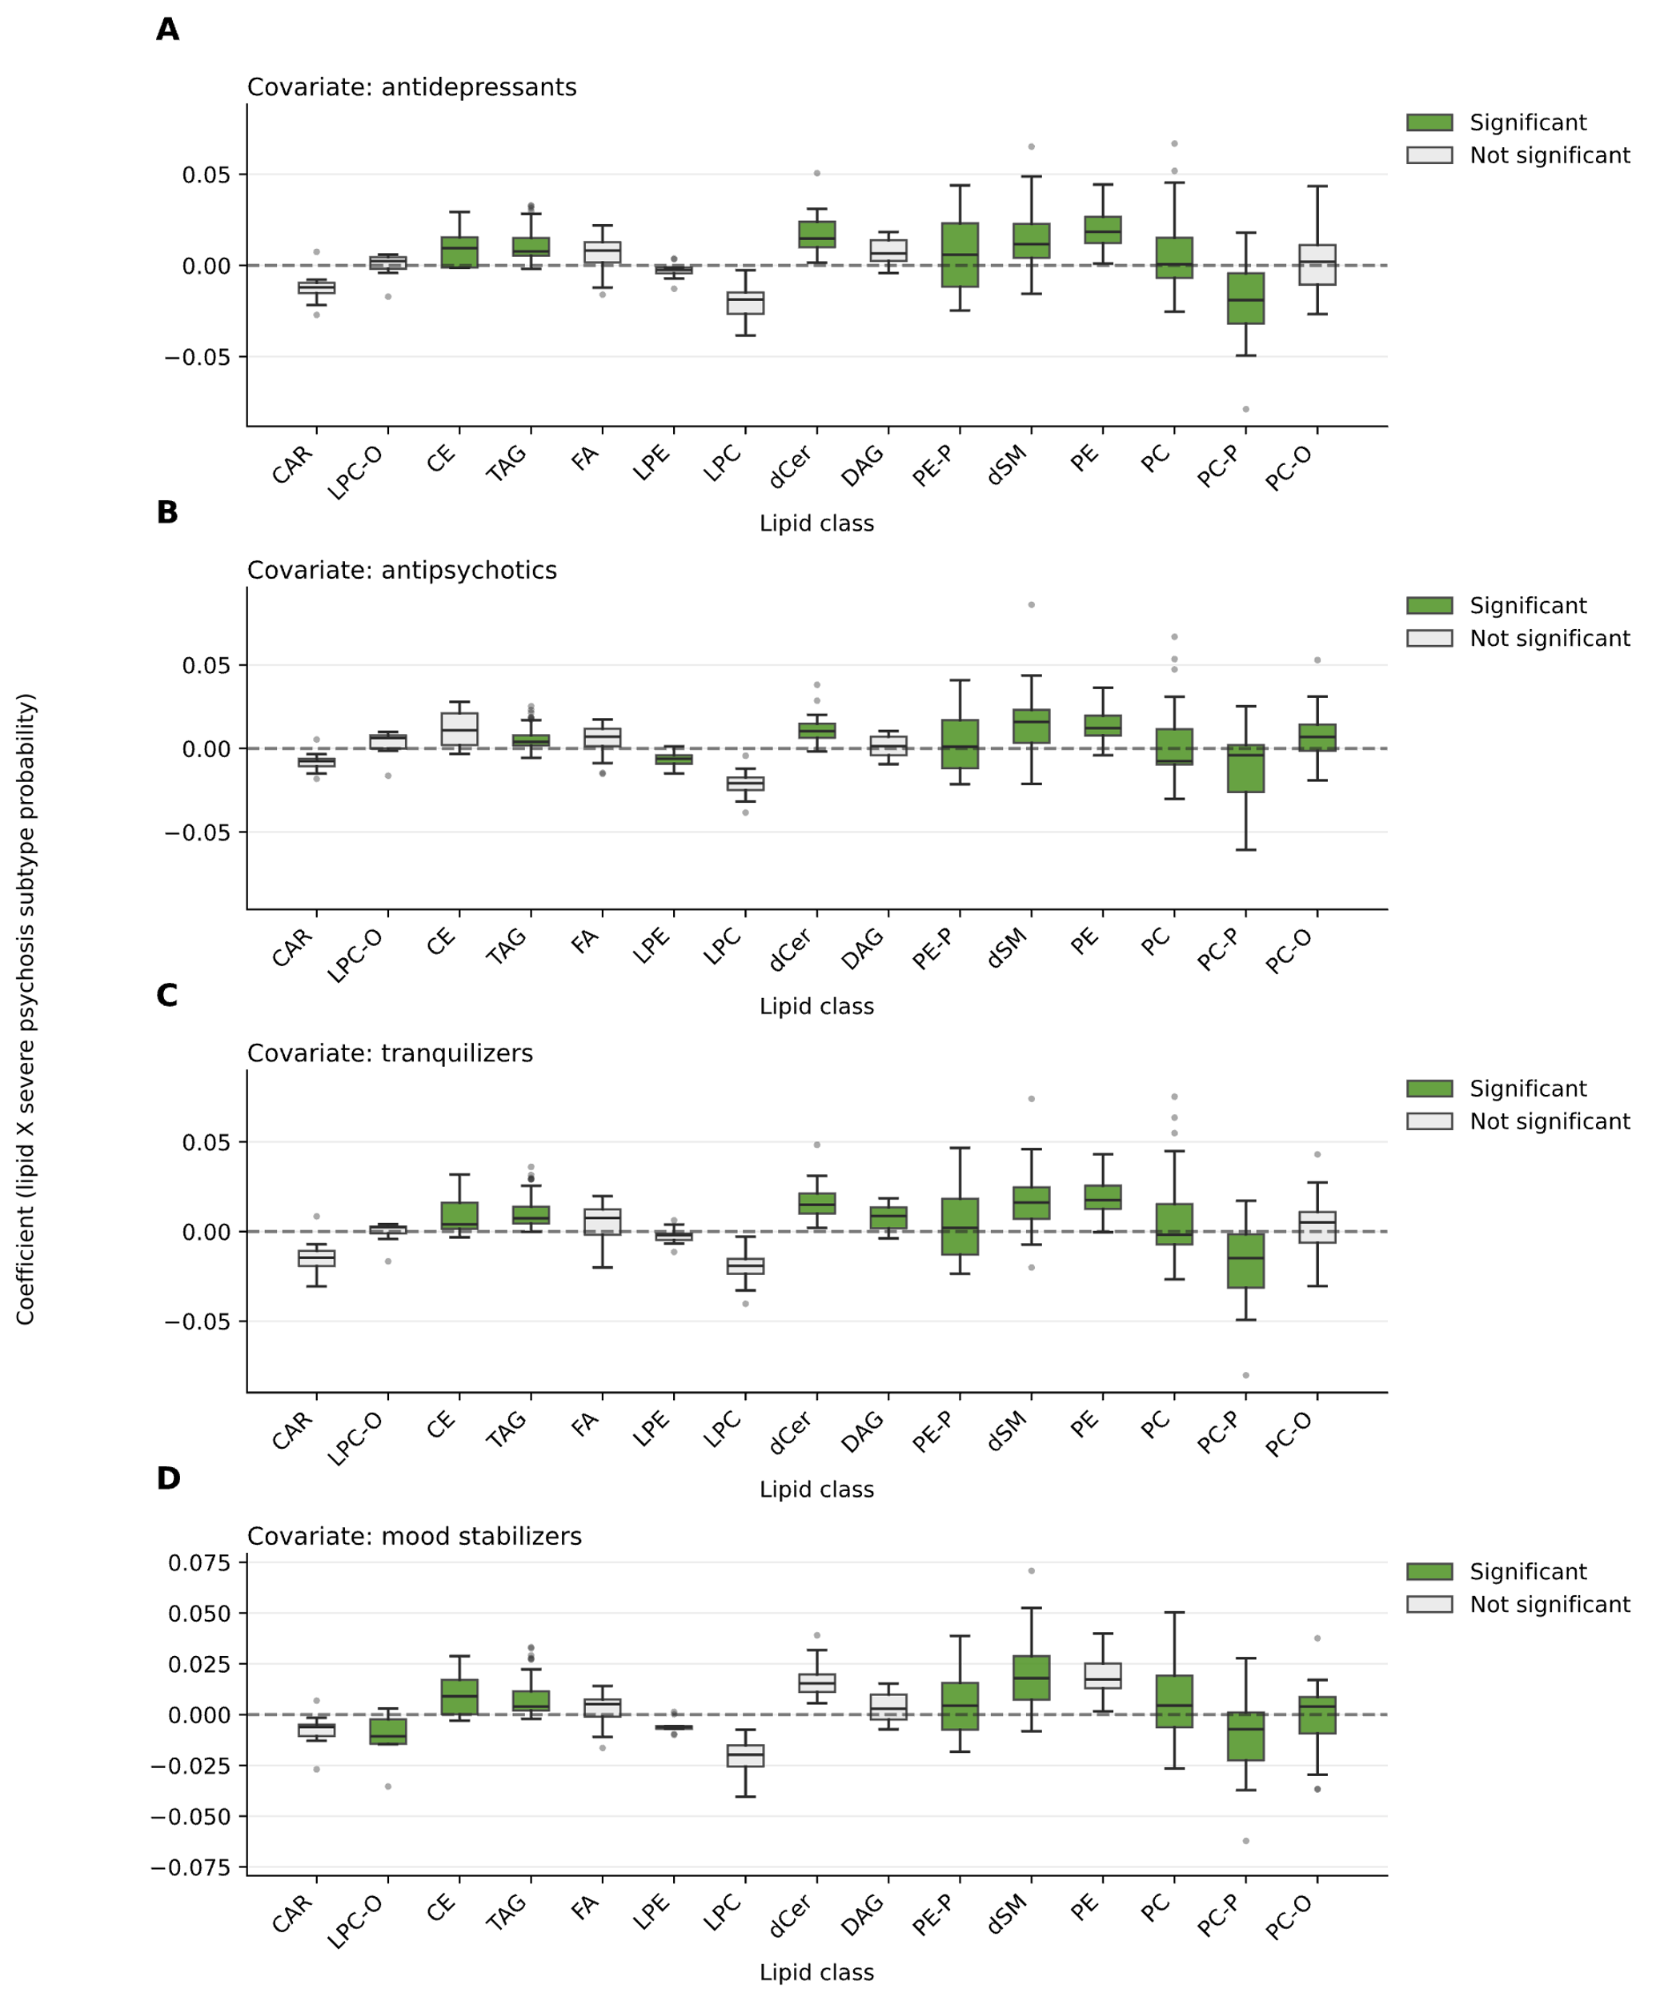
Supplementary Figure S8. Lipid class enrichment in severe psychosis subtype probability after adjustment for number of medications per class. Boxplots show distributions of species-level OLS regression coefficients (β) grouped by lipid class, from models additionally adjusting for antidepressants (A) antipsychotics (B), tranquilizers (C), and mood stabilizers (D) as covariates (alongside age, sex, BMI, duration of illness, and smoking status). Dark green boxes indicate lipid classes with FDR-significant enrichment (q < 0.05) from permutation-based enrichment analysis (5,000 permutations); open boxes indicate non-significant classes. The dashed line indicates β = 0; outliers shown as individual points.

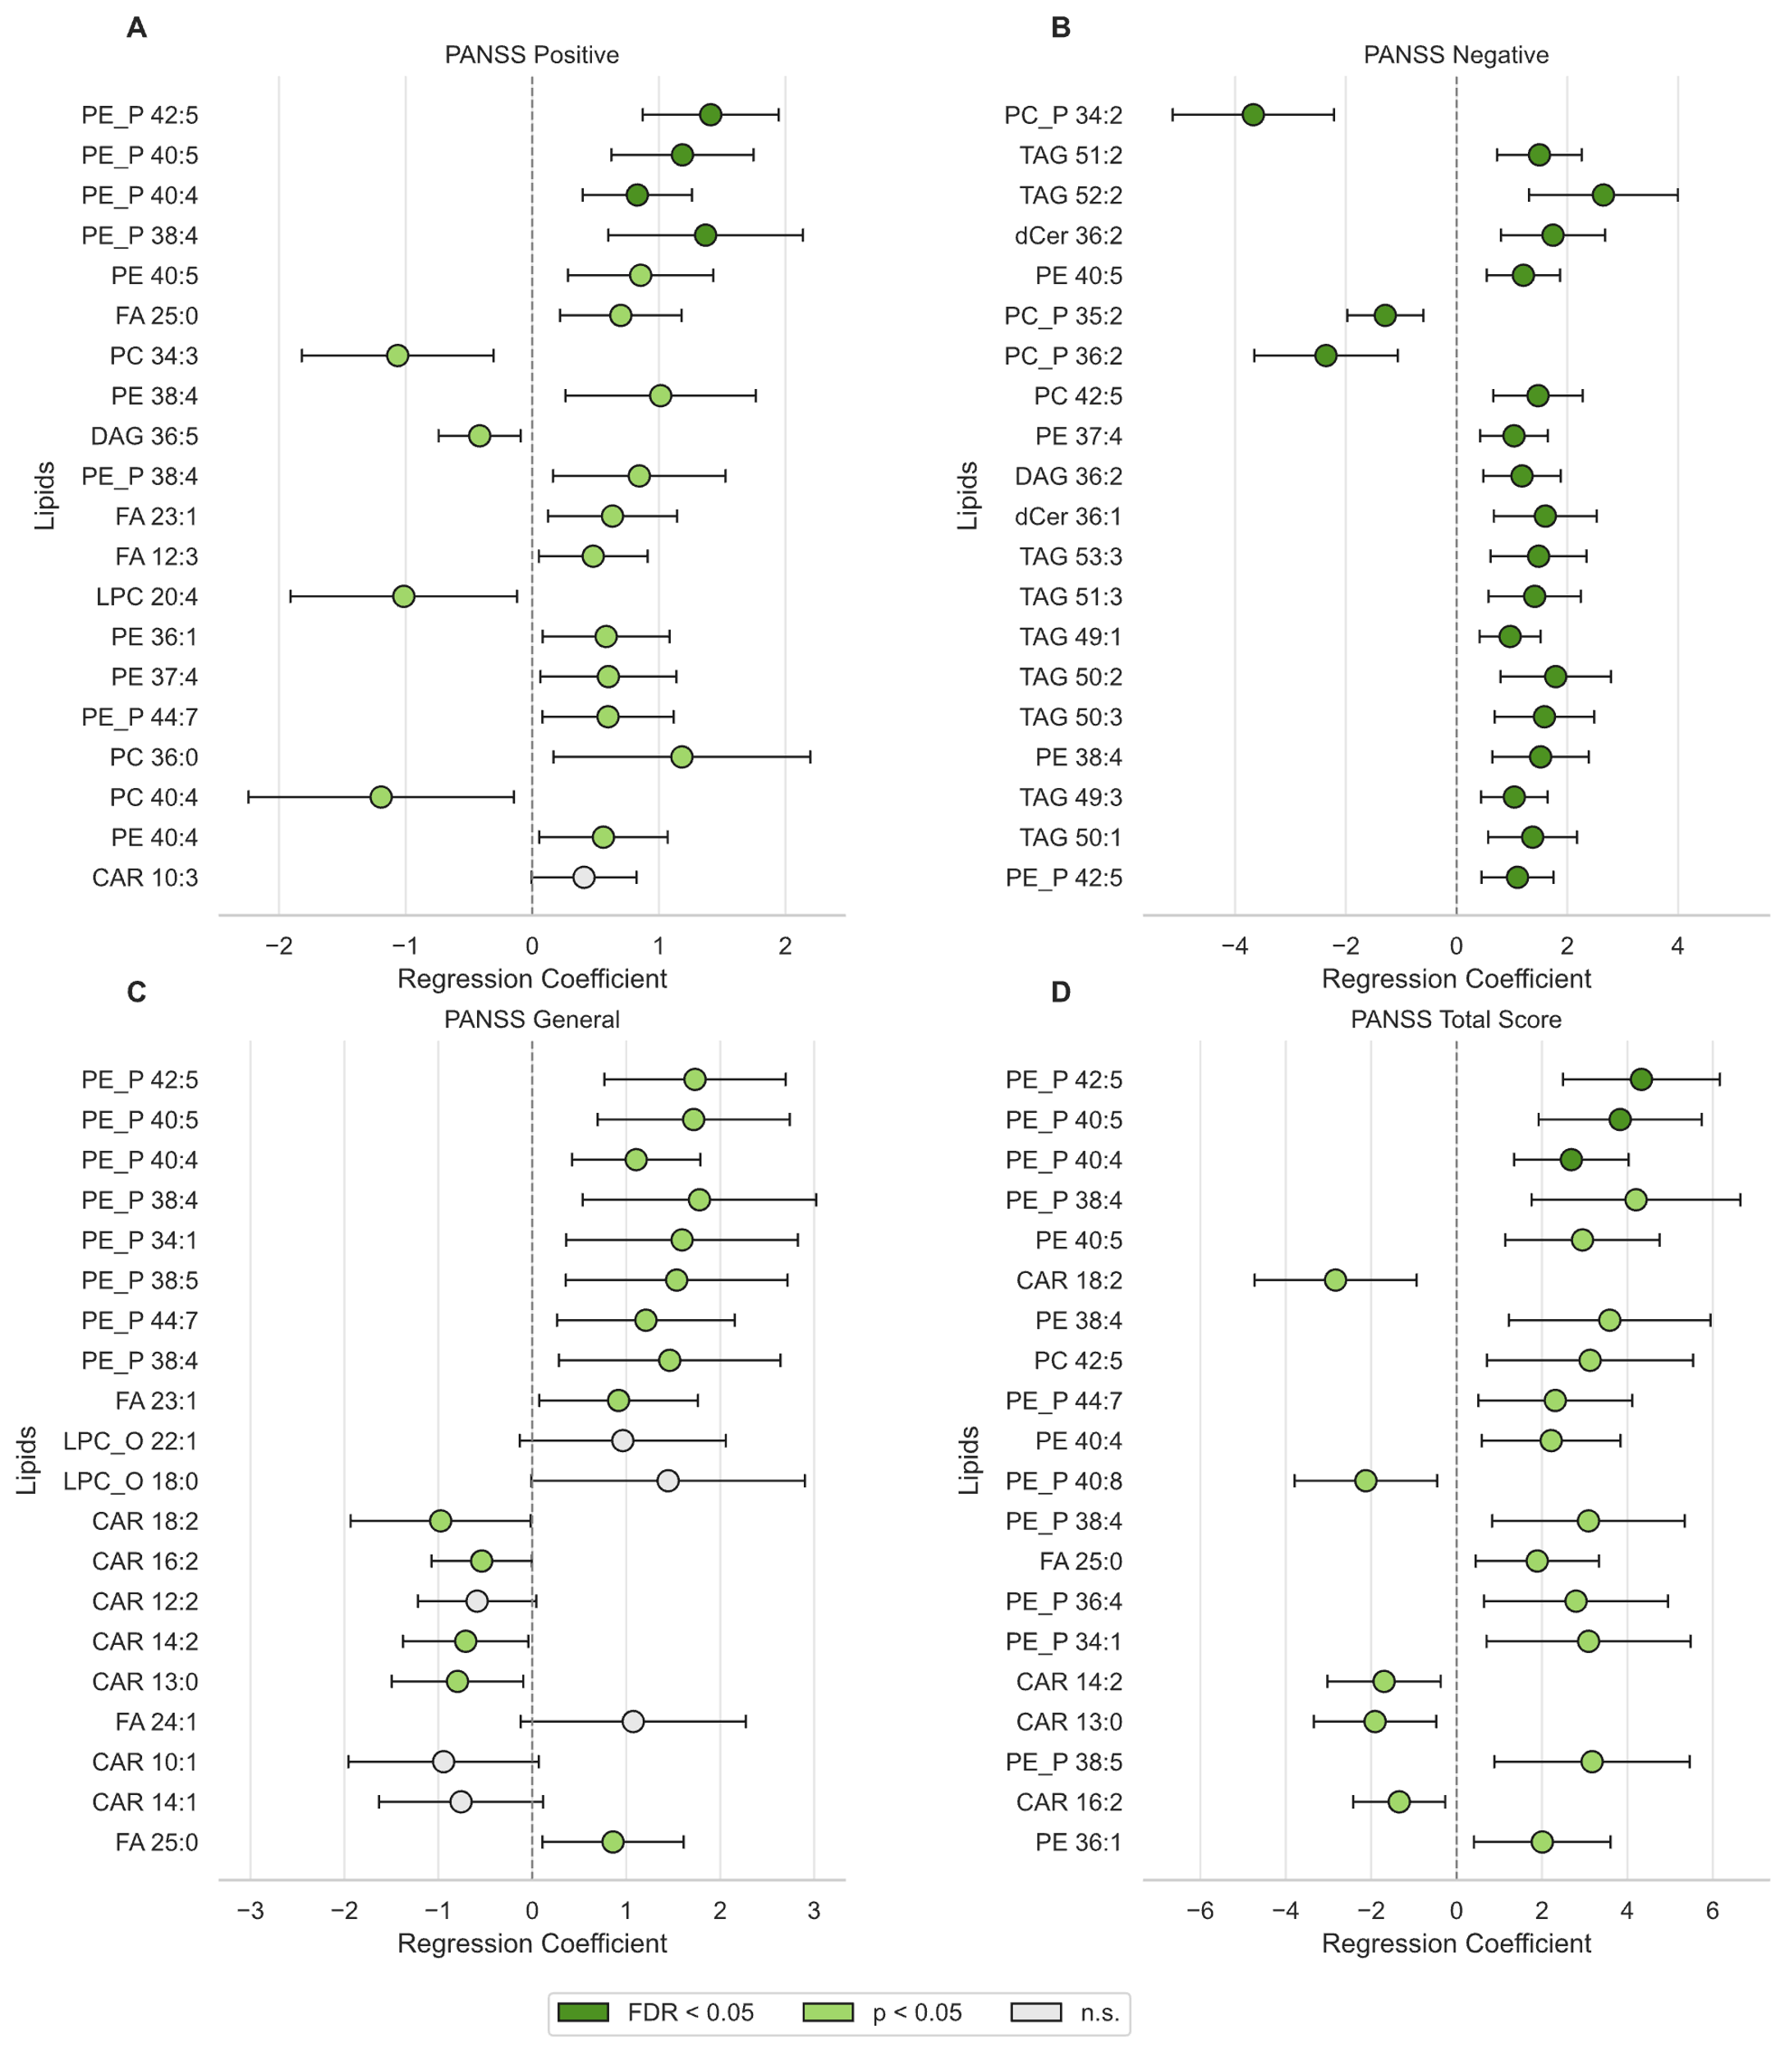
Supplementary Figure S9. Lipid species associations with PANSS subscale scores as primary outcomes. Forest plots show OLS regression coefficients (β) with 95% confidence intervals for the top 20 lipid species by absolute effect size, with PANSS positive (A), negative (B), general (C), and total (D) subscale scores as the outcome variable. All models adjusted for age, sex, BMI, duration of illness, and smoking status. Fill color indicates significance: dark green, FDR < 0.05; light green, p < 0.05 uncorrected; open, not significant. Note the differing x-axis scales across panels. PE-P species dominate positive associations across PANSS general and total scores; TAG species are prominent for PANSS negative; acylcarnitines show negative associations particularly in panels C and D.

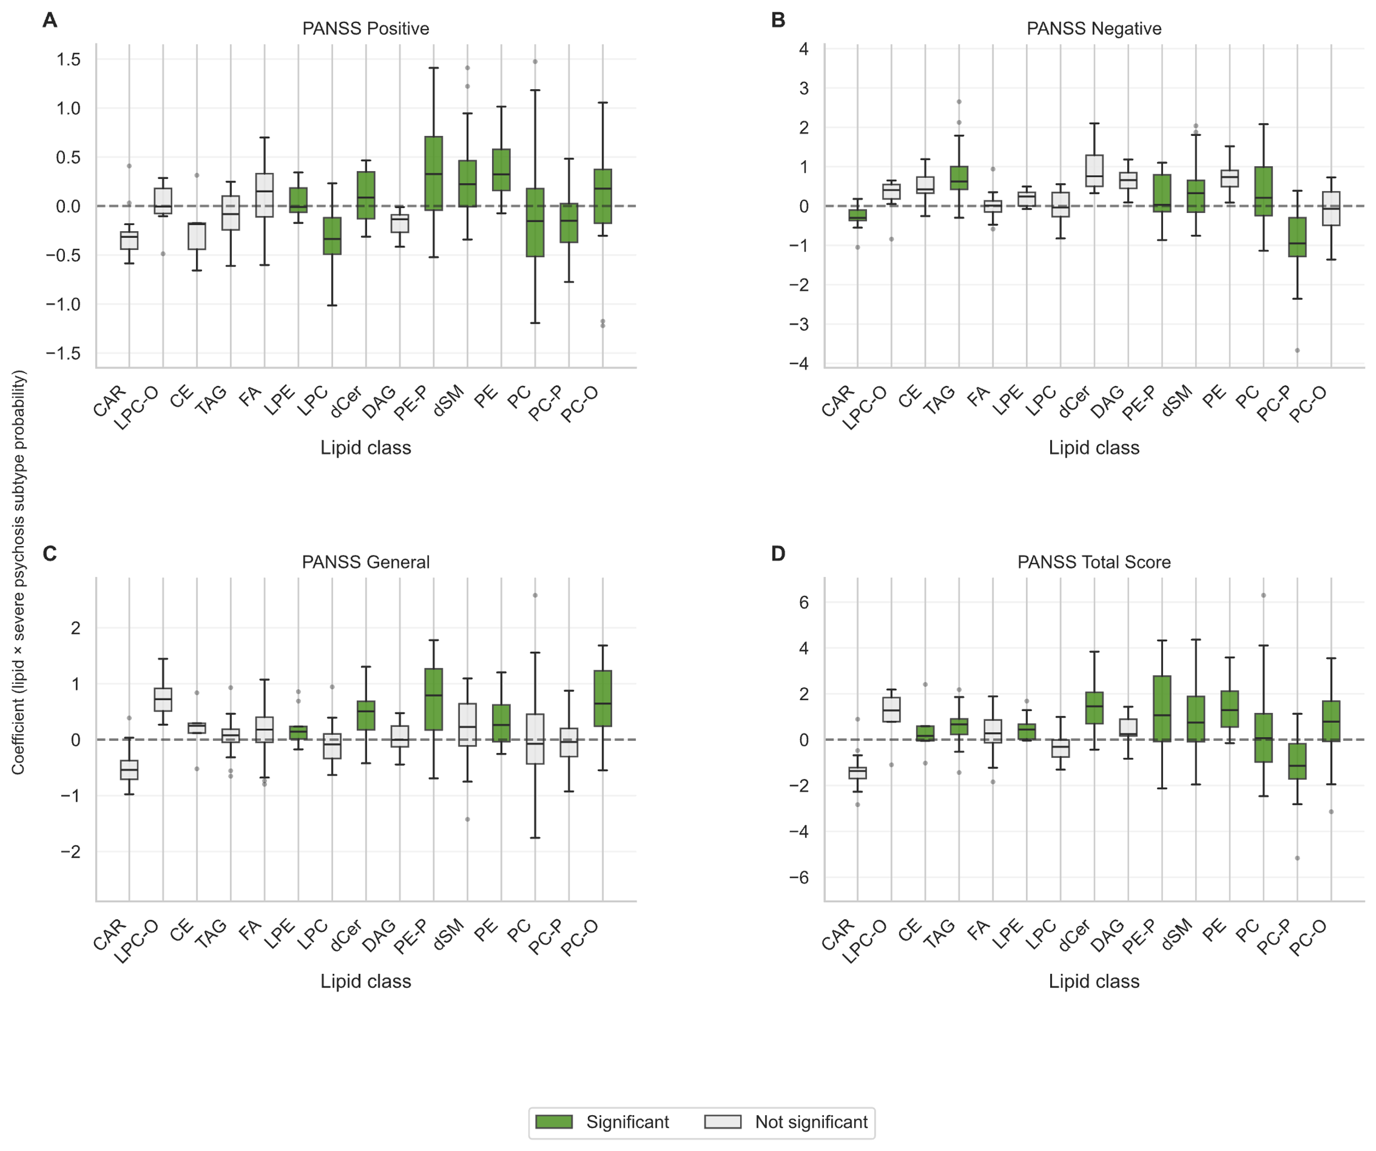
Supplementary Figure S10. Lipid class enrichment with PANSS subscale scores as primary outcomes. Boxplots show distributions of species-level OLS regression coefficients (β) grouped by lipid class, with PANSS positive (A), negative (B), general (C), and total (D) subscale scores as the outcome variable, adjusted for age, sex, BMI, duration of illness, and smoking status. Dark green boxes indicate FDR-significant enrichment (q < 0.05) from permutation-based enrichment analysis (5,000 permutations); open boxes indicate non-significant classes. The dashed line indicates β = 0; outliers shown as individual points. Note differing y-axis scales across panels.
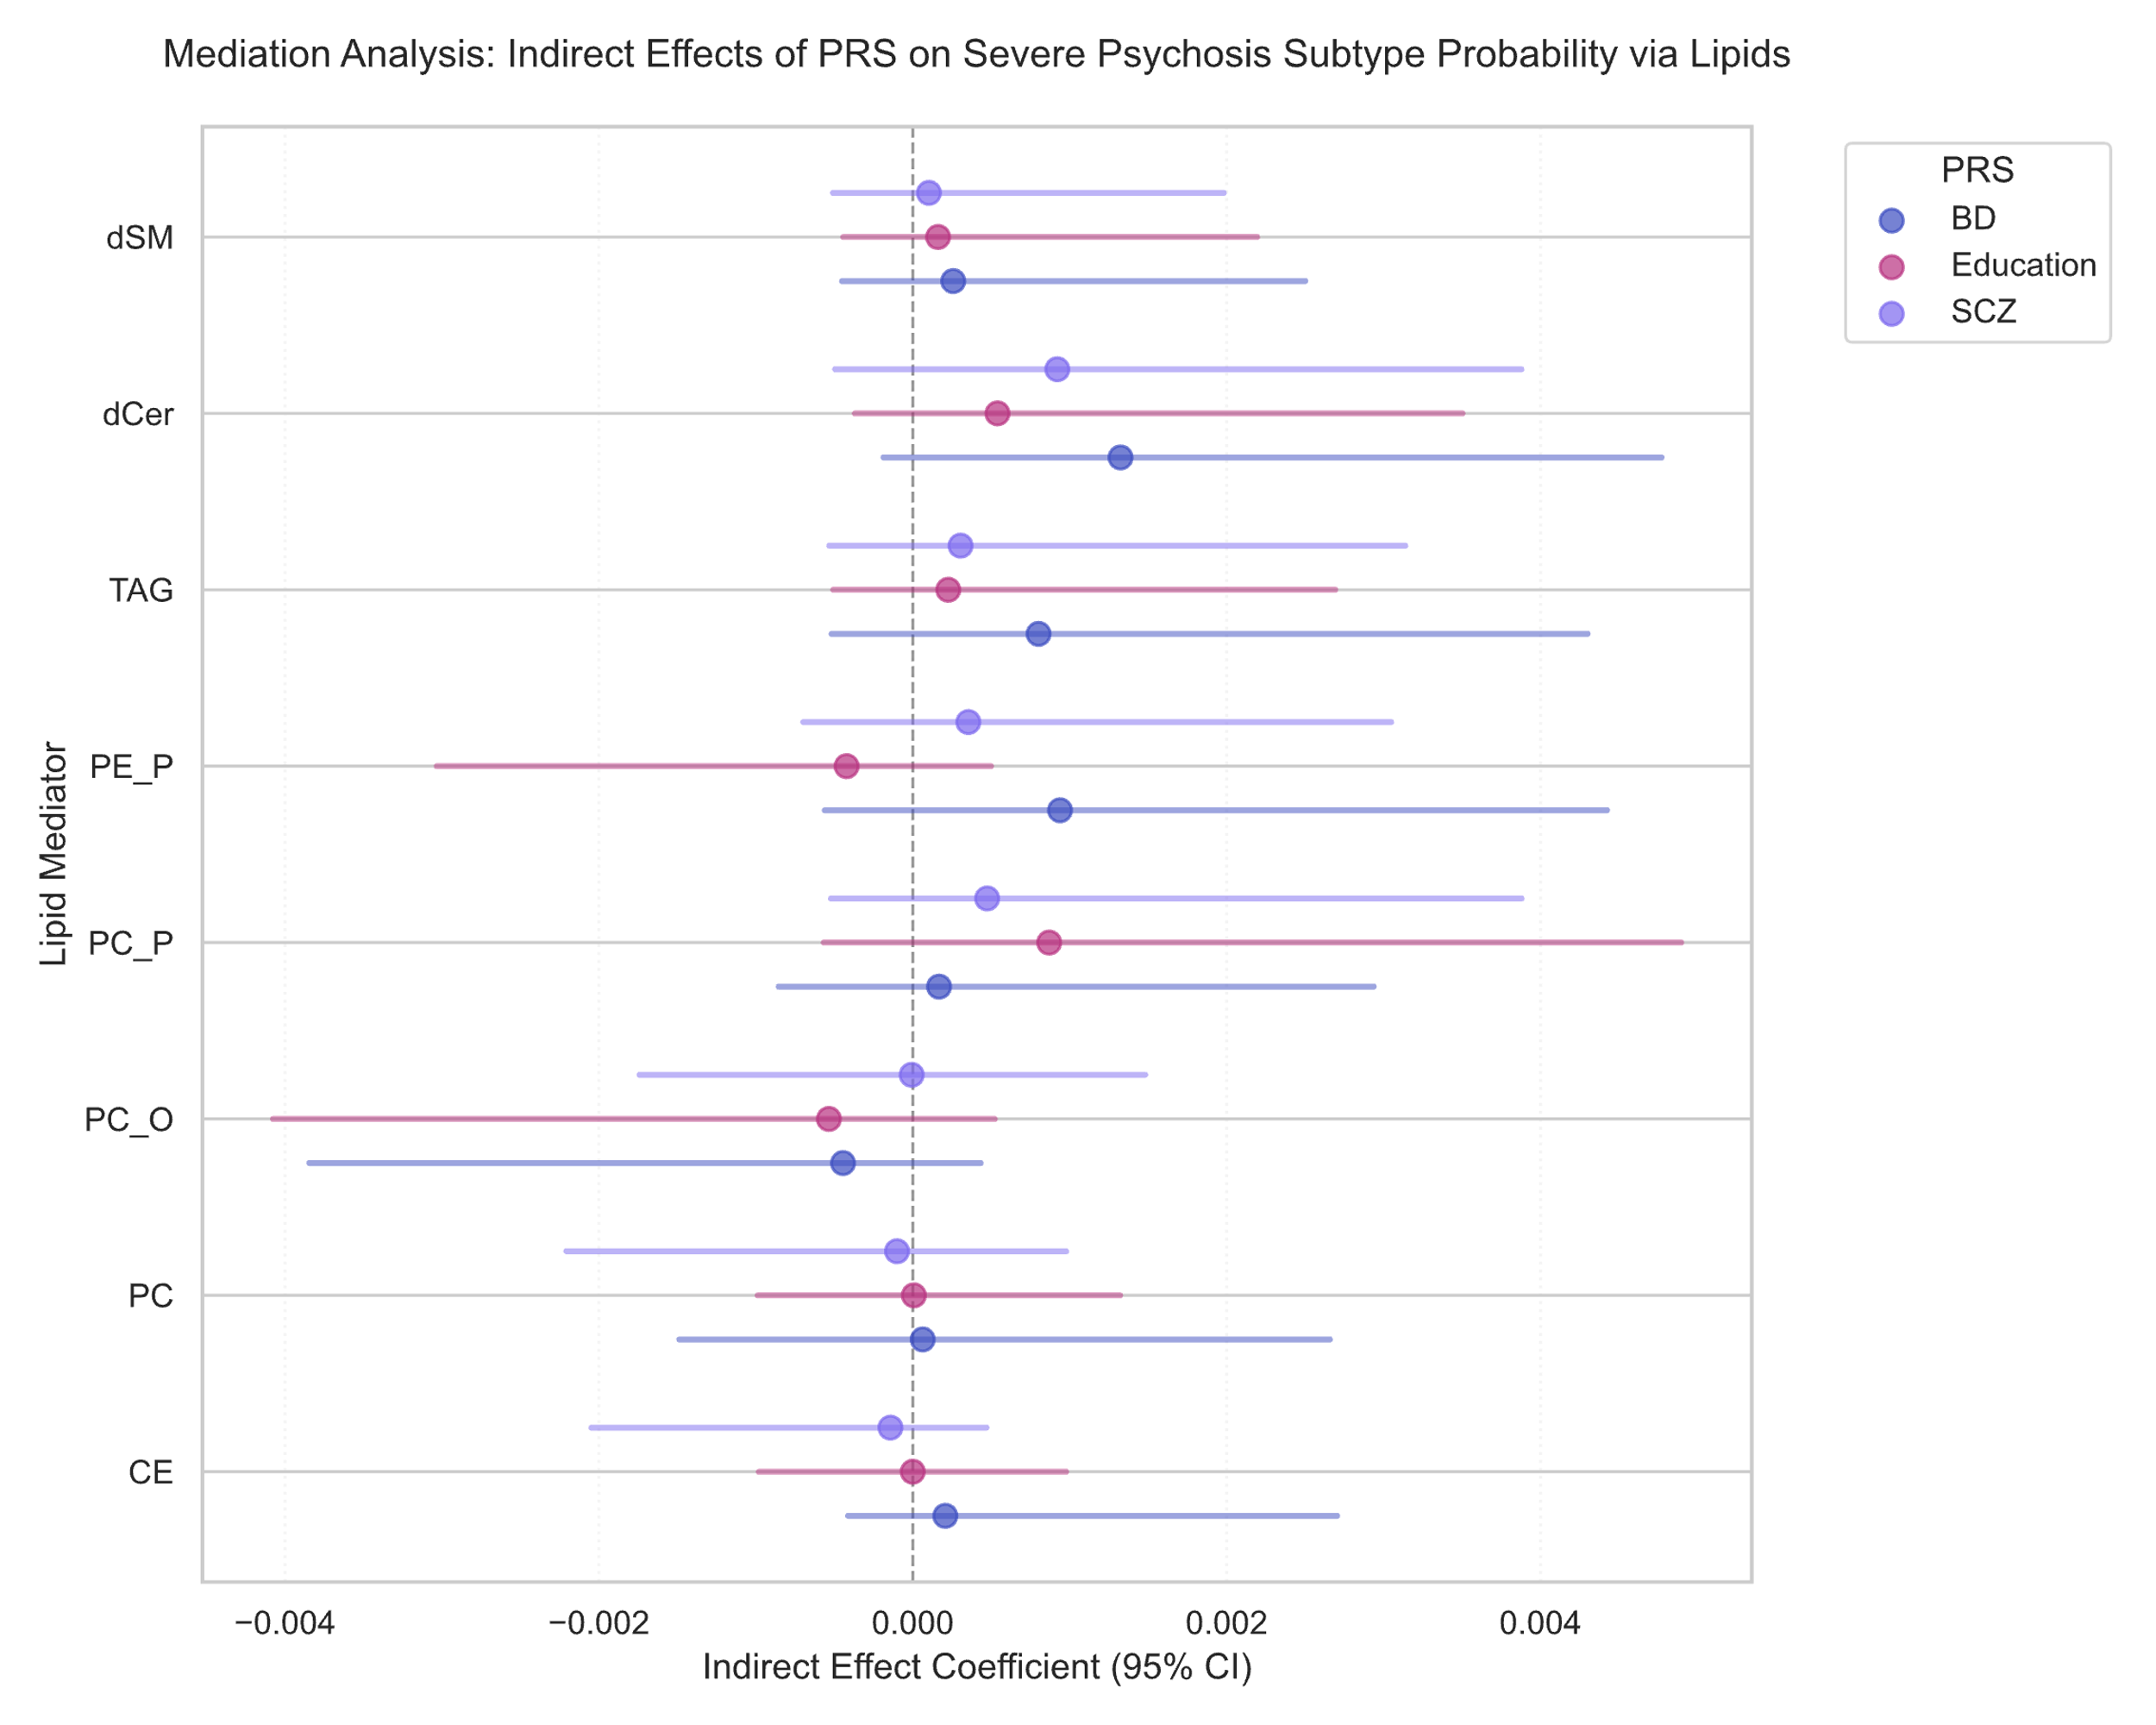
Supplementary Figure S11. Mediation of genetic liability through lipid classes. Forest plot of indirect effects (95% CI) from bootstrap mediation analysis testing whether enriched lipid classes mediate PRS associations with severe psychosis. None of 24 pathways showed significant mediation.

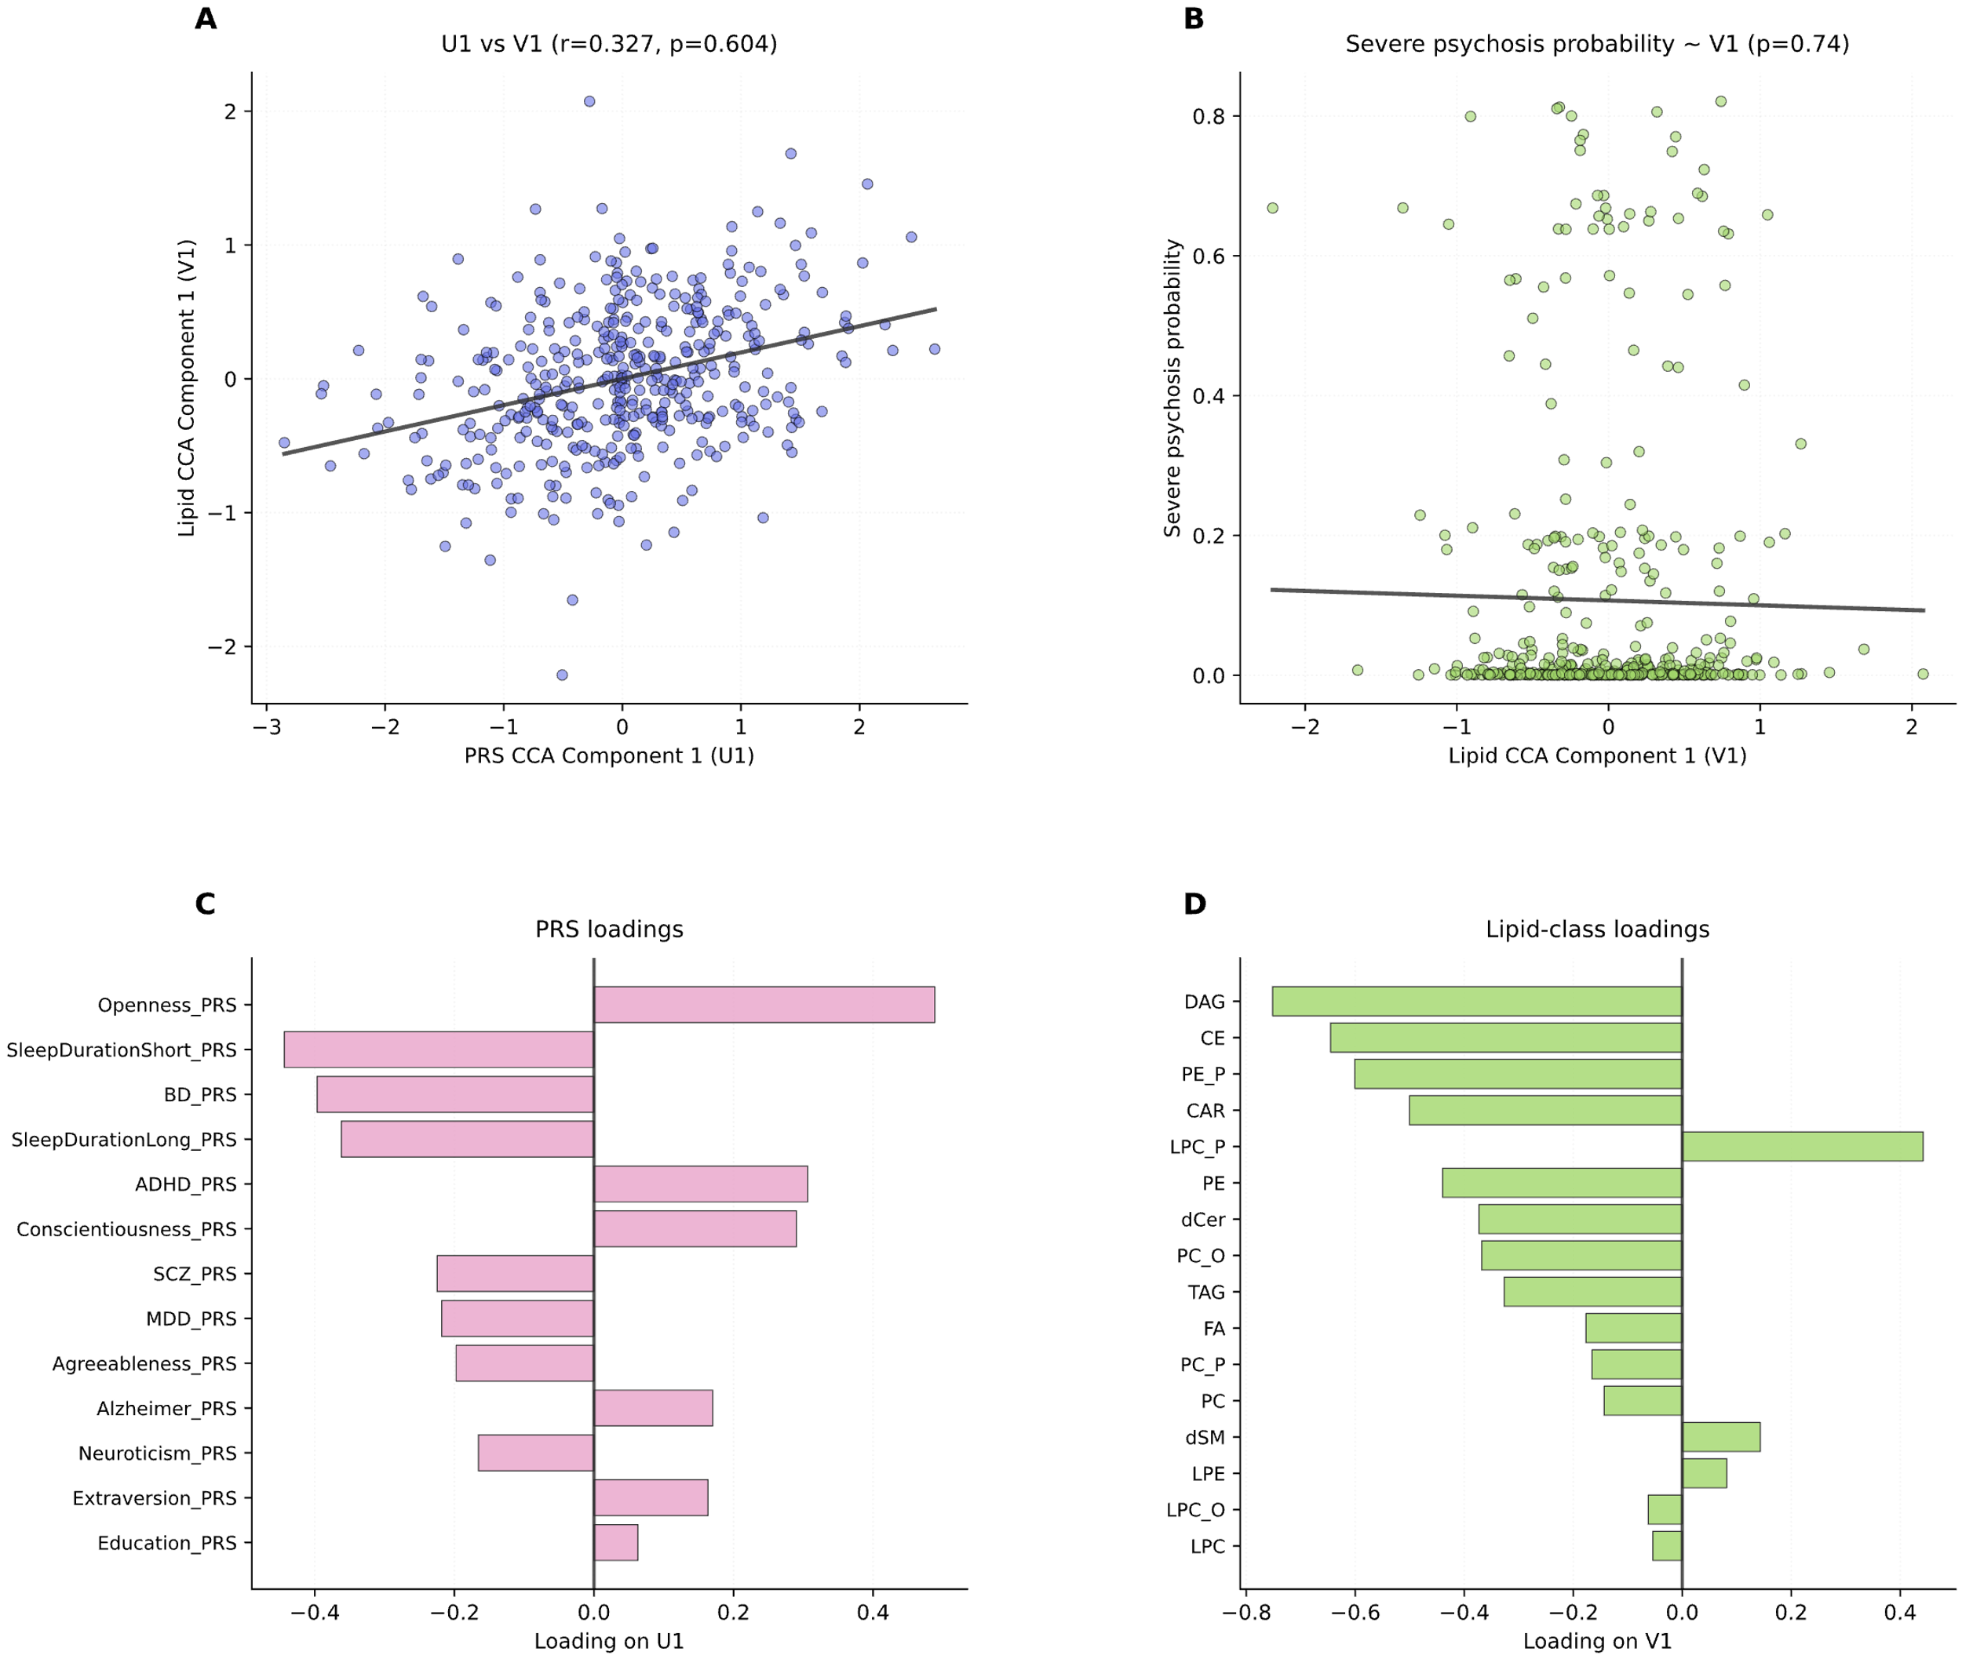
Supplementary Figure S12. Canonical correlation analysis of polygenic risk scores and lipid classes. (A) Relationship between the first PRS canonical component (U1) and the first lipid canonical component (V1); canonical correlation was modest and non-significant by permutation testing (r=0.33, p=0.604, 10,000 permutations). (B) Association of the lipid canonical score (V1) with severe psychosis subtype probability (β=−0.0068, p=0.741, permutation test, 20,000 permutations); the flat regression line indicates no severity-related structure in the shared genetic-lipidomic axis. (C) Canonical loadings for individual PRS on U1 and (D) lipid classes on V1; all loadings |r|≤0.40, indicating diffuse rather than feature-specific contributions to the canonical components.

References

1. Dwyer DB, Kalman JL, Budde M, Kambeitz J, Ruef A, Antonucci LA, et al. (2020): An Investigation of Psychosis Subgroups With Prognostic Validation and Exploration of Genetic Underpinnings: The PsyCourse Study. JAMA Psychiatry 77: 523.
2. Solomon P, Budde M, Kohshour MO, Adorjan K, Heilbronner M, Navarro-Flores A, et al. (2025): Disease severity across psychiatric disorders is linked to pro-inflammatory cytokines. Brain Behav Immun 129: 359–372.
3. Trubetskoy V, Pardiñas AF, Qi T, Panagiotaropoulou G, Awasthi S, Bigdeli TB, et al. (2022): Mapping genomic loci implicates genes and synaptic biology in schizophrenia. Nature 604: 502–508.
4. O’Connell KS, Koromina M, van der Veen T, Boltz T, David FS, Yang JMK, et al. (2025): Genomics yields biological and phenotypic insights into bipolar disorder. Nature 639: 968–975.
5. Adams MJ, Streit F, Meng X, Awasthi S, Adey BN, Choi KW, et al. (2025): Trans-ancestry genome-wide study of depression identifies 697 associations implicating cell types and pharmacotherapies. Cell 188: 640-652.e9.
6. Bellenguez C, Küçükali F, Jansen IE, Kleineidam L, Moreno-Grau S, Amin N, et al. (2022): New insights into the genetic etiology of Alzheimer’s disease and related dementias. Nat Genet 54: 412–436.
7. Okbay A, Wu Y, Wang N, Jayashankar H, Bennett M, Nehzati SM, et al. (2022): Polygenic prediction of educational attainment within and between families from genome-wide association analyses in 3 million individuals. Nat Genet 54: 437–449.
8. Grove J, Ripke S, Als TD, Mattheisen M, Walters RK, Won H, et al. (2019): Identification of common genetic risk variants for autism spectrum disorder. Nat Genet 51: 431–444.
9. Demontis D, Walters GB, Athanasiadis G, Walters R, Therrien K, Nielsen TT, et al. (2023): Genome-wide analyses of ADHD identify 27 risk loci, refine the genetic architecture and implicate several cognitive domains. Nat Genet 55: 198–208.
10. Gupta P, Galimberti M, Liu Y, Beck S, Wingo A, Wingo T, et al. (2024): A genome-wide investigation into the underlying genetic architecture of personality traits and overlap with psychopathology. Nat Hum Behav 8: 2235–2249.
11. Austin-Zimmerman I, Levey DF, Giannakopoulou O, Deak JD, Galimberti M, Adhikari K, et al. (2023): Genome-wide association studies and cross-population meta-analyses investigating short and long sleep duration. Nat Commun 14: 6059.
12. Ge T, Chen C-Y, Ni Y, Feng Y-CA, Smoller JW (2019): Polygenic prediction via Bayesian regression and continuous shrinkage priors. Nat Commun 10: 1776.
13. Liberzon A, Birger C, Thorvaldsdóttir H, Ghandi M, Mesirov JP, Tamayo P (2015): The Molecular Signatures Database (MSigDB) hallmark gene set collection. Cell Syst 1: 417–425.
14. Tkachev A, Stekolshchikova E, Vanyushkina A, Zhang H, Morozova A, Zozulya S, et al. (2023): Lipid Alteration Signature in the Blood Plasma of Individuals With Schizophrenia, Depression, and Bipolar Disorder. JAMA Psychiatry 80: 250.

