Supplementary Information
Emulsion-Oriented Assembly for Janus Double-Spherical Mesoporous Nanoparticles as Biological Logic Gates
Zhao et al.

Supplementary Methods

Chemicals:
Cetyltrimethylammonium bromide (CTAB, 99 %), tetraethyl orthosilicate (TEOS, AR), (3-iodopropyl) trimethoxysilane, pluronic® F-127, pluronic® P-123, pluronic® F-108, doxorubicin (DOX), β-cyclodextrin, glucose oxidase, glucose dehydrogenase from Pseudomonas sp., esterase from porcine liver, nicotinamide adenine dinucleotide (NAD+) were purchased from Sigma-Aldrich. Ammonium hydroxide solution (28 % NH₃ in H₂O), 1,3,5-trimethylbenzene (TMB, AR), hydrochloric acid (HCl), cyclohexane, chlorobenzene, toluene, octadecene, ethanol. dopamine, glucose, triethanolamine, tris(hydroxymethyl)aminomethane, acetonitrile, ethyl butyrate, benzimidazole were obtained from Shanghai Chemical Reagents Co. Ltd.

Fabrication of mesoporous silica nanoparticles (MSNs):
The typical synthesis of MSNs with a pore size of ~8 nm (MSN₈) was recorded in the main text of the manuscript. For the fabrication of MSNs with different mesopore sizes, the reaction was adjusted according to previous reports.^{1,2} For MSN₁₅ with a pore size of ~15 nm, the stirring speed was increased to 250 rpm, other processes were remained unchanged as that of MSN₈. For MSN₃ with a pore size of ~3 nm, octadecene was used to replace cyclohexane, other processes remained unchanged. For MSN₂₅ with a pore size of ~25 nm, chlorobenzene was used to replace cyclohexane, and due to the higher density of chlorobenzene, the mixture of TEOS and chlorobenzene was injected into the bottom of the solution to form a different bi-phase with the water phase on the top.

Fabrication of MSN&mPDA Janus nanoparticles:
The typical synthesis process of MSN₈&mPDA₁₅ Janus nanoparticles was recorded in the main text of the manuscript. For the synthesis of MSN&mPDA Janus nanoparticles with different pore sizes in the mPDA section, combinations of different amphiphilic Pluronic triblock copolymers were used: for mPDA with the pore size of ~ 5, 25 and 50 nm, the addition of copolymers was 0.15 g of Pluronic F-108 and 0.05 g of F-127, 0.19 g of F-127 and 0.01 g of P-123, 0.15 g of F-127 and 0.05 g of P-123, respectively.

Biological logic gate establishment:
To establish the biological logic gate, MSN&mPDA nanoparticles functionalized with benzimidazole moieties in the MSN section were first fabricated. In a typical synthesis, 20.0 mg of MSNs with CTAB extracted (the extraction process is recorded in the manuscript) was dispersed in 10.0 mL of acetonitrile, then 100 μL of (3-iodopropyl) trimethoxysilane was added. The mixture was stirred overnight, then centrifuged and washed with acetonitrile to obtain the iodine-propyl functionalized MSNs. Then the MSNs functionalized with iodine propyl were dispersed in 8.0 mL of benzimidazole toluene (1.0 mg mL⁻¹) solution at 80 °C, then 24.0 mL of trimethylamine was added, and the suspension was stirred for 72 h to achieve the benzimidazole moieties functionalized MSNs.³ The emulsion-orientated assembly of mPDA was the same as the above, and MSN&mPDA nanoparticles functionalized with benzimidazole moieties in the MSN section were obtained.
To achieve selective DOX loading, HCl was added to tune the pH of 4.0 mg mL⁻¹ DOX solution to ~ 5.5. Then, the Janus MSN&mPDA nanoparticles were added at a concentration of 2.0 mg ml⁻¹. The solution was stirred in dark for 24 h, then centrifuged to achieve MSN&mPDA loaded with DOX only in the MSN section (denoted as DOX/MSN&mPDA). To “cap” the silica mesopores, 10.0 mg of DOX/MSN&mPDA nanoparticles were then suspended in 10.0 mL of H₂O, then 5.0 mg of β-cyclodextrin was added. After stirring overnight, the nanoparticles were centrifuged and washed with water.
To achieve mPDAs’ selective modification of enzymes, the DOX/MSN&mPDA nanoparticles were dispersed in 10.0 mL of H₂O, and 10.0 mg of glucose oxidase (GOX) was added. After stirring for 24 h, the nanoparticles were centrifuged and washed with water to obtain the Janus MSN&mPDA nanoparticles with DOX loaded in the MSN section and enzyme-modified in the mPDA section (denoted as DOX/MSN&mPDA/GOX). The loading of other kinds of enzymes for different biological logic gates was processed in the same manner.

Characterizations:
Transmission electron microscopy (TEM), high-resolution transmission electron microscopy (HRTEM), high-angle annular dark-field imaging in the scanning TEM (HAADF-STEM) observations were acquired on JEM-2100F transmission electron microscope with an accelerating voltage of 200 kV equipped with a post-column Gatan imaging filter (GIF-Tridium). The samples for TEM measurements were suspended in ethanol and supported onto a carbon film on a Cu grid. Scanning electron microscopy (SEM) images were taken using a Hitachi S-4800 ultrahigh-resolution cold FEG with an in-lens electron optic operating at 20 kV. Nitrogen adsorption-desorption measurements were conducted to obtain information on the porosity. The measurements were conducted at 77 K with ASAP 2420 and Micromeritcs Tristar 3020 analyzer (USA). Before measurements, the samples were degassed under vacuum at 120 °C for at least 12 h. UV/Vis spectra were recorded on Lambda 35 PerkinElmer.

Supplementary Figures
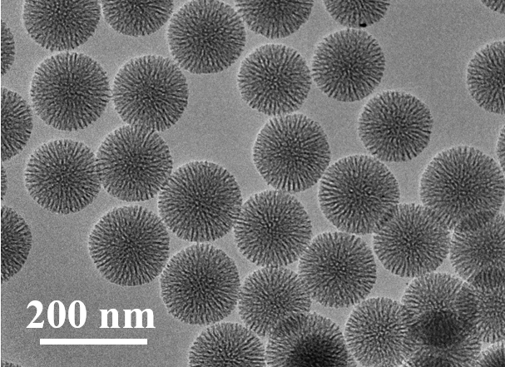
Supplementary Figure 1. Characterization of mesoporous silica nanoparticles. The transmission electron microscopy (TEM) image of the fabricated mesoporous silica nanoparticles (MSN). The MSNs were synthesized through a bi-phase method reported previously, and have a diameter of ~ 150 nm with ~ 8 nm mesopores.

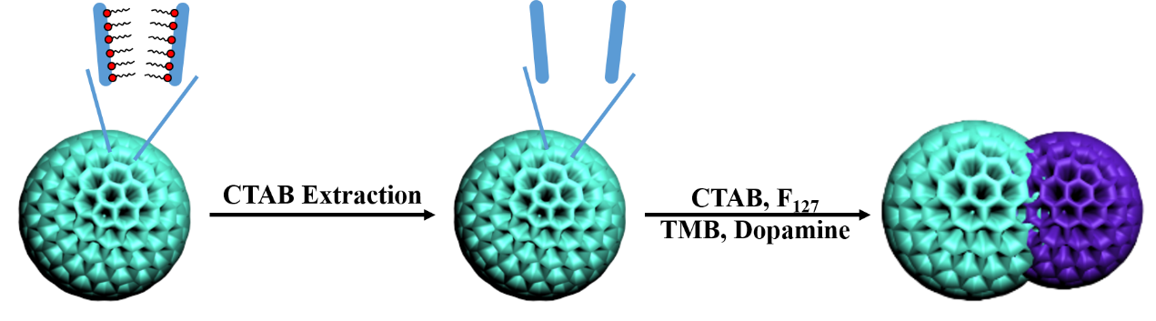
Supplementary Figure 2. Illustration of Janus nanoparticles’ fabrication process. Schematic illustration of the fabrication of dual-mesoporous Janus MSN&mPDA (mPDA = mesoporous polydopamine) nanoparticles. Firstly, the MSN nanoparticles went through the extraction of CTAB, then the emulsion orientated assembly of dopamine was performed to achieve the dual-mesoporous Janus MSN&mPDA structure.

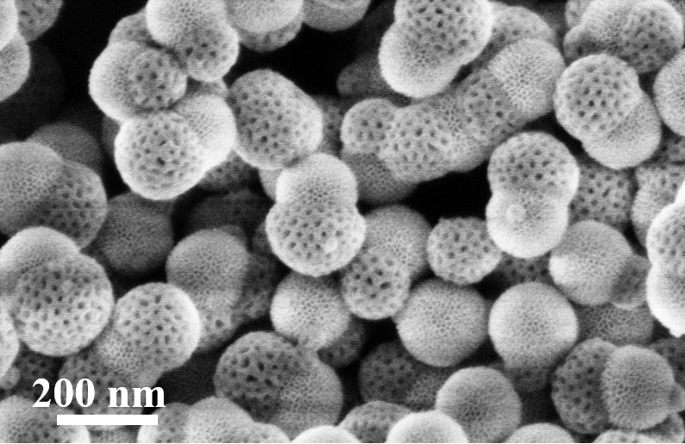
Supplementary Figure 3. Characterization of Janus nanoparticles. The large-scale scanning electron microscope image of the MSN&mPDA nanoparticles, demonstrating that the Janus double-spherical nanoparticles are uniformly constructed and well dispersed.

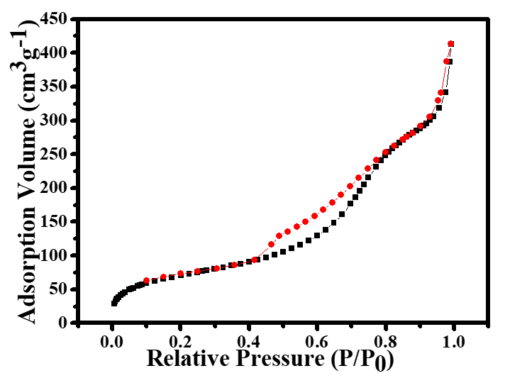
Supplementary Figure 4. Nitrogen-sorption isotherms of the Janus nanoparticles. Nitrogen sorption isotherms of the obtained dual-mesoporous MSN&mPDA Janus double-spherical nanoparticles. The Brunauer−Emmett−Teller surface area is measured to be about 243 m² g⁻¹. The isotherms show two capillary condensation steps in the P/P₀ ranges of 0.4 – 0.6 and 0.8 – 0.9, evidencing the existence of dual-mesoporous topology.

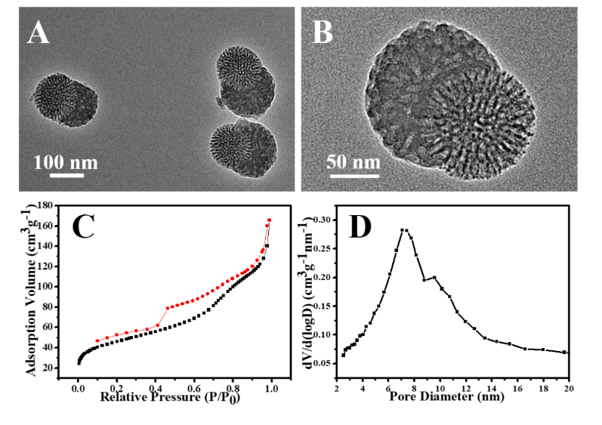
Supplementary Figure 5. Characterization of carbonized Janus nanoparticles. (A, B) TEM images with different magnification, (C) nitrogen sorption isotherms and (D) pore size distribution of the dual-mesoporous Janus MSN&mC double-spherical nanoparticles. The Janus MSN&mC nanoparticles were obtained after calcination of the at dual-mesoporous Janus MSN&mPDA nanoparticles 700 °C under nitrogen atmosphere, indicating that the overall asymmetric topology and the dual-mesoporous structure can be maintained after carbonization. The Brunauer−Emmett−Teller surface area is measured to be about 162 m² g⁻¹, pore volume of ~ 0.26 cm³ g⁻¹, with pore size distribution at ~ 7 nm and 10 nm.

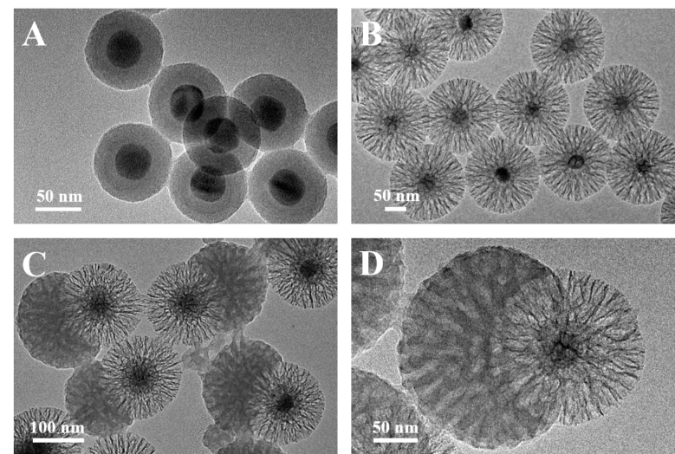
Supplementary Figure 6. Characterization of Janus UCNP@mSiO₂&mPDA nanoparticles. TEM images of (A) UCNP@SiO₂, (B) UCNP@SiO₂@mSiO₂ and (C, D) UCNP@SiO₂@mSiO₂&mPDA Janus nanoparticles with different magnification. UCNP = NaYF₄ upconversion nanoparticle.

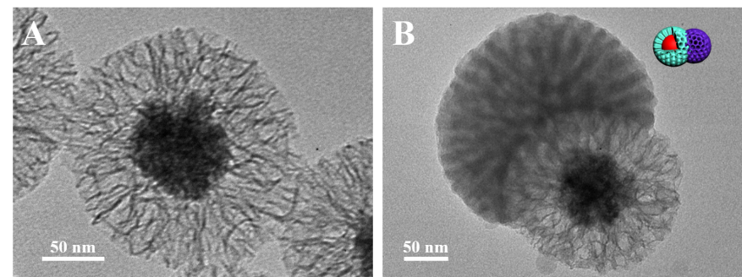
Supplementary Figure 7. Characterization of Janus Fe₃O₄@mSiO₂&mPDA nanoparticles. TEM images of (A) Fe₃O₄@mSiO₂ and (B) Janus Fe₃O₄@mSiO₂&mPDA nanoparticles.

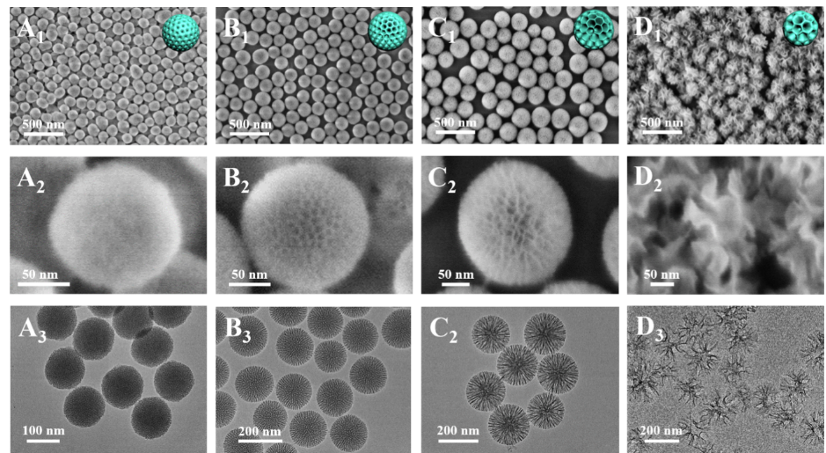
Supplementary Figure 8. Characterization of MSNs with different pore sizes. TEM and scanning electron microscopy (SEM) images with different magnifications of mesoporous silica nanoparticles with the same particle size but different pore diameters: (A) 3 nm, (B) 8 nm, (C) 15 nm and (D) 25 nm. The nanoparticles were all fabricated through the bi-phase method, only changing the oil phase and stirring speed.

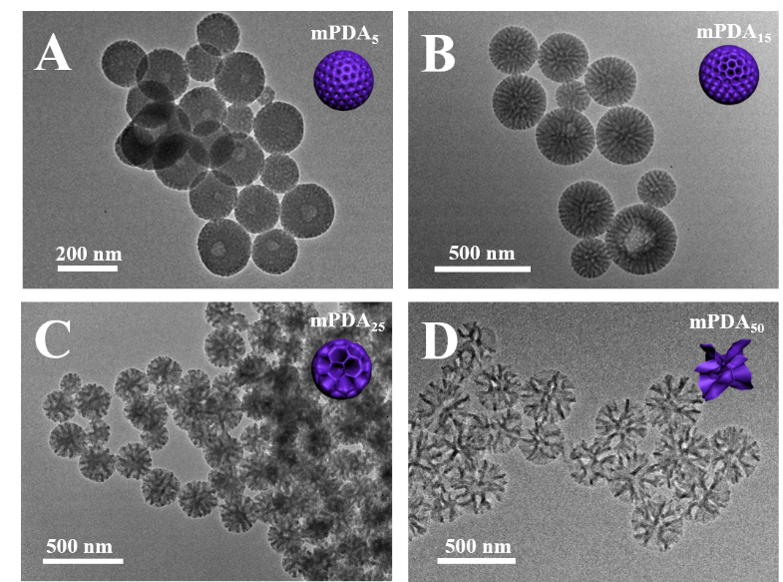
Supplementary Figure 9. Characterization of mPDA nanoparticles with different pore sizes. TEM images of the mPDA nanoparticles with different pore sizes: (A) 5 nm, (B) 15 nm, (C) 25 nm and (D) 50 nm. The nanoparticles were all fabricated through the same emulsion-induced interfacial assembly method^{4,5}, only changing the amount and type of amphiphilic Pluronic copolymers.

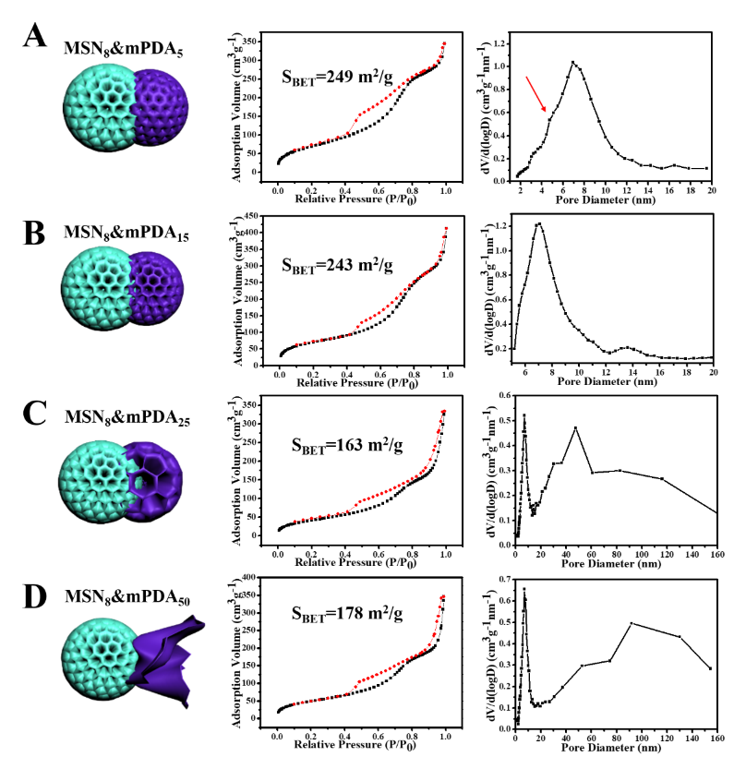
Supplementary Figure 10. Characterization of Janus nanoparticles’ mesopores. Nitrogen sorption isotherms of the obtained dual-mesoporous MSN&mPDA Janus nanoparticles with a pore size of MSN set as ~ 8 nm and varied mPDA pore size: (A) 5 nm, (B) 15 nm, (C) 25 nm and (D) 50 nm. Their isotherms are all typical type-IV curves with rapid increasements of adsorption volume in double intervals, evidencing the existence and controllability of the dual-mesoporous structure.

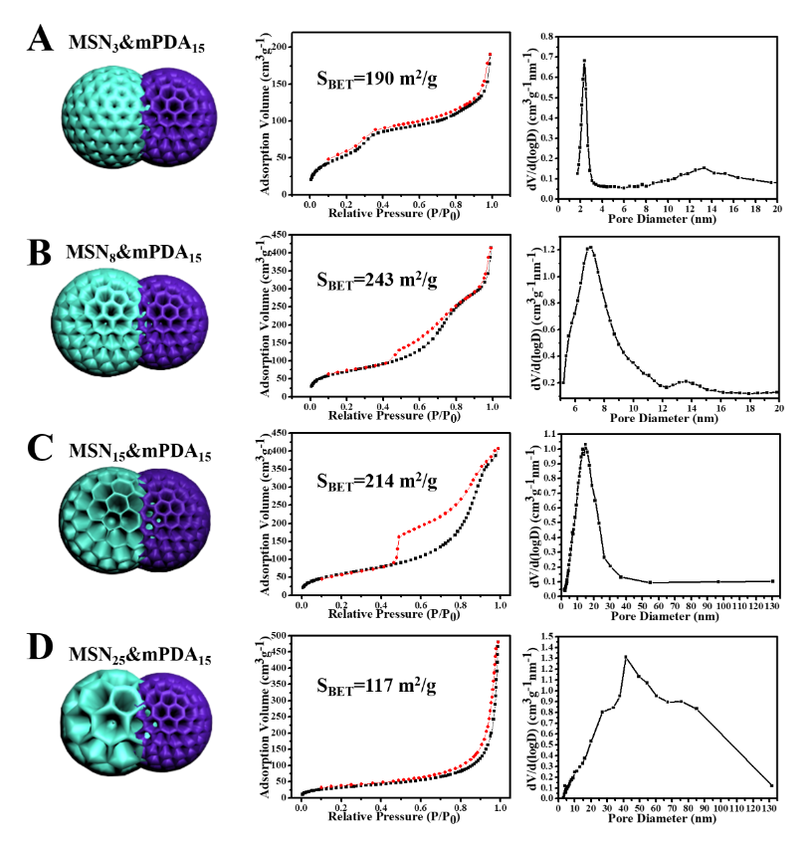
Supplementary Figure 11. Characterization of Janus nanoparticles’ mesopores. Nitrogen sorption isotherms of the obtained dual-mesoporous MSN&mPDA Janus nanoparticles with the pore size of mPDA set as ~ 8 nm and varied MSN pore size: (A) 3 nm, (B) 8 nm, (C) 15 nm and (D) 25 nm. Their isotherms are all typical type-IV curves with rapid increasements of adsorption volume in double intervals, evidencing the existence and controllability of the dual-mesoporous structure.

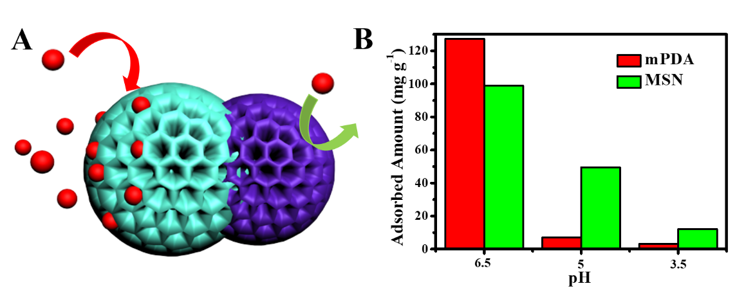
Supplementary Figure 12. pH-induced selective loading of DOX. (A) Schematic illustration and (B) graphic illustration of the pH-induced selective loading of DOX. As can be clearly observed from the graph, the loading amount of DOX in mPDA lowers dramatically in an acid environment, while that of the mesoporous silica is insignificant. The loading of DOX onto mPDA is mainly based on π-stacking interaction and sensitive to pH-induced protonation effect^{6,7}. On the other hand, the loading of DOX on the MSN compartment is mainly based on the capillary effect and insensitive to pH variation. Thus, DOX can be selectively loading in the silica compartment of the dual-mesoporous MSN&mPDA Janus nanoparticles under an acid environment.

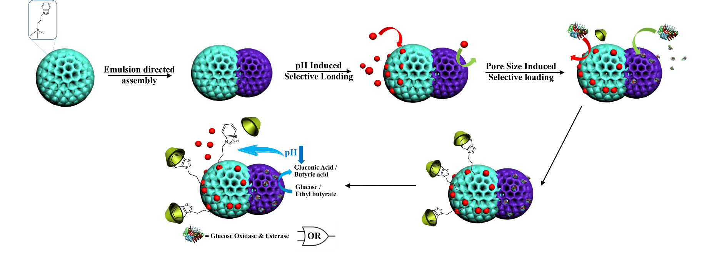
Supplementary Figure 13. Establishment of the biological logic gate on Janus nanoparticles. Schematic illustration of the establishment of the biological logic gate on the dual-mesoporous MSN&mPDA Janus double-spherical nanoparticles: mesoporous silica nanoparticles were first modified with benzimidazole groups, then MSN&mPDA Janus nanoparticles with benzimidazole groups only on the silica domain were obtained. DOX was selectively loaded in the silica mesopore channels through a pH-induced selective loading. Then enzyme was selectively loaded in the mPDA compartments through pore size induced selective loading, and β-cyclodextrin was added to cap the silica mesopores, forming the final MSN&mPDA Janus nanoparticles with selective loading of DOX and enzyme. DOX could be controllable released based on the acid-producing reaction between enzyme and input molecules.

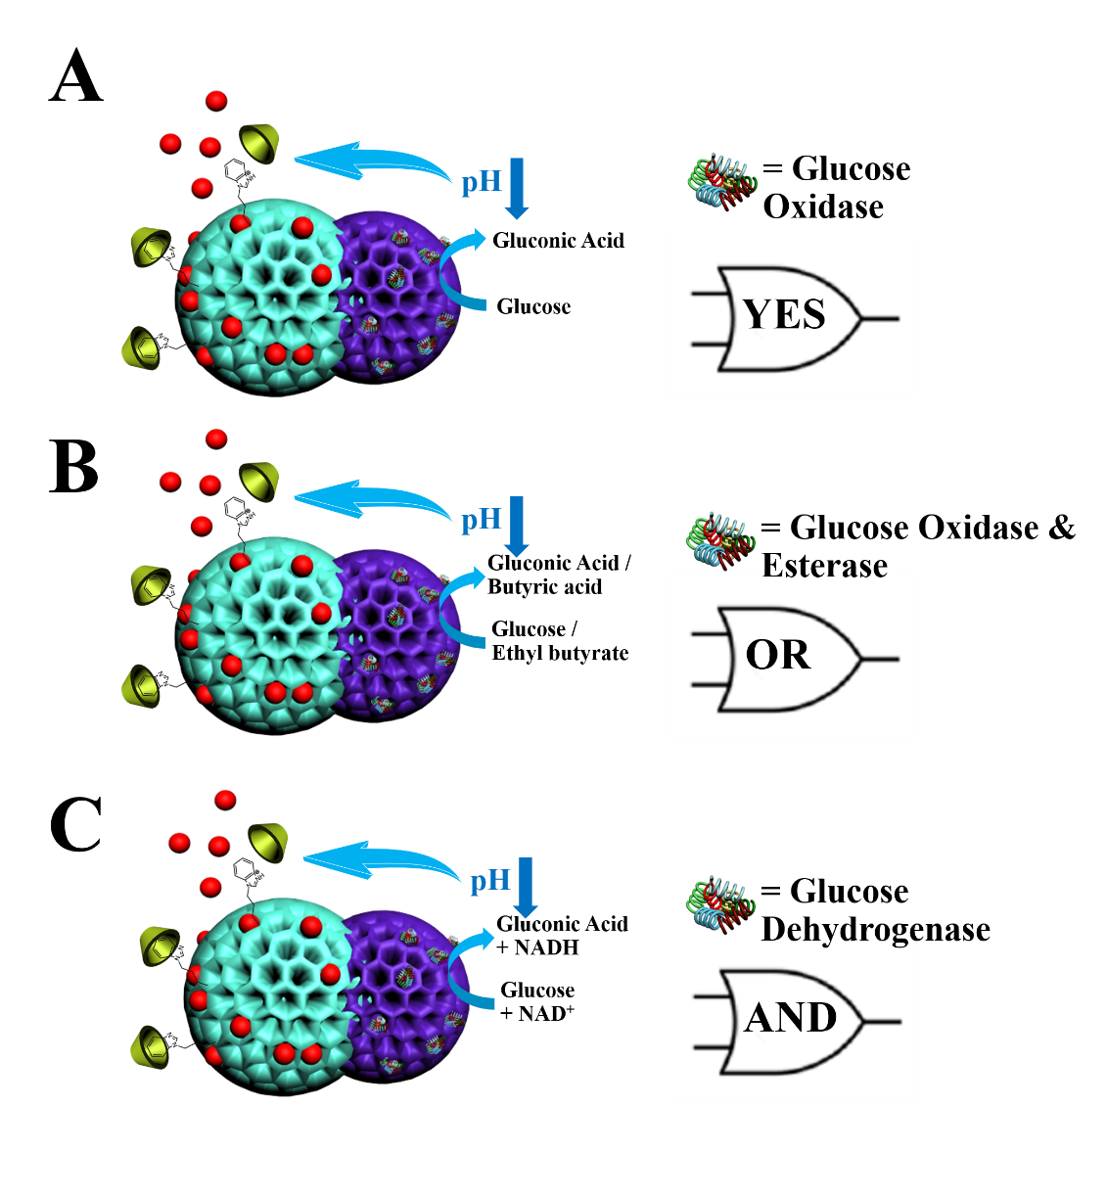
Supplementary Figure 14. Schematic illustration of the three established biological logic gates. (A) For the YES gate, the output signal from Doxorubicin (DOX) molecules is released when the input signal of glucose molecules is catalyzed by glucose oxidase (Gox) into glucose acid, opening the pH-responsive benzimidazole-β-cyclodextrin nanovalve and triggering the release of the loaded DOX molecules. (B) For the OR gate, Gox and esterase are loaded on the mPDA compartment, both glucose and ethyl butyrate can trigger the formation of acid and thus the opening of the nanovalves, realizing the DOX release. (C) For the AND gate, glucose dehydrogenase (GDH) is modified on the mPDA compartment. Gluconic acid can be formed only in the presence of both glucose and nicotinamide adenine dinucleotide, thus the release of DOX molecules can be achieved only when two inputs are provided together.

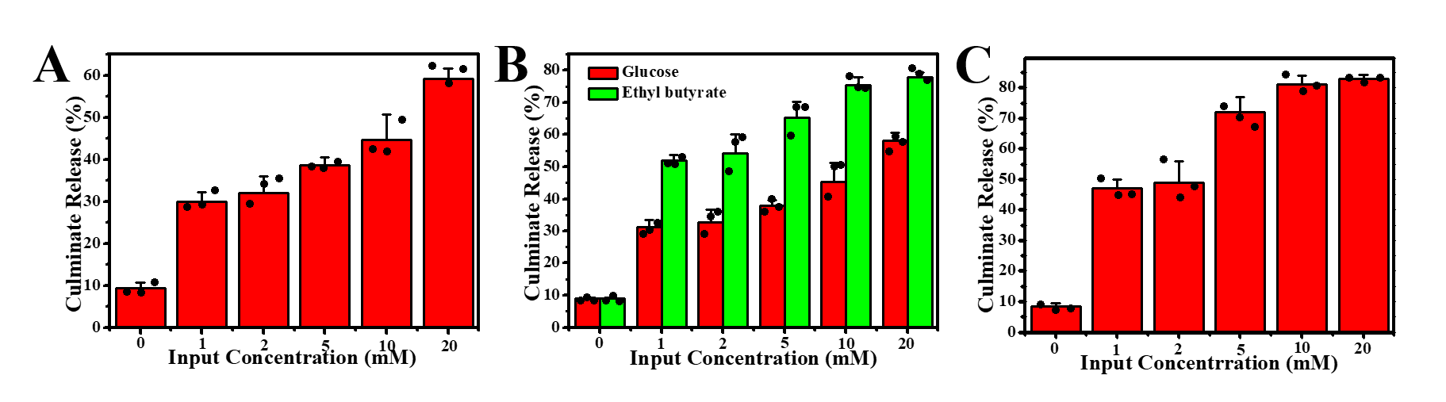
Supplementary Figure 15. Culminate release of DOX based on biological logic gates. Release kinetics of DOX with input material concentration locked at 1 mM and culminate release of DOX after 9 h with various input concentrations in three kinds of biological logic gates: (A) YES gate, (B) OR gate and (C) AND gate. These results demonstrate that the logic behavior of these biocomputing systems can function in a wild range of input concentrations.

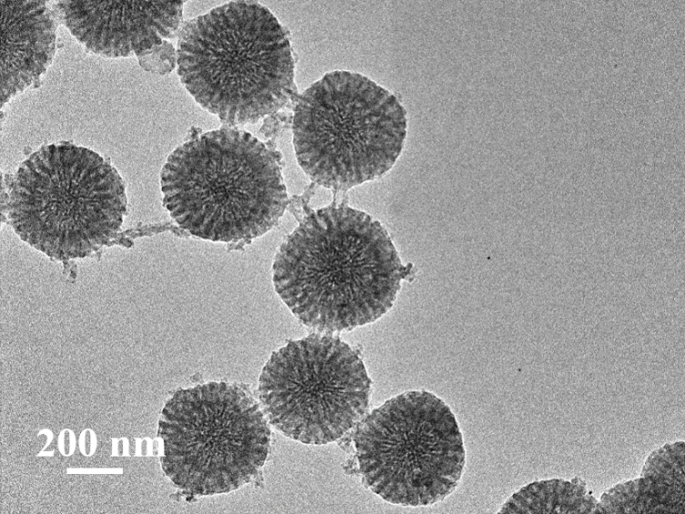
Supplementary Figure 16. Growth of mPDA without CTAB extraction from MSNs. The TEM image of products obtained by assembling mPDA on MSN nanoparticles when the CTAB was not extracted from the silica mesopores. Without previous extraction of CTAB, mPDA homogeneously grows on MSNs surface, rather than forming Janus structure.

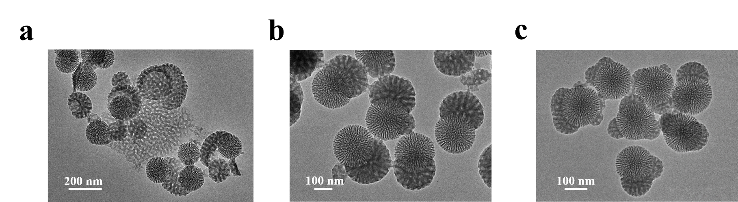
Supplementary Figure 17. Effect of CTAB amount. TEM images of products obtained of assembly mPDA on MSN nanoparticles with different amounts of CTAB added: (a) 0 mg. (b) 10 mg. (c) 30 mg. Without the addition of CTAB, mPDA did not assemble on MSNs and result in phase separation. By adding a suitable amount of CTAB, the Janus nanostructure could be obtained. When an excessive amount of CTAB was added, a multi-island assembly of mPDA was occurred.

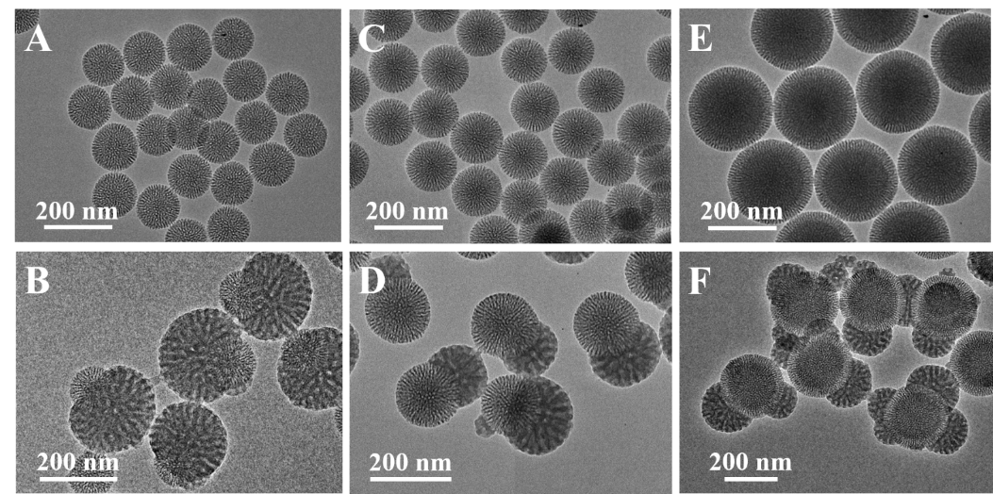
Supplementary Figure 18. Effect of MSNs’ diameter. TEM images of the mesoporous silica nanoparticles and the products obtained after mPDA assembly on them: (A, B) 100 nm, (C, D) 150 nm and (E, F) 250 nm. The Janus structures were achieved with the mesoporous silica nanoparticles that have a diameter smaller than ~ 150 nm. However, under the same reaction condition, only multi-island growth of mPDA was obtained on the mesoporous silica nanoparticles with a diameter of ~ 250 nm. These results demonstrated that particle diameter (surface tension) can affect the emulsion-orientated assembly of mPDA.

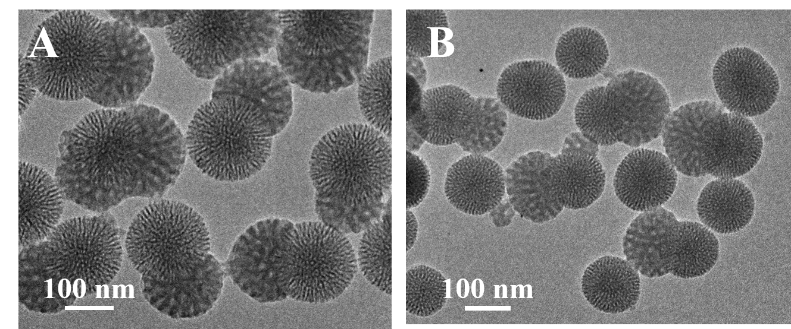
Supplementary Figure 19. Effect of MSNs’ hydrophilicity. TEM images of the MSN&mPDA Janus nanoparticles obtained when (A) mesoporous silica nanoparticles and (B) organic groups functioned mesoporous organosilica nanoparticles. The two kinds of nanoparticles have identical diameters and mesopores, the only difference was that the mesoporous organosilica nanoparticles were fabricated with a mixture of TEOS/BTEE ratio = 3, and that mesoporous silica nanoparticles were fabricated using pure TEOS. As can be clearly observed from TEM images, mPDAs had a higher tendency of phase separation when growing on mesoporous organosilica nanoparticles, demonstrating that particle hydrophilicity had impacts on the emulsion-orientated assembly.

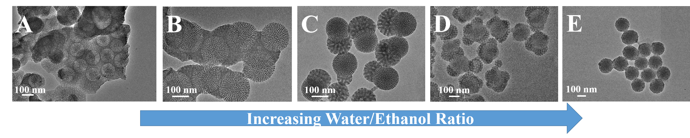
Supplementary Figure 20. Effect of water-ethanol ratio. TEM images of the MSN&mPDA Janus nanoparticles obtained in reactions with different ethanol/water ratio: (A) 2:1, (B) 1.5:1, (C) 1:1, (D) 1: 1.5 and (E) 1:2. The results demonstrate that the ethanol/water ratio has significant effects on the emulsion-orientated assembly of mPDA.

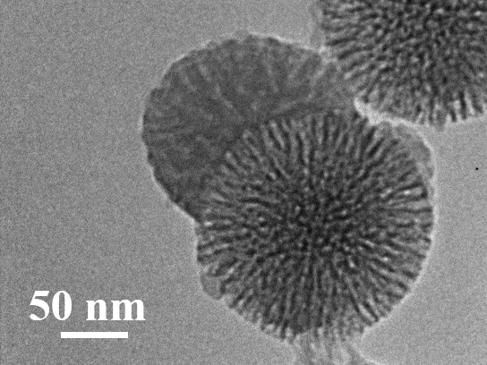
Supplementary Figure 21. Characterization of Janus MSN&mRF nanoparticles. The TEM image of the dual-mesoporous MSN&mRF (RF = resorcinol formaldehyde resin) Janus nanoparticles. The nanoparticles were fabricated in the same way as that of the dual-mesoporous MSN&mPDA Janus nanoparticles, only changing dopamine into resorcinol and formaldehyde.

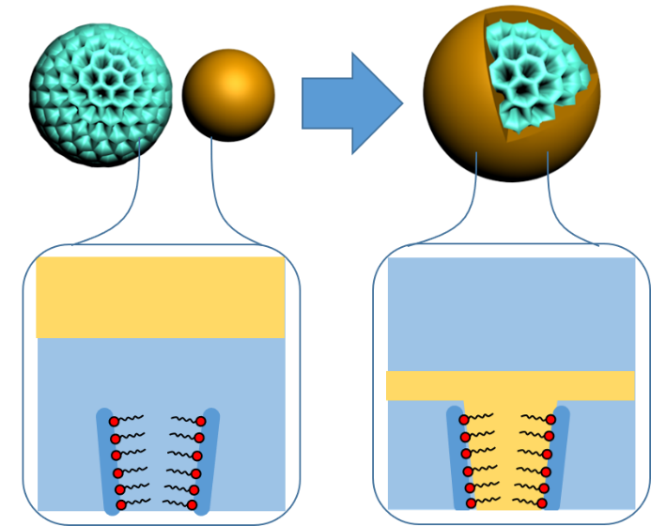
Supplementary Figure 22. Growth of mPDA without CTAB extraction from MSNs. Schematic illustration of the assembly of mPDA on MSN nanoparticles when the CTAB was not extracted from the silica mesopores. A large amount of CTAB in the silica mesopores could enhance the interaction between silica and TMB/F-127/polydopamine composites, resulting in uniform MSN@mPDA core@shell structures.

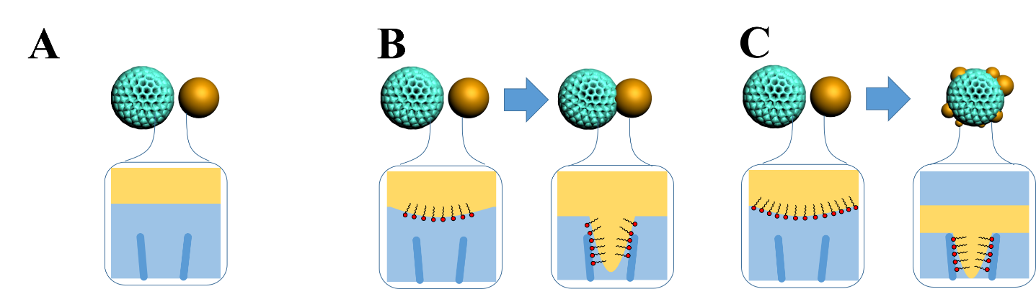
Supplementary Figure 23. Effect of CTAB amount. Schematic illustration of the assembly of mPDA on MSN nanoparticles with different amounts of CTAB added: (A) 0 mg. (B) 10 mg and (C) 30 mg. Without the addition of CTAB, the TMB droplet cannot form double-spherical structure with the MSN. With adding a suitable amount of CTAB, the Janus nanostructure was obtained. When an excessive amount of CTAB was added, the interaction between MSNs and TMB droplets is too strong, resulting in the TMB droplet covering the MSNs.

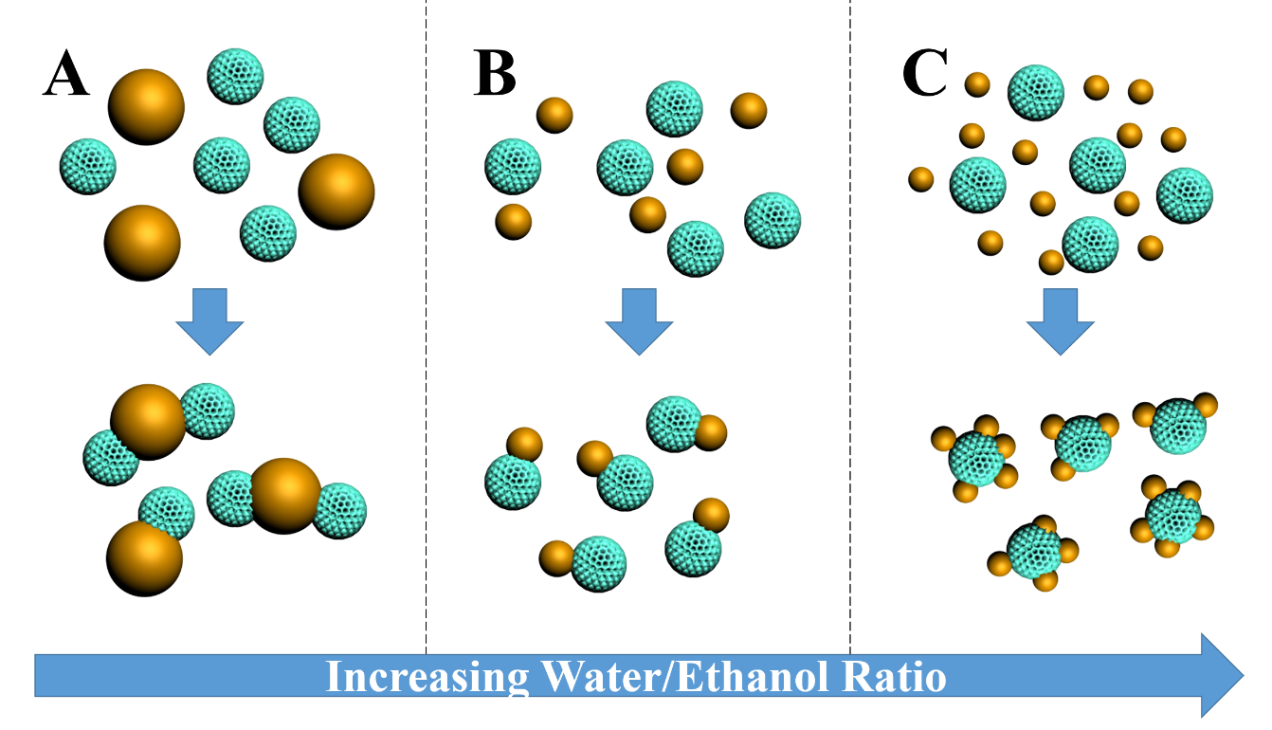
Supplementary Figure 24. Effect of water-ethanol ratio. Schematic illustration of the interaction between MSNs with TMB droplets with different ethanol/water ratios: (A) 1.5:1, (B) 1:1 and (C) 1: 1.5. Ethanol/water ratio could alter the size of TMB droplets, leading to different particle-droplet interactions and varied structures.

Supplementary References
1 Yue, Q. et al. An interface coassembly in biliquid phase: toward core-shell magnetic mesoporous silica microspheres with tunable pore size. J. Am. Chem. Soc. 137, 13282-13289 (2015).
2 Xu, C. et al. Core-cone structured monodispersed mesoporous silica nanoparticles with ultra-large cavity for protein delivery. Small 11, 5949-5955 (2015).
3 Llopis-Lorente, A. et al. Interactive models of communication at the nanoscale using nanoparticles that talk to one another. Nat. Commun. 8, 15511 (2017).
4 Guan, B. Y., Zhang, S. L. & Lou, X. W. D. Realization of walnut-shaped particles with macro-/mesoporous open channels through pore architecture manipulation and their use in electrocatalytic oxygen reduction. Angew. Chem. Int. Ed. 57, 6176-6180 (2018).
5 Guan, B. Y., Yu, L. & Lou, X. W. Formation of asymmetric bowl-like mesoporous particles via emulsion-induced interface anisotropic assembly. J. Am. Chem. Soc. 138, 11306-11311 (2016).
6 Zheng, X., Chen, F., Zhang, J. & Cai, K. Silica-assisted incorporation of polydopamine into the framework of porous nanocarriers by a facile one-pot synthesis. J. Mater. Chem. B 4, 2435-2443 (2016).
7 Yu, B., Wang, D. A., Ye, Q., Zhou, F. & Liu, W. Robust polydopamine nano/microcapsules and their loading and release behavior. Chem. Commun. 44, 6789-6791 (2009).

