Supplementary Information
Safety of Cardiopulmonary Exercise Testing in Patients with Severe Post-COVID-19 Condition: A Matched Case-Control Study
Journal: Scientific Reports (Original Research Article)

Vincent Weber¹, Aleksandar Tomaskovic¹, David T. Ochmann¹, Barlo Hillen^{1,2}, Severin Zentgraf¹, Mirjam S. Enger¹, Ella Lachtermann¹, Elmo W. I. Neuberger¹ and Perikles Simon¹

¹Department of Sports Medicine, Prevention and Rehabilitation, Institute for Sport Science, Johannes Gutenberg-University Mainz, Mainz, Germany
²Institute for Occupational, Social and Environmental Medicine, University Medical Center of the Johannes Gutenberg-University Mainz, Mainz, Germany

Corresponding Author:
Prof. Perikles Simon, MD, PhD
Department of Sports Medicine, Prevention and Rehabilitation
Institute of Sport Science
Johannes Gutenberg University Mainz
Albert Schweitzer Street 22
Mainz, 55128
Germany
Email: simonpe@uni-mainz.de
Supplementary File 1 The German version of the Symptom Severity Score Questionnaire, as used in the study, based on Baraniuk et al. (2013)
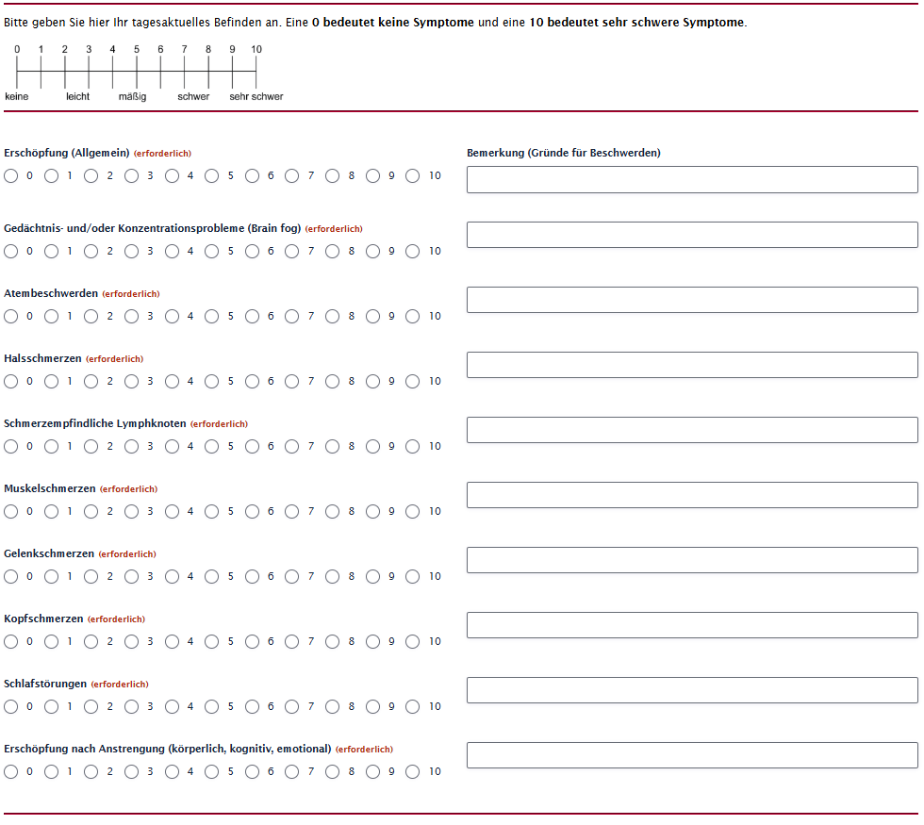
Baraniuk, J. N., Adewuyi, O., Merck, S. J., Ali, M., Ravindran, M. K., Timbol, C. R., Rayhan, R., Zheng, Y., Le, U., Esteitie, R., & Petrie, K. N. (2013). A Chronic Fatigue Syndrome (CFS) severity score based on case designation criteria. American Journal of Translational Research, 5(1), 53–68.

Supplementary File 2 Results of the CPET at exercise termination without two PCC patients with RER < 1.0 at exercise termination and their matched healthy controls.
 | PCC  at exhaustion | Control  at PCC exhaustion |  |  | Control  at exhaustion
 | N = 16 (50%)¹ | N = 16 (50%)¹ | % diff | p-value¹ | N = 16 (50%)¹ | % diff | p-value¹
VO₂ [mL/min/kg] | 16.3 ± 5.2 | 22.0 ± 6.8 | -24.4% | 0.014† | 24.9 ± 7.4 | -36.8% | <0.001†
VO₂ [%pred] | 68.7 ± 17.4 | 94.7 ± 27.4 | -25.5% | 0.004† | 113.1 ± 26.3 | -39.3% | <0.001†
Power output [W] | 76.9 ± 41.2 | 129.7 ± 35.0 | -38.0% | <0.001† | 157.5 ± 26.0 | -51.2% | <0.001†
Power output [W/kg] | 1.1 ± 0.5 | 1.8 ± 0.6 | -37.9% | <0.001† | 2.3 ± 0.6 | -51.0% | <0.001†
Power output [%pred] | 59.5 ± 21.7 | 100.1 ± 27.6 | -38.2% | <0.001† | 121.6 ± 22.6 | -51.1% | <0.001†
HR [1/min] | 142.3 ± 22.5 | 146.5 ± 21.6 | -1.6% | 0.6† | 163.4 ± 16.1 | -13.0% | 0.005†
RER | 1.10 ± 0.07 | 1.09 ± 0.07 | 0.0% | >0.9‡ | 1.2 ± 0.1 | -9.3% | <0.001‡
Lactate [mmol/L] | 3.7 ± 2.5 | 4.1 ± 2.6 | -7.1% | 0.6† | 7.0 ± 2.6 | -47.4% | <0.001†
RPE | 17.7 ± 1.9 | 16.4 ± 2.3 | 12.2% | 0.11† | 18.7 ± 1.6 | -5.4% | 0.12†
Cardiopulmonary and perceptual responses obtained during symptom-limited CPET are shown for patients with post-COVID-19 condition (PCC, n = 16) and matched healthy controls (n = 16). Data are presented as mean ± standard deviation. Significant P-values are marked in bold. Group comparisons between PCC and controls were performed using † Welch two-sample t-tests for normally distributed variables and ‡ Wilcoxon rank-sum tests for non-normally distributed variables, as indicated. The statistical significance level was set at p < 0.05. CPET: cardiopulmonary exercise testing; PCC: post-COVID-19 condition; VO₂: oxygen uptake; HR: heart rate; RER: respiratory exchange ratio; RPE: rate of perceived exertion; %pred: percent of predicted value according to sex, age, bodyweight; %diff: (mean_{PCC} – mean_{control}) / mean_{control} × 100. ¹Compared to PCC patients at exhaustion.

Supplementary File 3 Results of the CPET at the second ventilatory threshold for PCC patients and their matched healthy controls.
 | PCC  N = 18 (50%) | Control  N = 18 (50%) | % diff | p-value
VO_{2VT2} [mL/min/kg] | 14.8 ± 3.3 | 21.1 ± 5.7 | -30.0% | <0.001†
Power Output_{VT2} [W] | 67.0 ± 28.3 | 118.3 ± 21.1 | -43.4% | <0.001†
Power Output_{VT2} [W/kg] | 1.0 ± 0.3 | 1.7 ± 0.5 | -43.0% | <0.001†
HR_{VT2} [1/min] | 129.5 ± 19.5 | 140.1 ± 19.5 | -7.5% | 0.13†
RER_{VT2} | 0.99 ± 0.05 | 1.06 ± 0.05 | -6.3% | <0.001†
Lactate_{VT2} [mmol/L] | 1.9 ± 0.4 | 2.0 ± 0.5 | -8.4% | 0.2†
RPE_{VT2} | 15.4 ± 4.9 | 14.6 ± 1.8 | 6.1% | 0.9‡
Cardiopulmonary and perceptual responses obtained during symptom-limited CPET are shown for patients with post-COVID-19 condition (PCC, n = 18) and matched healthy controls (n = 18). Data are presented as mean ± standard deviation. Significant P-values are marked in bold. Group comparisons between PCC and controls were performed using † Welch two-sample t-tests for normally distributed variables and ‡ Wilcoxon rank-sum tests for non-normally distributed variables, as indicated. The statistical significance level was set at p < 0.05. CPET: cardiopulmonary exercise testing; PCC: post-COVID-19 condition; VO₂: oxygen uptake; HR: heart rate; RER: respiratory exchange ratio; RPE: rate of perceived exertion; %diff: (mean_{PCC} – mean_{control}) / mean_{control} × 100.

Supplementary File 4 Individual symptom severity for patients with post-COVID-19 condition over different time periods before and after the CPET.
Mean symptom severity for post-COVID-19 condition patients over different time periods before and after the CPET. Data are presented as estimated means and standard errors, with exact p-values added where post-hoc differences were significant. The statistical significance level was set at p < 0.05. CPET: cardiopulmonary exercise test.

